Lesson 2
Objective: Reason about embedded numbers in varied configurations using number bonds.

Suggested Lesson Structure
 Fluency Practice (12 minutes)
 Application Problem (8 minutes)
 Concept Development (30 minutes)
 Student Debrief (10 minutes)
Total Time (60 minutes)
Fluency Practice (12 minutes)
- Finger Counting from Left to Right K.CC.2, K.OA.5 (2 minutes)
- Show Me Your Math Fingers: Partners to 5 and 5 More K.CC.2, K.OA.3 (5 minutes)
- Number Bond Dash: 5 K.OA.3, K.OA.5 (5 minutes)
Finger Counting from Left to Right (2 minutes)
Note: Counting from left to right with their fingers allows students an organized way to use their most readily available tool: their fingers! This type of counting also mimics the number path, used in later lessons.
Instruct students to count with their “piano fingers.” Count by ones within 10 on the fingers from left to right, from pinky on the left hand as 1, to pinky on the right hand as 10.
Hover the fingers as if playing the piano. Drop the finger as it is counted and leave it down. Start and end at different numbers. (For example, in counting from 5 to 7, the 5 fingers of the left hand have played, and the student says, “6, 7,” while playing the thumb and pointer finger of the right hand.)
Show Me Your Math Fingers: Partners to 5 and 5 More (5 minutes)
Note: This activity addresses the core fluency objective for Grade 1 of adding and subtracting within 10.
The teacher calls out numbers within 5, and students hold up their fingers the Math Way. Each time students hold up their fingers, ask how many more fingers are needed to make 5. As students say the partner to 5, affirm their answers aloud, “Yes. 3 and 2 make 5.”
Move on to numbers 6–10. For each number, use the example below to reinforce the embedded five within each number.

T: Show me 6 the Math Way.
S: (Hold up all fingers on their left hand and their right thumb).
T: Now, hold your 5 up high. How many fingers are on your other hand?
S. 1!
T. Yes. 5 and 1 make 6.
Number Bond Dash: 5 (5 minutes)
Materials: (T) Stopwatch or timer (S) Number bond dash 5 (Fluency Template), marker to correct work
Note: The Number Bond Dash is a new routine that will be used throughout Module 1. By using the same system, students focus on the mathematics, rather than figuring out the routine.
Distribute Dash, face down, to students. Instruct students to flip their papers when you say, “Go!”
and complete as many number bonds as they can in 90 seconds. Assure them that it is okay if they run out of time before they finish. Tell them if they finish before time, they can practice counting to 20 on the back of their papers, starting with the number 5. Change counting sequence to meet the needs of your students in later lessons.
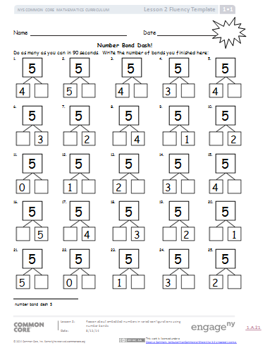
T: (Set the timer for 90 seconds.) On your mark, get set, GO! (Press start.)
T: (When the timer goes off, tell students to put down their pencils and grab a marker to correct their work.)
T: When you get an answer correct, put a check mark on the problem number. If you make a mix-up, fix it with your marker.
T: (Read the number bonds aloud, starting with Problem 1. When the answers to all problems have been provided, tell students to write the number they got correct in the star-like shape on top. Encourage them to remember their scores because they are going to try to do even better tomorrow.)
Tell students to remember how many problems they get correct so they can try to improve their scores tomorrow.

Application Problem (8 minutes)
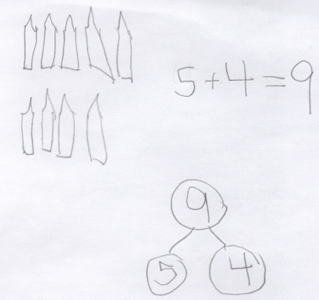
T: (Read the story aloud to the students.)
Bella spilled some pencils on the carpet. Geno came over to help her pick them up. Geno found 5 pencils under the desk and Bella found 4 by the door. How many pencils did they find together? Draw a math picture and write a number bond and a number sentence that tells about the story.
(Bonus: Have early finishers draw the 9 pencils in a different arrangement to show two parts.)
Note: This Application Problem is designed as a bridge from the previous lesson, which focused on seeing and counting on from 5. Students again work with 5 and another number to encourage this counting on.
Concept Development (30 minutes)
Materials: (T) Dot cards of 6–9 (Template) (S) Dot cards of 6–9 (Template), personal white board
T: (Draw 7 apples on the board, as shown to the right.) How many apples are there? (Pause. When all are ready, give the signal.)
Configuration of 7 to show or draw
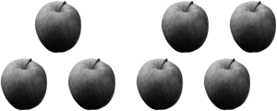

S: 7!
T: Talk to your partner about the different groups of apples you see hiding inside of 7. (Circulate and listen to student discussion.) What two different groups or number partners do you see?
S: (Answers may vary.) I saw 4 and 3.
T: (Group 4 and 3 apples by drawing a circle around them.)
T: Count on to find the total. Start with 4. (Point to each apple in the 3 group.)

NOTES ON
multiple means
of engagement:
Provide challenging extensions for some students. While holding a dot card, cover some of the dots. Tell them the whole, and see if they can figure out the two parts without seeing what is being hidden.

T/S: Foooouuuur, 5, 6, 7. What is the total?
S: 7.
T: What are the parts?
S: 4 and 3.
T: Let’s make a number bond to match this picture. (Draw the bond. Ask students to name the parts and the whole.)

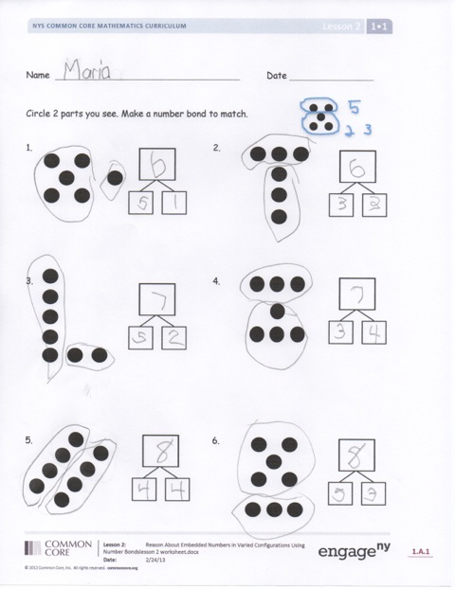
T: What other number partners do you see? (Elicit other ways that students see two embedded numbers within 7 and make corresponding number bonds.)
T: (Continue modeling, decomposing 6, 8, or 9 and filling in the two-part number bond by counting on to find the total.)
T: Let’s play Parts and Bonds.
T: Show a dot card inside your personal board to your partner. He circles two parts. You write a number bond to match his parts. Switch roles using the same dot card (change cards after two turns).
As students work, circulate and encourage active counting on.
Problem Set (10 minutes)
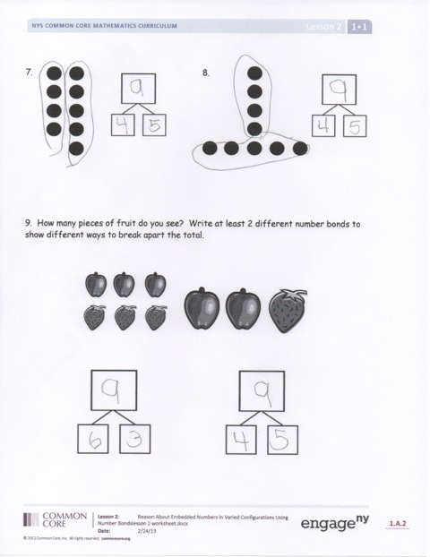
Students should do their personal best to complete the Problem Set within the allotted 10 minutes. For some classes, it may be appropriate to modify the assignment by specifying which problems they work on first. Some problems do not specify a method for solving. Students solve these problems using the RDW approach used for Application Problems.
Note: Once students have circled the parts, encourage them to count on from one quantity to determine the total (at this point it does not matter if it is the larger or the smaller quantity). If a student is reluctant, hide one part with a paper or hand, and ask, “How many are under my hand?” Let the student recount if necessary and hide the part again. Then, have him count on from the hidden part once he is confident.
Student Debrief (10 minutes)
Lesson Objective: Reason about embedded numbers in varied configurations using number bonds.
The Student Debrief is intended to invite reflection and active processing of the total lesson experience.

Invite students to review their solutions for the Problem Set. They should check work by comparing answers with a partner, discussing how they found embedded numbers and counted on to determine the total, before going over answers as a class. Look for misconceptions or misunderstandings that can be addressed in the Debrief. Guide students in a conversation to debrief the Problem Set and process the lesson.
You may choose to use any combination of the questions below to lead the discussion.
- Talk to your partner about how you found the total in Problem 6. Did you count all of the dots, or did you count on from a part you saw?
- Pick one problem where you and your partner came up with a different way to make the total. How is the total the same when you came up with different parts?
- Is there always more than one way to make the total?
- Look at Problem 9. How were your solutions different from or similar to your partner’s solutions?
- (Show examples of student work from the Application Problem.) What were the two parts in our story problem? What does that have in common with today’s lesson? Can you see another way to arrange these pencils?
- Turn to your partner and share what you learned in today’s lesson. What did you get better at doing today?
Exit Ticket (3 minutes)
After the Student Debrief, instruct students to complete the Exit Ticket. A review of their work will help you assess the students’ understanding of the concepts that were presented in the lesson today and plan more effectively for future lessons. You may read the questions aloud to the students.

Name Date

Number Bond Dash!
Do as many as you can in 90 seconds. Write the number of bonds you finished here:
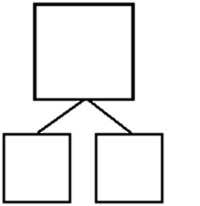1. 2. 3. 4. 5.
5
3

5
4

5
4

5
5

5
4

6. 7. 8. 9. 10.
5

2
5

1
5

4
5

2
5

3

11. 12. 13. 14. 15.
5
4

5
3

5
2

5
14

5
0

16. 17. 18. 19. 20.
5

1
5

2
5

3
5

4
5

5

21. 22. 23. 24. 25.
5
2

5
3

5
1

5
0

5
5

Name Date
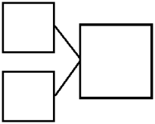
Circle 2 parts you see. Make a number bond to match.

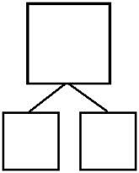
1. 2.

3. 4.

5. 6.

7. 8.

9. How many pieces of fruit do you see? Write at least 2 different number bonds to show different ways to break apart the total.

Name Date
Circle 2 parts you see. Make a number bond to match.

1. 2.

3. 4.

Name Date
Circle 2 parts you see. Make a number bond to match.
1. 2.

3. 4.

5. 6.

7. 8.

How many animals do you see? Write at least 2 different number bonds to show different ways to break apart the total.
9.

10.

number bond dash 5
dot cards of 6–9
dot cards of 6–9
dots cards of 6–9

