Lesson 1
Objective: Analyze and describe embedded numbers (to 10) using 5-groups and number bonds.

Suggested Lesson Structure

NOTES ON
FLUENCY PRACTICE:
Think of fluency activity as having three goals:
- Maintenance (staying sharp on previously learned skills).
- Preparation (targeted practice for the current lesson).
- Anticipation (skills that ensure that students will be ready for the in-depth work of upcoming lessons). Example of anticipatory fluency: Students must be secure in counting to 10 long before they can be expected to decompose 10.

 Fluency Practice (16 minutes)
 Application Problem (7 minutes)
 Concept Development (30 minutes)
 Student Debrief (7 minutes)
Total Time (60 minutes)
Fluency Practice (16 minutes)
- Math Fingers Flash K.CC2, K.CC.4 (3 minutes)
- Sprint: Count Dots K.CC.2, K.CC.5 (13 minutes)
Math Fingers Flash (3 minutes)
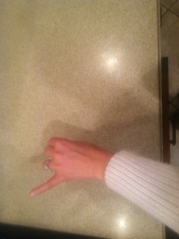
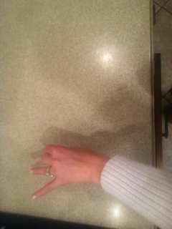
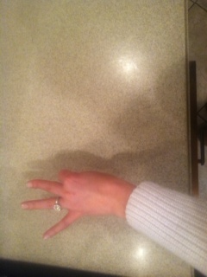
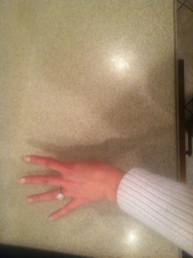
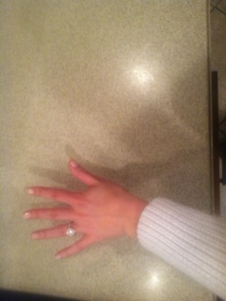
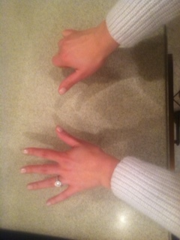
Note: Visually recognizing (perceptually subitizing) sets of objects, particularly fingers, allows students to move toward seeing two sets of objects together (conceptually subitizing), thus preparing them for the fluency objective of Grade 1.
Teacher flashes fingers the Math Way for numbers 0–10 (see pictures above: teacher’s raised fingers should begin with the right pinky and end with the left pinky so students see fingers from left to right).
T: I’m going to hold up some fingers the Math Way and then hide them. Look carefully and say the number you saw when I snap.
T: (Flash 3 fingers for 2–3 seconds and then hide them). Ready (snap).
S: 3!
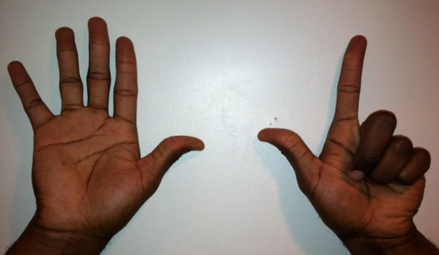
Repeat process for numbers within 5.
T: (Flash 7 fingers.) Ready (snap).
S: 7!
T: (Hold up 5 fingers on the right hand.) How many fingers are on this hand?
S: 5.
T: 5 (hold up the five hand, then hold up the other fingers, one at a time) 6, 7.
Repeat the process for numbers 6–10, inviting students to count on from 5 with you.
Sprint: Count Dots (13 minutes)
Materials: (S) Sprint: 5-group dots
Note: Visually recognizing two sets of objects together (conceptually subitizing) provides students with a foundation for counting on as they solve addition problems. See the Suggested Methods of Instructional Delivery section of the Module Overview for directions on giving Sprints.
Application Problem (7 minutes)
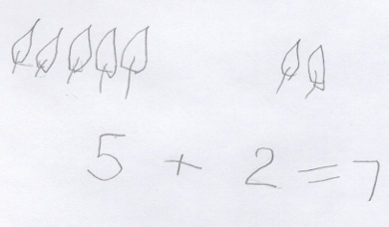
Dora found 5 leaves that blew in through the window. Then, she found 2 more leaves that blew in. Draw a picture and use numbers to show how many leaves Dora found in all.
Note: Rather than specifying to write a number sentence or number bond, since it is the first day of school, this Application Problem is more open-ended so that students can demonstrate their thinking and representational skills. This problem serves as a lead-up to the Concept Development of seeing the quantity of 5 and another number.
Concept Development (30 minutes)
Materials: (T) 1 egg carton cut to 10 slots (S) 1 egg carton cut to 10 slots, bag with 9 beads (or other fun classroom objects), number bond (Template), personal white board
Before the lesson, insert the number bond template into each student’s personal white board.
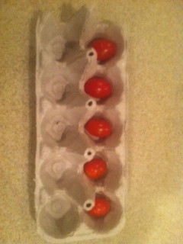
T: Take out your egg carton. Count to find out how many slots there are. Wait for the signal to tell me. (Pause. When all are ready, give the signal.)
S: 10!
T: Someone already cut 2 off.
T: How many slots are in the top row?
S: 5!

NOTES ON
MULTIPLE MEANS
OF ACTION
AND EXPRESSION:
Discourage the touch and count behavior which many students mistake for being good at school. Grade 1 students can subitize twos and threes without counting. They should be encouraged to recognize this since seeing embedded numbers (or subitizing) is the beginning of counting on.

T: How many slots are in the bottom row?
S: 5!
T: Take out the objects in your bag. First, count 5 into the top row from left to right. (Pause.) How many beads do you have in your top row?
S: 5!
T: Now, we are going to be number detectives. Let’s see what numbers are hiding inside of 5!
T: I see 2 hiding inside. Look. (Show the two objects you found.) What other numbers do you see hiding inside 5? Talk to your partner.
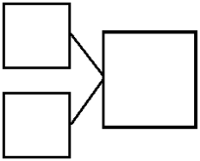T: (Circulate and listen. Encourage those who are touching and counting, rather than seeing the embedded numbers, to recognize quantities of at least 2 or 3.)
total
part
part
5
2
3
Number Bond
T: (Write the 5 in the total box of a number bond.) That’s our total, or whole. Do you remember these number bonds from kindergarten?
S: Yes!
T: You said there was a 2 hiding inside of 5. That’s a part.
(Write the 2 in the number bond.)
T: Let’s cover those 2 beads. What is the other part?
S: 3!
T: Let’s write that in the other part of the number bond. (Write 3.)
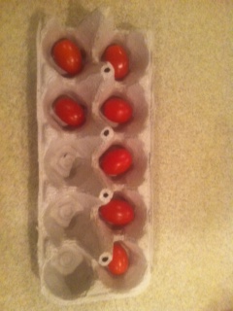
T: What two parts did we find make 5, detectives?
S: 2 and 3!
T: Let’s see if we can find different numbers inside of 5. (Write 5 in the total box inside a new number bond.)
T: (Continue to find the other numbers inside of 5 and generate the corresponding number bonds using the same process.)

NOTES ON
MULTIPLE MEANS
OF REPRESENTATION:
Have students write the two parts on their number bond template. For further support for counting on to give, have them draw the beads at first, and then later in the lesson, represent the
5-groups numerically.

T: Let’s take out 2 more beads, and put them in the bottom row of the egg carton.
T: How many beads are there now?
S: 7.
T: Turn and talk to your partner about what numbers you see inside 7.
S: (Share their observations as you circulate.)
T: I heard a student say that she saw 5 beads. Are there 5 beads?
S: Yes!
T: Let’s draw 5 dots as a part in our number bond instead of the number 5.
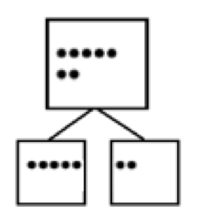T: Where did you see the 5?
Number bond with parts drawn the
5-groups way
S: In the top row.
T: Let’s cover the 5. What is the other part to make 7?
S: 2!
T: Let’s draw in 2 dots as the other part in the number bond.
MP.7
T: Let’s count on from 5 to find our total. Count with me. Let’s start with 5. (Point to the fifth dot.)
T/S: Fiiiiiive, 6, 7. (Point to each of the dots as you count them. Draw 7 dots in the total box the 5-group way.)
T: Let’s now represent this number bond with numbers instead of dots. (Lead the students to make the number bond numerically on their personal white boards.)
Continue to find five and its partner within 6, 7, 8, and 9. Other combinations will be explored in Lesson 2. Release the students to work independently as you determine is best.
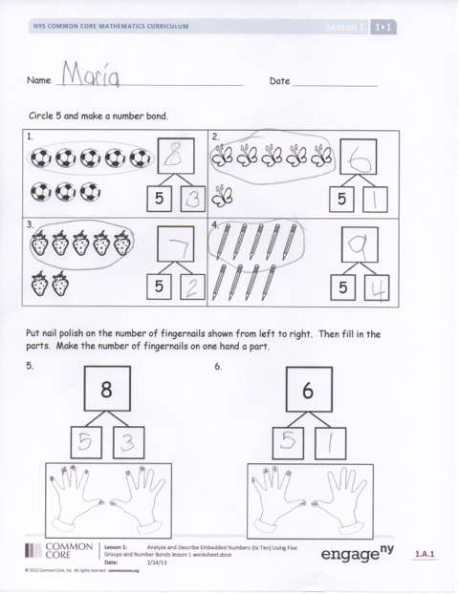
Problem Set (10 minutes)
Students should do their personal best to complete the Problem Set within the allotted 10 minutes. Some problems do not specify a method for solving. This is an intentional reduction of scaffolding that invokes MP.5, Use Appropriate Tools Strategically. Students should solve these problems using the RDW approach used for Application Problems.
For some classes, it may be appropriate to modify the assignment by specifying which problems students should work on first. With this option, let the purposeful sequencing of the Problem Set guide your selections so that problems continue to be scaffolded. Balance word problems with other problem types to ensure a range of practice. Consider assigning incomplete problems for homework or at another time during the day.

Student Debrief (7 minutes)
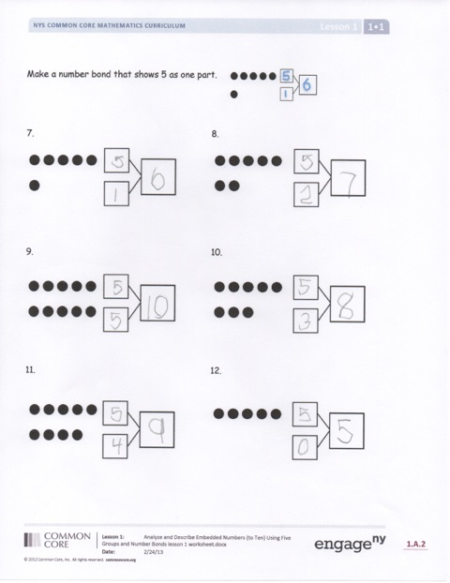
Lesson Objective: Analyze and describe embedded numbers (to 10) using 5-groups and number bonds.
The Student Debrief is intended to invite reflection and active processing of the total lesson experience.
Invite students to review their solutions for the Problem Set. Have them work in pairs to check over their work and discuss how they saw the 5 and the other part to make their number bonds and find the totals. Then go over answers as a class. Look for misconceptions or misunderstandings that can be addressed in the Debrief. Guide students in a conversation to debrief the Problem Set and process the lesson.
You may choose to use any combination of the questions below to lead the discussion.
- Are there 5 butterflies? Strawberries? (We want students to see that there are 5 soccer balls, etc., embedded within the larger numbers. There are 6 butterflies in all. Have them identify the other part once they have seen the five within the number.)
- Look at the soccer balls and the pencils. What is the same about them? What is different about them? (Guide students to see that both 8 and 9 have 5 embedded in them. If they notice the other embedded numbers of 1 to 8, that is great!)
- Can you show me 5 fingers? Show me 5 with two hands (i.e., 4 and 1, or 3 and 2). Now, show me 5 with one hand.
- Can you show me 6 the Math Way with your fingers? (FIve fingers on the left hand and the thumb on the right hand.) Can you show me the five inside 6? Continue with 7, 8, 9, and 10.
- (Show examples of student work from the Application Problem.) What were the two parts in our story problem? What does that have in common with today’s lesson?
Exit Ticket (3 minutes)
After the Student Debrief, instruct students to complete the Exit Ticket. A review of their work will help you assess the students’ understanding of the concepts that were presented in the lesson today and plan more effectively for future lessons. You may read the questions aloud to the students.

Name Date
Number correct:
A
*Write the number of dots. Find 1 or 2 groups that make finding the total number of dots easier!
1 |  |  | 16
2 |  |  | 17
3 |  |  | 18
4 |  |  | 19
5 |  |  | 20
6 |  |  | 21
7 |  |  | 22
8 |  |  | 23
9 |  |  | 24
10 |  |  | 25
11 |  |  | 26
12 |  |  | 27
13 |  |  | 28
14 |  |  | 29
15 |  |  | 30
Name Date
Number correct:
B
*Write the number of dots. Find 1 or 2 groups that make finding the total number of dots easier!
1 |  |  | 16
2 |  |  | 17
3 |  |  | 18
4 |  |  | 19
5 |  |  | 20
6 |  |  | 21
7 |  |  | 22
8 |  |  | 23
9 |  |  | 24
10 |  |  | 25
11 |  |  | 26
12 |  |  | 27
13 |  |  | 28
14 |  |  | 29
15 |  |  | 30

Name Date

Circle 5, and then make a number bond.
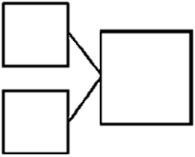1.  5 | 2.  5
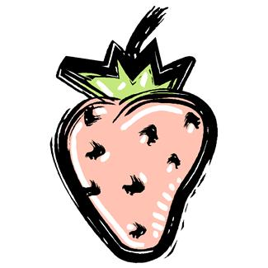3.  5 | 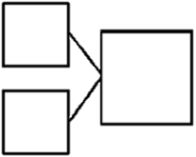4.  5

Put nail polish on the number of fingernails shown from left to right. Then, fill in the parts. Make the number of fingernails on one hand a part.
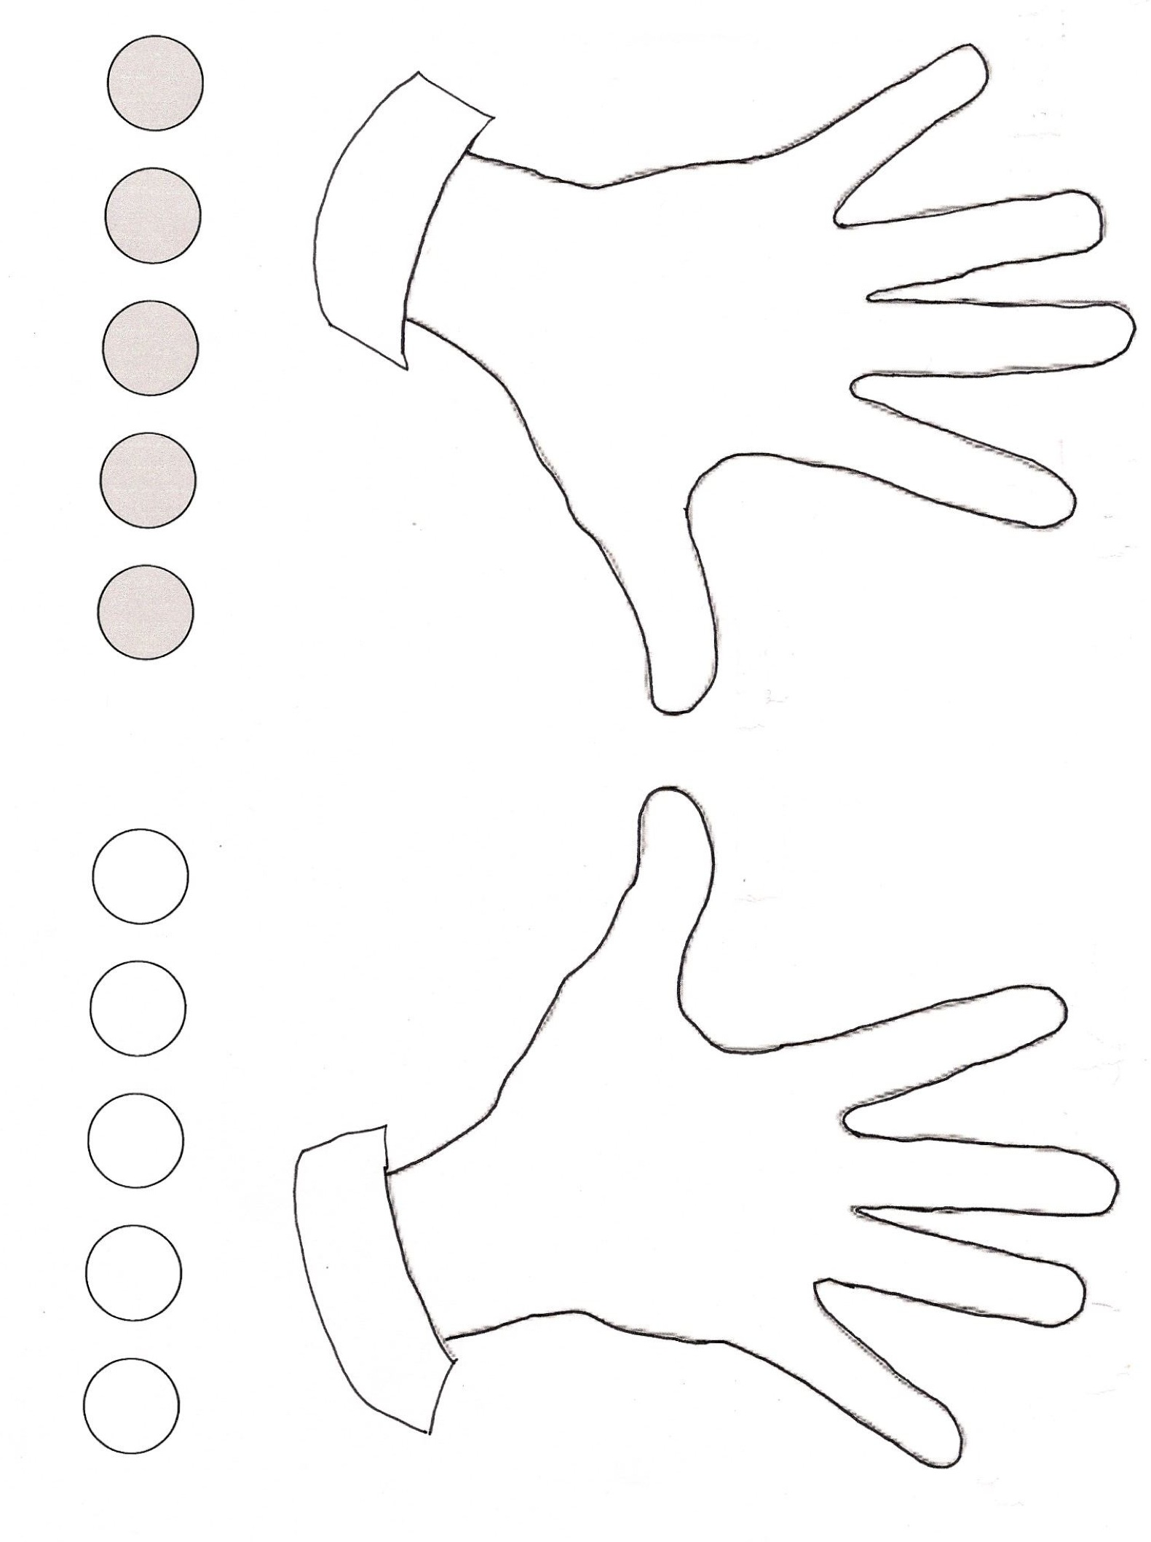5. 6.
8
6

Make a number bond that shows 5 as one part.

7. 8.

9. 10.

11. 12.

Name Date

Make a number bond for the pictures that shows 5 as one part.

1. 2.

Name Date

Circle 5, and then make a number bond.
1.  5 | 2.  5
3.  5 | 4.

Make a number bond that shows 5 as one part.
5. 6.

7. 8.

Make a number bond for the dominoes.
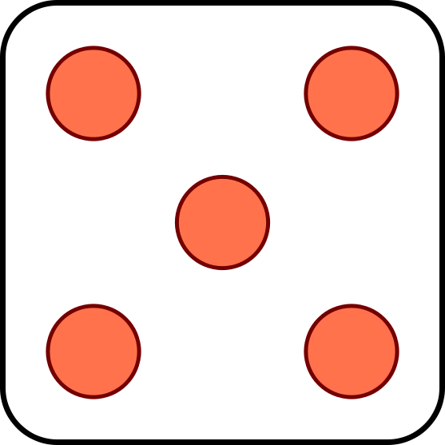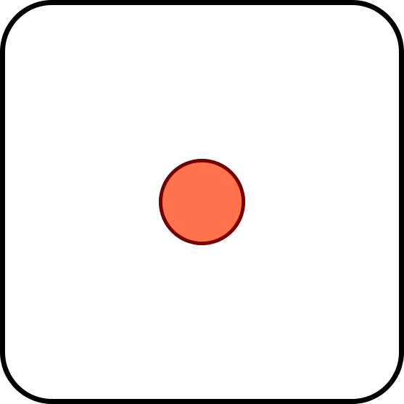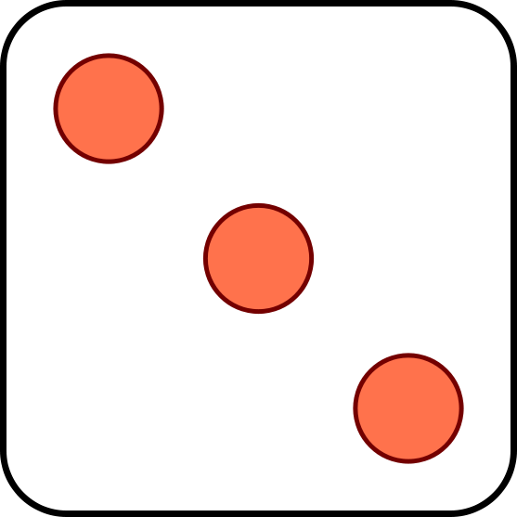 9. 10.

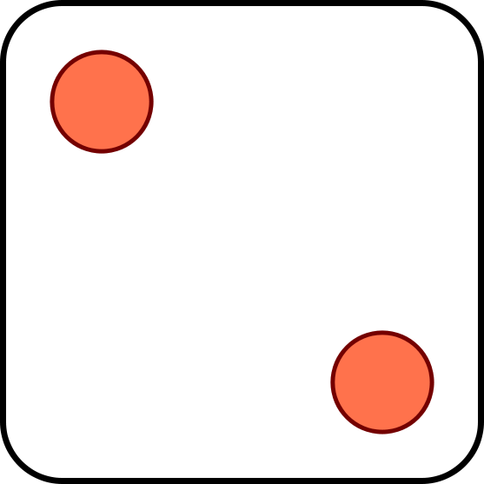 11. 12.

Circle 5 and count. Then, make a number bond.
13. | 14.
15. | 16.

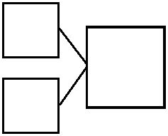

number bond

