Lesson 34
Objective: Create resource booklets to support fluency with Grade 3 skills.

Suggested Lesson Structure

NOTES ON
RESOURCES INCLUDED IN THIS LESSON:
This lesson includes suggestions and resources for assembling a summer practice packet in addition to the resource booklets that students create. Suggestions can be found just before the Student Debrief, and resources are at the end of the lesson.

 Application Problem (7 minutes)
 Fluency Practice (43 minutes)
 Student Debrief (10 minutes)
Total Time (60 minutes)
Application Problem (7 minutes)
There are 9 bicycles and some tricycles at the repair shop. There are 42 total wheels on all the bicycles and tricycles.
How many tricycles are in the shop?
Note: This word problem challenges students to solve using three out of the four operations. Students may find the total wheels on 9 bicycles mentally. The complexity is to understand that to find the total number of tricycles, they divide the remaining number of wheels by 3.

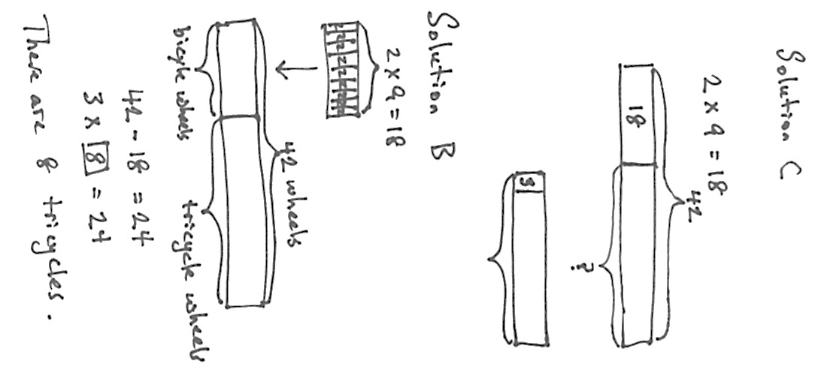
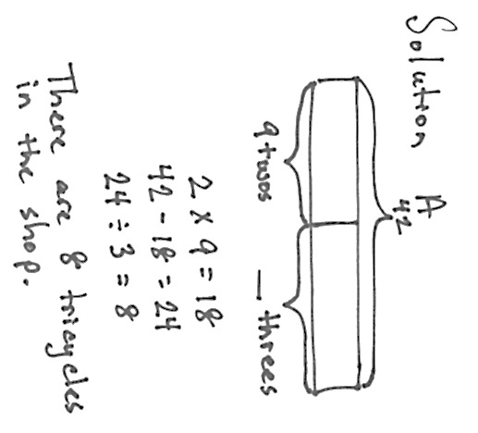

Fluency Practice (43 minutes)

NOTES ON
MULTIPLE MEANS OF ENGAGEMENT:
To support student participation in the discussion about fluency, consider providing the following scaffolds:
- Present a list of fluency activities students can refer to during discussion.
- Delineate how to assess improvement. Helpful questions students might ask partners include, “Which fluency activities did you use as you solved problems? Which fluency activities did you share at home or with friends? Were some fluencies challenging at first, but easy later?”

T: Think about all the fluency activities we did this year. Which were your favorites?
S: (Discuss.)
T: Which ones helped you improve your fluency with multiplication and division facts? Share with a partner.
S: Group Counting helped me skip-count forward and backward. That made it simple to use an easy fact to find a hard one. I worked so hard on my Sprints. They made me get so much faster! Multiply Bys were like that for me. Finding the unknown factor made me get good at thinking of multiplication and division in different ways.
T: Let’s do one last Grade 3 Sprint to celebrate just how far we’ve come. Then we’ll make summer practice booklets of our favorite games so we can keep playing at home in the weeks to come.

- Sprint: Multiply and Divide 3.OA.7 (10 minutes)
- Summer Practice Booklet Assembly (10 minutes)
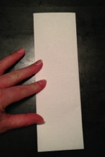
- Mixed Review Fluency Activities (23 minutes)
Sprint: Multiply and Divide (10 minutes)
Materials: (S) Multiply and Divide Sprint
Note: This Sprint focuses on student mastery of all products and quotients within 100.
Summer Practice Booklet Assembly (10 minutes)
Materials: (S) 11" × 17" paper (light colored construction paper or tag board preferred), scissors, (optional: game directions printouts from G3–M7–Lesson 33 for students to cut out and glue into booklets)
Model for students step by step, as shown in the photos to the right.
T: Let’s make a booklet of practice materials that you can use over the summer. Start with a blank piece of paper. Lay it on your desk so that the long sides of the rectangle are at the top and the bottom.
S: (Lay paper on desks.)
T: Fold the left edge of the paper to meet the right edge. The short sides should be together. Make a tight crease when you fold. The tighter the creases, the better your book will turn out.
S: (Fold paper.)
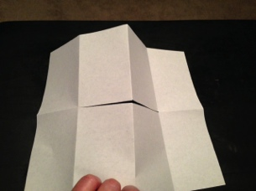
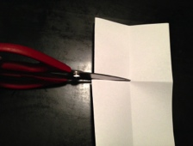
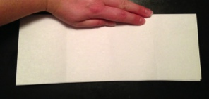
T: Keep the paper folded. Again, fold the left edge of the paper to meet the right edge. This time the long sides should be together. Make a tight crease. You should have a long, skinny rectangle now.
S: (Fold paper.)
T: Before we unfold, think about what fraction our paper is folded into. Say the fraction at my signal. (Signal.)
S: Fourths.
T: Unfold the paper completely and lay it out flat.
S: (Unfold paper.)
T: Now fold the top edge of the paper down to meet the bottom edge.
S: (Fold paper.)
T: Now what fraction is the paper folded into?
S: Eighths.
T: Unfold the paper completely and lay it out flat.
S: (Unfold paper.)
T: Fold the paper again the same way we first folded it. Make the left edge meet the right edge.
S: (Fold paper.)
T: Make sure the open side is on the right. Trace the middle fold line halfway across, starting from the left. Do not go past the fold that shows halfway.
S: (Trace.)
T: Now, cut on the line that you just drew. Do not cut past the fold that shows halfway.
S: (Cut.)
T: Please put your scissors away. (This is to prevent students from cutting the edges of the finalized book to even up the pages. If they do that, the book will fall apart because they may cut folds that hold the book together.)
S: (Put away scissors.)
T: Open up the paper again. You should have cut a slit in the middle of the paper.
S: (Open up the paper.)
T: Fold the top edge to meet the bottom edge so that you have a long rectangle, and the slit you cut is at the top of the folded rectangle.
S: (Fold the paper.)
T: Push the right side of the rectangle towards the left side. Keep going until the pages push together and fall to either side.
S: (Push the rectangle together to make booklet.)
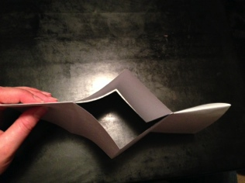
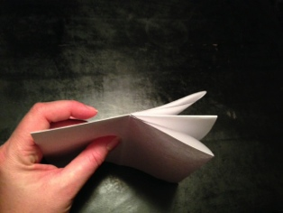
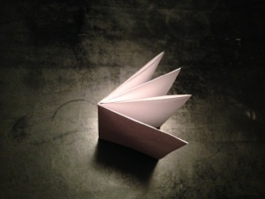

T: Fold the cover over the rest of the pages. Your pages will not line up perfectly, and it’s important that you don’t trim them with scissors or your book will fall apart. On the cover of the book, write Summer Practice and your name underneath.
S: (Title books.)
T: Pull out the sheet where you recorded your favorite games from yesterday. Work with a partner to write the names of your favorite games and directions for those games in your booklets so that you’ll remember them later. (Alternately, print the directions for the games from G3–M7–Lesson 33 for students to cut out their favorites and glue into the booklets.)
S: (Allow time for students to finish their booklets.)
Mixed Review Fluency Activities (23 minutes)

NOTES ON
MULTIPLE MEANS FOR ACTION AND EXPRESSION:
Depending on the needs of English language learners, summer packets may be provided in their first languages.
In addition, adjust physical exercises on the summer calendar to suit students’ needs. Possible alternatives are listed below:
- Chair push-ups
- Spins and twists
- Clapping, patting, and tapping
- Head nods
- Stretches
- Passive or assisted exercises
As students finish making booklets, invite them to play the games from G3–M7–Lesson 33 again.
Suggested Resources to Include in a Summer Practice Packet
Remind parents that curriculum materials are available for free online.
- Lesson 34 Summer Calendar (included at the end of this lesson)
- 5 Sprints (print, or use extras made during the year)
- 5 Multiply By Pattern Sheets (print, or use extras made during the year)

Student Debrief (10 minutes)
Lesson Objective: Create resource booklets to support fluency with Grade 3 skills.
The Student Debrief is intended to invite reflection and active processing of the total lesson experience.
Guide students in a conversation to process the lesson. You may choose to use any combination of the questions below to lead the discussion.
- What was your favorite math topic in third grade? Why?
- What models or manipulatives helped you with new concepts?
- What was your biggest accomplishment in math this year?
- What are some ways you can keep your math skills sharp during the summer?
- What are you most excited to learn next year as a fourth-grader?
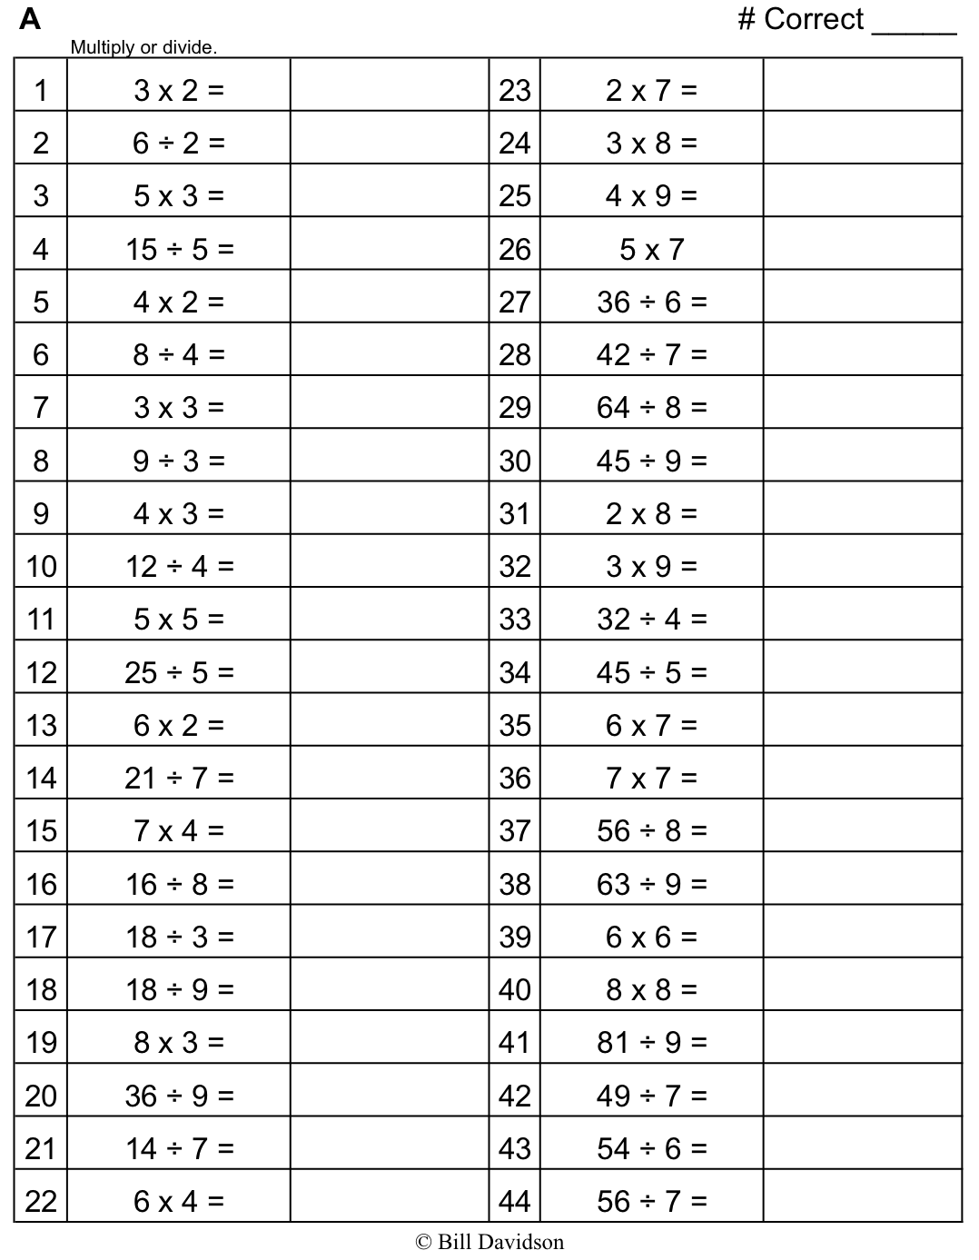

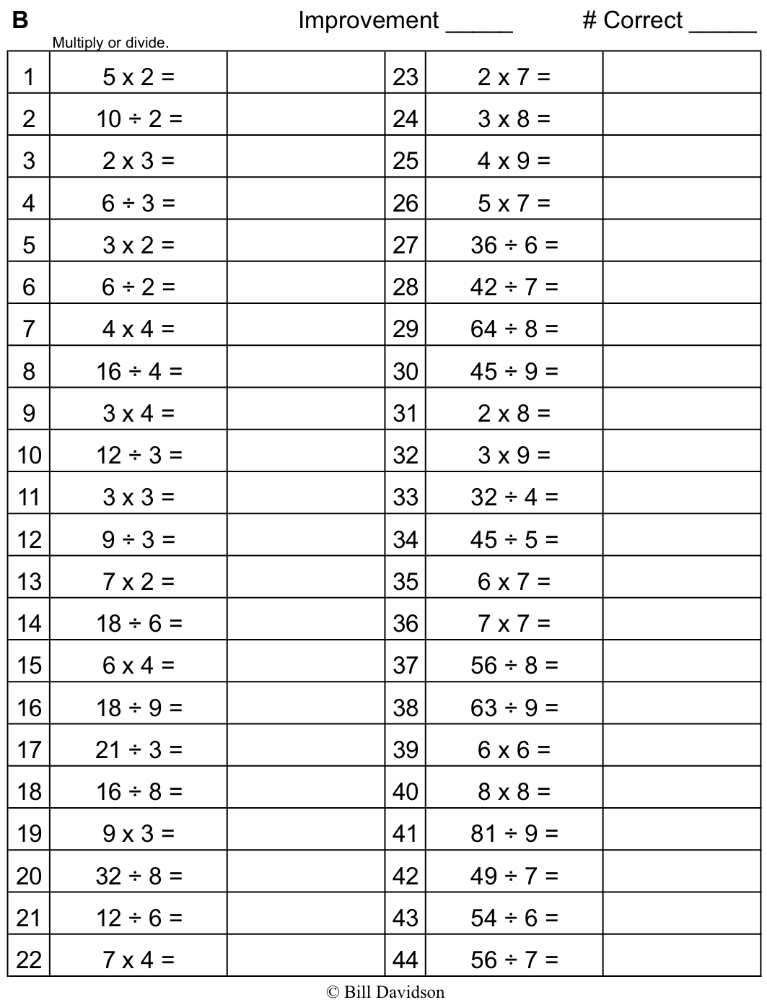
Name Date

Complete a math activity every day. To track your progress, color the box after you finish.
Summer Math Review: Weeks 1–5
 | Monday | Tuesday | Wednesday | Thursday | Friday
Week 1 | Do jumping jacks as you count by twos from 2 to 20 and back. | Play a game from your Summer Practice booklet. | Use your tangram pieces to make a picture of your summer break. | Time how long it takes you to do a specific chore, like making the bed. See if you can do it faster the next day. | Complete a Sprint.
Week 2 | Do squats as you count by threes from 3 to 30 and back. | Play a game from your Summer Practice booklet. | Collect data about your family’s or friends’ favorite type of music. Show it on a bar graph. What did you discover from your graph? | Read a recipe. What fractions does the recipe use? | Complete a Multiply By Pattern Sheet.
Week 3 | Hop on one foot as you count by fours from 4 to 40 and back. | Create a multiplication and/or division math game. Then play the game with a partner. | Measure the widths of different leaves from the same tree to the nearest quarter inch. Then draw a line plot of your data. Do you notice a pattern? | Read the weight in grams of different food items in your kitchen. Round the weights to the nearest 10 or 100 grams. | Complete a Sprint.
Week 4 | Bounce a ball as you count by 5 minutes to 1 hour, and then to the half hour and quarter hours. | Find, draw, and/or create different objects to show one-fourth. | Go on a shape scavenger hunt. Find as many quadrilaterals in your neighborhood or house as you can. | Find the sum and difference of 453 mL and 379 mL. | Complete a Multiply By Pattern Sheet.
Week 5 | Do arm swings as you count by sixes from 6 to 60 and back. | Draw and label a floor plan of your house. | Measure the perimeter of the room where you sleep in inches. Then calculate the area. | Use a stopwatch to measure how fast you can run 50 meters. Do it 3 times. What was your fastest time? | Complete a Sprint.

Name Date

Complete a math activity each day. Color the box for each day you do the suggested activity.
Summer Math Review: Weeks 6–10
 | Monday | Tuesday | Wednesday | Thursday | Friday
Week 6 | Alternate counting with a friend or family member by sevens from 7 to 70 and back. | Play a game from your Summer Practice booklet. | Write a story problem for 7 × 6. | Solve 15 × 4. Draw a model to show your thinking. | Complete a Multiply By Pattern Sheet.
Week 7 | Jump forward and back as you count by eights from 8 to 80 and back. | Play a game from your Summer Practice booklet. | Use string to measure the perimeter of circular items in your house to the nearest quarter inch. | Build a 4 by 6 array with objects from your house. Write 2 multiplication and 2 division sentences for your array. | Complete a Sprint.
Week 8 | Do arm crosses as you count by nines from 9 to 90 and back.  Teach someone the nines finger trick. | Create a multiplication and/or division math game. Then play the game with a partner. | Write a story problem for 72 ÷ 8. | Measure or find the capacity in milliliters of different liquids in your kitchen. Round each to the nearest 10 or 100 milliliters. | Complete a Multiply By Pattern Sheet.
Week 9 | Jump rope as you count up by tens from 280 to 370 and back down. | Find, draw, and/or create different objects to show one-third. | Go on a shape scavenger hunt. Find as many triangles and hexagons in your neighborhood as you can. | Measure the weight of different produce you buy at the grocery store. What unit did you measure in? What are the lightest and heaviest objects you weighed? | Complete a Sprint.
Week 10 | Count by sixes starting at 48. Count as high as you can in one minute. | Draw and label a floor plan of your dream tree house. | Find the perimeter of a different room in your house. How much smaller or larger is it compared to the perimeter of the room where you sleep? | Show someone your strategy to solve 8 × 16. | Complete a Multiply By Pattern Sheet.

