Lesson 33
Objective: Solidify fluency with Grade 3 skills.

Suggested Lesson Structure
 Fluency Practice (50 minutes)
 Student Debrief (10 minutes)
Total Time (60 minutes)
Fluency Practice (50 minutes)
- Sprint: Mixed Division 3.OA.7 (10 minutes)
- Multiply 3.OA.7 (3 minutes)
- Mixed Review Games (37 minutes)
Sprint: Mixed Division (10 minutes)
Materials: (S) Mixed Division Sprint
Note: This Sprint focuses on student mastery of all quotients within 100.
Multiply (3 minutes)
Materials: (S) Personal white boards
Note: This fluency activity focuses on student mastery of all products of two one-digit numbers.
T: (Write 4 $\text{×}$ 2 = ___.) Say the multiplication sentence.
S: 4 times 2 is 8.

NOTES ON
MULTIPLE MEANS OF REPRESENTATION:
Clarify the expression “flip the factors” for English language learners and others. Explain that students are to switch the placement of the factors in the multiplication sentence. It may be helpful to give an example.

Continue the process for the following possible sequence: 3 $\text{×}$ 4,
4 $\text{×}$ 4, and 5 $\text{×}$ 6.
T: (Write 7 $\text{×}$ 6 = ___.) Write the answer.
S: (Write 42.)
Continue the process for the following possible sequence: 8 $\text{×}$ 7 and 9 $\text{×}$ 6.
T: (Write 3 $\text{×}$ 2 = ___.) Say the multiplication sentence.
S: 3 times 2 is 6.
T: Flip the factors and say it.
S: 2 times 3 is 6.

NOTES ON
MULTIPLE MEANS OF ENGAGEMENT:
These are games that students can play with family members to maintain skills over the summer. It may be appropriate to invite parents and siblings to learn and participate. This might be done at a math or parents’ night. For example, students may consider who their game partners might be at home and make adjustments accordingly. For example, if played with a younger or older sibling, games may include math appropriate for siblings. Discuss with students how to best adapt the games for their personal summer experiences.

Continue the process for the following possible sequence: 6 $\text{×}$ 3, 7 $\text{×}$ 5, 7 $\text{×}$ 6, and 9 $\text{×}$ 8.
Mixed Review Games (37 minutes)
Materials: (S) Fluency game materials (listed with each activity and included at the end of the lesson), Problem Set
For the rest of today’s lesson students review and play fluency games from Grade 3. They play in pairs, alternating the role of teacher. Students might periodically move around the room selecting different partners, or stay in the same grouping for the duration of this practice. Choose a few ideas from the suggested games, and let students choose which ones they will play, or select other fluency favorites based on the needs and interests of the class.
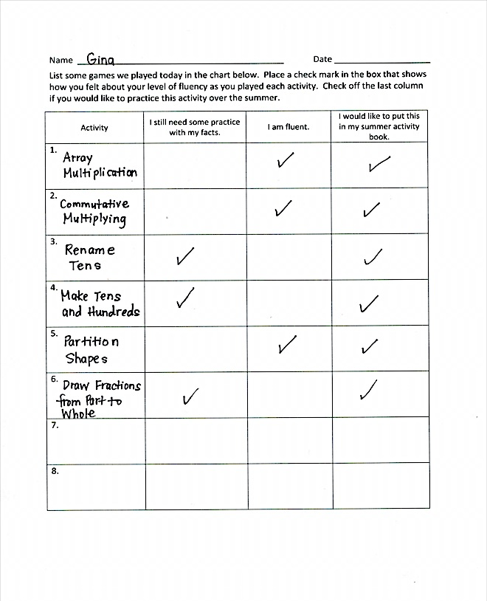
Students should have their Problem Set with them as they play the fluency games, and use it to keep a list of their favorite activities. They will reference the list in G3–M7–Lesson 34 when recording the directions for their favorites in a summer practice booklet.
Student Debrief (10 minutes)
Lesson Objective: Solidify fluency with Grade 3 skills.
The Student Debrief is intended to invite reflection and active processing of the total lesson experience.
Invite students to review their solutions for the Problem Set. They should check work by comparing answers with a partner before going over answers as a class. Look for misconceptions or misunderstandings that can be addressed in the Debrief. Guide students in a conversation to debrief the Problem Set and process the lesson.
You may choose to use any combination of the questions below to lead the discussion.
- What is something you did today that you could not do before you came to third grade?
- Are there any activities that were still a little challenging? What might you do to get better?
- Which of these games might be fun to play over the summer so you can keep your math skills sharp? Who will you teach to play with you?
Exit Ticket (3 minutes)
After the Student Debrief, instruct students to complete the Exit Ticket. A review of their work will help you assess the students’ understanding of the concepts that were presented in the lesson today and plan more effectively for future lessons. You may read the questions aloud to the students.

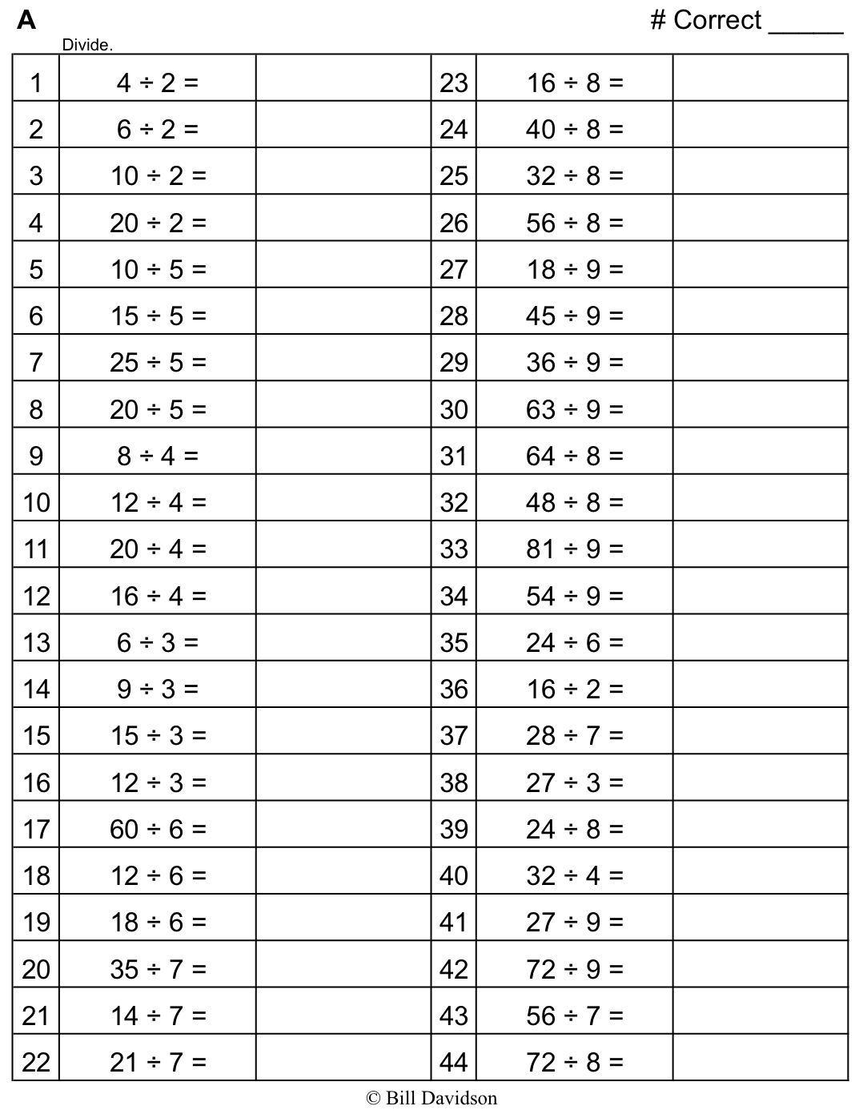
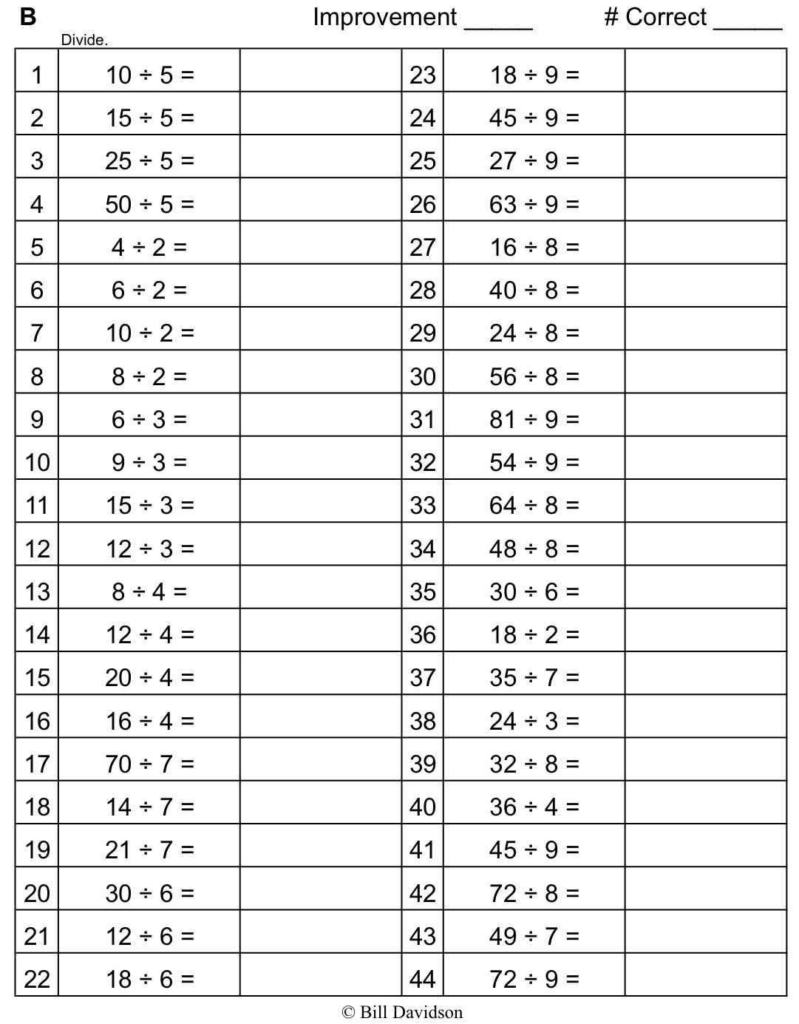
Name Date
List some games we played today in the chart below. Place a check mark in the box that shows how you felt about your level of fluency as you played each activity. Check off the last column if you would like to practice this activity over the summer.
Activity | I still need some practice with my facts. | I am fluent. | I would like to put this in my summer activity book.
1.

2.

3.

4.

5.

6.

7.

8.

Name Date
What fluency activity helped you the most in becoming fluent with your multiplication and division facts this year? Write three or four sentences to explain what made it so useful.

Name Date
Teach a family member your favorite fluency game from class. Record information about the game you taught below.

Name of the game: ______________________________________________________________

______________________________________________________________________________

Materials used: _________________________________________________________________

______________________________________________________________________________

Name of the person you taught to play: _____________________________________________

Describe what it was like to teach the game. Was it easy? Hard? Why? ___________________

______________________________________________________________________________

______________________________________________________________________________

______________________________________________________________________________

Will you play the game together again? Why or why not? ______________________________

______________________________________________________________________________

______________________________________________________________________________

Was the game as fun to play at home as in class? Why or why not? _______________________

______________________________________________________________________________

______________________________________________________________________________
Multiplication  Materials: (S) Personal white boards  T: (Draw an array with 3 rows of 2.) Say the repeated addition sentence.  S: 2 + 2 + 2 = 6.  T: (Write 3 $\text{×}$ ____ = ____.) On your personal board, complete the multiplication sentence.  S: (Write 3 $\text{×}$ 2 = 6.)  Repeat using the following ideas: 4 rows of 10, 3 rows of 4, 7 rows of 3, and 8 rows of 2. Or, you can think of your own. | Equal Groups  Materials: (S) Personal white boards  T: (Draw a picture with 2 groups of 4 circled.) Say the total as a repeated addition sentence.  S: 4 + 4 = 8.  T: Write a division sentence that means the number of groups is unknown.  S: (Write 8 ÷ 4 = 2.)  T: Below that division sentence write a division sentence that means the number In each group is unknown.  S: (Write 8 ÷ 2 = 4.)  Repeat using the following ideas: 5 groups of 3, 3 groups of 4, and 6 groups of 2. Or, you can think of your own.
Commutative Multiplying  Materials: (S) Personal white boards  T: (Draw an array with 3 rows of 2 dots.) How many rows of 2 do you see?  S: 3 rows of 2.  T: Write four different multiplication sentences for the picture.  S: (Write 3 $\text{×}$ 2 = 6, 2 $\text{×}$ 3 = 6, 6 = 3 $\text{×}$ 2, 6 = 2 $\text{×}$ 3.)  Repeat using the following ideas: 3 rows of 5, and 4 rows of 3. Or, you can think of your own.  T: (Write 4 $\text{×}$ 2 = 2 $\text{×}$ ___.) On your board, fill in the blank.  S: (Write 4 $\text{×}$ 2 = 2 $\text{×}$ 4.)  Repeat using the following ideas: 9 $\text{×}$ 5 = 5 $\text{×}$ ___ and 3 $\text{×}$ 6 = 6 $\text{×}$ ___. Or, you can think of your own. | Tape Diagrams  Materials: (S) Personal white boards  T: (Draw a tape diagram with 5 equal units and 2 stars in the first unit.) What is the value of each unit?  S: 2 stars.  T: How many units are there?  S: 5 units.  T: Write a multiplication sentence for this tape diagram.  S: (Write 5 $×$ 2 = 10.)  Repeat using the following ideas: 4 $×$ 3 = 12, 8 ÷ 4 = 2, and 15 ÷ 3 = 5. Or, you can think of your own.

Tens  Materials: (S) Hide Zero Cards, personal white boards  Note: Hide Zero Cards can be made with index cards for personal practice.  T: (Write 7 tens = ____.) Say the number.  S: 70.  Repeat using the following ideas: 10 tens, 12 tens, 20 tens, 28 tens, 30 tens, and 37 tens. Or, you can think of your own.  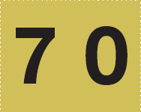  Hide Zero Cards | Tens and Hundreds  Materials: (S) Personal white boards  T: (Write 9 + __ = 10.) Say the missing number.  S: 1.  T: (Write 90 + __ = 100.) Say the missing number.  S: 10.  T: (Write 91 + __ = 100.) Say the missing number.  S: 9.  T: (Write 291 + __ = 300.) Say the missing number.  S: 9.  Repeat using the following ideas:  1 + __ = 10, 10 + __ = 100, 11 + __ = 100, 211 + __ = 300,  8 + __ = 10, 80 + __ = 100, 85 + __ = 100, and 385 + __ = 400  Or, you can think of your own.
Make Twenty-Four Game  Materials: Set of 6 cards per pair  Note: Students play in pairs. Each pair has a set of 6 cards, each with a number (2, 3, 4, 6, 8, and 12).  T: (Write ___ $\text{×}$ ___ = 24.) Spread the cards out in front of you.  T: Put your hands behind your back. I’ll put a number in the first blank. When you know the number that belongs in the second blank, touch the card that shows the number. The first one of us to touch the card keeps it. Whoever has the most cards at the end wins. (Write 12 in the first blank.)  S: (Touch the 2 card. The first to touch it keeps the card.)  Repeat but this time, you might make 36 with the same cards plus 9 and 18. | Write In the Parentheses  Materials: (S) Personal white boards  T: (Write 10 – 5 + 3 = 8.) On your board, copy the equation. Then, insert parentheses to make the statement true.  S: (Write (10 – 5) + 3 = 8.)  Repeat using the following ideas:  10 – 5 + 3 = 2, 10 = 20 – 7 + 3, 16 = 20 – 7 + 3,  8 + 2 $\text{×}$ 4 = 16, 8 + 2 $\text{×}$ 4 = 40, 12 = 12 ÷2 $\text{×}$ 2, 3 = 12 ÷ 2 $\text{×}$ 2, 10 = 35 – 5 $\text{×}$ 5, and 20 – 10 ÷ 5 = 2.  Or, you can think of your own.
