Lesson 32
Objective: Explore and create unconventional representations of one-half.

Suggested Lesson Structure
 Fluency Practice (13 minutes)
 Application Problem (7 minutes)
 Concept Development (30 minutes)
 Student Debrief (10 minutes)
Total Time (60 minutes)
Fluency Practice (13 minutes)
- Sprint: Mixed Multiplication 3.OA.7 (10 minutes)
- Divide 3.OA.7 (3 minutes)
Sprint: Mixed Multiplication (10 minutes)
Materials: (S) Mixed Multiplication Sprint
Note: This Sprint focuses on student mastery of all products of one-digit numbers.
Divide (3 minutes)
Materials: (S) Personal white boards
Note: This fluency activity focuses on student mastery of all quotients within 100.
T: (Write 10 ÷ 2 = ____.) Say the division sentence.
S: 10 ÷ 2 = 5.
Continue the process for the following possible sequence: 4 ÷ 2, 8 ÷ 4, and 15 ÷ 3.
T: (Write 24 ÷ 4 = ____.) Write the answer.
S: (Write 24 ÷ 4 = 6.)
Continue the process for the following possible sequence: 45 ÷ 9, 63 ÷ 7, 48 ÷ 6, 56 ÷ 8, and 81 ÷ 9.

Application Problem (7 minutes)
Hannah traces square-inch tiles to draw 3 larger squares. She draws the 3 large squares side by side to make a rectangle. She shades one-half of each larger square, as shown.

- Do you agree that all 3 squares are one-half shaded? Explain your answer.
- What is the area of the rectangle?
- What is the total area of the shaded space?
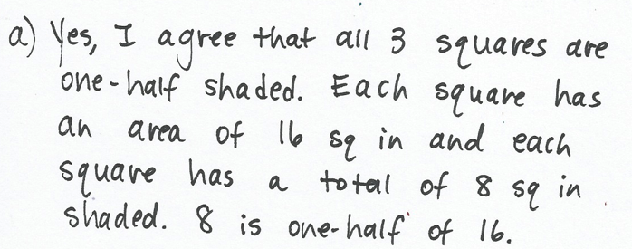
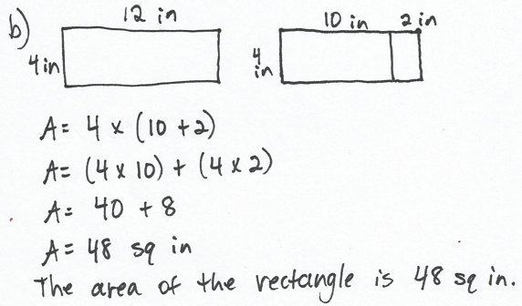
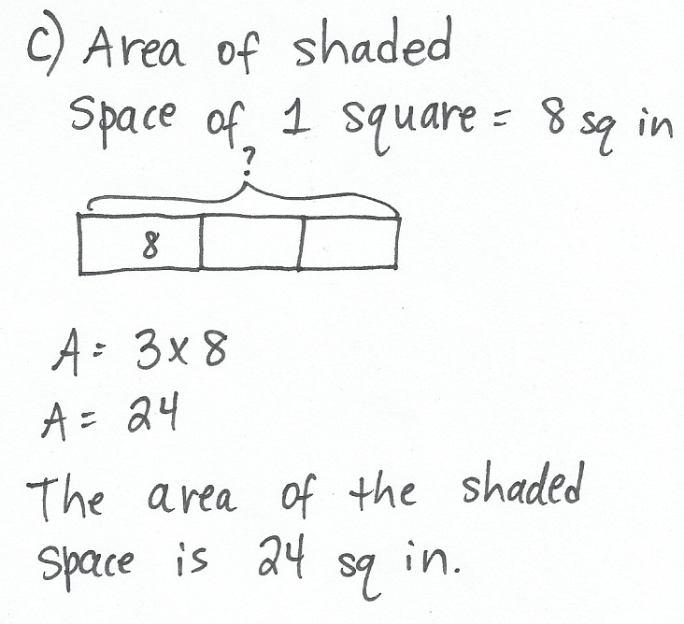

Note: This Application Problem reviews the concept of unconventional representations of one-half from
G3–M7–Lesson 31.
Concept Development (30 minutes)
Materials: (T) Completed page 1 sample of Problem Set (analyzing tool) (S) 4 circle templates, ruler, crayons, Problem Set
.
Distribute four circle templates to each student.
MP.6
MP.6
MP.6
T: Let’s represent one-half using our circles. They don’t have a grid like yesterday’s squares did. Talk with your partner about what tools or strategies you might use to help you be precise as you show one-half.
MP.6
S: We can fold the circle in half and use the fold line for help. Or, we could use rulers. That little dot looks like it’s in the middle. If we fold or draw from that, it should be pretty close to one-half.
T: Go ahead and fold one circle to estimate one-half now.
S: (Fold.)
T: Take your second circle. Fold it in half, and then fold it half again. (Model.) Open your circle. What fractional unit did you divide your circle into?
S: Fourths!
T: Why might fourths be useful for representing one-half?
S: If you color in two it’ll be one-half, just like before. True, but you can also color the fourths that are diagonal from each other to get a little more interesting with your one-half.
T: Fold your fourths back up, then fold the circle in half for a third time. What fractional unit is your circle divided into now?
S: Eighths!
T: Talk to your partner about how that grows the possibilities for showing one-half.
S: (Discuss.)
T: Besides folding your circle into different fractional units, how else could you get creative about the way you show one-half with your circle?
S: You could use your pencil eraser to erase dots from the shaded spot, then redraw them on the unshaded parts. Or, you could use your ruler to measure shapes inside the shaded part, then erase them and redraw them on the unshaded part.
T: Use folding and other ideas to create different, creative representations of one-half.
S: (Work to create representations using their four circles.)
Once every student has made at least four representations, guide an analysis of the representations to confirm that they accurately represent one-half. Have students work in pairs to do this, or set up a gallery walk.
T: Do all of our circles represent exactly one-half? Talk with your partner. Why or why not?
S: Mine do. I measured them with a ruler. I don’t know about that. It’s hard to draw a perfectly straight line from the middle, even with a ruler. Mine aren’t exact. I folded.
MP.6
T: We did a lot of estimating with our circles, so we can say that our circles show representations of about one-half.
If time allows, encourage students to present their circles to a small group and explain how they know they shaded about one-half of their circles. After explanations, students should correct any mistakes. To finish the lesson, students can use crayons to color over their pencil shading. Combine all the finished circles to form a class quilt to display the various representations of one-half.
Problem Set (10 minutes)
Students should do their personal best to complete the Problem Set within the allotted 10 minutes. For some classes, it may be appropriate to modify the assignment by specifying which problems they work on first. Some problems do not specify a method for solving. Students solve these problems using the RDW approach used for Application Problems.
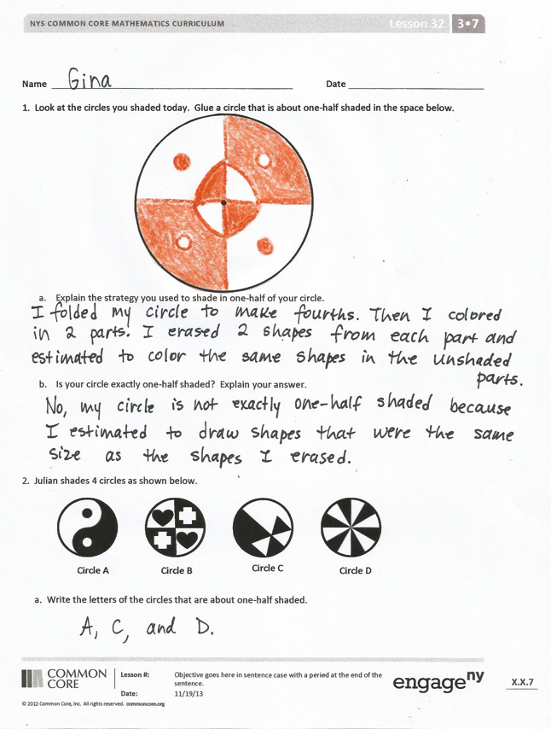
Student Debrief (10 minutes)
Lesson Objective: Explore and create unconventional representations of one-half.
The Student Debrief is intended to invite reflection and active processing of the total lesson experience.
Invite students to review their solutions for the Problem Set. They should check work by comparing answers with a partner before going over answers as a class. Look for misconceptions or misunderstandings that can be addressed in the Debrief. Guide students in a conversation to debrief the Problem Set and process the lesson.
You may choose to use any combination of the questions below to lead the discussion.
- Share answers to Problem 1(b). Were any of the circles that we made today exactly one-half shaded? How do you know?
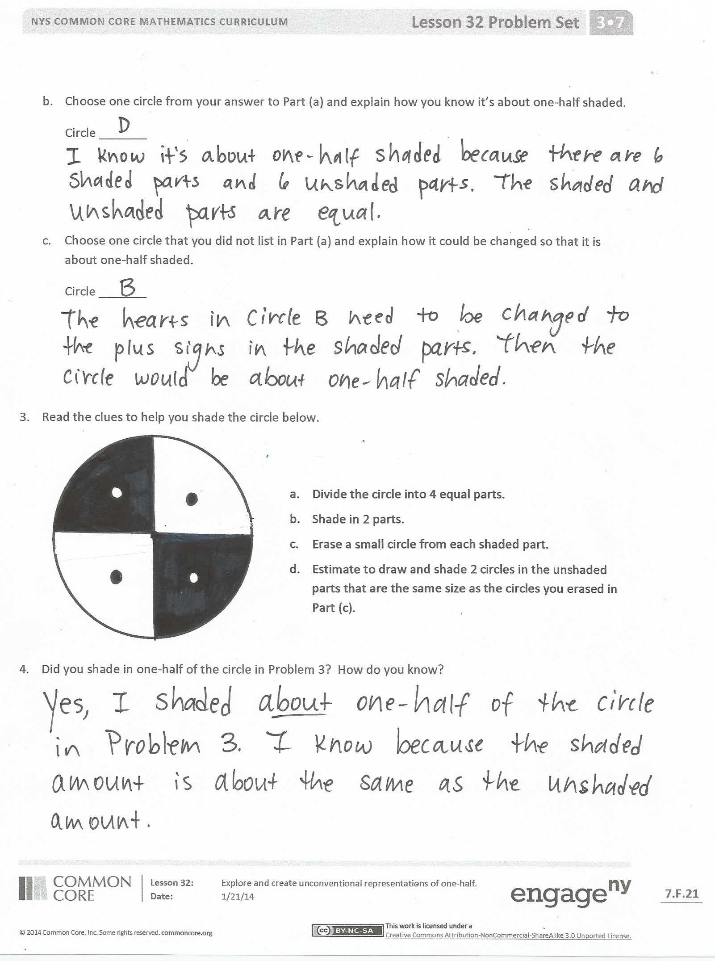
- Look at Circle A in Problem 2. Is it one-half shaded? How do you know? What do we have to think is true about the small black and white circles? About the black and white swirls? Why?
- Compare the circle you shaded in Problem 3 to a partner’s. How are they the same? How are they different?
- How was the shading we did with circles similar to the shading we did with rectangles? How was it different?
- Why do you think it’s helpful to explore different representations of one-half?
Exit Ticket (3 minutes)
After the Student Debrief, instruct students to complete the Exit Ticket. A review of their work will help you assess the students’ understanding of the concepts that were presented in the lesson today and plan more effectively for future lessons. You may read the questions aloud to the students.

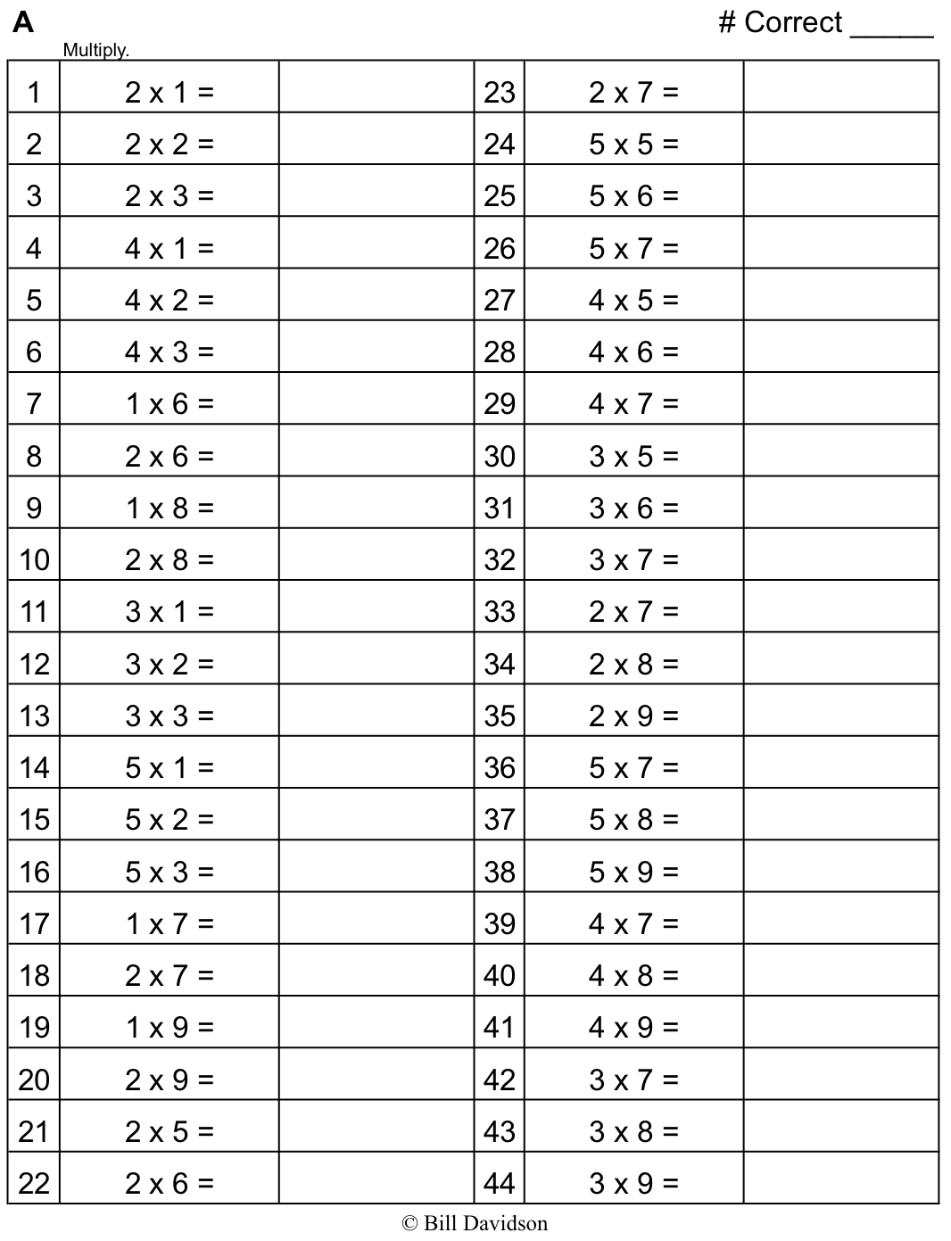
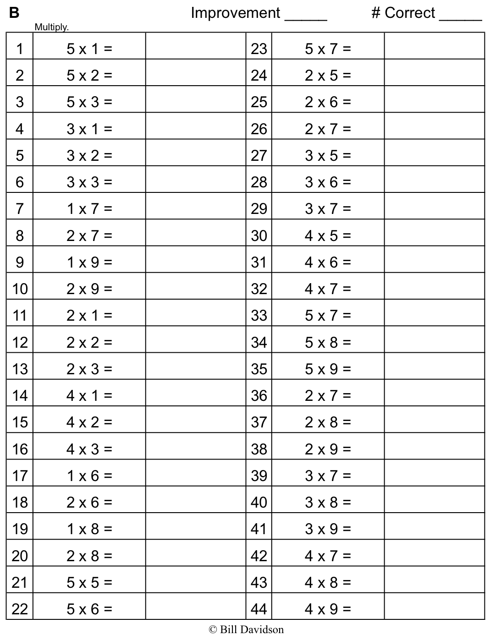

Name Date
- Look at the circles you shaded today. Glue a circle that is about one-half shaded in the space below.

- Explain the strategy you used to shade in one-half of your circle.

- Is your circle exactly one-half shaded? Explain your answer.

- Julian shades 4 circles as shown below.
Circle A
Circle D
Circle C
Circle B

  - Write the letters of the circles that are about one-half shaded.

  - Choose one circle from your answer to Part (a) and explain how you know it’s about one-half shaded.
Circle _______

  - Choose one circle that you did not list in Part (a) and explain how it could be changed so that it is about one-half shaded.
Circle _______

- Read the clues to help you shade the circle below.
.

- Divide the circle into 4 equal parts.
- Shade in 2 parts.
- Erase a small circle from each shaded part.
- Estimate to draw and shade 2 circles in the unshaded parts that are the same size as the circles you erased in Part (c).

- Did you shade in one-half of the circle in Problem 3? How do you know?

Name Date
  - Riddian shades a circle as shown below.

- Is Riddian’s shape about one-half shaded? How do you know?

- Estimate to shade about one-half of the circle in an unusual way.
.
Name Date
  - Estimate to finish shading the circles below so that each circle is about one-half shaded.
a.
b.
c.

  - Choose one of the circles in Problem 1, and explain how you know it’s about one-half shaded.

Circle _____

  - Can you say the circles in Problem 1 are exactly one-half shaded? Why or why not?
  - Marissa and Jake shade in circles as shown below.
Marissa’s Circle
Jake’s Circle

- Whose circle is about one-half shaded? How do you know?

- Explain how the circle that is not one-half shaded can be changed so that it is one-half shaded.

  - Estimate to shade about one-half of each circle below in an unusual way.
.
.
.

.
.

.
.
.
.

