Lesson 31
Objective: Explore and create unconventional representations of one-half.

Suggested Lesson Structure
 Fluency Practice (14 minutes)
 Application Problem (6 minutes)
 Concept Development (30 minutes)
 Student Debrief (10 minutes)
Total Time (60 minutes)
Fluency Practice (14 minutes)
- Sprint: Divide by 9 3.OA.7 (10 minutes)
- Multiply and Divide 3.OA.7 (4 minutes)

Sprint: Divide by 9 (10 minutes)
Materials: (S) Divide by 9 Sprint
Note: This Sprint builds fluency with multiplication and division facts using units of 9.

Multiply and Divide (4 minutes)

NOTES ON
MULTIPLE MEANS FOR ACTION AND EXPRESSION:
Support students working below grade level during the Multiply and Divide fluency activity by coupling language and number sentences with models, such as tape diagrams, number bonds, and arrays. It may be helpful to repeat exercises until students gain ease and confidence.

Materials: (S) Personal white boards
Note: This fluency activity focuses on student mastery of all products and quotients within 100.
T: (Write 5 $\text{×}$ 4 = ___.) Write the multiplication sentence.
S: (Write 5 $\text{×}$ 4 = 20.)
Continue the process for the following possible sequence: 5 $\text{×}$ 8,
7 $\text{×}$ 8, 6 $\text{×}$ 4, 6 $\text{×}$ 8, 9 $\text{×}$ 8, and 8 $\text{×}$ 9.
T: (Write 6 ÷ 3 = ___.) Write the division sentence.
S: (Write 6 ÷ 3 = 2.)
Continue the process for the following possible sequence:
15 ÷ 3, 30 ÷ 6, 18 ÷ 3, 36 ÷ 6, 14 ÷ 7, 28 ÷ 7, and 56 ÷ 7.
T: (Write 3, 2.) Write two multiplication sentences and two division sentences using these factors.
S: (Write 3 $\text{×}$ 2 = 6, 2 $\text{×}$ 3 = 6, 6 ÷ 2 = 3, and 6 ÷ 3 = 2.)
Continue the process for the following possible sequence: 9 and 5, 6 and 4, and 7 and 8.
Application Problem (6 minutes)
Mara draws a 6 inch by 8 inch rectangle. She shades one-half of the rectangle. What is the area of the shaded part of Mara’s rectangle?
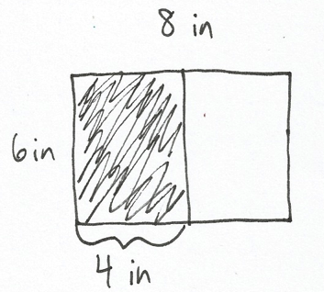
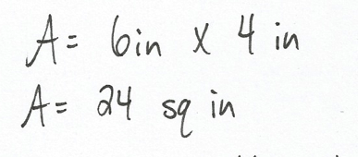
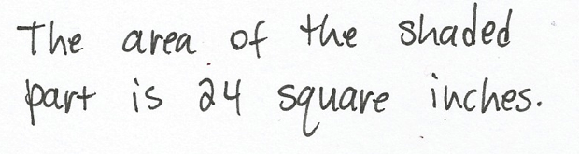

Note: Students may also divide the rectangle lengthwise and get an 8 inch by 3 inch rectangle, or find the area of the whole rectangle and divide it by 2. This problem reviews calculating area from G3−Module 4. Invite students to discuss how this problem could be solved using reasoning skills and mental math.
Concept Development (30 minutes)
Materials: (S) Square template, ruler, crayons, Problem Set
Part 1: Explore different representations of one-half.
Project the following images.
T: Study these images. Estimate to decide which shapes have one-half shaded. Discuss your reasoning with a partner.
A
B
C

S: Shape A definitely does because the black and white parts look like they’re the same size. I think Shape C does too, because that little black trapezoid just got cut out and flipped over. The black and white parts still look equal. I don’t think Shape B shows one-half shaded. That bottom black part looks like it’s made of two parallelograms, not one. That means that three are shaded and two are not. Three shaded parallelograms is more than one-half of that shape.
T: I heard many students mention same-sized, or equal parts. Tell your partner why equal parts are important when we’re talking about one-half.
S: If the parts are the same size, and the same number of parts is shaded and unshaded, then we know we have one-half. If the parts aren’t equal we can’t really tell. You can compare the number of shaded and unshaded parts when shapes are divided up into equal parts. Like my friend did when she was talking about Shape B. Three out of 5 parts are shaded.
T: When I asked you to study the shapes, I said you should estimate to decide which represent one-half. Why did I use the word estimate?
S: Because you wanted us to look at them and take a guess. We don’t really know for sure if the parts are equal just by looking at them. It seems like it, but they could be a little different. To be sure we’d have to measure, or maybe make the shapes ourselves out of unit squares or something.
MP.6
T: Let’s do that now. I’ll pass out squares with grids in them that will help you be precise in showing one-half. Instead of making my shapes, make your own representations. Be as creative as you can!
Part 2: Create different representations of one-half of a 6 by 6 square.
Each student is given squares from the square template. Students shade each square to show different ways to represent one-half of a 36 square unit square (in pencil). Students then trade squares with a partner to analyze each other’s work. The Problem Set is a tool for students to use to record their analysis of their partner’s work. After the analysis, students can make adjustments to their work, if necessary.

NOTES ON
MULTIPLE MEANS OF ENGAGEMENT:
As students make unconventional representations of one-half, offer autonomy and choice to those working above grade level and others. Encourage student creativity by making the exploration as open-ended as possible. For example, students might cut or combine their 36 unit squares to extend the variety of designs and increase the challenge of partner analysis.

Prepare students:
- Students should create between 4 and 10 different representations of one-half using the square templates.
- Students should label each square with a letter so partners can refer to squares by letter name.
- If necessary, review strategies that students can use to shade in one-half of a unit square.
- After representations are made, students analyze each other’s work to confirm that squares are in fact one-half shaded.

NOTES ON
MULTIPLE MEANS OF ACTION AND EXPRESSION:
If the 36-square inch square is too small or otherwise challenging for some learners, magnify it and present it on a SMART board or computer.

- Show a completed Problem Set (analyzing tool) to establish your expectation for student analysis of their partner’s work.
Once every student has made at least four representations, guide an analysis of the representations to confirm that they accurately represent one-half. Students may work in pairs to do this, or participate in a gallery walk. Students can use the Problem Set as a tool to record their analysis.

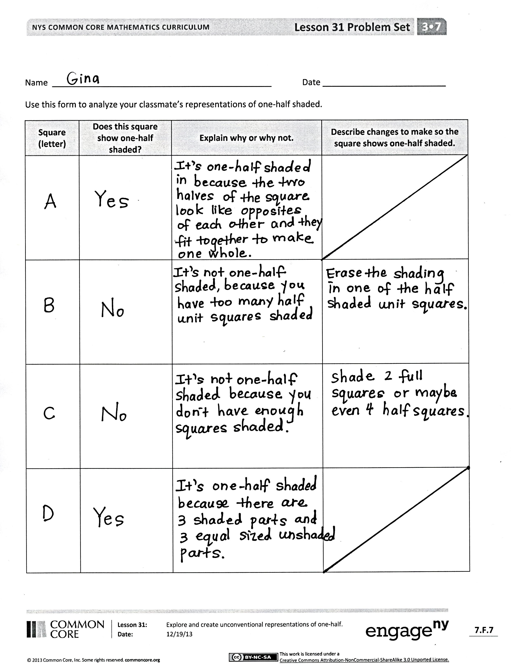
When the analysis is complete and mistakes are corrected, students can use crayons to color over their pencil shading. Then combine all the finished squares to form a class quilt to display the various representations of one-half.
Student Debrief (10 minutes)
Lesson Objective: Explore and create unconventional representations of one-half.
The Student Debrief is intended to invite reflection and active processing of the total lesson experience.
Invite students to review their solutions for the Problem Set. They should check work by comparing answers with a partner before going over answers as a class. Look for misconceptions or misunderstandings that can be addressed in the Debrief. Guide students in a conversation to debrief the Problem Set and process the lesson.
You may choose to use any combination of the questions below to lead the discussion.
- Look at our class quilt. How is it possible to have so many different ways to show one-half of the same square?
- What is the area in square units of the shaded part of each of your squares? How do you know?
- What fraction of our class quilt is shaded in? How do you know?
- Did anyone shade in one-half of a unit square? How? Are there other ways to shade in one-half of a unit square?
- How did the Application Problem connect to today’s lesson?
Exit Ticket (3 minutes)
After the Student Debrief, instruct students to complete the Exit Ticket. A review of their work will help you assess the students’ understanding of the concepts that were presented in the lesson today and plan more effectively for future lessons. You may read the questions aloud to the students.

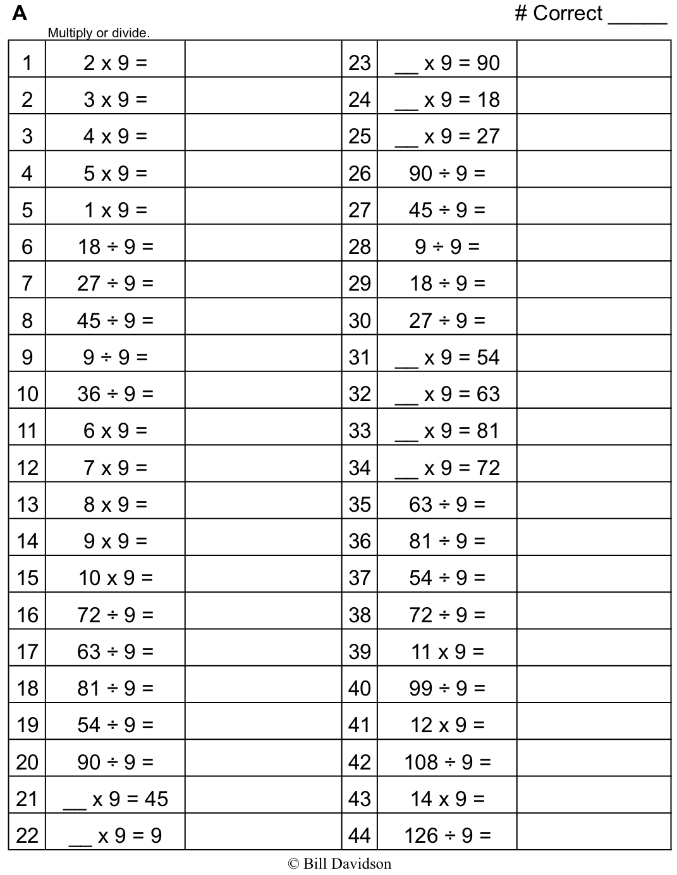

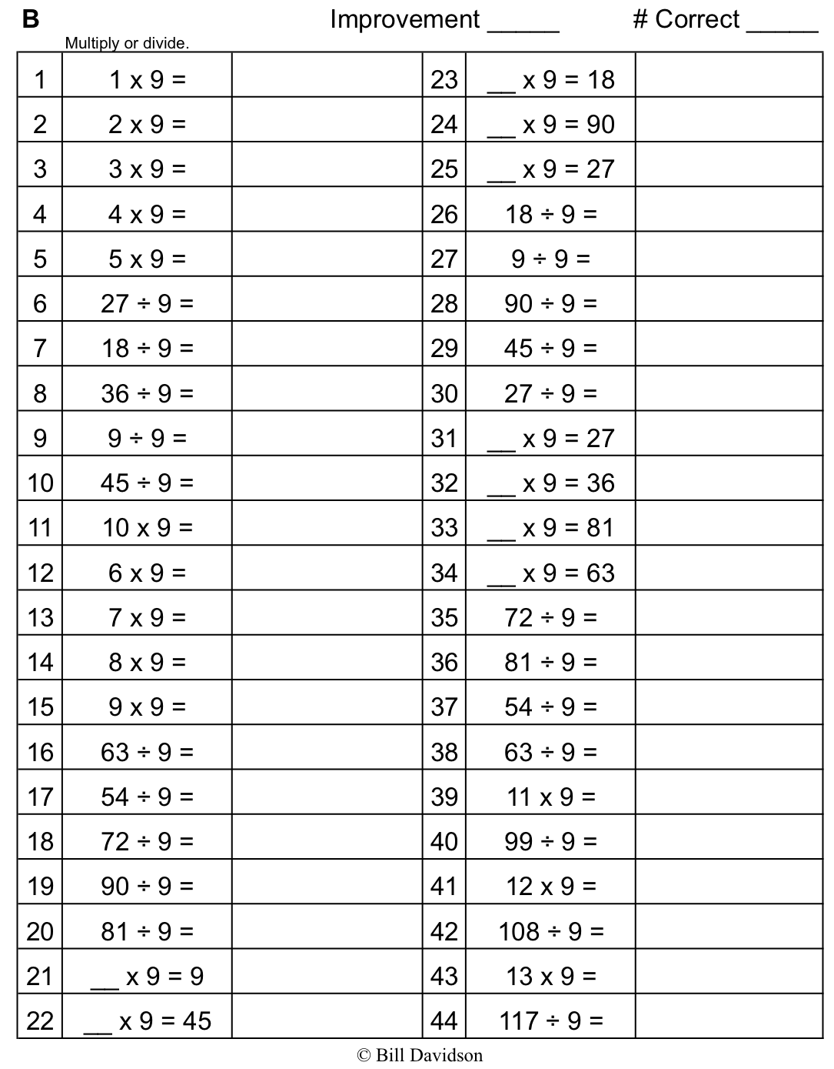

Name Date
Use this form to analyze your classmate’s representations of one-half shaded.
Square (letter) | Does this square show one-half shaded? | Explain why or why not. | Describe changes to make so the square shows one-half shaded.

Name Date
Marty shades the square as shown below and says one-half of the big square is shaded. Do you agree? Why or why not?

Name Date
- Use the rectangle below to answer Problems 1(a) through 1(d).

- What is the area of the rectangle in square units?

- What is the area of half of the rectangle in square units?

- Shade in half of the rectangle above. Be creative with your shading!

- Explain how you know you shaded in half of the rectangle.

- During math class, Arthur, Emily, and Gia draw a shape and then shade one-half of it. Analyze each student’s work. Tell if each student was correct or not, and explain your thinking.
Student | Drawing | Your Analysis
Arthur
Emily
Gia

- Shade the grid below to show two different ways of shading half of each shape.

