Lesson 30
Objective: Share and critique peer strategies for problem solving.

Suggested Lesson Structure
 Fluency Practice (12 minutes)
 Concept Development (38 minutes)
 Student Debrief (10 minutes)
Total Time (60 minutes)
Fluency Practice (12 minutes)
- Multiply by 9 3.OA.7 (8 minutes)
- Multiply and Divide 3.OA.7 (4 minutes)

Multiply by 9 (8 minutes)
Materials: (S) Multiply by 9 Pattern Sheet (6–10)
Note: This activity builds fluency with multiplication facts using units of 9. It works toward students knowing from memory all products of two one-digit numbers. See G3–M7–Lesson 1 for the directions for administration of a Multiply By pattern sheet.
T: (Write 7 × 9 = ____.) Let’s skip-count up by nines. I’ll raise a finger for each nine. (Count with fingers to 7 as students count.)
S: 9, 18, 27, 36, 45, 54, 63.
T: Let’s skip-count by nines starting at 45. Why is 45 a good place to start?
S: It’s a fact we already know, so we can use it to figure out a fact we don’t know.
T: (Count up with fingers as students say numbers.)
S: 45 (5 fingers), 54 (6 fingers), 63 (7 fingers).
T: Let’s see how we can skip-count down to find the answer, too. Start at 90 with 10 fingers, 1 for each nine. (Count down with fingers as students say numbers.)
S: 90 (10 fingers), 81 (9 fingers), 72 (8 fingers), 63 (7 fingers).
Continue with the following suggested sequence: 9 × 9, 6 × 9, and 8 × 9.
T: (Distribute Multiply by 9 Pattern Sheet.) Let’s practice multiplying by 9. Be sure to work left to right across the page.

Multiply and Divide (4 minutes)
Materials: (S) Personal white boards
Note: This fluency activity focuses on student mastery of all products of two one-digit numbers.
T: (Write 2 × 2 = ____.) Say the multiplication sentence.
S: 2 × 2 = 4.
Continue the process for the following possible sequence: 3 × 3, 4 × 4, and 5 × 5.
T: (Write 3 × 2 = ____.) Say the multiplication sentence.
S: 3 × 2 = 6.
T: Flip it.
S: 2 × 3 = 6.
Continue the process for the following possible sequence: 4 × 2, 5 × 3, and 4 × 3.
T: (Write 4 ÷ 2 = ____.) Say the division sentence.
S: 4 ÷ 2 = 2.
Continue the process for the following possible sequence: 15 ÷ 5, 9 ÷ 3, and 24 ÷ 4.
Concept Development (38 minutes)

NOTES ON
MULTIPLE MEANS OF REPRESENTATION:
Provide sentence starters to help English language learners confidently articulate what Student A did to solve:
- Student A drew a ____ and labeled….
- He wrote the equation ____ which makes sense because….
- He found the length of the rope by….
- He subtracted ___ because….

Materials: (T) Student work sample images, timer
(S) Problem Sets from G3–M7–Lessons 28, 29 and 30, personal white boards
Part 1: Analyze sample student work for accuracy and efficiency.
Write or project the following problem.
T: Read Problem 3 from yesterday’s Problem Set.
S: (Read: Jeremiah and Hayley use a piece of rope to mark a square space for their booth at the science fair. The area of their space is 49 square feet. What is the length of the rope that Jeremiah and Hayley use if they leave a 3-foot opening for them to get in and out of the space?)
T: (Project Student A’s work.) Let’s look at and discuss some possible solutions for this problem. Talk to your partner: What did Student A do to solve?

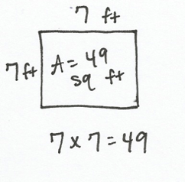
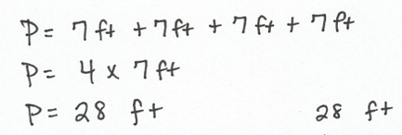
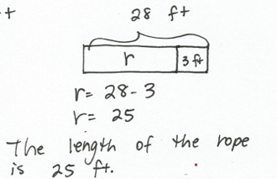

Student A

S: He found the side lengths of the square. Then, he figured out the perimeter of the square and subtracted the 3-foot opening to find the length of the rope.
T: Other than getting the right answer, what did Student A do well?
S: He drew a picture of the square and labeled the area and the side lengths. He multiplied 4 sides times 7 centimeters to find the perimeter. He drew a tape diagram to show why he subtracted in the last step. He used a letter to represent the unknown.
Facilitate a discussion in which students analyze this work more closely. Use any combination of the following questions to guide the conversation.
- Was the drawing helpful? What makes it helpful or unhelpful?
- Did Student A represent all the important information in his drawing? Why or why not?
- Was this drawing the best one to use? Why or why not?
- Can you retell the story using only the drawing and labels? Explain.
- How did he organize the information?
T: What suggestion would you make to Student A to improve his work?
S: He doesn’t need the addition number sentence for perimeter since he has the multiplication number sentence. In the second step of the problem, it’s not really clear what he’s solving for. Maybe instead of using the letter P, he could write perimeter so anyone who looks at his work knows he’s finding the perimeter. He could draw another picture to show the square with the 3-foot opening in it. Then he could just add the side lengths, and he wouldn’t have to show the third step of subtracting.
Repeat the process of analyzing using the two samples below. Modify these or create others as appropriate for the class. Select samples that are likely to stimulate discussion beneficial to student needs.
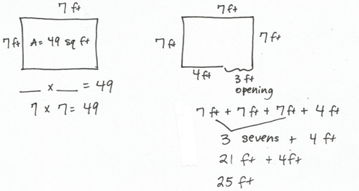
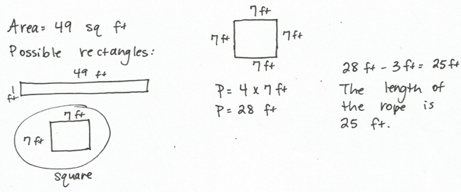
Student B
Student C

Conclude analysis of the sample student work for this problem by discussing the following questions:
- Can you think of a quicker way to solve this problem? Why or why not?
- Would you have chosen any of these ways to solve this problem? Why or why not?
Part 2: Analyze peer work for accuracy and efficiency.
Note: Students should have enough copies of the Problem Set to complete a critique for each member of their group, or they can record their thoughts in their math journals.
Students work in groups of four to share solutions and critique their classmates’ work. Each student takes a turn presenting his or her solution to a problem from the G3–M7–Lesson 28 or 29 Problem Sets. Today’s Problem Set is a critiquing tool that group members can use as a guide for analysis and a place they can record their thoughts at each step of the way. When a student finishes presenting, the other group members take a few minutes to ask the presenter clarifying questions. They might use questions similar to those given for discussion facilitation in Part 1. Students continue in this manner until each group member has presented at least one solution for the group to analyze.
MP.3

NOTES ON
MULTIPLE MEANS OF ENGAGEMENT:
Student presenters may use translators, interpreters, or sentence frames to present and respond to feedback. Models shared may include concrete manipulatives, adaptive materials, or technology. If timing is a consideration, prepare presenters beforehand.

Each student chooses at least one problem from the
G3–M7–Lesson 28 or 29 Problem Sets to share.
Prepare students:
- Model how students should present their work to their group.
- List some of the clarifying questions that group members can choose to ask the presenter.
- Show a completed Problem Set (critiquing tool) to establish your expectations for the group members who are critiquing their classmate’s solution.
- Remind students to show their appreciation to classmates, both for sharing their work and for providing feedback about their work.
- Inform students that you will set a timer to let them know when they should transition to a new presenter, if appropriate for your class.
- Provide each group with a talking tool (e.g., a craft stick) to establish a protocol for only one student in the group to talk while the others listen, if appropriate for your class. Model using and then passing the tool to other group members to talk.

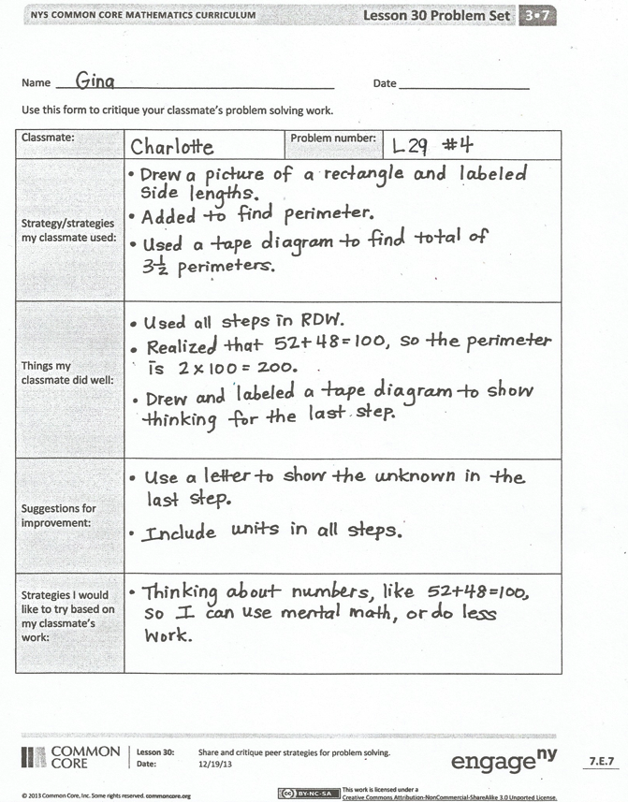
Student Debrief (10 minutes)
Lesson Objective: Share and critique peer strategies for problem solving.
The Student Debrief is intended to invite reflection and active processing of the total lesson experience.
Invite students to review their solutions for the Problem Set. They should check work by comparing answers with a partner before going over answers as a class. Look for misconceptions or misunderstandings that can be addressed in the Debrief. Guide students in a conversation to debrief the Problem Set and process the lesson.
You may choose to use any combination of the questions below to lead the discussion.
- How did today’s Problem Set or critiquing tool help you analyze your classmates’ work?
- How does having your work critiqued by your classmates improve your problem solving skills?
- How does critiquing your classmates’ work improve your problem solving skills?
- What was difficult about today’s group activity? Why was it difficult?
- What strategies did you see in your classmates’ work that you might try in future problems?
Exit Ticket (3 minutes)
After the Student Debrief, instruct students to complete the Exit Ticket. A review of their work will help you assess the students’ understanding of the concepts that were presented in the lesson today and plan more effectively for future lessons. You may read the questions aloud to the students.
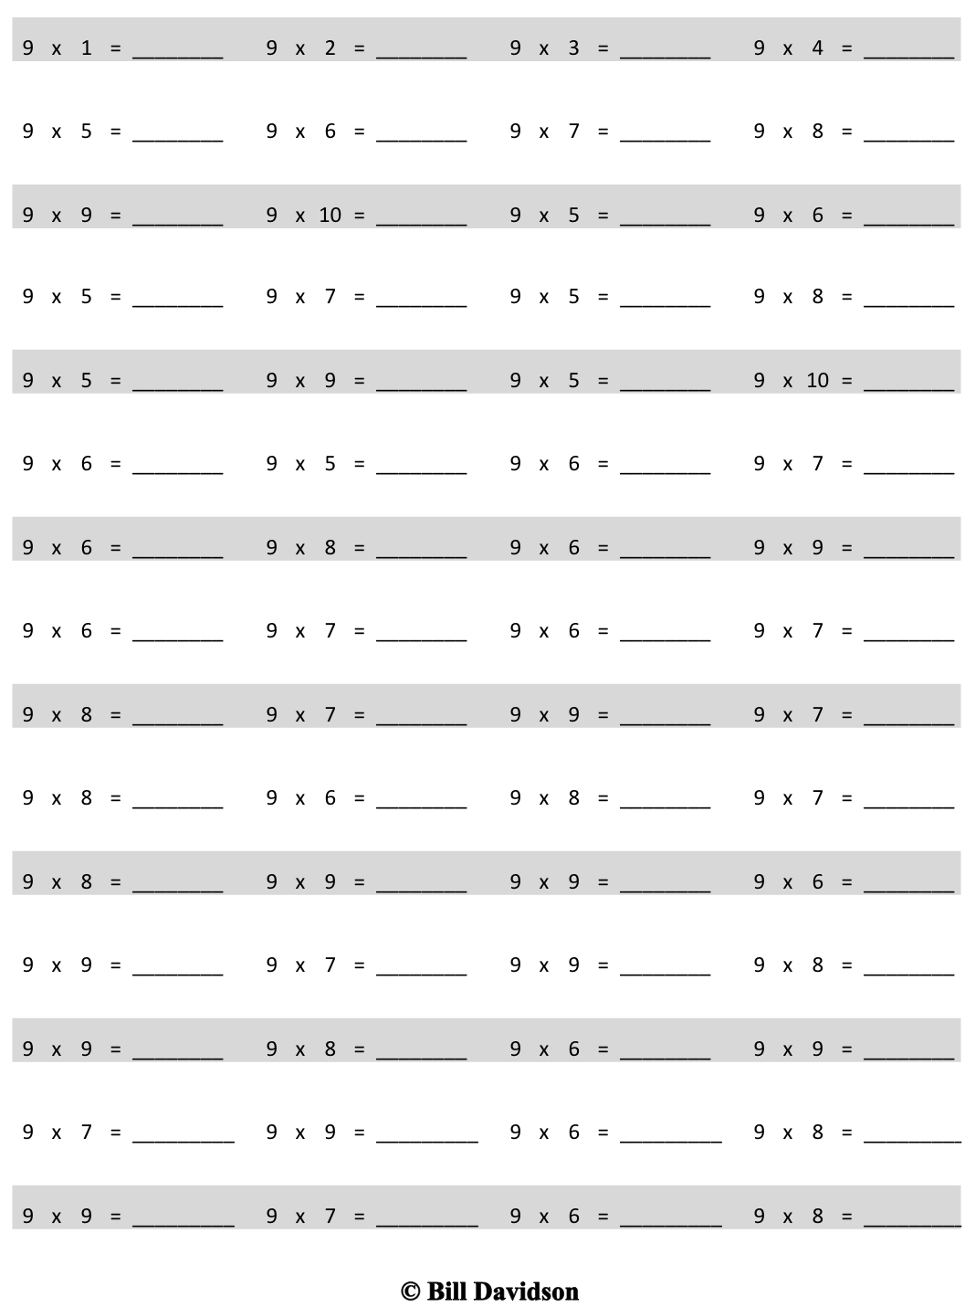
Multiply.

Name Date
Use this form to critique your classmate’s problem-solving work.
Classmate: |  | Problem number:
Strategies my classmate used:
Things my classmate did well:
Suggestions for improvement:
Strategies I would like to try based on my classmate’s work:

Name Date
Jayden solves the problem as shown below.
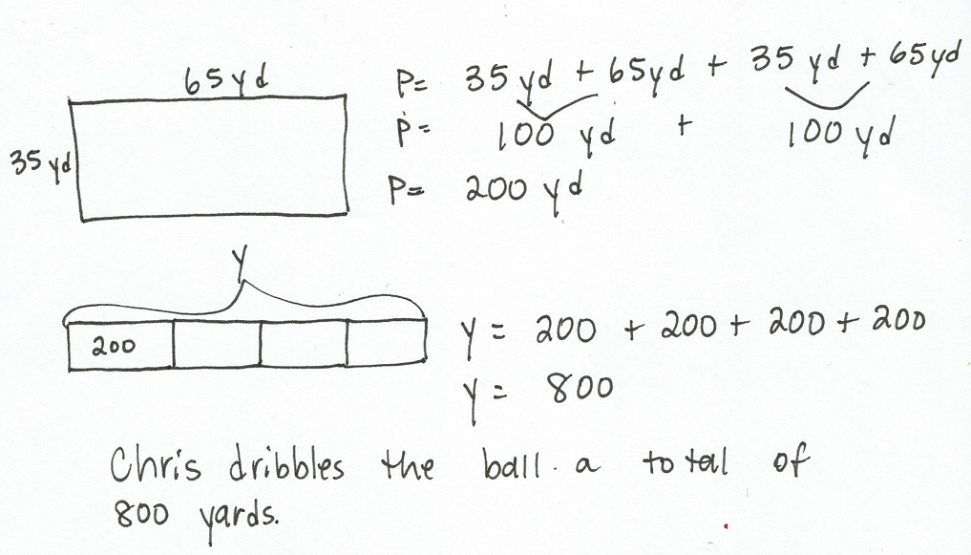
- The recreation center soccer field measures 35 yards by 65 yards. Chris dribbles the soccer ball around the field 4 times. What is the total number of yards Chris dribbles the ball?

- What strategies did Jayden use to solve this problem?

- What did Jayden do well?

Name Date
Use this form to critique Student A’s problem solving work on the next page.
Student: | Student A | Problem number:
Strategies Student A used:
Things Student A did well:
Suggestions for improvement:
Strategies I would like to try based on Student A’s work:

Name STUDENT A Date
- Katherine puts 2 squares together to make the rectangle below. The side lengths of the squares measure 8 inches.
8 in

- What is the area of Katherine’s rectangle?

- What is the perimeter of Katherine’s rectangle?
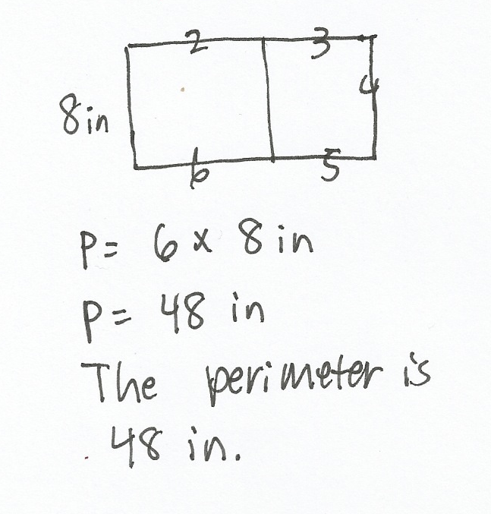
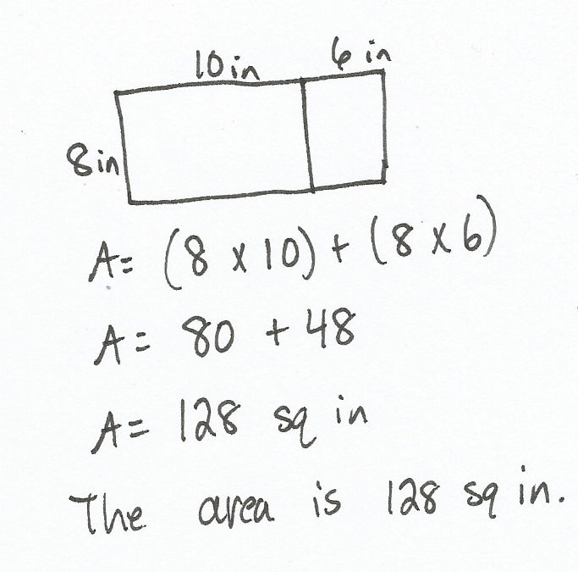

- Katherine decides to draw another rectangle of the same size. What is the area of the new rectangle?
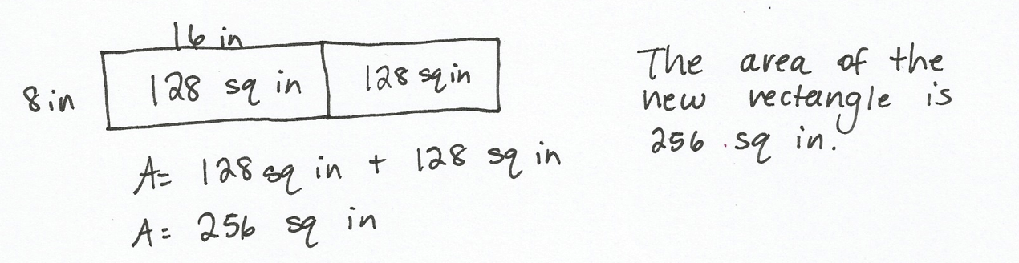
8 in

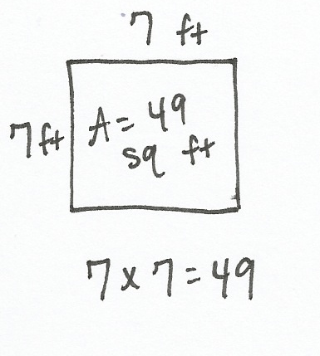
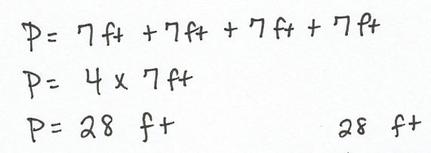
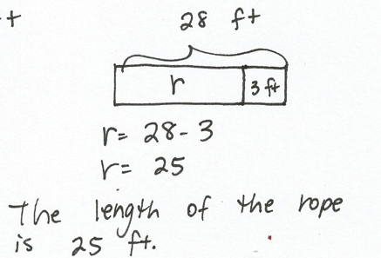
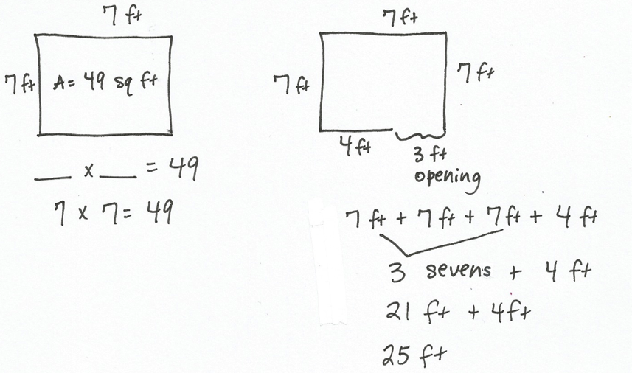
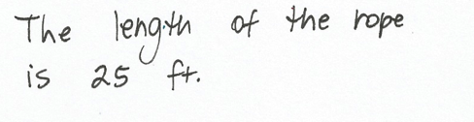
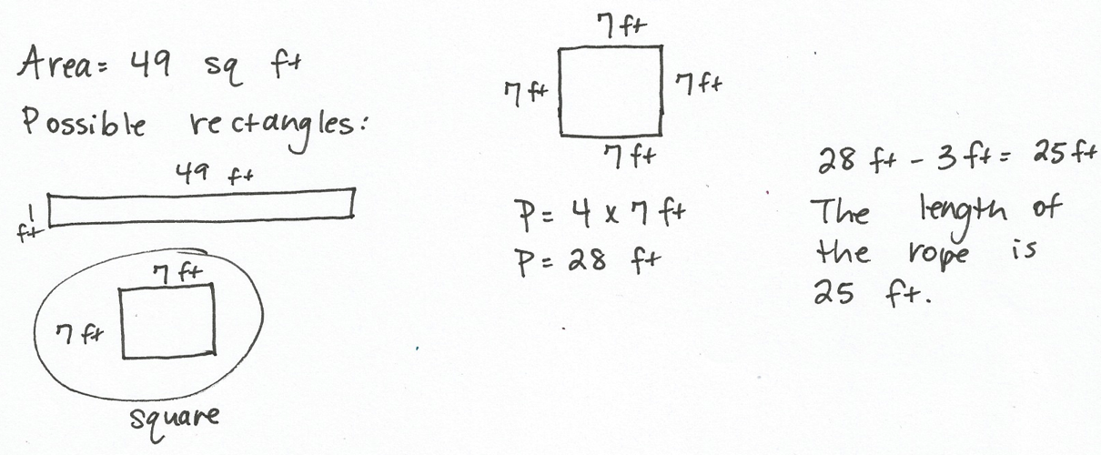

Student A
Student B
Student C

