Lesson 28
Objective: Solve a variety of word problems involving area and perimeter using all four operations.

Suggested Lesson Structure
 Fluency Practice (12 minutes)
 Concept Development (38 minutes)
 Student Debrief (10 minutes)
Total Time (60 minutes)
Fluency Practice (12 minutes)
- Multiply by 8 3.OA.7 (8 minutes)
- Find the Perimeter 3.MD.8 (4 minutes)

Multiply by 8 (8 minutes)
Materials: (S) Multiply by 8 Pattern Sheet (6–10)
Note: This activity builds fluency with multiplication facts using units of 8. It works toward students knowing from memory all products of two one-digit numbers. See G3–M7–Lesson 1 for the directions for administration of a Multiply By pattern sheet.
T: (Write 7 × 8 = ____.) Let’s skip-count up by eights. I’ll raise a finger for each eight. (Count with fingers to 7 as students count.)
S: 8, 16, 24, 32, 40, 48, 56.
T: Let’s skip-count by eights starting at 40. Why is 40 a good place to start?
S: It’s a fact we already know, so we can use it to figure out a fact we don’t know.
T: (Count up with fingers as students say numbers.)
S: 40 (5 fingers), 48 (6 fingers), 56 (7 fingers).
T: Let’s see how we can skip-count down to find the answer, too. Start at 80 with 10 fingers, 1 for each eight. (Count down with fingers as students say numbers.)
S: 80 (10 fingers), 72 (9 fingers), 64 (8 fingers), 56 (7 fingers).
Continue with the following suggested sequence: 9 × 8, 6 × 8, and 8 × 8.
T: (Distribute Multiply by 8 Pattern Sheet.) Let’s practice multiplying by 8. Be sure to work left to right across the page.
Find the Perimeter (4 minutes)
Materials: (S) Personal white boards
Note: This fluency activity prepares students for the word problems in today’s lesson.
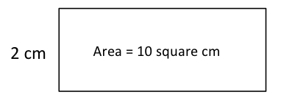
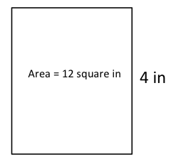
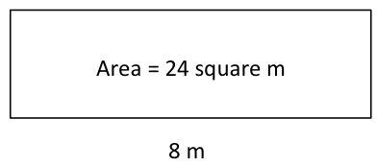
T: (Project rectangle with a width of 2 cm. Inside the rectangle, write Area = 10 sq cm.) On your boards, write the length of this rectangle.
S: (Write 5 cm.)
T: (Write 5 cm on the length of the rectangle. Below the rectangle write Perimeter = ___.) On your boards, write the perimeter of this rectangle. Write out a four-step addition sentence if you need to.
S: (Write Perimeter = 14 cm.)
T: On your boards, sketch a rectangle that has an area of 10 square cm, but different side lengths from this rectangle.
S: (Sketch a rectangle with side lengths of 1 cm and 10 cm.)
T: (Write Perimeter = ___.) Calculate the perimeter of the new rectangle.
S: (Write Perimeter = 22 cm.)
Repeat the process for the other rectangles.
Concept Development (38 minutes)
Materials: (S) Problem Set

NOTES ON
MULTIPLE MEANS OF ACTION AND EXPRESSION:
Learners who have not memorized 7, 8, and 9 facts may benefit from using strategies to solve the word problems on the Problem Set. Encourage students to use personally efficient strategies, such as counting up from familiar facts (as practiced in the Multiply by 8 fluency activity) and the distributive property.

Note: Save this lesson’s Problem Set for use in G3–M7–Lesson 30.
This is a problem solving lesson in which students work in pairs or independently to solve the four problems on the Problem Set. Consider using the three-step approach outlined in
G3–M7–Lesson 23 to guide them through solving (basic steps shown below). Specific information about each problem follows and can be used to further facilitate conversation.
MP.1
Three-Step Approach to Solving:
1. Read and model.
2. Write an equation, calculate to solve, and write a statement.
MP.1
MP.1
3. Assess the solution for reasonableness.
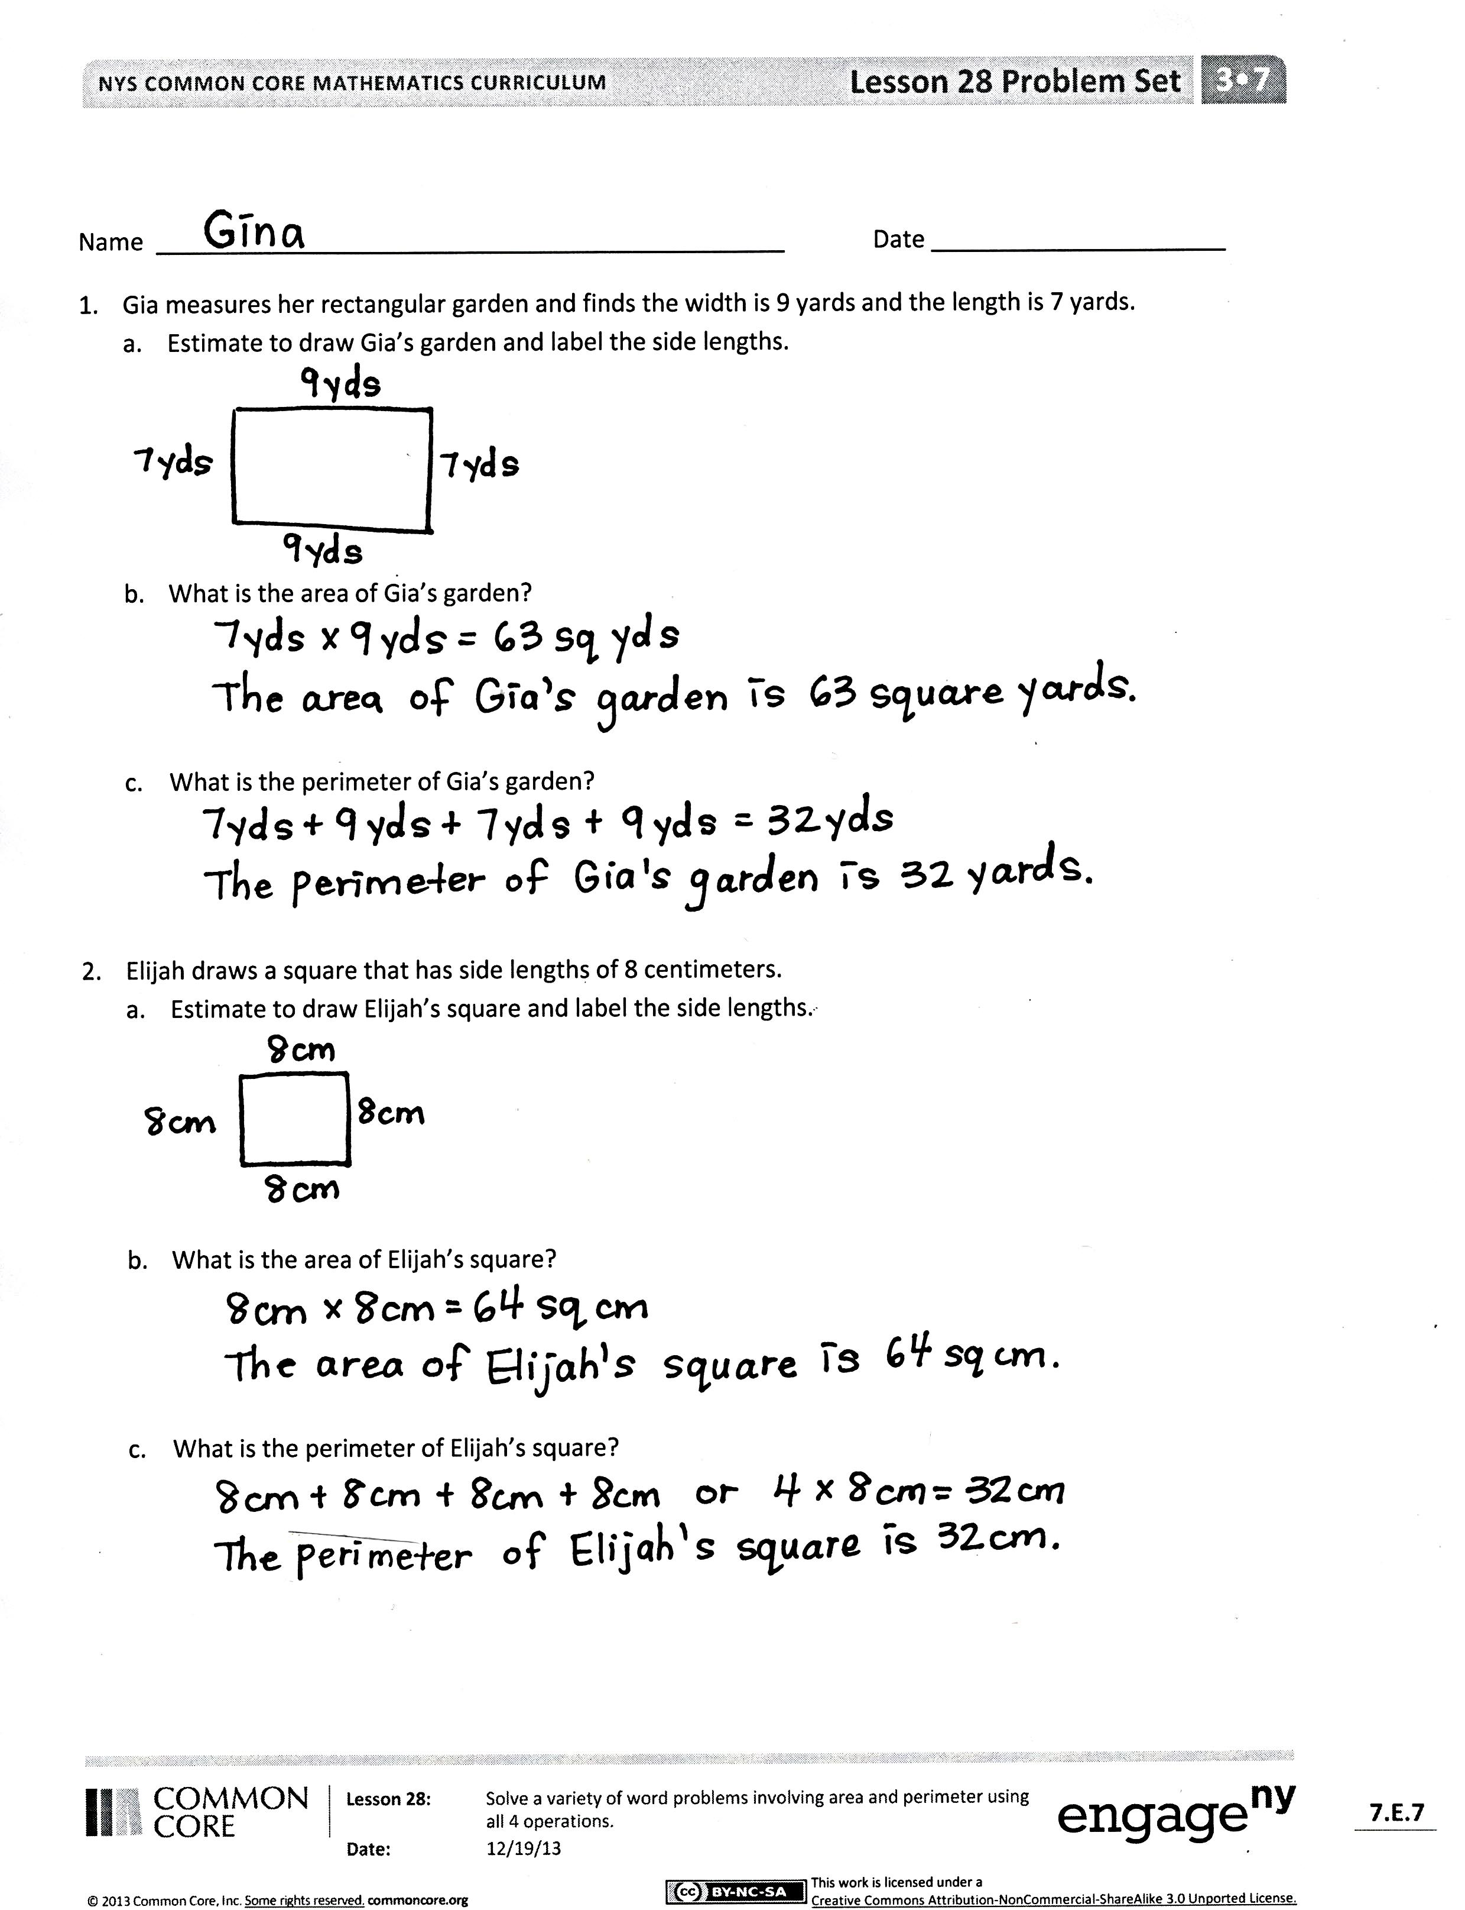
Note: This Problem Set breaks each question into several parts to provide a scaffold for students to solve a variety of word problems involving area and perimeter. This helps ease students into the more challenging word problems in G3–M7–Lesson 29.
Problem 1: Gia measures her rectangular garden and finds the width is 9 yards and the length is 7 yards.
- Estimate to draw Gia’s garden, and label the side lengths.
- What is the area of Gia’s garden?
- What is the perimeter of Gia’s garden?
This first problem provides a simple, straightforward start to the set. It allows the students to begin problem solving confidently and successfully.
Problem 2: Elijah draws a square that has side lengths of 8 centimeters.
- Estimate to draw Elijah’s square, and label the side lengths.
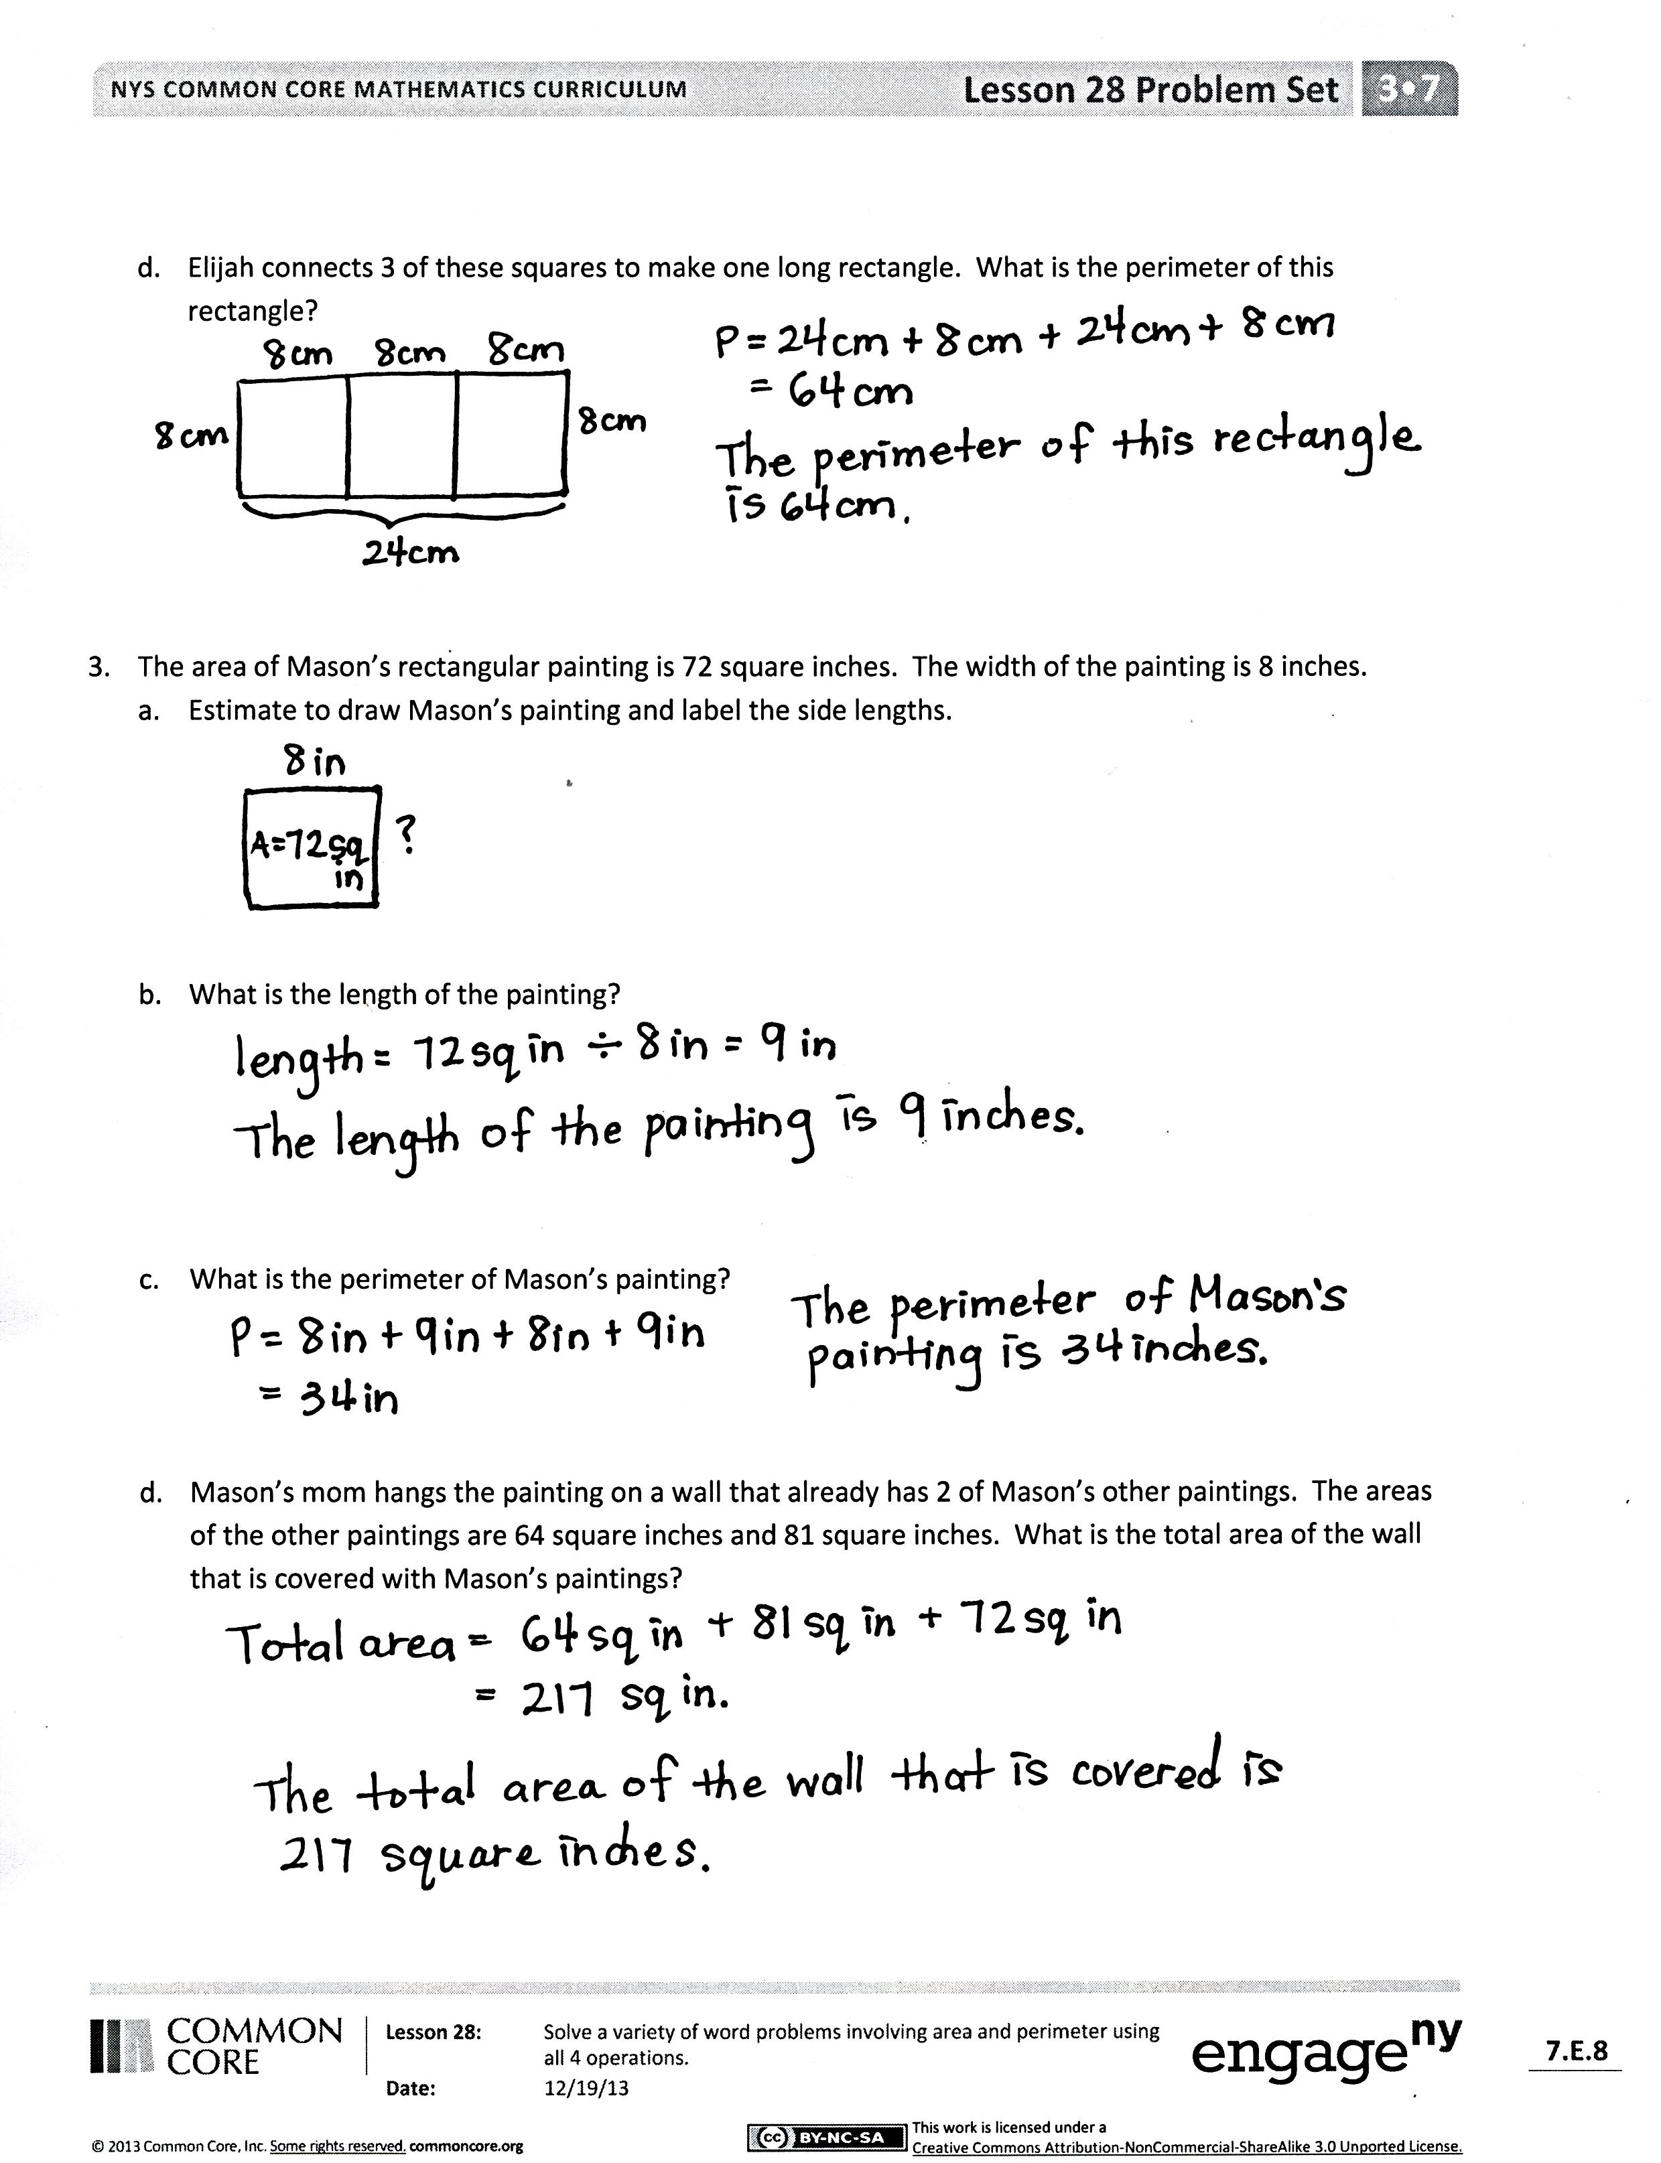
- What is the area of Elijah’s square?
- What is the perimeter of Elijah’s square?
- Elijah connects three of these squares to make one long rectangle. What is the perimeter of this rectangle?
Students should recognize the side lengths of a square are all equal. Part (d) provides the complexity in this problem. When Elijah connects three of these squares to make one long rectangle, students need to recognize that the length of the rectangle continues to be 8 centimeters, but the width is now tripled to 24 centimeters. They then add the new side lengths to find the perimeter of the rectangle, 64 centimeters. A misconception in Part (d) may be thinking that the perimeter of the rectangle can be found by multiplying the perimeter of the square by 3.
Problem 3: The area of Mason’s rectangular painting is 72 square inches. The width of the painting is 8 inches.
- Estimate to draw Mason’s painting and label the side lengths.
- What is the length of the painting?
- What is the perimeter of Mason’s painting?
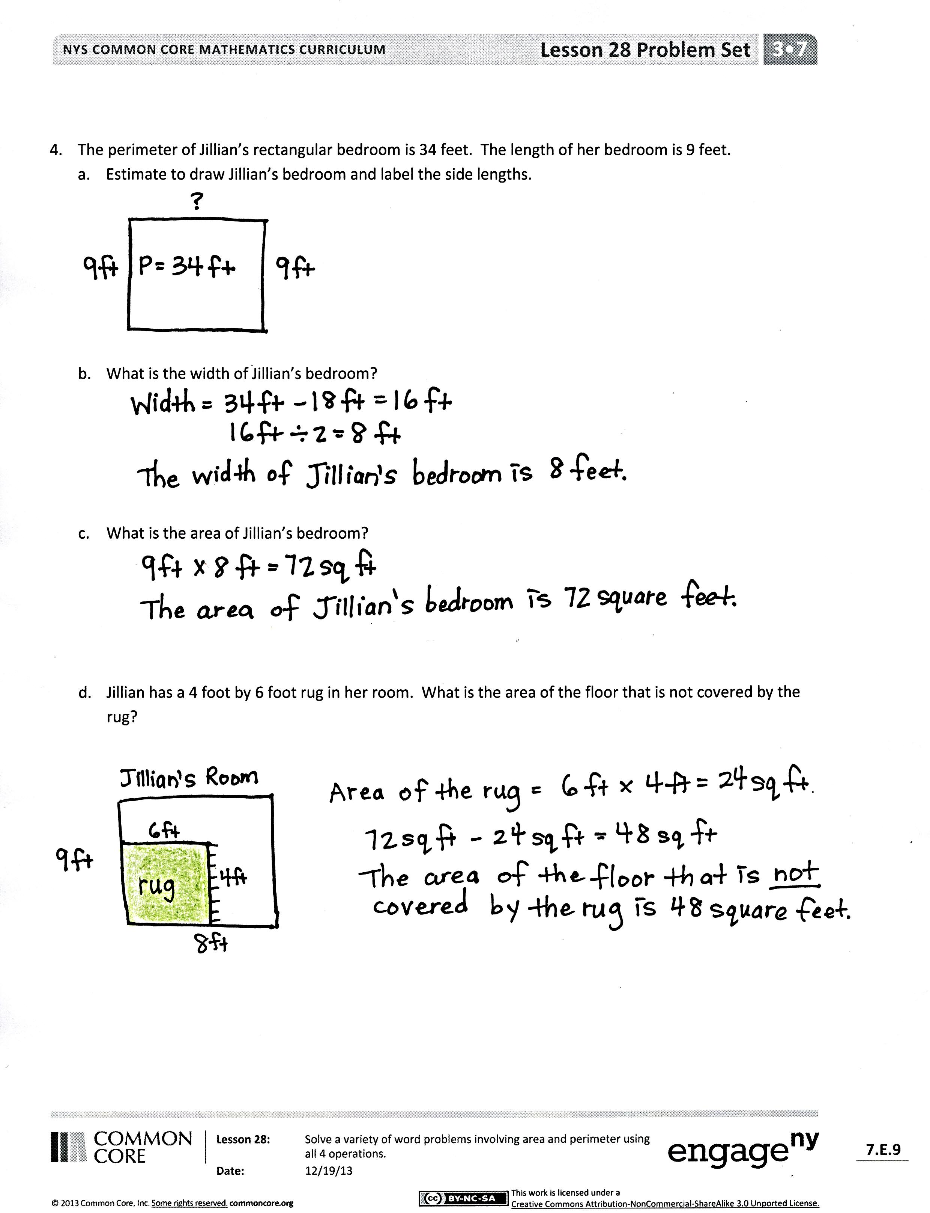
- Mason’s mom hangs the painting on a wall that already has two of Mason’s other paintings. The areas of the other paintings are 64 square inches and 81 square inches. What is the total area of the wall that is covered with Mason’s paintings?
To find the unknown length, students may write a division problem or an unknown factor problem. A misconception in Part (d) may be thinking that the total area is found by adding 64 square inches plus 81 square inches, and forgetting about Mason’s original painting since the third area is not stated directly in the problem.
Problem 4: The perimeter of Jillian’s rectangular bedroom is 34 feet. The length of her bedroom is 9 feet.
- Estimate to draw Jillian’s bedroom, and label the side lengths.
- What is the width of Jillian’s bedroom?
- What is the area of Jillian’s bedroom?
- Jillian has a 4 foot by 6 foot rug in her room. What is the area of the floor that is not covered by the rug?
This problem asks students to find an unknown side length given one side length and the perimeter. Students need to recall that opposite sides of a rectangle are equal; they might subtract 2 nines from the given perimeter (34 feet) to find the total of 2 lengths of the room. Again applying the knowledge that opposite sides of a rectangle are equal, students can divide the total of 2 lengths by 2 to find the value of 1 length. In Part (d), students first need to find the total area of the rug (24 sq ft) and then subtract it from the total area of Jillian’s room (72 sq ft). Encourage students to draw and shade a rectangular rug inside a larger rectangle that represents Jillian’s room.
Student Debrief (10 minutes)
Lesson Objective: Solve a variety of word problems involving area and perimeter using all four operations.
The Student Debrief is intended to invite reflection and active processing of the total lesson experience.
Invite students to review their solutions for the Problem Set. They should check work by comparing answers with a partner before going over answers as a class. Look for misconceptions or misunderstandings that can be addressed in the Debrief. Guide students in a conversation to debrief the Problem Set and process the lesson.
You may choose to use any combination of the questions below to lead the discussion
- How was it helpful to have each question broken down into several parts?
- Share your drawing of Elijah’s larger rectangle in Problem 2(d). How does the drawing of the rectangle help you figure out the side lengths?
- Explain to a partner how knowing the area and the width helped you find the length of the rectangle in Problem 3.
- How did you know you needed to add the areas of three paintings in Problem 3(d)?
- Explain to a partner the steps you took to find the width of the rectangle in Problem 4(b).
- Compare your model with your partner’s model for Problem 4(d). What was the same? What was different?
- Which problem did you find most difficult? Why?
Exit Ticket (3 minutes)
After the Student Debrief, instruct students to complete the Exit Ticket. A review of their work will help you assess the students’ understanding of the concepts that were presented in the lesson today and plan more effectively for future lessons. You may read the questions aloud to the students.
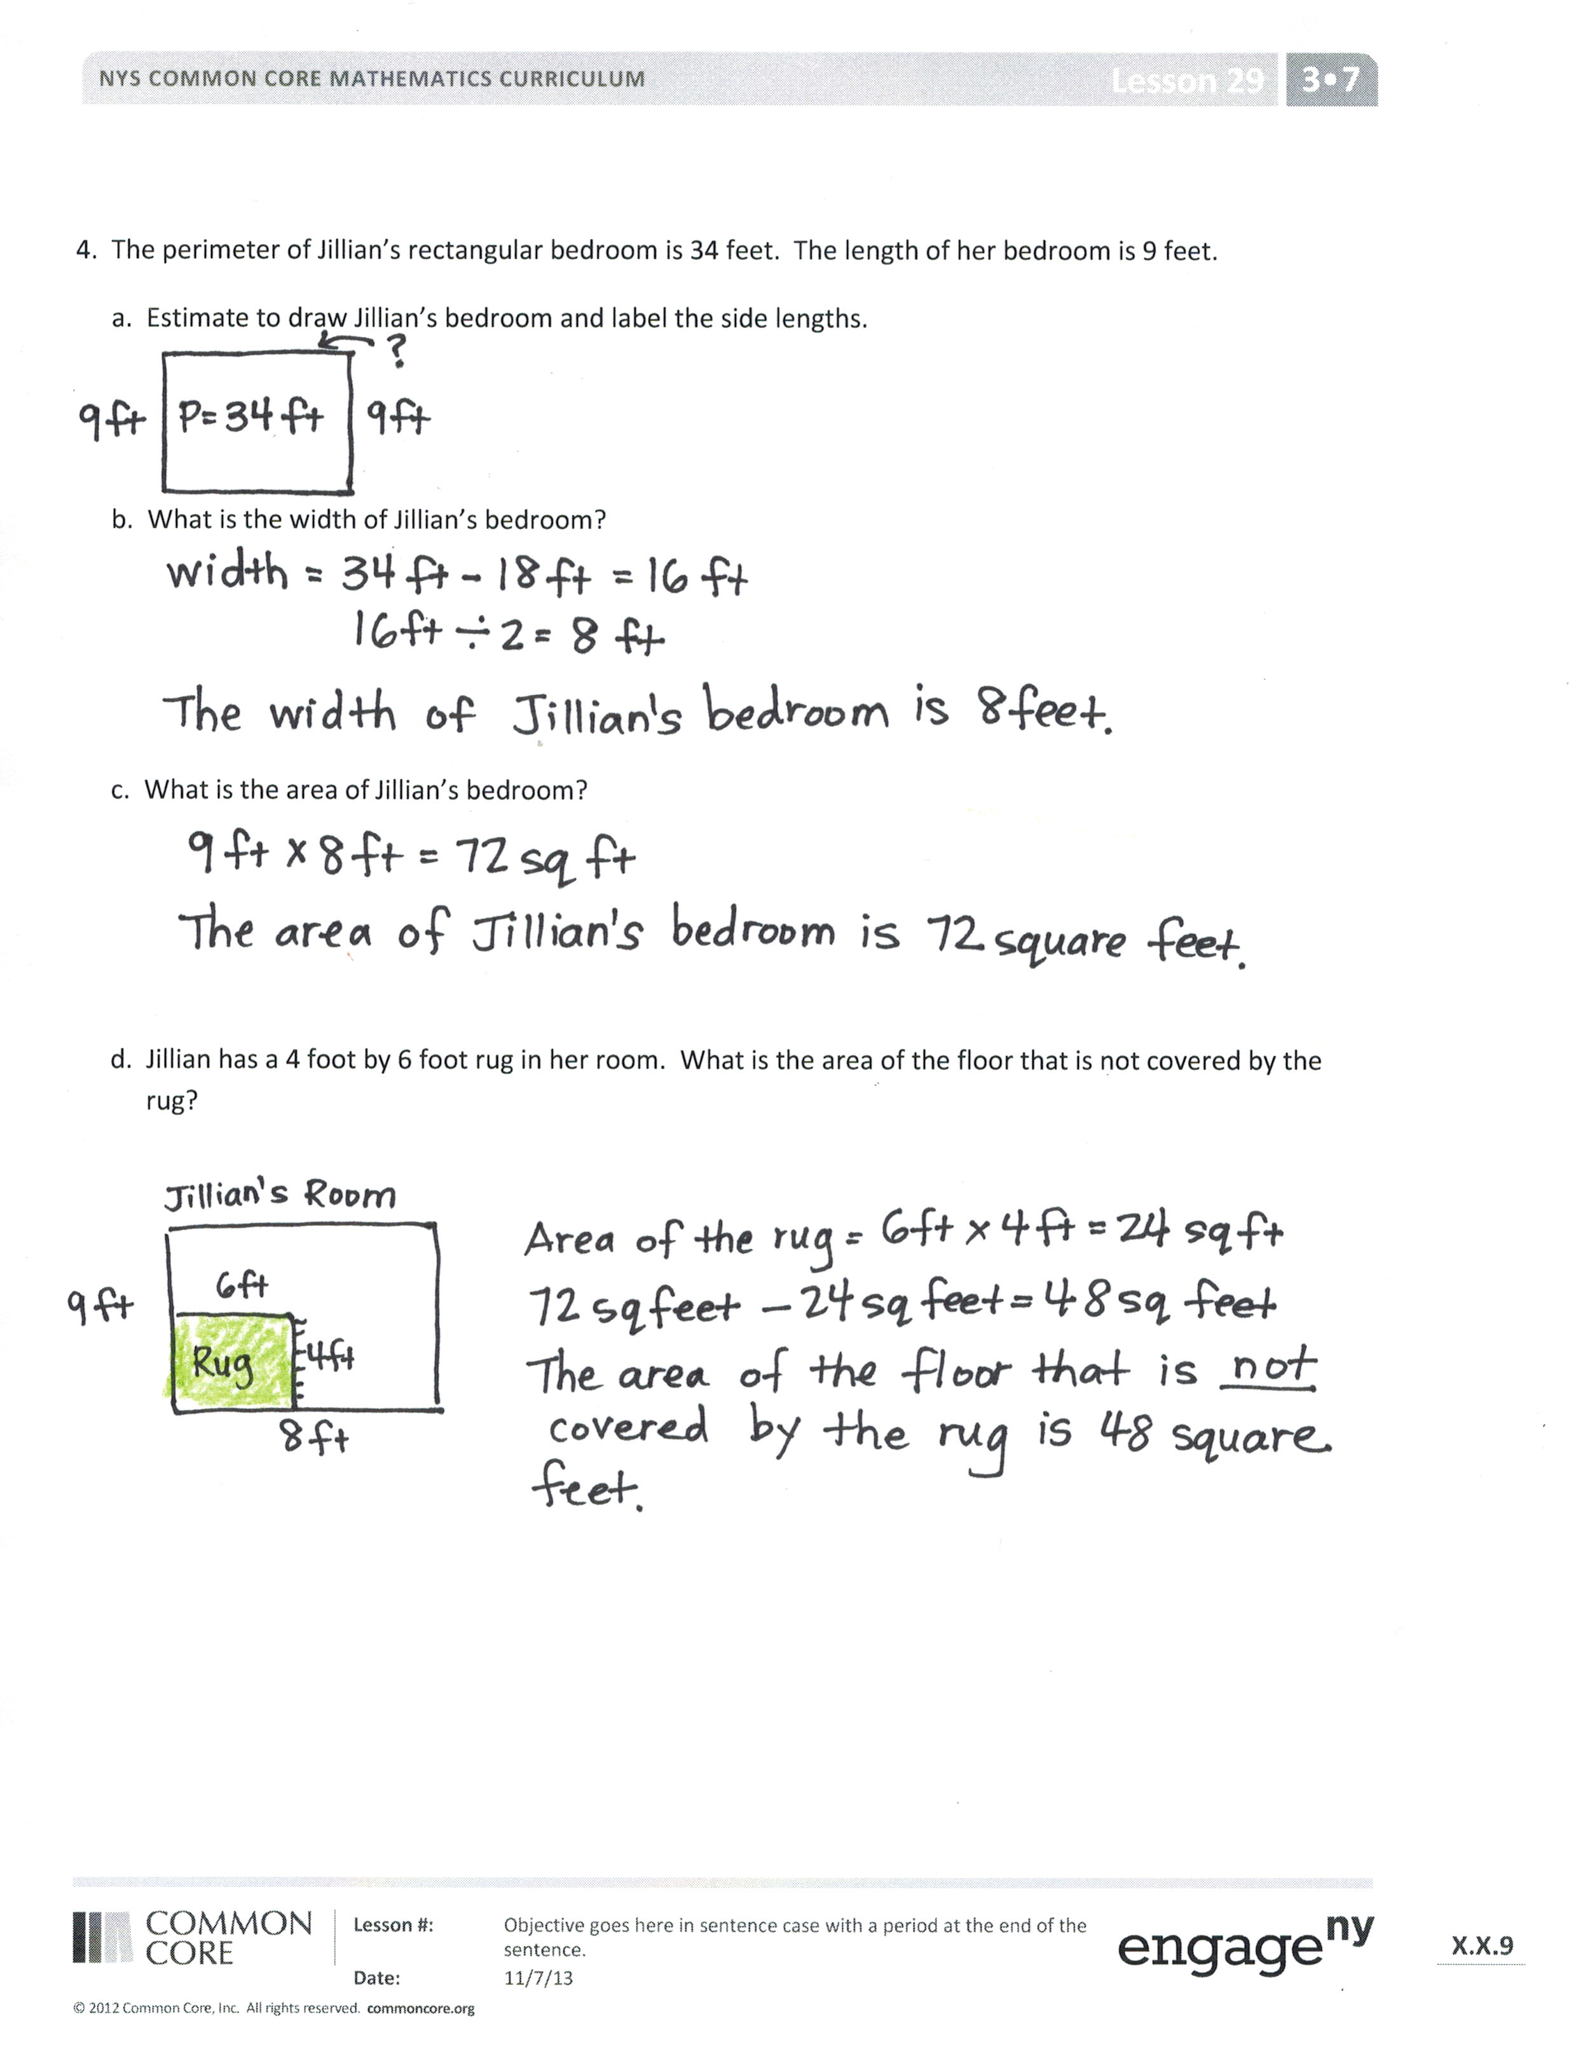

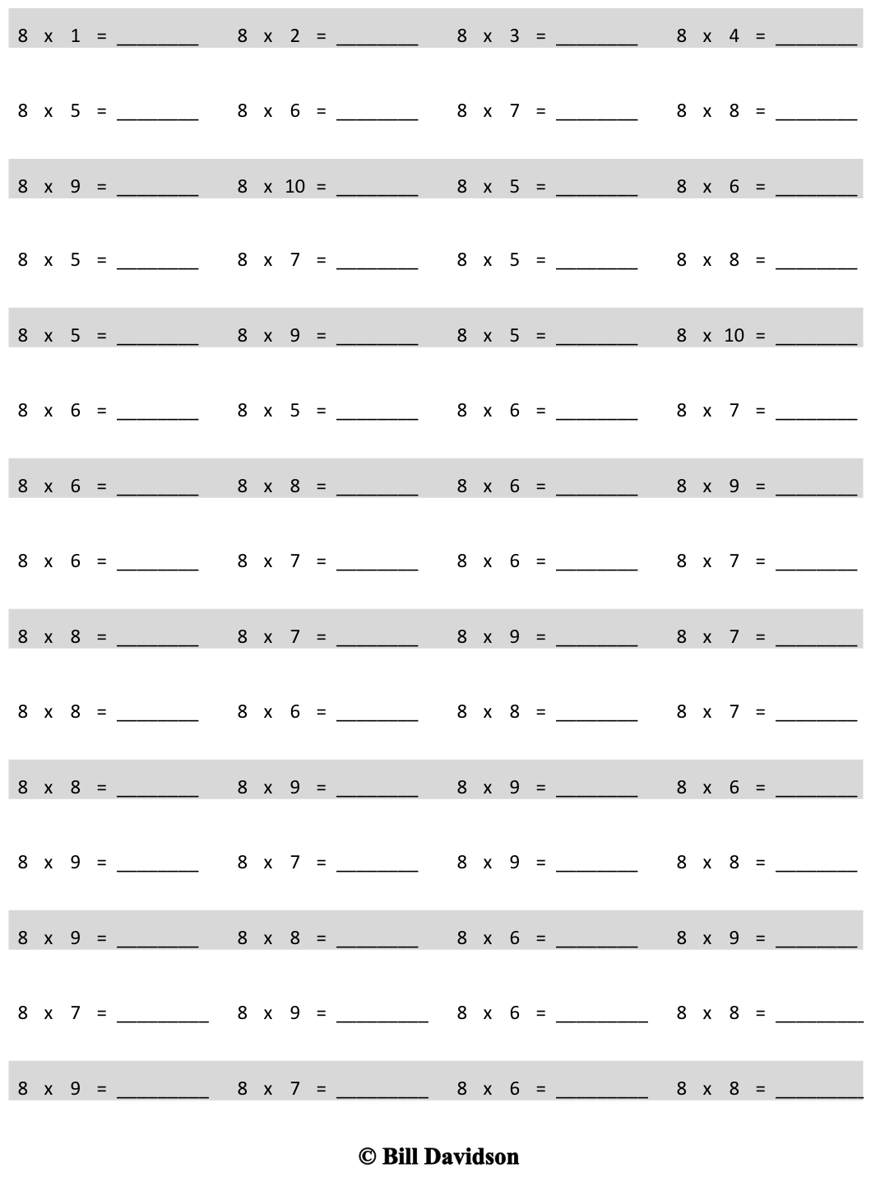
Multiply.

Name Date
- Gia measures her rectangular garden and finds the width is 9 yards and the length is 7 yards.
  - Estimate to draw Gia’s garden, and label the side lengths.

- What is the area of Gia’s garden?

- What is the perimeter of Gia’s garden?

- Elijah draws a square that has side lengths of 8 centimeters.
  - Estimate to draw Elijah’s square, and label the side lengths.

  - What is the area of Elijah’s square?

  - What is the perimeter of Elijah’s square?

  - Elijah connects three of these squares to make one long rectangle. What is the perimeter of this rectangle?

- The area of Mason’s rectangular painting is 72 square inches. The width of the painting is 8 inches.
  - Estimate to draw Mason’s painting, and label the side lengths.

- What is the length of the painting?

- What is the perimeter of Mason’s painting?

- Mason’s mom hangs the painting on a wall that already has two of Mason’s other paintings. The areas of the other paintings are 64 square inches and 81 square inches. What is the total area of the wall that is covered with Mason’s paintings?

- The perimeter of Jillian’s rectangular bedroom is 34 feet. The length of her bedroom is 9 feet.
  - Estimate to draw Jillian’s bedroom, and label the side lengths.

  - What is the width of Jillian’s bedroom?

  - What is the area of Jillian’s bedroom?

  - Jillian has a 4-foot by 6-foot rug in her room. What is the area of the floor that is not covered by the rug?

Name Date
Jennifer measures her rectangular sandbox and finds the width is 8 feet and the length is 6 feet.
  - Estimate to draw Jennifer’s sandbox, and label the side lengths.

  - What is the area of Jennifer’s sandbox?

  - What is the perimeter of Jennifer’s sandbox?

Name Date
- Carl draws a square that has side lengths of 7 centimeters.
  - Estimate to draw Carl’s square, and label the side lengths.

- What is the area of Carl’s square?

- What is the perimeter of Carl’s square?

- Carl draws two of these squares to make one long rectangle. What is the perimeter of this rectangle?

- Mr. Briggs puts food for the class party on a rectangular table. The table has a perimeter of 18 feet and a width of 3 feet.
  - Estimate to draw the table, and label the side lengths.

  - What is the length of the table?

  - What is the area of the table?

  - Mr. Briggs puts three of these tables together side by side. What is the area?

