Lesson 27
Objective: Use rectangles to draw a robot with specified perimeter measurements, and reason about the different areas that may be produced.

Suggested Lesson Structure
 Fluency Practice (14 minutes)
 Concept Development (36 minutes)
 Student Debrief (10 minutes)
Total Time (60 minutes)
Fluency Practice (14 minutes)

NOTES ON
MULTIPLE MEANS OF ENGAGEMENT:
One way to differentiate the Divide by 7 Sprint for students working above grade level is to make individualized performance goals. Students may enjoy recording and charting their completion time, seeking to improve their speed. Other goals may include good sportsmanship, persistence, high ambition, and leadership. Engage students in discussions of what constitutes excellence.

- Sprint: Divide by 7 3.OA.7 (10 minutes)
- Find the Area 3.MD.7 (4 minutes)

Sprint: Divide by 7 (10 minutes)
Materials: (S) Divide by 7 Sprint
Note: This Sprint builds fluency with multiplication and division facts using units of seven.
Find the Area (4 minutes)
Materials: (S) Personal white boards
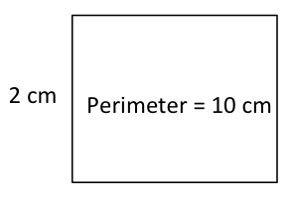
Note: This fluency activity reviews G3–M7–Lesson 19.
T: (Project rectangle with a width of 2 cm. Inside the rectangle, write Perimeter = 10 cm.) On your board, write the length of this rectangle.
S: (Write 3 cm.)
T: (Write 3 cm on the length of the rectangle. Below the rectangle, write Area = ___.) On your board, write the area of this rectangle. Write out a multiplication sentence if you need to.
S: (Write Area = 6 sq cm.)
T: Draw a different rectangle that has the same area.
S: (Draw a 1 cm × 6 cm rectangle.)
Repeat process for the other rectangles.
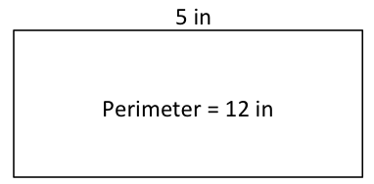
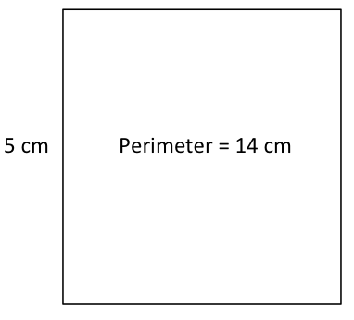

Concept Development (36 minutes)
Materials: (T) Copy or image of a completed sample robot project, evaluation rubric (S) Ruler, 3 strings from G3–M7–Lesson 26, copy of sample Problem Set, Problem Set
Note: Students may analyze one another’s work anonymously. If that’s best for the class, be sure that work is labeled with a number or symbol rather than with student names.
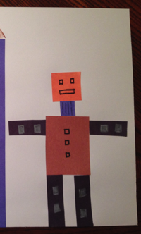
Part A: Robot Evaluation
Sample Robot

T: (Project a sample robot, as shown to the right. Consider using blank paper to cover the environment to help students focus on the robot.) Here is a finished robot. Let’s analyze the work. How can we check the measurements and perimeter calculations?
S: We can use rulers to check measurements, then add to double check the perimeters.
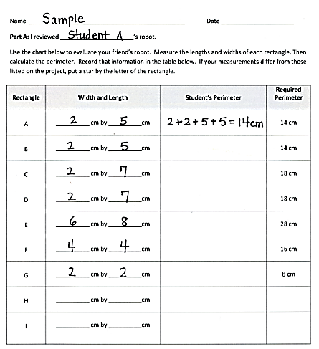
T: (Pass out sample rubric, shown to the right.) To analyze the accuracy of this robot, I used my ruler to measure the widths and lengths of each body part and recorded them on the chart in front of you. Then, I calculated the perimeter of Rectangle A and checked it with the required perimeter, labeled in the final column. Check my calculation for Rectangle A. Does it match the required perimeter?
Sample Rubric
S: Yes, they are both 14 centimeters.
T: Work with a partner to finish calculating the rest of the perimeters using the given lengths and widths. If you find that your measurements differ from the required perimeter, put a star by the letter of the rectangle.
S: (Calculate perimeters.)
T: What did you find?
S: These perimeters are all correct!
T: What’s next on our list?
S: Checking that the body is double the perimeter of an arm and that the neck is half the perimeter of the head.
T: Do that now. Record your calculations, and then check your answer with a partner’s.
S: (Record.) It’s done correctly. A perimeter of 28 centimeters for the robot’s body is double 14 centimeters, and 8 centimeters for the robot’s neck is half of 16 centimeters.
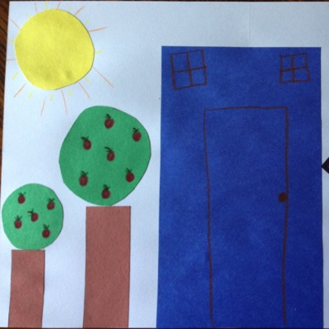
T: Each of you will analyze a classmate’s robot just as we did this one. Write your classmate’s name on your Problem Set. Confirm the measurements and perimeters calculated by your classmate with your ruler. (Distribute a classmate’s work to each student, and circulate to answer questions that arise.)
Sample Robot Environment
Part B: Robot Environment Evaluation
In Part B students use the same process as Part A to evaluate a different classmate’s robot environment. Each student uses their three strings to measure non-rectangular items like the sun and the tree tops. Make sure to discuss how these circular measurements most likely will not produce exact numbers. Provide examples of perimeter measurements that it’s appropriate to call “about 25 centimeters.”
If time permits, have students evaluate a different classmate’s robot or robot environment.
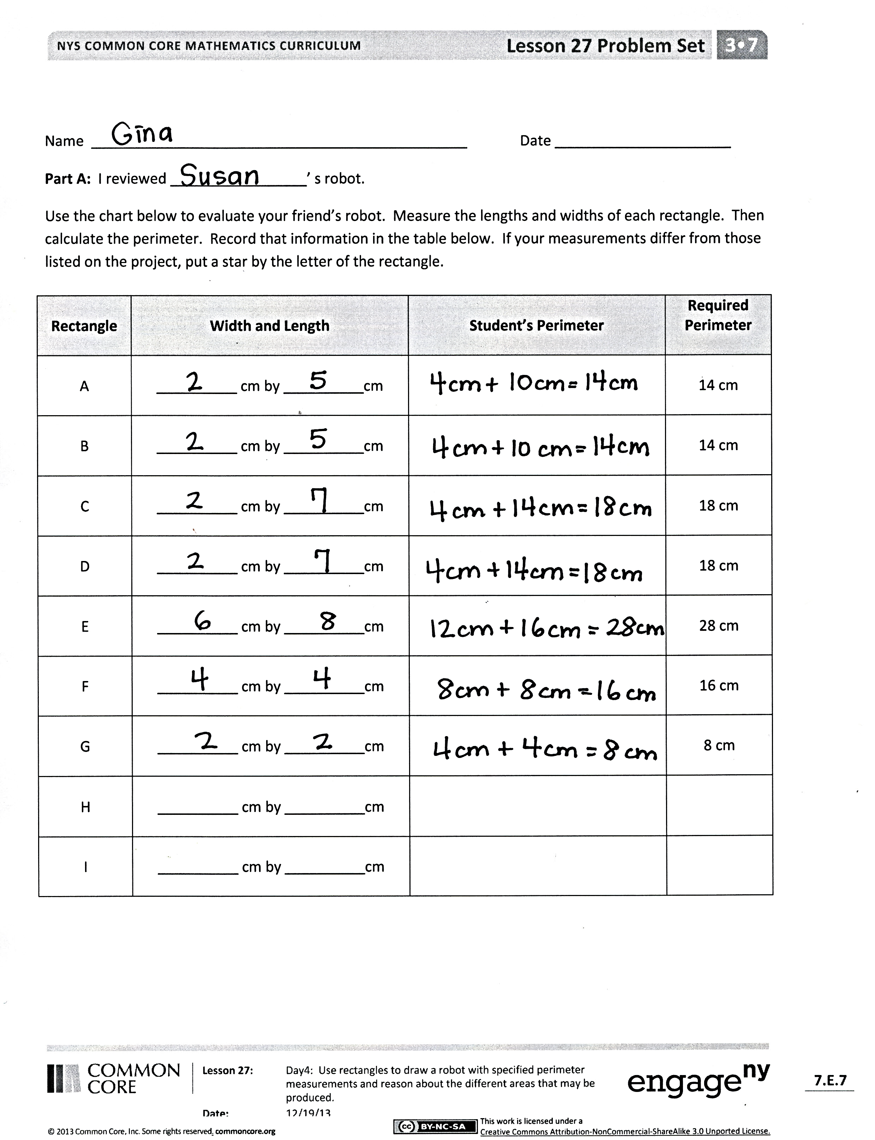
Student Debrief (10 minutes)
Lesson Objective: Use rectangles to draw a robot with specified perimeter measurements, and reason about the different areas that may be produced.
The Student Debrief is intended to invite reflection and active processing of the total lesson experience.
Invite students to review their solutions for the Problem Set. They should check work by comparing answers with a partner before going over answers as a class.
Look for misconceptions or misunderstandings that can be addressed in the Debrief. Guide students in a conversation to debrief the Problem Set and process the lesson.
You may choose to use any combination of the questions below to lead the discussion.
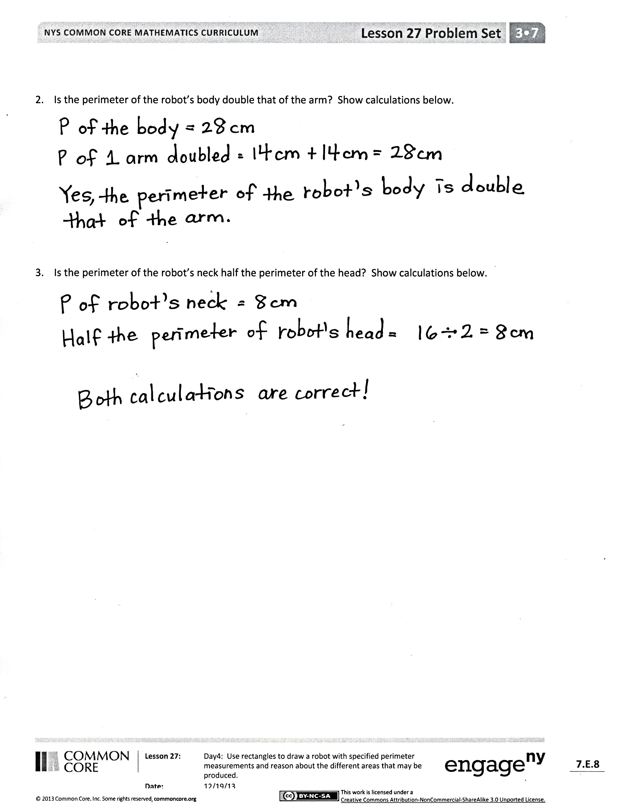
- How was the student work you checked similar to the design you created? How was it different?
- How was checking student work different from creating your design yesterday? If you could go back and change your design, would you? If so, in what ways?
MP.3
- What did you learn about the areas of rectangles that have the same perimeters? How does this help you better understand the relationship between area and perimeter?
Exit Ticket (3 minutes)
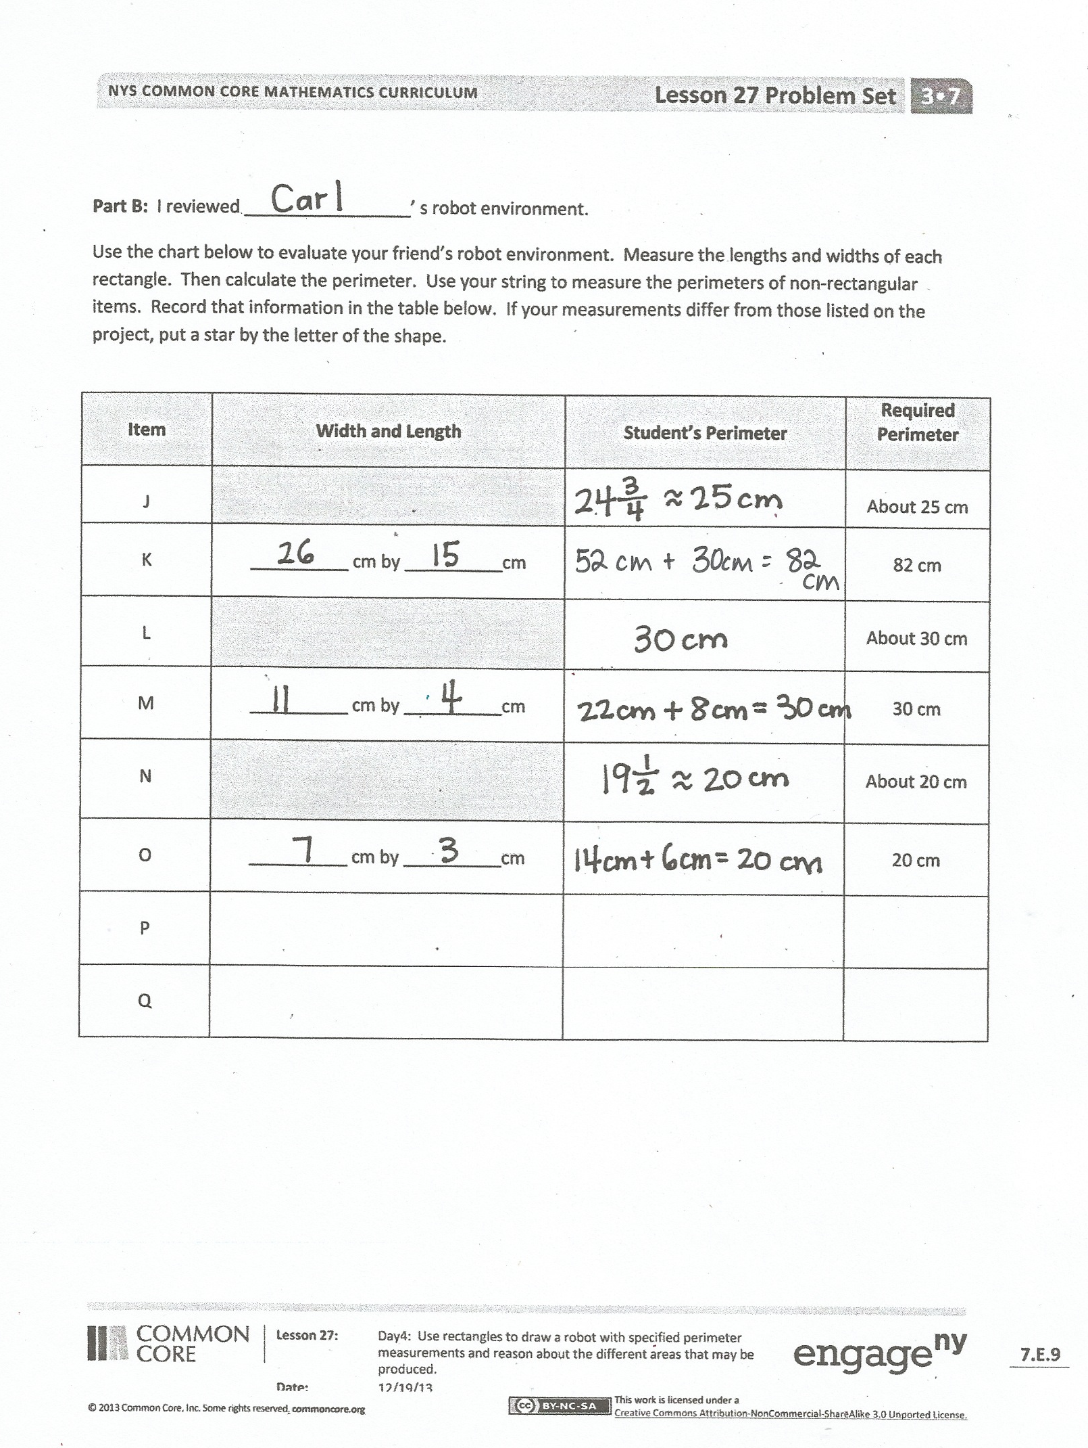
After the Student Debrief, instruct students to complete the Exit Ticket. A review of their work will help you assess the students’ understanding of the concepts that were presented in the lesson today and plan more effectively for future lessons. You may read the questions aloud to the students.

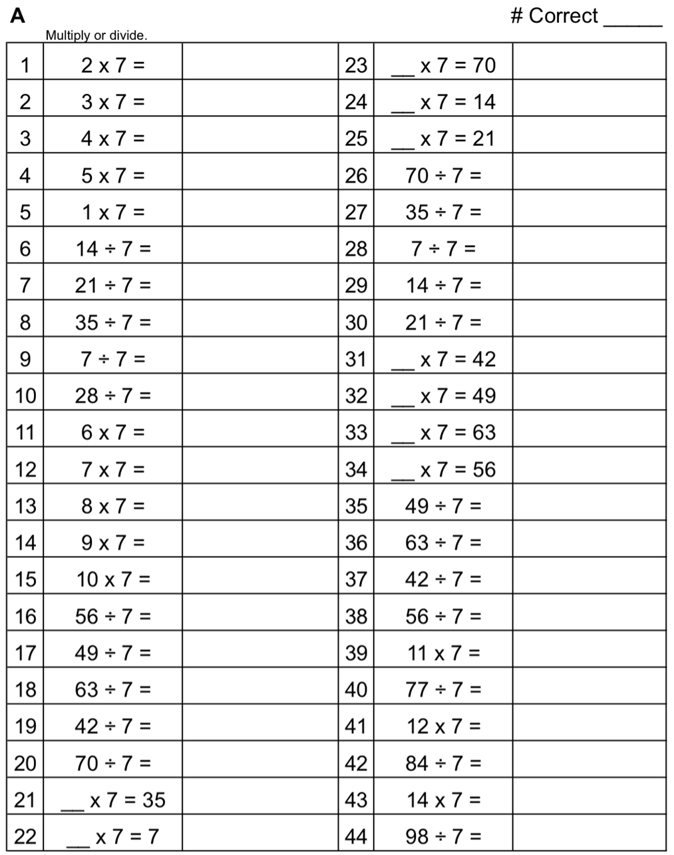

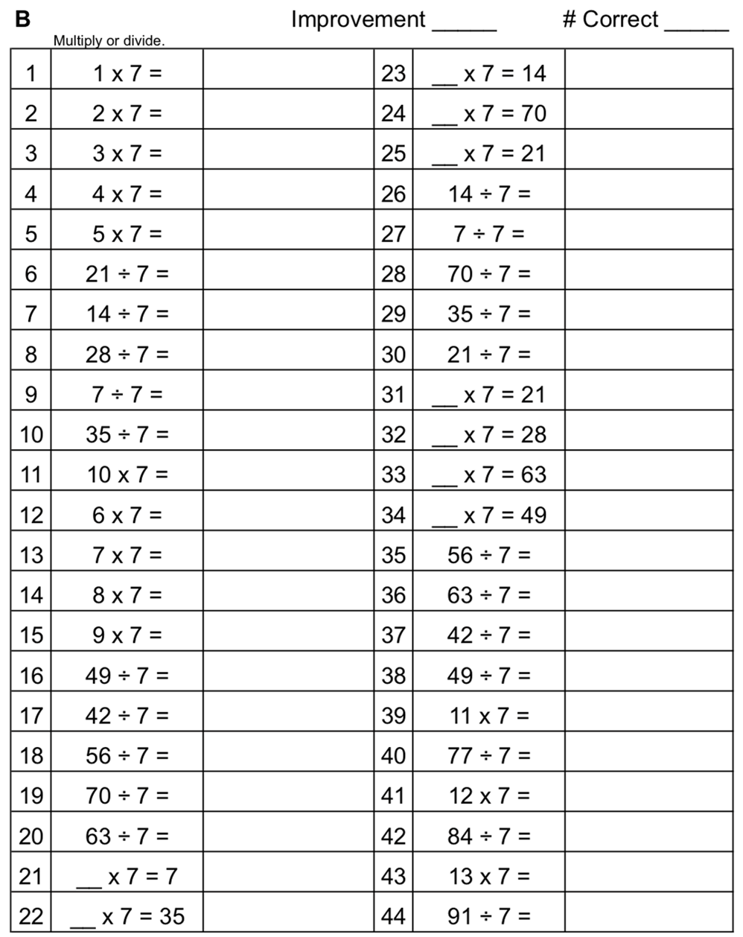

Name Date
Part A: I reviewed _________________’s robot.
Rectangle | Width and Length | Student’s Perimeter | Required Perimeter
A | __________ cm by __________cm |  | 14 cm
B | __________ cm by __________cm |  | 14 cm
C | __________ cm by __________cm |  | 18 cm
D | __________ cm by __________cm |  | 18 cm
E | __________ cm by __________cm |  | 28 cm
F | __________ cm by __________cm |  | 16 cm
G | __________ cm by __________cm |  | 8 cm
H | __________ cm by __________cm
I | __________ cm by __________cm
- Use the chart below to evaluate your friend’s robot. Measure the lengths and widths of each rectangle. Then calculate the perimeter. Record that information in the table below. If your measurements differ from those listed on the project, put a star by the letter of the rectangle.

- Is the perimeter of the robot’s body double that of the arm? Show calculations below.

- Is the perimeter of the robot’s neck half the perimeter of the head? Show calculations below.

Part B: I reviewed _________________’s robot environment.
Use the chart below to evaluate your friend’s robot environment. Measure the lengths and widths of each rectangle. Then calculate the perimeter. Use your string to measure the perimeters of non-rectangular items. Record that information in the table below. If your measurements differ from those listed on the project, put a star by the letter of the shape.
Item | Width and Length | Student’s Perimeter | Required Perimeter
J |  |  | About 25 cm
K | __________ cm by __________cm |  | 82 cm
L |  |  | About 30 cm
M | __________ cm by __________cm |  | 30 cm
N |  |  | About 20 cm
O | __________ cm by __________cm |  | 20 cm
P
Q

Name Date
- a. Record the perimeters and areas of Rectangles A and B in the chart below.

8 cm
2 cm
B
5 cm
Item | Width and Length | Student’s Perimeter | Required Perimeter
J |  |  | About 25 cm
K | __________ cm by __________cm |  | 82 cm

A
5 cm
Item | Width and Length | Student’s Perimeter | Required Perimeter
J |  |  | About 25 cm
K | __________ cm by __________cm |  | 82 cm

Rectangle | Width and Length | Perimeter | Area
A | __________ cm by __________cm
B | __________ cm by __________cm

- What is the same about Rectangles A and B? What is different?

Name Date
- Record the perimeters and areas of the rectangles in the chart on the next page.
6 cm
6 cm
8 cm
4 cm
1 cmcm
11 cmcm
5 cm
5 cm
8 cm
2 cm
4 cm
6 cm
A
B
C
D
E
F

Rectangle | Width and Length | Perimeter | Area
A | __________ cm by __________cm
B | __________ cm by __________cm
C | __________ cm by __________cm
D | __________ cm by __________cm
E | __________ cm by __________cm
F | __________ cm by __________cm
- Find the area and perimeter of each rectangle.

- What do you notice about the perimeters of Rectangles A, B, and C?

- What do you notice about the perimeters of Rectangles D, E, and F?

- Which two rectangles are squares? Which square has the greatest perimeter?
Name Date
Evaluation Rubric
4 | 3 | 2 | 1 | Subtotal
Perimeter calculations for all shapes are correct, and both evaluations of a classmate’s project have been completed. | Perimeter calculations include 1 to 2 errors, and both evaluations of a classmate’s project have been completed. | Perimeter calculations include 3 to 4 errors, and at least 1 evaluation of a classmate’s project has been completed. | Perimeter calculations include 5 or more errors, and at least 1 evaluation of a classmate’s project has been completed. | _____/4

Name Date
Evaluation Rubric
4 | 3 | 2 | 1 | Subtotal
Perimeter calculations for all shapes are correct, and both evaluations of a classmate’s project have been completed. | Perimeter calculations include 1 to 2 errors, and both evaluations of a classmate’s project have been completed. | Perimeter calculations include 3 to 4 errors, and at least 1 evaluation of a classmate’s project has been completed. | Perimeter calculations include 5 or more errors, and at least 1 evaluation of a classmate’s project has been completed. | _____/4

