Lesson 26
Objective: Use rectangles to draw a robot with specified perimeter measurements, and reason about the different areas that may be produced.

Suggested Lesson Structure
 Fluency Practice (11 minutes)
 Application Problem (5 minutes)
 Concept Development (34 minutes)
 Student Debrief (10 minutes)
Total Time (60 minutes)
Fluency Practice (11 minutes)
- Multiply by 7 3.OA.7 (8 minutes)
- Find the Side Lengths 3.MD.8 (3 minutes)

Multiply by 7 (8 minutes)
Materials: (S) Multiply by 7 Pattern Sheet (6–10)
Note: This activity builds fluency with multiplication facts using units of 7. It works toward students knowing from memory all products of two one-digit numbers. See G3–M7–Lesson 1 for the directions for administration of a Multiply By pattern sheet.

NOTES ON
MULTIPLE MEANS OF ACTION AND EXPRESSION:
Adjust the Multiply by 7 fluency activity according to student needs. For English language learners try speaking more slowly, pausing more frequently, giving an example, or coupling language with visual aids, such as arrays or tape diagrams. Students who have not memorized the 7 skip-count, may benefit from repeating the count many times.

T: (Write 7 × 7 = ____.) Let’s skip-count up by sevens. I’ll raise a finger for each seven. (Count with fingers to 7 as students count.)
S: 7, 14, 21, 28, 35, 42, 49.
T: Let’s skip-count by sevens starting at 35. Why is 35 a good place to start?
S: It’s a fact we already know. It can help us figure out a fact we don’t know.
T: (Count up with fingers as students say numbers.)
S: 35 (5 fingers), 42 (6 fingers), 49 (7 fingers).
T: Let’s see how we can skip-count down to find the answer, too. Start at 70 with 10 fingers, 1 for each seven. (Count down with fingers as students say numbers.)
S: 70 (10 fingers), 63 (9 fingers), 56 (8 fingers), 49 (7 fingers).
Continue with the following suggested sequence: 9 × 7, 6 × 7, and 8 × 7.
T: (Distribute Multiply by 7 Pattern Sheet.) Let’s practice multiplying by 7. Be sure to work left to right across the page.

Find the Side Lengths (3 minutes)

NOTES ON
MULTIPLE MEANS OF ENGAGEMENT:
Scaffold the Find the Perimeter fluency activity for students working below grade level with graduated questioning.
- What is the perimeter of Image A? Each triangle side is the same length.
- How many triangle sides do you count around the perimeter? Count with me.
- Say the division sentence to solve for the side length.

Materials: (S) Personal white board
Note: This fluency activity reviews G3–M7–Lesson 23.
T: (Project Image A. Beneath it write __ cm ÷ __ = __ cm.) Each side of the triangle is the same length. The perimeter of this shape is 80 cm. Find the side lengths of each triangle by filling in the missing numbers.
S: (Write 80 cm ÷ 8 = 10 cm.)
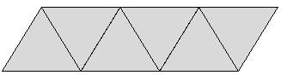
P = 80 cm
Image A

Repeat the process for Images B and C.
P = 90 m

Image B
P = 64 in
Image C

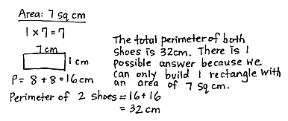
Application Problem (5 minutes)
Drew makes rectangular shoes for his robot. Each shoe has whole number side lengths and an area of 7 square centimeters. What is the total perimeter of both shoes? Is there more than one answer? Why or why not?
Note: This problem reviews finding the perimeter of a rectangle given its area. Students will find there is only one answer in this case, because there is only one factor pair for an area of 7.
Concept Development (34 minutes)
Materials: (S) Ruler, scissors, string, Problem Sets from G3–M7– Lessons 25 and 26, circles template

NOTES ON
MULTIPLE MEANS OF REPRESENTATION:
If helpful, line each circle on the template with glue. Let the glue dry to make a tactile barrier for students as they measure with string. Demonstrate how to anchor the string and keep it taut around the circle.

Part 1: Create a robot environment.
Students begin with their G3–M7–Lesson 25 Problem Sets.
T: Today we’ll use the map you sketched and labeled on yesterday’s Problem Set to measure and cut out the items in your robot’s environment. Tell your partner the first step to making circular items.
S: First, I’ll measure string using a ruler and cut it to the size of each circular item.
T: What three measurements do you need to mark and cut using your strings?
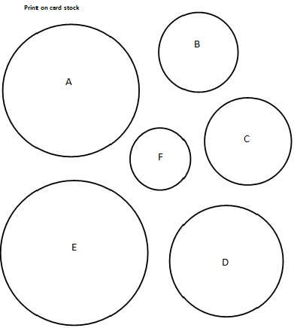
S: 25, 30, and 20 centimeters. Those are the sizes of the circles in the environment.
Circles Template
T: Once you’ve measured and cut your string, it’ll be challenging to trace it into circles. I’ve made a template of circles to help you. (Pass out circles template.) What do you notice about the number of circles on your sheet?
S: There are six circles. But we only need three.
T: Once you’ve measured and cut your three strings, match them to the circles on the template you’ll use to help you trace. Remember that with string, we can’t always be exact. Start measuring now. (Allow students time to measure.) Which circles do we need to cut out and trace to make the circles in our robot’s environment?
S: Circles A, C, and D.
T: Go ahead and cut, trace, and glue all the pieces to make your robot’s environment.
S: (Measure, trace, cut, and glue environment.)
Encourage students who finish early to add details and finishing touches to their work.
Part 2: Analyze the line plot.
T: (Distribute the G3–M7–Lesson 26 Problem Set.) Find the area of your robot’s rectangular body. Let’s plot everyone’s data on our number lines.
T/S: (Gather data and record the following possible measurements on the line plot: 13, 24, 33, 40, 45, 48, and 49 square centimeters.)
T: Each robot’s body has a perimeter of 28 centimeters. Why do you think we have so many different area measurements for the same perimeter?
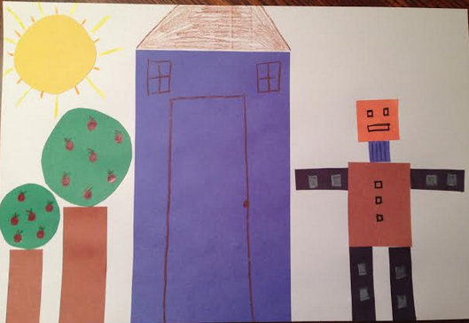
S: (Discuss.)
T: What does this tell you about the relationship between area and perimeter?
S: That we can have many different areas for the same perimeter. They are two separate things. Maybe there’s not really a connection between them.
T: Take some time to record your answers to Problems 1(a) and 1(b).
S: (Record.)
Problem Set (10 minutes)
Students should do their personal best to complete Problems 2, 3, and 4 within the allotted 10 minutes. For some classes, it may be appropriate to modify the assignment by specifying which problems they work on first. Some problems do not specify a method for solving. Students solve these problems using the RDW approach used for Application Problems.
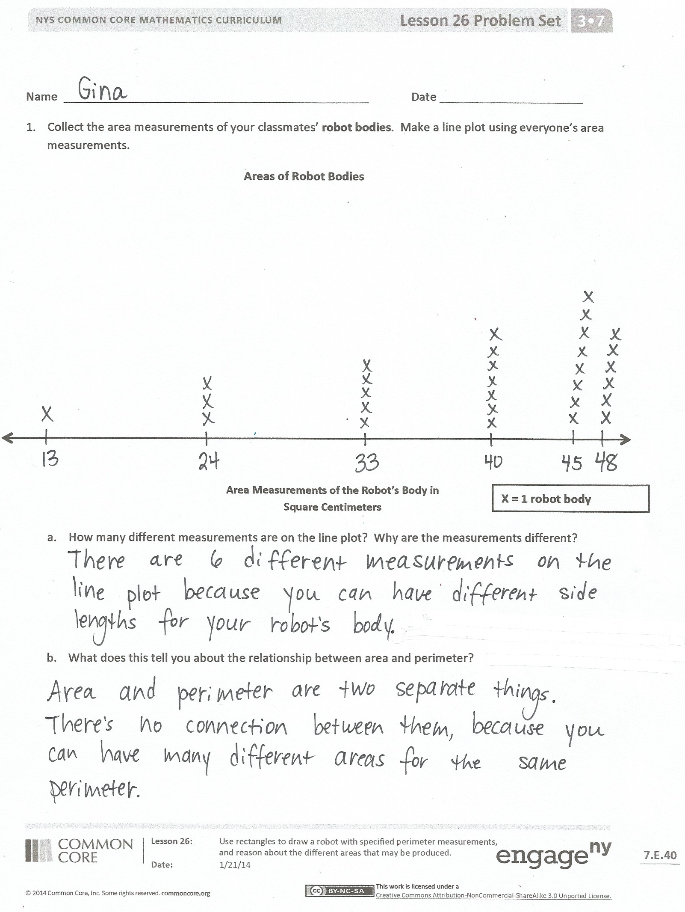
Student Debrief (10 minutes)
Lesson Objective: Use rectangles to draw a robot with specified perimeter measurements, and reason about the different areas that may be produced.
The Student Debrief is intended to invite reflection and active processing of the total lesson experience.
Invite students to review their solutions for the Problem Set. They should check work by comparing answers with a partner before going over answers as a class. Look for misconceptions or misunderstandings that can be addressed in the Debrief. Guide students in a conversation to debrief the Problem Set and process the lesson.
You may choose to use any combination of the questions below to lead the discussion.
- (Share student calculations from Problem 2.) Why do you think the problem asked to measure the perimeter in inches instead of centimeters?
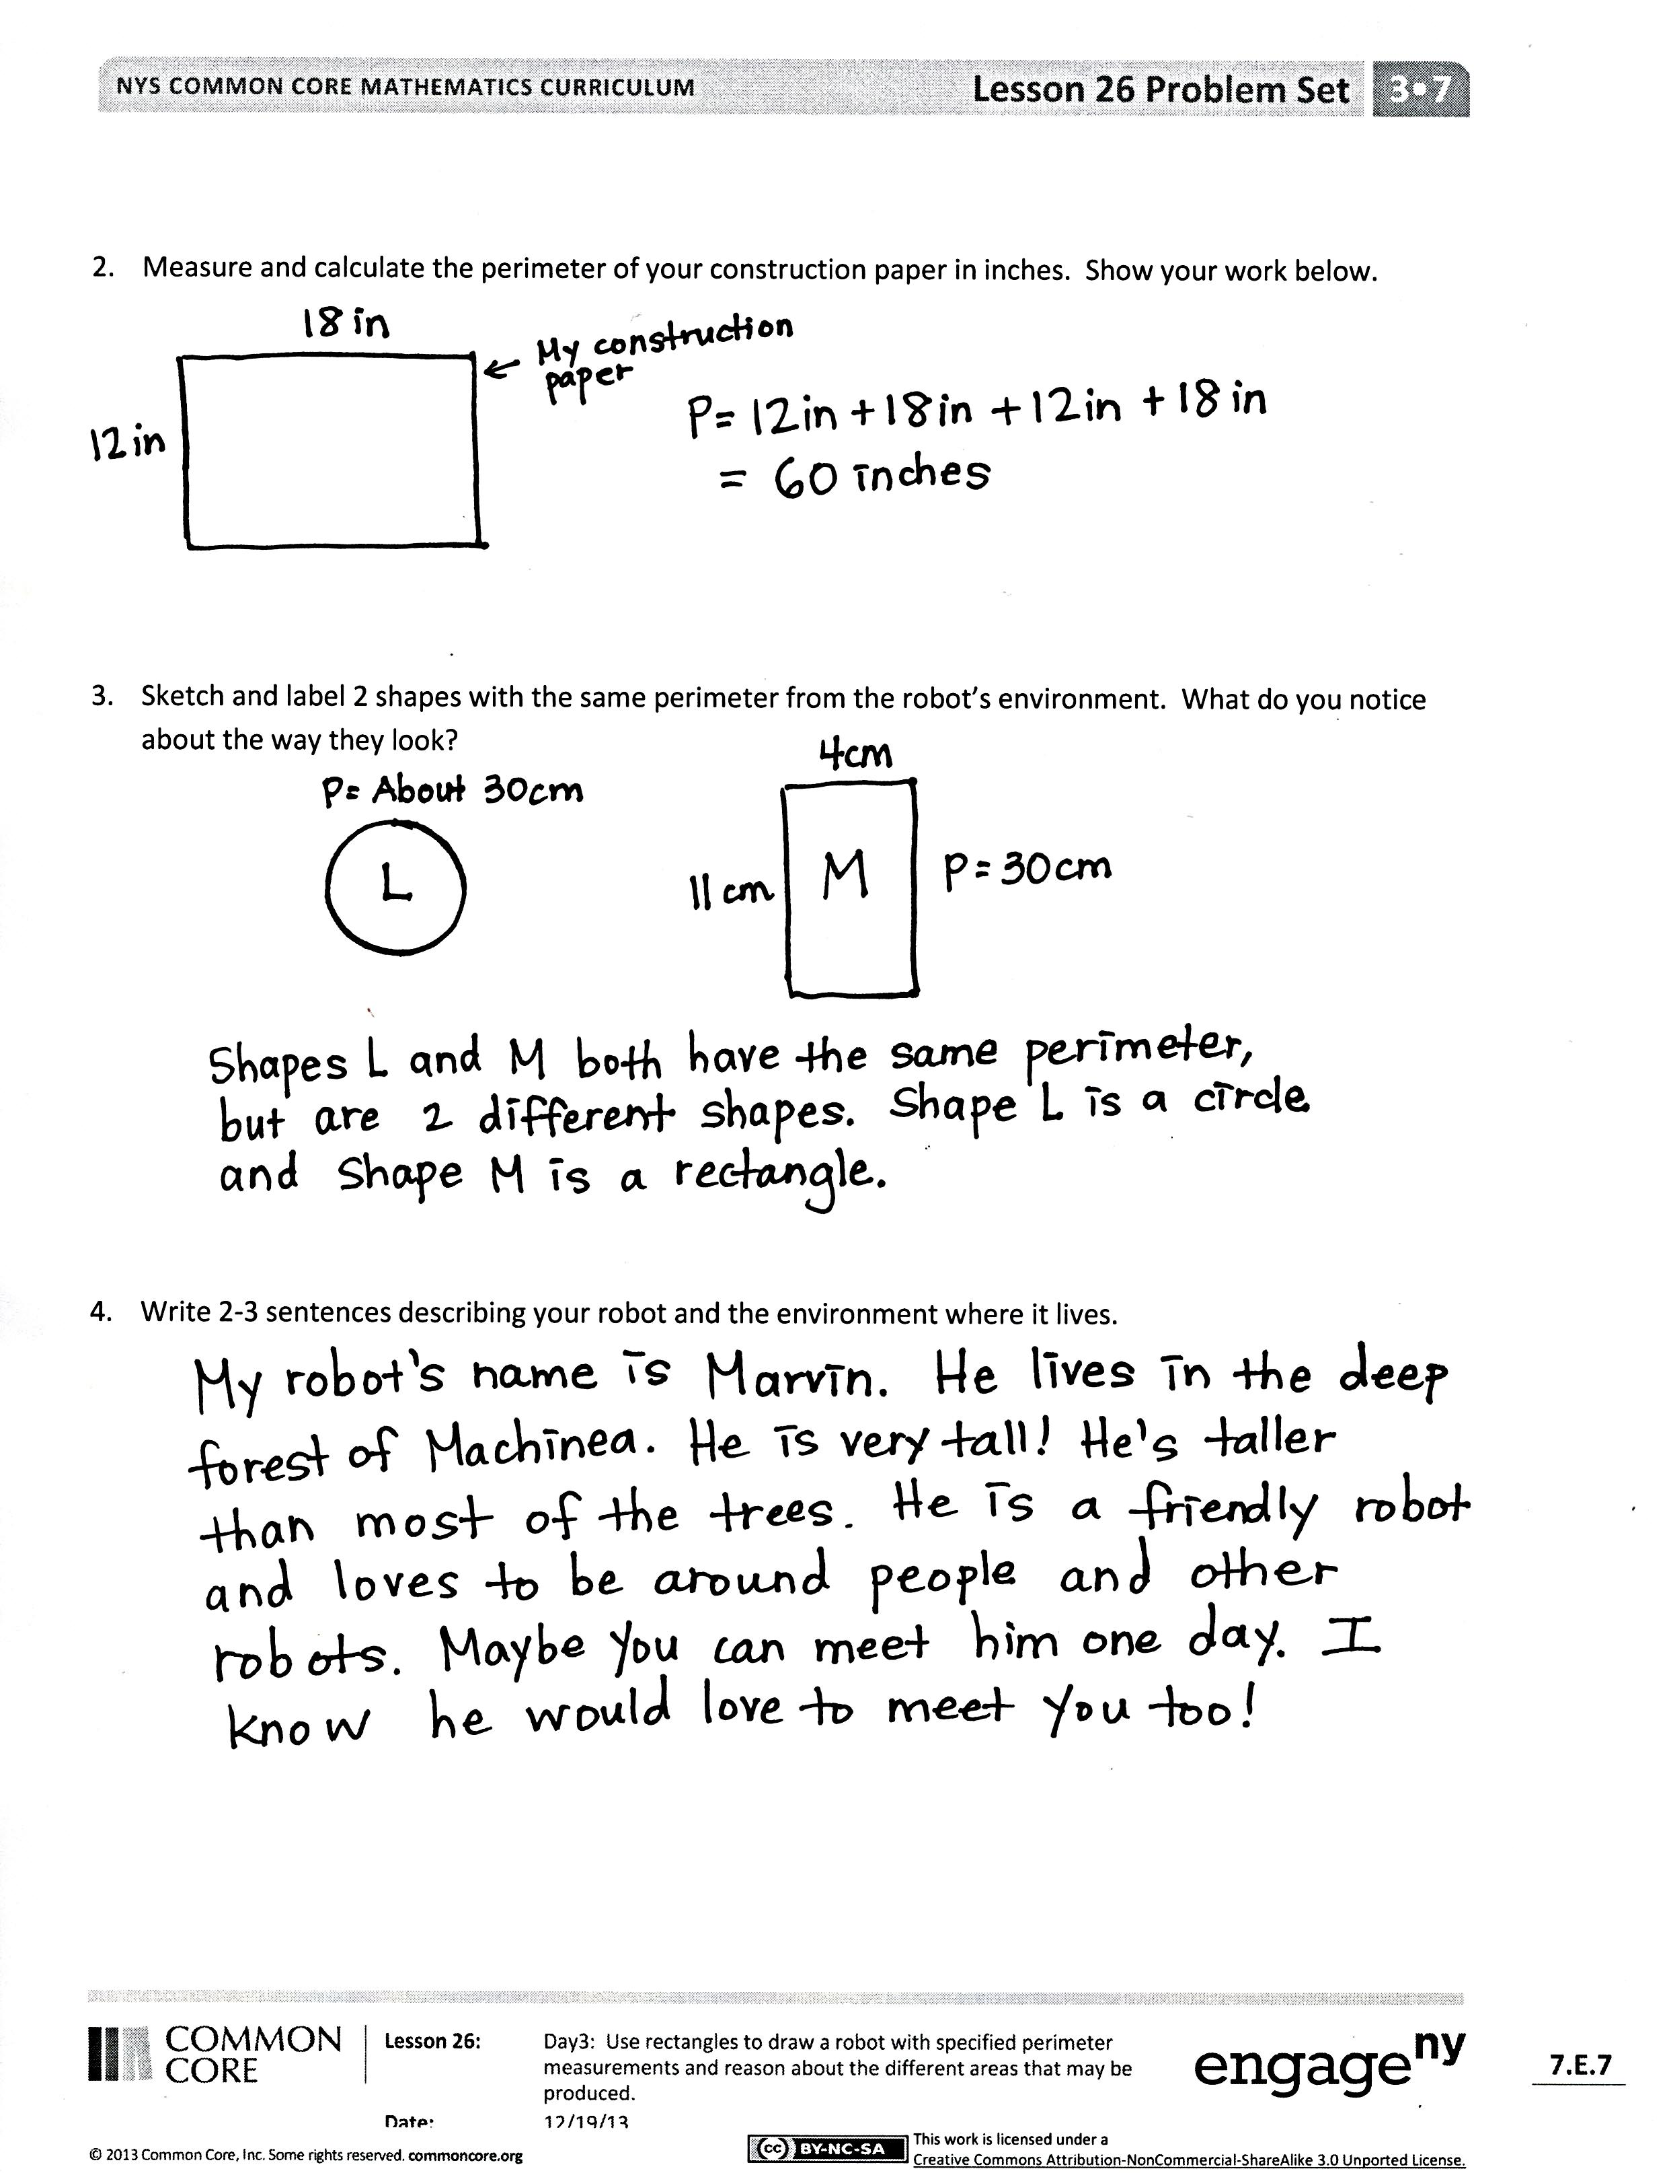
- (Share student sketches in Problem 3.) Discuss that many different shapes can have the same perimeter. Can a triangle and a hexagon have the same perimeter?
- Have students share their responses to Problem 4.
- Each piece of art looks unique even though you each used the same perimeters. Through this experience what did you learn about the relationship between area and perimeter?
Exit Ticket (3 minutes)
After the Student Debrief, instruct students to complete the Exit Ticket. A review of their work will help you assess the students’ understanding of the concepts that were presented in the lesson today and plan more effectively for future lessons. You may read the questions aloud to the students.

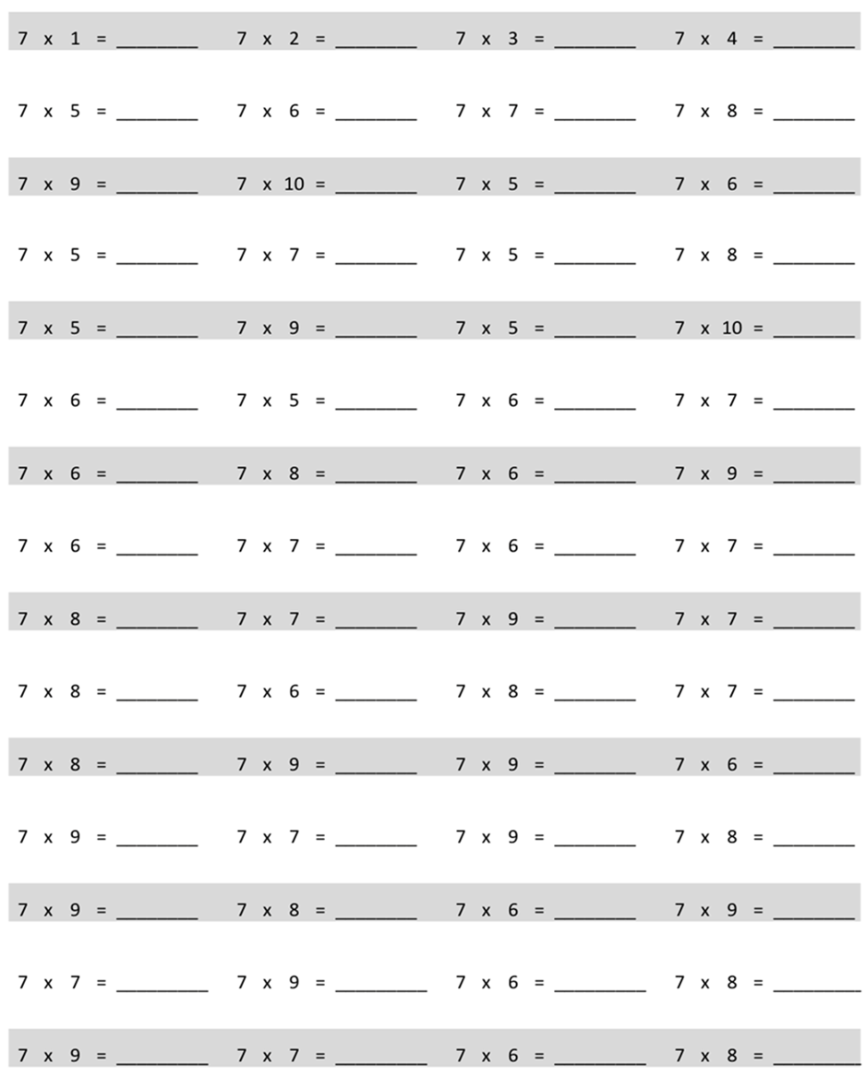
Multiply.

Name Date
- Collect the area measurements of your classmates’ robot bodies. Make a line plot using everyone’s area measurements.
Areas of Robot Bodies

X = 1 Robot Body
Area Measurements of the Robot’s Body in Square Centimeters

- How many different measurements are on the line plot? Why are the measurements different?

- What does this tell you about the relationship between area and perimeter?

- Measure and calculate the perimeter of your construction paper in inches. Show your work below.

- Sketch and label two shapes with the same perimeter from the robot’s environment. What do you notice about the way they look?

- Write two or three sentences describing your robot and the environment in which it lives.

Name Date
  - Use string to help you sketch a circle with a perimeter of about 15 centimeters.

  - Estimate to draw a rectangle with a perimeter of 15 centimeters. Label the width and length.

Name Date
- Use Rectangles A and B to answer the questions below.
5 cm
3 cm
4 cm
Rectangle A
Rectangle B
4 cm

- What is the perimeter of Rectangle A?

- What is the perimeter of Rectangle B?

- What is the area of Rectangle A?

- What is the area of Rectangle B?

- Use your answers to Parts (a) through (d) to help you explain the relationship between area and perimeter.

- Each student in Mrs. Dutra’s class draws a rectangle with whole number side lengths and a perimeter of 28 centimeters. Then they find the area of each rectangle and create the table below.
Area in Square Centimeters | Number of Students
13 | 2
24 | 1
33 | 3
40 | 5
45 | 4
48 | 2
49 | 2

- Give two examples to show how it is possible to have different areas for rectangles that have the same perimeter.

- Did any students in Mrs. Dutra’s class draw a square? Explain how you know.

- What are the side lengths of the rectangle that most students in Mrs. Dutra’s class made with a perimeter of 28 centimeters?

Note: Print on card stock.
C
D
E
F
A
B

