Lesson 25
Objective: Use rectangles to draw a robot with specified perimeter measurements, and reason about the different areas that may be produced.

Suggested Lesson Structure
 Fluency Practice (10 minutes)
 Concept Development (40 minutes)
 Student Debrief (10 minutes)
Total Time (60 minutes)
Fluency Practice (10 minutes)
- Sprint: Divide by 6 3.OA.7 (10 minutes)

Sprint: Divide by 6 (10 minutes)
Materials: (S) Divide by 6 Sprint
Note: This Sprint builds fluency with multiplication and division facts using units of 6.
Concept Development (40 minutes)
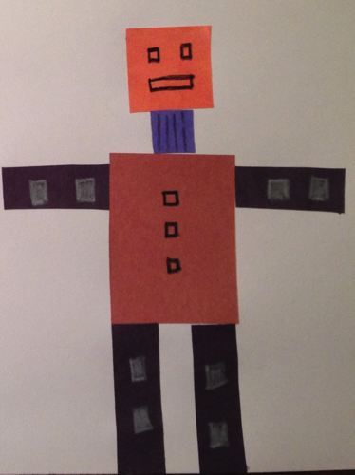
Materials: (S) Problem Sets from G3–M7–Lessons 24 and 25, evaluation rubric, centimeter grid paper, glue, ruler, right angle tool, crayons, assorted colors of construction paper, 12" × 18" construction paper, string, scissors
Finished Robot Sample
Students use today’s Problem Set to map out the robot in its environment. Once they have their map completed, students create just their robot using the widths and lengths they recorded on the Problem Set in G3–M7–Lesson 24. Give them the option of cutting their rectangles out of centimeter grid paper or creating rectangles on construction paper with a right angle tool and ruler. Once all pieces for the robot are cut, students can glue the pieces to a 12" × 18" piece of construction paper.

To prepare students:
- Inform students that they will sketch a map of their robot in its environment on the Problem Set. The widths, lengths, and perimeters of the rectangles need to be labeled. Circular items should be labeled with their perimeters. This map will be used again tomorrow as students construct their robot’s environment.
Figure A
Figure B
- Inform students they may use either centimeter grid paper or a right angle tool and ruler to create their rectangular robot pieces. Those who use centimeter grid paper might color their pieces if time allows.
MP.6
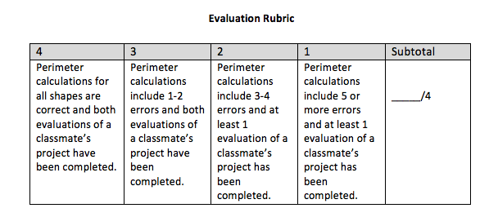
- Let students know that their peers will analyze their work. It’s important to glue pieces on the 12" × 18" construction paper without affecting the perimeters of the objects, as in Figure A above. Demonstrate that the measureable perimeter of the tree trunk changes with the placement of the tree top in Figure B.
- Share the evaluation rubric (pictured right and included at the end of the lesson) with students so they know the expectations for the finished product.
- Inform students that they will have time tomorrow to put the finishing touches on their robots if they don’t have enough time today.
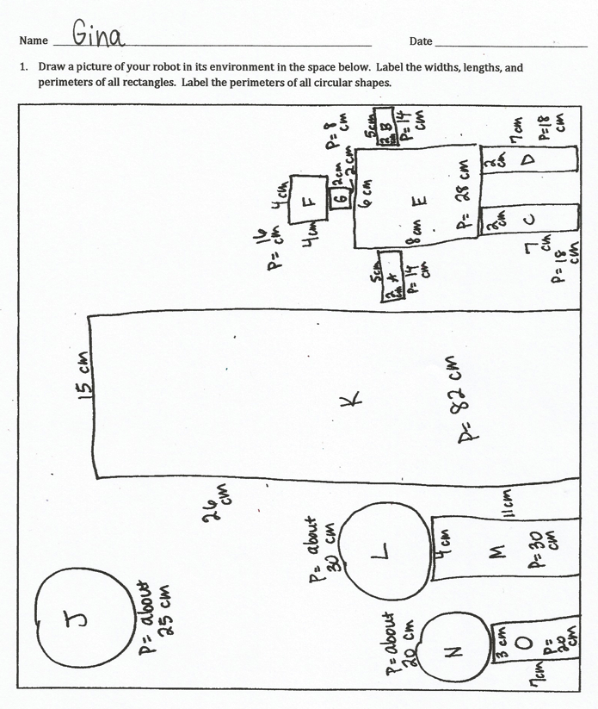
Note: In G3–M7–Lesson 27, students analyze one another’s work for accuracy. If an anonymous process is preferred, have students identify their work with a number or other symbol, rather than by name.
Student Debrief (10 minutes)
Lesson Objective: Use rectangles to draw a robot with specified perimeter measurements, and reason about the different areas that may be produced.
The Student Debrief is intended to invite reflection and active processing of the total lesson experience.
Invite students to review their solutions for the Problem Set. They should check work by comparing answers with a partner before going over answers as a class. Look for misconceptions or misunderstandings that can be addressed in the Debrief. Guide students in a conversation to debrief the Problem Set and process the lesson.

NOTE
TO TEACHER:
Students should keep both the Problem Set and their robot art for use in subsequent lessons.

You may choose to use any combination of the questions below to lead the discussion.
- Compare your drawing to a partner’s. What is similar? What is different?
- Which of your shapes looks most like your partner’s? Why?
- Even though you all used the same perimeters for the robot’s body parts, your robots all look different. How is this possible?
- What was the most difficult part of creating your robot? Why?
- If you did this again, what would you do differently? Why?
Exit Ticket (3 minutes)
After the Student Debrief, instruct students to complete the Exit Ticket. A review of their work will help you assess the students’ understanding of the concepts that were presented in the lesson today and plan more effectively for future lessons. You may read the questions aloud to the students.

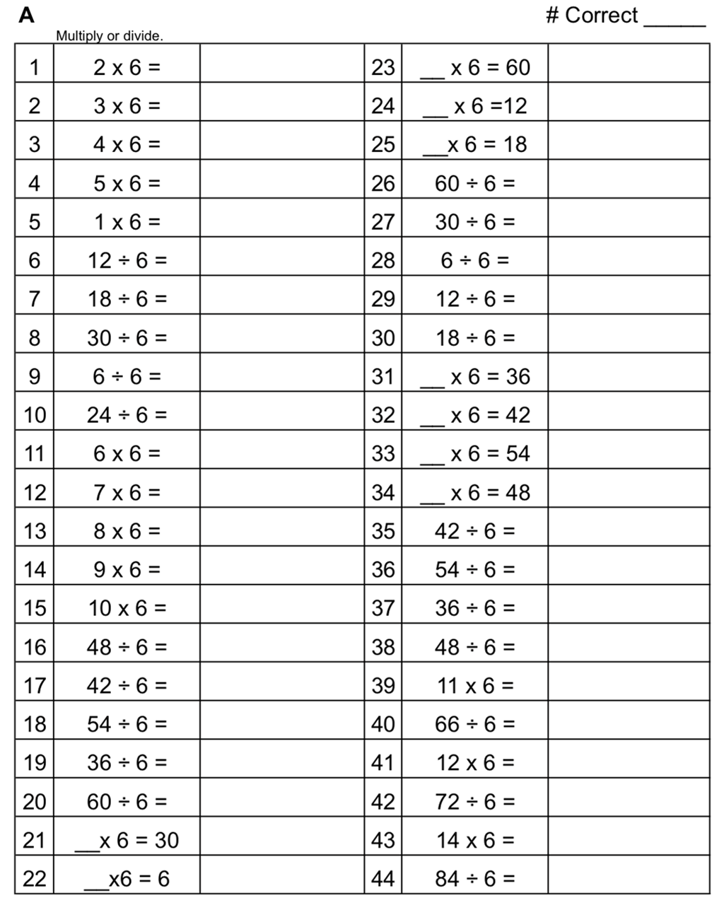

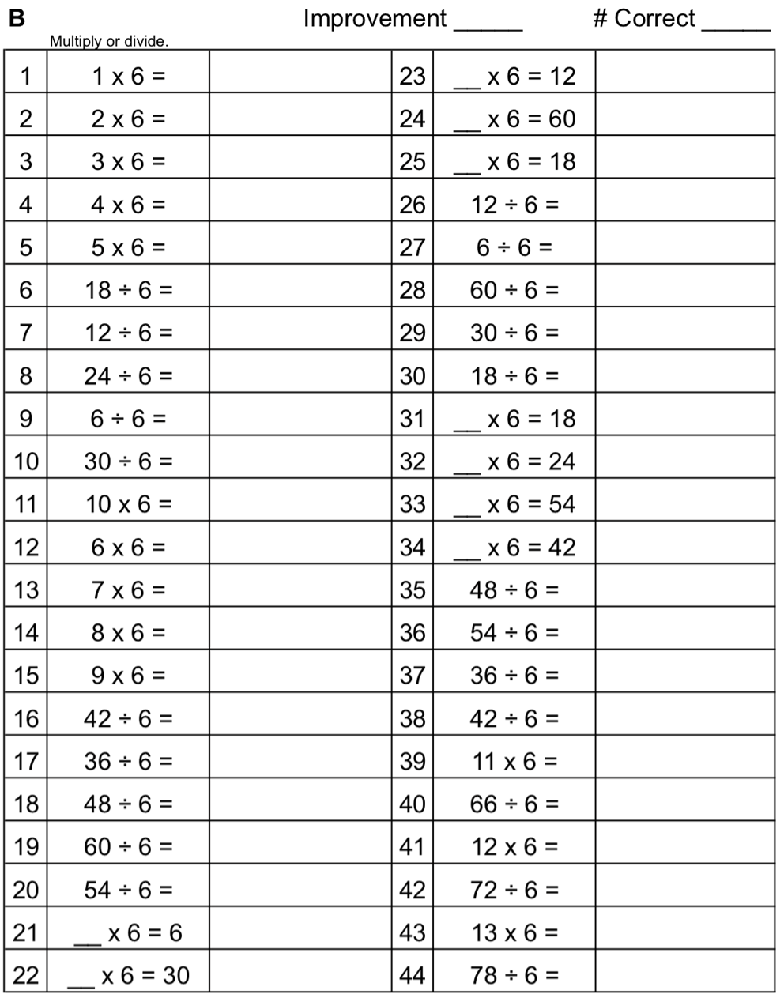

Name Date
Draw a picture of your robot in its environment in the space below. Label the widths, lengths, and perimeters of all rectangles. Label the perimeters of all circular shapes.

Name Date
- Sketch rectangles with the following perimeters. Label the side lengths.

  - 22 cm

  - 30 cm

- Explain the steps you took to create the rectangles with the given perimeters.

Name Date
- The robot below is made of rectangles. The side lengths of each rectangle are labeled. Find the perimeter of each rectangle and record it in the table on the next page.
C
F
A
4 cm
4 cm
2 cm
2 cm
6 cm
8 cm
5 cm
2 cm
5 cm
2 cm
2 cm
2 cm
7 cm
7 cm

B
E
D

G

Rectangle | Perimeter
A | P = 4 × 4 cm  P = 16 cm
B
C
D
E
F
G

Name Date
Evaluation Rubric
4 | 3 | 2 | 1 | Subtotal
Perimeter calculations for all shapes are correct, and both evaluations of a classmate’s project have been completed. | Perimeter calculations include 1 to 2 errors, and both evaluations of a classmate’s project have been completed. | Perimeter calculations include 3 to 4 errors, and at least 1 evaluation of a classmate’s project has been completed. | Perimeter calculations include 5 or more errors, and at least 1 evaluation of a classmate’s project has been completed. | _____/4

Name Date
Evaluation Rubric
4 | 3 | 2 | 1 | Subtotal
Perimeter calculations for all shapes are correct, and both evaluations of a classmate’s project have been completed. | Perimeter calculations include 1 to 2 errors, and both evaluations of a classmate’s project have been completed. | Perimeter calculations include 3 to 4 errors, and at least 1 evaluation of a classmate’s project has been completed. | Perimeter calculations include 5 or more errors, and at least 1 evaluation of a classmate’s project has been completed. | _____/4

