Lesson 24
Objective: Use rectangles to draw a robot with specified perimeter measurements, and reason about the different areas that may be produced.

Suggested Lesson Structure
 Fluency Practice (12 minutes)
 Concept Development (38 minutes)
 Student Debrief (10 minutes)
Total Time (60 minutes)
Fluency Practice (12 minutes)
- Multiply by 6 3.OA.7 (8 minutes)
- Find the Side Lengths 3.MD.8 (4 minutes)

Multiply by 6 (8 minutes)
Materials: (S) Multiply by 6 Pattern Sheet (6–10)
Note: This activity builds fluency with multiplication facts using units of 6. It works toward students knowing from memory all products of two one-digit numbers. See G3–M7–Lesson 1 for the directions for administration of a Multiply By pattern sheet.
T: (Write 7 × 6 = ____.) Let’s skip-count up by sixes. I’ll raise a finger for each six. (Count with fingers to 7 as students count.)
S: 6, 12, 18, 24, 30, 36, 42.
T: Let’s skip-count by sixes starting at 30. Why is 30 a good place to start?
S: It’s a fact we already know, so we can use it to figure out a fact we don’t know.
T: (Count up with fingers as students say numbers.)
S: 30 (5 fingers), 36 (6 fingers), 42 (7 fingers).
T: Let’s see how we can skip-count down to find the answer, too. Start at 60 with 10 fingers, 1 for each six. (Count down with fingers as students say numbers.)
S: 60 (10 fingers), 54 (9 fingers), 48 (8 fingers), 42 (7 fingers).
Continue with the following suggested sequence: 9 × 6, 6 × 6, and 8 × 6.
T: (Distribute Multiply by 6 Pattern Sheet.) Let’s practice multiplying by 6. Be sure to work left to right across the page.

Find the Side Lengths (4 minutes)
Materials: (S) Personal white boards

NOTES ON
MULTIPLE MEANS OF REPRESENTATION:
Students who have difficulty seeing the projected images may construct them from pattern blocks at their desks.

Note: This fluency activity reviews G3–M7–Lesson 23.
T: (Project triangle image. Beneath it, write __ cm ÷ __ = __ cm.) Each side of the triangle is the same length. The perimeter of this shape is 24 cm. Find the side lengths of each triangle by filling in the missing numbers.
S: (Write 24 cm ÷ 6 = 4 cm.)
Continue process for other images.
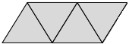
P = 24 cm
P = 48 m

P = 90 in

Concept Development (38 minutes)
Materials: (S) Problem Set, personal white boards
Note: The whole-class portion of the Concept Development should take about 15 minutes, with the remainder of the time allotted to be used for completing the Problem Set. Save today’s Problem Set for use in G3–M7–Lessons 25–26.

NOTES ON
MULTIPLE MEANS OF ACTION AND EXPRESSION:
When introducing and giving instructions for designing a robot and its environment, it may be necessary to make certain adjustments for English language learners. Speaking slower, pausing more frequently, giving an example, using visual aids or gestures, while checking for understanding, and explaining in the students’ first language may prove helpful.

T: Today you will use all you’ve learned about perimeter and area to start designing a robot and an environment for it. We’ll work on this for four days, so today we’ll just do our planning. Read the directions for completing the chart on the first page of the Problem Set.
S: (Read: Use the given perimeters in the chart below to choose the widths and lengths of your robot’s rectangular body parts. Write the widths and lengths in the chart below. Use the blank rows if you want to add extra rectangular body parts to your robot.)
T: We will not be working with fractional units, only whole numbers, throughout the project. Talk to a partner: How can you use the given perimeters to find possible widths and lengths of each robot body part?
S: I can find half of the perimeter and then find pairs of numbers that add up to half of the perimeter. These pairs of numbers are the possible widths and lengths.
T: Do that now for the perimeter of one of your robot’s arms, 14 centimeters. (Allow time for students to work.) How many rectangles can you make for that perimeter with whole number side lengths?
S: Three rectangles!
T: Sketch the rectangles, and then compare them to decide which one to use for your robot’s arm. Record the width and length of your choice in the chart.
S: (Sketch rectangles and record choices in the chart.)
T: Look at the chart on page 2 of your Problem Set. Why are some of the width and length spaces shaded in?
S: They’re circles, so they don’t have length and width. We don’t know how to use the perimeter of a circle to find its width and length. Circles don’t even have a width and length.
T: So, do you have to write anything in your chart for the widths and lengths of the circular items?
S: No!
T: What is the given perimeter of the robot’s house?
S: 82 centimeters.
T: What is half of 82?
S: 41!
T: Think about finding the pairs of numbers that add to 41. (Or, writing all the doubles to 82, depending on which strategy you taught in G3–M7–Lesson 20.)
S: That’s a lot of pairs of numbers! It’ll take a long time, and it seems easy to miss one.
T: Talk to a partner: If you want a tall, skinny house for your robot, will the difference between the width and length be big or small? How do you know?
MP.5
S: It’ll be big. A big difference between the width and length makes a tall and skinny rectangle. That’s true. When the difference is small, the rectangle starts to look like a square.
T: Keep that in mind when you plan for the robot’s house. Instead of listing all the pairs of numbers that add to 41 and then deciding, think about the pairs of numbers that have a sum of 41 that will make the type of house you want.
Release students to work on their plans for their robot and their robot’s environment. Circulate as students work, checking for understanding and clearing up any misconceptions.
Problem Set (23 minutes)
Students should do their personal best to complete the Problem Set within the allotted 23 minutes. Students who do not finish planning during this time can finish for homework, possibly instead of the homework provided.
Students who finish early may begin constructing their robots.
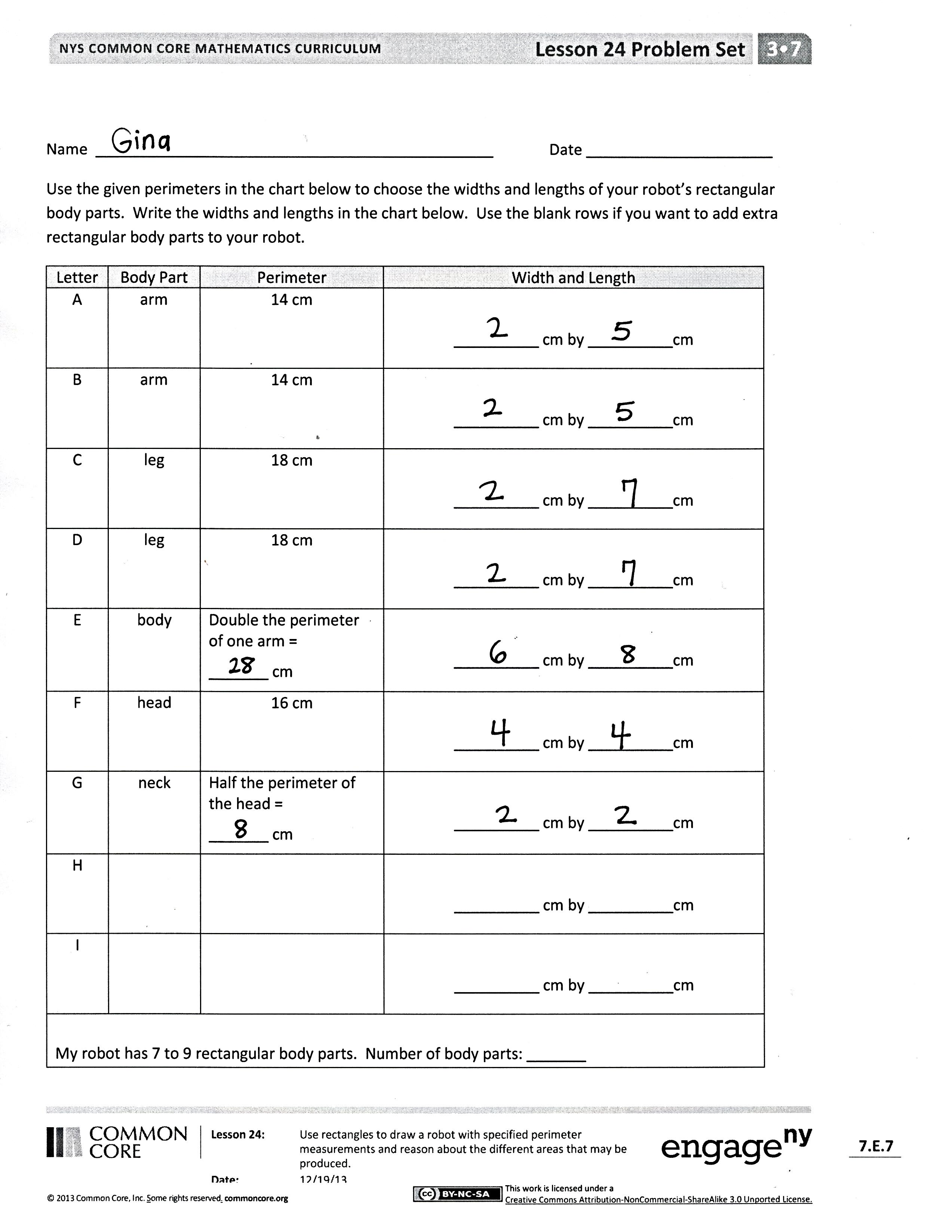
Student Debrief (10 minutes)
Lesson Objective: Use rectangles to draw a robot with specified perimeter measurements, and reason about the different areas that may be produced.
The Student Debrief is intended to invite reflection and active processing of the total lesson experience.
Invite students to review their solutions for the Problem Set. They should check work by comparing answers with a partner before going over answers as a class. Look for misconceptions or misunderstandings that can be addressed in the Debrief. Guide students in a conversation to debrief the Problem Set and process the lesson.
You may choose to use any combination of the questions below to lead the discussion.
- Which body part has the greatest perimeter? Why? The smallest perimeter? Why?
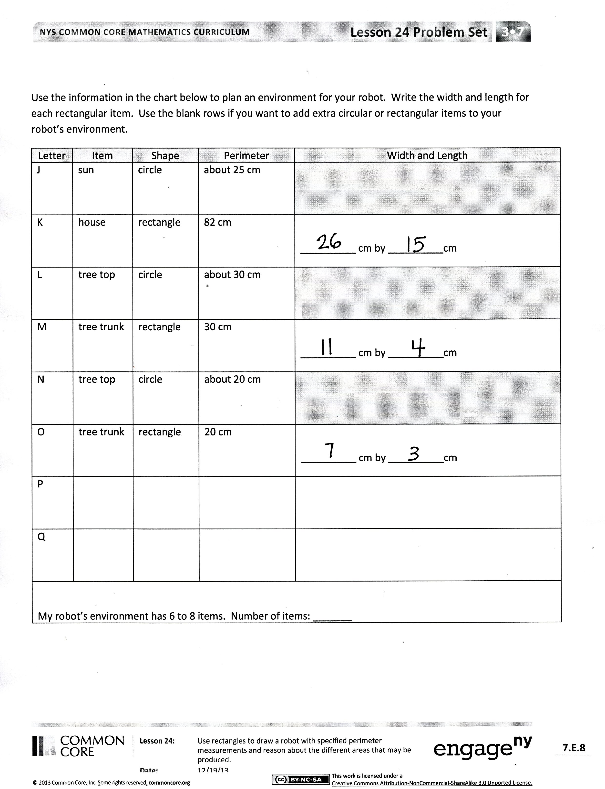
- The perimeter of the body is double the perimeter of an arm. Are the width and length of your robot’s body double the width and length of its arm? Why or why not?
- The perimeter of the neck is half the perimeter of the head. Are the width and length of your robot’s neck half the width and length of its head? Why or why not?
- Explain to a partner how you found the width and length of your robot’s house. What shape house will your robot have? How do you know?
- What extra body parts or items for the environment did you plan? What shapes are your extra body parts or items?
Exit Ticket (3 minutes)
After the Student Debrief, instruct students to complete the Exit Ticket. A review of their work will help you assess the students’ understanding of the concepts that were presented in the lesson today and plan more effectively for future lessons. You may read the questions aloud to the students.

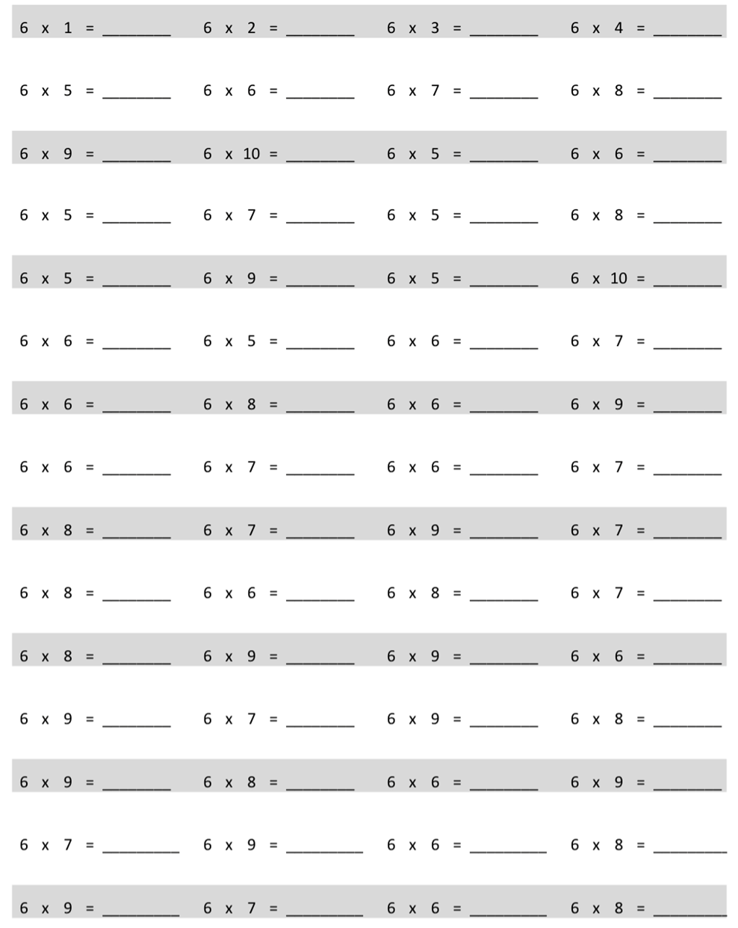
Multiply.

Name Date
Use the given perimeters in the chart below to choose the widths and lengths of your robot’s rectangular body parts. Write the widths and lengths in the chart below. Use the blank rows if you want to add extra rectangular body parts to your robot.
Letter | Body Part | Perimeter | Width and Length
A | arm | 14 cm | __________ cm by __________cm
B | arm | 14 cm | __________ cm by __________cm
C | leg | 18 cm | __________ cm by __________cm
D | leg | 18 cm | __________ cm by __________cm
E | body | Double the perimeter of one arm =  _______ cm | __________ cm by __________cm
F | head | 16 cm | __________ cm by __________cm
G | neck | Half the perimeter of the head =  _______ cm | __________ cm by __________cm
H |  |  | __________ cm by __________cm
I |  |  | __________ cm by __________cm
My robot has 7 to 9 rectangular body parts. Number of body parts: _______
Use the information in the chart below to plan an environment for your robot. Write the width and length for each rectangular item. Use the blank rows if you want to add extra circular or rectangular items to your robot’s environment.
Letter | Item | Shape | Perimeter | Width and Length
J | sun | circle | about 25 cm
K | house | rectangle | 82 cm | __________ cm by __________cm
L | tree top | circle | about 30 cm
M | tree trunk | rectangle | 30 cm | __________ cm by __________cm
N | tree top | circle | about 20 cm
O | tree trunk | rectangle | 20 cm | __________ cm by __________cm
P
Q
My robot’s environment has 6 to 8 items. Number of items: _______

Name Date
Estimate to draw three different rectangles with a perimeter of 16 centimeters. Label the width and length of each rectangle.

Name Date
- Brian draws a square with a perimeter of 24 inches. What is the width and length of the square?

- A rectangle has a perimeter of 18 centimeters.

  - Estimate to draw as many different rectangles as you can that have a perimeter of 18 centimeters. Label the width and length of each rectangle.

  - How many different rectangles did you find?

  - Explain the strategy you used to find the rectangles.

- The chart below shows the perimeters of three rectangles.
  - Write possible widths and lengths for each given perimeter.
Rectangle | Perimeter | Width and Length
A | 6 cm | __________ cm by __________cm
B | 10 cm | __________ cm by __________cm
C | 14 cm | __________ cm by __________cm

  - Double the perimeters of the rectangles in Part (a). Then find possible widths and lengths.
Rectangle | Perimeter | Width and Length
A | 12 cm | __________ cm by __________cm
B |  | __________ cm by __________cm
C |  | __________ cm by __________cm

