Lesson 23
Objective: Solve a variety of word problems with perimeter.

Suggested Lesson Structure
 Fluency Practice (10 minutes)
 Concept Development (40 minutes)
 Student Debrief (10 minutes)
Total Time (60 minutes)
Fluency Practice (10 minutes)
- Sprint: Divide by 5 3.OA.7 (10 minutes)

Sprint: Divide by 5 (10 minutes)
Materials: (S) Divide by 5 Sprint
Note: This Sprint builds fluency with multiplication and division facts using units of 5.
Concept Development (40 minutes)

NOTES ON
MULTIPLE MEANS OF ENGAGEMENT:
Give everyone a fair chance to be successful by providing appropriate scaffolds. Demonstrating students may use peer translators or sentence frames to present and respond to feedback. Models shared may include concrete manipulatives or adaptive materials.
If the pace of the lesson is a consideration, prepare presenters beforehand. Problem 4 may be most approachable for students working below grade level.

Materials: (S) Problem Set
In this problem solving lesson, students work in pairs or independently to solve the six problems on the Problem Set. The teacher facilitates conversation and may provide structure for problem solving using Steps 1–3 below. Specific information about each problem follows and can be used to facilitate conversation.
MP.1
Suggested Problem Solving Steps:
For each problem, select two pairs of students to work at the class board or central space. Other students work independently or in pairs at their tables.
1. Read and model.
Review the following questions after reading the first problem:
- Can you draw something?
- What can you draw?
- What conclusions can you make from your drawing?
When most students have finished, have the pairs of students at the board share only their labeled diagrams. Have the demonstrating students receive and respond to feedback and questions from their peers.
2. Write an equation, calculate to solve, and write a statement.
Allow time for students to finish work on the question. They then retrace the steps of their thinking as they share their work with a partner or another pair. Students write their equations and statements on their own Problem Sets. Demonstrating students can model this process for others.
3. Assess the solution for reasonableness.

NOTE ON
MULTIPLE MEANS OF REPRESENTATION:
Students who have difficulty drawing an octagon to solve Problem 1 might choose instead to model with a tape diagram consisting of 8 equal parts and having a total value of 48 cm.

Give students one to two minutes to validate and explain the reasonableness of their solution. You might provide two or three of the following sentence starters to guide them in this work:
- I reread the question to remind myself that it asks for _____.
- My answer matches what the question asks because _____.
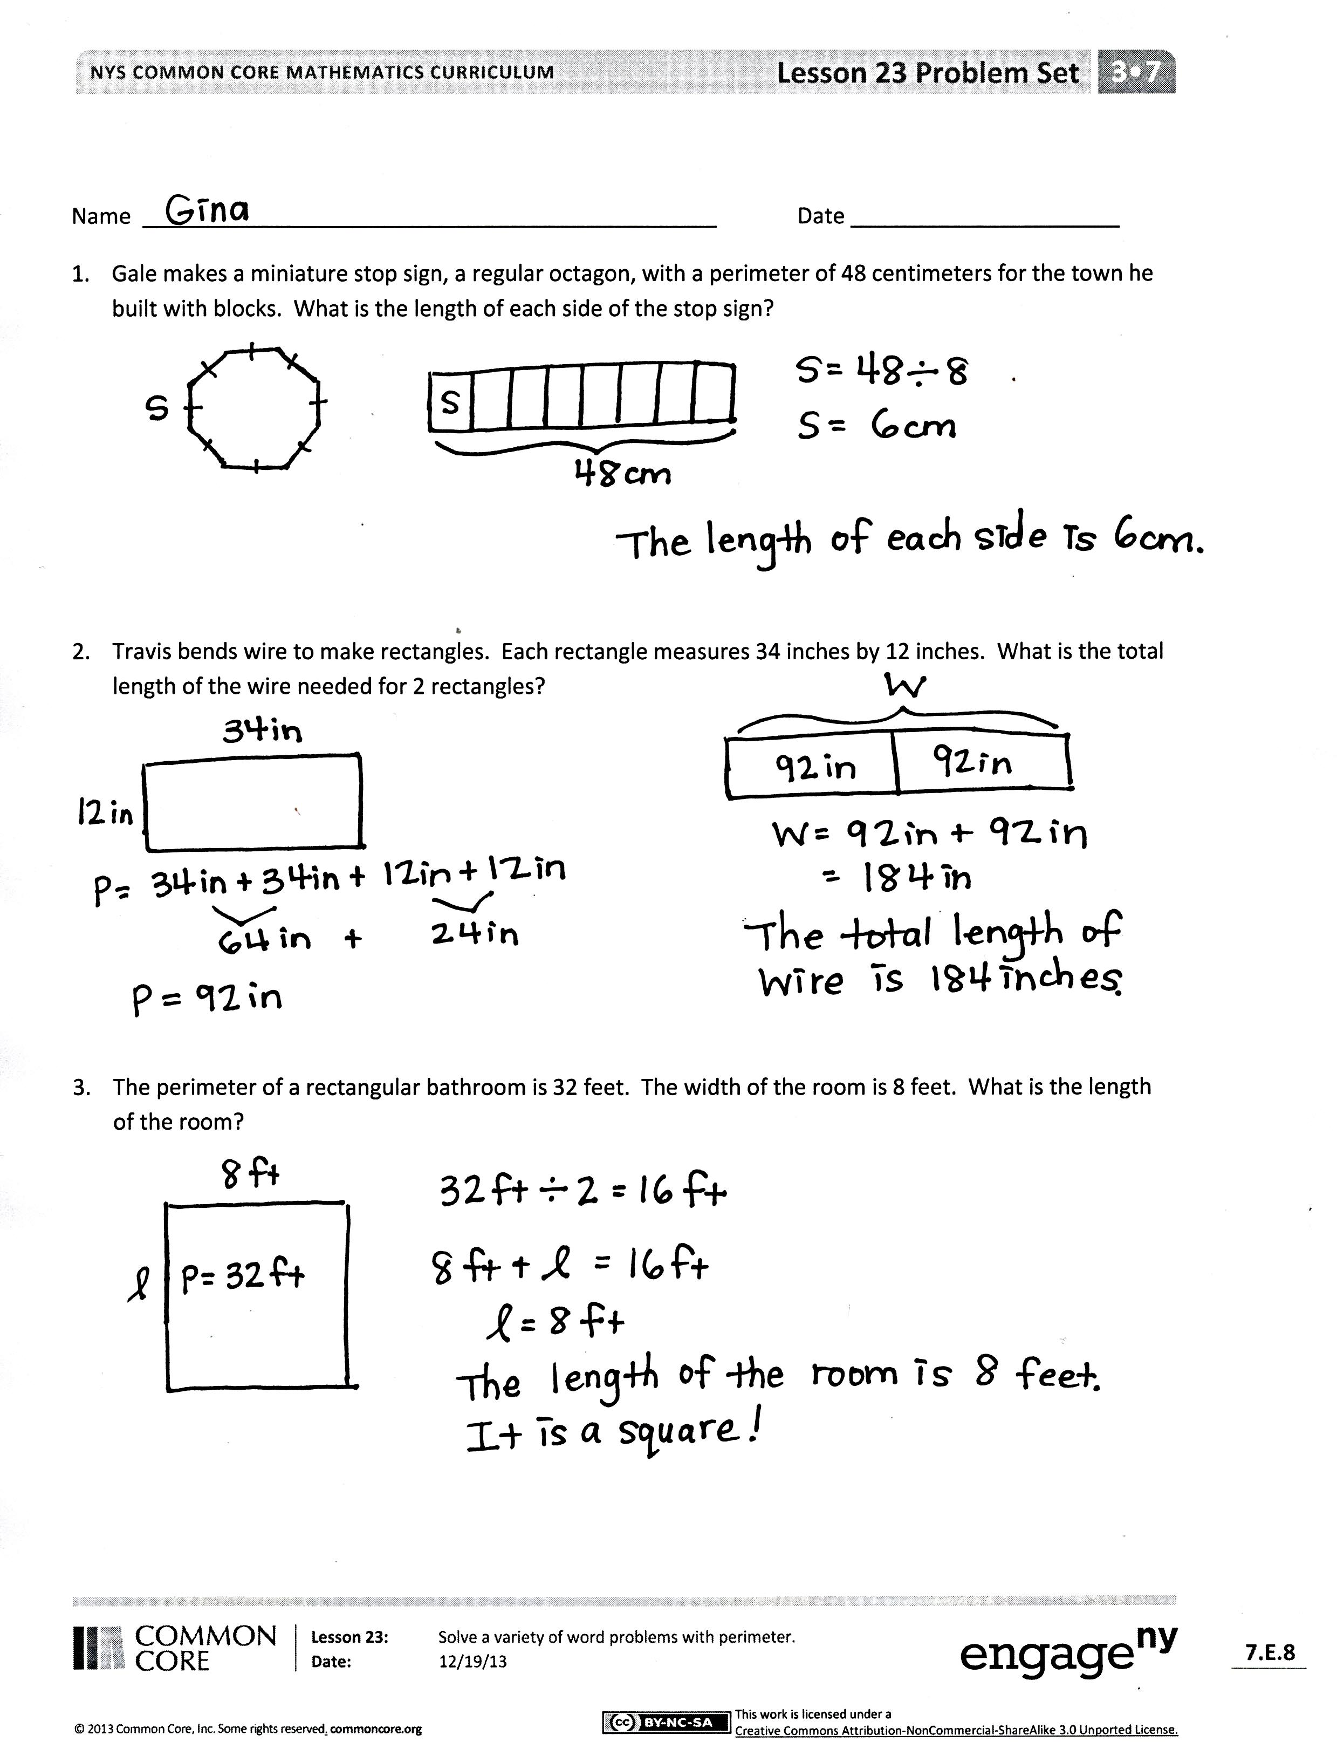
- The units of my answer make sense because _____.
- I know my answer is neither too small nor too big because _____.
- My answer wouldn’t make any sense if it was _____ because _____.
Problem 1: Gale makes a miniature stop sign, a regular octagon, with a perimeter of 48 centimeters for the town he built with blocks. What is the length of each side of the stop sign?
Students might solve by first drawing an octagon, then labeling a side length with a letter, and dividing the perimeter (48 cm) by the number of sides on an octagon (8).
Problem 2: Travis bends wire to make rectangles. Each rectangle measures 34 inches by 12 inches. What is the total length of the wire needed for two rectangles?
This is a two-step problem. Students find the perimeter of one rectangle, then add to find the perimeter of two rectangles. They should recognize that the total perimeter of two rectangles is equal to the total length of wire needed. To solve the first step, students might draw a rectangle, label the side lengths, and find the perimeter. In the second step, students might use a variety of strategies to solve 92 + 92, including using the standard algorithm or adding like units: 9 tens plus 9 tens equals 18 tens and 2 ones plus 2 ones equals 4 ones, and 18 tens 4 ones equals 184.
Problem 3: The perimeter of a rectangular bathroom is 32 feet. The width of the room is 8 feet. What is the length of the room?
This problem presents a new complexity because it is the first time students find an unknown side length given the perimeter and one side length. This is a multistep word problem, which can be approached in a variety of ways. Knowing that opposite sides of a rectangle are equal, students might first divide the perimeter by 2 (32 ft ÷ 2 = 16 ft) and then find the number pair that adds to 16 (8 ft + ___ ft = 16 ft). In their problem solving process, students might include a drawing of the rectangular room and label the unknown length with a letter.
Students may be tempted to divide the given perimeter (32 feet) by the width of the room (8 feet) since this is a fact they know. However, they should see that a 4 foot by 8 foot rectangle does not have a perimeter of 32 feet.
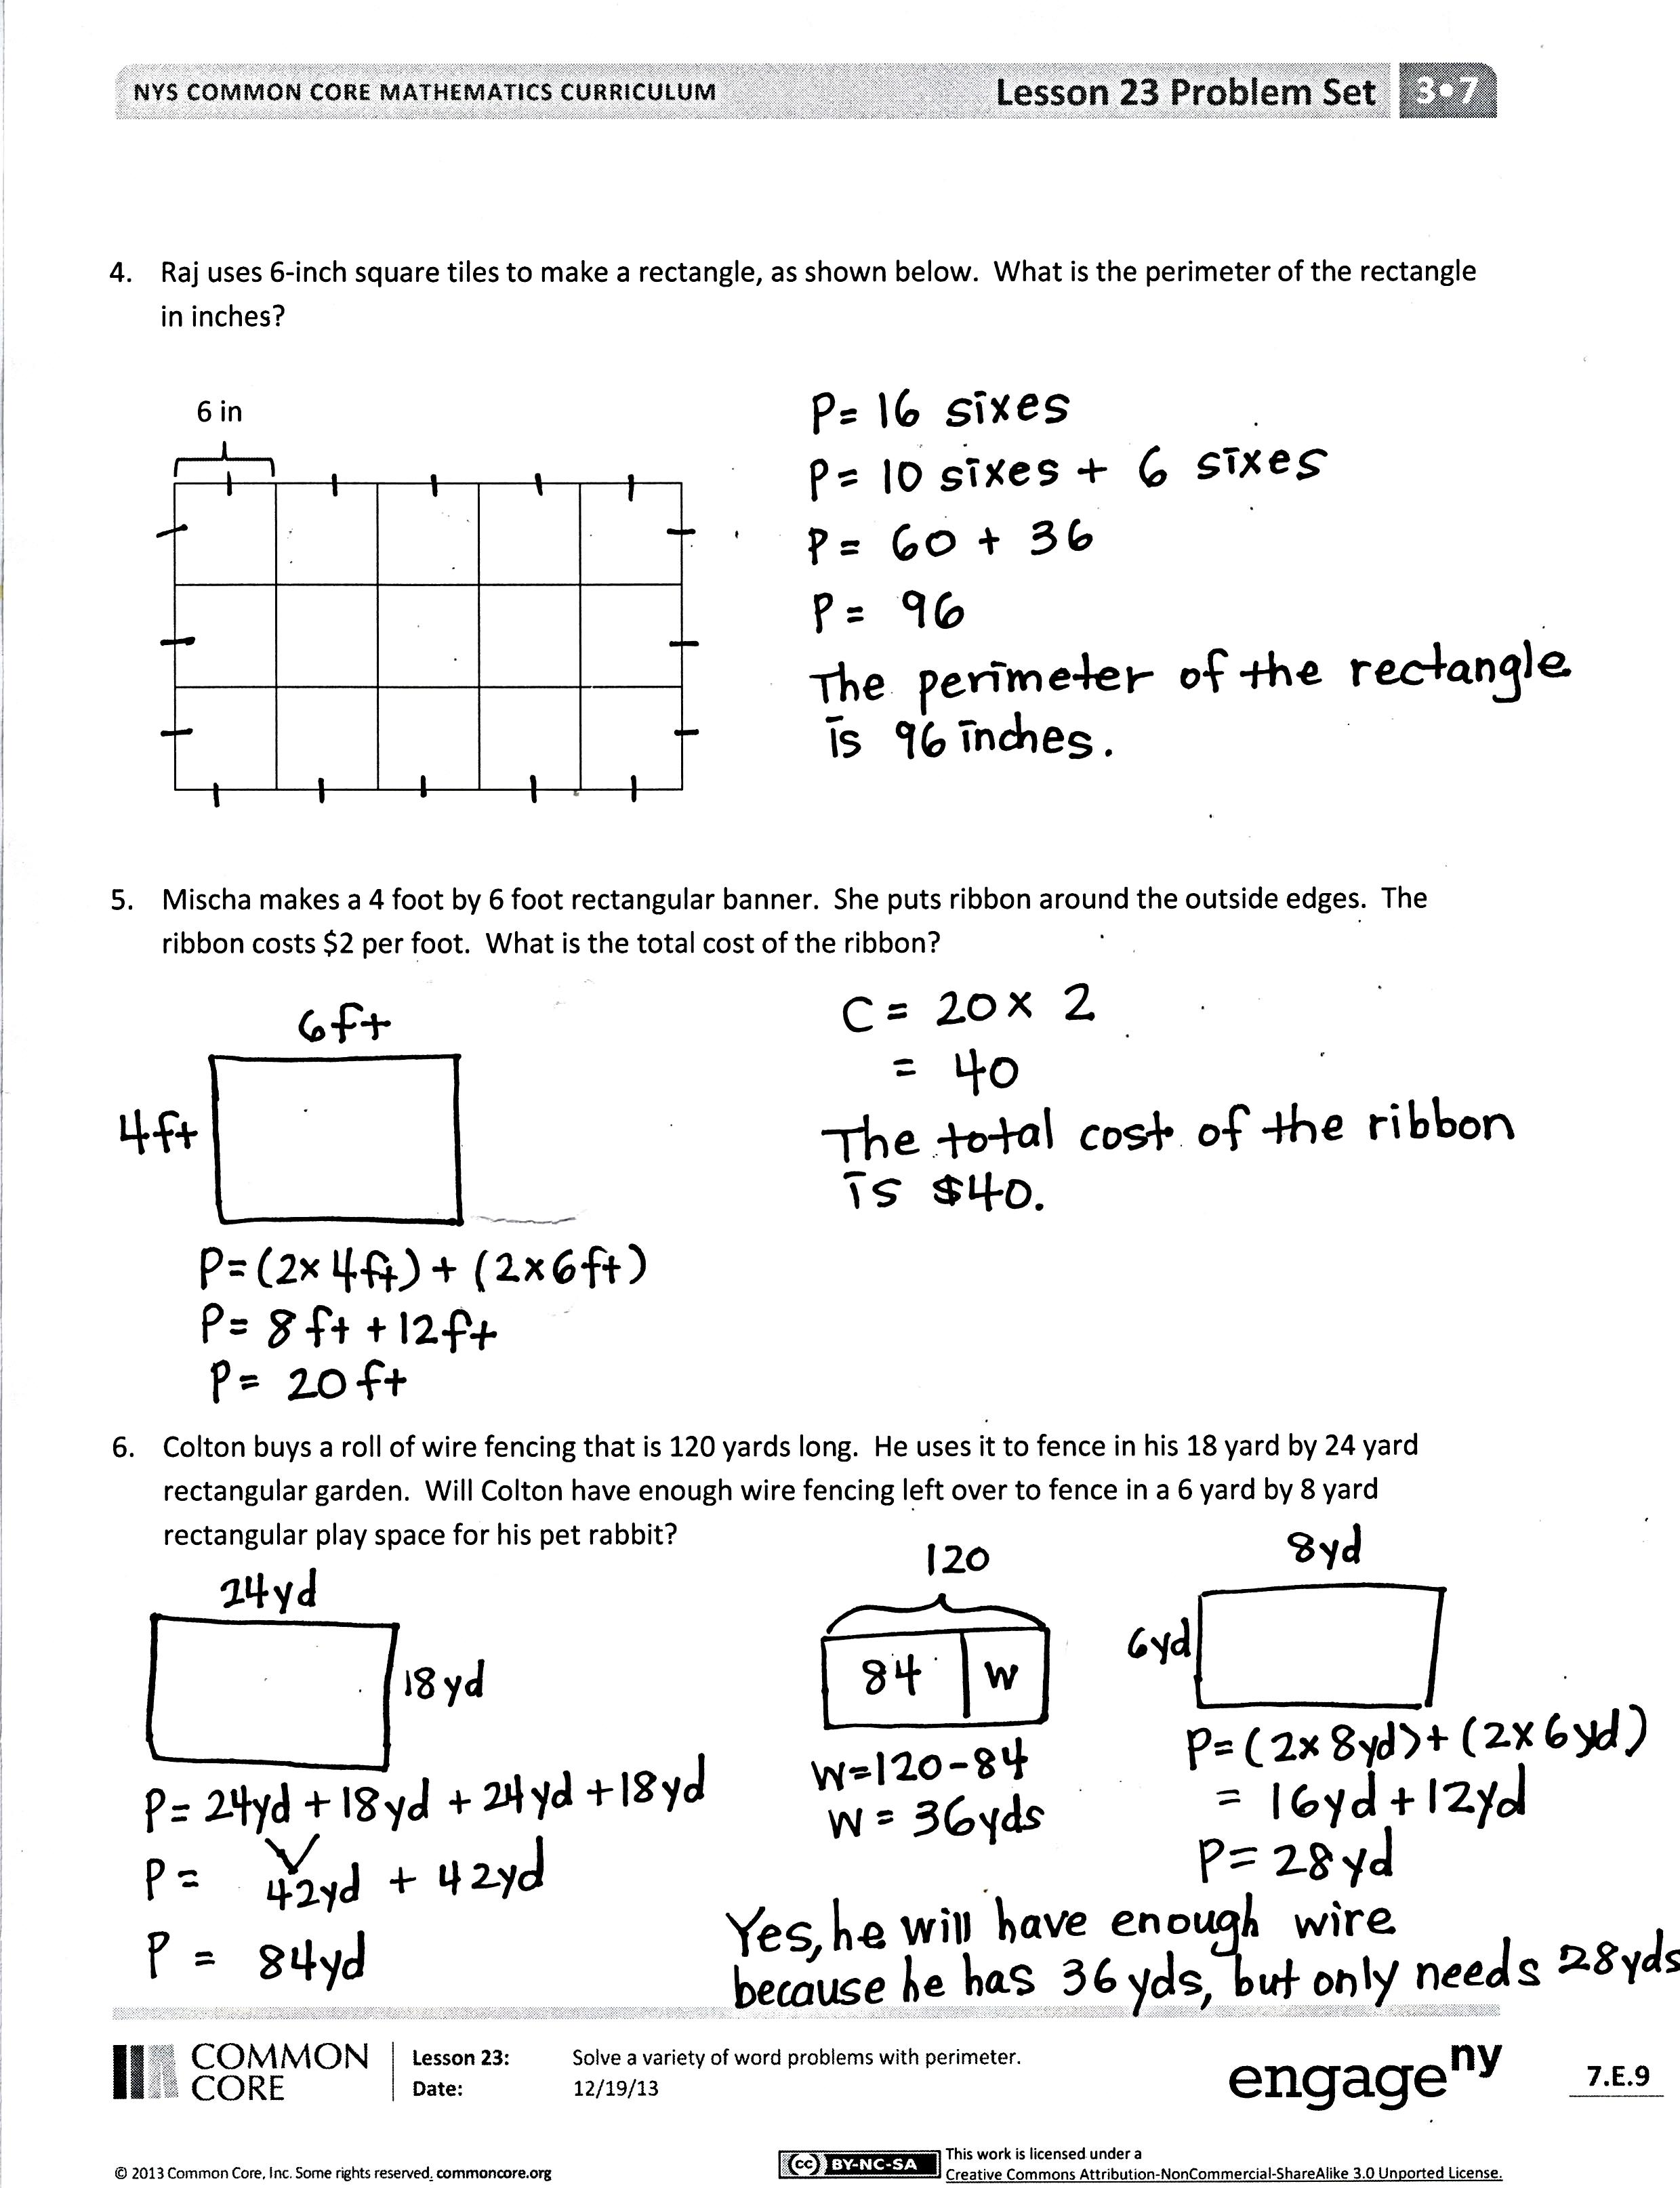
Problem 4: Raj uses 6-inch square tiles to make a rectangle, as shown below [at right]. What is the perimeter of the rectangle in inches?
Students are not given the length or width of the rectangle, but should recognize that its square tiles each have side lengths of 6 inches. This problem allows for a variety of strategies to find perimeter. Some students might first find the value of each side length, either by adding or multiplying sixes. Then, they could add or double each side length to find the perimeter. Others might realize that the perimeter is equal to 16 sixes and apply the break apart and distribute strategy to find the total. Encourage diversity with solution strategies to make for interesting conversation about the problem.
Some students might count the unit squares that make up the perimeter (12 unit squares) and multiply that number by 6, getting an answer of 72 inches. If students count unit squares, they need to be sure to count the sides of the unit squares that make up the perimeter.
Problem 5: Mischa makes a 4 foot by 6 foot rectangular banner. She puts ribbon around the outside edges. The ribbon costs $2 per foot. What is the total cost of the ribbon?
Students find the perimeter of the banner because they recognize it is equal to the length of the ribbon. They might calculate the cost of the ribbon by multiplying the length (20 feet) by the cost ($2 per foot). Students can use a variety of strategies to solve, including turning it into a doubles addition fact or thinking of it as 2 tens times 2. Students might also calculate the cost of the ribbon for each side and then add to find the total cost. Encourage drawing the rectangular banner with the side lengths labeled. In the second step, encourage using a letter to represent the unknown cost of the ribbon.
Problem 6: Colton buys a roll of wire fencing that is 120 yards long. He uses it to fence in his 18 yard by 24 yard rectangular garden. Will Colton have enough wire fencing left over to fence in a 6 yard by 8 yard rectangular play space for his pet rabbit?
To solve, students need to find the perimeter of the garden, the difference between the length of the wire fencing and the perimeter of the garden, and the perimeter of the rabbit’s play space. Students then compare the amount of left-over fencing to the perimeter of the rabbit’s play space to determine whether or not Colton has enough left over.
Student Debrief (10 minutes)
Lesson Objective: Solve a variety of word problems with perimeter.
The Student Debrief is intended to invite reflection and active processing of the total lesson experience.
Invite students to review their solutions for the Problem Set. They should check work by comparing answers with a partner before going over answers as a class. Look for misconceptions or misunderstandings that can be addressed in the Debrief. Guide students in a conversation to debrief the Problem Set and process the lesson.
You may choose to use any combination of the questions below to lead the discussion.
- How was setting up the problem to solve Problem 1 different from setting up the other problems? What did you need to know about the stop sign before you could solve?
- Explain to a partner how knowing the perimeter and the width helped you find the length of the rectangle in Problem 3.
- Explain to a partner how you were able to find the perimeter of the rectangle in Problem 4 without knowing either side length.
- How does knowing the perimeter of the banner in Problem 5 help you find the cost of the ribbon?
- You found that Colton has enough fencing to complete both projects in Problem 6. How much fencing will be left over after he fences in his garden and a play space for his rabbit?
- Which problem did you find most difficult? Why?
Exit Ticket (3 minutes)
After the Student Debrief, instruct students to complete the Exit Ticket. A review of their work will help you assess the students’ understanding of the concepts that were presented in the lesson today and plan more effectively for future lessons. You may read the questions aloud to the students.

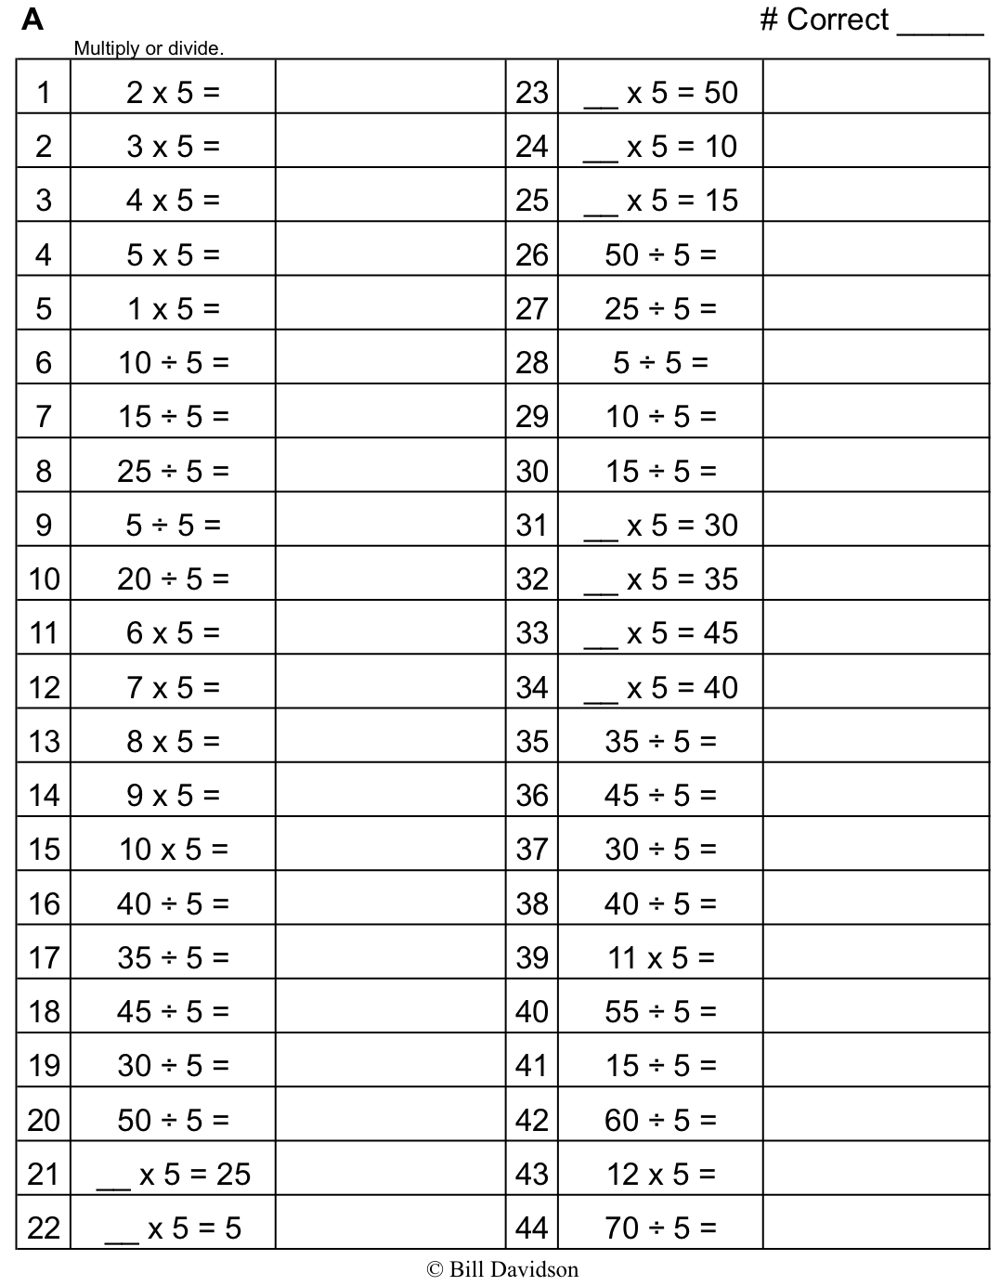
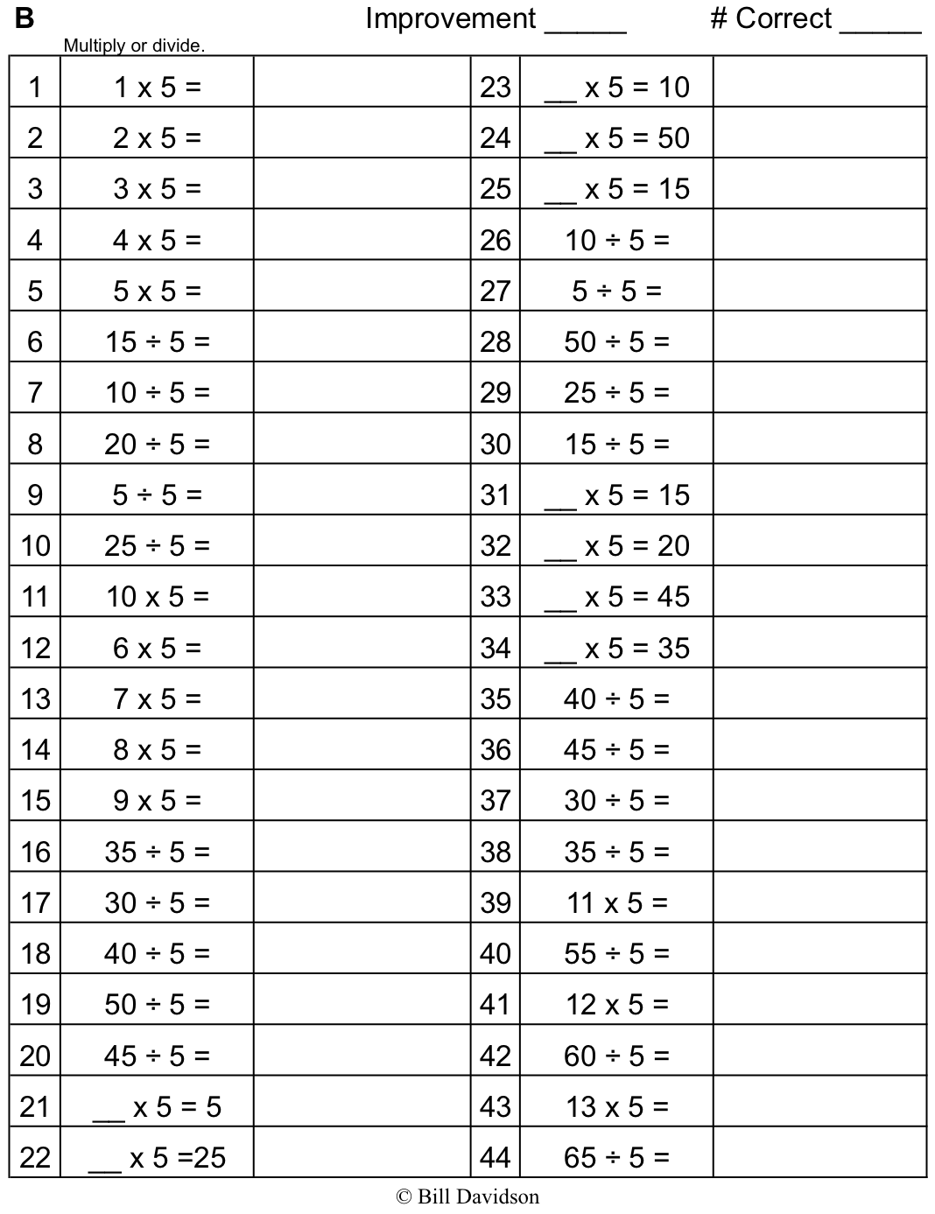

Name Date
- Gale makes a miniature stop sign, a regular octagon, with a perimeter of 48 centimeters for the town he built with blocks. What is the length of each side of the stop sign?

- Travis bends wire to make rectangles. Each rectangle measures 34 inches by 12 inches. What is the total length of the wire needed for two rectangles?

- The perimeter of a rectangular bathroom is 32 feet. The width of the room is 8 feet. What is the length of the room?

- Raj uses 6-inch square tiles to make a rectangle, as shown below. What is the perimeter of the rectangle in inches?

6 in

- Mischa makes a 4 foot by 6 foot rectangular banner. She puts ribbon around the outside edges. The ribbon costs $2 per foot. What is the total cost of the ribbon?

- Colton buys a roll of wire fencing that is 120 yards long. He uses it to fence in his 18 yard by 24 yard rectangular garden. Will Colton have enough wire fencing left over to fence in a 6 yard by 8 yard rectangular play space for his pet rabbit?

Name Date
Adriana traces a regular triangle to create the shape below. The perimeter of her shape is 72 centimeters. What are the side lengths of the triangle?

Name Date
- Rosie draws a square with a perimeter of 36 inches. What are the side lengths of the square?

- Judith uses craft sticks to make two 24-inch by 12-inch rectangles. What is the total perimeter of the two rectangles?

- An architect draws a square and a rectangle as shown below to represent a house that has a garage. What is the total perimeter of the house with its attached garage?
55 ft
40 ft
30 ft
House
Garage

- Manny draws three regular pentagons to create the shape shown below. The perimeter of one of the pentagons is 45 inches. What is the perimeter of Manny’s new shape?

- Johnny uses 2-inch square tiles to make a square, as shown below. What is the perimeter of Johnny’s square?

2 in

- Lisa tapes three 7-inch by 9-inch pieces of construction paper together to make a happy birthday sign for her mom. She uses a piece of ribbon that is 144 inches long to make a border around the outside edges of the sign. How much ribbon is left over?
7 in
9 in

