Lesson 22
Objective: Use a line plot to record the number of rectangles constructed in Lessons 20 and 21.

Suggested Lesson Structure
 Fluency Practice (13 minutes)
 Concept Development (37 minutes)
 Student Debrief (10 minutes)
Total Time (60 minutes)
Fluency Practice (13 minutes)
- Sprint: Divide by 4 3.OA.7 (10 minutes)
- Find the Perimeter and Area 3.MD.7 (3 minutes)

NOTES ON
MULTIPLE MEANS OF ENGAGEMENT:
If you have observed that students do not multiply and divide by 4 with fluency, review quickly or prepare students beforehand. Then, guide students to set a goal.

Sprint: Divide by 4 (10 minutes)
Materials: (S) Divide by 4 Sprint
Note: This Sprint builds fluency with multiplication and division facts using units of 4.
Find the Perimeter and Area (3 minutes)
Materials: (S) Personal white boards
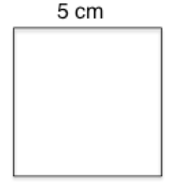
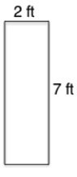
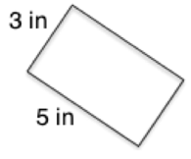
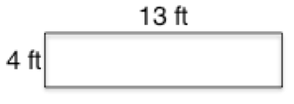
Note: This fluency activity reviews finding perimeter and area.
T: (Project a square with a given length of 5 cm.) This shape is a square. On your boards, calculate the perimeter using an addition sentence.
S: (Write 5 cm + 5 cm + 5 cm + 5 cm = 20 cm.)
T: Calculate the area using a multiplication sentence.
S: (Write 5 cm × 5 cm = 25 sq cm.)
Repeat this process for the remaining rectangles.

Concept Development (37 minutes)
Materials: (T) Line plot template (S) Problem Set, ruler, data chart from G3–M7–Lessons 20–21, line plot from G3–M7–Lesson 19, scissors, 11-inch piece of string (per pair), rectangle template (per pair)
Problem 1: Draw a line plot representing measurement data.
Guide students through the process of recording the number of rectangles they made for each given perimeter on the line plot in Problem 1 of the Problem Set.
- Use a ruler to partition equal intervals.
- Label the number line to show the different perimeters.
- Record the data on the line plot using X’s to represent one rectangle.
Problem 2: Observe and interpret data on a line plot.
T: Study the perimeter measurements on your line plot. Are they even, odd, or both?
S: They’re all even!
T: Why do you think that is? Discuss with your tablemates.
S: The teacher just made them up that way. To get the perimeter of a rectangle, we add four sides. Maybe the totals have to be divisible by 4, so they have to be even because 4 is even? But, we don’t know how to divide 10, 14, 18, or 22 by 4. Wait, to get perimeter we find the sum of the width and length. Then we double it. If you double a number, I think it’s always even because you have to multiply by 2. Let me try a few to check…. Yep! Everything I multiply by 2 has an even product.
T: You’re close! All the rectangles that we made had whole number side lengths. When we add whole number side lengths and double them, the perimeter will be even. (Pass out 11-inch long pieces of string.) Use your ruler to measure the length of the string in centimeters.

NOTES ON
MULTIPLE MEANS OF ACTION AND EXPRESSION:
Provide the option of wire, in addition to string, because it may be easier for students to measure and shape wire into a rectangle. However, students may need assistance cutting off an inch of wire. Gluing string or anchoring wire (so that it does not move) may decrease possible frustration as students measure side lengths. If you choose to glue, provide additional pieces of string.

S: (Measure string.)
T: How long is the string?
S: 11 inches!
T: Work with your partner to shape your string into a rectangle.
S: (Make a rectangle with the string.)
T: What is the perimeter of your rectangle? How do you know?
S: 11 inches because it’s the same as the length of the string.
T: Is 11 an odd or even number?
S: Odd!
T: So, do all rectangles have an even perimeter?
S: No!
T: Use your ruler to measure the side lengths of your rectangle to the nearest quarter inch.
S: (Measure side lengths.)
T: Are the side lengths of your rectangle whole numbers?
S: No, they have fractions of inches!
T: That’s right! Your rectangle has an odd perimeter because the side lengths aren’t whole numbers. Use this information to help you answer Problem 2. (Why are all of the perimeter measurements even? Do all rectangles have an even perimeter?)
S: (Answer Problem 2.)
T: Now study the data on your line plot. Think of a true statement to share about the data. (Allow students time to think, then invite them to share.)
S: We made the most rectangles with a perimeter of 20 units. We made the fewest rectangles with a perimeter of 10 units. We made the same number of rectangles with perimeters of 12 and 14 units and 16 and 18 units. We made a total of 21 rectangles from these seven perimeters. The number of rectangles is mostly growing as the measurement gets bigger.
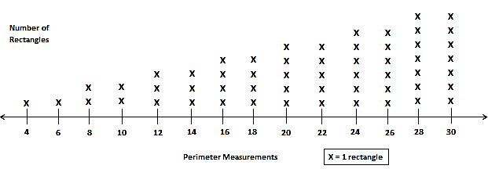
T: Let me show you what the line plot looks like with more measurements. (Project line plot template, shown to the right.)
T: What pattern do you notice in the data?
S: Starting with 8, the number of rectangles grows for every other measurement. Not just that, but they grow in pairs. Look, 4 and 6 are the same. Then 8 and 10 are the same, except they grow by 1 more possible rectangle. It’s like that all the way to 30!
T: Using this pattern, how many rectangles do you think you could build with unit squares, given perimeters of 32 units and 34 units?
S: Both would be 8 rectangles since each pair of measurements grows by 1.
T: Use your ruler to help you cut an inch off your string. (Allow students time to cut.) How long is your string now?
S: 10 inches.
T: (Pass out rectangle template.) Working with your partner, use your string to measure the perimeters of these rectangles. (Allow students time to measure.) What did you notice about the perimeters of these rectangles?
S: They’re all 10 inches!
T: Use your ruler to measure the side lengths of Rectangle A to the nearest quarter inch. (Allow students time to measure.) Are the side lengths of this rectangle whole numbers?
MP.6
S: No, they have fractions of inches.
T: On your line plot, it shows that you only made two rectangles with a perimeter of 10, but here we have four rectangles with a perimeter of 10. When we have side lengths that are not whole numbers, we can find more rectangles for given perimeters than our line plot shows.
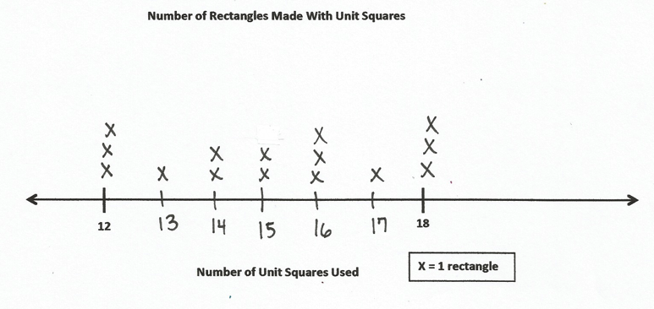
Problem 3: Compare area and perimeter line plots.
Line Plot from G3–M7–Lesson 19
T: Let’s compare today’s line plot with the one you created in Lesson 19. (Allow students time to take out their Lesson 19 Problem Set.) How are the line plots different?
S: One line plot shows the number of rectangles for a given area. The other shows the number of rectangles for a given perimeter.
T: Look at the data on both line plots for 12. What do you notice?
S: There is an equal number of rectangles that we made for that perimeter and that area.
T: Is that true for other numbers on your line plots?
S: No!
T: Do you think there’s a connection between the number of rectangles you built for a given area and perimeter?
S: Sometimes, but not always. It only looks like there is a relationship with certain numbers, like 12. There’s not really a pattern, so I don’t think there’s a relationship.
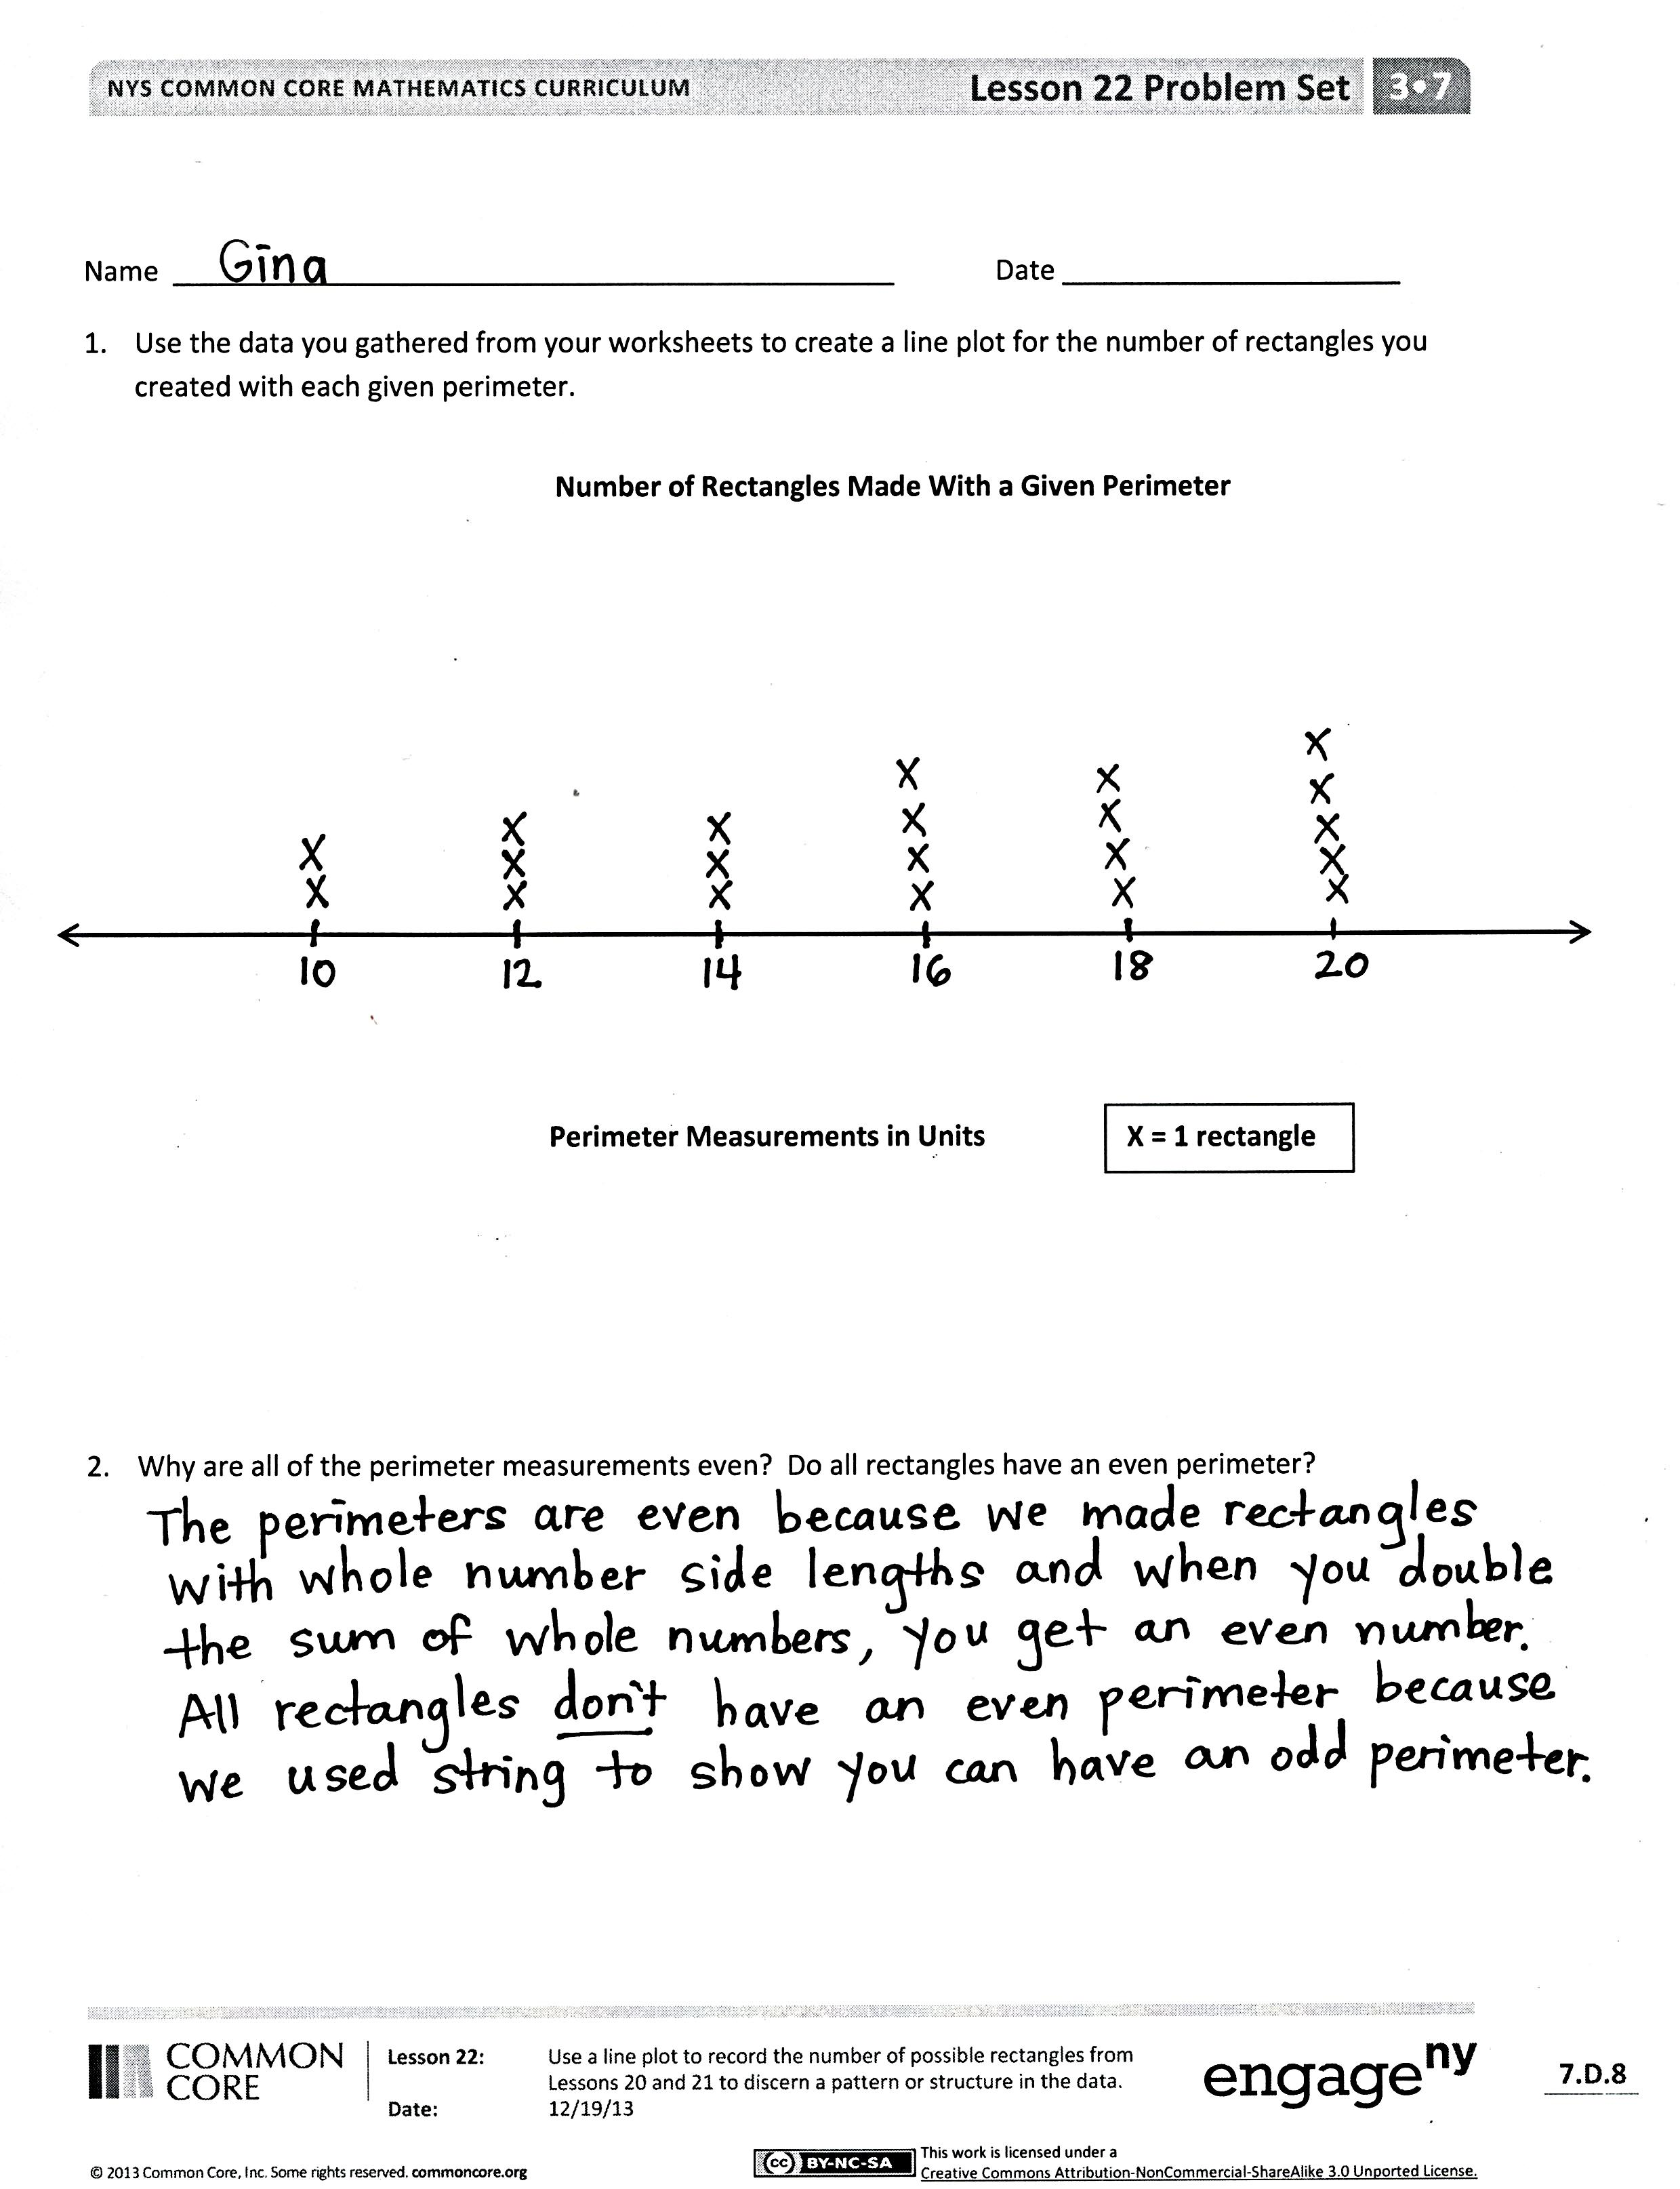
T: Right. Using our data, we can’t make a general rule about a connection between perimeter and area. Take some time to record your thoughts in Problem 3. (Compare the two line plots we created. Is there any reason to think that knowing only the area of a rectangle would help you to figure out its perimeter, or knowing only the perimeter of a rectangle would help you figure out its area?)
S: (Record.)
Problem Set (10 minutes)
Students should do their personal best to complete Problems 4 and 5 within the allotted 10 minutes. For some classes, it may be appropriate to modify the assignment by specifying which problems they work on first. Some problems do not specify a method for solving. Students solve these problems using the RDW approach used for Application Problems.

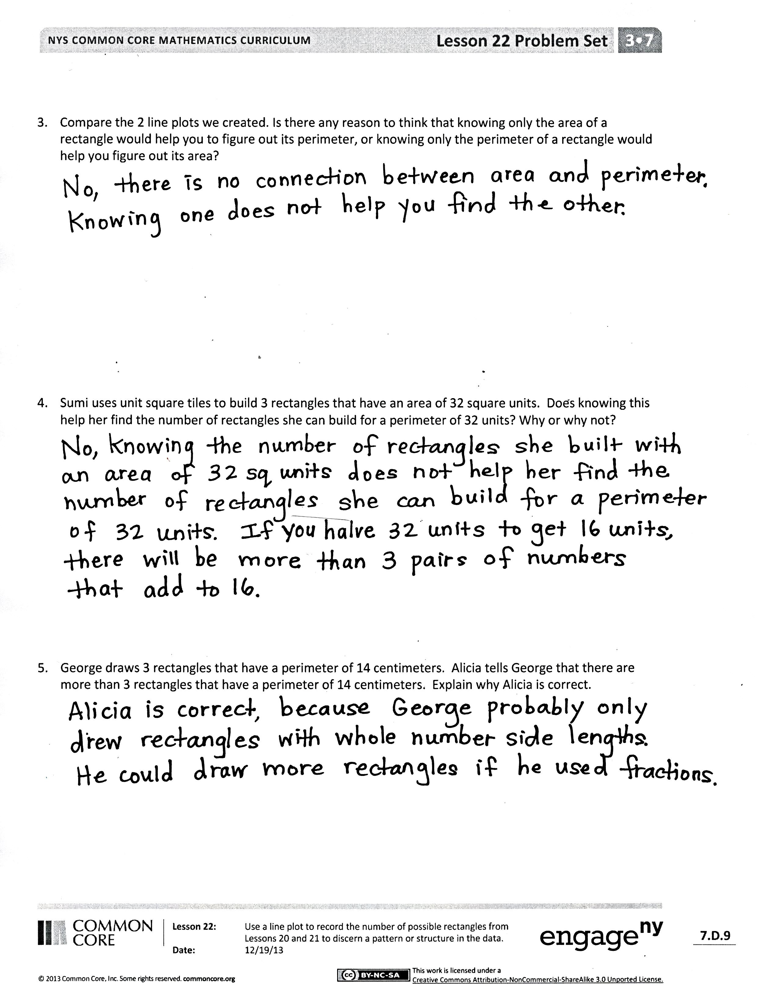
Student Debrief (10 minutes)
Lesson Objective: Use a line plot to record the number of rectangles constructed in Lessons 20 and 21.
The Student Debrief is intended to invite reflection and active processing of the total lesson experience.
Invite students to review their solutions for the Problem Set. They should check work by comparing answers with a partner before going over answers as a class. Look for misconceptions or misunderstandings that can be addressed in the Debrief. Guide students in a conversation to debrief the Problem Set and process the lesson.
You may choose to use any combination of the questions below to lead the discussion.
- How did using a ruler help you partition your number line evenly?
- How does a line plot make data easier to read and compare?
- Share student answers to Problem 4.
- Did you agree with Alicia in Problem 5? Why or why not?
- What did using the string in today’s lesson help you discover about perimeter?
- What do you notice about the connection between area and perimeter?
Exit Ticket (3 minutes)
After the Student Debrief, instruct students to complete the Exit Ticket. A review of their work will help you assess the students’ understanding of the concepts that were presented in the lesson today and plan more effectively for future lessons. You may read the questions aloud to the students.

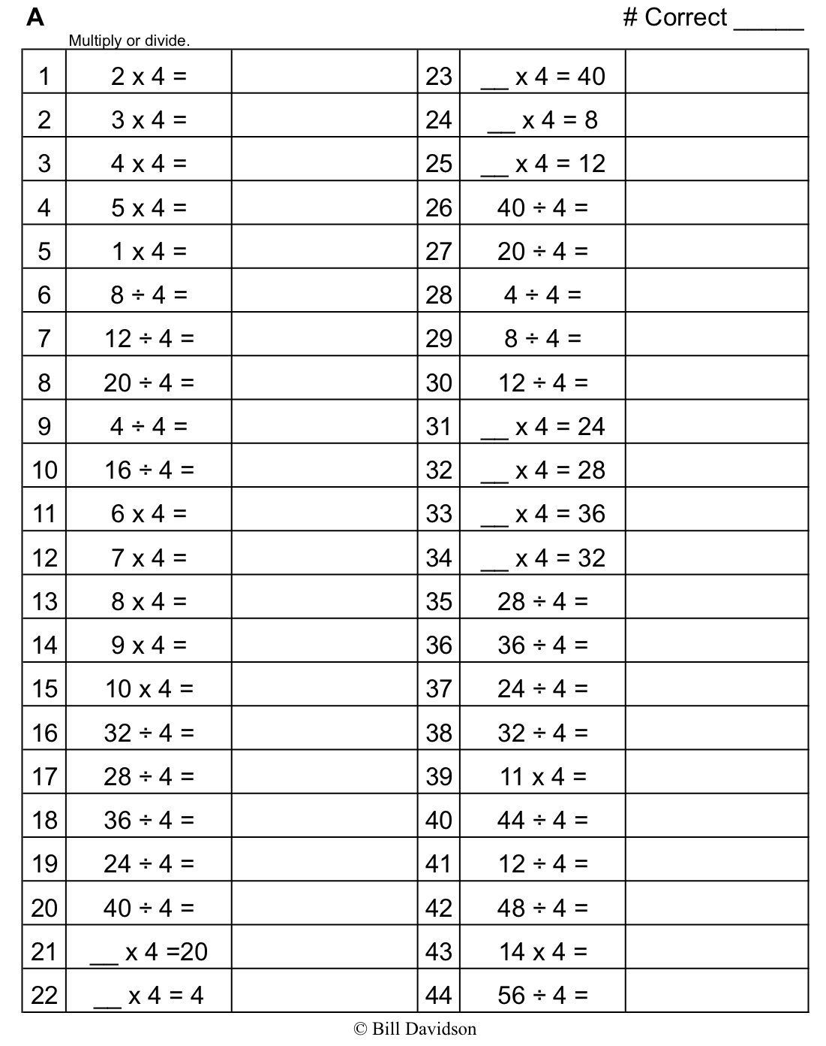
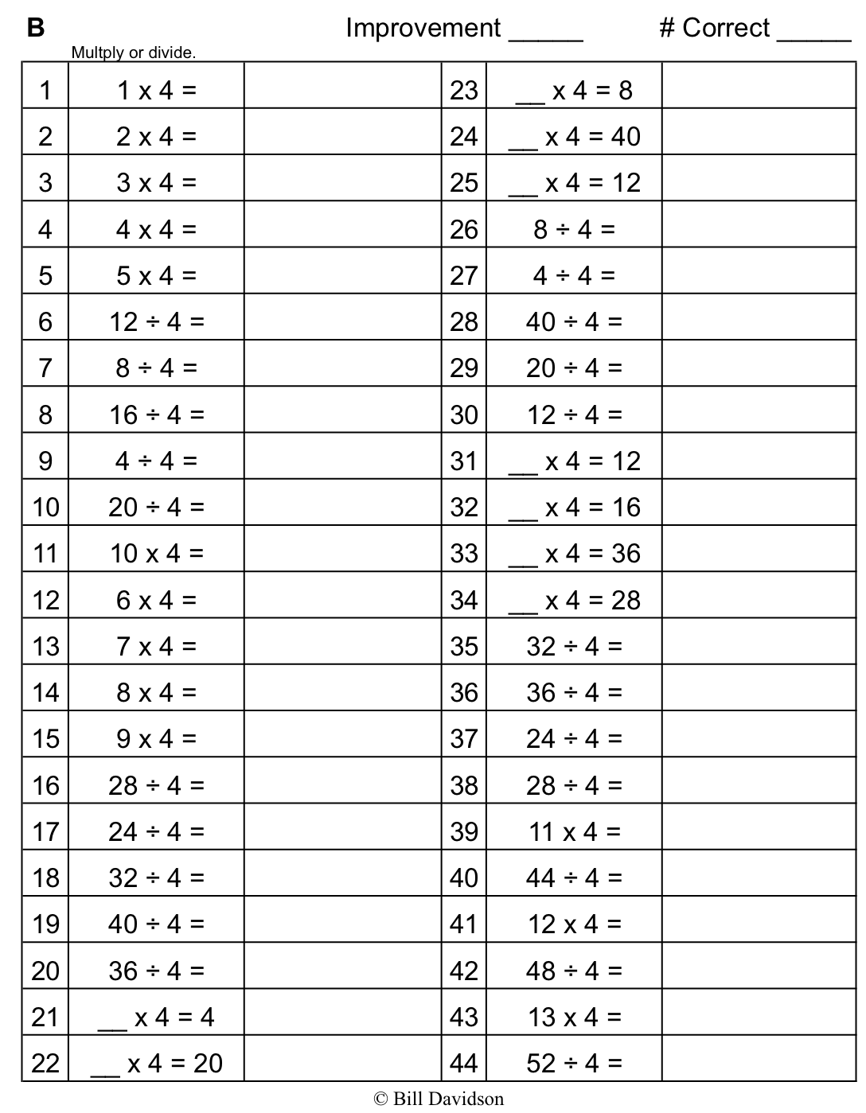
Multiply.

Name Date
- Use the data you gathered from your Problem Sets to create a line plot for the number of rectangles you created with each given perimeter.
Number of Rectangles Made with a Given Perimeter
Perimeter Measurements in Units

X = 1 Rectangle

- Why are all of the perimeter measurements even? Do all rectangles have an even perimeter?

- Compare the two line plots we created. Is there any reason to think that knowing only the area of a rectangle would help you to figure out its perimeter, or knowing only the perimeter of a rectangle would help you figure out its area?

- Sumi uses unit square tiles to build 3 rectangles that have an area of 32 square units. Does knowing this help her find the number of rectangles she can build for a perimeter of 32 units? Why or why not?

- George draws 3 rectangles that have a perimeter of 14 centimeters. Alicia tells George that there are more than 3 rectangles that have a perimeter of 14 centimeters. Explain why Alicia is correct.

Name Date
Suppose you have a rectangle with a perimeter of 2 cm. What can you conclude about the side lengths? Can all 4 sides of the rectangle measure a whole number of centimeters?

Name Date
- The following line plot shows the number of rectangles a student made using square unit tiles. Use the line plot to answer the questions below.

Perimeter Measurements
X = 1 Rectangle
Number of Rectangles Made with Given Perimeters

- Why are all of the perimeter measurements even? Do all rectangles have even perimeters?

- Explain the pattern in the line plot. What types of side lengths make this pattern possible?

- How many X’s would you draw for a perimeter of 32? Explain your answer.

- Luis uses unit square tiles to build a rectangle with a perimeter of 24 inches. Does knowing this help him find the number of rectangles he can build with an area of 24 square inches? Why or why not?

- Esperanza makes a rectangle with a piece of string. She says the perimeter of her rectangle is 33 centimeters. Explain how it’s possible for her rectangle to have an odd perimeter.

Rectangle A

Rectangle D
Rectangle C
Rectangle B
X = 1 Rectangle
Number of Rectangles
Perimeter Measurements
10
8
4
6
12
20
18
14
16
22
30
28
24
26
X
X
X
X
X
X
X

X
X
X
X
X
X
X

X
X
X
X
X
X

X
X
X
X
X
X

X
X
X
X
X

X
X
X
X
X

X
X
X
X

X
X
X
X

X
X
X

X
X
X

X
X

X
X

X

X

