Lesson 21
Objective: Construct rectangles with a given perimeter using unit squares and determine their areas.

Suggested Lesson Structure
 Fluency Practice (10 minutes)
 Application Problem (5 minutes)
 Concept Development (35 minutes)
 Student Debrief (10 minutes)
Total Time (60 minutes)
Fluency Practice (10 minutes)
- Sprint: Divide by 3 3.OA.7 (10 minutes)

Sprint: Divide by 3 (10 minutes)
Materials: (S) Divide by 3 Sprint
Note: This Sprint builds fluency with multiplication and division facts using units of 3.
Application Problem (5 minutes)

NOTES ON
MULTIPLE MEANS OF ACTION AND EXPRESSION:
Scaffold the Application Problem for students working below grade level. One solution path (shown here) is to find half of the perimeter and list all addend pairs with a sum of 7. Set individualized goals for effort and persistence, perhaps by providing a checklist of problem solving self-talk, such as, “What information do I know?”
Mrs. Zeck will use 14 feet of tape to mark a rectangle on the gym wall. Draw several rectangles that Mrs. Zeck could make with her tape. Label the side lengths of each rectangle.
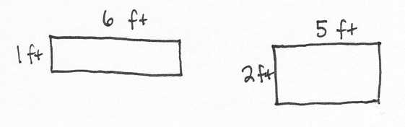
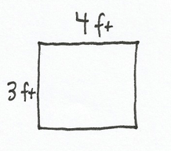
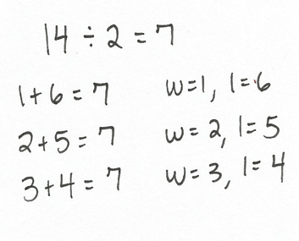

Note: This problem reviews G3–M7–Lesson 20. If time allows, invite students to discuss which rectangular target they would want to try to hit by throwing a ball from the opposite side of the gym.
Concept Development (35 minutes)
Materials: (S) Centimeter grid paper, Problem Set, personal white board
T: Read the first sentence of Problem 1 on the Problem Set.
S: (Read: On your centimeter grid paper, shade and label as many rectangles as you can with a perimeter of 16 centimeters.)
T: Tell a partner the strategy you will use to find rectangles with a perimeter of 16 centimeters.
MP.5
S: (I’ll start by finding half of the perimeter, which is 8. Then, I’ll write addition sentences that equal 8. The numbers in these addition sentences are the widths and lengths of the rectangles.)
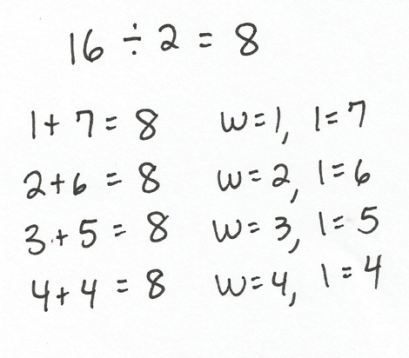
T: Work with a partner to find the widths and lengths for rectangles with a perimeter of 16 centimeters. (Sample student work shown to the right.)
T: Share your work with another pair of students. If your answers are different, figure out why and come to an agreement.
S: (Share with another pair, and make adjustments.)
T: How many different rectangles did you find with a perimeter of 16 centimeters?
S: 4 rectangles!
T: Talk to a partner: Are any of your rectangles squares? How do you know?
S: Yes, the rectangle with a width of 4 and a length of 4 is a square. That’s right, because all the side lengths are equal.
T: Shade each rectangle on your centimeter grid paper and label the side lengths. Darken the perimeters of the rectangles so they stand out on the grid.
S: (Shade rectangles on centimeter grid paper.)
When students finish shading, facilitate a class discussion using the following suggested questions.
- How can you be sure that all of the rectangles have a perimeter of 16 centimeters?
- Do you think the rectangles all have the same area? Why or why not?
- Which rectangle do you think has the smallest area? The biggest area? Why?
After the discussion, ask students to finish Problem 1, which includes sketching each rectangle, labeling the side lengths, and finding the areas. Repeat the process for Problem 2 on the Problem Set, releasing students to work independently as they are ready.

Problem Set (10 minutes)
Students should do their personal best to complete Problems 3 and 4 on the Problem Set within the allotted 10 minutes. For some classes, it may be appropriate to modify the assignment by specifying which problems they work on first. Some problems do not specify a method for solving. Students solve these problems using the RDW approach used for Application Problems.
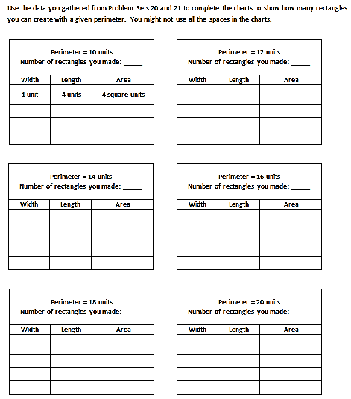
To prepare for G3–M7–Lesson 22, students should add their data from today’s lesson to the sheet shown at right. (A master copy is included after the Problem Set at the end of this lesson.) An extra five minutes is built into the time allotted for the Concept Development to accommodate this. However, choose when the data collection might happen most smoothly for your class, perhaps at the end of the Problem Set, Debrief, or after completing the Exit Ticket.

Student Debrief (10 minutes)
Lesson Objective: Construct rectangles with a given perimeter using unit squares and determine their areas.
The Student Debrief is intended to invite reflection and active processing of the total lesson experience.
Invite students to review their solutions for the Problem Set. They should check work by comparing answers with a partner before going over answers as a class. Look for misconceptions or misunderstandings that can be addressed in the Debrief. Guide students in a conversation to debrief the Problem Set and process the lesson.
You may choose to use any combination of the questions below to lead the discussion.
- Compare the rectangles you drew on your grid paper for Problems 1 and 2. What patterns do you see in the side lengths?
- Look at the charts in Problem 3. Can a rectangle with a perimeter of 10 units have a greater area than a rectangle with a perimeter of 20 units? How do you know?
- Share answers to Problem 4. Do you know for sure what Macy’s and Gavin’s rectangles look like? Why or why not?

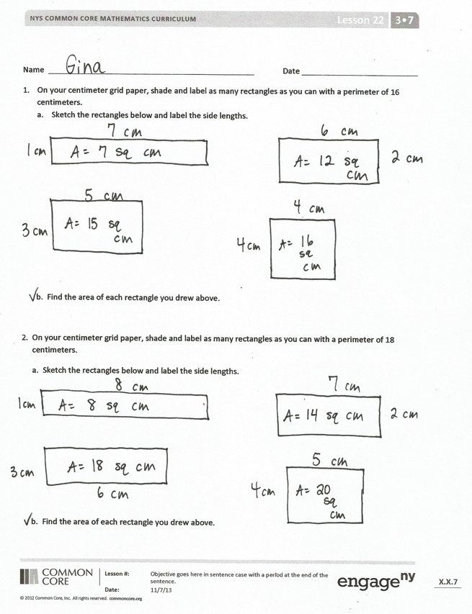
- Look at the number of rectangles you made with the given perimeters in Problems 1, 2, and 3. Why do you think you can make more rectangles with some perimeters than with others?
Exit Ticket (3 minutes)
After the Student Debrief, instruct students to complete the Exit Ticket. A review of their work will help you assess the students’ understanding of the concepts that were presented in the lesson today and plan more effectively for future lessons. You may read the questions aloud to the students.

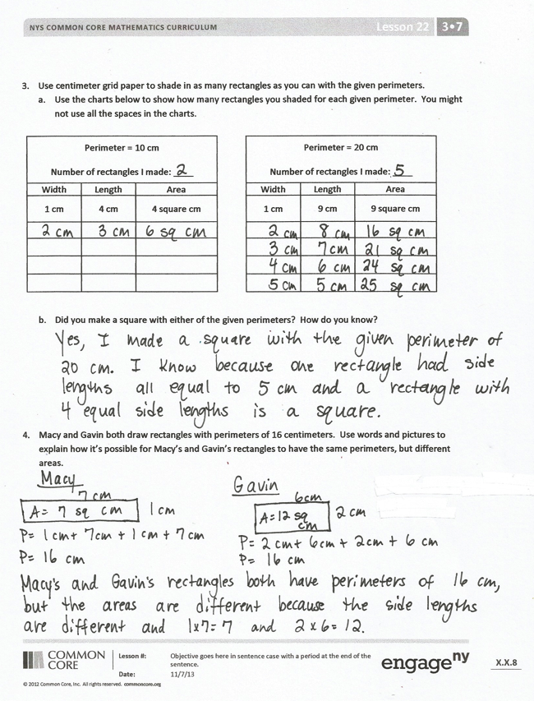
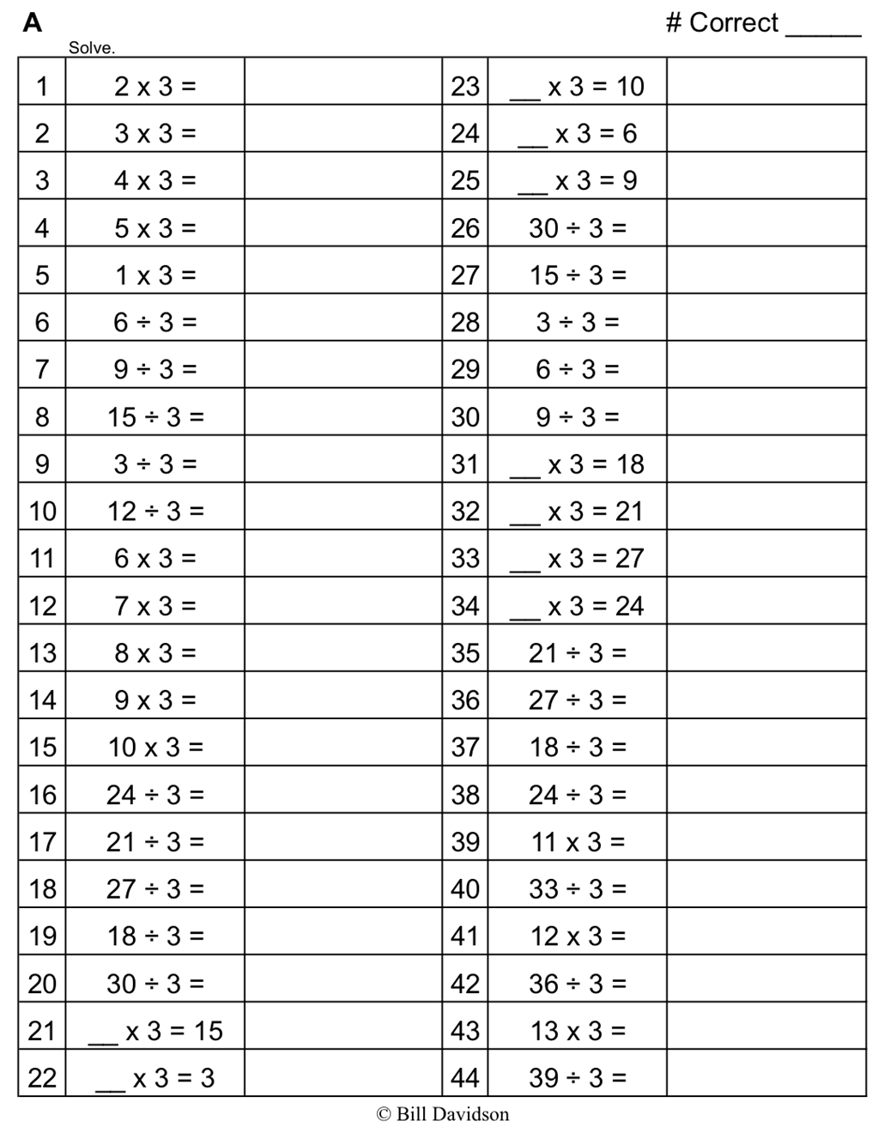

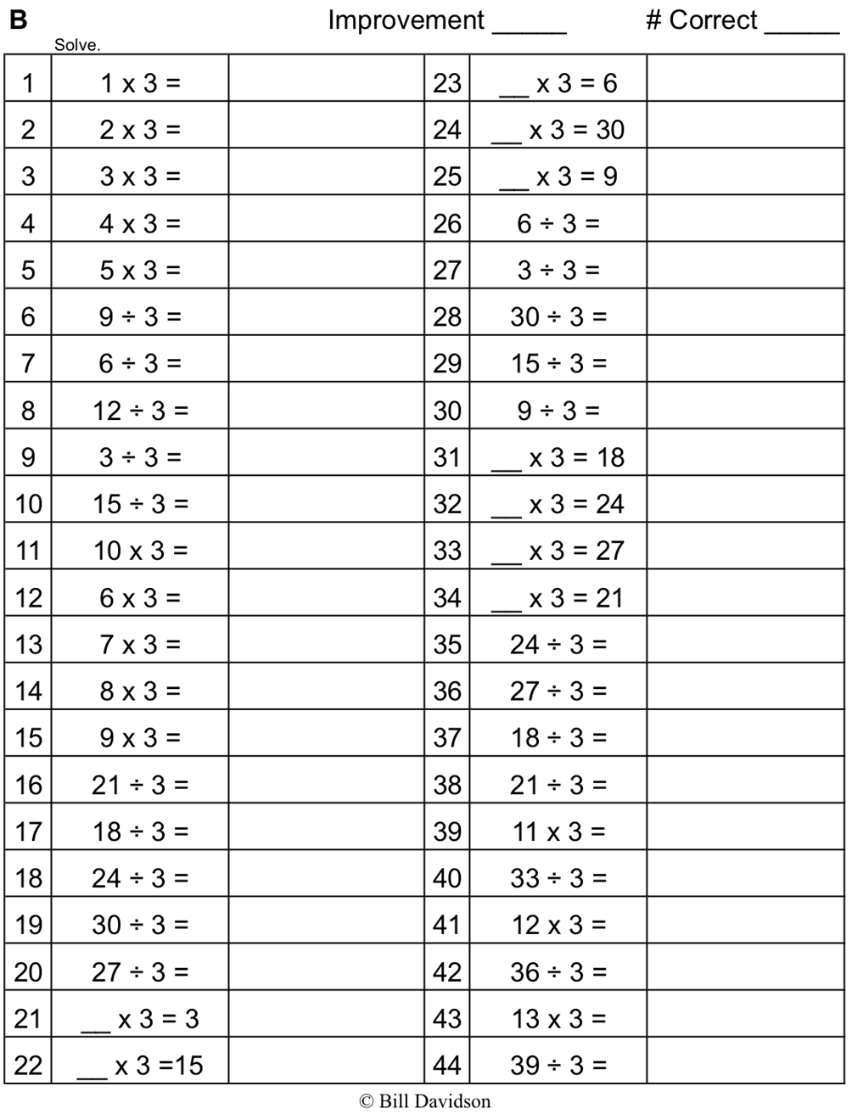

Name Date
- On your centimeter grid paper, shade and label as many rectangles as you can with a perimeter of 16 centimeters.
- Sketch the rectangles below and label the side lengths.

- Find the area of each rectangle you drew above.

- On your centimeter grid paper, shade and label as many rectangles as you can with a perimeter of 18 centimeters.
- Sketch the rectangles below and label the side lengths.

- Find the area of each rectangle you drew above.

- Use centimeter grid paper to shade in as many rectangles as you can with the given perimeters.
- Use the charts below to show how many rectangles you shaded for each given perimeter. You might not use all the spaces in the charts.
Perimeter = 10 cm

Number of rectangles I made: ____
Width | Length | Area
1 cm | 4 cm | 4 square cm

Perimeter = 20 cm

Number of rectangles I made: ____
Width | Length | Area
1 cm | 9 cm | 9 square cm

- Did you make a square with either of the given perimeters? How do you know?

- Macy and Gavin both draw rectangles with perimeters of 16 centimeters. Use words and pictures to explain how it is possible for Macy’s and Gavin’s rectangles to have the same perimeters, but different areas.

Name Date
On the grid below, shade and label at least two different rectangles with a perimeter of 20 centimeters.

Name Date
- Margo finds as many rectangles as she can with a perimeter of 14 centimeters.
- Shade Margo’s rectangles on the grid below. Label the length and width of each rectangle.

- Find the areas of the rectangles in Part (a) above.

- The perimeters of the rectangles are the same. What do you notice about the areas?

- Tanner uses unit squares to build rectangles that have a perimeter of 18 units. He creates the chart below to record his findings.
- Complete Tanner’s chart. You might not use all the spaces in the chart.
Perimeter = 18 units

Number of rectangles I made = _____
Width | Length | Area
1 unit | 8 units | 8 square units

- Explain how you found the widths and lengths in the chart above.

- Jason and Dina both draw rectangles with perimeters of 12 centimeters, but their rectangles have different areas. Explain with words, pictures, and numbers how this is possible.

Name Date
Use the data you gathered from Problem Sets 20 and 21 to complete the charts to show how many rectangles you can create with a given perimeter. You might not use all the spaces in the charts.
Perimeter = 10 units
Number of rectangles you made: _____
Width | Length | Area
1 unit | 4 units | 4 square units

Perimeter = 12 units
Number of rectangles you made: _____
Width | Length | Area

Perimeter = 14 units
Number of rectangles you made: _____
Width | Length | Area

Perimeter = 16 units
Number of rectangles you made: _____
Width | Length | Area

Perimeter = 18 units
Number of rectangles you made: _____
Width | Length | Area

Perimeter = 20 units
Number of rectangles you made: _____
Width | Length | Area

