Lesson 20
Objective: Construct rectangles with a given perimeter using unit squares and determine their areas.

Suggested Lesson Structure
 Fluency Practice (10 minutes)
 Application Problem (7 minutes)
 Concept Development (33 minutes)
 Student Debrief (10 minutes)
Total Time (60 minutes)
Fluency Practice (10 minutes)
- Sprint: Divide by 2 3.OA.7 (10 minutes)

Sprint: Divide by 2 (10 minutes)
Materials: (S) Divide by 2 Sprint
Note: This Sprint builds fluency with multiplication and division facts using units of 2.
Application Problem (7 minutes)
Molly builds a rectangular playpen for her pet rabbit. The playpen has an area of 15 square yards.
- Estimate to draw and label as many possibilities as you can for the playpen.
- Find the perimeters of the rectangles in Part (a).
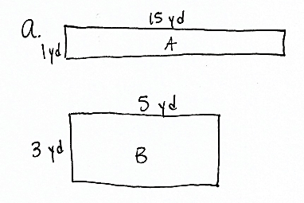
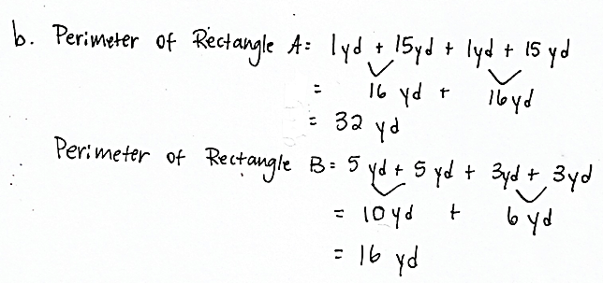
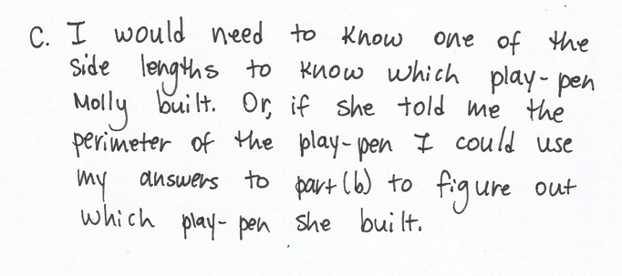
- What other information do you need in order to recreate Molly’s playpen?
Note: This reviews the concepts learned in G3–M7–Lessons 18 and 19. You might invite students to discuss whether or not one of the rectangles from Part (a) would be preferred as an outdoor playpen for a rabbit.
Concept Development (33 minutes)
Materials: (S) Problem Set, personal white board, unit square tiles
Note: This lesson includes two strategies for finding the length and width of a rectangle when the perimeter is known. One strategy is written into the vignette, and the other is explained after the vignette. Before delivering the lesson, read through both and decide which is most appropriate for the class. Depending on the class, both may be taught.
T: Read the first sentence in Problem 1.
S: (Read: Use your unit square tiles to build as many rectangles as you can with a perimeter of 12 units.)
T: How is this problem different from the work we’ve been doing the past few days?
S: Before, we knew the area of the rectangle and had to find length and width. Now, we need to use the perimeter to find the length and width.

NOTES ON
MULTIPLE MEANS OF ACTION AND EXPRESSION:
Offer students the option of using a
12-cm or 12-inch piece of string or wire (rather than square tiles) to build rectangles with a perimeter of 12 units in Problem 1 of the Problem Set.

T: When we knew area, we used pairs of factors to help us find length and width. What strategy might we use to help us when we know the perimeter?
S: We have to build or draw rectangles with different lengths and widths and see if the perimeter is 12 units. That could take a long time.
T: Let’s see what we can figure out. (Project the labeled rectangle and equation shown to the right.) Discuss with a partner how this equation represents the perimeter of the rectangle.
3 cm
8 cm
8 cm
3 cm
P = 2 × (3 cm + 8 cm)
S: (Discuss.)
T: Solve the addition fact and rewrite the equation using the sum.
S: (Write P = 2 × 11 cm.)
T: When we multiply a number by 2, what are we doing to that number?
S: Doubling it!
T: So, this equation shows perimeter as double the sum of the width and length. Talk to a partner: Can the perimeter of all rectangles be written as double the sum of the width and length?
MP.5
S: Yes, because all rectangles have opposite sides that are equal.
T: Let’s see how knowing that helps with Problem 1. It asks us to use unit squares to build as many rectangles as we can that have a perimeter of 12 units. We know that the perimeter, 12 units, is double the sum of the width and length. What is the opposite of doubling a number?
S: Dividing a number by 2. Halving a number.
T: (Write the equation 12 ÷ 2 = 6.) What does the 6 in this equation represent in relation to a rectangle with a perimeter of 12?
S: You divided the perimeter by 2, so 6 is the sum of the width and length. You halved the perimeter and 6 is the sum of the width and length.
T: Now that we know the sum of the width and length, we can find pairs of numbers that add to 6. Start at 1 and work with a partner to write number sentences that have a sum of 6. You only need to include a combination once.
MP.5
12 ÷ 2 = 6
1 + 5 = 6
2 + 4 = 6
3 + 3 = 6
Sample teacher’s board:
S: (Write 1 + 5 = 6, 2 + 4 = 6, and 3 + 3 = 6.)
T: (Write number sentences.) Check your work with mine, and make changes, if necessary. (Allow students time to check their work.) What do these combinations represent?
S: They’re the possible widths and lengths for a rectangle with a perimeter of 12 units! Wait, how do we know which is width and which is length?

NOTES ON
MULTIPLE MEANS OF REPRESENTATION:
When using square tiles to build rectangles of a certain perimeter, clarify the unit being counted. Students count unit squares to find area, and count unit side lengths to find perimeter.

T: Sketch a rectangle one way, then trade the numbers that go with width and length and sketch again. What happens?
S: Oh! It’s the same rectangle, just flipped. I guess it doesn’t matter which is which for now.
T: Use your unit squares to build each rectangle with the widths and lengths that we found. Confirm that the perimeter is 12 units each time. Then, complete Problem 1 on the Problem Set.
S: (Build rectangles, and then complete Problem 1.)
T: At the beginning of our lesson, we wondered which strategy we could use to find the width and length of a rectangle when we know the perimeter. Retell this strategy to your partner.
S: (Discuss.)
Alternative (or Additional) Strategy:
If appropriate for your class, you might choose to teach the following strategy instead of or in addition to the strategy demonstrated above. While this strategy has more steps than the strategy in the vignette, it does not require students to know or figure out half of the perimeter. Finding half of the perimeter can become tricky when students start to work with larger perimeters. As noted above, use discretion when deciding which strategy is appropriate for the class.
- Start with the same 3-cm by-8 cm rectangle as in the vignette.
- Show the equation P = (2 × 3 cm) + (2 × 8 cm). Ask students how the equation represents the perimeter of the rectangle.
- Students see that the equation shows the perimeter as the sum of double the width and double the length.
- Knowing that, students can start at 1 and double numbers until they get to the given perimeter. Then, they can find pairs of doubles that add up to the perimeter.
- These pairs of doubles represent double the widths and lengths, so students will have to divide each number by 2 to get the widths and lengths.
Example: Given a perimeter of 22 centimeters, students could find possible side lengths as shown below.
P = 22 cm
Doubles: 2, 4, 6, 8, 10, 12, 14, 16, 18, 20, 22
Pairs of doubles that add to 22: | Half of these doubles:
2 + 20 | w = 1, l = 10
4 + 18 | w = 2, l = 9
6 + 16 | w = 3, l = 8
8 + 14 | w = 4, l = 7
10 + 12 | w = 5, l = 6

Problem Set (10 minutes)
Students should do their personal best to complete the Problem Set within the allotted 10 minutes. For some classes, it may be appropriate to modify the assignment by specifying which problems they work on first. Some problems do not specify a method for solving. Students solve these problems using the RDW approach used for Application Problems.
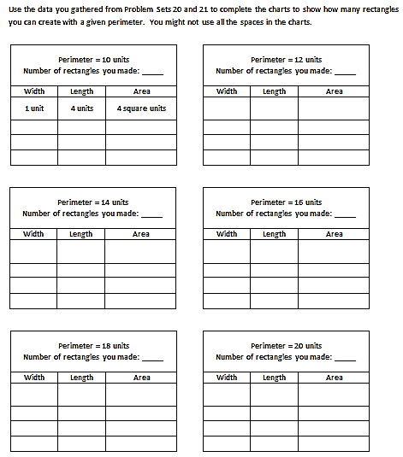
To prepare for G3–M7–Lesson 22, students should add their data from today’s lesson to the sheet shown at right. (A master copy is included after the Problem Set at the end of this lesson.) Data will need to be collected on the same sheet again at the end of G3–M7–Lesson 21. An extra five minutes is built into the time allotted for the Concept Development to accommodate this. However, choose when the data collection might happen most smoothly for your class, perhaps at the end of the Problem Set, Debrief, or after completing the Exit Ticket.

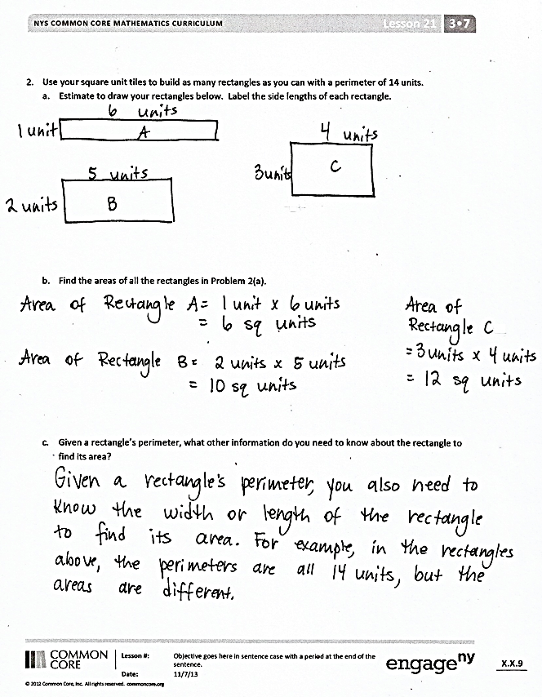
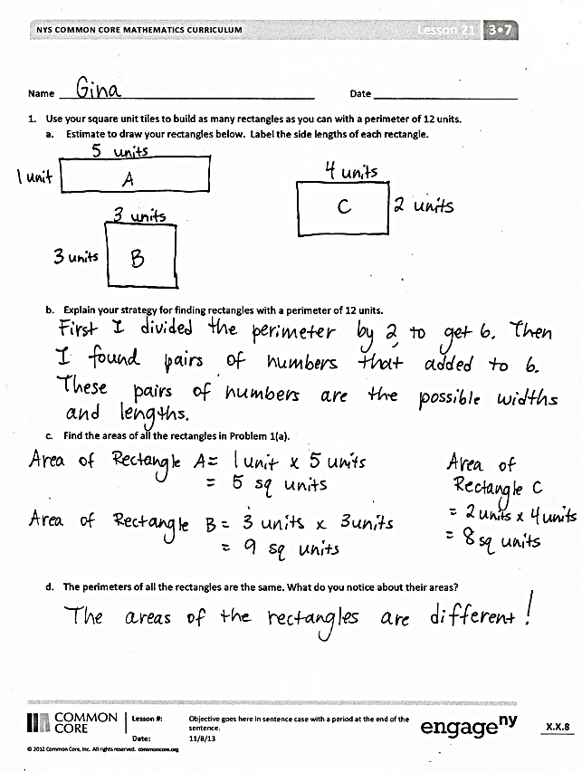
Student Debrief (10 minutes)
Lesson Objective: Construct rectangles with a given perimeter using unit squares and determine their areas.
The Student Debrief is intended to invite reflection and active processing of the total lesson experience.
Invite students to review their solutions for the Problem Set. They should check work by comparing answers with a partner before going over answers as a class. Look for misconceptions or misunderstandings that can be addressed in the Debrief. Guide students in a conversation to debrief the Problem Set and process the lesson.
You may choose to use any combination of the questions below to lead the discussion.
- Share answers to Problems 1(c) and 1(d). Why are the areas of the rectangles different, even though the perimeters are the same?
- What are the widths and lengths of the rectangles you drew in Problem 2(a)? Explain to a partner how you found the widths and lengths.
- Share your answer to Problem 2(c) with a partner. Why can’t you find the area of a rectangle when you only know the rectangle’s perimeter?
- Look at the rectangles you drew in Problems 1(a) and 2(a). Which perimeter allowed you to draw a square? How do you know?
Exit Ticket (3 minutes)
After the Student Debrief, instruct students to complete the Exit Ticket. A review of their work will help you assess the students’ understanding of the concepts that were presented in the lesson today and plan more effectively for future lessons. You may read the questions aloud to the students.

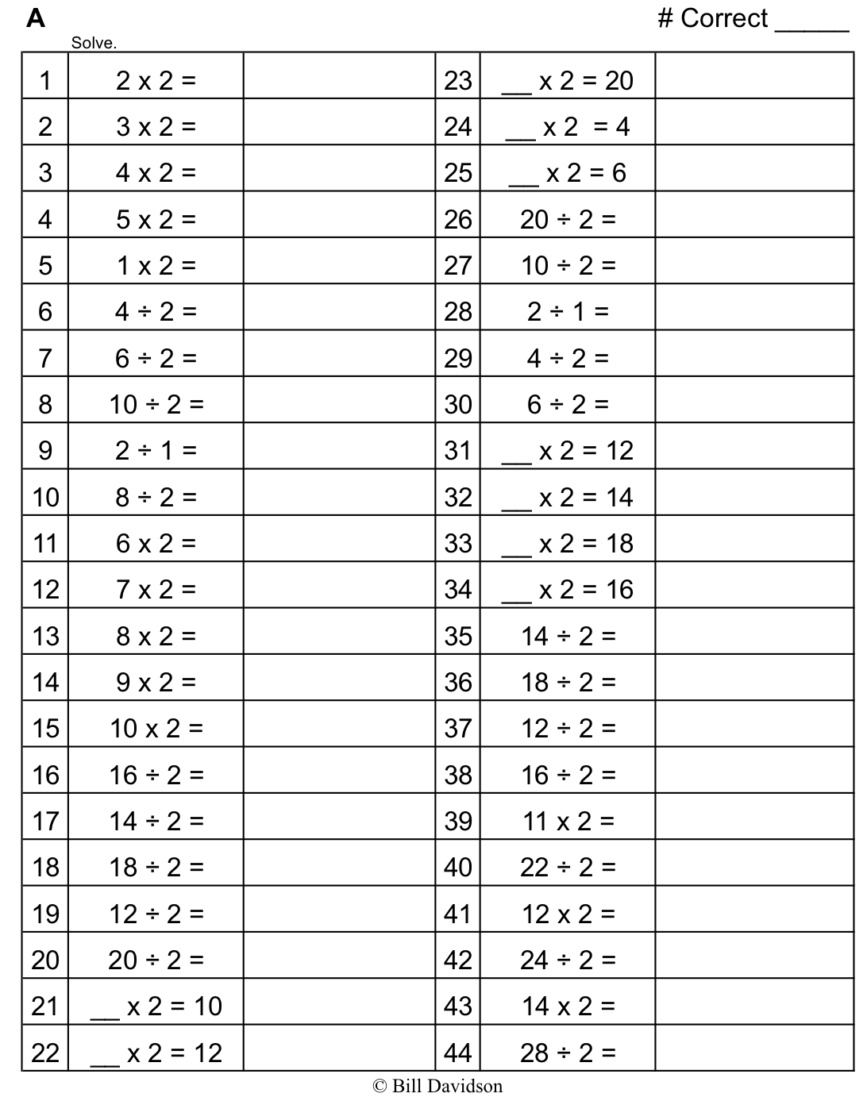
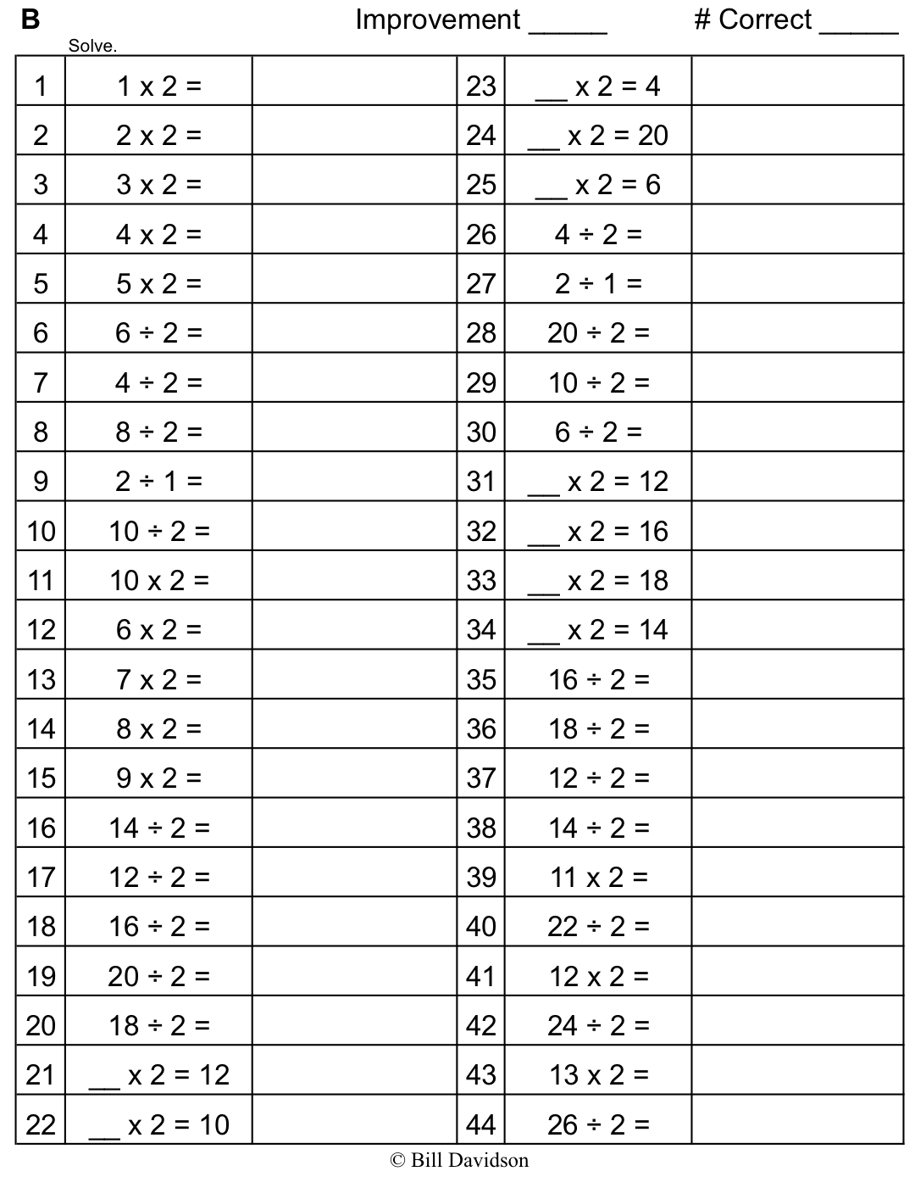

Name Date
- Use your square unit tiles to build as many rectangles as you can with a perimeter of 12 units.
- Estimate to draw your rectangles below. Label the side lengths of each rectangle.

- Explain your strategy for finding rectangles with a perimeter of 12 units.

- Find the areas of all the rectangles in Part (a) above.

- The perimeters of all the rectangles are the same. What do you notice about their areas?

- Use your square unit tiles to build as many rectangles as you can with a perimeter of 14 units.
- Estimate to draw your rectangles below. Label the side lengths of each rectangle.

- Find the areas of all the rectangles in Part (a) above.

- Given a rectangle’s perimeter, what other information do you need to know about the rectangle to find its area?

Name Date
- Use your square unit tiles to build as many rectangles as you can with a perimeter of 8 units.
  - Estimate to draw your rectangles below. Label the side lengths of each rectangle.

  - Find the areas of the rectangles in Part (a) above.

--------------------------------------------------------------------------------------------------------------------------------------------
Name Date
- Cut out the unit squares above. Then, use them to make as many rectangles as you can with a perimeter of 10 centimeters.
  - Estimate to draw your rectangles below. Label the side lengths of each rectangle.

  - Find the areas of the rectangles in Part (a) above.

- Gino uses unit square tiles to make rectangles with a perimeter of 14 units. He draws his rectangles as shown below. Using square unit tiles, can Gino make another rectangle that has a perimeter of 14 units? Explain your answer.
1 unit
6 units

3 units
4 units

- Katie draws a square that has a perimeter of 20 centimeters.
  - Estimate to draw Katie’s square below. Label the length and width of the square.

  - Find the area of Katie’s square.

  - Estimate to draw a different rectangle that has the same perimeter as Katie’s square.

  - Which shape has a greater area, Katie’s square or your rectangle?

Name Date
Use the data you gathered from Problem Sets 20 and 21 to complete the charts to show how many rectangles you can create with a given perimeter. You might not use all the spaces in the charts.
Perimeter = 10 units
Number of rectangles you made: _____
Width | Length | Area
1 unit | 4 units | 4 square units

Perimeter = 12 units
Number of rectangles you made: _____
Width | Length | Area

Perimeter = 14 units
Number of rectangles you made: _____
Width | Length | Area

Perimeter = 16 units
Number of rectangles you made: _____
Width | Length | Area

Perimeter = 18 units
Number of rectangles you made: _____
Width | Length | Area

Perimeter = 20 units
Number of rectangles you made: _____
Width | Length | Area

