Lesson 18

Objective: Construct rectangles from a given number of unit squares and determine the perimeters.

Suggested Lesson Structure

 Fluency Practice (12 minutes)

 Application Problem (8 minutes)

 Concept Development (30 minutes)

 Student Debrief (10 minutes)

**Total Time (60 minutes)**

Fluency Practice (12 minutes)

* Find the Missing Factors  **3.MD.7** (4 minutes)
* Draw Tape Diagrams  **3.MD.7** (4 minutes)
* Find the Area and Perimeter  **3.MD.8** (4 minutes)

Find the Missing Factors (4 minutes)

Materials: (S) Personal white boards

**1 × __ = 6**

**2 × __ = 6**

**3 × __ = 6**

**6 × __ = 6**

Note: This fluency activity prepares students for today’s lesson.

T: (Project missing factor multiplication sentences equaling 6, shown right.) On your boards, complete the missing factors to create four different multiplication sentences.

S: (Write 1 × 6 = 6, 2 × 3 = 6, 3 × 2 = 6, 6 × 1 = 6.)

Repeat the process for 8, 9, and 12.

Draw Tape Diagrams (4 minutes)

Materials: (S) Personal white boards



Note: This fluency activity prepares students for today’s lesson.

T: (Project a tape diagram with one small unit on the left and an open end on the right. Write 2 inside the small unit.) On your boards, copy the diagram.

S: (Draw diagram and write 2 inside the small unit.)

T: (Write 14 at the top of the tape diagram.) Complete your diagram with equal units. Close the tape diagram when the total value of your units reaches 14.

S: (Draw 6 more units of 2.)

T: (Write ___ × 2 = 14.) Say the multiplication sentence.

S: 7 × 2 = 14.

T: (Write 2 × __ = 14.) Say the multiplication sentence.

S: 2 × 7 = 14.

Continue the process for 8 units of 3, 4 units of 7, and 6 units of 9.

Find the Area and Perimeter (4 minutes)

Materials: (S) Grid paper, personal white boards

Note: This fluency activity reviews G3–M7–Lesson 13.

T: (Project a 4-unit by 2-unit rectangle.) What’s the length of the rectangle?

|  |  |  |  |
| --- | --- | --- | --- |
|  |  |  |  |
|  |  |  |  |

**A = 8 square units**

**P = 12 units**

**2 units**

**4 units**

S: 4 units.

T: (Write *4 units* below the rectangle.) What’s the width of the rectangle?

S: 2 units.

T: (Write *2 units* to the right of the rectangle. Beneath it, write *A = ___*.) On your boards, write the area.

S: (Write *A = 8 square units*.)

T: (Write *A = 8 square units*. Write *P = ___*.) Write the perimeter of the rectangle.

S: (Write *P = 12 units*.)

Continue the process for the following possible suggestions: 4-unit by 3-unit rectangle, 2-unit by 6-unit rectangle, 4-unit by 4-unit square, 8-unit by 2-unit rectangle, and 3-unit by 6-unit rectangle.

Application Problem (8 minutes)

|  |  |
| --- | --- |
|  | NOTES ON  MULTIPLE MEANS OF REPRESENTATION: |
| Students who find making dot arrays challenging may be supported by using grid paper to organize and track dots. | |

Rita says that since 15 is larger than 12, she can draw more arrays to show 15 than she can to show 12. Is she correct? Model to solve.

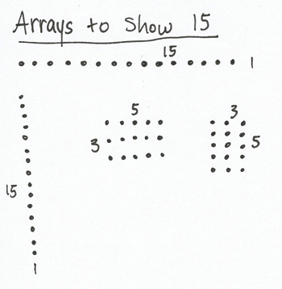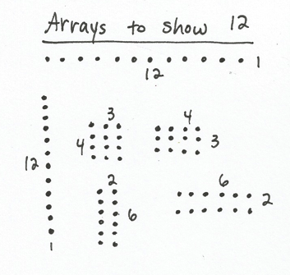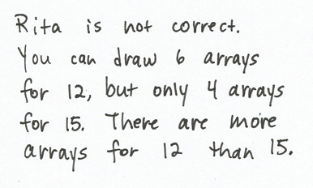

Note: This problem activates prior knowledge about brainstorming factors that equal a specific product. This skill will be needed in the Concept Development as the students list all factors and then draw rectangles for a given area.

Concept Development (30 minutes)

Materials: (S) Personal white board, grid paper, 18 unit square tiles (per pair of students)

T: With your partner, use unit square tiles to build as many rectangles as you can that have an area of 18 square units. Shade unit squares on your grid paper to represent each rectangle you build and label the side lengths.

S: (Build and shade rectangles.)

T: Talk to your partner: Can you build any other rectangles with your unit squares that have an area of 18 square units? How can you be sure?

S: I think we got them all. We’re really just building arrays, so we can think about multiplication facts. 🡪 We can list all the pairs of factors that make 18 when you multiply them. Then, we can check to make sure we have a rectangle for each pair of factors.

T: Work with your partner to write all multiplication facts you know for 18.

S: (Write 1 × 18, 2 × 9, 3 × 6, 6 × 3, 9 × 2, 18 × 1.)

T: How many facts did you come up with, and what are they? (As students share facts, list them on the board.)

S: 6 facts!

T: How can you be sure you found them all?

S: We started at 1 and thought, “1 times what equals 18?” We wrote down facts when we found ones that worked. We did that for every number up to 18. It’s kind of like our Find the Missing Factorsfluency activity.

T: Which of these facts are related through commutativity?

S: 1 × 18 and 18 × 1, 2 × 9 and 9 × 2, 3 × 6 and 6 × 3.

T: If you ignore duplicates, how many rectangles can you build using these facts?

S: 3!

|  |  |
| --- | --- |
|  | NOTES ON  MULTIPLE MEANS FOR ACTION AND EXPRESSION: |
| Support English language learners by providing a word bank and allow students to discuss their thoughts before writing on their Problem Sets.  Possible sentence starter: “To find the perimeter, we need to know…”  Possible words for the word bank are given below:  length width rectangle  different area perimeter | |
|  | |

T: Check your work to be sure you found all the possible rectangles that you can make with your unit square tiles that have an area of 18 square units.

S: (Check work and make adjustments, if necessary.)

T: Your three rectangles look different. How do you know they have the same area?

S: I used 18 unit squares to make each one. 🡪 When I multiply the side lengths, I get 18 for each of them.

T: Talk to a partner: Do you think our three rectangles also have the same perimeter?

S: (Discuss with partner.)

T: Find the perimeter for each rectangle.

S: (Perimeter of 1 by 18 rectangle is 38 units, perimeter of 2 by 9 rectangle is 22 units, and perimeter of 3 by 6 rectangle is 18 units.)

T: Talk to your partner: Why do you think these rectangles have different perimeters?

S: The sides of the rectangles are all different lengths. 🡪 But why does that matter? They all have the same total number of square units! 🡪 But the squares are arranged differently. In the 1 by 18 rectangle, a lot of the sides on each unit square are part of the perimeter. That makes this rectangle have the greatest perimeter. 🡪 But in the 2 by 9 rectangle, most unit squares have only one side that is part of the perimeter. 🡪 I get it now. Like on the 3 by 6 rectangle some unit squares aren’t part of the perimeter at all, because they’re just stuck in the middle. That’s why it has the smallest perimeter.

**MP.3**

T: What is the relationship between the shape of the rectangle and the size of its perimeter?

S: Rectangles that are long and skinny have greater perimeters because more sides of each square are part of the perimeter. 🡪 You mean more sides of each square are counted as part of the perimeter. 🡪 Yeah, and that makes the numbers you add up bigger. And that means a bigger perimeter. 🡪 The ones that are wider and closer to being squares have some unit squares in the middle that don’t have *any* sides that are part of the perimeter.

T: Compare the areas and perimeters of your rectangles. Do you see a connection between them?

S: The 3 by 6 rectangle has a perimeter of 18 units and an area of 18 square units. 🡪 But the other ones don’t match at all, so area and perimeter don’t go together all the time. 🡪 Yeah, that must’ve just been a coincidence that it matched up for the 18 square unit rectangle.

Problem Set (10 minutes)

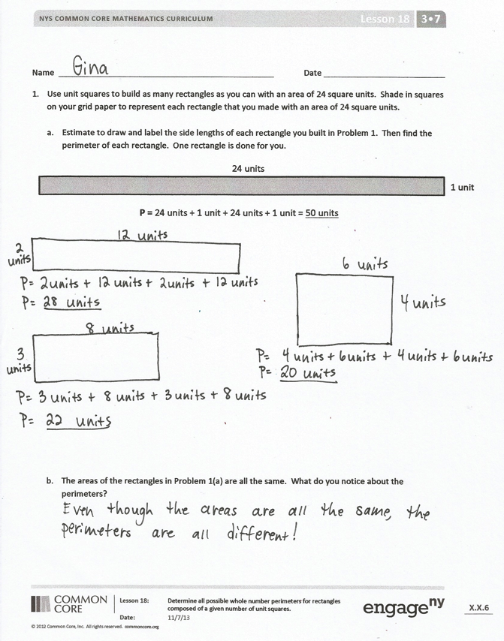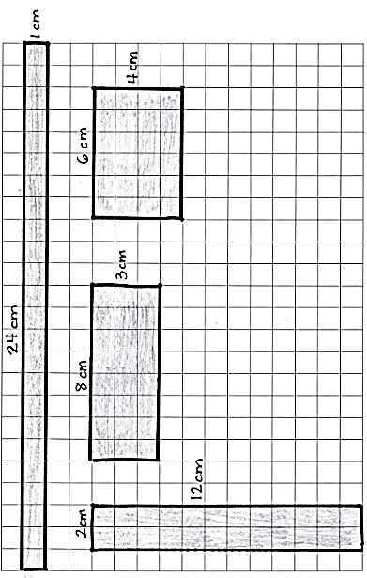

**Example of Problem 1 Grid Paper**

Students should do their personal best to complete the Problem Set within the allotted 10 minutes. For some classes, it may be appropriate to modify the assignment by specifying which problems they work on first. Some problems do not specify a method for solving. Students solve these problems using the RDW approach used for Application Problems.

Note: Students will need 24 unit square tiles and grid paper to complete the Problem Set.

Student Debrief (10 minutes)

**Lesson Objective:** Construct rectangles from a given number of unit squares and determine the perimeters.

The Student Debrief is intended to invite reflection and active processing of the total lesson experience.

Invite students to review their solutions for the Problem Set. They should check work by comparing answers with a partner before going over answers as a class. Look for misconceptions or misunderstandings that can be addressed in the Debrief. Guide students in a conversation to debrief the Problem Set and process the lesson.

You may choose to use any combination of the questions below to lead the discussion.

* Explain your strategy for finding rectangles with an area of 24 square units in Problem 1.
* Why were you able to find more rectangles using 24 square units than you were using 18 square units?
* Invite students to articulate observations about the relationship between a rectangle’s shape and perimeter in Problem 1(a).
* Why were you able to find a square in Problem 2, but not Problem 1?
* Share answers to Problem 3.
* Why do you think a square has a smaller perimeter than any other rectangle with the same area?
* How did the Application Problem relate to today’s lesson?
* How did today’s Fluency Practice prepare you for today’s lesson?

Exit Ticket (3 minutes) 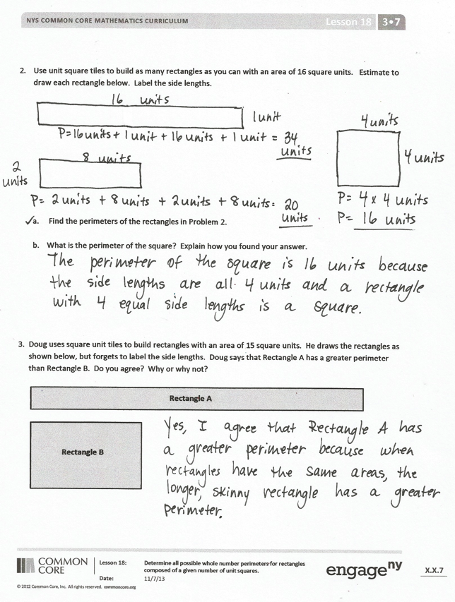

After the Student Debrief, instruct students to complete the Exit Ticket. A review of their work will help you assess the students’ understanding of the concepts that were presented in the lesson today and plan more effectively for future lessons. You may read the questions aloud to the students.

Name Date

1. Use unit squares to build as many rectangles as you can with an area of 24 square units. Shade in squares on your grid paper to represent each rectangle that you made with an area of 24 square units.
2. Estimate to draw and label the side lengths of each rectangle you built in Problem 1. Then, find the perimeter of each rectangle. One rectangle is done for you.

**24 units**

**1 unit**

**P =** 24 units + 1 unit + 24 units + 1 unit = 50 units

1. The areas of the rectangles in Part(a) above are all the same. What do you notice about the perimeters?
2. Use unit square tiles to build as many rectangles as you can with an area of 16 square units. Estimate to draw each rectangle below. Label the side lengths.
3. Find the perimeters of the rectangles you built.
4. What is the perimeter of the square? Explain how you found your answer.
5. Doug uses square unit tiles to build rectangles with an area of 15 square units. He draws the rectangles as shown below, but forgets to label the side lengths. Doug says that Rectangle A has a greater perimeter than Rectangle B. Do you agree? Why or why not?

**Rectangle A**

**Rectangle B**

Name Date

Tessa uses square-centimeter tiles to build rectangles with an area of 12 square centimeters. She draws the rectangles as shown below. Label the missing side lengths of each rectangle. Then, find the perimeter of each rectangle.

**12 cm**

**______ cm**

**P =**

**3 cm**

**______ cm**

**P =**

**6 cm**

**______ cm**

**P =**

Name Date

1. Shade in squares on the grid below to create as many rectangles as you can with an area of 18 square centimeters.

|  |  |  |  |  |  |  |  |  |  |  |  |  |  |  |  |  |  |
| --- | --- | --- | --- | --- | --- | --- | --- | --- | --- | --- | --- | --- | --- | --- | --- | --- | --- |
|  |  |  |  |  |  |  |  |  |  |  |  |  |  |  |  |  |  |
|  |  |  |  |  |  |  |  |  |  |  |  |  |  |  |  |  |  |
|  |  |  |  |  |  |  |  |  |  |  |  |  |  |  |  |  |  |
|  |  |  |  |  |  |  |  |  |  |  |  |  |  |  |  |  |  |
|  |  |  |  |  |  |  |  |  |  |  |  |  |  |  |  |  |  |
|  |  |  |  |  |  |  |  |  |  |  |  |  |  |  |  |  |  |
|  |  |  |  |  |  |  |  |  |  |  |  |  |  |  |  |  |  |
|  |  |  |  |  |  |  |  |  |  |  |  |  |  |  |  |  |  |
|  |  |  |  |  |  |  |  |  |  |  |  |  |  |  |  |  |  |
|  |  |  |  |  |  |  |  |  |  |  |  |  |  |  |  |  |  |
|  |  |  |  |  |  |  |  |  |  |  |  |  |  |  |  |  |  |
|  |  |  |  |  |  |  |  |  |  |  |  |  |  |  |  |  |  |

1. Find the perimeter of each rectangle in Problem 1 above.
2. Estimate to draw as many rectangles as you can with an area of 20 square centimeters. Label the side lengths of each rectangle.
3. Which rectangle above has the greatest perimeter? How do you know?
4. Which rectangle above has the smallest perimeter? How do you know?

|  |  |  |  |  |  |  |  |  |  |  |  |  |  |  |  |  |  |  |  |
| --- | --- | --- | --- | --- | --- | --- | --- | --- | --- | --- | --- | --- | --- | --- | --- | --- | --- | --- | --- |
|  |  |  |  |  |  |  |  |  |  |  |  |  |  |  |  |  |  |  |  |
|  |  |  |  |  |  |  |  |  |  |  |  |  |  |  |  |  |  |  |  |
|  |  |  |  |  |  |  |  |  |  |  |  |  |  |  |  |  |  |  |  |
|  |  |  |  |  |  |  |  |  |  |  |  |  |  |  |  |  |  |  |  |
|  |  |  |  |  |  |  |  |  |  |  |  |  |  |  |  |  |  |  |  |
|  |  |  |  |  |  |  |  |  |  |  |  |  |  |  |  |  |  |  |  |
|  |  |  |  |  |  |  |  |  |  |  |  |  |  |  |  |  |  |  |  |
|  |  |  |  |  |  |  |  |  |  |  |  |  |  |  |  |  |  |  |  |
|  |  |  |  |  |  |  |  |  |  |  |  |  |  |  |  |  |  |  |  |
|  |  |  |  |  |  |  |  |  |  |  |  |  |  |  |  |  |  |  |  |
|  |  |  |  |  |  |  |  |  |  |  |  |  |  |  |  |  |  |  |  |
|  |  |  |  |  |  |  |  |  |  |  |  |  |  |  |  |  |  |  |  |
|  |  |  |  |  |  |  |  |  |  |  |  |  |  |  |  |  |  |  |  |
|  |  |  |  |  |  |  |  |  |  |  |  |  |  |  |  |  |  |  |  |
|  |  |  |  |  |  |  |  |  |  |  |  |  |  |  |  |  |  |  |  |
|  |  |  |  |  |  |  |  |  |  |  |  |  |  |  |  |  |  |  |  |
|  |  |  |  |  |  |  |  |  |  |  |  |  |  |  |  |  |  |  |  |
|  |  |  |  |  |  |  |  |  |  |  |  |  |  |  |  |  |  |  |  |
|  |  |  |  |  |  |  |  |  |  |  |  |  |  |  |  |  |  |  |  |
|  |  |  |  |  |  |  |  |  |  |  |  |  |  |  |  |  |  |  |  |
|  |  |  |  |  |  |  |  |  |  |  |  |  |  |  |  |  |  |  |  |
|  |  |  |  |  |  |  |  |  |  |  |  |  |  |  |  |  |  |  |  |
|  |  |  |  |  |  |  |  |  |  |  |  |  |  |  |  |  |  |  |  |
|  |  |  |  |  |  |  |  |  |  |  |  |  |  |  |  |  |  |  |  |