Lesson 16
Objective: Use string to measure the perimeter of various circles to the nearest quarter inch.

Suggested Lesson Structure
 Fluency Practice (16 minutes)
 Concept Development (34 minutes)
 Student Debrief (10 minutes)
Total Time (60 minutes)
Fluency Practice (16 minutes)
- Multiply by 9 3.OA.7 (8 minutes)
- Equivalent Counting with Units of 6 3.OA.7 (4 minutes)
- Find the Perimeter 3.MD.8 (4 minutes)

Multiply by 9 (8 minutes)

Materials: (S) Multiply by 9 Pattern Sheet (1–5)
Note: This activity builds fluency with multiplication facts using units of 9. It works toward students knowing from memory all products of two one-digit numbers. See G3–M7–Lesson 1 for the directions for administration of a Multiply By pattern sheet.
T: (Write 5 × 9 = ____.) Let’s skip-count by nine to find the answer. (Count with fingers to 5 as students count.)
S: 9, 18, 27, 36, 45.
T: (Circle 45 and write 5 × 9 = 45 above it. Write 3 × 9 = ____.) Let’s skip-count up by nines again. (Count with fingers to 3 as students count.)
S: 9, 18, 27.
T: Let’s see how we can skip-count down to find the answer, too. Start at 45 with 5 fingers, 1 for each nine. (Count down with fingers as students say numbers.)
S: 45 (five fingers), 36 (4 fingers), 27 (3 fingers).
Repeat the process for 4 × 9.
T: (Distribute Multiply by 9 pattern sheet.) Let’s practice multiplying by 9. Be sure to work left to right across the page.

Equivalent Counting with Units of 6 (4 minutes)
Note: This activity builds fluency with multiplication facts using units of 6.
T: Count by sixes to 60. (Write as students count.)
S: 6, 12, 18, 24, 30, 36, 42, 48, 54, 60.
T: (Write 1 six beneath the 6.) Count to 10 sixes. (Write as students count.)
6 12 18 24 30 36 42 48 54 60
1 six 2 sixes 3 sixes 4 sixes 5 sixes 6 sixes 7 sixes 8 sixes 9 sixes 10 sixes

S: 1 six, 2 sixes, 3 sixes, 4 sixes, 5 sixes, 6 sixes, 7 sixes, 8 sixes, 9 sixes, 10 sixes.
T: Let’s count to 10 sixes again. This time, stop when I raise my hand.
S: 1 six, 2 sixes, 3 sixes.
T: (Raise hand.) Say the multiplication sentence.
S: 3 × 6 = 18.
T: Continue.
S: 4 sixes, 5 sixes.
T: (Raise hand.) Say the multiplication sentence.
S: 5 × 6 = 30.
T: Continue.
S: 6 sixes, 7 sixes, 8 sixes.
T: (Raise hand.) Say the multiplication sentence.
S: 8 × 6 = 48.
T: Continue.
S: 9 sixes, 10 sixes.
T: (Raise hand.) Say the multiplication sentence.
S: 10 × 6 = 60.
T: Let’s count back down, starting at 10 sixes.
Continue the pattern back down to 0 sixes.
Find the Perimeter (4 minutes)
Materials: (S) Personal white boards
Note: This fluency activity reviews G3–M7–Lesson 13.
T: (Project rectangle with a given length of 5 cm and width of 3 cm.) What is the length of the rectangle?
S: 5 centimeters.
T: What’s the width of the rectangle?
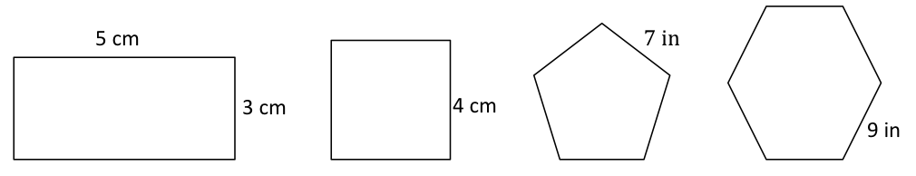

S: 3 centimeters.
T: (Write P = ___ cm + __ cm + __ cm + __ cm.) On your boards, find the perimeter by writing an addition sentence.
S: (Write P = 5 cm + 3 cm + 5 cm + 3 cm. Beneath it, write P = 16 cm.)
T: (Project square with a given side length of 4 cm.) What’s the length of each side of the square?
S: 4 centimeters.
T: (Write P = __ cm + __ cm + __ cm + __ cm.) Write the perimeter as an addition sentence.
S: (Write P = 4 cm + 4 cm + 4 cm + 4 cm. Beneath it, write P = 16 cm.)
Continue process with pentagon and hexagon.
Concept Development (34 minutes)
Materials: (T) Circle template (copied on cardstock), white string, black marker, ruler (S) White string, ruler, black marker, circle template (one circle per pair, copied on cardstock), personal white board
Note: The white string in the materials list will be used in both parts of this lesson. Be sure to cut the string so it is long enough to go around the item with the greatest perimeter in Part 2.
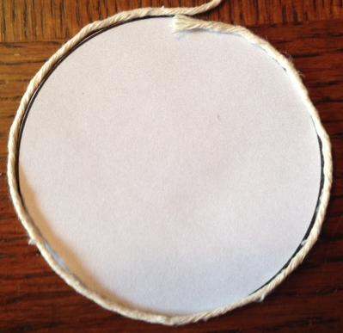
Part 1: Use string and a ruler to find the perimeter of a circle.
T: (Pass out a circle to each pair of students.) Talk to your partner: Does this circle have a perimeter?
S: I don’t think so because it doesn’t have straight lines. Remember when we made tessellations? Those shapes didn’t have straight lines, but they still had perimeters. The black line shows the boundary of the circle, so that’s the circle’s perimeter.
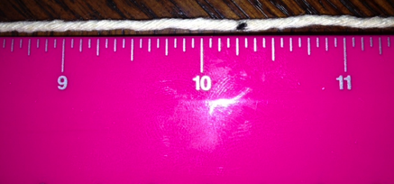
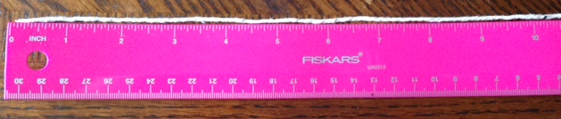
T: Can you find the perimeter of the circle in inches using just your ruler?

S: I don’t think so.
T: (Pass out white string to each pair of students.) Work with your partner to wrap the string around the perimeter of the circle. (Model.) Partner A, hold the string in place. Partner B, use the black marker to mark the string where it meets the end after going all the way around once.
S: (Mark string.)
T: What does the string around the circle represent?
S: The perimeter of the circle.
T: How can you use this string and your ruler to find the perimeter of the circle?
S: We can straighten the string out and measure it. Since the string has about the same length as the perimeter, we can use our rulers to measure the length of the string to the black mark.
T: Work with your partner to measure the length of the string from the end to where you made the mark. Record your measurement on your board to the nearest quarter inch.
S: (Measure string.)
T: What is the length of the string to the nearest quarter inch?
S: $\text{10}\frac{\text{1}}{\text{4}}$ inches!
T: So, the perimeter of the circle is…?
S: $\text{10}\frac{\text{1}}{\text{4}}$ inches!
Part 2: Use string and a ruler to find the perimeter of circular objects.
Materials: (S) Problem Set, markers, variety of circular objects (e.g., paper plates, lids, Frisbee, CDs, pie pans, cups, rolls of masking tape), ruler, white string
Students work in pairs at a station with 10 circular objects, applying what they learned in Part 1 to find the perimeters of those objects. (There may be more than one pair per station.) They use string and a ruler as tools.

NOTES ON
MULTIPLE MEANS
OF ACTION AND EXPRESSION:
Support English language learners as they construct their written responses on the Problem Set. Provide sentence starters and a word bank.
Sentence starters may include, “I agree/don’t agree because….”
Possible words for the word bank may include the following:
first then next finally
stretch string perimeter measure length long because

T: Work with a partner at your station to complete the chart in Problem 1 of the Problem Set. Use your string and a ruler to find the perimeters of 10 circular objects. Record the perimeters in the chart to the nearest quarter inch.
To prepare students:
- Explain how to use different color markers to mark the perimeter of each object on the string so that they can keep track of the length they are measuring.
- Clarify that, if necessary, students can get a new piece of string.
- Discuss how to use the string and a ruler to find the perimeter of a circular object that has a perimeter greater than 12 inches.
- Remind students that they are working with a partner and they need to be sure the work is done cooperatively.

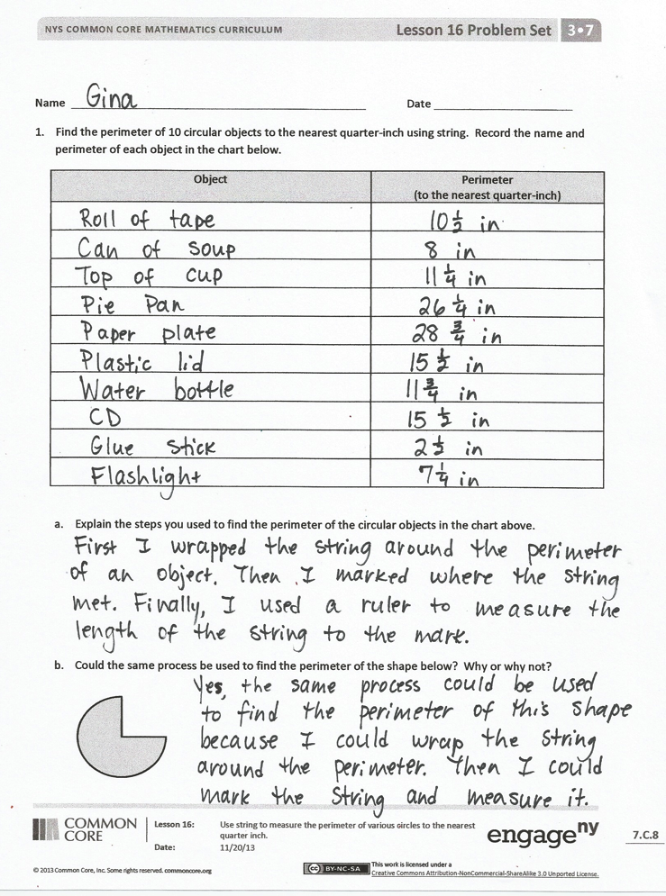
Problem Set (10 minutes)
Students should do their personal best to complete the Problem Set within the allotted 10 minutes. For some classes, it may be appropriate to modify the assignment by specifying which problems they work on first. Some problems do not specify a method for solving. Students solve these problems using the RDW approach used for Application Problems.
Student Debrief (10 minutes)
Lesson Objective: Use string to measure the perimeter of various circles to the nearest quarter inch.
The Student Debrief is intended to invite reflection and active processing of the total lesson experience.
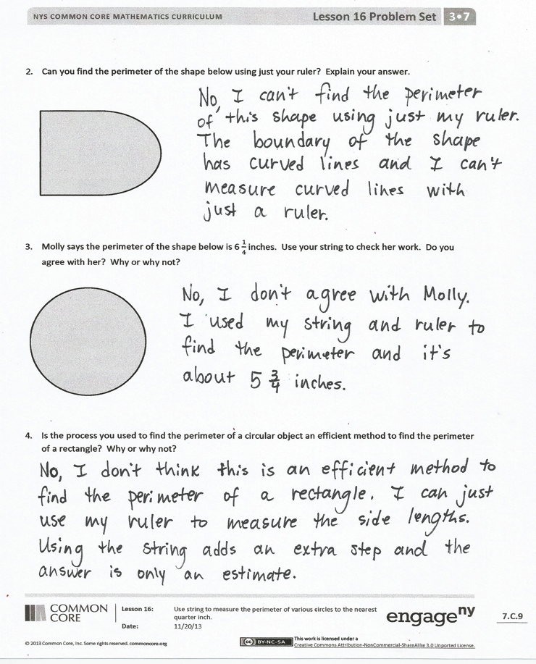
Invite students to review their solutions for the Problem Set. They should check work by comparing answers with a partner before going over answers as a class. Look for misconceptions or misunderstandings that can be addressed in the Debrief. Guide students in a conversation to debrief the Problem Set and process the lesson.
You may choose to use any combination of the questions below to lead the discussion.
- Look at your answers in the chart in Problem 1. Which circular object has the smallest perimeter? The greatest perimeter?
- Discuss your answer to Problem 1(b) with a partner. Can you use just a ruler to find the perimeter of this shape? Why or why not? Can you use your ruler to measure some of the side lengths? Which ones? Then how would you find the total perimeter?
MP.6
- Talk to a partner: Do you think the method we used today to find the perimeter of a circle gives the exact perimeter? Why or why not?
- Describe the steps you used to find the perimeter of the circle in Problem 3.
- Share answers to Problem 4.
- Extend discussion by having students compare the distance across the middle of a circle to the circle’s perimeter. They can then estimate to see that the circle’s perimeter is about 3 times greater.
Exit Ticket (3 minutes)
After the Student Debrief, instruct students to complete the Exit Ticket. A review of their work will help you assess the students’ understanding of the concepts that were presented in the lesson today and plan more effectively for future lessons. You may read the questions aloud to the students.

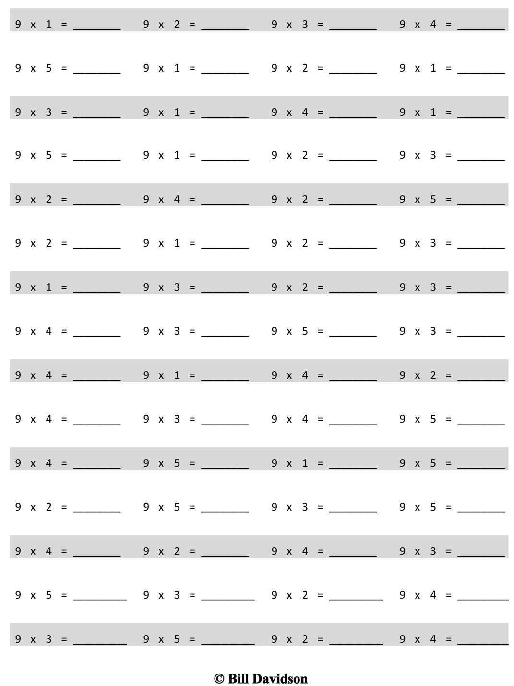
Multiply.

Name Date
- Find the perimeter of 10 circular objects to the nearest quarter inch using string. Record the name and perimeter of each object in the chart below.
Object | Perimeter  (to the nearest quarter inch)

- Explain the steps you used to find the perimeter of the circular objects in the chart above.

- Could the same process be used to find the perimeter of the shape below? Why or why not?

- Can you find the perimeter of the shape below using just your ruler? Explain your answer.

- Molly says the perimeter of the shape below is $\text{6}\frac{\text{1}}{\text{4}}$ inches. Use your string to check her work. Do you agree with her? Why or why not?

- Is the process you used to find the perimeter of a circular object an efficient method to find the perimeter of a rectangle? Why or why not?

Name Date
Use your ruler and string to the find the perimeter of the shape below to the nearest quarter inch.
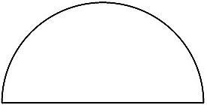

Name Date
  - Find the perimeter of 5 circular objects from home to the nearest quarter inch using string. Record the name and perimeter of each object in the chart below.
Object | Perimeter  (to the nearest quarter inch)
Example: Peanut Butter Jar Cap | $\text{9}\frac{1}{2}$ inches

- Explain the steps you used to find the perimeter of the circular objects in the chart above.

  - Use your string and ruler to find the perimeter of the two shapes below to the nearest quarter inch.
A

B

- Which shape has a longer perimeter?

- Find the difference between the two perimeters. Show your work.

  - Describe the steps you took to find the perimeter of the objects in Problem 2. Would you use this method to find the perimeter of a square? Explain why or why not.

