Lesson 14
Objective: Determine the perimeter of regular polygons and rectangles when whole number measurements are missing.

Suggested Lesson Structure
 Fluency Practice (12 minutes)
 Application Problem (5 minutes)
 Concept Development (33 minutes)
 Student Debrief (10 minutes)
Total Time (60 minutes)
Fluency Practice (12 minutes)
- Multiply by 9 3.OA.7 (8 minutes)
- Equivalent Counting with Units of 7 3.OA.7 (4 minutes)

Multiply by 9 (8 minutes)
Materials: (S) Multiply by 9 Pattern Sheet (6–10)
Note: This activity builds fluency with multiplication facts using units of 9. It works toward students knowing from memory all products of two one-digit numbers. See G3–M7–Lesson 1 for the directions for administration of a Multiply By pattern sheet.
T: (Write 7 × 9 = ____.) Let’s skip-count up by nines. I’ll raise a finger for each nine. (Count with fingers to 7 as students count.)
S: 9, 18, 27, 36, 45, 54, 63.
T: Let’s skip-count by nines starting at 45. Why is 45 a good place to start?
S: It’s a fact we already know so we can use it to figure out a fact we don’t know.
T: (Count up with fingers as students say numbers.)
S: 45 (5 fingers), 54 (6 fingers), 63 (7 fingers).
T: Let’s see how we can skip-count down to find the answer, too. Start at 90 with 10 fingers, 1 for each eight. (Count down with fingers as students say numbers.)
S: 90 (10 fingers), 81 (9 fingers), 72 (8 fingers), 63 (7 fingers).
Continue with the following suggested sequence: 9 × 9, 6 × 9, and 8 × 9.
T: (Distribute Multiply by 9 Pattern Sheet.) Let’s practice multiplying by 9. Be sure to work left to right across the page.

Equivalent Counting with Units of 7 (4 minutes)
Note: This activity builds fluency with multiplication facts using units of 7.
T: Count by sevens to 70. (Write as students count.)
S: 7, 14, 21, 28, 35, 42, 49, 56, 63, 70.
T: (Write 1 seven beneath the 7.) Count to 10 sevens. (Write as students count.)
7 14 21 28 35 42 49 56 63 70
1 seven 2 sevens 3 sevens 4 sevens 5 sevens 6 sevens 7 sevens 8 sevens 9 sevens 10 sevens

S: 1 seven, 2 sevens, 3 sevens, 4 sevens, 5 sevens, 6 sevens, 7 sevens, 8 sevens, 9 sevens, 10 sevens.
T: Let’s count to 10 sevens again. This time, stop when I raise my hand.
S: 1 seven, 2 sevens, 3 sevens.
T: (Raise hand.) Say the multiplication sentence.
S: 3 × 7 = 21.
T: Continue.
S: 4 sevens, 5 sevens.
T: (Raise hand.) Say the multiplication sentence.
S: 5 × 7 = 35.
T: Continue.
S: 6 sevens, 7 sevens, 8 sevens.
T: (Raise hand.) Say the multiplication sentence.
S: 8 × 7 = 56.
T: Continue.
S: 9 sevens, 10 sevens.
T: (Raise hand.) Say the multiplication sentence.
S: 10 × 7 = 70.
T: Let’s count back down, starting at 10 sevens.
Continue the process back down to 0 sevens or 1 seven.
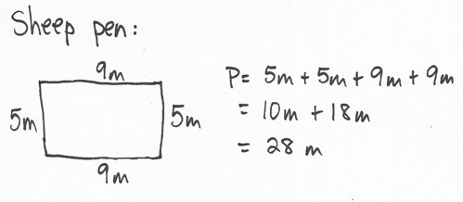
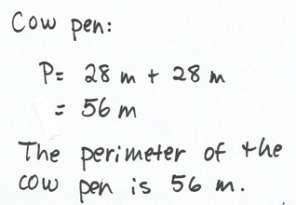
Application Problem (5 minutes)
A rectangular sheep pen measures 5 meters long and 9 meters wide. The perimeter of the cow pen is double the perimeter of the sheep pen. What is the perimeter of the cow pen?
Note: The Application Problem reviews G3–M7–Lesson 13 in solving perimeter word problems with given side lengths.
Concept Development (33 minutes)
Materials: (S) Personal white boards
Have students insert the shape template into their personal white boards.
Problem 1: Find perimeter of rectangles with missing side lengths.
6 cm
9 cm
T: (Project or draw rectangle as shown.) This shape is a rectangle. Use the given side lengths and what you know about rectangles to label the missing side lengths.
S: (Label missing side lengths.)
T: (Label the missing side lengths 6 cm and 9 cm.) Check your work against mine and make changes if you need to. (Allow students time to check their work.) Write an addition sentence that shows the perimeter of the rectangle.

NOTES ON
MULTIPLE MEANS OF ENGAGEMENT:
Vary the difficulty level of the work in Problem 1 of Concept Development by adjusting the numbers. Students who understand the concept quickly and calculate perimeter mentally may jump to the last challenge of calculating larger side lengths or side lengths that require conversions, such as the following:

2 ft
39 in
S: (Write 9 cm + 9 cm + 6 cm + 6 cm = 30 cm.)
T: What is the perimeter of the rectangle?
S: 30 centimeters!
T: Talk to a partner. What strategy did you use to add the side lengths?
S: I doubled 9 and doubled 6, and then added 18 plus 12 to get 30. I added 9 plus 6 to get 15 and then doubled 15 to get 30. I took 1 from each 6 to make tens with the 9’s. Then I added 10 + 5 + 10 + 5. I saw that I had 3 tens, which is 30.
Repeat the process, with the suggestions below. Students can sketch the rectangles with the given side lengths, label the missing side lengths, and then find the perimeter.
- A rectangle with side lengths of 10 inches and 8 inches.
- A rectangle with side lengths of 14 centimeters and 36 centimeters.
Problem 2: Find the perimeter of regular polygons with one side length given.
3 cm
T: (Project or draw the hexagon as shown.) This is a regular hexagon. Talk to a partner. How can the labeled side length help you find the missing side lengths?
MP.3
S: Since I know it’s a regular hexagon and I know one side length, I know the other side lengths. Yeah, since it’s a regular hexagon, I know that all the side lengths are equal. So, all 6 sides are each 3 centimeters.
T: That’s right. Label the missing side lengths.

NOTES ON
MULTIPLE MEANS OF REPRESENTATION:
Because regular has multiple meanings, a specific reminder to English language learners that it means equal-sided when used in the context of regular polygon may be helpful.

S: (Label missing side lengths.)
T: Write an addition sentence that shows the perimeter of the hexagon.
S: (Write 3 cm + 3 cm + 3 cm + 3 cm + 3 cm + 3 cm = 18 cm.)
T: What is the perimeter of the hexagon?
S: 18 centimeters!
T: Talk to a partner. Can you write your addition sentence as a multiplication sentence?
S: Yes, it’s repeated addition of 3. I can show that with multiplication. It shows 6 threes. I can write that as 6 × 3.
T: Write a multiplication sentence that shows the perimeter of the hexagon.
S: (Write 6 × 3 = 18.)
T: Discuss with a partner what the factors in this multiplication sentence represent.
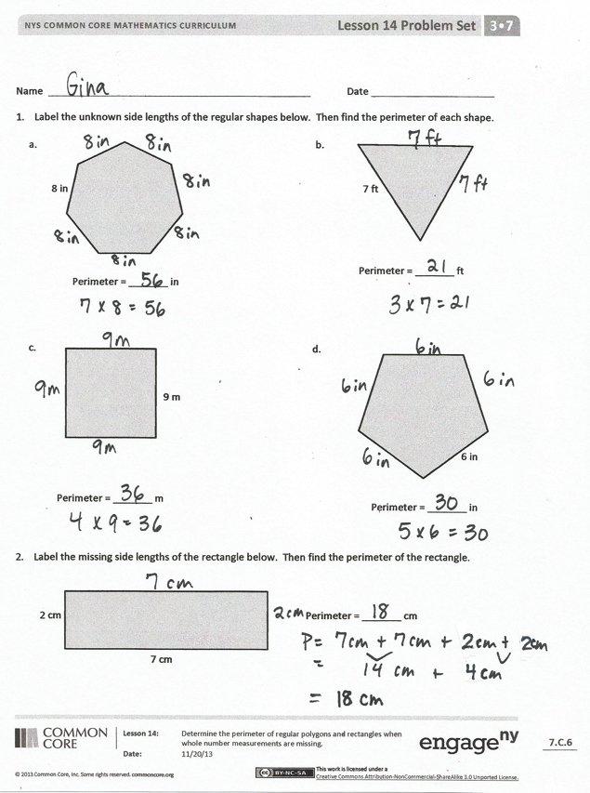
S: The 6 is the number of sides on the hexagon, and the 3 is the length of each of those sides.
T: Rewrite your multiplication sentence with units to show 6 sides times the length of each side.
S: (Write 6 × 3 cm = 18 cm.)
Repeat the process with the suggestions below. Students write both an addition and a multiplication sentence to find the perimeter of each shape.
- A regular pentagon with side lengths of 7 inches.
- A regular triangle (equilateral triangle) with side lengths of 17 centimeters. (Discuss using the break apart and distribute strategy to solve with multiplication.)
T: Talk to a partner: Which method is more efficient for finding the perimeter of a regular shape, adding or multiplying?
MP.3
S: I think multiplying is because it’s faster than adding. If the side lengths are small numbers, then multiplying. But if the side lengths were bigger, like 154, I would add instead.
Problem Set (10 minutes)
Students should do their personal best to complete the Problem Set within the allotted 10 minutes. For some classes, it may be appropriate to modify the assignment by specifying which problems they work on first. Some problems do not specify a method for solving. Students solve these problems using the RDW approach used for Application Problems.
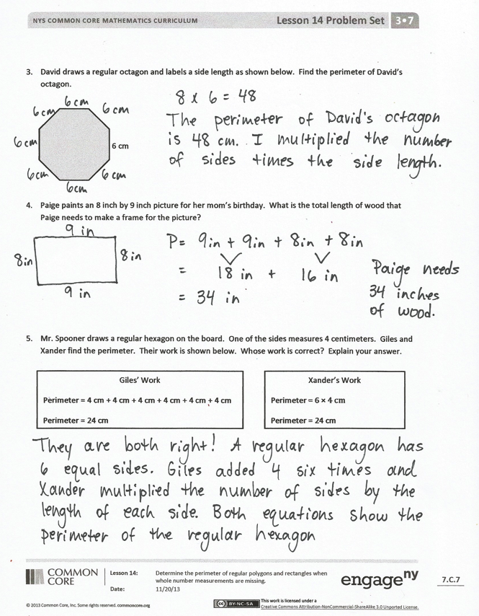
Student Debrief (10 minutes)
Lesson Objective: Determine the perimeter of regular polygons and rectangles when whole number measurements are missing.
The Student Debrief is intended to invite reflection and active processing of the total lesson experience.
Invite students to review their solutions for the Problem Set. They should check work by comparing answers with a partner before going over answers as a class. Look for misconceptions or misunderstandings that can be addressed in the Debrief. Guide students in a conversation to debrief the Problem Set and process the lesson.
You may choose to use any combination of the questions below to lead the discussion.
- Compare your work for Problem 1 with a partner’s work. Did you add or multiply to find the perimeters? Why?
- How was finding the perimeter in Problem 2 different from finding the perimeters in Problem 1?
- Tell your partner an addition and a multiplication equation for Problem 3. How are the equations related? How do they represent the perimeter of the octagon?
- What strategy did you use to add the side lengths in Problem 4? Explain your strategy choice to a partner.
- Share answers to Problem 5. Whose strategy is more efficient, Giles’ or Xander’s? Why?
- Explain to a partner how to find the perimeter of a regular shape given the name or picture of the shape and a side length.
Exit Ticket (3 minutes)
After the Student Debrief, instruct students to complete the Exit Ticket. A review of their work will help you assess the students’ understanding of the concepts that were presented in the lesson today and plan more effectively for future lessons. You may read the questions aloud to the students.

Multiply.
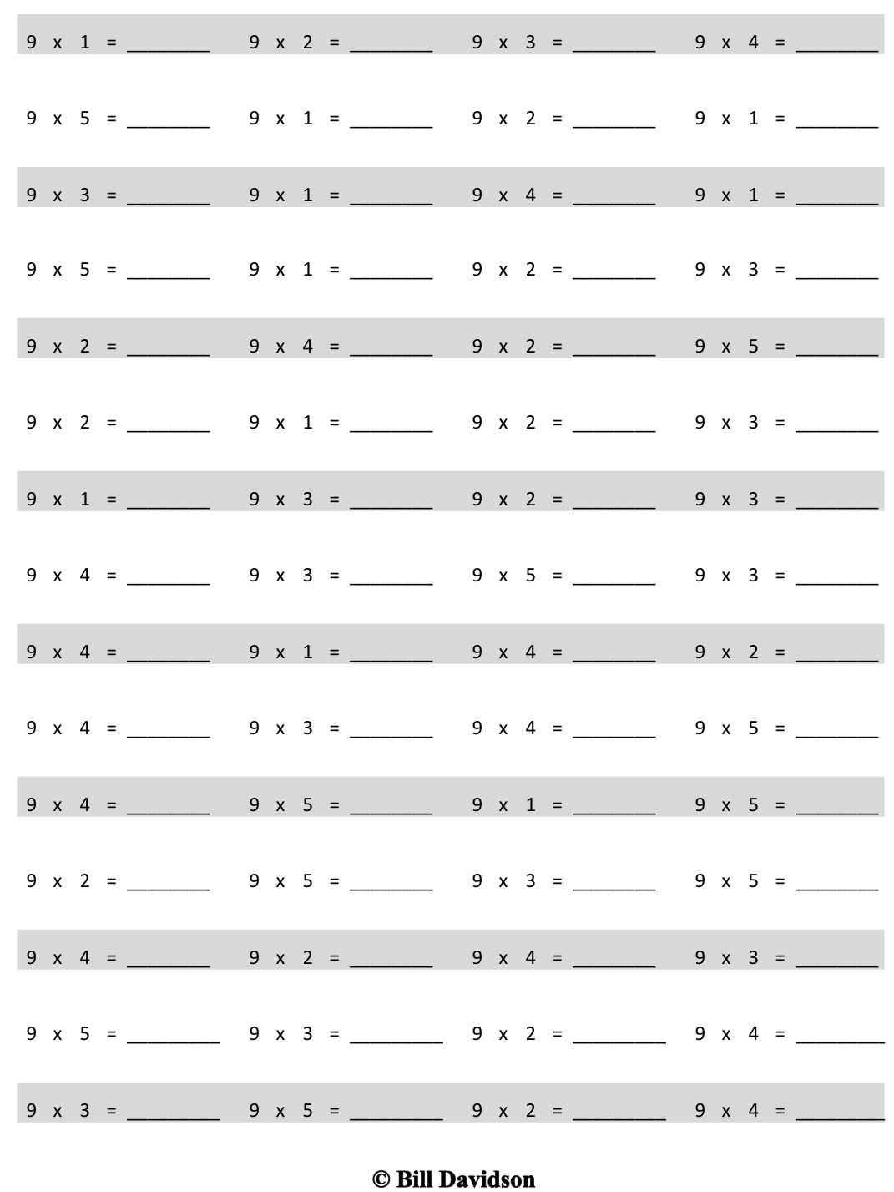

Name Date
- Label the unknown side lengths of the regular shapes below. Then find the perimeter of each shape.
a.
Perimeter = _______ in
8 in
b.
Perimeter = _______ ft
7 ft
c.
Perimeter = _______ m
9 m
d.
Perimeter = _______ in
6 in

- Label the missing side lengths of the rectangle below. Then find the perimeter of the rectangle.
Perimeter = _______ cm
7 cm
2 cm

- David draws a regular octagon and labels a side length as shown below. Find the perimeter of David’s octagon.
6 cm

- Paige paints an 8 inch by 9 inch picture for her mom’s birthday. What is the total length of wood that Paige needs to make a frame for the picture?

- Mr. Spooner draws a regular hexagon on the board. One of the sides measures 4 centimeters. Giles and Xander find the perimeter. Their work is shown below. Whose work is correct? Explain your answer.
Xander’s Work
Perimeter = 6 × 4 cm
Perimeter = 24 cm
Giles’ Work
Perimeter = 4 cm + 4 cm + 4 cm + 4 cm + 4 cm + 4 cm
Perimeter = 24 cm

Name Date
Travis traces a regular pentagon on his paper. Each side measures 7 centimeters. He also traces a regular hexagon on his paper. Each side of the hexagon measures 5 centimeters. Which shape has a greater perimeter? Show your work.

Name Date
- Label the unknown side lengths of the regular shapes below. Then find the perimeter of each shape.
a.
Perimeter = _______ in
b.
Perimeter = _______ cm
8 cm
c.
Perimeter = _______ m
d.
Perimeter = _______ in
6 in
9 m
4 in

- Label the missing side lengths of the rectangle below. Then find the perimeter of the rectangle.
Perimeter = _______ cm
9 cm
4 cm

- Roxanne draws a regular pentagon and labels a side length as shown below. Find the perimeter of Roxanne’s pentagon.
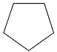
7 cm

- Each side of a square field measures 24 meters. What is the perimeter of the field?

- What is the perimeter of a rectangular sheet of paper that measures 8 inches by 11 inches?

