Lesson 12
Objective: Measure side lengths in whole number units to determine the perimeter of polygons.

Suggested Lesson Structure

NOTES ON
LESSON SEQUENCE:
In this lesson, the Application Problem comes after the Concept Development and before independent work time on the Problem Set. This provides students with an opportunity to apply their learning from the Concept Development to a word problem and debrief it as a class before moving on to independent application on the Problem Set. As a result, the 15 minutes for the Application Problem includes 10 minutes for the Problem Set.
 Fluency Practice (15 minutes)
 Concept Development (20 minutes)
 Application Problem (15 minutes)
 Student Debrief (10 minutes)
Total Time (60 minutes)
Fluency Practice (15 minutes)
- Multiply by 7 3.OA.7 (8 minutes)
- Equivalent Counting with Units of 3 3.OA.7 (4 minutes)
- Area and Perimeter 3.G.2 (3 minutes)

Multiply by 7 (8 minutes)
Materials: (S) Multiply by 7 Pattern Sheet (6–10)
Note: This activity builds fluency with multiplication facts using units of 7. It works toward students knowing from memory all products of two one-digit numbers. See G3–M7–Lesson 1 for the directions for administration of a Multiply By pattern sheet.
T: (Write 7 × 7 = ____.) Let’s skip-count up by sevens. I’ll raise a finger for each three. (Count with fingers to 7 as students count.)
S: 7, 14, 21, 28, 35, 42, 49.
T: Let’s skip-count by sevens starting at 35. Why is 35 a good place to start?
S: It’s a fact we already know, so we can use it to figure out a fact we don’t know.
T: (Count up with fingers as students say numbers.)
S: 35 (5 fingers), 42 (6 fingers), 49 (7 fingers).
T: Let’s see how we can skip-count down to find the answer, too. Start at 70 with 10 fingers, 1 for each seven. (Count down with fingers as students say numbers.)
S: 70 (10 fingers), 63 (9 fingers), 56 (8 fingers), 49 (7 fingers).
Continue with the following suggested sequence: 9 × 7, 6 × 7, and 8 × 7.
T: (Distribute Multiply by 7 Pattern Sheet.) Let’s practice multiplying by 7. Be sure to work left to right across the page.

Equivalent Counting with Units of 3 (4 minutes)
Note: This activity builds fluency with multiplication facts using units of 3. Stop the count by raising a hand.
T: Count by threes to 30. (Write as students count.)
S: 3, 6, 9, 12, 15, 18, 21, 24, 27, 30.
3 6 9 12 15 18 21 24 27 30
1 three 2 threes 3 threes 4 threes 5 threes 6 threes 7 threes 8 threes 9 threes 10 threes

T: (Write 1 three beneath the 3.) Count to 10 threes. (Write as students count.)
S: 1 three, 2 threes, 3 threes, 4 threes, 5 threes, 6 threes, 7 threes, 8 threes, 9 threes, 10 threes.
T: Let’s count to 10 threes again. This time, stop when I raise my hand.
S: 1 three, 2 threes, 3 threes.
T: (Raise hand.) Say the multiplication sentence.
S: 3 × 3 = 9.
T: Continue.
S: 4 threes, 5 threes.
T: (Raise hand.) Say the multiplication sentence.
S: 5 × 3 = 15.
Continue the process up to 10 threes and down to 0 threes.

Area and Perimeter (3 minutes)
Materials: (S) Grid paper
Note: This activity reviews G3–M7–Lesson 10.
T: On your grid paper, shade a rectangle that is 2 units wide by 3 units long.
S: (Shade a 2 unit by 3 unit rectangle.)
T: What is the area of the rectangle?
S: 6 square units!
T: Draw a line around the perimeter of the rectangle.
S: (Draw line around perimeter.)
T: At the signal, show your paper. (Signal.)
S: (Show paper with perimeter marked.)
Continue the process for the following possible suggestions: 4 units by 2 units and 5 units by 3 units.

Concept Development (20 minutes)
Materials: (S) Shape template, ruler, personal white board

NOTES ON
MULTIPLE MEANS OF REPRESENTATION:
When asking, “What forms the boundary of Shape A?” use gestures to convey the meaning clearly to English language learners. For example, while saying the word boundary, project or hold the shape and trace its sides.

T: (Pass out shape template.) Yesterday you learned that the boundary of a shape is the shape’s perimeter. What forms the boundary of Shape A? Talk to a partner.
S: The outside edges of the shape. The sides of the shape form the boundary.
T: The sides form the boundary of Shape A. Trace the perimeter of Shape A with your finger. (Allow students time to trace.) Your finger just traveled around the perimeter of Shape A. What tool can you use to figure out how many centimeters your finger traveled?
A
10 cm
10 cm
4 cm
4 cm
S: A ruler!
T: Measure and label the side lengths of Shape A in centimeters. (Allow students time to work, then project Shape A with side lengths labeled.) Check your side lengths against mine. Write and solve a number sentence to show how to find the total of Shape A’s side lengths.

NOTES ON
MULTIPLE MEANS OF REPRESENTATION:
Outlining the shapes on the template with glue that dries and makes a hard boundary may be beneficial to some students as they measure, particularly students with low vision.

MP.5
S: (Possible number sentences: 10 + 10 + 4 + 4 = 28. (2 × 10) + (2 × 4) = 20 + 8 = 28. (10 + 4) × 2 = 28.)
T: What strategy did you use to find the total of the side lengths?
S: I doubled 10 to get 20 and doubled 4 to get 8. Then I added 20 and 8 to get 28. That’s like what I did. I thought of it as 2 tens plus 2 fours. I added 10 and 4
to get 14. I knew there were 2 fourteens, so I doubled 14 to get 28.
T: What is 28 centimeters a measurement of?
S: The perimeter!
T: What kind of polygon is Shape A?
S: A quadrilateral because it has four sides. A parallelogram because it has two sets of parallel lines. A rectangle because the opposite sides are equal.
Repeat the process with Shapes B through E. Students measure the side lengths in centimeters, calculate the perimeter, discuss strategies for finding the total, and name each shape. As they are ready, release them to work independently or with a partner.

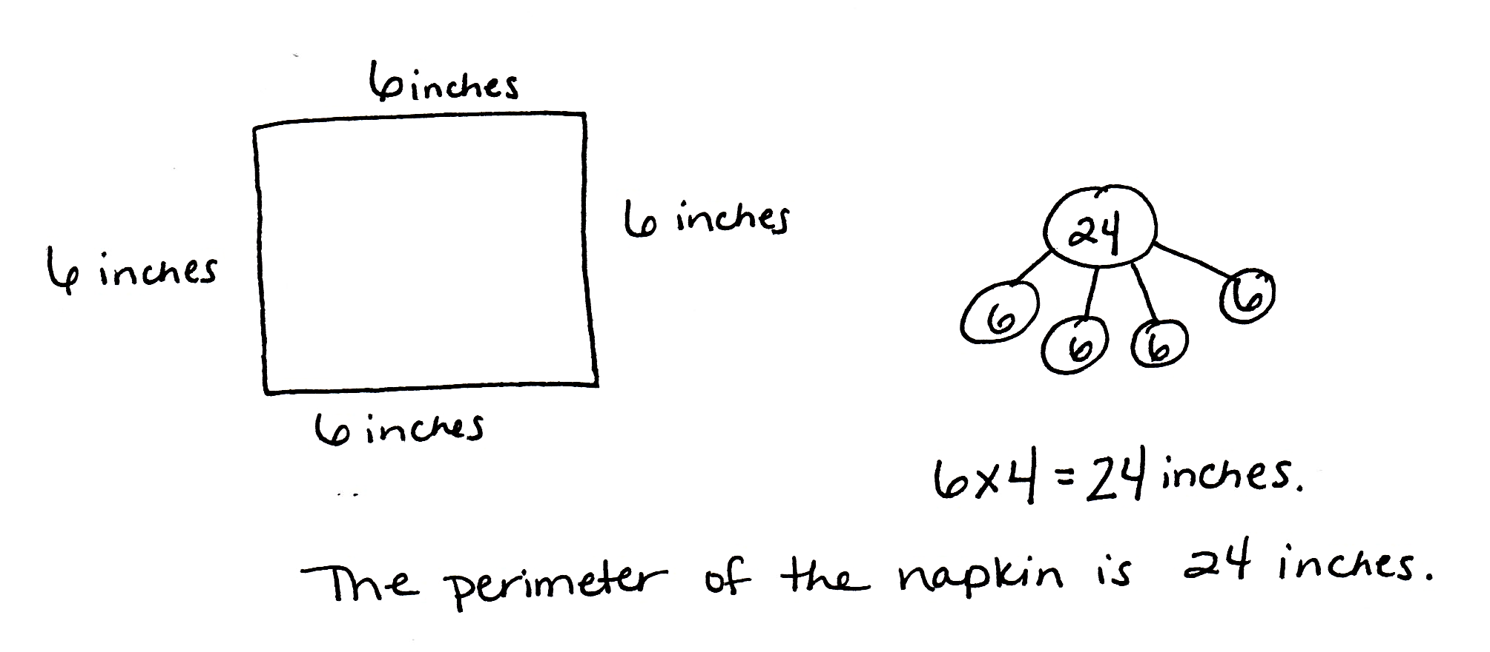
Application Problem (15 minutes)
Angela measures the sides of a square napkin with her ruler. Each side measures 6 inches. What is the perimeter of the napkin?
Note: This problem allows students to transfer their conceptual knowledge from the lesson to an Application Problem before practicing this independently with the remainder of the Problem Set.
Problem Set (10 minutes)
Students should do their personal best to complete the Problem Set within the allotted 10 minutes. For some classes, it may be appropriate to modify the assignment by specifying which problems they work on first. Some problems do not specify a method for solving. Students solve these problems using the RDW approach used for Application Problems.
Student Debrief (10 minutes)
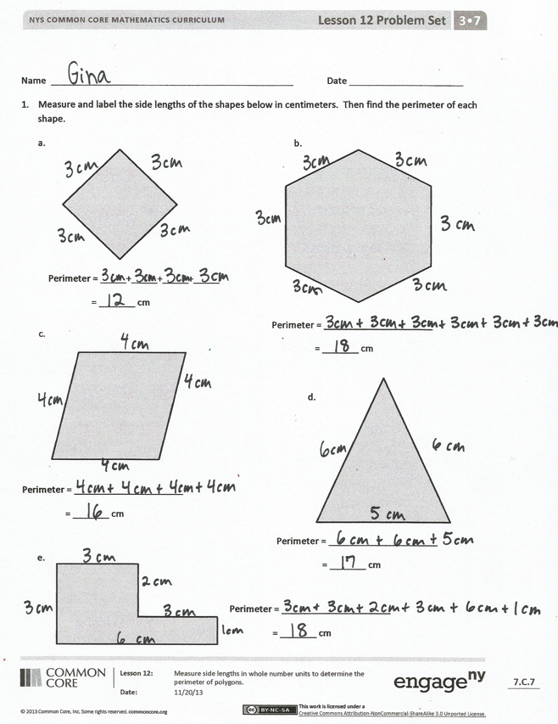
Lesson Objective: Measure side lengths in whole number units to determine the perimeter of polygons.
The Student Debrief is intended to invite reflection and active processing of the total lesson experience. Invite students to review their solutions for the Problem Set. They should check work by comparing answers with a partner before going over answers as a class. Look for misconceptions or misunderstandings that can be addressed in the Debrief. Guide students in a conversation to debrief the Problem Set and process the lesson.
You may choose to use any combination of the questions below to lead the discussion.
- Which shape has the smallest perimeter in Problem 1? How do you know?
- What unit did you use to record the perimeters of the shapes in Problem 1? Why?
- What do you notice about the perimeters of the shapes in Problems 1(b) and 1(e)?
- How did doing the Application Problem together help you get ready for the Problem Set?
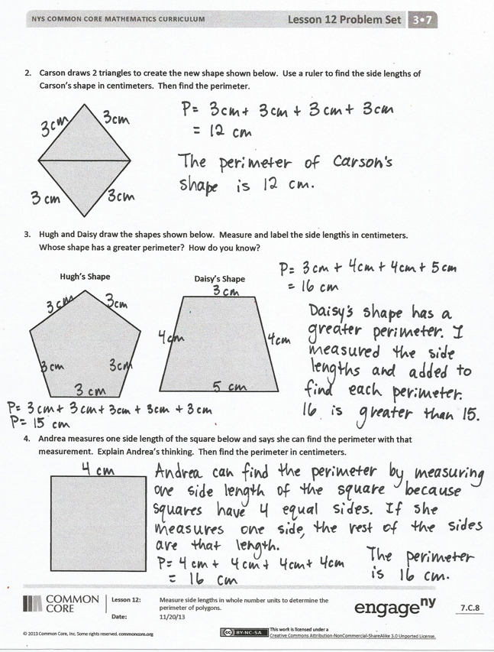
- How could you find the perimeter of each triangle in Problem 2?
- Whose shape has more sides in Problem 3? Do more sides mean a greater perimeter? Why or why not?
- What multiplication number sentence can you use to find the perimeter of the square in Problem 4? (This anticipates the work done in G3–M7–Lesson 15 of finding the perimeter of a regular polygon given one side length.)
- Explain to a partner how to use a ruler to find the perimeter of a shape.
Exit Ticket (3 minutes)
After the Student Debrief, instruct students to complete the Exit Ticket. A review of their work will help you assess the students’ understanding of the concepts that were presented in the lesson today and plan more effectively for future lessons. You may read the questions aloud to the students.

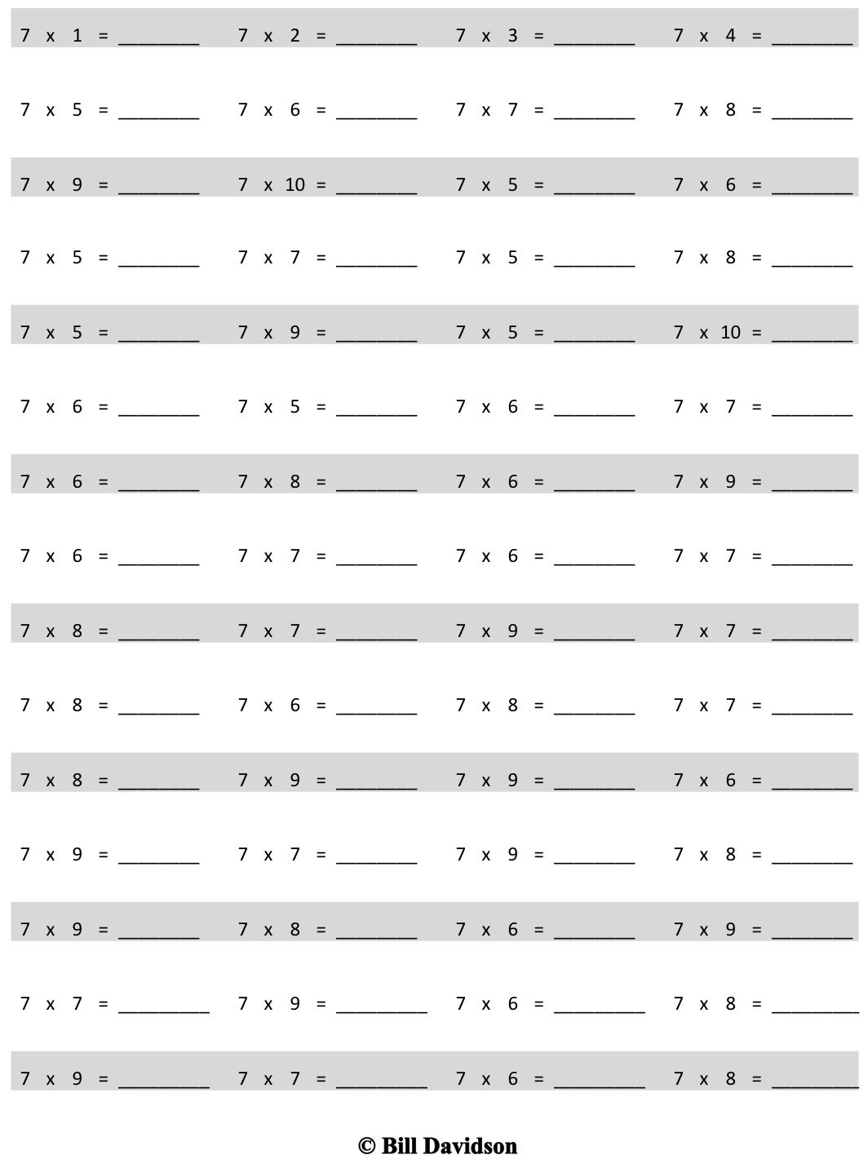
Multiply.
Name Date
- Measure and label the side lengths of the shapes below in centimeters. Then find the perimeter of each shape.
a. b.
Perimeter = _____+_____+_____+_____
= _______ cm
Perimeter = _____________________
= _______ cm

c.
Perimeter = _____________________
= _______ cm
d.
Perimeter = _____________________
= _______ cm
e.
Perimeter = _____________________
= _______ cm
- Carson draws two triangles to create the new shape shown below. Use a ruler to find the side lengths of Carson’s shape in centimeters. Then find the perimeter.

- Hugh and Daisy draw the shapes shown below. Measure and label the side lengths in centimeters. Whose shape has a greater perimeter? How do you know?
Hugh’s Shape
Daisy’s Shape

- Andrea measures one side length of the square below and says she can find the perimeter with that measurement. Explain Andrea’s thinking. Then find the perimeter in centimeters.

Name Date
Measure and label the side lengths of the shape below in centimeters. Then find the perimeter.
Perimeter = __________________________________________
= _______ cm

Name Date
- Measure and label the side lengths of the shapes below in centimeters. Then find the perimeter of each shape.
Perimeter = _____+_____+_____
= _______ cm
d.
Perimeter = _____________________
= _______ cm
Perimeter = _____________________
= _______ cm
b.
Perimeter = _____________________
= _______ cm
a.
c.

e.
Perimeter = _____________________
= _______ cm
- Melinda draws two trapezoids to create the hexagon shown below. Use a ruler to find the side lengths of Melinda’s hexagon in centimeters. Then find the perimeter.

- Victoria and Eric draw the shapes shown below. Eric says his shape has a greater perimeter because it has more sides than Victoria’s shape. Is Eric right? Explain your answer.
Eric’s Shape
Victoria’s Shape

- Jamal uses his ruler and a right angle tool to draw the rectangle shown below. He says the perimeter of his rectangle is 32 centimeters. Do you agree with Jamal? Why or why not?

A
B
C

E
D

