Lesson 10
Objective: Decompose quadrilaterals to understand perimeter as the boundary of a shape.

Suggested Lesson Structure
 Fluency Practice (12 minutes)
 Application Problem (8 minutes)
 Concept Development (30 minutes)
 Student Debrief (10 minutes)
Total Time (60 minutes)
Fluency Practice (12 minutes)
- Multiply by 7 3.OA.7 (8 minutes)
- Equivalent Counting with Units of 2 3.OA.7 (4 minutes)

Multiply by 7 (8 minutes)
Materials: (S) Multiply by 7 Pattern Sheet (1–5)
Note: This activity builds fluency with multiplication facts using units of 7. It works toward students knowing from memory all products of two one-digit numbers. See G3–M7–Lesson 1 for the directions for administration of a Multiply By pattern sheet.
T: (Write 5 × 7 = ____.) Let’s skip-count by sevens to find the answer. (Count with fingers to 5 as students count.)
S: 7, 14, 21, 28, 35.
T: (Circle 35 and write 5 × 7 = 35 above it. Write 3 × 7 = ____.) Let’s skip-count up by sevens again. (Count with fingers to 3 as students count.)
S: 7, 14, 21.
T: Let’s see how we can skip-count down to find the answer, too. Start at 35 with 5 fingers, 1 for each seven. (Count down with fingers as students say numbers.)
S: 35 (5 fingers), 28 (4 fingers), 21 (3 fingers).
Repeat the process for 4 × 7.
T: (Distribute Multiply by 7 Pattern Sheet.) Let’s practice multiplying by 7. Be sure to work left to right across the page.

Equivalent Counting with Units of 2 (4 minutes)
Note: This activity builds fluency with multiplication facts using units of 2.
T: Count by twos to 20. (Write as students count. See chart below.)
S: 2, 4, 6, 8, 10, 12, 14, 16, 18, 20.
T: (Write 1 two beneath the 2.) Count to 10 twos. (Write as students count.)
S: 1 two, 2 twos, 3 twos, 4 twos, 5 twos, 6 twos, 7 twos, 8 twos, 9 twos, 10 twos.
2 4 6 8 10 12 14 16 18 20
1 two 2 twos 3 twos 4 twos 5 twos 6 twos 7 twos 8 twos 9 twos 10 twos

T: Let’s count to 10 twos again. This time, stop when I raise my hand.
S: 1 two, 2 twos, 3 twos.
T: (Raise hand.) Say the multiplication sentence.
S: 3 × 2 = 6.
T: Continue.
S: 4 twos, 5 twos.
T: (Raise hand.) Say the multiplication sentence.
S: 5 × 2 = 10.
T: Continue.
S: 6 twos, 7 twos, 8 twos.
T: (Raise hand.) Say the multiplication sentence.
S: 8 × 2 = 16.
Continue the process up to 10 twos and down to 0 twos.

NOTES ON
MULTIPLE MEANS OF REPRESENTATION:
Scaffold the Application Problem with questions such as these:
- What do you know about the sides of a square?
- What other measures can you label?
- What is the area of the square?
- Shade the two large triangles. What is the shaded fraction of the square?
- What is the area of the two large triangles?

Application Problem (8 minutes)
Trista uses all seven of her tangram pieces to make a square as shown. One side of the large square is 4 inches long. What is the total area of the two large triangles? Explain your answer.

4 in

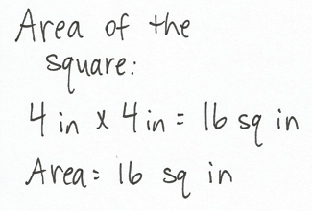
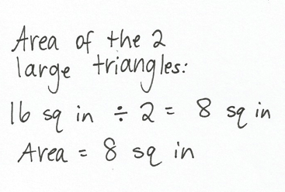
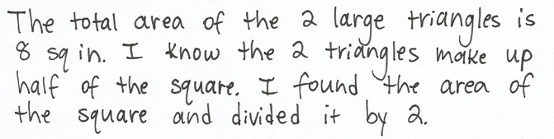

Note: This problem reviews the work done with tangrams in G3–M7–Lessons 8 and 9. It also reviews the concept of area from G3–Module 4. Students may not immediately recognize that the two large triangles make up half of the square. If necessary, have them use tangram pieces to demonstrate this before solving.
Concept Development (30 minutes)
Materials: (T) 2" square on cardstock, scissors, tape (S) 2" square on cardstock, tape, crayons, Problem Set, scissors, black markers, red markers, white string
Problem 1: Decompose a square to define perimeter.
Note: Students should save the shape created here for G3–M7–Lesson 11.
Use a 2-inch square to answer the questions below.
- Trace the square in the space below in red crayon.
- Trace the new shape you made with the square in the space below with a red crayon.
- Which shape has a greater perimeter? How do you know?
- Color the inside of the shapes in Problems 1(a) and 1(b) with a blue crayon.
- Which color represents the perimeters of the shapes? How do you know?
- What does the other color represent? How do you know?
- Which shape has a greater area? How do you know?
T: (Give each student a 2-inch square.) Trace your 2-inch square in Problem 1(a) with a red crayon.
S: (Trace square with red crayon.)
T: (Distribute white string.) Work with your partner to wrap the string around the outside edges of your square. (Model.) Partner A, hold the string in place. Partner B, use the black marker to mark the string where it meets the end after going all the way around once.
S: (Mark string.)
T: Switch roles to help your partner mark his or her string.
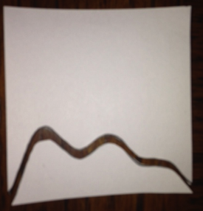
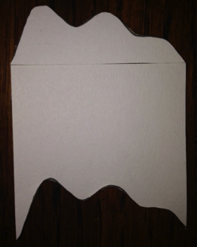
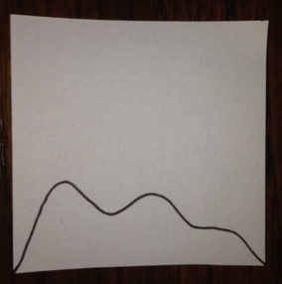
S: (Switch roles and mark string.)
T: Set your string aside. Draw a line from the top right hand corner of the square to the bottom right hand corner. Be creative! Your line shouldn’t be straight, but you will cut along it. Keep that in mind as you draw. (Model.)
S: (Draw line.)
T: Carefully cut along your line. (Model.)
S: (Cut along line.)
T: Use your finger to trace around the edge of the piece you cut out. We call the boundary of the shape its perimeter. Say the word to yourself as you trace.
S: Perimeter. (Trace.)
T: Slide the piece that you cut out to the opposite side of your square. Line up the straight edge of the piece that you cut out with the edge of the square. Tape the pieces together, making sure that there aren’t any gaps. (Model.)
S: (Slide and tape.)
T: What happened to the perimeter of the shape you cut out?
S: It got curvy instead of straight. Two sides changed and two sides stayed the same. Part of it is stuck to the square. The new perimeter is the edge of the whole new shape we made by taping.
T: Work with a partner to wrap your string around your new shape. This time use the red marker to mark the string where it meets the end after going all the way around once. Then switch roles so your partner can mark his or her string.
MP.3
S: (Mark string.)
T: The marks on your string represent the perimeters of the square and your new shape. Talk to a partner: Compare the perimeters of the square and your new shape.
S: The perimeter of my new shape is greater than the perimeter of the square. Yeah, mine too!
T: Did the area of the square change when you made your new shape? Talk to a partner.
S: We didn’t get rid of any part of the square, we just changed the way it looks. Yeah, the same amount of space is covered, so the area stays the same.
T: Follow the directions to complete Problem 1(b–g) on your Problem Set. (Allow students time to work.) Which color in Problems 1(a) and 1(b) represents the perimeter of the shapes?
S: Red!
T: What does the color blue represent?
S: Area!
Problem Set (5 minutes)
Students should do their personal best to complete Problems 2 and 3 of the Problem Set within the allotted 5 minutes.
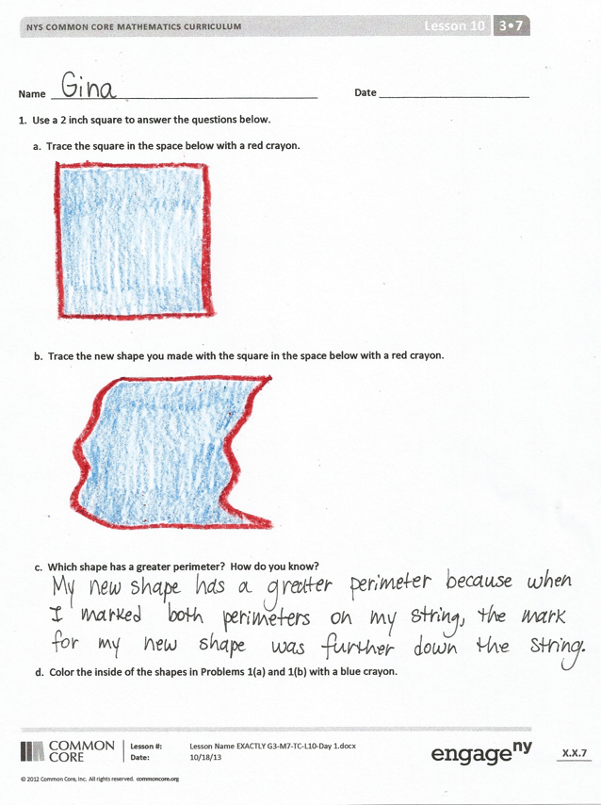
Student Debrief (10 minutes)
Lesson Objective: Decompose quadrilaterals to understand perimeter as the boundary of a shape.
The Student Debrief is intended to invite reflection and active processing of the total lesson experience.
Invite students to review their solutions for the Problem Set. They should check work by comparing answers with a partner before going over answers as a class. Look for misconceptions or misunderstandings that can be addressed in the Debrief. Guide students in a conversation to debrief the Problem Set and process the lesson.
You may choose to use any combination of the questions below to lead the discussion.
- Does the shape you drew in Problem 1(a) have the same perimeter as the shape your partner drew for Problem 1(a)? How do you know?
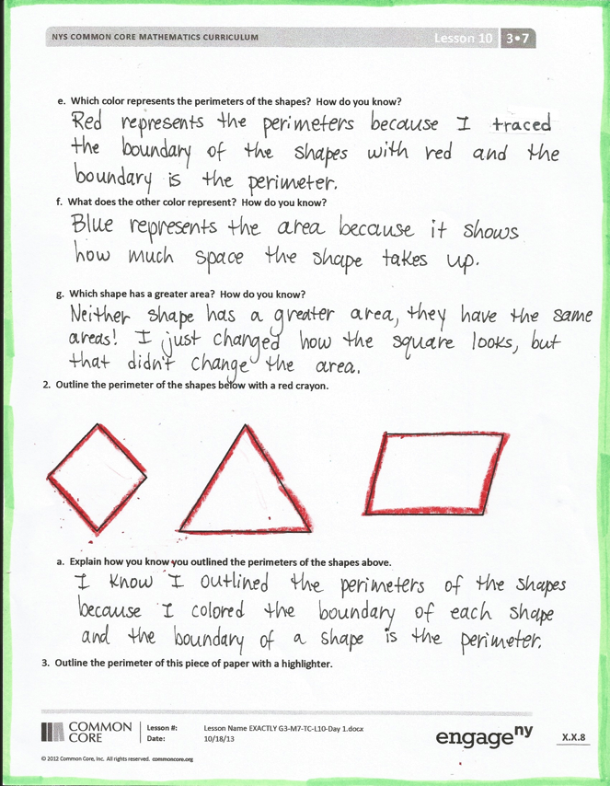
- Use your string to compare the perimeter of your new shape to your partner’s. Whose shape has a greater perimeter? How do you know?
- How is area different than perimeter? Why did the perimeter of the shape change, but the area stay the same?
- Explain to a partner how you could use your piece of string to figure out which shape has the greatest perimeter in Problem 2.
Exit Ticket (3 minutes)
After the Student Debrief, instruct students to complete the Exit Ticket. A review of their work will help you assess the students’ understanding of the concepts that were presented in the lesson today and plan more effectively for future lessons. You may read the questions aloud to the students.

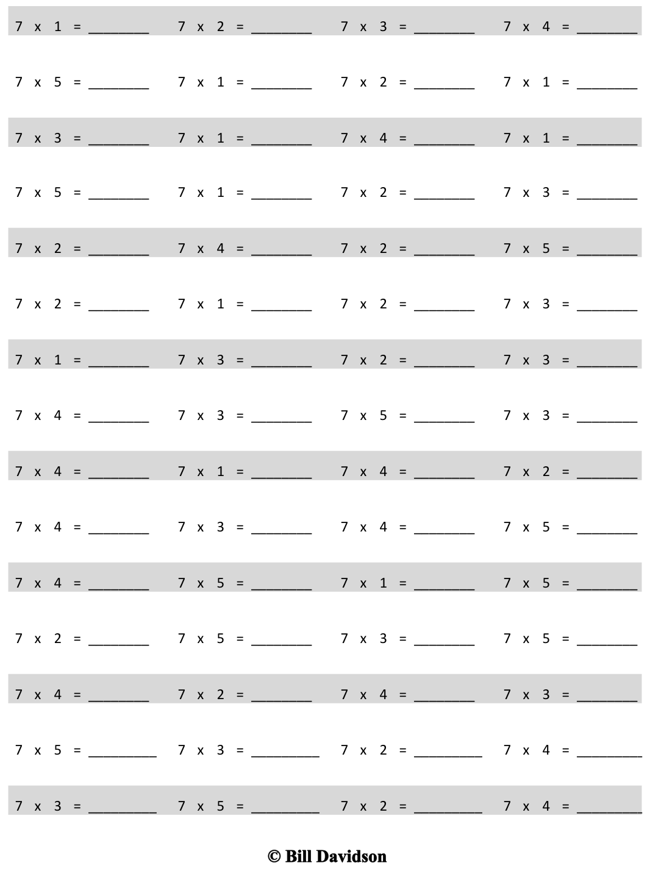
Multiply.
Name Date
- Use a 2-inch square to answer the questions below.
  - Trace the square in the space below with a red crayon.

  - Trace the new shape you made with the square in the space below with a red crayon.

- Which shape has a greater perimeter? How do you know?

- Color the inside of the shapes in Problems 1(a) and 1(b) with a blue crayon.

- Which color represents the perimeters of the shapes? How do you know?

- What does the other color represent? How do you know?

- Which shape has a greater area? How do you know?

- Outline the perimeter of the shapes below with a red crayon.

- Explain how you know you outlined the perimeters of the shapes above.

- Outline the perimeter of this piece of paper with a highlighter.

Name Date
Jason paints the outside edges of a rectangle purple. Celeste paints the inside of the rectangle yellow.
- Use your crayons to color the rectangle that Jason and Celeste painted.

- Which color represents the perimeter of the rectangle? How do you know?

Name Date
  - Trace the perimeter of the shapes below with a blue crayon.

- Explain how you know you traced the perimeters of the shapes above.

- Explain how you could use a string to figure out which shape above has the greatest perimeter.

  - Draw a rectangle on the grid below.

- Trace the perimeter of the rectangle with a blue crayon.
- Color the area of the rectangle red.
- How is the perimeter of the rectangle different than the area of the rectangle?

  - Maya draws the shape shown below. Noah colors the inside of Maya’s shape as shown. Noah says he colored the perimeter of Maya’s shape. Maya says Noah colored the area of her shape. Who is right? Explain your answer.

