Lesson 7
Objective: Reason about composing and decomposing polygons using tetrominoes.

Suggested Lesson Structure
 Fluency Practice (15 minutes)
 Concept Development (35 minutes)
 Student Debrief (10 minutes)
Total Time (60 minutes)
Fluency Practice (15 minutes)
- Multiply by 5 3.OA.7 (8 minutes)
- Physiometry 3.G.1 (3 minutes)
- Classify the Shape 3.G.1 (4 minutes)

Multiply by 5 (8 minutes)
Materials: (S) Multiply by 5 Pattern Sheet (6–10)
Note: This activity builds fluency with multiplication facts using units of 5. It works toward students knowing from memory all products of two one-digit numbers. See G3–M7–Lesson 1 for directions for administration of Multiply By pattern sheet.
T: (Write 7 × 5 = ____.) Let’s skip-count up by fives. I’ll raise a finger for each five. (Count with fingers to 7 as students count.)
S: 5, 10, 15, 20, 25, 30, 35.
T: Let’s skip-count by fives starting at 25. Why is 25 a good place to start?
S: It’s a fact we already know, so we can use it to figure out a fact we don’t know.
T: (Count up with fingers as students say numbers.)
S: 25 (5 fingers), 30 (6 fingers), 35 (7 fingers).
T: Let’s see how we can skip-count down to find the answer, too. Start at 50 with 10 fingers, 1 for each five. (Count down with fingers as students say numbers.)
S: 50 (10 fingers), 45 (9 fingers), 40 (8 fingers), 35 (7 fingers).
Continue with the following suggested sequence: 9 × 5, 6 × 5, and 8 × 5.
T: (Distribute Multiply by 5 Pattern Sheet.) Let’s practice multiplying by 5. Be sure to work left to right across the page.
Physiometry (3 minutes)
Note: Kinesthetic memory is strong memory. This fluency activity reviews terms from G3–M7–Lessons 4 and 5.
T: Stand up.
S: (Stand up.)
T: (Stretch one arm up, directly at the ceiling. Stretch the other arm parallel to the floor.) What type of angle do you think I’m modeling with my arms?
S: Right angle.
T: Model a right angle with your arms.
S: (Mirror teacher.)
T: (Stretch the arm parallel to the floor towards the ceiling. Move the arm pointing towards the ceiling so that it points towards the opposite wall.) Model another right angle.
S: (Mirror teacher.)
T: How many sides does a triangle have?
S: Three sides.
T: Using your arms, model a triangle with the person standing next to you.
S: (Model triangle in pairs.)
T: What do we call a four-sided figure?
S: Quadrilateral.
T: Use your body to make a quadrilateral with your partner.
S: (Model quadrilateral in pairs.)
T: (Point to a side wall.) Point to the wall that runs parallel to the one I’m pointing to.
S: (Point to the opposite side wall.)
T: (Point at back wall so students point to the front wall.)
T: (Point at front wall so students point to the back wall.)
T: Point to the walls that make a right angle with the wall I’m pointing to.
T: (Point at back wall so students point to the side walls.)
T: (Point at side wall so students point to the front and back walls.)
Repeat with the front wall.
Classify the Shape (4 minutes)
Materials: (S) Personal white boards
Note: This fluency activity reviews G3–M7–Lesson 4.
T: (Project a trapezoid.) How many sides does this shape have?
S: Four sides.
T: Shapes that have four sides are called…?
S: Quadrilaterals.
T: How many sets of parallel lines does this quadrilateral have?
S: One set.
T: What do we call quadrilaterals that have at least one set of parallel lines?
S: Trapezoids.
T: (Project a parallelogram with no angles that measure 90°.) Is this shape a quadrilateral?
S: Yes.
T: Why?
S: It has four sides.
T: Is this quadrilateral a trapezoid?
S: Yes.
T: Why?
S: It has at least one set of parallel lines.
T: How many sets of parallel sides does it have?
S: Two sets of parallel sides.
T: What do we call all quadrilaterals that have two sets of parallel sides?
S: Parallelograms.
T: (Project a rectangle that is not a square.) Is it a quadrilateral?
S: Yes.
T: Why?
S: It has four sides.
T: Write how many right angles this quadrilateral has.
S: (Write 4.)
T: Is this quadrilateral a trapezoid?
S: Yes.
T: Why?
S: It has at least one set of parallel lines.
T: Is this trapezoid also a parallelogram?
S: Yes.
T: Why?
S: It has two sets of parallel sides.
T: On your boards, write down the name of quadrilaterals that have four right angles and two sets of parallel sides.
S: (Write rectangle.)
T: (Project a square.) Is this shape a quadrilateral?
S: Yes.
T: Why?
S: It has four sides.
T: On your boards, write how many right angles this quadrilateral has.
S: (Write 4.)
T: Is this quadrilateral a trapezoid?
S: Yes.
T: Why?
S: It has at least one set of parallel lines.
T: Is this trapezoid also a parallelogram?
S: Yes.
T: Why?
S: It has two sets of parallel sides.
T: Is this parallelogram also a rectangle?
S: Yes.
T: Why?
S: It has two sets of parallel sides and four right angles.
T: The sides of this rectangle are equal. What do we call a rectangle with equal side lengths?
S: Square.
T: (Project hexagon.) How many sides does the shape have?
S: Six sides.
T: What do we call a shape with six sides?
S: Hexagon.
Repeat the process for pentagon.
Concept Development (35 minutes)
Materials: (T) Tetrominoes set (S) Problem Set, tetrominoes set, crayons
Note on materials: The templates in this lesson are full sheets of each of the five types of tetrominoes (shown below). Make copies of each template on a different color cardstock to color code the pieces. Then cut the tetrominoes out and bag sets that include multiple copies of each tetromino type for student use during the lesson. Enlist the help of volunteers to assist you in preparing the tetrominoes for this lesson.
Problem 1: Use tetrominoes to compose polygons.
T: (Project or hold up tetrominoes.) Each of these shapes is called a tetromino. The area of each tetromino is measured in square units. What is the area of each one in square units?
S: 4 square units.
T: Notice that each square unit shares a whole side with another square. Whisper the name of these shapes to a partner.

NOTES ON
MULTIPLE MEANS OF REPRESENTATION:
Tetromino is pronounced /tɛˈtrɑːmɪnoʊ/. If helpful, explain to English language learners and others that the number prefix tetra- brings a meaning of four, similar to the number prefix quadr-. Relate tetromino to familiar words, such as the video game Tetris and domino (having two squares).

S: (Whisper tetromino to a partner.)
T: Take a few minutes to make some shapes with the tetrominoes. (Allow students time to explore.) What shapes did you make?
S: (Possible responses include rectangle, square, and hexagon.)
T: Tell your partner how you moved the tetrominoes to make them fit together.
S: I turned some of the pieces. I rotated them.
T: To make shapes you’ll have to rotate them, and sometimes even flip them over (demonstrate turning one over so the back is face up). Read Problem 1.
S: (Read: Use tetrominoes to create at least two different rectangles. Then color the grid below to show how you created your rectangles. You may use the same tetromino more than once.)

Tetrominoes
T: Look at the grid in Problem 1. How many squares will you color for each tetromino you use?
S: Four squares!
T: How will someone who looks at your grid be able to tell which tetromino pieces you used to make each rectangle?
S: I can color the grid the same color as the tetromino pieces! I can color the squares on the grid to look like the shape of each tetromino that I use.
T: Go ahead and use your tetrominoes to answer Problem 1. (Circulate.)
T: Talk to a partner: How do you know the shapes that you made in Problem 1 are rectangles?
S: They look like rectangles! I counted the units for the sides of my shapes. The opposite sides are equal. I know rectangles have opposite sides that are equal. I can use the corner of an index card to make sure my shapes have four right angles. My shapes have two sets of parallel lines, like a rectangle. Opposite sides that are equal, four right angles, and two sets of parallel lines are attributes of rectangles. My shapes have all of these attributes, so my shapes are rectangles!
MP.3
T: Talk to a partner: What is the smallest rectangle you can make with tetrominoes? How do you know?
S: A 1 unit by 4 unit rectangle. The long, straight tetromino is already a rectangle, and its area is 4 square units. Or, we could make a 2 unit by 2 unit rectangle with the square piece. The square is a rectangle too and its area is 4 square units!
T: Work with a partner to make the smallest rectangle you can without using the square or long, straight tetromino. (Allow students time to work.)
S: We made a 3 unit by 4 unit rectangle with two T-shaped tetrominoes and one L-shaped tetromino. We made the same size rectangle, but we used two L-shaped tetrominoes and one Z-shaped tetromino. I think our rectangle is the smallest because we made a 2 by 4 rectangle using two L-shaped tetrominoes.
Problem 2: Use tetrominoes to compose polygons with given areas.
T: Read Problem 2.

NOTE ON
MULTIPLE MEANS OF ENGAGEMENT:
Part of the excitement of having to find two combinations that make a square is that once the first square comes together, students are excited to see what other pieces they can use to make the second square. To vary the level of challenge, limit which pieces or how many they can use.

S: (Read: Use tetrominoes to create at least two squares, each with an area of 36 square units. Then color the grid below to show how you created your square. You may use the same tetromino more than once.
  - Write a number sentence to show the area of a square above as the sum of the areas of the tetrominoes you used to make the square.
  - Write a number sentence to show the area of a square above as the product of its side lengths.)
T: How is Problem 2 different from Problem 1?
S: It tells us the area of the square has to be 36 square units.
T: Talk to your partner: How many tetrominoes will you use to solve Problem 2? How do you know?
S: Enough to fill 36 square units. Nine tetrominoes, because each tetromino has an area of 4 square units and 9 × 4 = 36! I can also divide to figure it out, like this: 36 ÷ 4 = 9.
T: What will be the side lengths of your square? How do you know?
S: 6 units, because the side lengths of a square are equal.
T: Talk to a partner: How can the grid help you make a square with an area of 36 square units?
S: I can mark a 6 by 6 square on the grid so that I know my square has the right area. Then I can just color the grid–I don’t even need to use the tetrominoes. I think after I colored the grid, I would build the square with the tetrominoes, just to be sure!
T: If that works for you, then use that strategy. Or, you can use the strategy you used with the rectangles and build with the tetrominoes first, and then color the grid.
Have students solve all of Problem 2. When students are done, facilitate a discussion using the following suggested questions.
- How do you know your shape is a square?
- What is the smallest square you can make with tetrominoes?
- What is the smallest square you can make without using the square tetromino?
- Can you make a square with tetrominoes that has an area of 25 square units? Why or why not?

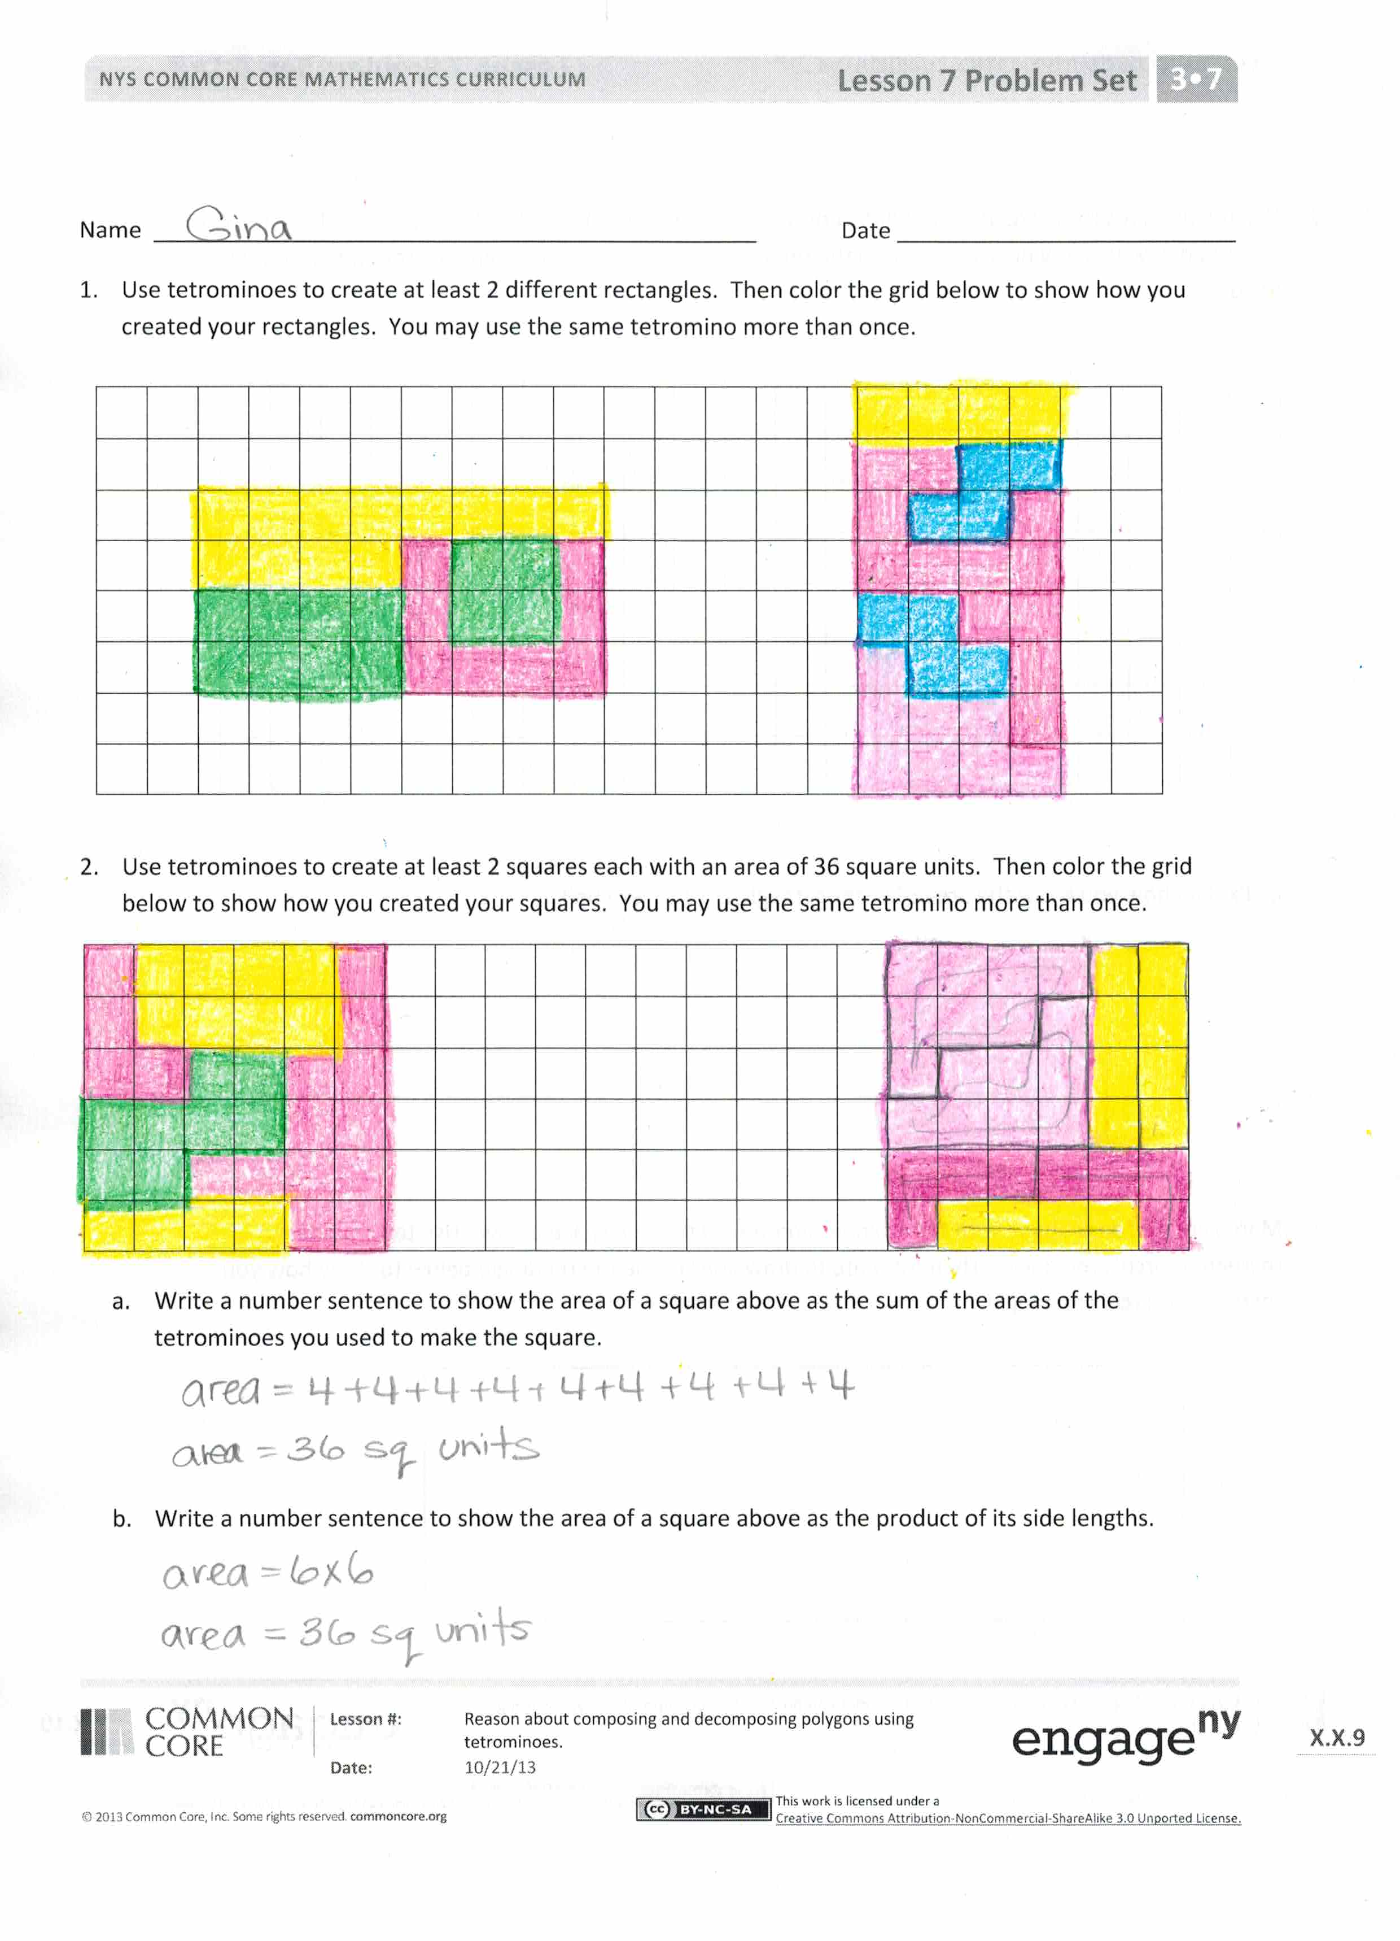
Problem Set (10 minutes)
Students should do their personal best to complete the Problem Set within the allotted 10 minutes. For some classes, it may be appropriate to modify the assignment by specifying which problems they work on first. Some problems do not specify a method for solving. Students solve these problems using the RDW approach used for Application Problems.
Student Debrief (10 minutes)
Lesson Objective: Reason about composing and decomposing polygons using tetrominoes.
The Student Debrief is intended to invite reflection and active processing of the total lesson experience.
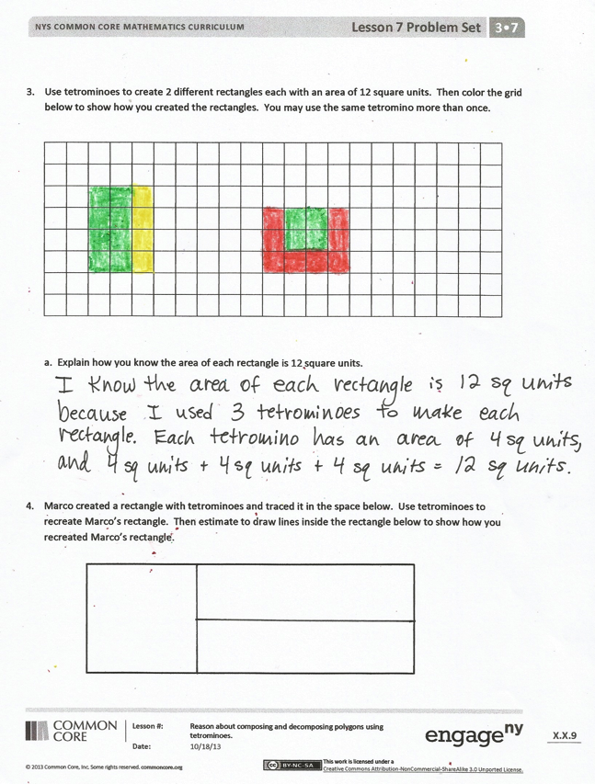
Invite students to review their solutions for the Problem Set. They should check work by comparing answers with a partner before going over answers as a class. Look for misconceptions or misunderstandings that can be addressed in the Debrief. Guide students in a conversation to debrief the Problem Set and process the lesson.
You may choose to use any combination of the questions below to lead the discussion.
- Compare the rectangles you made in Problem 1 to a partner’s. How are they the same? How are they different?
- Compare the squares you made in Problem 2 to a partner’s. How are they the same? How are they different?
- Say the addition number sentence in Problem 2(a) as a multiplication number sentence. Explain to a partner what the factors in the multiplication number sentence represent.
- Invite students to share how they justified their solution to Problem 3(a).
- Share solutions to Problem 4.
- What are two attributes of tetrominoes?

Exit Ticket (3 minutes)
After the Student Debrief, instruct students to complete the Exit Ticket. A review of their work will help you assess the students’ understanding of the concepts that were presented in the lesson today and plan more effectively for future lessons. You may read the questions aloud to the students.

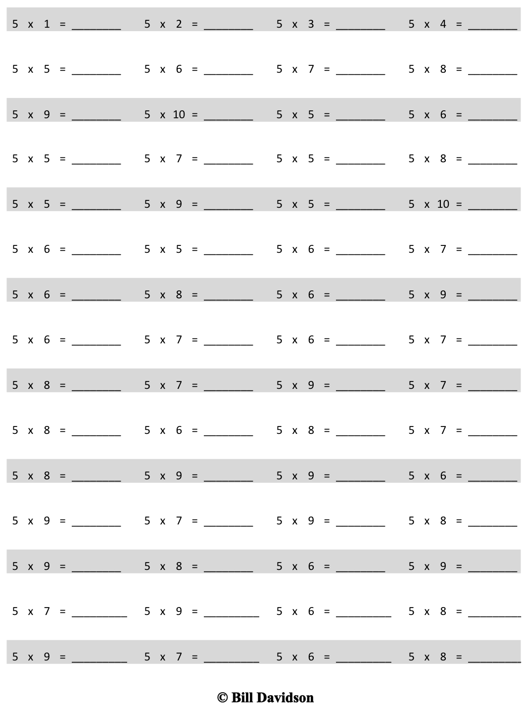
Multiply.
Name Date
- Use tetrominoes to create at least two different rectangles. Then color the grid below to show how you created your rectangles. You may use the same tetromino more than once.

- Use tetrominoes to create at least two squares, each with an area of 36 square units. Then color the grid below to show how you created your squares. You may use the same tetromino more than once.

  - Write a number sentence to show the area of a square above as the sum of the areas of the tetrominoes you used to make the square.

  - Write a number sentence to show the area of a square above as the product of its side lengths.

- Use tetrominoes to create at least two different rectangles each with an area of 12 square units. Then color the grid below to show how you created the rectangles. You may use the same tetromino more than once.

  - Explain how you know the area of each rectangle is 12 square units.

- Marco created a rectangle with tetrominoes and traced it in the space below. Use tetrominoes to recreate Marco’s rectangle. Then estimate to draw lines inside the rectangle below to show how you recreated Marco’s rectangle.

Name Date
Use your tetrominoes to make a rectangle that has an area of 20 square units. Then color the grid to show how you made your rectangle. You may use the same tetromino more than once.

Name Date
- Color tetrominoes on the grid to create three different rectangles. You may use the same tetromino more than once.

Tetrominoes

- Color tetrominoes on the grid below:

Tetrominoes
- To create a square with an area of 16 square units.
- Create at least two different rectangles each with an area of 24 square units.
You may use the same tetromino more than once.
- Explain how you know the rectangles you created in Problem 2(b) have the correct area.

