Lesson 6
Objective: Draw polygons with specified attributes to solve problems.

Suggested Lesson Structure
 Fluency Practice (12 minutes)
 Application Problem (8 minutes)
 Concept Development (30 minutes)
 Student Debrief (10 minutes)
Total Time (60 minutes)
Fluency Practice (12 minutes)
- Equivalent Counting with Units of 7 3.OA.7 (4 minutes)
- Classify the Shape 3.G.1 (5 minutes)
- Physiometry 3.G.1 (3 minutes)

Equivalent Counting with Units of 7 (4 minutes)
Note: This activity builds fluency with multiplication facts using units of 7. The progression builds in complexity. Work the students up to the highest level of complexity in which they can confidently participate.
T: Count to 10. (Write as students count. See chart below.)
S: 1, 2, 3, 4, 5, 6, 7, 8, 9, 10.
1 2 3 4 5 6 7 8 9 10
1 seven 2 sevens 3 sevens 4 sevens 5 sevens 6 sevens 7 sevens 8 sevens 9 sevens 10 sevens
7 14 21 28 35 42 49 56 63 70
1 seven 14 3 sevens 28 5 sevens 42 7 sevens 56 9 sevens 70
7 2 sevens 21 4 sevens 35 6 sevens 49 8 sevens 63 10 sevens

T: (Write 1 seven beneath the 1.) Count to 10 sevens. (Write as students count.)
S: 1 seven, 2 sevens, 3 sevens, 4 sevens, 5 sevens, 6 sevens, 7 sevens, 8 sevens, 9 sevens, 10 sevens.
T: Count by sevens to 70. (Write as students count.)
S: 7, 14, 21, 28, 35, 42, 49, 56, 63, 70.
T: (Write 1 seven beneath the 7. Write 14 beneath the 14.) I’m going to give you a challenge. Let’s alternate between saying the units of seven and the number. (Write as students count.)
S: 1 seven, 14, 3 sevens, 28, 5 sevens, 42, 7 sevens, 56, 9 sevens, 70.
T: (Write 7 beneath 1 seven and 2 sevens beneath the 14.) Let’s alternate again. (Write as students count.)
S: 7, 2 sevens, 21, 4 sevens, 35, 6 sevens, 49, 8 sevens, 63, 10 sevens.
Classify the Shape (5 minutes)
Materials: (S) Personal white boards
Note: This fluency activity reviews identifying attributes and naming shapes.
T: (Project a trapezoid.) How many sides does this shape have?
S: Four sides.
T: Shapes that have four sides are called…?

NOTES ON
MULTIPLE MEANS OF REPRESENTATION:
If necessary, adjust questions for Classify the Shape for English language learners and others who may not easily name shapes. Instead of asking, “What are shapes that have four sides called?” ask, “This is a trapezoid. Say trapezoid. How many sides does a trapezoid have?”
S: Quadrilaterals.
T: How many sets of parallel sides does this quadrilateral have?
S: One set.
T: What do we call quadrilaterals that have at least one set of parallel sides?
S: Trapezoids.
T: (Project a parallelogram with no angles that measure 90°.) Is this shape a quadrilateral?
S: Yes.
T: Why?
S: It’s a shape with four sides.
T: How many right angles does this shape have?
S: Zero right angles.
T: Is this quadrilateral a trapezoid?
S: Yes.
T: Why?
S: It has at least one set of parallel lines.
T: How many sets of parallel sides does it have?
S: Two sets of parallel sides.
T: What do we call all quadrilaterals that have two sets of parallel sides?
S: Parallelograms.
T: (Project a rectangle that is not a square.) Is this a quadrilateral?
S: Yes.
T: Why?
S: It’s a shape with four sides.
T: Write how many right angles this quadrilateral has.
S: (Write 4.)
T: Is this quadrilateral a trapezoid?
S: Yes.
T: Why?
S: It has at least one set of parallel lines.
T: Is this trapezoid also a parallelogram?
S: Yes.
T: Why?
S: It has two sets of parallel sides.
T: On your boards, write the name of quadrilaterals that have four right angles and two sets of parallel sides.
S: (Write rectangle.)
T: (Project a square.) Is this shape a quadrilateral?
S: Yes.
T: On your boards, write how many right angles this quadrilateral has.
S: (Write 4.)
T: Is this quadrilateral a trapezoid?
S: Yes.
T: Why?
S: It has at least one set of parallel lines.
T: Is this trapezoid also a parallelogram?
S: Yes.
T: Why?
S: It has two sets of parallel sides.
T: Is this parallelogram also a rectangle?
S: Yes.
T: Why?
S: It has two sets of parallel sides and four right angles.
T: The sides of this rectangle are equal. What do we call a rectangle with equal side lengths?
S: A square.

Physiometry (3 minutes)
Note: Kinesthetic memory is strong memory. This fluency activity reviews vocabulary from G3–M7–Lessons 4 and 5.
T: Stand up. (After students stand, stretch one arm up directly at the ceiling. Stretch the other arm toward a wall, parallel to the floor.) What type of angle am I modeling with my arms?
S: A right angle.
T: Model a right angle with your arms.
S: (Mirror teacher.)
T: (Stretch the arm pointing toward a wall directly up toward the ceiling. Move the arm pointing towards the ceiling so that it points directly towards the opposite wall.) Model another right angle.
S: (Mirror teacher.)
T: How many sides does a triangle have?
S: Three sides.
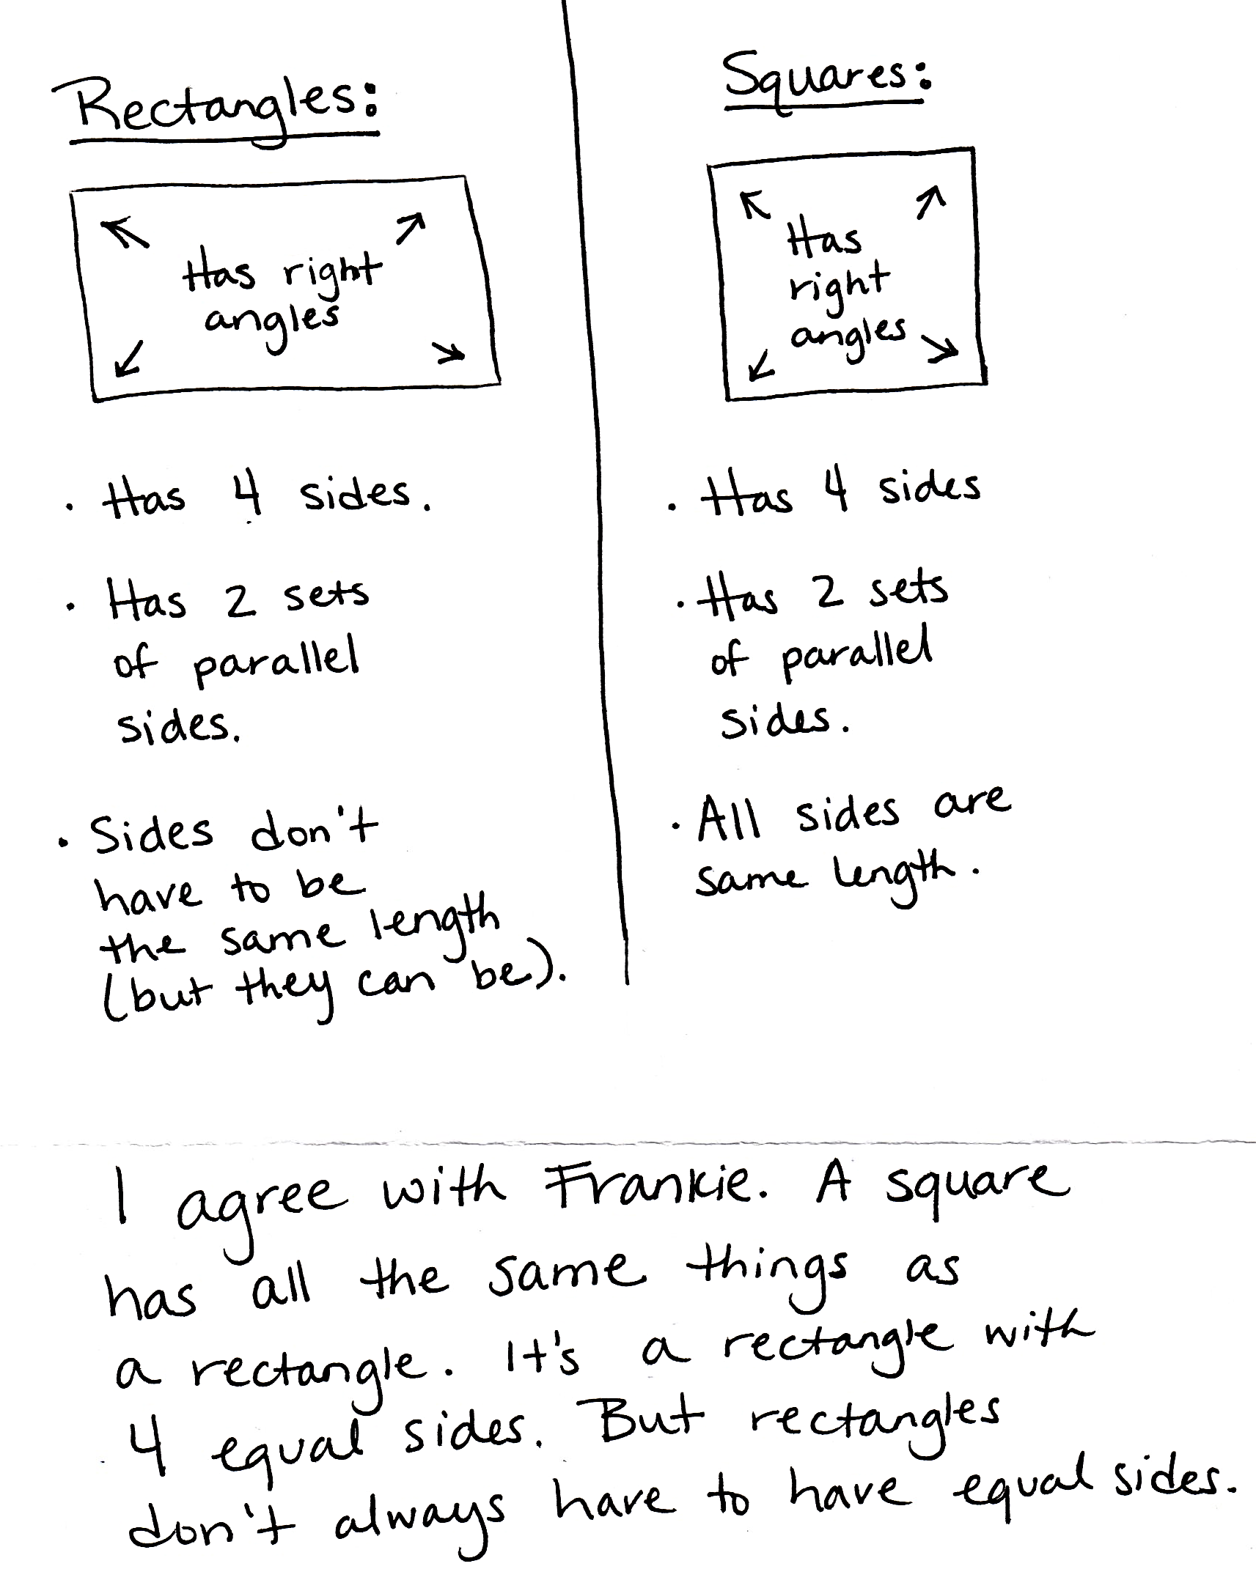
T: Using your arms, model a triangle with the person standing next to you.
S: (Connect arms with partner to model a three-sided figure.)
T: What do we call a four-sided figure?
S: Quadrilateral.
T: Use your body to make a quadrilateral with your partner.
S: (Model a four-sided figure with partner.)
Application Problem (8 minutes)
Frankie says that all squares are rectangles, but not all rectangles are squares. Do you agree with this statement? Why or why not? Draw diagrams to support your statement.
Note: This Application Problem engages students in MP.3, constructing viable arguments and critiquing the reasoning of others while revisiting the classification of squares as being a special type of rectangle.
Concept Development (30 minutes)
Materials: (T) Game cards (S) Personal white board, black shape (pictured below, 1 per pair), ruler, right angle tool, math journal, game cards (1 set per pair, cut out)
Project the black shape shown and give a copy of the shape to each pair of students.
T: Work with a partner to analyze this shape, and list as many attributes as you can on your personal board. Use your right angle tools and rulers to help you.
S: (Work in pairs. Produce these possible responses: quadrilateral, trapezoid, four-sided, one pair of parallel sides, two right angles, two equal sides.)

NOTES ON
MULTIPLE MEANS FOR ACTION AND EXPRESSION:
Scaffold shape analysis with questions or sentence frames:
- I see _____ angles.
- How many right angles do you count?
- How many equal sides do you measure?
- This shape is called a _____.
- How many sets of parallel sides do you see?

Build class consensus by inviting different pairs to share attributes. Use a right angle tool to verify the two right
angles and a ruler to verify the equal sides. Write the list of attributes on the board as students share. Then ask students to erase their boards.
T: We found two angles that are right angles. Let’s talk about a way to describe the other angles, too. Now compare this angle with our right angle tool. (Place right angle tool so that students can see that one angle is greater than a right angle.) Is this angle greater than or less than a right angle? How do you know?
S: It’s greater than a right angle because it’s bigger than the right angle tool! The sides of the angle open wider than the right angle. The right angle is just a part of the bigger angle.
T: Some angles are greater than a right angle. Let’s add 1 angle greater than a right angle to our list of attributes for this shape. (Place right angle tool so that students can see that 1 angle is less than a right angle.) What about this angle?

NOTES ON
MULTIPLE MEANS OF ENGAGEMENT:
If appropriate for your class, continue to use the written list with the attributes you discussed together at the beginning of the lesson to support students with drawing until they are ready to move on.
S: It’s less than a right angle. I can see that because it’s smaller than the right angle tool.
T: True. Some angles are less than a right angle. Let’s add 1 angle less than a right angle to our list of attributes for this shape.
T: (Circle 1 angle greater than a right angle on the list of attributes on the board.) Draw a shape with one angle that is greater than a right angle.
S: (Draw. There are a variety of possibilities.)
T: (Compare a few different shapes and ask the class to confirm their validity. Circle 2 right angles on the list of attributes.) Talk to a partner: What tool or tools will you use to draw a different shape that has at least two right angles?
MP.5
S: My right angle tool! I think I’ll use my ruler too. The right angle tool will help me make sure I have at least two right angles, and my ruler will help me draw straight lines.
T: I agree! Use your ruler and right angle tool to draw a different shape that has at least two right angles.
S: (Draw. There are a variety of possibilities.)
T: (Circulate to see that students have drawn shapes that have at least two right angles, then have students erase their boards. Circle quadrilateral, 2 equal sides, and 1 pair of parallel sides.) Talk to a partner: What tool or tools will you use to draw a shape with the circled attributes?
MP.5
S: A ruler. I’ll use my ruler to make sure I have two equal sides. My ruler will also help me draw straight lines. Since I don’t have to worry about drawing any right angles, I can just use my ruler to measure the side lengths and to draw straight lines.
T: Use your ruler to draw a shape with the circled attributes. Label the equal side lengths.
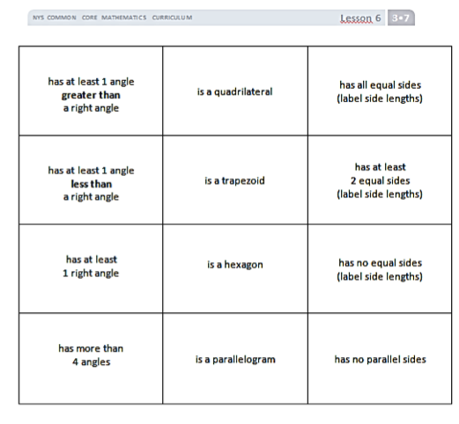
Continue as necessary.
Game Cards Front
Game Cards Back
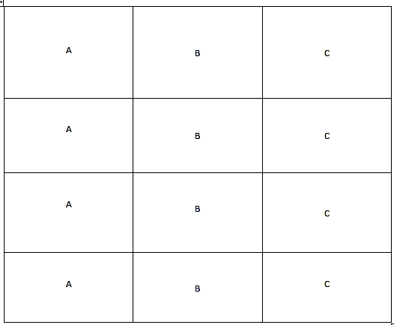
T: Work with a partner to figure out whether or not you can draw a quadrilateral with more than four angles. (Allow students time to work.) What do you think?
S: No, you can’t. Every time we made an extra angle, it made an extra side too! In the shapes we drew, the number of sides matched the number of angles. To get more than four angles, you need more than four sides, and then the shape isn’t a quadrilateral anymore!
T: True. Let’s play a game! (Hold up game cards.) These are the directions:
- Place the cards face down.
- Pick one card from each letter.
- Flip over the cards you chose. Record the game card descriptions in your journal.
- Use the appropriate tools to draw the shape in your math journal. If the shape is not possible, list reasons in your math journal why it is not.
T: Ready? (Draw three cards and read or project the cards. Is a quadrilateral, has all equal sides, and has at least 1 right angle are the cards used in the example that follows.)
S: This one is easy! I can just draw a square! (Record descriptions and draw shape.)
T: At the signal, show your drawing. (Signal. Validate shapes, and repeat the process. The cards has no parallel sides, has more than 4 angles, and is a parallelogram are used in the example that follows.)
S: Wait! I can’t draw this shape! (Note descriptions and reasons in math journals.)
T: Tell your partner why this shape can’t be drawn.
S: Because a parallelogram has to have two pairs of parallel sides! It can’t have no parallel sides!
Repeat the process. As students are ready, have them work independently, in pairs, or in small groups to play the game on their own. Have them play two or three rounds on their own.
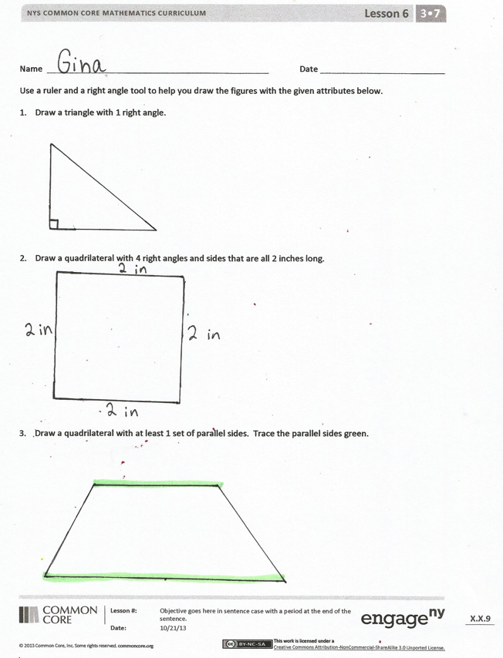
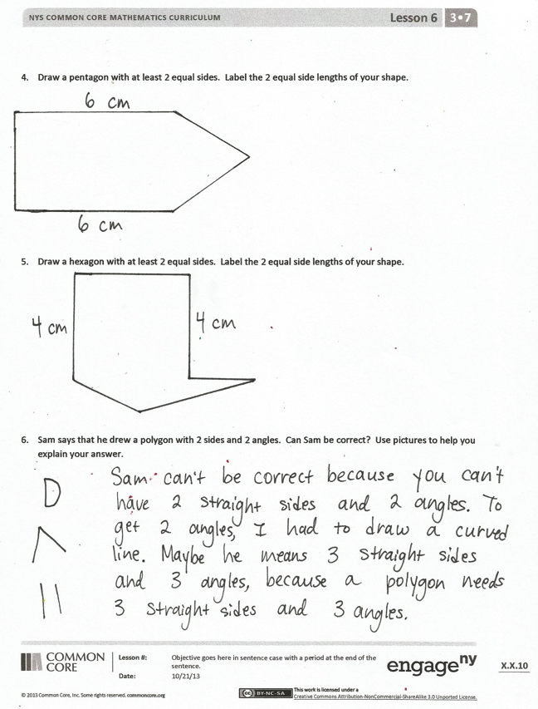
Problem Set (10 minutes)
Students should do their personal best to complete the Problem Set within the allotted 10 minutes. For some classes, it may be appropriate to modify the assignment by specifying which problems they work on first. Some problems do not specify a method for solving. Students solve these problems using the RDW approach used for Application Problems.
Student Debrief (10 minutes)
Lesson Objective: Draw polygons with specified attributes to solve problems.
The Student Debrief is intended to invite reflection and active processing of the total lesson experience.
Invite students to review their solutions for the Problem Set. They should check work by comparing answers with a partner before going over answers as a class. Look for misconceptions or misunderstandings that can be addressed in the Debrief. Guide students in a conversation to debrief the Problem Set and process the lesson.
You may choose to use any combination of the questions below to lead the discussion.
- Besides quadrilateral, what is another name for the shape you drew for Problem 3? (Possible answers are trapezoid, parallelogram, rectangle, square, and rhombus.) How can it be that so many names describe our shape?
- Which shape was most difficult to draw precisely? Why?
- Ask students to share their ideas about Problem 6. How did our work in today’s lesson prepare you to answer that question?
- Invite students to share some of the combinations that they drew or could not draw during the game. They can explain why they could not draw some, and think about more than one possible shape for others.
- How did today’s Fluency Practice connect to the lesson?
Exit Ticket (3 minutes)
After the Student Debrief, instruct students to complete the Exit Ticket. A review of their work will help you assess the students’ understanding of the concepts that were presented in the lesson today and plan more effectively for future lessons. You may read the questions aloud to the students.

Name Date
Use a ruler and a right angle tool to help you draw the figures with the attributes given below.
- Draw a triangle with 1 right angle.

- Draw a quadrilateral with 4 right angles and sides that are all 2 inches long.

- Draw a quadrilateral with at least 1 set of parallel sides. Trace the parallel sides green.

- Draw a pentagon with at least 2 equal sides. Label the 2 equal side lengths of your shape.

- Draw a hexagon with at least 2 equal sides. Label the 2 equal side lengths of your shape.

- Sam says that he drew a polygon with 2 sides and 2 angles. Can Sam be correct? Use pictures to help you explain your answer.

Name Date
Use a ruler and a right angle tool to help you draw a shape that matches the attributes of Jeanette’s shape. Label your drawing to explain your thinking.
Jeanette says her shape has 4 right angles and 2 sets of parallel sides. It is not a regular quadrilateral.

Name Date
Use a ruler and a right angle tool to help you draw the figures with the given attributes below.
- Draw a triangle that has no right angles.

- Draw a quadrilateral that has at least 2 right angles.

- Draw a quadrilateral with 2 equal sides. Label the 2 equal side lengths of your shape.

- Draw a hexagon with at least 2 equal sides. Label the 2 equal side lengths of your shape.

- Draw a pentagon with at least 2 equal sides. Label the 2 equal side lengths of your shape.

- Cristina describes her shape. She says it has 3 equal sides that are each 4 centimeters in length. It has no right angles. Do your best to draw Cristina’s shape and label the side lengths.

has at least 1 angle  greater than  a right angle | is a quadrilateral | has all equal sides  (label side lengths)
has at least 1 angle  less than  a right angle | is a trapezoid | has at least  2 equal sides  (label side lengths)
has at least  1 right angle | is a hexagon | has at least 1 set  of parallel sides
has more than  4 angles | is a parallelogram | has no parallel sides

A | B | C
A | B | C
A | B | C
A | B | C

