Lesson 5
Objective: Compare and classify other polygons.

Suggested Lesson Structure
 Fluency Practice (15 minutes)
 Concept Development (35 minutes)
 Student Debrief (10 minutes)
Total Time (60 minutes)
Fluency Practice (15 minutes)
- Multiply by 5 3.OA.7 (7 minutes)
- Equivalent Counting with Units of 6 3.OA.7 (4 minutes)
- Classify the Polygon 3.G.1 (4 minutes)

Multiply by 5 (7 minutes)

Materials: (S) Multiply by 5 Pattern Sheet (1–5)
Note: This activity builds fluency with multiplication facts using units of 5. It works toward students knowing from memory all products of two one-digit numbers. See G3–M7–Lesson 1 for the directions for administration of a Multiply By pattern sheet.
T: (Write 5 × 5 = ____.) Let’s skip-count by fives to find the answer. (Count with fingers to 5 as students count.)
S: 5, 10, 15, 20, 25.
T: (Circle 25 and write 5 × 5 = 25 above it. Write 3 × 5 = ____.) Let’s skip-count up by fives again. (Count with fingers to 3 as students count.)
S: 5 (one finger), 10 (two fingers), 15 (three fingers).
T: Let’s see how we can skip-count down to find the answer, too. Start at 25 with 5 fingers, 1 for each five. (Count down with fingers as students say numbers.)
S: 25 (five fingers), 20 (4 fingers), 15 (3 fingers).
Repeat the process for 4 × 5.
T: (Distribute Multiply by 5 Pattern Sheet.) Let’s practice multiplying by 5. Be sure to work left to right across the page.

Equivalent Counting with Units of 6 (4 minutes)
Note: This activity builds fluency with multiplication facts using units of 6. The progression builds in complexity. Work the students up to the highest level of complexity in which they can confidently participate.
T: Count to 10. (Write as students count. See chart below.)
S: 1, 2, 3, 4, 5, 6, 7, 8, 9, 10.
1 2 3 4 5 6 7 8 9 10
1 six 2 sixes 3 sixes 4 sixes 5 sixes 6 sixes 7 sixes 8 sixes 9 sixes 10 sixes
6 12 18 24 30 36 42 48 54 60
1 six 12 3 sixes 24 5 sixes 36 7 sixes 48 9 sixes 60
6 2 sixes 18 4 sixes 30 6 sixes 42 8 sixes 54 10 sixes

T: (Write 1 six beneath the 1.) Count to 10 sixes. (Write as students count.)
S: 1 six, 2 sixes, 3 sixes, 4 sixes, 5 sixes, 6 sixes, 7 sixes, 8 sixes, 9 sixes, 10 sixes.
T: Count by sixes to 60. (Write as students count.)
S: 6, 12, 18, 24, 30, 36, 42, 48, 54, 60.
T: (Write 1 six beneath the 6. Write 12 beneath the 12.) I’m going to give you a challenge. Let’s alternate between saying the units of six and the number. (Write as students count.)
S: 1 six, 12, 3 sixes, 24, 5 sixes, 36, 7 sixes, 48, 9 sixes, 60.
T: (Write 6 beneath 1 six and 2 sixes beneath the 12.) Let’s alternate again. (Write as students count.)
S: 6, 2 sixes, 18, 4 sixes, 30, 6 sixes, 42, 8 sixes, 54, 10 sixes.
Classify the Polygon (4 minutes)

NOTES ON
MULTIPLE MEANS OF ENGAGEMENT:
English language learners and others who may not be able to quickly articulate the names of polygons might benefit from adjusting the questions. For example, ask, “Is this a quadrilateral? How many sides does a quadrilateral have?”

Materials (S) Personal white boards
Note: This fluency activity reviews identifying attributes and naming polygons.
T: (Project a trapezoid.) How many sides does this polygon have?
S: Four sides.
T: What do we call polygons that have four sides?
S: Quadrilaterals.
T: How many sets of parallel lines does this quadrilateral have?
S: One set.
T: What do we call quadrilaterals that have at least one set of parallel lines?
S: Trapezoids.
T: (Project a parallelogram with no angles that measure 90°.) Is this polygon a quadrilateral?
S: Yes.
T: How many right angles does this particular quadrilateral have?
S: Zero right angles.
T: Is this quadrilateral a trapezoid?
S: Yes.
T: Why?
S: It has at least one set of parallel lines.
T: How many sets of parallel sides does it have?
S: Two sets of parallel sides.
T: What do we call all quadrilaterals that have two sets of parallel sides?
S: Parallelograms.
T: (Project a rectangle that is not a square.) Is this polygon a quadrilateral?
S: Yes.
T: Write how many right angles this quadrilateral has.
S: (Write 4.)
T: Is this quadrilateral a trapezoid?
S: Yes.
T: Why?
S: It has at least one set of parallel lines.
T: Is this trapezoid also a parallelogram?
S: Yes.
T: Why?
S: It has two sets of parallel sides.
T: Is this parallelogram also a rectangle?
S: Yes.
T: Why?
S: It has two sets of parallel sides and four right angles.
T: (Project a square.) Is this polygon a quadrilateral?
S: Yes.
T: Why?
S: It has four sides.
T: Write how many right angles this quadrilateral has.
S: (Write 4.)
T: Is this quadrilateral a trapezoid?
S: Yes.
T: Why?
S: It has at least one set of parallel lines.
T: Is this trapezoid also a parallelogram?
S: Yes.
T: Why?
S: It has two sets of parallel sides.
T: Is this parallelogram also a rectangle?
S: Yes.
T: Why?
S: It has two sets of parallel sides and 4 right angles.
T: The sides of this rectangle are equal. What do we call a rectangle with equal side lengths?
S: Squares.
Concept Development (35 minutes)
Materials: (S) Right angle tool, Polygons (M–X) template, ruler, Problem Set, scissors
Problem 1: Group polygons by attributes.
T: Look at Polygons M–X. Compare them with yesterday’s polygons. What do you notice?
S: Now there are many different kinds of polygons. All of the polygons aren’t quadrilaterals. I see triangles, some quadrilaterals, hexagons, and funny looking polygons, too.
T: Take out your right angle tools and rulers.
MP.6
S: (Take out tools.)
T: Look at the chart on your Problem Set. Yesterday we grouped polygons with four sides. Today we’re first going to group polygons with all equal sides. What tools will we need in order to make sure our work is precise?
S: A ruler. A centimeter ruler. An inch ruler.
T: Look at your ruler and talk to a partner. Which unit will be the most precise: inches, half inches, quarter inches, or centimeters?
S: Inches are the biggest unit, so they won’t be the most precise. Half inches and centimeters are smaller than inches. A quarter inch is even smaller than a half inch and a centimeter. We should use the quarter inch because it’s the smallest unit, so it will be the most precise.
T: Work with your partner to measure the sides of all of your polygons to the nearest quarter inch. Label the inside side lengths to help you remember. Then cut out Polygons M-X.
S: (Measure, label, and cut.)
T: Group into categories of all sides are equal and not all sides are equal. Then complete the first two sections of your chart.
S: (Group and complete chart.)
T: Did you group all of your polygons in one of these two categories?
S: Yes!
T: The next two parts of our chart start with the words at least 1. When it says at least 1, can the polygon have more than one?
S: Yes, it just means that you need to have one for sure.
T: Use your right angle tool to measure and group the polygons that have at least 1 right angle.
Have students complete the rest of the chart. Circulate to look for and correct any misconceptions.
T: Let’s examine the polygons that have all equal sides more closely. Look at Polygon S. What do you know about the side lengths?
S: They’re all the same!
T: What do you know about the angles?
1 in
1 in
1 in
1 in
1 in
S: They’re all right angles. So, the angles are all the same, too!
T: A polygon with all equal sides and all equal angles is called a regular polygon. (Project polygon as shown.) How many sides does this polygon have?
S: Five sides!
T: What do we call a polygon with five sides?
S: A pentagon!
T: Talk to a partner: Is this a regular pentagon?
S: All the sides are equal. But it doesn’t look like all the angles are equal. Yeah, it looks like there are two right angles, but the angle at the top looks smaller than a right angle. So, this pentagon can’t be a regular pentagon!
T: You’re right! This isn’t a regular pentagon because the sides are all equal, but the angles aren’t all equal.
Problem 2: Compare polygons.
T: Count each polygon’s sides. Then write the number of sides under the polygon’s letter. Do that now. (Allow students time to finish.) Now group the polygons with the same number of sides.
S: (Group.)
T: Compare the polygons in each group. Are they the same type of polygon? For example, Polygon U is a six-sided polygon, or a hexagon. Polygon T also has six sides. Is Polygon T a hexagon, too?
S: No, Polygon T doesn’t look like a hexagon. They are both still hexagons. It’s just that Polygon U has all equal sides. That’s why it looks like the more familiar one.
T: It’s true. Remember we saw all different types of quadrilaterals. Some looked familiar to us, like a square or rectangle, and others were more unusual. But they all had four sides and were all still quadrilaterals.
T: Now spread out your polygons. I’ll call out an attribute. You to hold up a polygon that fits the attribute. Ready? Show a polygon that has no equal sides.
S: (Show Polygon N, O, R, T, Q, V, or X.)
T: Show a polygon that has exactly one right angle.
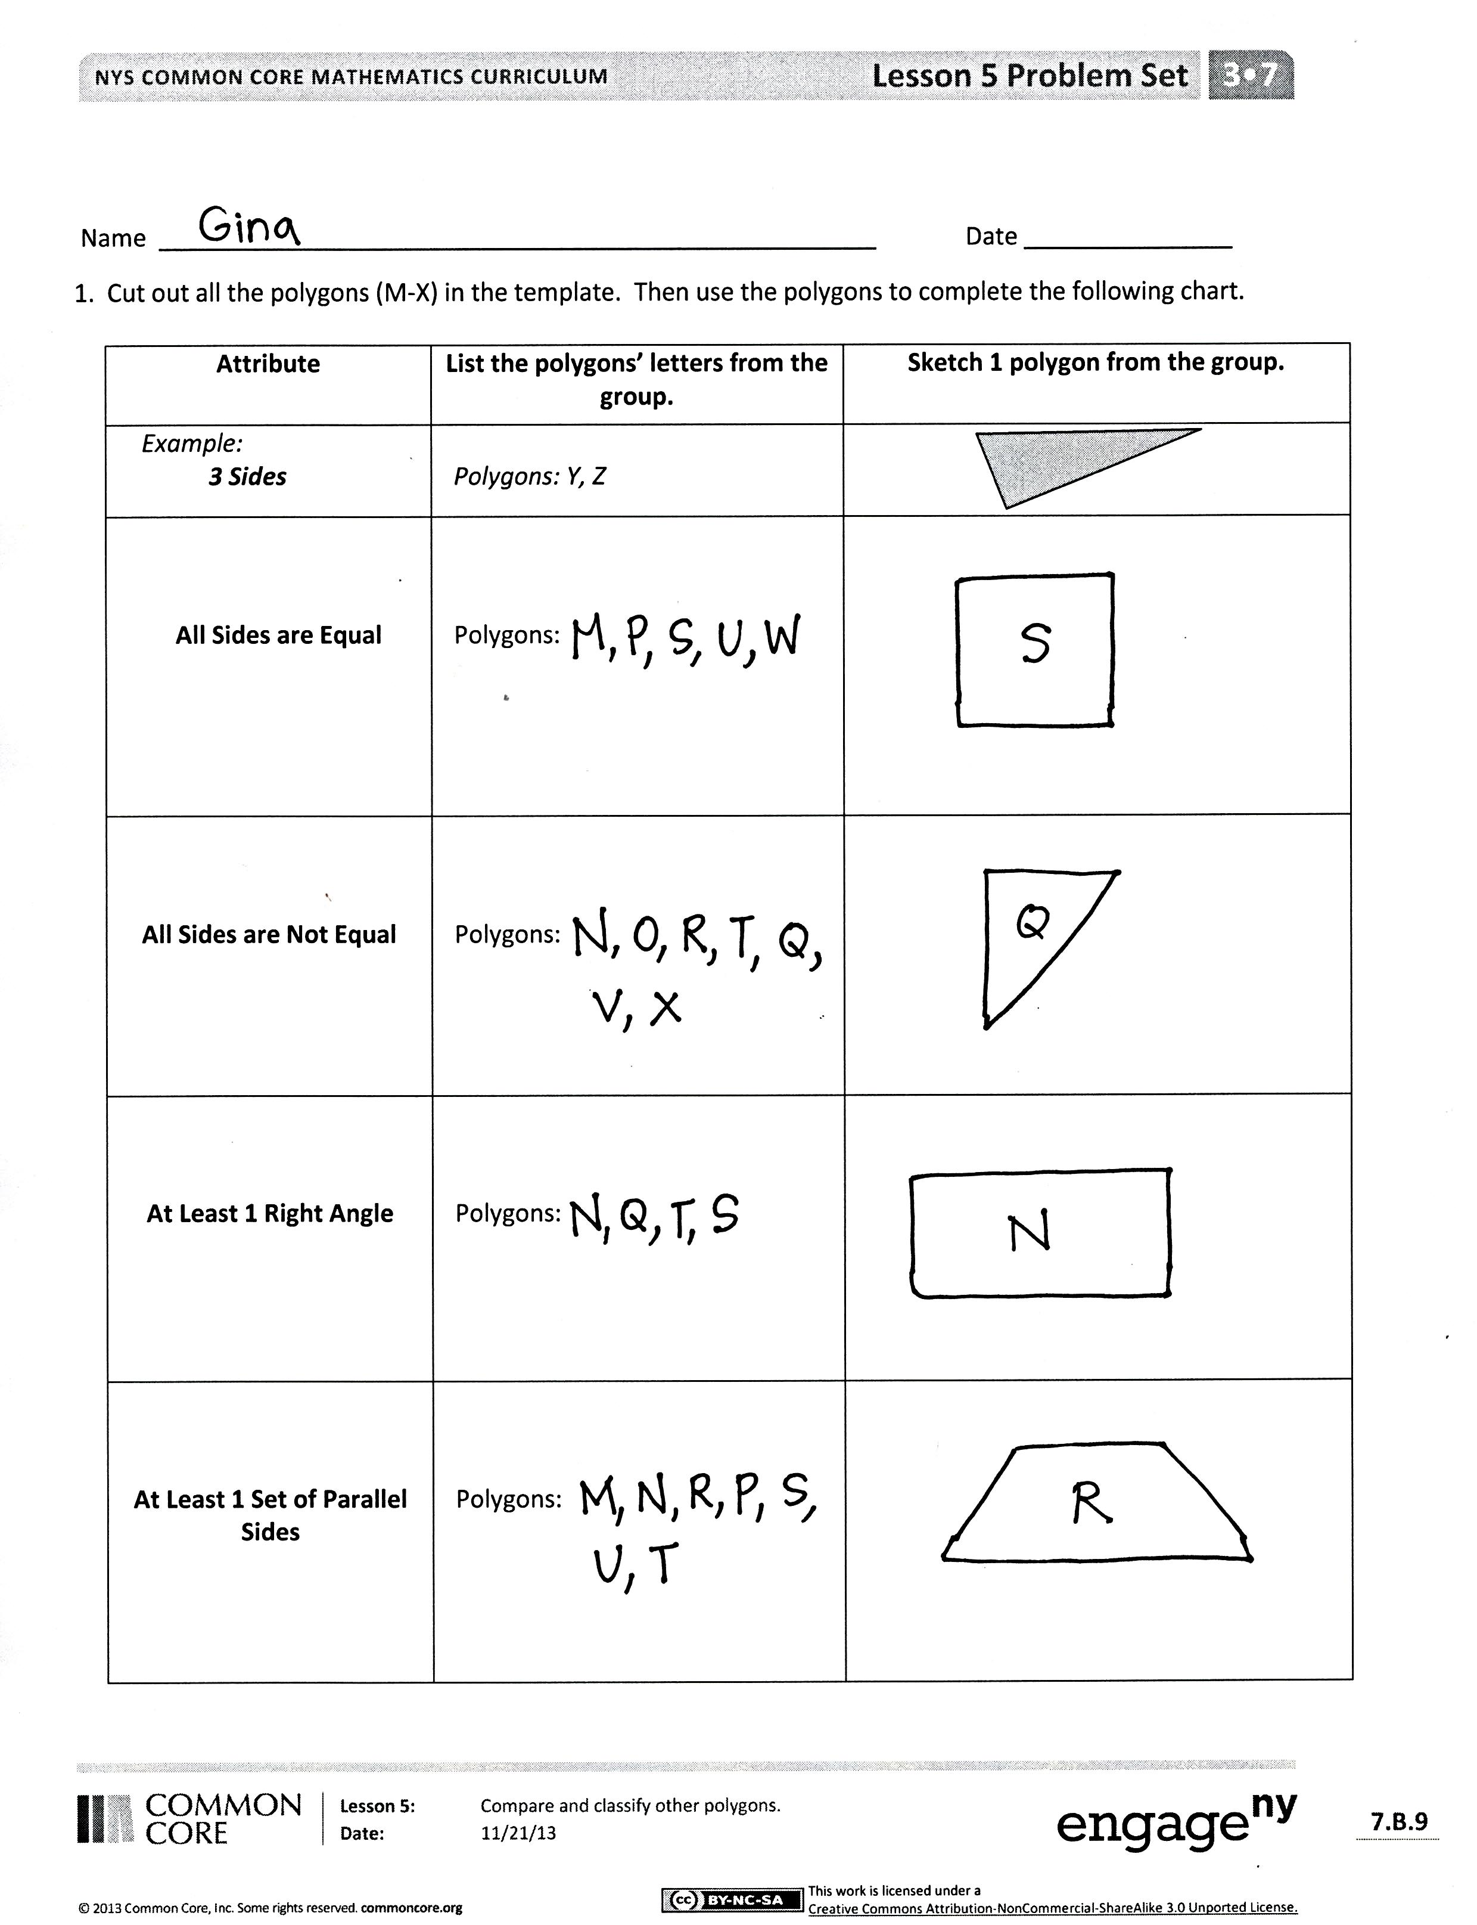
S: (Show Polygon Q.)
T: Show a polygon that has four equal sides.
S: (Show Polygon S.)
T: Show a shape that has only one set of parallel lines.
S: (Show Shape R.)
T: Here’s a challenge. Show a polygon that has exactly three sets of parallel lines.
S: (Show Polygon U.)
Have students finish the rest of the Problem Set independently.
Student Debrief (10 minutes)
Lesson Objective: Compare and classify other polygons.
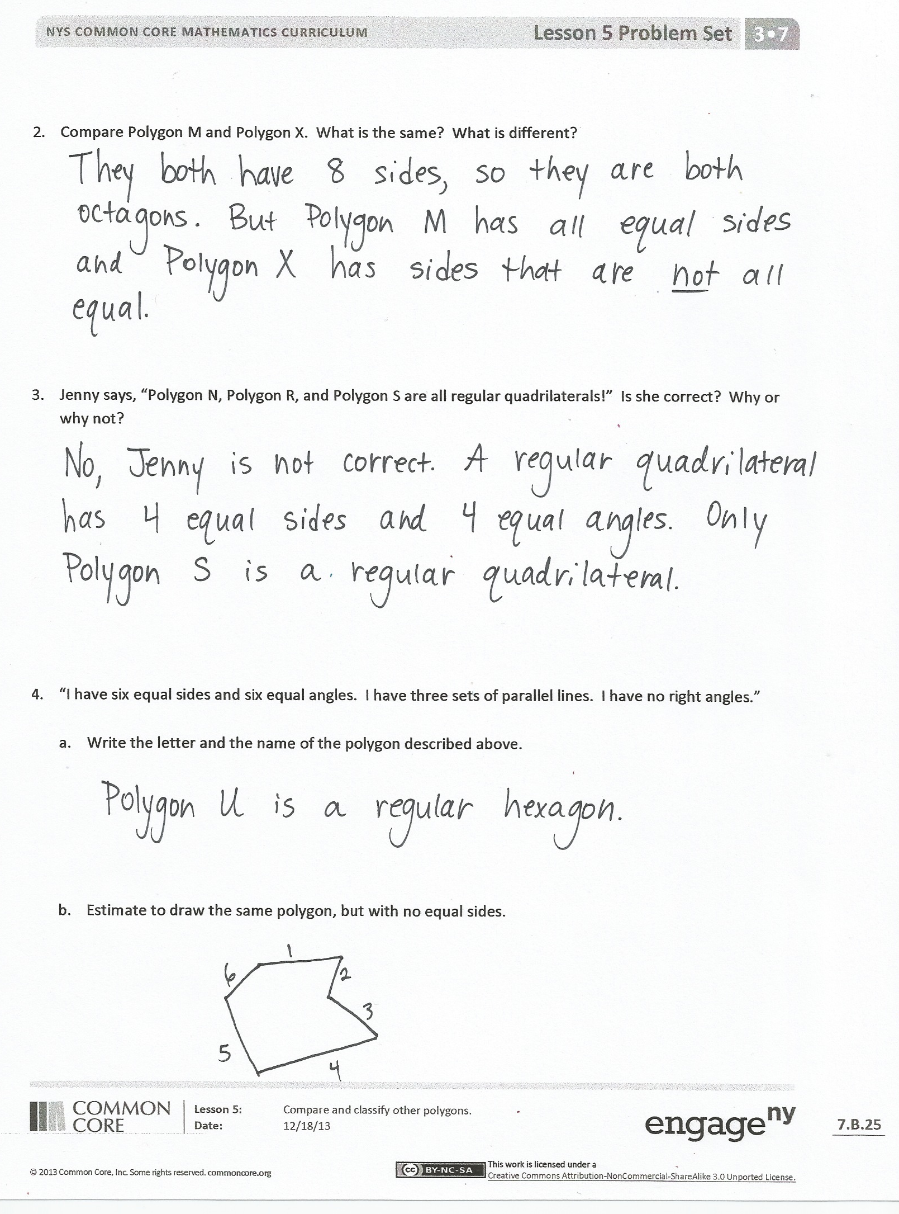
The Student Debrief is intended to invite reflection and active processing of the total lesson experience.
Invite students to review their solutions for the Problem Set. They should check work by comparing answers with a partner before going over answers as a class. Look for misconceptions or misunderstandings that can be addressed in the Debrief. Guide students in a conversation to debrief the Problem Set and process the lesson.
You may choose to use any combination of the questions below to lead the discussion.
- Share student work for Problem 3 and compare the three quadrilaterals. Which attributes are the same and different?
- Compare student sketches in Problem 4(b). Continue to have students draw different polygons on their boards as you call out different attributes. For example, “Sketch a pentagon with no equal sides; sketch a triangle with one right angle.” Have students compare polygons to understand that polygons are defined by the number of sides not just how they look.
- Was it easier to group quadrilaterals or group polygons with different numbers of sides? Why?
- Tell your partner two attributes of a regular polygon. Which quadrilateral is a regular polygon?
- How did today’s Fluency Practice connect to the lesson?
Exit Ticket (3 minutes)
After the Student Debrief, instruct students to complete the Exit Ticket. A review of their work will help you assess the students’ understanding of the concepts that were presented in the lesson today and plan more effectively for future lessons. You may read the questions aloud to the students.

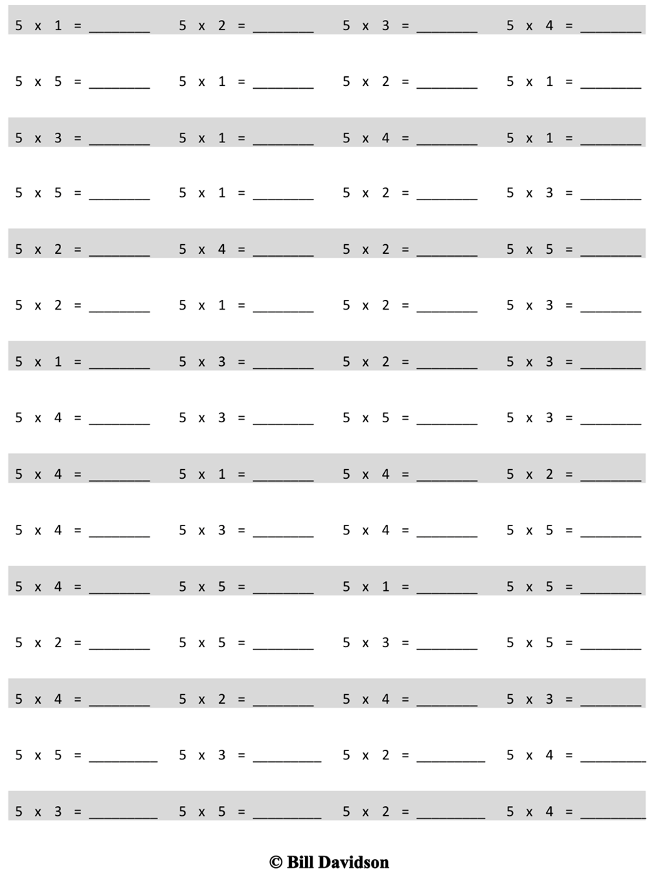
Multiply.

Name Date
1. Cut out all the polygons (M–X) in the template. Then use the polygons to complete the following chart.
Attribute | List the polygons’ letters from the group. | Sketch 1 polygon from the group.
Example: 3 Sides | Polygons: Y, Z
All Sides are Equal | Polygons:
All Sides are Not Equal | Polygons:
At Least 1 Right Angle | Polygons:
At Least 1 Set of Parallel Sides | Polygons:

- Compare Polygon M and Polygon X. What is the same? What is different?

- Jenny says, “Polygon N, Polygon R, and Polygon S are all regular quadrilaterals!” Is she correct? Why or why not?

- “I have six equal sides and six equal angles. I have three sets of parallel lines. I have no right angles.”

- Write the letter and the name of the polygon described above.

- Estimate to draw the same polygon, but with no equal sides.

Name Date
Jonah draws the polygon below. Use your ruler and right angle tool to measure his polygon. Then answer the questions below.

- Is Jonah’s polygon a regular polygon? Explain how you know.

- How many right angles does his polygon have? Circle the right angles on his polygon.

- How many sets of parallel lines does his polygon have?

- What is the name of Jonah’s polygon?

Name Date
- Match the polygons with their appropriate clouds. A polygon can match to more than 1 cloud.
All sides are equal
All sides are not equal
At least 1 set of
parallel sides
At least 1 right angle

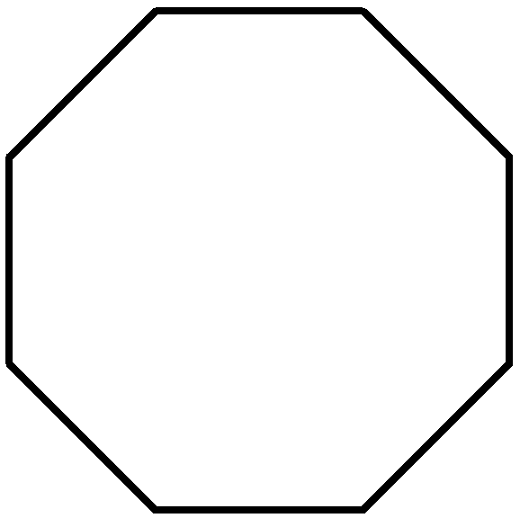
hexagon
pentagon
decagon
regular octagon
rectangle
square
- The two polygons below are regular polygons. How are these polygons the same? How are they different?
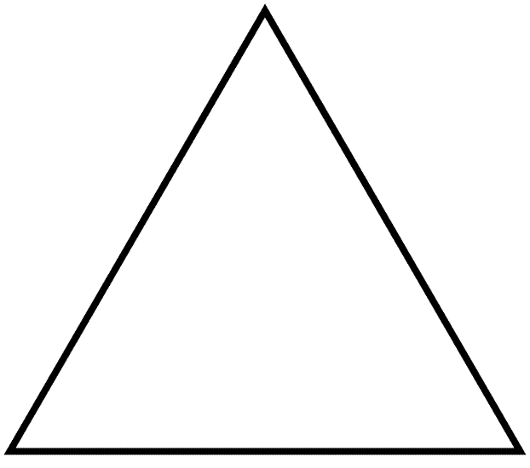

- Lucia draws the polygons below. Are any of the polygons she drew regular polygons? Explain how you know.

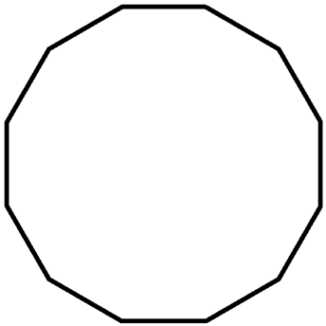
N
O
R
P
Q
M

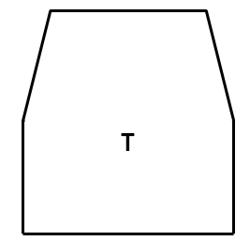
V
X
S
U
W

