Lesson 3
Objective: Share and critique peer solution strategies to varied word problems.

Suggested Lesson Structure
 Fluency Practice (15 minutes)
 Concept Development (35 minutes)
 Student Debrief (10 minutes)
Total Time (60 minutes)
Fluency Practice (15 minutes)
- Name the Shape 2.G.1 (3 minutes)
- Multiply by 4 3.OA.7 (8 minutes)
- Equivalent Counting with Units of 3 3.OA.7 (4 minutes)

Name the Shape (3 minutes)
Note: This fluency activity reviews Grade 2 geometry concepts in preparation for G3–M7–Topic B.

T: (Project trapezoid.) How many sides does this shape have?
S: Four sides.
T: What’s the name for all four-sided figures?
S: Quadrilateral.
T: (Project pentagon.) How many sides does this shape shape?
S: Five sides.
T: What’s the name for all five-sided figures?
S: Pentagon.
Continue the process for all three hexagons.

Multiply by 4 (8 minutes)
Materials: (S) Multiply by 4 Pattern Sheet (1–5)
Note: This activity builds fluency with multiplication facts using units of 4. It works toward students knowing from memory all products of two one-digit numbers. See G3–M7–Lesson 1 for the directions for administration of a Multiply By pattern sheet.
T: (Write 5 × 4 = ____.) Let’s skip-count by fours to find the answer. (Count with fingers to 5 as students count.)
S: 4, 8, 12, 16, 20.
T: (Circle 20 and write 5 × 4 = 20 above it. Write 3 × 4 = ____.) Let’s skip-count up by fours again. (Count with fingers to 3 as students count.)
S: 4, 8, 12.
T: Let’s see how we can skip-count down to find the answer, too. Start at 20 with 5 fingers, 1 for each four. (Count down with fingers as students say numbers.)
S: 20 (5 fingers), 16 (4 fingers), 12 (3 fingers).
Repeat the process for 4 × 4.
T: (Distribute Multiply By 4 Sprint.) Let’s practice multiplying by 4. Be sure to work left to right across the page.

Equivalent Counting with Units of 3 (4 minutes)
Note: This activity builds fluency with multiplication facts using units of 3. The progression builds in complexity. Work the students up to the highest level of complexity in which they can confidently participate.
T: Count to 10. (Write as students count. See chart below.)
1 2 3 4 5 6 7 8 9 10
1 three 2 threes 3 threes 4 threes 5 threes 6 threes 7 threes 8 threes 9 threes 10 threes
3 6 9 12 15 18 21 24 27 30
1 three 6 3 threes 12 5 threes 18 7 threes 24 9 threes 30
3 2 threes 9 4 threes 15 6 threes 21 8 threes 27 10 threes

S: 1, 2, 3, 4, 5, 6, 7, 8, 9, 10.
T: (Write 1 three beneath the 1.) Count to 10 threes. (Write as students count.)
S: 1 three, 2 threes, 3 threes, 4 threes, 5 threes, 6 threes, 7 threes, 8 threes, 9 threes, 10 threes.
T: Count by threes to 30. (Write as students count.)
S: 3, 6, 9, 12, 15, 18, 21, 24, 27, 30.
T: (Write 1 three beneath the 3. Write 6 beneath the 6.) I’m going to give you a challenge. Let’s alternate between saying the units of three and the number. (Write as students count.)
S: 1 three, 6, 3 threes, 12, 5 threes, 18, 7 threes, 24, 9 threes, 30.
T: (Write 3 beneath 1 three and 2 threes beneath the 6.) Let’s alternate again. (Write as students count.)
S: 3, 2 threes, 9, 4 threes, 15, 6 threes, 21, 8 threes, 27, 10 threes.
Concept Development (35 minutes)
Materials: (T) Student work samples (larger images included at the end of the lesson) (S) Problem Set, personal white boards
Problem 1: Assess sample student work for accuracy and efficiency.
(Write or project the following problem: Mrs. Mashburn buys 6 boxes of pencils. Nine pencils come in each box. She gives each of the 24 students in her class 2 pencils. How many pencils does she have left?)
T: Use the Read-Draw-Write process to solve this problem. Remember to take a moment to visualize what’s happening in the problem after you read.
S: (Use the RDW process to solve.)
T: Compare your work with a partner’s. (Allow students time to compare.) How many pencils does Mrs. Mashburn have left?
S: 6 pencils!
T: (Project Student A’s work.) Let’s look at and discuss some possible solutions for this problem. What did Student A do to solve this problem?
S: He used a tape diagram to find the total number of pencils. Then, he figured out how many pencils the teacher gave away and subtracted. He broke apart 24 × 2 to make it an easier problem!
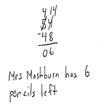
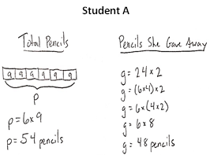

T: Other than getting the right answer, what did Student A do well?
S: Student A used all the steps in the RDW process. He labeled the parts of the problem, Total Pencils and Pencils She Gave Away. He broke apart 24 into 6 × 4, which helped him solve 24 × 2. He moved the parentheses to solve hard multiplication.

Facilitate a discussion in which students analyze this work. Choose any combination of the following questions to help guide the conversation:
- Was the drawing helpful? What makes the drawing helpful or unhelpful?
- Did Student A represent all the important information in his drawing? Why or why not?
- Was this drawing the best one to use? Why or why not?
- Can you retell the story using only the drawing and labels? Explain.
- How did he organize the information?
- Was his method of solving the most efficient way? Why or why not?
- Would you have chosen to solve the problem this way? Why or why not?

T: What suggestion would you make to Student A to improve his work?
S: Moving the parentheses is a lot of work for 24 × 2. It’s faster to solve with mental math, by thinking of it as 24 + 24. Instead of the subtraction equation, maybe just count on from 48 to 54. The difference is small. Use 2 to complete the 10, then add 4. That’s 6. He could use a letter to represent the unknown in the problem. He could draw another tape diagram to show why he subtracted in the last step.
Use the following two samples below, modify them, or create new ones, and repeat the process of analyzing sample student work. Select which samples to use by considering the discussion that would most benefit the needs of the students.
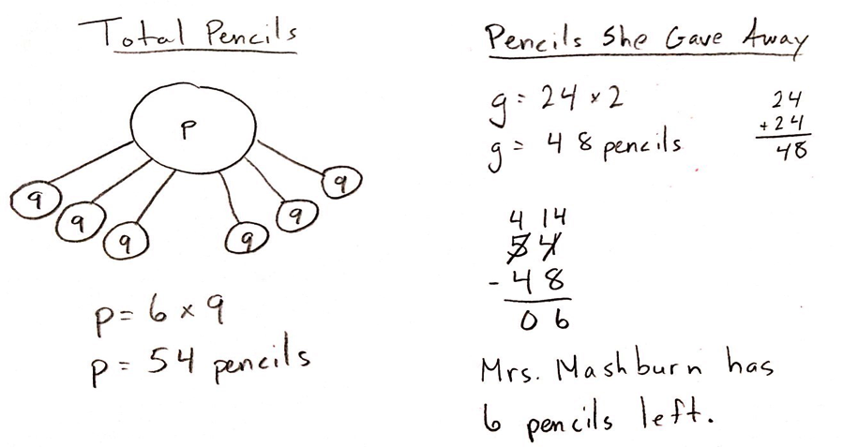
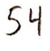
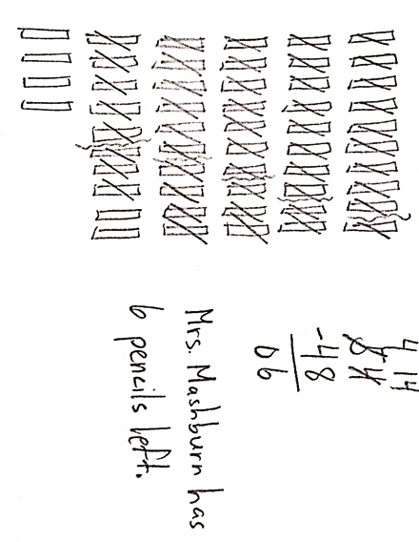
Student B

Student C

Note: If modifying these samples or creating new ones, consider the discussion that would most benefit the needs of the students. For example, modify the samples to show the following suggested common mistakes:
- Student B might miscalculate 6 × 9 as 56.
- Student C might forget to cross out or draw a pencil.
- The sentence might not address the question directly.
- The student might misread the problem, e.g., and solve for a scenario where Mrs. Mashburn gives each student 6 pencils.

T: Discuss with a partner: How are the three ways of solving similar? How are they different?
S: (Allow time for partner discussion.)
T: Which solution would you say is most efficient? Why? Talk with your partner.
S: Either Student A’s or Student B’s. I think Student B’s, because he solved 24 × 2 more easily than Student A. I agree. They both drew clear pictures to find the total number of pencils, but Student B’s way of doing the equation is easier and may be quicker for finding the number of pencils the teacher gave away.
T: Which solution would you say is least efficient? Why?
S: Student C’s. Drawing the pencils and crossing them out must have taken forever. And, Student C didn’t really even need the equation if she did it that way. It’s easy to see from the model that there are 6 left.
T: Compare all three samples to your own work. With a partner, discuss the strengths of your own work and also talk about what you might try differently.
S: (Discuss.)
Problem 2: Assess peer work for accuracy and efficiency.
Distribute the Problem Set to each student.
T: Work with your partner to find two different ways to solve Problem 1 on your Problem Set. Be sure to use the RDW process when solving.
After students solve, elicit possible solutions from them. Lead a discussion in which students compare and contrast each other’s work and analyze the clarity of each solution path. Students may then independently solve the rest of the problems on the Problem Set. Ask students to swap boards with their partners after solving, and discuss the following:

NOTES ON
MULTIPLE MEANS OF ACTION AND EXPRESSION:
Remind and guide students to identify strategies, including but not limited to the following:
- Use the Associative Property to make an easier problem, e.g., 12 × 3 = (6 × 2) × 3 = 6 × (2 × 3)
- Combine easy number pairs.
- Use methods for multiplying by 7, 8, 9, e.g., 6 × 9 = (5 × 9) + 9 = 54, or the finger strategy.
- Model with a labeled tape diagram.

- Study your partner’s work. Try to explain how you partner solved the problem.
- Compare the strategies that you used with your partner’s strategies. How are they the same? How are they different?
MP.3
MP.3
- What did your partner do well?
- What suggestions do you have for your partner that might improve her work?
- Why would your suggestions be an improvement?
- What are the strengths of your own work? Why do some methods work better for you than others?

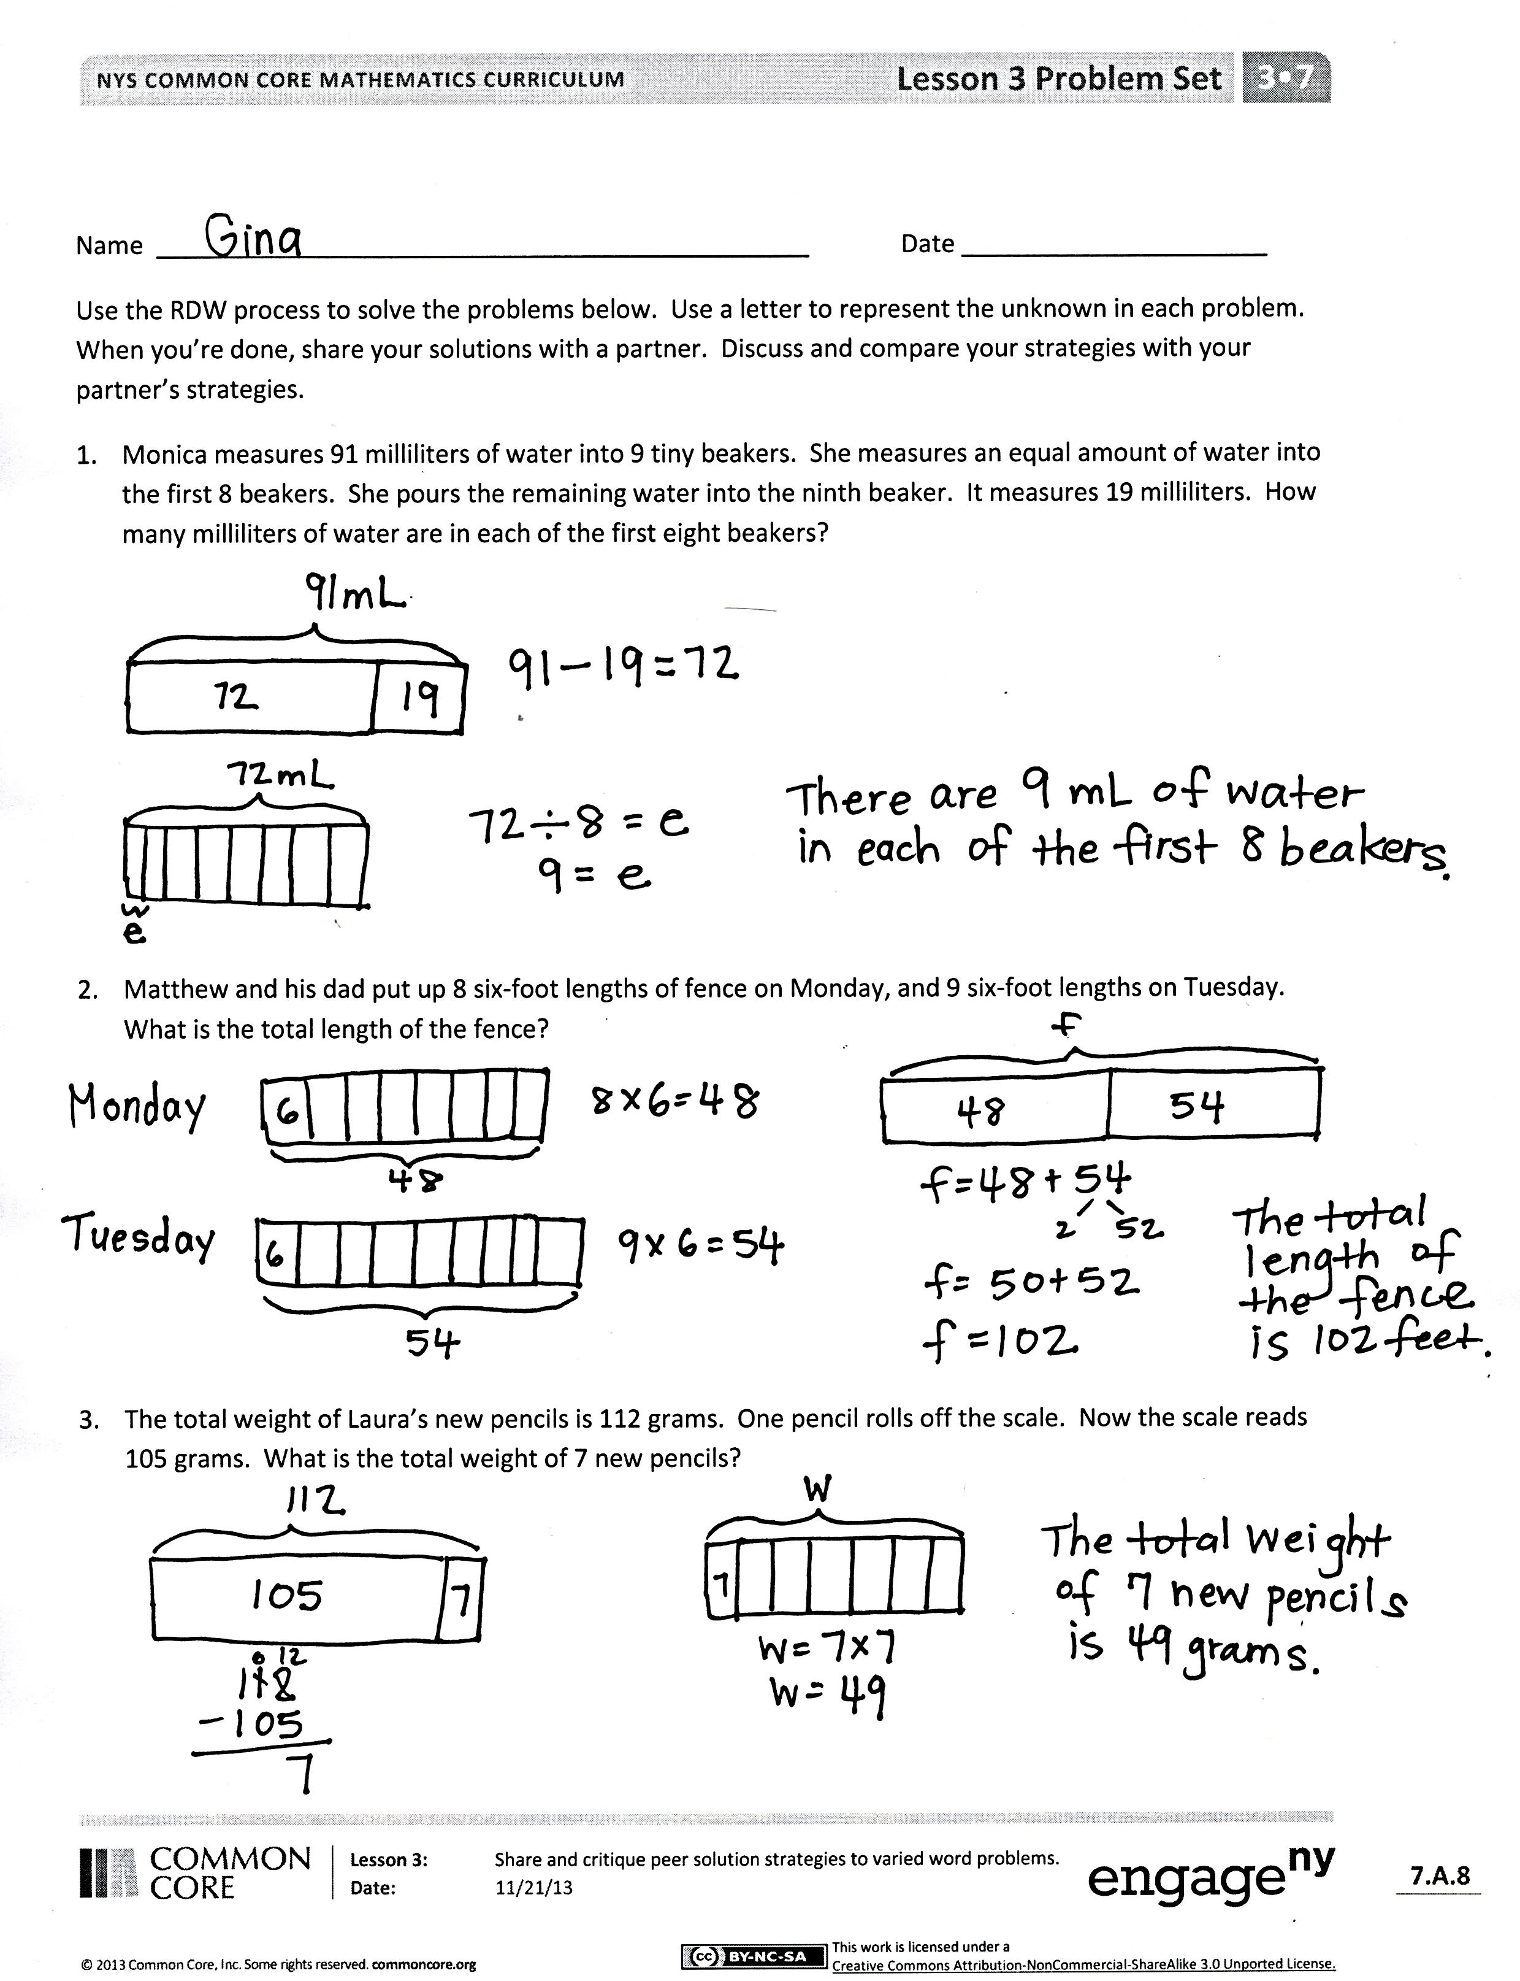
Student Debrief (10 minutes)
Lesson Objective: Share and critique peer solution strategies to varied word problems.
The Student Debrief is intended to invite reflection and active processing of the total lesson experience.
Invite students to review their solutions for the Problem Set. They should check work by comparing answers with a partner before going over answers as a class. Look for misconceptions or misunderstandings that can be addressed in the Debrief. Guide students in a conversation to debrief the Problem Set and process the lesson.
You may choose to use any combination of the questions below to lead the discussion.
- What can you draw to show Problem 2? How can you build equations from those drawings?
- Invite students to share and compare their processes for solving Problem 4.
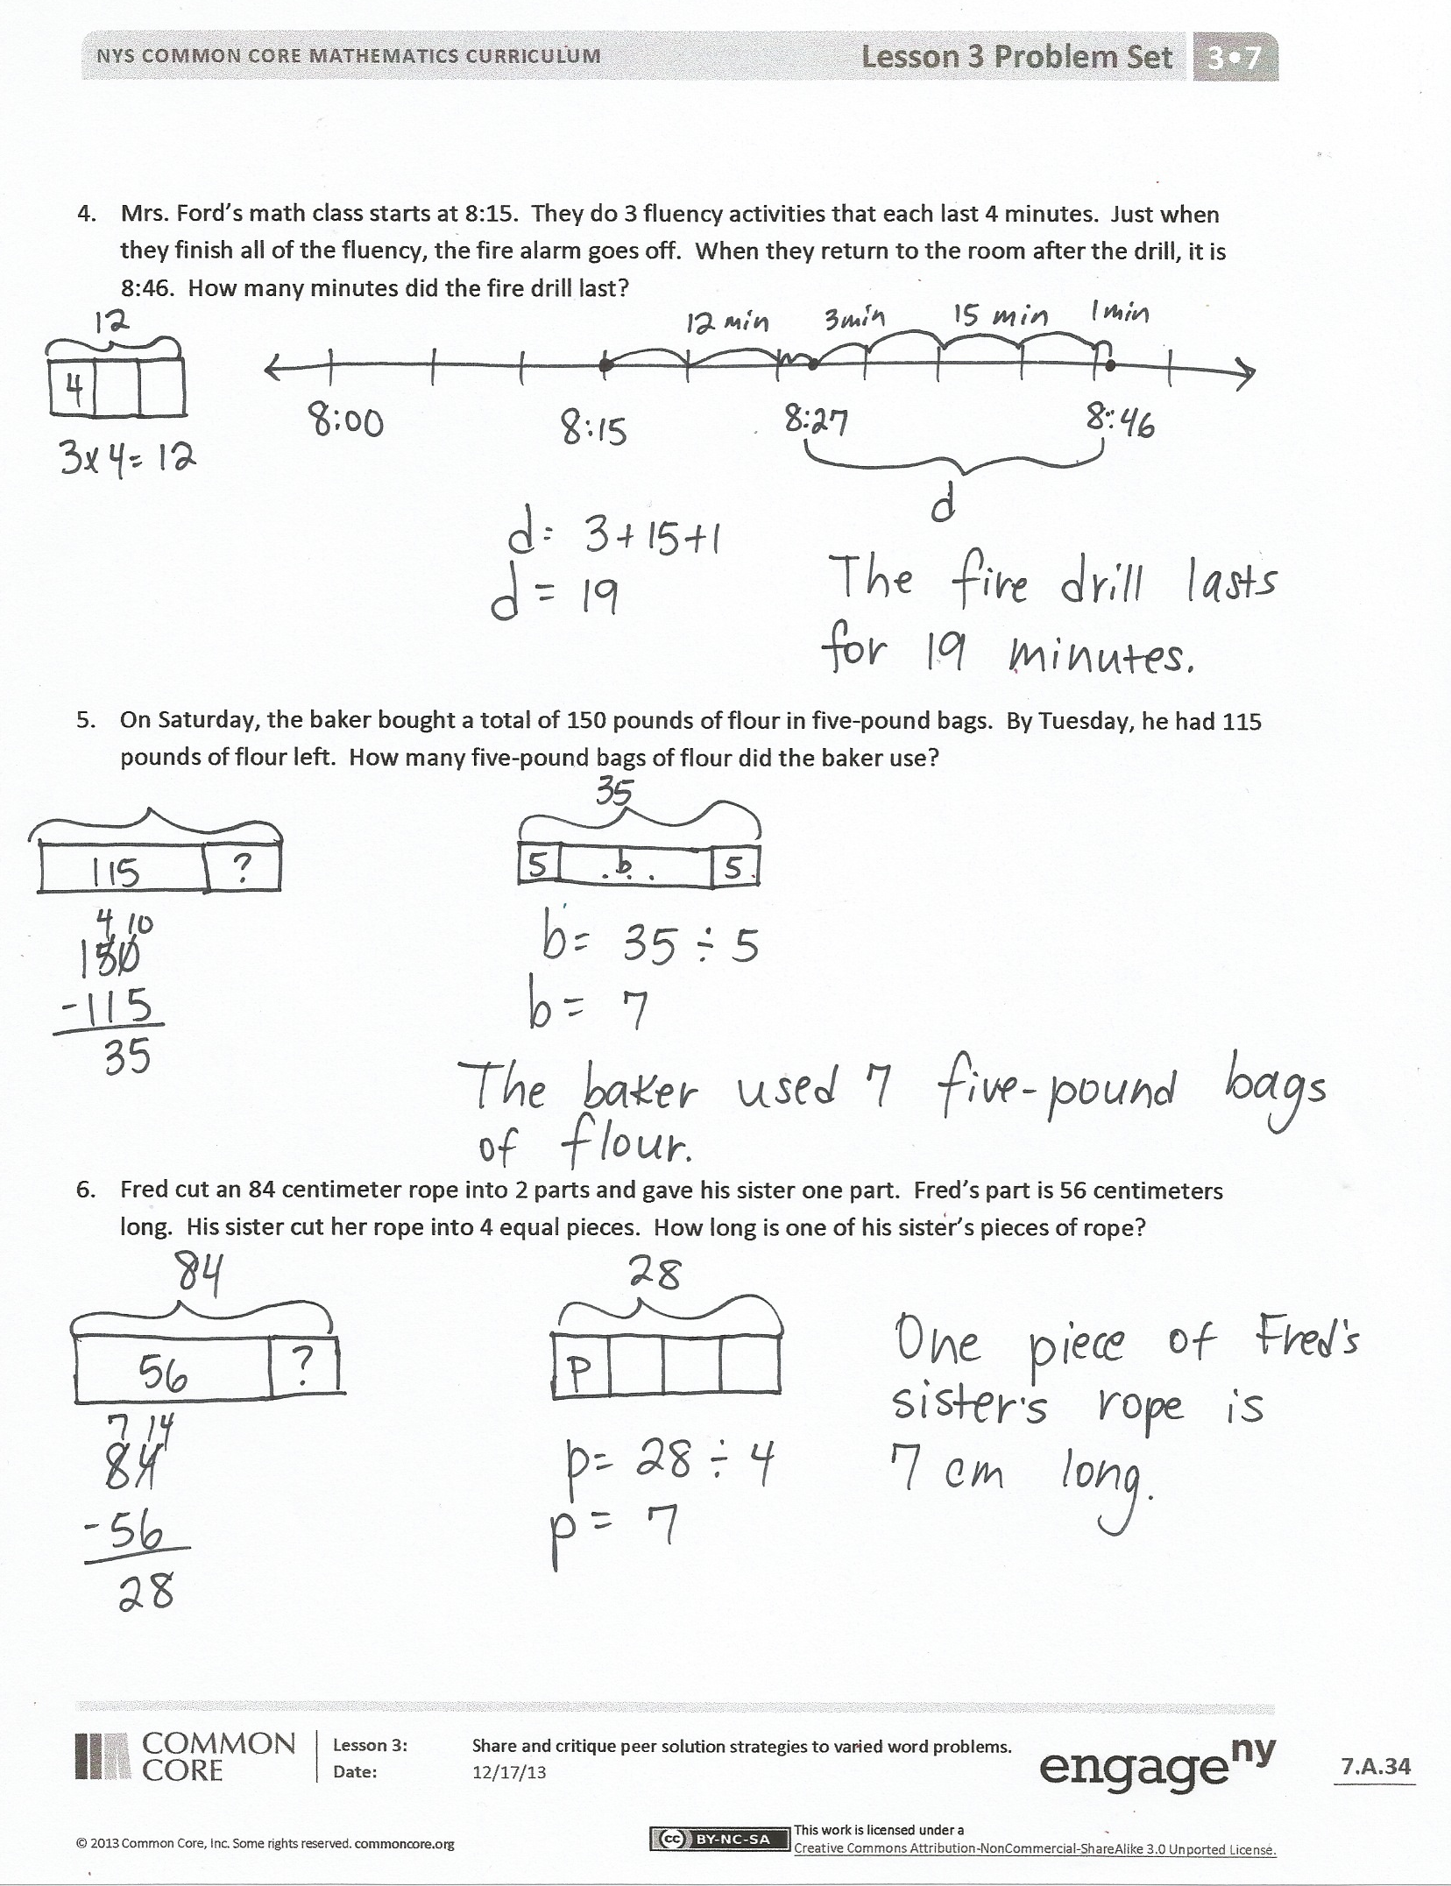
- What was your first step toward solving Problem 5? How did you figure that out? Once you finished the first step, how did you choose a strategy for solving the second step?
- How might it be helpful to your own work to analyze another person’s work?
- What was it like to have a friend critique your work?
Exit Ticket (3 minutes)
After the Student Debrief, instruct students to complete the Exit Ticket. A review of their work will help you assess the students’ understanding of the concepts that were presented in the lesson today and plan more effectively for future lessons. You may read the questions aloud to the students.

Name Date
Use the RDW process to solve the problems below. Use a letter to represent the unknown in each problem. When you are finished, share your solutions with a partner. Discuss and compare your strategies with your partner’s strategies.
- Monica measures 91 milliliters of water into 9 tiny beakers. She measures an equal amount of water into the first 8 beakers. She pours the remaining water into the ninth beaker. It measures 19 milliliters. How many milliliters of water are in each of the first eight beakers?

- Matthew and his dad put up 8 six-foot lengths of fence on Monday and 9 six-foot lengths on Tuesday. What is the total length of the fence?

- The total weight of Laura’s new pencils is 112 grams. One pencil rolls off the scale. Now the scale reads 105 grams. What is the total weight of 7 new pencils?

- Mrs. Ford’s math class starts at 8:15. They do 3 fluency activities that each last 4 minutes. Just when they finish all of the fluency, the fire alarm goes off. When they return to the room after the drill, it is 8:46. How many minutes did the fire drill last?

- On Saturday, the baker bought a total of 150 pounds of flour in five-pound bags. By Tuesday, he had 115 pounds of flour left. How many five-pound bags of flour did the baker use?

- Fred cut an 84 centimeter rope into 2 parts and gave his sister one part. Fred’s part is 56 centimeters long. His sister cut her rope into 4 equal pieces. How long is one of his sister’s pieces of rope?

Name Date
Use the RDW process to solve the problem below. Use a letter to represent the unknown.
Twenty packs of fruit snacks come in a box. Each pack weighs 6 ounces. Students eat some. There are 48 ounces of fruit snacks left in the box. How many ounces of fruit snacks did the students eat?

Name Date
Use the RDW process to solve the problems below. Use a letter to represent the unknown in each problem.
- Jerry pours 86 milliliters of water into 8 tiny beakers. He measures an equal amount of water into the first 7 beakers. He pours the remaining water into the eighth beaker. It measures 16 milliliters. How many milliliters of water are in each of the first 7 beakers?

- Mr. Chavez’s third-graders go to gym class at 11:15. Students rotate through three activities for 8 minutes each. Lunch begins at 12:00. How many minutes are left from the end of the gym activities until lunch begins?

- A box contains 100 pens. In each box there are 38 black pens and 42 blue pens, while the rest are green pens. Mr. Cane buys 6 boxes of pens. How many green pens does he have in total?

- Greg has $56. Tom has $17 more than Greg. Jason has $8 less than Tom.
  - How much money does Jason have?

- How much money do the 3 boys have in total?

- Laura cuts 64 inches of ribbon into two parts and gives her mom one part. Laura’s part is 28 inches long. Her mom cuts her ribbon into 6 equal pieces. How long is one of her mom’s pieces of ribbon?

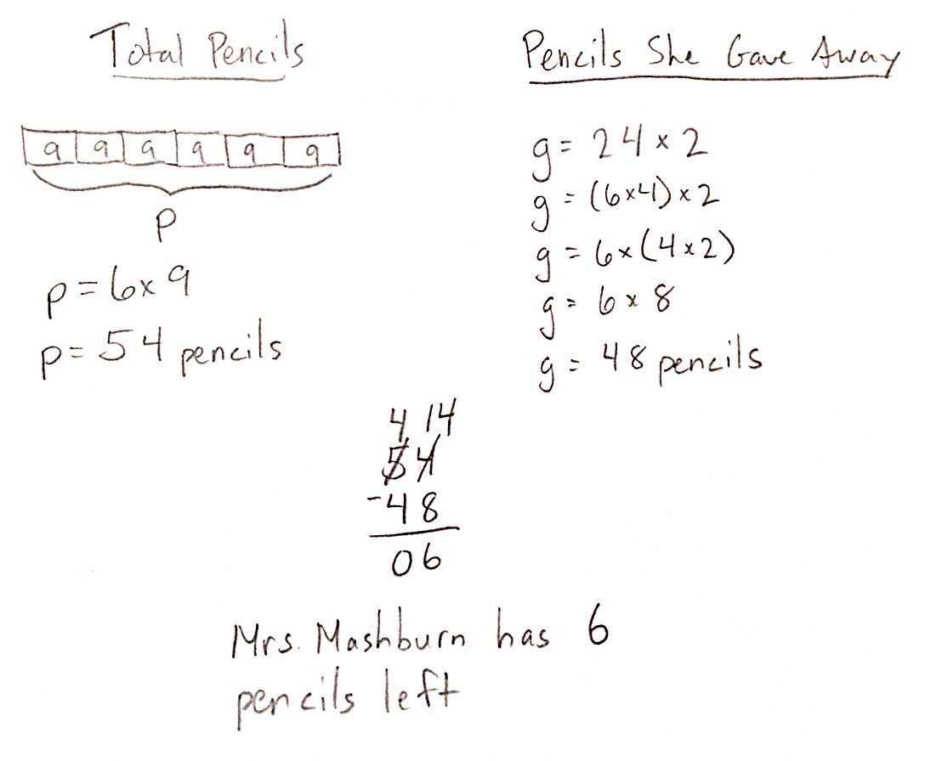
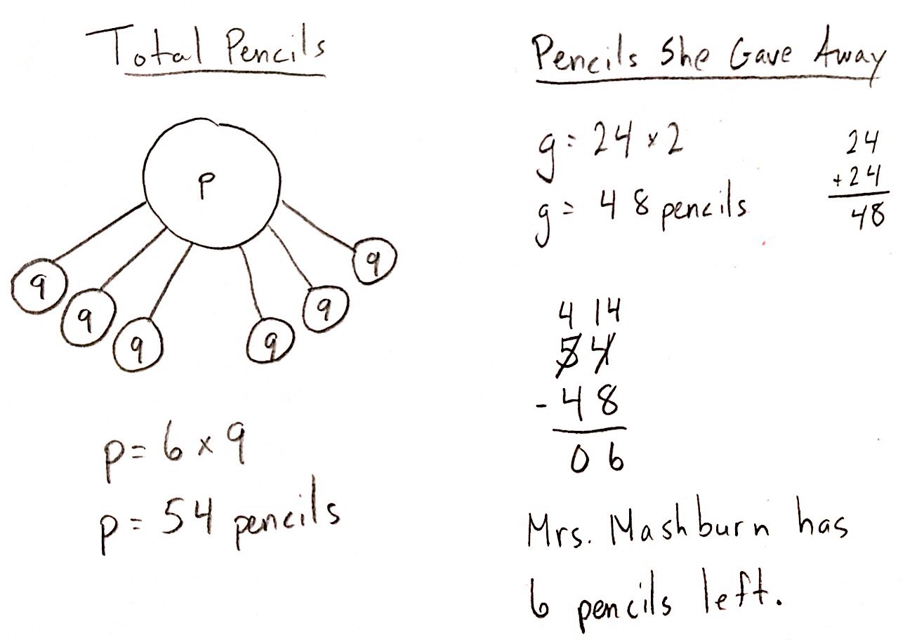
Student A

Student B

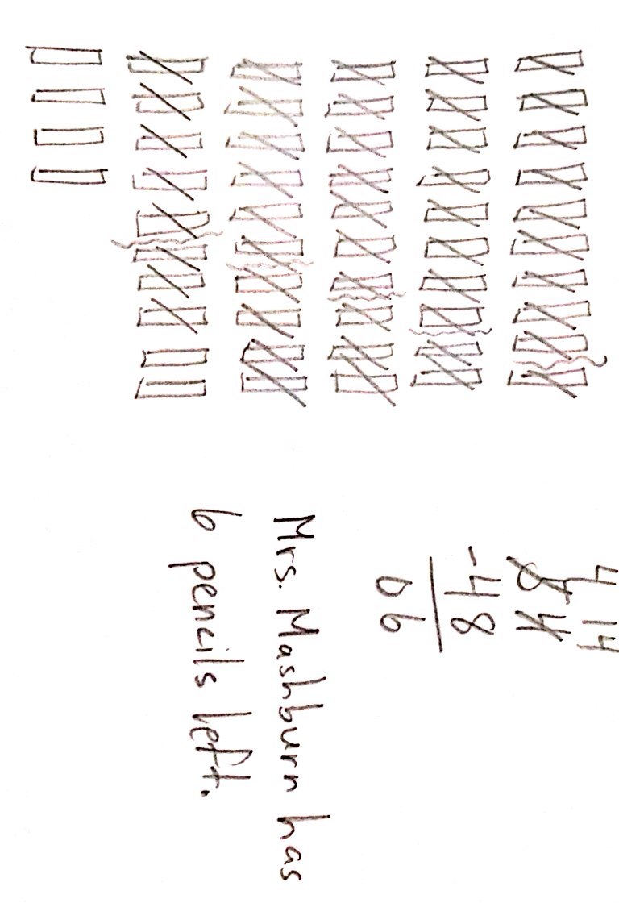
Student C

