Lesson 1
Objective: Solve word problems in varied contexts using a letter to represent the unknown.

Suggested Lesson Structure
 Fluency Practice (15 minutes)
 Concept Development (35 minutes)
 Student Debrief (10 minutes)
Total Time (60 minutes)
Fluency Practice (15 minutes)
- Name the Shape 2.G.1 (3 minutes)
- Multiply by 3 3.OA.7 (8 minutes)
- Equivalent Counting with Units of 2 3.OA.7 (4 minutes)

Name the Shape (3 minutes)
Note: This fluency activity reviews Grade 2 geometry concepts in preparation for G3–M7–Topic B.

T: (Project triangle.) What’s the name of the shape?
S: Triangle.
T: (Project square.) What’s one name of the shape?
S: Square. Rectangle.
T: How many sides does a square have?
S: Four sides.
T: What’s the name for all four-sided figures?
S: Quadrilaterals.
Continue the process for pentagon, hexagon, and octagon.

Multiply by 3 (8 minutes)
Materials: (S) Multiply by 3 Pattern Sheet (1–5)
Note: This activity builds fluency with multiplication facts using units of 3. It works toward students knowing from memory all products of two one-digit numbers.
T: (Write 5 × 3 = ____.) Let’s skip-count by threes to find the answer. (Count with fingers to 5 as students count.)
S: 3, 6, 9, 12, 15.
T: (Circle 15 and write 5 × 3 = 15 above it. Write 3 × 3 = ____.) Let’s skip-count up by threes again. (Count with fingers to 3 as students count.)
S: 3, 6, 9.
T: Let’s see how we can skip-count down to find the answer, too. Start at 15 with 5 fingers, 1 for each three. (Count down with fingers as students say numbers.)
S: 15 (5 fingers), 12 (4 fingers), 9 (3 fingers).
Repeat the process for 4 × 3.
T: Let’s practice multiplying by 3. Be sure to work left to right across the page.

Directions for Administration of Multiply By Pattern Sheet
- Distribute Multiply By pattern sheet.
- Allow a maximum of two minutes for students to complete as many problems as possible.
- Direct students to work left to right across the page.
- Encourage skip-counting strategies to solve unknown facts.

Equivalent Counting with Units of 2 (4 minutes)
Note: This activity builds fluency with multiplication facts using units of 2. The progression builds in complexity. Work the students up to the highest level of complexity in which they can confidently participate.
T: Count to 10. (Write as students count. See chart below.)
S: 1, 2, 3, 4, 5, 6, 7, 8, 9, 10.
T: (Write 1 two beneath the 1.) Count to 10 twos. (Write as students count.)
S: 1 two, 2 twos, 3 twos, 4 twos, 5 twos, 6 twos, 7 twos, 8 twos, 9 twos, 10 twos.
1 2 3 4 5 6 7 8 9 10
1 two 2 twos 3 twos 4 twos 5 twos 6 twos 7 twos 8 twos 9 twos 10 twos
2 4 6 8 10 12 14 16 18 20
1 two 4 3 twos 8 5 twos 12 7 twos 16 9 twos 20
2 2 twos 6 4 twos 10 6 twos 14 8 twos 18 10 twos
T: Count by twos to 20. (Write as students count.)
S: 2, 4, 6, 8, 10, 12, 14, 16, 18, 20.
T: (Write 1 two beneath the 2. Write 4 beneath the 4.) I’m going to give you a challenge. Let’s alternate between saying the units of two and the number. (Write as students count.)
S: 1 two, 4, 3 twos, 8, 5 twos, 12, 7 twos, 16, 9 twos, 20.
T: (Write 2 beneath 1 two and 2 twos beneath the 4.) Let’s alternate again. (Write as students count.)
S: 2, 2 twos, 6, 4 twos, 10, 6 twos, 14, 8 twos, 18, 10 twos.
Concept Development (35 minutes)

NOTES ON
MULTIPLE MEANS OF ENGAGEMENT:
If English language learners and others are unfamiliar with the context of Problem 1 of the Problem Set, change hayrides and orchard to terms from a more familiar context, such as rides and carnival.

Materials: (S) Problem Set, personal white boards
Have students place the Problem Set into their personal boards.
T: Let’s solve the first problem using our Read Draw Write process. What should we do first?
S: Read the problem!
T: Let’s read together: The sign below shows information about hayrides at the orchard. Lena’s family buys 2 adult tickets and 2 child tickets for the hayride. How much does it cost Lena’s family to go on the hayride? (Sign shown right.) Take 15 seconds to visualize the action, then tell your partner the scene it describes.
Chart to Accompany Problem 1
Hayrides
Adult ticket . . . . . . . . . $7
Child ticket . . . . . . . . . $4
Leave every 15 minutes starting at 11:00.
S: My family goes apple picking at the orchard in the fall! I know that hayride. It’s a tractor! I can imagine a girl, and her parents, and her sister or brother buying tickets.
T: Reread the question to yourself. Then use your own words to tell your partner what it’s asking.
S: It wants to know how much money Lena’s family spends on hayride tickets.

NOTE ON
MULTIPLE MEANS OF REPRESENTATION:
Depending on the technology available, students may solve directly on the Problem Set rather than on personal white boards. The purpose of using personal boards is for ease of sharing work. If necessary, slip out the Problem Set and show the work on the clear plastic sleeve using an overhead projector.

T: Notice the information provided to help you answer the question. What do you see?
S: The problem says that there are four people in Lena’s family. Two adults and two kids. There’s a chart too. It tells the different prices of tickets, and also when the hayrides leave.
T: Think about the Read-Draw-Write process. What question should we ask ourselves next?
S: What can I draw?

T: Reread the problem and think about your answer to that question. (Allow students time to do so.) Show your thinking on your board. As you label your drawing, use a letter to represent the unknown.
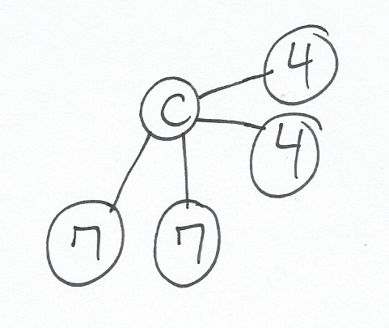
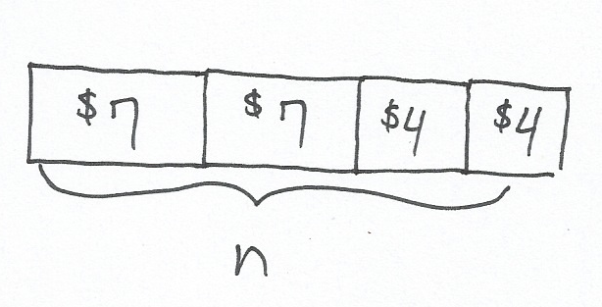
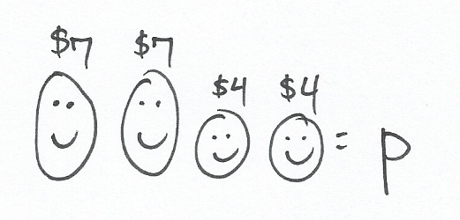
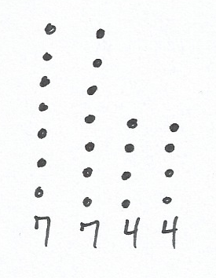
Some possible student models are shown below.

T: Tell your partner how your drawing represents the problem. Be sure to discuss your labels too.
S: (Discuss drawings and labels with partners.)
Circulate and identify two or three students with different models to share their explanations with the class. Encourage the class to question the presenter if the explanation is incomplete or clarification is needed. Ask the students to discuss the usefulness of the various models presented by their classmates.
T: What information is known and what information is unknown in this problem?
S: We know the cost of adult and child tickets, and how many of each the family bought. We don’t know how much the tickets cost altogether. We know parts, but not the whole.
MP.1
T: Look back at your drawing. Think about what number sentences you can write based on your drawing to model the problem and solve. Share your thinking with a partner.
S: I was just going to write 7 + 7 + 4 + 4 = c and find the answer. I was thinking 2 × 7 = 14 and 2 × 4 = 8, so 14 + 8 = n. That works, but if you’re going to multiply, you can just write (2 × 7) + (2 × 4) = p. Or, you can write, 2 × (7 + 4) = n.
T: Choose a strategy and solve.
S: (Solve.)
Circulate and identify two or three students with different solutions to share their work with the class. During the discussion, focus on the relationship between the drawing and the equation. Students should notice that most, if not all, combinations of models and equations work together.
T: The final step of our Read-Draw-Write process is to?
S: Write! Write a sentence with words to answer the problem.
T: Do that now. Reread the question to be sure your sentence accurately answers it.
S: (Possible answer: It costs Lena’s family $22 to go on the hayride.)
T: Look back at your work and try to remember your thinking at each step of the way. (Give students a few moments to recall their thoughts.) Explain your steps to your partner.
S: I first read the problem and visualized. Then I noticed the chart with prices. I drew a number bond to show 2 adult tickets and 2 child tickets, and I labeled the whole as the unknown. I thought about what I knew and what I didn’t know. Then I wrote this equation to find the total of the adult tickets, and then the total of the child tickets. I found the whole total. Last, I reread the question and wrote a word sentence to answer it.
T: Suppose you tried this problem again. Would you try a different drawing? A different equation? Why or why not? Discuss with your partner. (Allow students time to discuss.)
MP.1
Depending on lesson pacing and the needs of the class, guide students through another problem. Consider other methods of guidance including:
- Have the students read and draw the situation independently. Share and discuss more after they have completed their drawing.
- Discuss the visualization of the story, and then release students to draw and label a model and write a matching equation. Share and discuss after they have done their drawing and equation.
If another problem is selected, facilitate discussion that encourages students to think about more than one approach to a problem. Dialogue should broaden their perspectives and begin to engage them in critically considering their choices.
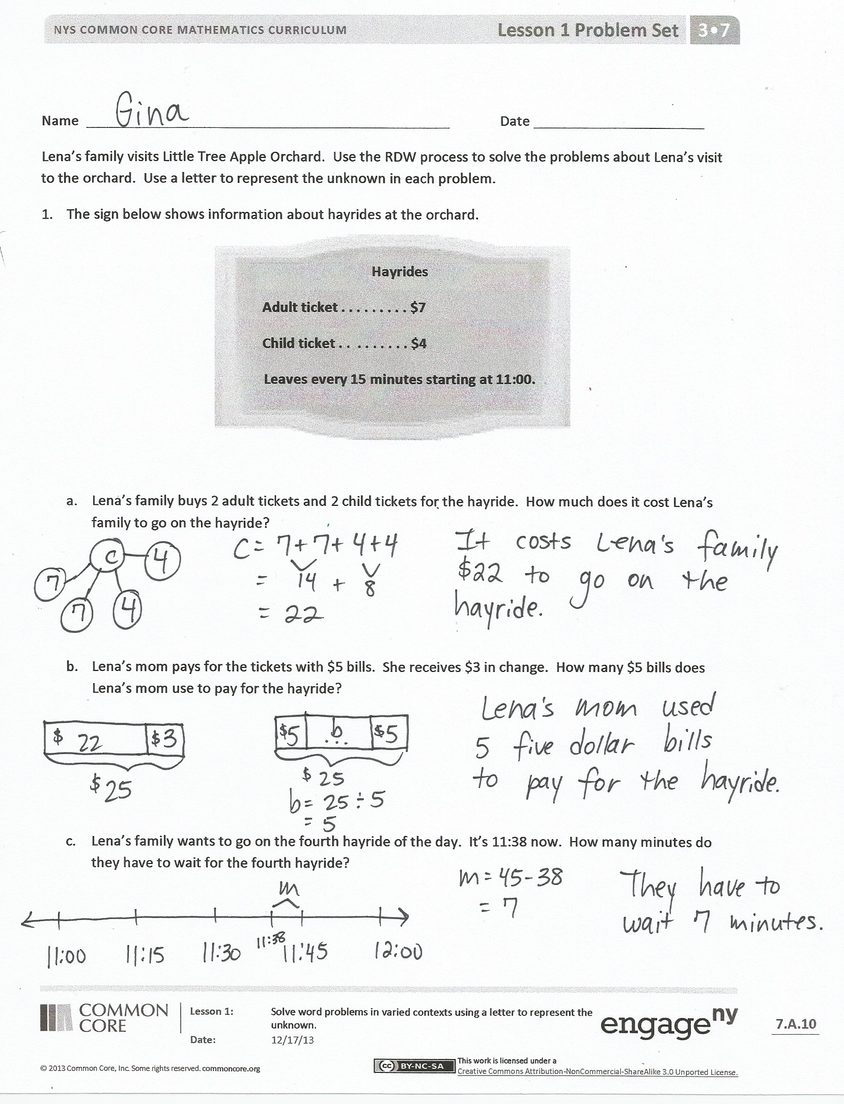
Problem Set (25 minutes)
Students should do their personal best to complete the Problem Set within the allotted 25 minutes. Some problems do not specify a method for solving. This is an intentional reduction of scaffolding that invokes MP.5, Use Appropriate Tools Strategically. Students should solve these problems using the RDW approach used for Application Problems.
For some classes, it may be appropriate to modify the assignment by specifying which problems students should work on first. With this option, let the careful sequencing of the Problem Set guide your selections so that problems continue to be scaffolded. Balance word problems with other problem types to ensure a range of practice. Assign incomplete problems for homework or at another time during the day.
Student Debrief (10 minutes)
Lesson Objective: Solve word problems in varied contexts using a letter to represent the unknown.
The Student Debrief is intended to invite reflection and active processing of the total lesson experience.
Invite students to review their solutions for the Problem Set. They should check work by comparing answers with a partner before going over answers as a class. Look for misconceptions or misunderstandings that can be addressed in the Debrief. Guide students in a conversation to debrief the Problem Set and process the lesson.
You may choose to use any combination of the questions below to lead the discussion, depending on how you asked students to solve the Problem Set.
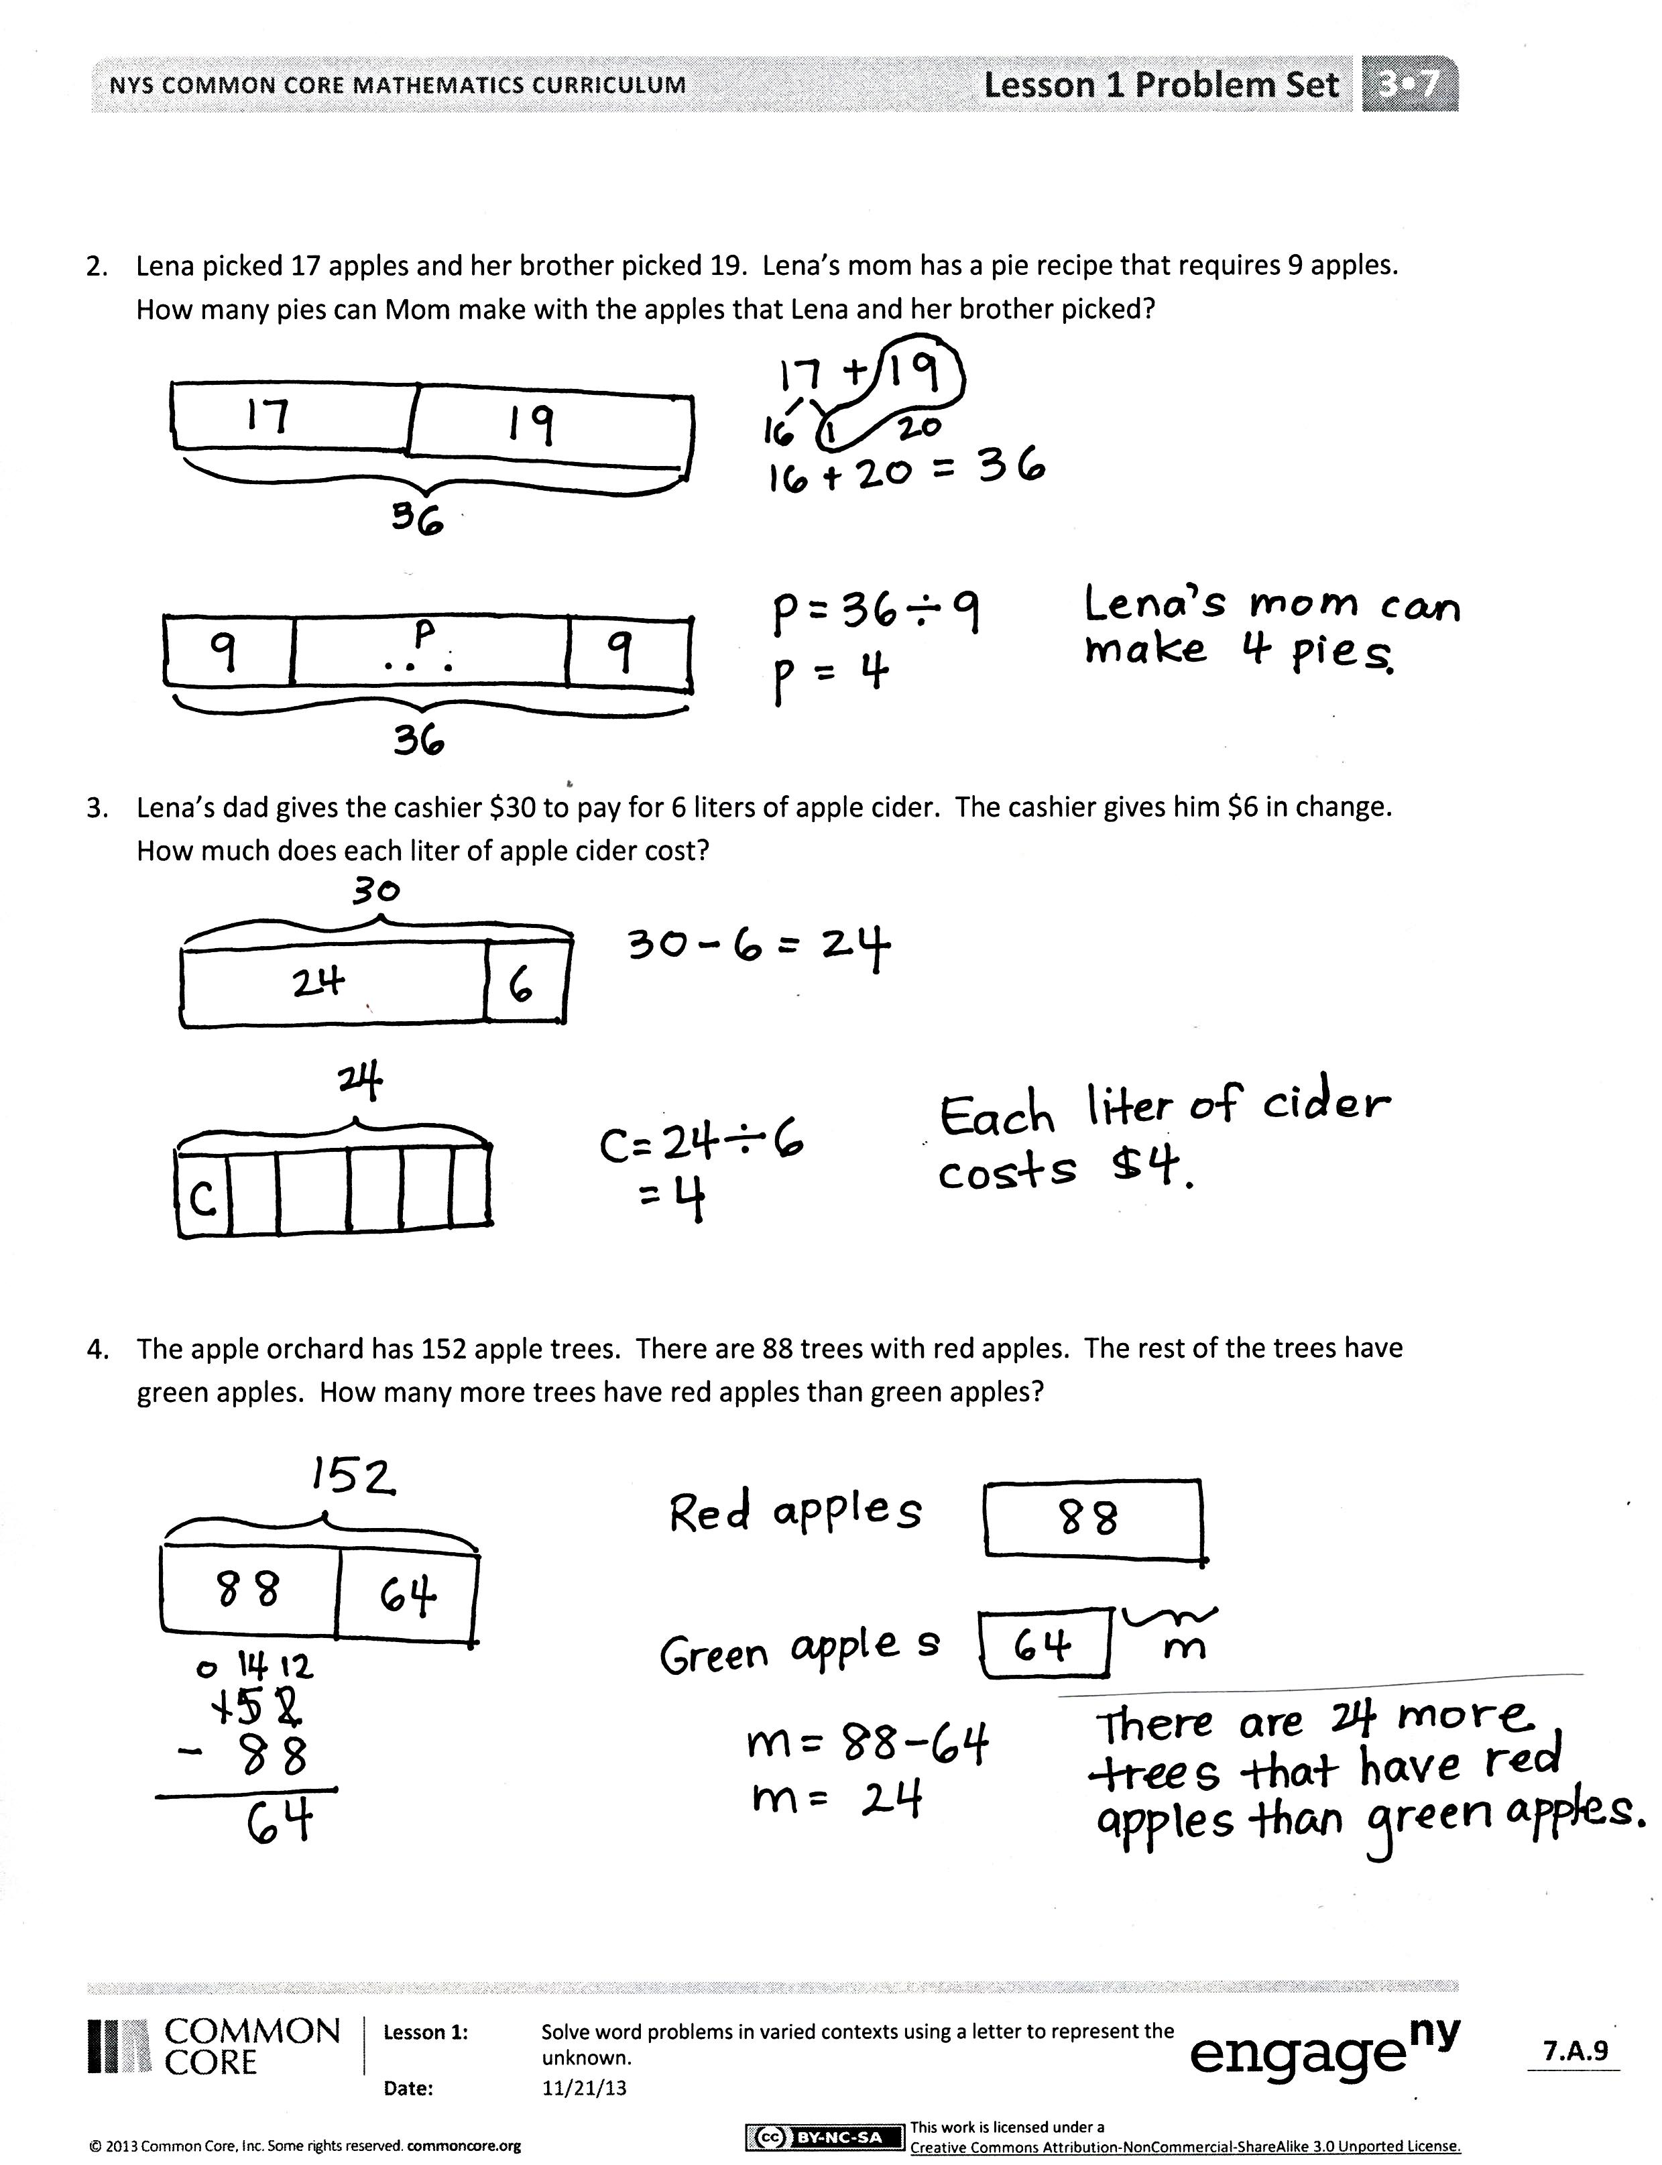
- Invite students who used different drawings for the same problem to share their work. Facilitate a comparative discussion.
- Did you try one of the drawing or equation ideas from our lesson today in another problem on the Problem Set? What did you use? Why did you use it for that problem?
- What operations were needed to solve Problem 2? What helped you figure that out?
- In Problems 2 and 3, division was used after either addition or subtraction. What equations did you write to show that? How can both operations be shown with a single equation?
- Why do you think we spent so much time in our lesson today talking about different ways to draw and write equations for the same problem?
Exit Ticket (3 minutes)
After the Student Debrief, instruct students to complete the Exit Ticket. A review of their work will help you assess the students’ understanding of the concepts that were presented in the lesson today and plan more effectively for future lessons. You may read the questions aloud to the students.

Multiply.
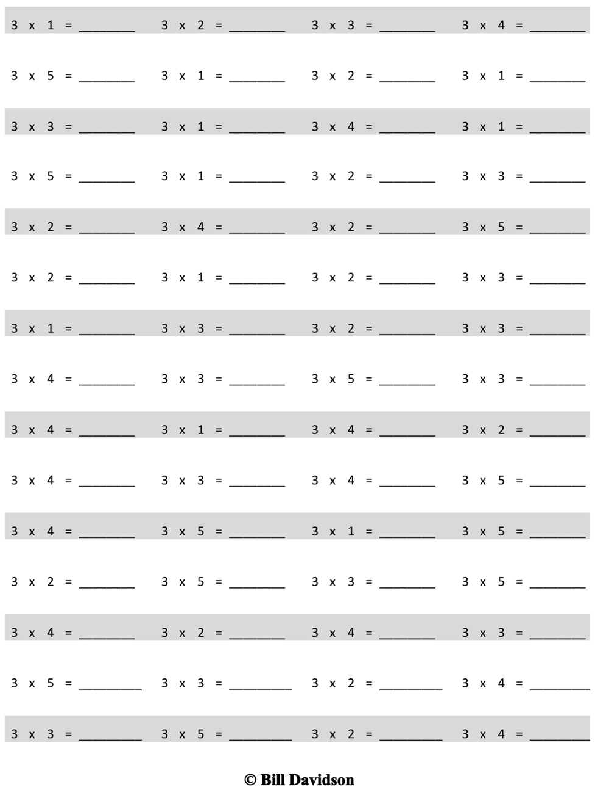

Name Date
Lena’s family visits Little Tree Apple Orchard. Use the RDW process to solve the problems about Lena’s visit to the orchard. Use a letter to represent the unknown in each problem.
- The sign below shows information about hayrides at the orchard.
Hayrides
Adult ticket . . . . . . . . . $7
Child ticket . . . . . . . . . $4
Leaves every 15 minutes starting at 11:00.

- Lena’s family buys 2 adult tickets and 2 child tickets for the hayride. How much does it cost Lena’s family to go on the hayride?

- Lena’s mom pays for the tickets with $5 bills. She receives $3 in change. How many $5 bills does Lena’s mom use to pay for the hayride?

- Lena’s family wants to go on the fourth hayride of the day. It’s 11:38 now. How many minutes do they have to wait for the fourth hayride?

- Lena picked 17 apples and her brother picked 19. Lena’s mom has a pie recipe that requires 9 apples. How many pies can Mom make with the apples that Lena and her brother picked?

- Lena’s dad gives the cashier $30 to pay for 6 liters of apple cider. The cashier gives him $6 in change. How much does each liter of apple cider cost?

- The apple orchard has 152 apple trees. There are 88 trees with red apples. The rest of the trees have green apples. How many more trees have red apples than green apples?

Name Date
Use the RDW process to solve the problem below. Use a letter to represent the unknown.
Sandra has her sticker collection in 7 albums. Each album has 40 stickers in it. She starts a new album that has 9 stickers in it. How many total stickers does she have in her collection?

Name Date
Max’s family takes the train to visit the city zoo. Use the RDW process to solve the problems about Max’s trip to the zoo. Use a letter to represent the unknown in each problem.
  - The sign below shows information about the train schedule into the city.
Train Fare–One Way

Adult……………………..…..$ 8
Child…………………………..$ 6
Leaves every 15 minutes starting at 6:00 a.m.

    - Max’s family buys 2 adult tickets and 3 child tickets. How much does it cost for Max’s family to take the train into the city?

  - Max’s father pays for the tickets with $10 bills. He receives $6 in change. How many $10 bills does Max’s father use to pay for the train tickets?

  - Max’s family wants to take the fourth train of the day. It’s 6:38 a.m. now. How many minutes do they have to wait for the fourth train?

- At the city zoo, they see 17 young bats and 19 adult bats. The bats are placed equally into 4 areas. How many bats are in each area?

- Max’s father gives the cashier $20 to pay for 6 water bottles. The cashier gives him $8 in change. How much does each water bottle cost?

- The zoo has 112 species of reptiles and amphibians in their exhibits. There are 72 species of reptiles and the rest are amphibians. How many more species of reptiles are there than amphibians in the exhibits?

