Lesson 9
Objective: Analyze data to problem solve.

Suggested Lesson Structure
 Fluency Practice (14 minutes)
 Application Problem (5 minutes)
 Concept Development (31 minutes)
 Student Debrief (10 minutes)
Total Time (60 minutes)
Fluency Practice (14 minutes)
- Group Counting 3.OA.1 (3 minutes)
- Multiply by 7 3.OA.7 (7 minutes)
- Count by Halves and Fourths 3.MD.4 (4 minutes)
Group Counting (3 minutes)
Materials: (S) Personal white board
Note: This group counting activity reviews the relationship between counting by a unit and multiplying and dividing with that unit.
T: Count by sixes to 60.
S: 6, 12, 18, 24, 30, 36, 42, 48, 54, 60.
T: (Write 4 sixes = .) Write the number sentence.
S: (Write 4 sixes = 24.)
T: Write 4 sixes as a multiplication sentence.
S: (Write 4 × 6 = 24.)
T: (Write 48 ÷ 6 = .) Write the number sentence. Count by sixes if you’re unsure.
S: (Write 48 ÷ 6 = 8.)
T: Count by eights to 80.
S: 8, 16, 24, 32, 40, 48, 56, 64, 72, 80.
T: (Write 3 eights = .) Write the number sentence.
S: (Write 3 eights = 24.)
T: Write 3 eights as a multiplication sentence.
S: (Write 3 × 8 = 24.)
T: (Write 56 ÷ 8 = .) Write the number sentence. Count by eights if you’re unsure.
S: (Write 56 ÷ 8 = 7.)
T: Count by nines to 90.
S: 9, 18, 27, 36, 45, 54, 63, 72, 81, 90.
T: (Write 4 nines = .) Write the number sentence.
S: (Write 4 nines = 36.)
T: Write 4 nines as a multiplication sentence.
S: (Write 4 × 9 = 36.)
T: (Write 54 ÷ 9 = .) Write the number sentence. Count by nines if you’re unsure.
S: (Write 54 ÷ 9 = 6.)
Multiply by 7 (7 minutes)
Materials: (S) Multiply by 7 (6–10) (Pattern Sheet)
Note: This activity builds fluency with multiplication facts using units of 7. It works toward students knowing from memory all products of two one-digit numbers. See Lesson 6 for the directions for administration of a Multiply-By Pattern Sheet.
T: (Write 6 × 7 = ____.) Let’s skip-count up by sevens to solve. I’ll raise a finger for each seven. (Raise a finger for each number to track the count. Record the skip-count answers on the board.)
S: 7, 14, 21, 28, 35, 42.
T: Let’s skip-count down to find the answer, too. Start at 70. (Count down with fingers as students say numbers.)
S: 70, 63, 56, 49, 42.
Continue with the following suggested sequence: 8 × 7, 7 × 7, and 9 × 7.
T: (Distribute the Multiply by 7 Pattern Sheet.) Let’s practice multiplying by 7. Be sure to work left to right across the page.
Count by Halves and Fourths (4 minutes)
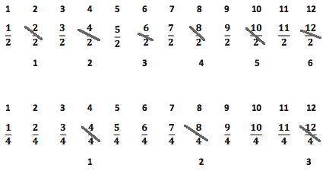
Note: This activity reviews Lesson 6.

T: Count by halves to 12 halves as I write. Please don’t count faster than I can write. (Write as students count.)
S: 1 half, 2 halves, 3 halves, 4 halves, 5 halves, 6 halves, 7 halves, 8 halves, 9 halves, 10 halves, 11 halves, 12 halves.
T: (Point to $\frac{2}{2}$.) Say 2 halves as a whole number.
S: 1.
T: (Lightly cross out $\frac{2}{2}$ and write 1 beneath it.)
Continue the process for the following sequence: $\frac{4}{2}$, $\frac{6}{2}$, $\frac{8}{2}$, $\frac{10}{2}$, and $\frac{12}{2}$.
T: Count by halves, saying whole numbers when you arrive at whole numbers. Try not to look at the board. (Direct students to count forward and backward on the number line, occasionally changing directions.)
Repeat the process for fourths.
Application Problem (5 minutes)
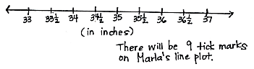
Marla creates a line plot with a half-inch scale from 33 to 37 inches. How many tick marks will be on her line plot?

Note: This problem reviews the concepts taught in Lessons 7─8. Invite students to share their strategies for solving this problem.
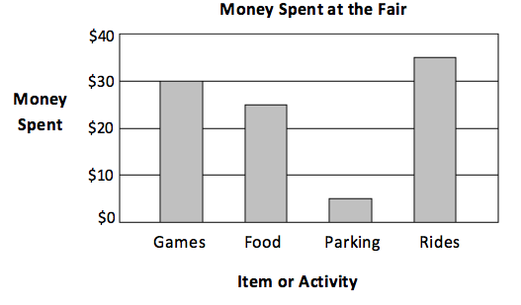
Concept Development (31 minutes)
Template
Materials: (S) Bar graph and line plot (Template) shown right, personal white board
Problem 1: Solve problems with categorical data.
Project the bar graph from the Template as shown.
T: This graph shows how some friends spent their money at the fair.
Project or read the following problem: How much more money was spent on rides than on parking?
T: How can you use the graph to help you solve this problem? Talk to a partner.
S: I can read the value of the rides bar and then subtract the value of the parking bar. $35 – $5.
T: Choose a strategy and solve. (Allow students time to work.) How much more money was spent on rides than on parking?
S: $30.
T: Talk to your partner: Why do you think more money was spent on rides than on parking?

NOTES ON
MULTIPLE MEANS
OF REPRESENTATION:
Guide students to use tools within the graph to read values. In Money Spent at the Fair, students should note that rows are at increments of $10. Keeping this in mind, guide students to quickly read the half unit as $5. Scaffold fluency by having students draw lines in each bar to make $10 units, connecting back to their reading of picture graphs.

S: The rides are one of the most fun activities at the fair. Yeah, it wouldn’t make sense if parking cost more than the rides. If parking was more expensive than the rides, people might not come to the fair at all!
Project or read the following problem: The friends take a total of $120 to the fair. How much do they have left after the fair?
T: What is the first thing we need to find out?
S: We need to find the total amount they spent at the fair.
T: Talk to your partner. How will the graph help us find the total amount?
S: We can find how much the friends spent on each thing shown by the bar graph. Then, we can add the amounts together.
T: Use the graph to write a number sentence to show how much money the friends spend in all.
S: (Write $30 + $25 + $5 + $35 = $95.)
T: How much do the friends spend in all?
S: $95.
T: Have we solved the problem?
S: No. We need to find how much money the friends have left.
T: Write a number sentence to show how much money the friends have left. (Allow students time to work.) How much money do they have left after the fair?
S: $25.
As time allows, continue with the additional questions below. Students may work independently, in pairs, or in groups.
- How much less did the friends spend on rides than on games and food combined?
- Parking costs $1 for each hour. The group of friends arrived at the fair at 3:00 p.m. What time did they leave?

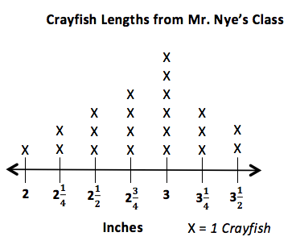
Problem 2: Solve problems with measurement data.
Template
Project the line plot from the Template as shown.
T: This line plot shows the lengths of the crayfish in Mr. Nye’s third-grade science class.
Project or read the following problem: What is the total length of all the crayfish that are 3 inches long?
MP.2
T: Talk to your partner. How can you use the line plot to help you solve this problem?
S: I can skip-count the X’s on the 3-inch mark by three. I know there are 6 crayfish that are 3 inches long, so I can just multiply 6 times 3.
T: Solve. (Allow students time to work.) What is the total length?
S: 18 inches!
Project or read the following problem: Mrs. Curie’s students also measure the lengths of their crayfish. They notice the number of crayfish that are less than 3 inches long is half of the number of crayfish that are 3 inches long in Mr. Nye’s class. How many crayfish are less than 3 inches long in Mrs. Curie’s class?
T: What do you need to figure out first to solve this problem?
S: The number of crayfish in Mr. Nye’s class that are less than 3 inches long.
T: Discuss with a partner how to find the number of crayfish in Mr. Nye’s class that are less than 3 inches long.
S: (Discuss.)
T: How many crayfish are less than 3 inches long in Mr. Nye’s class?
S: 10 crayfish!
T: How does this help you find the answer to the problem?
S: Well, Mrs. Curie’s class has half as many, so I can just divide 10 by 2. I know that half of 10 is 5.
T: How many crayfish are less than 3 inches long in Mrs. Curie’s class?
S: 5 crayfish!
As time allows, continue with the additional questions below. Students may work independently, in pairs, or in groups.
- Ginny uses half-inch square tiles to measure the longest crayfish. How many half-inch square tiles does she use?
- Use the line plot and the chart below to find the total number of crayfish that all of the third-grade classes are studying.
Classroom | Mr. Franklin | Mrs. Curie | Mr. Nye | Mrs. Nobel
Number of Crayfish | 21 | 23 | ? | 24
- The crayfish are kept in small tanks. There are 3 crayfish in each tank. How many tanks does
Mr. Nye’s class need?
T: Data is shown in different forms depending on how it is used. Compare the money spent at the fair problem to Mr. Nye’s class’s crayfish problem. Talk to your partner. Would it make sense for the money spent at the fair data to be switched to a line plot? Explain why or why not. Think about how each representation helps you analyze the data.
S: Line plots usually show how many times a certain thing happens, like how many crayfish are a certain measurement. It wouldn’t make sense to try to show money spent at the fair on a line plot. We use a number line to make a line plot. It wouldn’t make sense to put rides, food, games, and parking as labels on a number line! What would each X represent?
T: Bar graphs are used to compare things between different groups, and line plots are used to show frequency of data along a number line.
T: Turn and talk to your partner. If we wanted to show the number of coins in 4 piggy banks, what graph would you use and why?
S: A bar graph, because we have 4 different groups.
It doesn’t make sense to plot piggy banks on a number line since we’re comparing what’s in each piggy bank.
If needed and time permits, continue asking students about which graph would be most appropriate for specific data. The chart below shows some of the titles of bar graphs and line plots they have seen in this module.
Bar Graphs | Line Plots
- Number of fish in each tank  - Number of students in each class  - Amount of money saved each month  - Number of magazines sold by each student  - Number of visitors to a carnival each day  - Number of coins in each piggy bank | - Lengths of straws  - Number of hours spent outside over the weekend  - Heights of children on third-grade basketball team  - Lengths of caterpillars  - Lengths of plants’ roots  - Heights of bean plants  - Heights of sunflower plants  - Widths of silver maple tree leaves

Problem Set (10 minutes)

NOTES ON
MULTIPLE MEANS
OF ENGAGEMENT:
Instead of completing the last word problem of the Problem Set, offer students working above grade level an open-ended challenge similar to the ones listed below:
- Represent the information from Lengths of Blades of Grass in Inches in a different type of graph. How does the presentation change your perception and understanding of the data?
- What other information might you obtain if you were to make a line plot for the Number of Apples Picked picture graph?

Students should do their personal best to complete the Problem Set within the allotted 10 minutes. For some classes, it may be appropriate to modify the assignment by specifying which problems they work on first. Some problems do not specify a method for solving. Students should solve these problems using the RDW approach used for Application Problems.
Student Debrief (10 minutes)
Lesson Objective: Analyze data to problem solve.
The Student Debrief is intended to invite reflection and active processing of the total lesson experience.
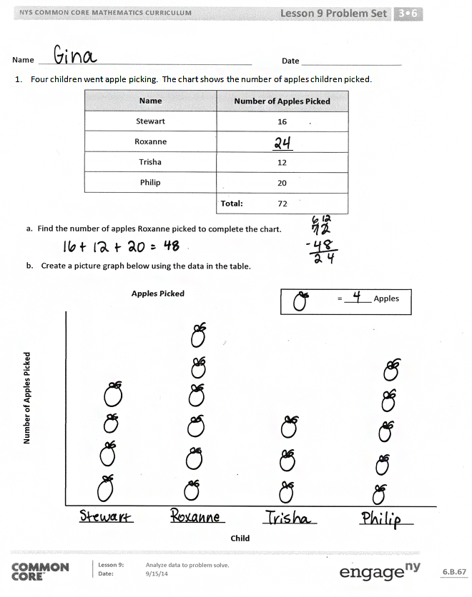
Invite students to review their solutions for the Problem Set. They should check work by comparing answers with a partner before going over answers as a class. Look for misconceptions or misunderstandings that can be addressed in the Debrief. Guide students in a conversation to debrief the Problem Set and process the lesson.
Any combination of the questions below may be used to lead the discussion.
- What scale did you use for Problem 1(b)? Would that scale work if Philip picked 21 apples?
- Compare your solution for Problem 2(b) to a partner’s solution. Did you and your partner use the same strategy to solve the problem?
- Explain to your partner how you chose the scale for the line plot in Problem 3(a).
- Other than counting the X’s, is there another strategy you can use to find the total number of blades of grass that were measured in Problem 3(b)? (Count the boxes in the chart or multiply to find the total number of boxes in the chart.)
- Would it make sense to display the number of apples data in a line plot? Why or why not?
- When is it best to show your data as a picture graph? A bar graph? A line plot? What is the difference?
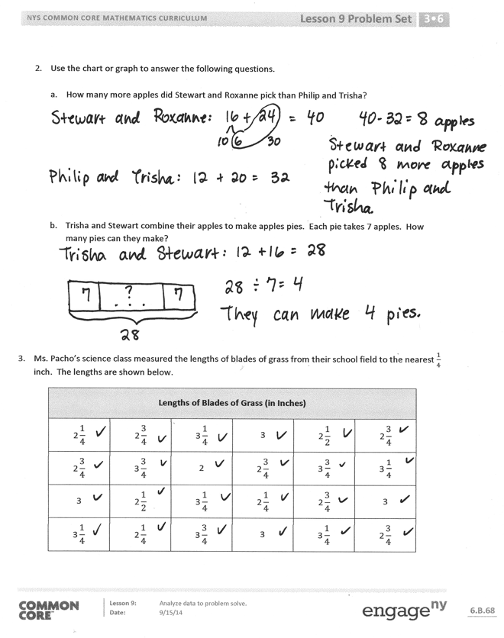
Exit Ticket (3 minutes)
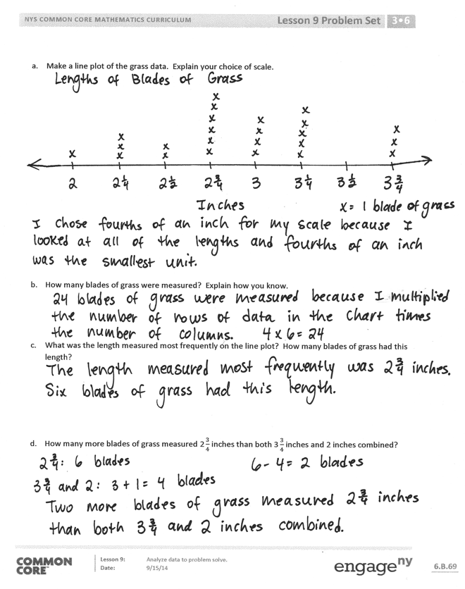
After the Student Debrief, instruct students to complete the Exit Ticket. A review of their work will help with assessing students’ understanding of the concepts that were presented in today’s lesson and planning more effectively for future lessons. The questions may be read aloud to the students.

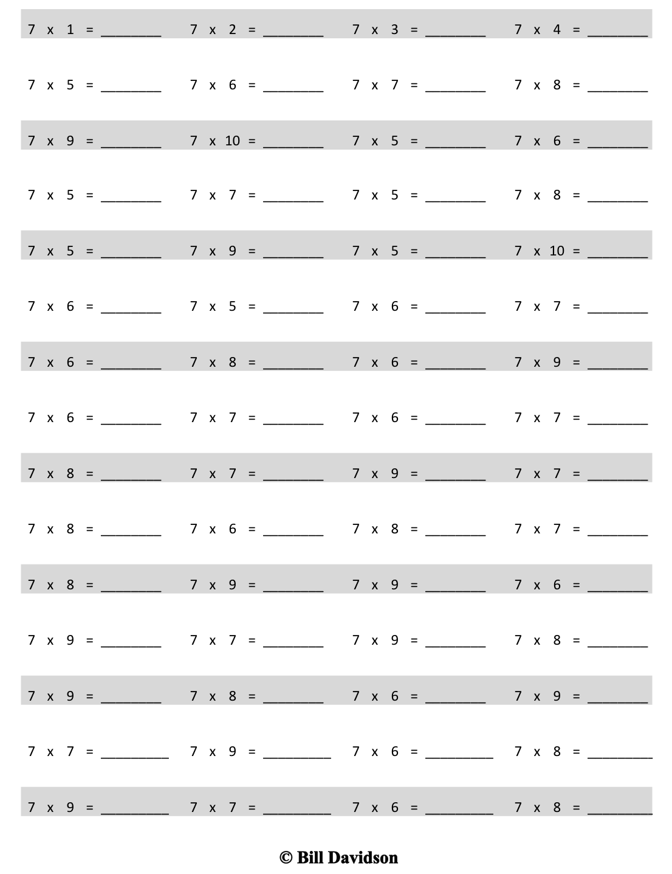
Multiply.

Name Date
- Four children went apple picking. The chart shows the number of apples children picked.
Name | Number of Apples Picked
Stewart | 16
Roxanne | ______
Trisha | 12
Philip | 20
 | Total: 72

- Find the number of apples Roxanne picked to complete the chart.

- Create a picture graph below using the data in the table.
= ______ Apples
Apples Picked

Number of Apples Picked

Child

- Use the chart or graph to answer the following questions.
- How many more apples did Stewart and Roxanne pick than Philip and Trisha?

- Trisha and Stewart combine their apples to make apples pies. Each pie takes 7 apples. How many pies can they make?

- Ms. Pacho’s science class measured the lengths of blades of grass from their school field to the nearest $\frac{1}{4}$ inch. The lengths are shown below.
Lengths of Blades of Grass (in Inches)
$$\text{2}\frac{1}{4}$$ | $$\text{2}\frac{3}{4}$$ | $$\text{3}\frac{1}{4}$$ | 3 | $$\text{2}\frac{1}{2}$$ | $$\text{2}\frac{3}{4}$$
$$\text{2}\frac{3}{4}$$ | $$\text{3}\frac{3}{4}$$ | 2 | $$\text{2}\frac{3}{4}$$ | 3 $\frac{3}{4}$ | 3 $\frac{1}{4}$
3 | $$\text{2}\frac{1}{2}$$ | $$\text{3}\frac{1}{4}$$ | $$\text{2}\frac{1}{4}$$ | $$\text{2}\frac{3}{4}$$ | 3
$$\text{3}\frac{1}{4}$$ | $$\text{2}\frac{1}{4}$$ | $$\text{3}\frac{3}{4}$$ | 3 | $$\text{3}\frac{1}{4}$$ | $$\text{2}\frac{3}{4}$$

- Make a line plot of the grass data. Explain your choice of scale.

- How many blades of grass were measured? Explain how you know.

- What was the length measured most frequently on the line plot? How many blades of grass had this length?

- How many more blades of grass measured $\text{2}\frac{3}{4}$ inches than both $\text{3}\frac{3}{4}$ inches and 2 inches combined?

Name Date
Mr. Gallagher’s science class goes bird watching. The picture graph below shows the number of birds the class observes.

= ______ Birds
6
Number of Birds Observed
Monday
Tuesday
Wednesday
Thursdayay
Number of Birds Mr. Gallagher’s Class Observed
Day

- How many more birds did Mr. Gallagher’s class observe on Wednesday and Thursday than on Monday and Tuesday?

- Mr. Manning’s class observed 104 birds. How many more birds did Mr. Gallagher’s class observe?

Name Date
- The table below shows the amount of money Danielle saves for four months.

Month | Money Saved
January | $9
February | $18
March | $36
April | $27

Create a picture graph below using the data in the table.
= ______ Dollars
Money Danielle Saves
Month

Money Saved

- Use the table or graph to answer the following questions.
- How much money does Danielle save in four months?

- How much more money does Danielle save in March and April than in January and February?

- Danielle combines her savings from March and April to buy books for her friends. Each book costs $9. How many books can she buy?

- Danielle earns $33 in January. She buys a necklace for $8, and a birthday present for her brother. She saves the $13 she has left. How much does the birthday present cost?
Item or Activity
Games Food Parking Rides

$40

$30

$20

$10

Money Spent at the Fair
Money Spent
$0

2$\frac{3}{4}$
X
X
X
X
X
X
X
X
X
X
X
X

Crayfish Lengths from Mr. Nye’s Class

2$\frac{1}{2}$
2$\frac{1}{4}$
3$\frac{1}{2}$
3
Inches
X
X

X
X
X
X
X
X

X
3$\frac{1}{4}$
2
X = 1 Crayfish

multiply by 7 (6–10)
bar graph and line plot

