Lesson 7
Objective: Represent measurement data with line plots.

Suggested Lesson Structure
 Fluency Practice (15 minutes)
 Application Problem (5 minutes)
 Concept Development (30 minutes)
 Student Debrief (10 minutes)
Total Time (60 minutes)
Fluency Practice (15 minutes)
- Group Counting 3.OA.1 (3 minutes)
- Multiply by 6 3.OA.7 (8 minutes)
- Count by Halves and Fourths 3.MD.4 (4 minutes)
Group Counting (3 minutes)
Note: This group counting activity reviews the relationship between counting by a unit and multiplying and dividing with that unit.
T: Count by sevens to 70.
S: 7, 14, 21, 28, 35, 42, 49, 56, 63, 70.
T: (Write 4 × 7 = .) What is the value of 4 sevens? Count by sevens if you’re unsure.
S: 28.
T: Say the multiplication sentence.
S: 4 × 7 = 28.
Continue this process for 6 × 7 and 8 × 7.
T: (Write 21 ÷ 7 = .) What is 21 ÷ 7? Count by sevens if you’re unsure.
S: 3.
Continue this process for 35 ÷ 7, 49 ÷ 7, and 63 ÷ 7.
T: Count by eights to 80.
S: 8, 16, 24, 32, 40, 48, 56, 64, 72, 80.
T: (Write 3 × 8 = .) What is the value of 3 eights?
S: 24.
T: Say the multiplication sentence.
S: 3 × 8 = 24.
Continue this process for 6 × 8 and 8 × 8.
T: (Write 24 ÷ 8 = .) What is 24 ÷ 8? Count by eights if you’re unsure.
S: 3.
Continue this process for 32 ÷ 8, 56 ÷ 8, and 72 ÷ 8.

Multiply by 6 (8 minutes)
Materials: (S) Multiply by 6 (6–10) (Pattern Sheet)
Note: This activity builds fluency with multiplication facts using units of 6. It works toward students knowing from memory all products of two one-digit numbers. See Lesson 6 for the directions for administration of a Multiply-By Pattern Sheet.
T: (Write 7 × 6 = .) Let’s skip-count up by sixes. I’ll raise a finger for each six. (Raise a finger for each number to track the count. Record the skip-count answers on the board.)
S: 6, 12, 18, 24, 30, 36, 42.
T: Let’s see how we can skip-count down to find the answer, too. Start at 60 with 10 fingers, 1 for each six. (Count down with fingers as students say numbers.)
S: 60 (10 fingers), 54 (9 fingers), 48 (8 fingers), 42 (7 fingers).
Continue with the following suggested sequence: 9 × 6, 6 × 6, and 8 × 6.
T: (Distribute Multiply by 6 Pattern Sheet.) Let’s practice multiplying by 6. Be sure to work left to right across the page.
Count by Halves and Fourths (4 minutes)
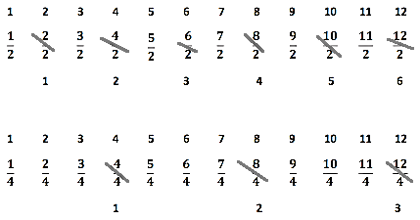
Note: This activity reviews Lesson 6.
Halves:
Fourths:
T: Count by halves to 12 halves as I write. Please don’t count faster than I can write. (Write in fractional form as students count.)
S: 1 half, 2 halves, 3 halves…11 halves, 12 halves.
T: (Point to $\frac{2}{2}$.) Say 2 halves as a whole number.
S: 1.
T: (Lightly cross out $\frac{2}{2}$ ,and write 1 beneath it.)
Continue the process for the following sequence: $\frac{4}{2}$, $\frac{6}{2}$ , $\frac{8}{2}$, $\frac{10}{2}$, and $\frac{12}{2}$.
T: Count by halves. Say whole numbers when you arrive at whole numbers. Try not to look at the board. (Students count forward and backward on the number line. Occasionally change directions.)
Repeat the process for fourths.
Application Problem (5 minutes)
The chart shows the lengths of straws measured in Mr. Han’s class.
- How many straws were measured? Explain how you know.
- What is the smallest measurement on the chart? The greatest?
- Were the straws measured to the nearest inch? How do you know?
Straw Lengths (in Inches)
3 | 4 | $$\text{4}\frac{1}{2}$$ | $$\text{2}\frac{3}{4}$$ | $$\text{3}\frac{3}{4}$$
$$\text{3}\frac{3}{4}$$ | $$\text{4}\frac{1}{2}$$ | $$\text{3}\frac{1}{4}$$ | 4 | $$\text{4}\frac{3}{4}$$
$$\text{4}\frac{1}{4}$$ | 5 | 3 | $$\text{3}\frac{1}{2}$$ | $$\text{4}\frac{1}{2}$$
$$\text{4}\frac{1}{2}$$ | 4 | $$\text{3}\frac{1}{4}$$ | 5 | $$\text{4}\frac{1}{4}$$

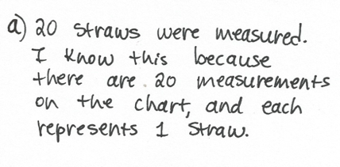
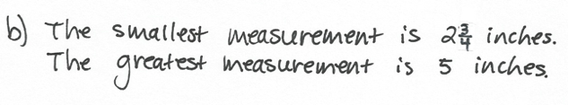
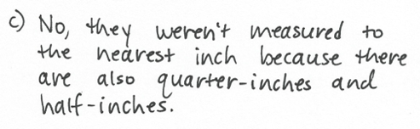
Note: The Straw Lengths chart is included on the template used in the Concept Development. Rather than recreate it for this problem, the template can be projected instead. Students will use the measurements from the chart to create a line plot in the Concept Development. The questions from the Application Problem help facilitate the discussion in the Concept Development about how to create a scale for the line plot.
Concept Development (30 minutes)

NOTES ON
MULTIPLE MEANS
OF REPRESENTATION:
Use color to customize the presentation of the data in the chart. Enhance learners’ perception of the information by lightly shading every other row, highlighting numerators and/or denominators, or consistently writing whole numbers in a specific color, e.g., using red for 4.

Materials: (S) Student-made ruler from Lesson 5, Straw Lengths (Template) pictured with Problem 2 below
Problem 1: Draw a line plot representing measurement data.
T: Let’s represent Mr. Han’s class’s straw data using a line plot. First, we need to determine the scale for our line plot. The first measurement on the line plot will be the smallest measurement in the chart. What is the smallest measurement?
S: $\text{2}\frac{3}{4}$ inches.
T: What do you think will be the last measurement on the line plot?
S: 5 inches because it is the largest measurement.
T: Turn and talk to your partner. Look over the data in the chart. How do you know what interval we should count by to create our scale?
S: Counting by whole inches is the easiest, but it won’t allow us to plot all of our numbers. The data has numbers with whole inches, half inches, and quarter inches. It makes the most sense to count by quarter inches because they’re the smallest.
T: To find out how many tick marks we need, we can count by fourths from $\text{2}\frac{3}{4}$ to 5. Each time we count, keep track with your fingers.
T: Let’s count.
S: (Track the count by fourths from $\text{2}\frac{3}{4}$ to 5.)
T: How many tick marks do we need to draw altogether?
S: 10 tick marks.
MP.6
T: I heard some count $\text{3}\frac{2}{4}$ and others count $\text{3}\frac{1}{2}$. Who is correct? Talk to your partner.
S: 2 fourths equals a half, so they are the same. $\frac{1}{4}$ and $\frac{1}{4}$ is the same as one-half.
T: Both fractions name the same length. In the data chart, it is written as $\text{3}\frac{1}{2} ,$ so it is best to label it the same way.
T: (Pass out template). On the template, you see the chart from the Application Problem and an empty number line. We need to partition our number line into equal intervals and label our scale. How can we use our ruler to create equal intervals?
S: We can make a mark at every inch until we have 10 marks.
T: Draw to show 10 marks. Then, label each mark from $\text{2}\frac{3}{4}$ to 5 inches. (Model as students work.)
S: (Draw and label.)
Problem 2: Plot data set on the line plot.

NOTES ON
MULTIPLE MEANS
OF ENGAGEMENT:
Encourage students working below grade level and others to whisper-read the data as they plot if this helps them track the information. Students may work in pairs.
Alternatively, challenge students working above grade level to offer two other representations of the data (picture graph, bar graph, tape diagram, tally chart). Have students compare and list the advantages of using a line plot.
T: Now, it’s time to record the data on our line plot. Look at the first measurement in the chart. Look for that measurement on your line plot. (Allow time for students to locate.)
T: Plot that data on the line plot with an X. (Model.) How can we make sure that we plot the data only once?
S: We can cross or check off each one as we go.
T: Plot the rest of the data with care, either crossing or checking off each measure you plot. (Allow students time to work.)
T: Let’s give this line plot a title that tells what it shows. What data is represented on the line plot?
S: Lengths of different straws.
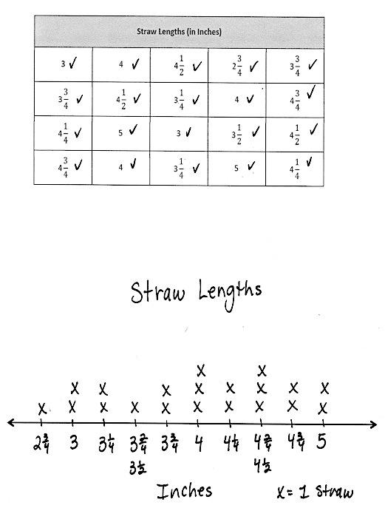
T: Let’s title our line plot Straw Lengths. (Model.) Add the title to your graph. (Allow students time to work.) Let’s add a key to show what each X represents. What does each X represent?
Sample Work
S: A straw!
T: (Model adding a key to the line plot.) Add a key to your line plot. (Allow students time to work.) Let’s also put a label beneath the number line to tell the unit our line plot shows. What unit did we use to measure?
S: Inches!
T: Let’s add the word Inches underneath the numbers on the number line. (Model.) Now that our line plot has a title, a key, and a unit label, anybody who looks at the line plot will know what it is showing.
Continue with the following suggested questions:
- How many straws were at least inches tall?
- How many straws were taller/shorter than inches?
- Which measurements happened most/least frequently?
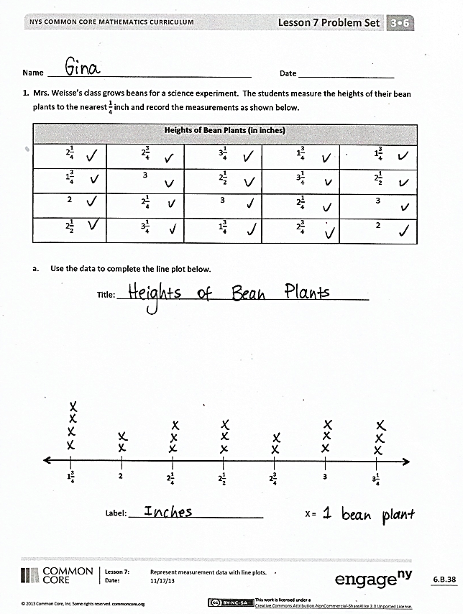
Problem Set (10 minutes)
Students should do their personal best to complete the Problem Set within the allotted 10 minutes. For some classes, it may be appropriate to modify the assignment by specifying which problems they work on first. Some problems do not specify a method for solving. Students should solve these problems using the RDW approach used for Application Problems.
Student Debrief (10 minutes)
Lesson Objective: Represent measurement data with line plots.
The Student Debrief is intended to invite reflection and active processing of the total lesson experience.
Invite students to review their solutions for the Problem Set. They should check work by comparing answers with a partner before going over answers as a class. Look for misconceptions or misunderstandings that can be addressed in the Debrief. Guide students in a conversation to debrief the Problem Set and process the lesson.
Any combination of the questions below may be used to lead the discussion.
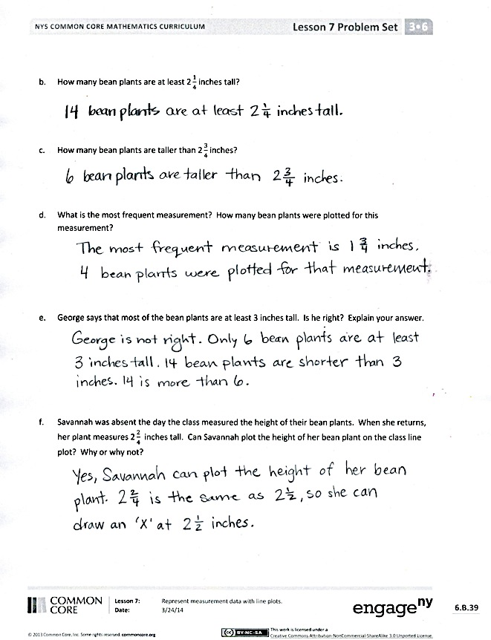
- What process did you use to complete the line plot in Problem (a)?
- What other questions could be answered based on the Heights of Bean Plants data?
- Why do you think four of the bean plants were so short? What questions would you ask Mr. Han’s class about this? (Possible student answers: Did they have different soil? Were they short but very healthy? Was it a different kind of bean plant?)
- In what ways is a line plot similar to a picture graph in how it displays data? Bar graph? In what ways is it different?
- Why is it important to create a scale before partitioning a number line?
- In what ways did your knowledge of fractions help you create your line plots?
- How did the Fluency Practice activities connect to today’s new learning?
- How did the Application Problem help you get ready for today’s lesson?
Exit Ticket (3 minutes)
After the Student Debrief, instruct students to complete the Exit Ticket. A review of their work will help with assessing students’ understanding of the concepts that were presented in today’s lesson and planning more effectively for future lessons. The questions may be read aloud to the students.

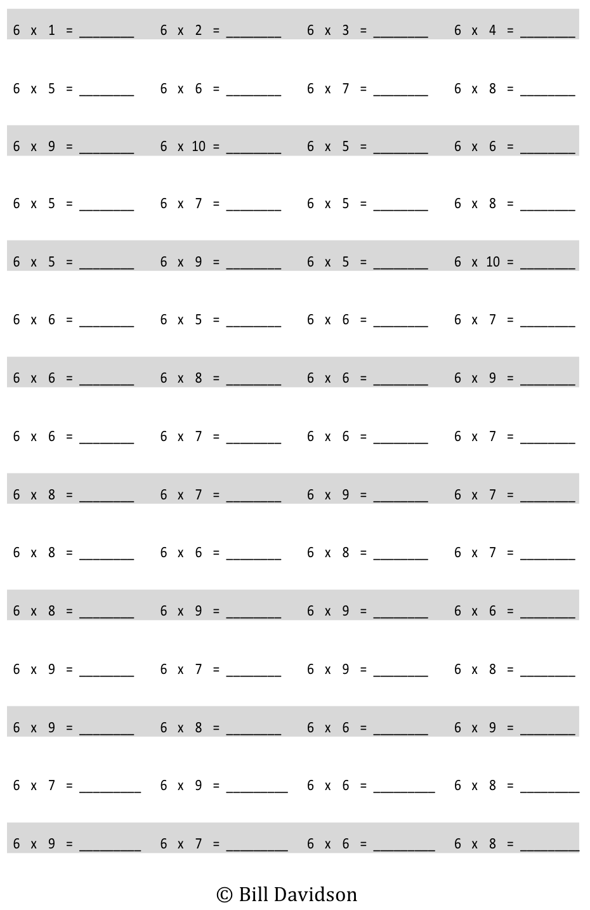
Multiply.
Name Date
Mrs. Weisse’s class grows beans for a science experiment. The students measure the heights of their bean plants to the nearest $\frac{\text{1}}{\text{4}}$ inch and record the measurements as shown below.
Heights of Bean Plants (in Inches)
$$\text{2}\frac{1}{\text{4}}$$ | $$\text{2}\frac{3}{4}$$ | $$\text{3}\frac{1}{4}$$ | $$\text{1}\frac{3}{4}$$ | $$\text{1}\frac{3}{4}$$
$$\text{1}\frac{3}{4}$$ | 3 | $$\text{2}\frac{1}{2}$$ | $$\text{3}\frac{1}{4}$$ | $$\text{2}\frac{1}{2}$$
2 | $$\text{2}\frac{1}{\text{4}}$$ | 3 | $$\text{2}\frac{\text{1}}{4}$$ | 3
$$\text{2}\frac{1}{2}$$ | $$\text{3}\frac{1}{4}$$ | $$\text{1}\frac{3}{4}$$ | $$\text{2}\frac{3}{4}$$ | 2

- Use the data to complete the line plot below.
Title: __________________________________________________________

2$\frac{3}{4}$
3
3$\frac{1}{4}$
2$\frac{1}{2}$
2$\frac{1}{4}$
2
1$\frac{3}{4}$

- How many bean plants are at least $\text{2}\frac{1}{4}$ inches tall?

Label: _______________________________ X =

- How many bean plants are taller than $\text{2}\frac{3}{4}$ inches?

- What is the most frequent measurement? How many bean plants were plotted for this
measurement?

- George says that most of the bean plants are at least 3 inches tall. Is he right? Explain your answer.

- Savannah was absent the day the class measured the heights of their bean plants. When she returns, her plant measures $\text{2}\frac{2}{4}$inches tall. Can Savannah plot the height of her bean plant on the class line plot? Why or why not?

Name Date
Scientists measure the growth of mice in inches. The scientists measure the length of the mice to the nearest $\frac{1}{4}$ inch and record the measurements as shown below.
Lengths of Mice (in Inches)
$$\text{3}\frac{1}{4}$$ | 3 | $$\text{3}\frac{1}{4}$$ | $$\text{3}\frac{3}{4}$$ | 4
$$\text{3}\frac{3}{4}$$ | 3 | $$\text{4}\frac{1}{2}$$ | $$\text{4}\frac{1}{2}$$ | $$\text{3}\frac{3}{4}$$
4 | $$\text{4}\frac{1}{4}$$ | 4 | $$\text{4}\frac{1}{4}$$ | 4

Label each tick mark. Then, record the data on the line plot below.
Title: __________________________________________________________

3$\frac{3}{4}$
3

X = 1 mouse

Label: _____________________________________________

Name Date
Mrs. Felter’s students build a model of their school’s neighborhood out of blocks. The students measure the heights of the buildings to the nearest $\frac{1}{4}$ inch and record the measurements as shown below.
Heights of Buildings (in Inches)
$$\text{3}\frac{1}{4}$$ | $$\text{3}\frac{3}{4}$$ | $$\text{4}\frac{1}{4}$$ | $$\text{4}\frac{1}{2}$$ | $$\text{3}\frac{1}{2}$$
4 | 3 | $$\text{3}\frac{3}{4}$$ | 3 | $$\text{4}\frac{1}{2}$$
3 | $$\text{3}\frac{1}{2}$$ | $$\text{3}\frac{3}{4}$$ | $$\text{3}\frac{1}{2}$$ | 4
$$\text{3}\frac{1}{2}$$ | $$\text{3}\frac{1}{4}$$ | $$\text{3}\frac{1}{2}$$ | 4 | $$\text{3}\frac{3}{4}$$
3 | $$\text{4}\frac{1}{4}$$ | 4 | $$\text{3}\frac{1}{4}$$ | 4

- Use the data to complete the line plot below.
Title: __________________________________________________________

4
4$\frac{1}{4}$
4$\frac{1}{2}$
3$\frac{3}{4}$
3$\frac{1}{2}$
3$\frac{1}{4}$
3

Label: ______________________________________________ X =

- How many buildings are $\text{4}\frac{1}{4}$ inches tall?

- How many buildings are less than $\text{3}\frac{1}{2}$ inches?

- How many buildings are in the class model? How do you know?

- Brook says most buildings in the model are at least 4 inches tall. Is she correct? Explain your
thinking.

Straw Lengths (in Inches)
3 | 4 | $$\text{4}\frac{1}{2}$$ | $$\text{2}\frac{3}{4}$$ | $$\text{3}\frac{3}{4}$$
$$\text{3}\frac{3}{4}$$ | $$\text{4}\frac{1}{2}$$ | $$\text{3}\frac{1}{4}$$ | 4 | $$\text{4}\frac{3}{4}$$
$$\text{4}\frac{1}{4}$$ | 5 | 3 | $$\text{3}\frac{1}{2}$$ | $$\text{4}\frac{1}{2}$$
$$\text{4}\frac{3}{4}$$ | 4 | $$\text{3}\frac{1}{4}$$ | 5 | $$\text{4}\frac{1}{4}$$

multiply by 6 (6–10)
straw lengths

