Lesson 6
Objective: Interpret measurement data from various line plots.

Suggested Lesson Structure
 Fluency Practice (14 minutes)
 Application Problem (5 minutes)
 Concept Development (31 minutes)
 Student Debrief (10 minutes)
Total Time (60 minutes)
Fluency Practice (14 minutes)
- Group Counting 3.OA.1 (3 minutes)
- Multiply by 6 3.OA.7 (7 minutes)
- Read Bar Graphs 3.MD.3 (4 minutes)
Group Counting (3 minutes)
Note: Group counting reviews interpreting multiplication as repeated addition.
T: Count by sevens to 70. (Write as students count.)
S: 7, 14, 21, 28, 35, 42, 49, 56, 63, 70.
T: Let’s count again. Try not to look at the board. When I raise my hand, stop.
S: 7, 14, 21.
T: (Raise hand.) 21 is the same as how many sevens?
S: 3 sevens.
T: Say 3 sevens as a multiplication sentence.
S: 3 × 7 = 21.
T: Continue.
S: 28, 35, 42, 49, 56.
T: (Raise hand.) 56 is how many sevens?
S: 8 sevens.
T: Say 8 sevens as a multiplication sentence.
S: 8 × 7 = 56.
T: (Write 14 ÷ 7 = .) Let’s find the answer counting by sevens.
S: 7, 14.
T: How many sevens are in 14?
S: 2 sevens.
T: Say the division number sentence.
S: 14 ÷ 7 = 2.
Continue the process for the following possible sequence: 28 ÷ 7 and 63 ÷ 7.

Multiply by 6 (7 minutes)

Materials: (S) Multiply by 6 (1─5) (Pattern Sheet)
Note: This activity builds fluency with multiplication facts using units of 6. It works toward students knowing from memory all products of two one-digit numbers.
T: (Write 5 × 6 = ____.) Let’s skip-count up by sixes to find the answer. (Raise a finger for each number to track the count. Record the skip-count answers on the board.)
S: 6, 12, 18, 24, 30.
T: (Circle 30, and write 5 × 6 = 30 above it. Write 3 × 6 = ____.) Let’s skip-count up by sixes again. (Track with fingers as students count.)
S: 6, 12, 18.
T: Let’s see how we can skip-count down to find the answer, too. Start at 30 with 5 fingers, 1 for each six. (Count down with your fingers as students say numbers.)
S: 30 (5 fingers), 24 (4 fingers), 18 (3 fingers).
Repeat the process for 4 × 6.
T: (Distribute Multiply by 6 Pattern Sheet.) Let’s practice multiplying by 6. Be sure to work left to right across the page.

Directions for Administration of Multiply-By Pattern Sheet
- Distribute Multiply-By Pattern Sheet.
- Allow a maximum of two minutes for students to complete as many problems as possible.
- Direct students to work left to right across the page.
- Encourage skip-counting strategies to solve unknown facts.
Read Bar Graphs (4 minutes)
Materials: (T) Number of Miles bar graph (Fluency Template) pictured below (S) Personal white board
Note: This fluency activity reviews Lesson 4. Students may initially need support beyond what is written below to find the exact number of miles driven, slightly extending the time this activity takes.
T: (Project bar graph.) What does this bar graph show?
S: The number of miles a truck driver drove Monday through Friday.
T: On which day did the truck driver drive the most miles?
S: Wednesday.
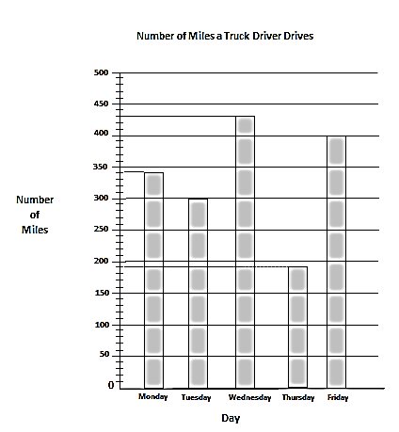
T: On which day did the truck driver drive the least number
of miles?
S: Thursday.
T: What is the scale for number of miles?
S: 50.
T: How many intervals are there between each 50?
S: 5.
T: On your boards, write a number sentence to show the value of the smaller intervals.
S: (Write 50 ÷ 5 = 10.)
T: How many miles did the truck driver drive on Monday?
S: 340 miles.
T: (Write 340 miles.)
Continue the process for the following: Tuesday, Wednesday, Thursday, and Friday.
T: Write a number sentence to find how many miles the truck driver drove from Monday through Wednesday.
S: (Write 340 + 300 + 430 = 1,070.)
T: Write a number sentence to find how many more miles the truck driver drove on Friday than on Thursday.
S: (Write 400 – 190 = 210.)
Application Problem (5 minutes)
Katelynn measures the height of her bean plant on Monday and again on Friday. She says that her bean plant grew 10 quarter inches. Her partner records $\text{2}\frac{1}{2}$ inches on his growth chart for the week. Is her partner right? Why or why not?
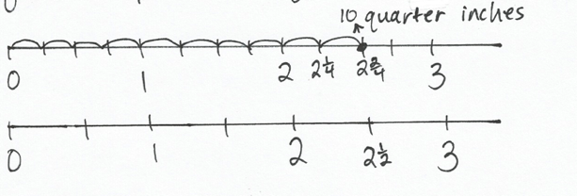
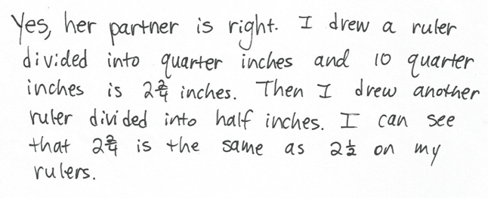
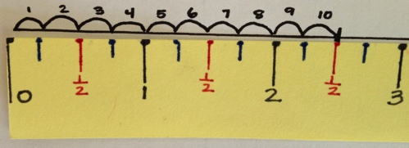

or

Note: This problem reviews the relationship between quarter, half, and whole inches from Lesson 5. Students can choose to draw their own rulers or use the rulers they made from Lesson 6 to solve the problem.
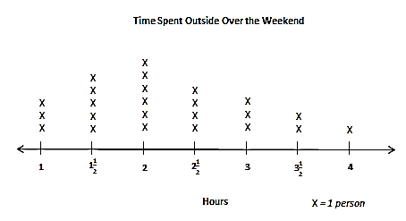
Concept Development (31 minutes)
Template
Materials: (T) Time spent outside line plot (Template) pictured to the right (S) Personal white board, blank paper, markers, Time Spent Outside line plot (Template)
Problem 1: Use line plots with fractions to display measurement data.
T: (Project line plot, but only reveal the number line, as shown below. Point to the tick mark between 1 and 2.) What should I label this tick mark on the number line?

1
2
3
4

S: $\text{1}\frac{1}{2}$ because it looks like it’s halfway between 1 and 2.
T: (Label $\text{1}\frac{1}{2}$.) When I point to each tick mark, tell me what to write. (Point to the tick marks between 2 and 3 and then 3 and 4, respectively labeling them $\text{2}\frac{1}{2}$ and $\text{3}\frac{1}{2}$.)
T: Talk to a partner. How is this number line similar to the ruler we made yesterday? How is it different?
S: They both show the numbers from 1 to 4. The ruler actually goes to 6 inches. They’re both lines marked with whole units and fraction units. The number line shows the halves between each whole number, but the ruler shows quarter inches too.
T: (Reveal the rest of the line plot.) What does the number 1 on this line plot represent?
S: 1 hour.
T: What does the number $\text{1}\frac{1}{2}$ represent?
S: One and 1 half hours. One full hour and half of another hour. One hour and 30 minutes.
T: If the label on our line plot was people instead of hours, could we have fractions?
S: What is a fraction of a person? My dad always says, “When I was half your size.”
No, it wouldn’t make sense because you can’t have a fraction of a person.
T: So, when we use fractions on line plots, we need to make sure that it makes sense for the units to be given as fractions. Talk to your partner. What else besides time could you show on a line plot with fractions?
S: The lengths of our straws from yesterday. The heights of our classmates. Our shoe sizes.
The heights of our bean plants. Anything we can measure!
T: That’s right, we can show measurements on a line plot with fractions. How is a line plot like a bar graph or tape diagram?
S: The X’s are like the units of 1 in a tape diagram. The X’s look like bars. The tallest column of X’s shows the most.
T: Which amount of time spent outside has the most X’s?

NOTES ON
MULTIPLE MEANS
OF ENGAGEMENT:
Give English language learners guided practice using frequent, common, at least, more than, and less than as they speak and write their observations about data and otherwise. Have students practice with partners using sentence frames like the ones below.
- The most frequently used word in our class is ____.
- ____ students read for at least 20 minutes last night.
- The most common excuse for not having homework is ____.

S: 2 hours!
T: When we made bar graphs and picture graphs, we used the word favorite to talk about the data that had the largest value. Does it make sense to say 2 hours was the favorite amount of time spent outside?
S: No.
T: We can say that 2 hours was the most frequent or common amount of time spent outside because it has the most X’s. What was the second most frequent amount of time spent outside?
S: $\text{1}\frac{1}{2}$ hours.
T: What does each X on the line plot represent?
S: A person!
T: How many people spent $\text{2}\frac{1}{2}$ hours outside?
S: 4 people!
Problem 2: Read and interpret line plots with fractions.
Students work in groups of four to write true statements about the Time Spent Outside line plot. The goal is to write as many true statements as possible in the time given. Each student in the group uses a different colored marker and can only write with his or her specified color. This ensures engagement and equal participation in this activity. Groups then prepare a poster with their statements to present to the class.
If time allows, the class can create a new line plot for this part of the lesson. Students can measure their pencils to the nearest quarter inch. Then, they can record their pencil’s measurement on a class line plot, using stickers (e.g., stars or colored dots) or by making X’s.
Prepare students:
- Write a list of words that the students must include in their statements. This list should include the following words: at least, frequent, less than, and more than. Be sure to check for understanding of these words.
- To achieve the highest score of 4, each of the following must be included and be correct:
- A statement using the word frequent or common.
- A statement using the words at least.
- A comparison statement using more than requiring subtraction to solve.
- A comparison statement using less than requiring subtraction to solve.
- Remind students that the amount of each color marker will be observed to check for equal participation.
For the presentation, students can do a modified gallery walk where one student from each group stays at the poster to be available to answer any questions about the statements.
Problem Set (10 minutes)

NOTES ON
MULTIPLE MEANS
OF REPRESENTATION:
Students working below grade level may benefit from modifications to Problem 2 of the Problem Set that make the data easier to discern. Consider the following:
- Enlarge the Length of Caterpillars line plot.
- Have students label column totals.
- Have students mark or highlight data they have counted.
- Draw rectangles around data in each column, or cover remaining data with a piece of paper to help students focus on one set of data at a time.

Students should do their personal best to complete the Problem Set within the allotted 10 minutes. For some classes, it may be appropriate to modify the assignment by specifying which problems they work on first. Some problems do not specify a method for solving. Students should solve these problems using the RDW approach used for Application Problems.
Student Debrief (10 minutes)
Lesson Objective: Interpret measurement data from various line plots.
The Student Debrief is intended to invite reflection and active processing of the total lesson experience.
Invite students to review their solutions for the Problem Set. They should check work by comparing answers with a partner before going over answers as a class. Look for misconceptions or misunderstandings that can be addressed in the Debrief. Guide students in a conversation to debrief the Problem Set and process the lesson.
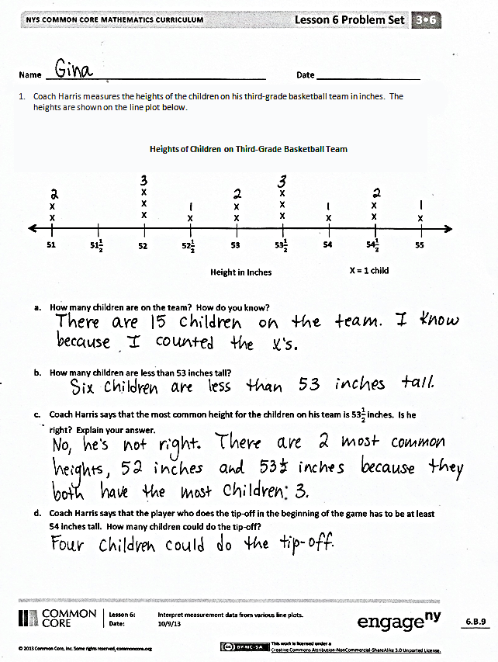
Any combination of the questions below may be used to lead the discussion.
- Using your answers from Problems 1(a) and (b), what subtraction sentence could you use to find the number of children who are at least 53 inches tall? (15 – 6 = 9.)
- How many half inches does the child who is $\text{52}\frac{1}{2}$ inches tall need to grow to be tall enough to do the tip-off?
- What is the most frequent length of the worms in Problem 2? How do you know?
- What kind of data can be shown on a line plot with fractions? Are there any limitations?
- How did the Application Problem prepare you for today’s lesson?

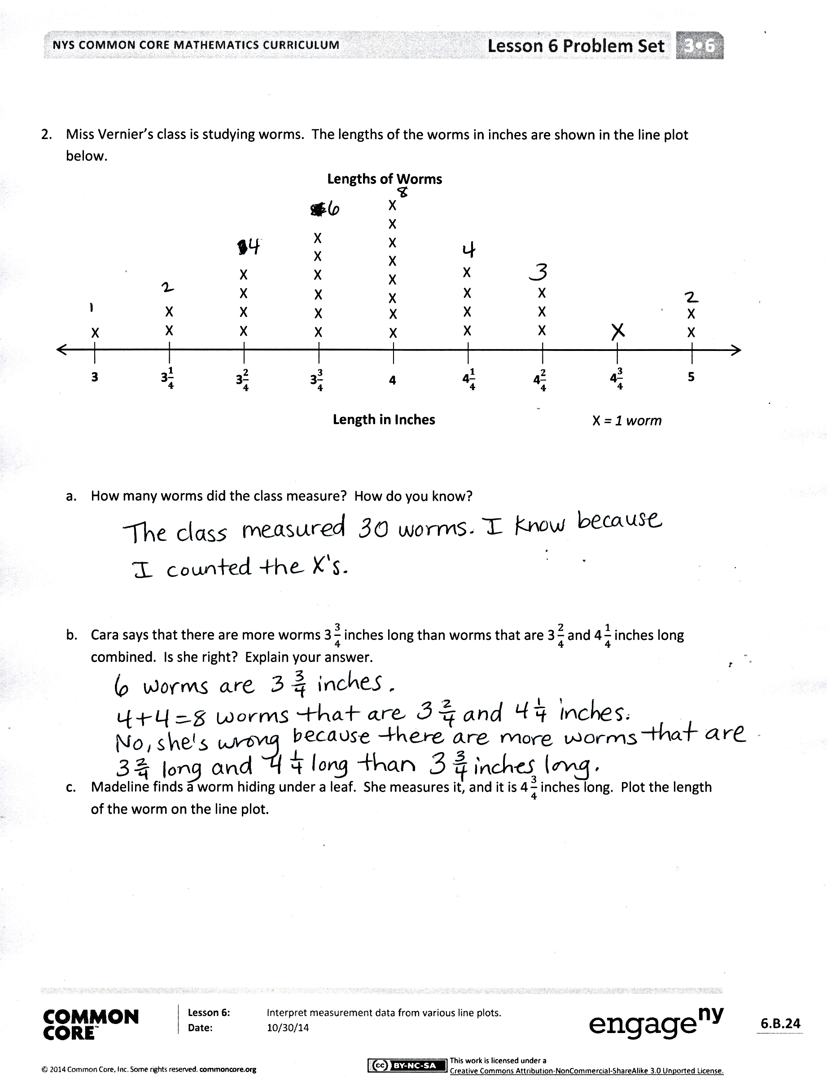
Exit Ticket (3 minutes)
After the Student Debrief, instruct students to complete the Exit Ticket. A review of their work will help with assessing students’ understanding of the concepts that were presented in today’s lesson and planning more effectively for future lessons. The questions may be read aloud to the students.

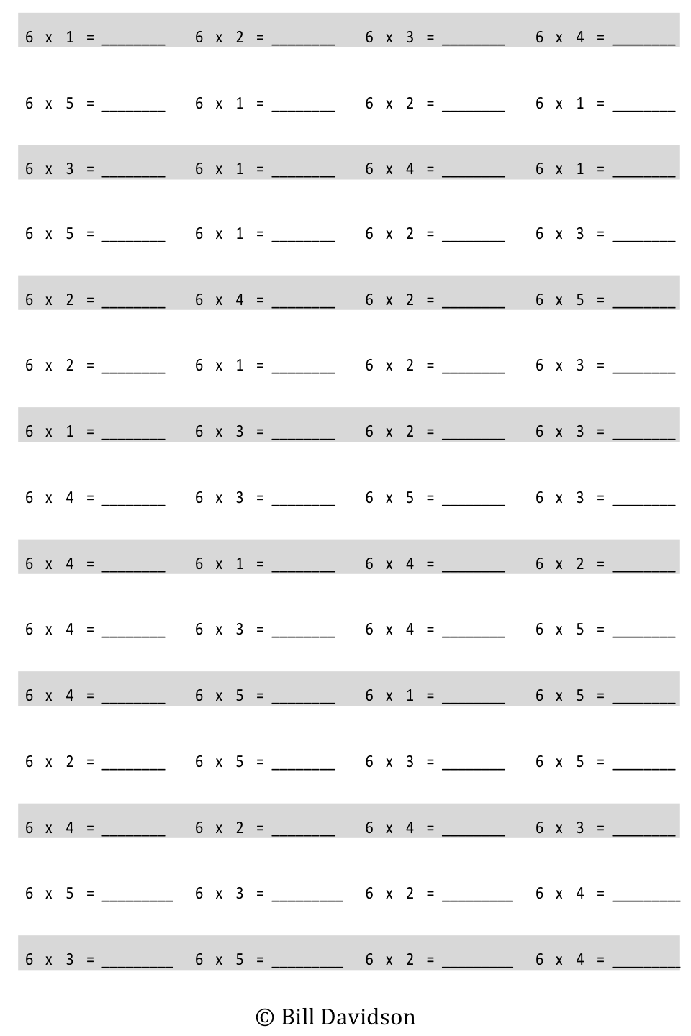
×
Multiply.

Name Date
- Coach Harris measures the heights of the children on his third-grade basketball team in inches. The heights are shown on the line plot below.
Heights of Children on Third-Grade Basketball Team

51
51$\frac{1}{2}$
52$\frac{1}{2}$
53$\frac{1}{2}$
54$\frac{1}{2}$
52
53
54
55
Height in Inches
X
X
X
X
X
X

X
X
X

X

X
X
X
X
X
X = 1 child

- How many children are on the team? How do you know?

- How many children are less than 53 inches tall?

- Coach Harris says that the most common height for the children on his team is $\text{53}\frac{1}{2}$ inches. Is he right? Explain your answer.

- Coach Harris says that the player who does the tip-off in the beginning of the game has to be at least 54 inches tall. How many children could do the tip-off?

- Miss Vernier’s class is studying worms. The lengths of the worms in inches are shown in the line plot below.
Lengths of Worms

3
3$\frac{1}{4}$
3$\frac{3}{4}$
4$\frac{1}{4}$
4$\frac{3}{4}$
3$\frac{2}{4}$
4
4$\frac{2}{4}$
5
Length in Inches

X
X
X
X
X
X
X

X
X
X
X
X

X
X
X

X
X
X
X
X
X
X
X
X X
X

X = 1 worm

X
X
X

X

X
X

- How many worms did the class measure? How do you know?

- Cara says that there are more worms $\text{3}\frac{3}{4}$ inches long than worms that are $\text{3}\frac{2}{4}$ and $\text{4}\frac{1}{4}$ inches long combined. Is she right? Explain your answer.

- Madeline finds a worm hiding under a leaf. She measures it, and it is $\text{4}\frac{3}{4}$ inches long. Plot the length of the worm on the line plot.

Name Date
Ms. Bravo measures the lengths of her third-grade students’ hands in inches. The lengths are shown on the line plot below.

X
Lengths of Hands of Third-Grade Students

3$\frac{2}{4}$
3$\frac{3}{4}$
4$\frac{3}{4}$
4$\frac{1}{4}$
5$\frac{1}{4}$
4$\frac{2}{4}$
5
5$\frac{2}{4}$
4
Inches

X
XX
X
X
XX
X
X
X
X

X
X
X
X
X

X
X

X
X

X
X
X
X = 1 student

- How many students are in Ms. Bravo’s class? How do you know?

- How many students’ hands are longer than $\text{4}\frac{2}{4}$ inches?

- Darren says that more students’ hands are $\text{4}\frac{2}{4}$ inches long than 4 and $\text{5}\frac{1}{4}$ inches combined. Is he right? Explain your answer.

Name Date
- Ms. Leal measures the heights of the students in her kindergarten class. The heights are shown on the line plot below.
Heights of Students in Ms. Leal’s Kindergarten Class

40
40$\frac{1}{2}$
41$\frac{1}{2}$
42$\frac{1}{2}$
43$\frac{1}{2}$
41
42
43
44
Inches
X
X
X
X
X
X
X

X
X
X
X

X

X
X
X
X
X
X
X
X
X = 1 student

- How many students in Ms. Leal’s class are 41 inches tall?

- How many students are in Ms. Leal’s class? How do you know?

- How many students in Ms. Leal’s class are more than 42 inches tall?

- Ms. Leal says that for the class picture students in the back row must be at least $\text{42}\frac{1}{2}$ inches tall. How many students will be in the back row?
- Mr. Stein’s class is studying plants. They plant seeds in clear plastic bags and measure the lengths of the roots. The lengths of the roots in inches are shown in the line plot below.
Lengths of Plants’ Roots

2
2$\frac{1}{4}$
2$\frac{3}{4}$
3$\frac{1}{4}$
3$\frac{3}{4}$
2$\frac{2}{4}$
3
3$\frac{2}{4}$
4
Inches

X
X
X
X
X
X

X
X
X

X
X

X

X
X
X
X
X

X
X
X
X
X
X
X
X = 1 plant

- How many roots did Mr. Stein’s class measure? How do you know?

- Teresa says that the 3 most frequent measurements in order from shortest to longest are $\text{3}\frac{1}{4}$ inches,
$\text{3}\frac{2}{4}$ inches, and $\text{3}\frac{3}{4}$ inches. Do you agree? Explain your answer.

- Gerald says that the most common measurement is 14 quarter inches. Is he right? Why or why not?

Number
of
Miles
0
50
100
150
200
250
300
350
400
450
500
Monday
Tuesday
Wednesday
Thursday
Friday
Number of Miles a Truck Driver Drives
Day

X
X
X
X
X
X
X
X
X
X
X
X
X
X
Time Spent Outside Over the Weekend

1
1$\frac{1}{2}$
2$\frac{1}{2}$
3$\frac{1}{2}$
2
3
4
Hours
X

X
X
X
X
X
X
X
X
X
X = 1 person

multiply by 6 (1–5)
number of miles bar graph
time spent outside line plot

