Lesson 5
Objective: Create ruler with 1-inch, $\frac{1}{2}$ inch, and $\frac{1}{4}$ inch intervals, and generate measurement data.

Suggested Lesson Structure
 Fluency Practice (10 minutes)
 Concept Development (40 minutes)
 Student Debrief (10 minutes)
Total Time (60 minutes)
Fluency Practice (10 minutes)
- Group Counting 3.OA.1 (6 minutes)
- Factors of 12 3.MD.4 (4 minutes)
Group Counting (6 minutes)
Materials: (S) Personal white board
Note: This group counting activity reviews units of 6 and the relationship between multiplication and division.
T: Count by sixes to 60. (Write on the board as students count.)
S: 6, 12, 18, 24, 30, 36, 42, 48, 54, 60.
6 12 18 24 30 36 42 48 54 60
1 six 2 sixes 3 sixes 4 sixes 5 sixes 6 sixes 7 sixes 8 sixes 9 sixes 10 sixes
6 ÷ 6 12 ÷ 6 18 ÷ 6 24 ÷ 6 30 ÷ 6 36 ÷ 6 42 ÷ 6 48 ÷ 6 54 ÷ 6 60 ÷ 6

T: (Beneath 6, write 1 six. Point to the 12.) 12 is the same as how many sixes?
S: 2 sixes.
T: (Write 2 sixes beneath 12. Point to the 18.) 18 is the same as how many sixes?
S: 3 sixes.
T: (Write 3 sixes beneath 18. Point to 1 six.) Let’s count units of 6. (Write as students count.)
S: 1 six, 2 sixes, 3 sixes, 4 sixes, 5 sixes, 6 sixes, 7 sixes, 8 sixes, 9 sixes, 10 sixes.
T: (Point to 60.) How many sixes are in 60?
S: 10 sixes.
T: (Beneath 10 sixes, write 60 ÷ 6 = .) What’s 60 ÷ 6?
S: 10.
T: (Write 60 ÷ 6 = 10. Beneath 1 six, write 6 ÷ 6 = .) On your personal white board, write the number sentence.
S: (6 ÷ 6 = 1.)
Repeat the process for the rest of the chart.
Factors of 12 (4 minutes)
Note: This activity prepares students for today’s lesson.
T: (Write 12 × = 12.) Say the number sentence, completing the unknown factor.
S: 12 × 1 = 12.
Continue with the following possible sequence: 1 × = 12, 6 × = 12, 4 × = 12, 2 × = 12, and
3 × = 12.
T: I’ll say a factor. You say the factor you need to multiply it by to get 12. The first factor is 1.
S: 12.
T: 6?
S: 2.
T: 4?
S: 3.
T: 12?
S: 1.
T: 3?
S: 4.
Concept Development (40 minutes)
Materials: (S) 1" × 6" strip of yellow construction paper, colored pencils or markers (black, red, and blue), ruler, lined paper (Template), 1 straw precut (vary 1", $\frac{1}{2}$", and $\frac{1}{4}$″ lengths among students), Problem Set
Problem 1: Partition and measure a paper strip into a ruler with whole-inch, half-inch, and quarter-inch measurements.
T: (Give each student one copy of the lined paper Template.) Turn your paper so the margin is horizontal. Draw a number line on top of the margin. Mark 0 on the point where I did. (Model.)
MP.5
T: Use your black marker to plot a point at every 4 spaces. Use the paper’s vertical lines to measure the 4 spaces. Then, label the number line from 0 to 6, making sure there are 4 spaces for each part. Tell your partner how you know each part is equal.
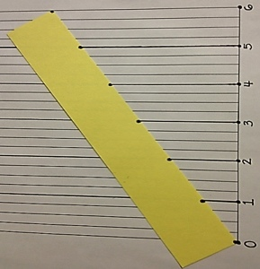
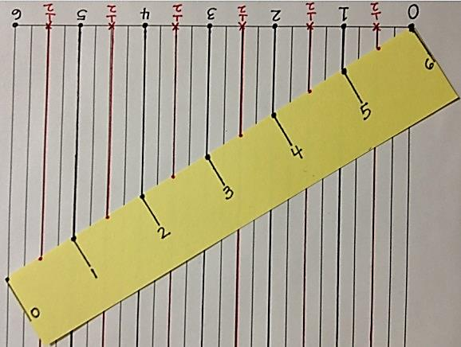
S: (Discuss.)
Measuring Inches
Measuring Half Inches
Creating the Number Line
T: Use a ruler to trace the vertical lines up from your number line to the top of the paper at each point. (Pass out 1 yellow strip to each student.) Lay the yellow strip so that the left end touches the 0 endpoint on the original number line, and the right end touches the vertical line that you traced at the number 6 (as shown to the right).
T: Where the lines touch your strip, plot points on your strip. Extend the points to make them tick marks. Then, turn your strip and number below each tick mark from 0–6. (After labeling and turning the strip back to its original position, the numbers on the strip will be upside down and ordered opposite from those on the number line. This is shown to the right.)
MP.5
T: Use your ruler to verify that the intervals on your strip are equal. Measure the full length of the yellow strip in inches. Measure the equal parts.
T: What measurement does each mark represent?
S: 1 inch.
T: We now know every 4 spaces marks 1 inch on our strip. Let’s repeat the process, but this time we will mark a point on our number line (lined paper) at every 2 spaces. What measurement will each mark represent? Talk to a partner.
S: Two spaces is half. So, that must mean we will mark half inches!
Repeat the process:
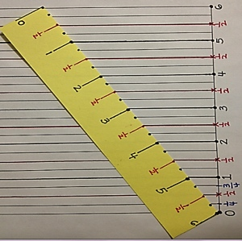
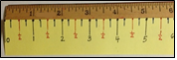
- Plot points at every 2 spaces with a red marker to mark half inches. If a point is already marked with a whole inch, plot the new, red point above the black point. Then, plot and label every half inch between the whole inches on the strip.
Measuring Quarter Inches
- Plot points at every single interval with a blue marker to mark the quarter inches. If a point is already marked with a whole or half inch, plot the new, blue point above the black or red point. Then, plot every quarter inch between the half inches on the strip. Do not have students label every quarter inch on the strip since the spaces are too small.
Place the paper strip under a ruler to verify the accuracy of the paper strip’s measurements. Encourage students to recognize that their paper strips are, in fact, rulers as well.
T: Into what three units of measurement did we partition our paper strips, or rulers?
S: Whole inches, half inches, and quarter inches.
T: Point to 2 inches on your paper ruler.
S: (Point.)
T: Show your partner 1 half inch less than 2 inches on your paper ruler.

NOTES ON
MULTIPLE MEANS
OF ACTION AND EXPRESSION:
Scaffold student partitioning and measuring of the paper strip with the following options:
- Instruct how to align the zero points of the ruler and the strip step-by-step.
- Decrease the number of steps by pre-numbering the number line or pre-marking inches.
- Use color. Highlight every fourth line of the grid, or lightly shade every other 4 lines.
- Make the inch lines tactile with glue or Wikki Stix to help students with low vision or perceptual difficulties. Because the surface of the grid will be bumpy, have students label numbers once the strip is off the lined paper.

S: (Show.)
T: What is 1 half inch less than 2 inches?
S: $1\frac{1}{2}$ inches.
T: Show $\text{3}\frac{1}{4 }$ inches.
S: (Show.)
T: Show your partner 1 and a quarter inch more than
$\text{3}\frac{1}{4}$ inches.
S: (Show.)
T: What is 1 and a quarter inch more than $\text{3}\frac{1}{4}$ inches?
S: $\text{4}\frac{1}{2}$ inches.
Continue the process as needed with $\frac{1}{2}$ inch less than 4 inches, $\frac{1}{4}$inch more than $\text{1}\frac{1}{4}$ inches, $\frac{1}{4}$inch less than 2 inches, $\frac{3}{4}$inch more than 3 inches, and $\frac{3}{4}$inch less than 3 inches.
T: How many half inches are in 1 inch?
S: 2 half inches.
T: How many quarter inches are in 1 inch?
S: 4 quarter inches.
T: How many quarter inches are in 1 half inch?
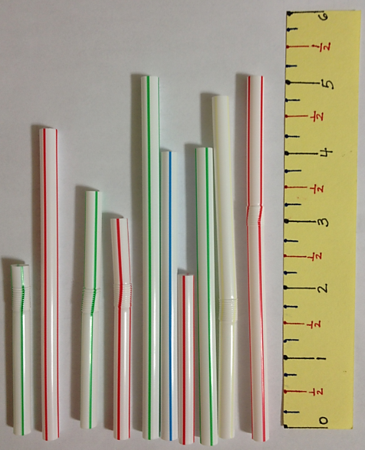
S: 2 quarter inches.
T: How many quarter inches are in 3 inches?
S: 12 quarter inches.
Problem 2: Generate measurement data.
Pass out the Problem Set and 1 pre-cut straw to each student.
T: On Problem 1 of your Problem Set, use your paper ruler to measure your straw to the nearest inch, half inch, and quarter inch. What do you do if your measurement is not exact?
S: We have to estimate.
T: When you estimate, ask yourself, “Is it more than halfway or less than halfway?” After measuring the straw you have, measure six of your classmates’ straws and record their measurements in the chart on your Problem Set.
Note: Students should save their rulers. They will also be used in Lessons 6─7.
Problem Set (10 minutes)

NOTES ON
MULTIPLE MEANS
OF ACTION AND EXPRESSION:
Support English language learners as they write their responses on the Problem Set. Allow students to discuss their thoughts in their language of choice before writing. Provide sentence starters and a word bank.
Sentence starters may include the following:
- One half inch is the same as_____.
- It’s best to use the quarter-inch ruler to measure because_____.
Possible words for the word bank may include the following:
exact estimate accurate
precise measure

Students should do their personal best to complete the remainder of the Problem Set within the allotted 10 minutes. For some classes, it may be appropriate to modify the assignment by specifying which problems they work on first. Some problems do not specify a method for solving. Students should solve these problems using the RDW approach used for Application Problems.
Student Debrief (10 minutes)
Lesson Objective: Create ruler with 1-inch, $\frac{1}{2}$ inch, and
$\frac{1}{4}$ inch intervals, and generate measurement data.
The Student Debrief is intended to invite reflection and active processing of the total lesson experience.
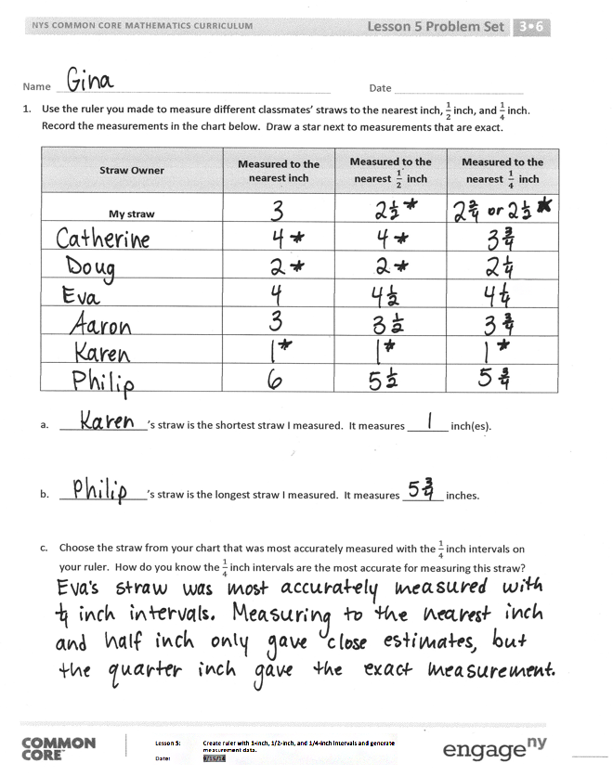
Invite students to review their solutions for the Problem Set. They should check work by comparing answers with a partner before going over answers as a class. Look for misconceptions or misunderstandings that can be addressed in the Debrief. Guide students in a conversation to debrief the Problem Set and process the lesson.
Any combination of the questions below may be used to lead the discussion.
- Look at your data for Problem 1. Did you notice a pattern?
- Share your answer for Problem 1(c).
- Have students share their thinking for Problem 2(c). If time permits, have a few students measure an object larger than 6 inches with their paper ruler using the method they describe.
- Share your answer to Problem 3. What number sentence could you use to find the answer?
- How did using the lined paper help you partition your paper strip accurately?
- Each paper strip measured 6 inches, so our measurements were easy to mark. What if the strips were 8 inches instead? How would you partition the number line?
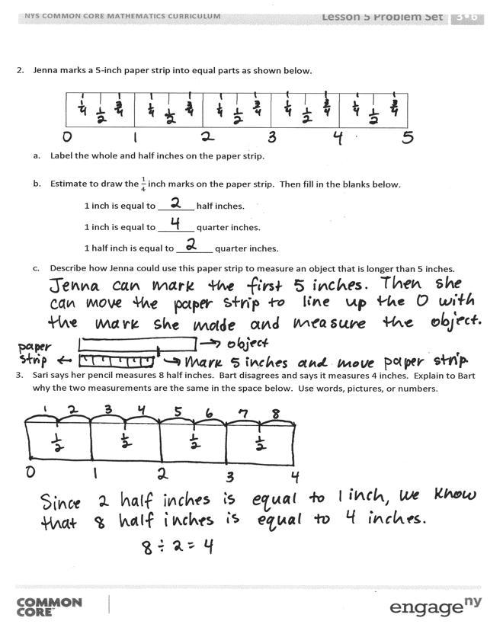
Exit Ticket (3 minutes)
After the Student Debrief, instruct students to complete the Exit Ticket. A review of their work will help with assessing students’ understanding of the concepts that were presented in today’s lesson and planning more effectively for future lessons. The questions may be read aloud to the students.

Name Date
- Use the ruler you made to measure different classmates’ straws to the nearest inch, $\frac{1}{2}$ inch, and $\frac{1}{4}$ inch. Record the measurements in the chart below. Draw a star next to measurements that are exact.
Straw Owner | Measured to the  nearest inch | Measured to the  nearest $\frac{1}{2}$ inch | Measured to the  nearest $\frac{1}{4}$ inch
My straw

- _______________ ’s straw is the shortest straw I measured. It measures _______ inch(es).

- _______________ ’s straw is the longest straw I measured. It measures _______ inches.

- Choose the straw from your chart that was most accurately measured with the $\frac{1}{4}$ inch intervals on your ruler. How do you know the $\frac{1}{4}$ inch intervals are the most accurate for measuring this straw?

- Jenna marks a 5-inch paper strip into equal parts as shown below.

- Label the whole and half inches on the paper strip.

- Estimate to draw the $\frac{1}{4}$ inch marks on the paper strip. Then, fill in the blanks below.
1 inch is equal to _______ half inches.
1 inch is equal to _______ quarter inches.
1 half inch is equal to _______ quarter inches.

- Describe how Jenna could use this paper strip to measure an object that is longer than 5 inches.

- Sari says her pencil measures 8 half inches. Bart disagrees and says it measures 4 inches. Explain to Bart why the two measurements are the same in the space below. Use words, pictures, or numbers.

Name Date
Davon marks a 4-inch paper strip into equal parts as shown below.

- Label the whole and quarter inches on the paper strip.

- Davon tells his teacher that his paper strip measures 4 inches. Sandra says it measures 16 quarter inches. Explain how the two measurements are the same. Use words, pictures, or numbers.

Name Date
- Travis measured 5 different-colored pencils to the nearest inch, $\frac{1}{2}$ inch, and $\frac{1}{4}$ inch. He records the measurements in the chart below. He draws a star next to measurements that are exact.
Colored Pencil | Measured to the  nearest inch | Measured to the  nearest $\frac{1}{2}$ inch | Measured to the  nearest $\frac{1}{4}$ inch
Red | 7 | $$\text{6}\frac{1}{2}$$ | $$\text{6}\frac{3}{4}$$
Blue | 5 | 5 | $$\text{5}\frac{1}{4}$$
Yellow | 6 | $\text{5}\frac{1}{2}$ | $\text{5}\frac{1}{2}$
Purple | 5 | $$\text{4}\frac{1}{2}$$ | $$\text{4}\frac{3}{4}$$
Green | 2 | 3 | $$\text{1}\frac{3}{4}$$

- Which colored pencil is the longest? _______________________________
It measures ________ inches.

- Look carefully at Travis’s data. Which colored pencil most likely needs to be measured again? Explain how you know.

- Evelyn marks a 4-inch paper strip into equal parts as shown below.

- Label the whole and half inches on the paper strip.

- Estimate to draw the $\frac{1}{4}$ inch marks on the paper strip. Then, fill in the blanks below.

1 inch is equal to _______ half inches.
1 inch is equal to _______ quarter inches.
1 half inch is equal to _______ quarter inches.
2 quarter inches are equal to _______ half inch.

- Travis says his yellow pencil measures $\text{5}\frac{1}{2}$ inches. Ralph says that’s the same as 11 half inches. Explain how they are both correct.

lined paper

