Lesson 4
Objective: Solve one- and two-step problems involving graphs.

Suggested Lesson Structure
 Fluency Practice (10 minutes)
 Application Problem (8 minutes)
 Concept Development (32 minutes)
 Student Debrief (10 minutes)
Total Time (60 minutes)
Fluency Practice (10 minutes)
- Read Line Plots 2.MD.9 (5 minutes)
- Read Bar Graphs 3.MD.3 (5 minutes)
Read Line Plots (5 minutes)
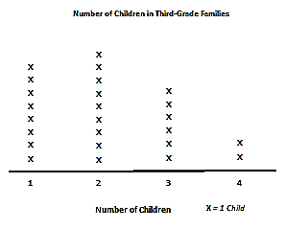
Materials: (T) Line plot (Fluency Template 1) pictured to the right
(S) Personal white board
Note: This activity reviews Grade 2 concepts about line plots in preparation for Topic B.
T: (Project line plot.) This line plot shows how many children are in the families of students in a third-grade class. How many students only have one child in their family? Let’s count to find the answer. (Point to the X’s as students count.)
S: 1, 2, 3, 4, 5, 6, 7, 8.
Continue the process for 2 children, 3 children, and 4 children.

NOTES ON
MULTIPLE MEANS
OF REPRESENTATION:
Scaffold for English language learners and others how to solve for how many more. Ask, “How many third graders have 2 children in their family? How many have 3 children? Which is more—6 or 9? How many more? (Count up from 6 to 9).”

T: Most students have how many children in their family?
S: 2 children.
T: On your personal white boards, write a number sentence to show how many more third graders have
2 children in their family than 3 children.
S: (Write 9 – 6 = 3.)
Continue the process to find how many fewer third graders have 4 children in their family than 2 children and how many more third graders have 1 child in their family than 3 children.
T: On your board, write a number sentence to show how many third graders have 3 or 4 children in their family.
S: (Write 6 + 2 = 8.)
Continue the process to find how many third graders have 1 or 2 children in their family and how many third graders have a sibling.
Read Bar Graphs (5 minutes)
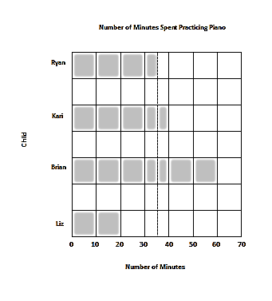
Materials: (T) Bar graph (Fluency Template 2) pictured to the right (S) Personal white board
Notes: This activity reviews Lesson 3.
T: (Project the bar graph Template.) This bar graph shows how many minutes 4 children spent practicing piano.
T: Did Ryan practice for more or less than 30 minutes?
S: More.
T: Did he practice for more or less than 40 minutes?
S: Less.
T: What fraction of the time between 30 and 40 minutes did Ryan practice piano?
S: 1 half of the time.
T: What’s halfway between 30 minutes and 40 minutes?
S: 35 minutes.
T: The dotted line is there to help you read 35 since 35 is between two numbers on the graph. How long did Kari spend practicing piano?
S: 40 minutes.
Continue the process for Brian and Liz.
T: Who practiced the longest?
S: Brian.
T: Who practiced the least amount of time?
S: Liz.
T: On your personal white board, write a number sentence to show how much longer Brian practiced than Kari.
S: (Write 60 – 40 = 20 minutes.)
Continue the process to find how many fewer minutes Ryan practiced than Brian.
T: On your board, write a number sentence to show how many total minutes Kari and Liz spent practicing piano.
S: (Write 40 + 20 = 60 minutes.)
Continue the process to find how many total minutes Ryan and Brian spent practicing piano and how many total minutes all the children practiced.
Application Problem (8 minutes)
The following chart shows the number of times an insect’s wings vibrate each second. Use the following clues to complete the unknowns in the chart.
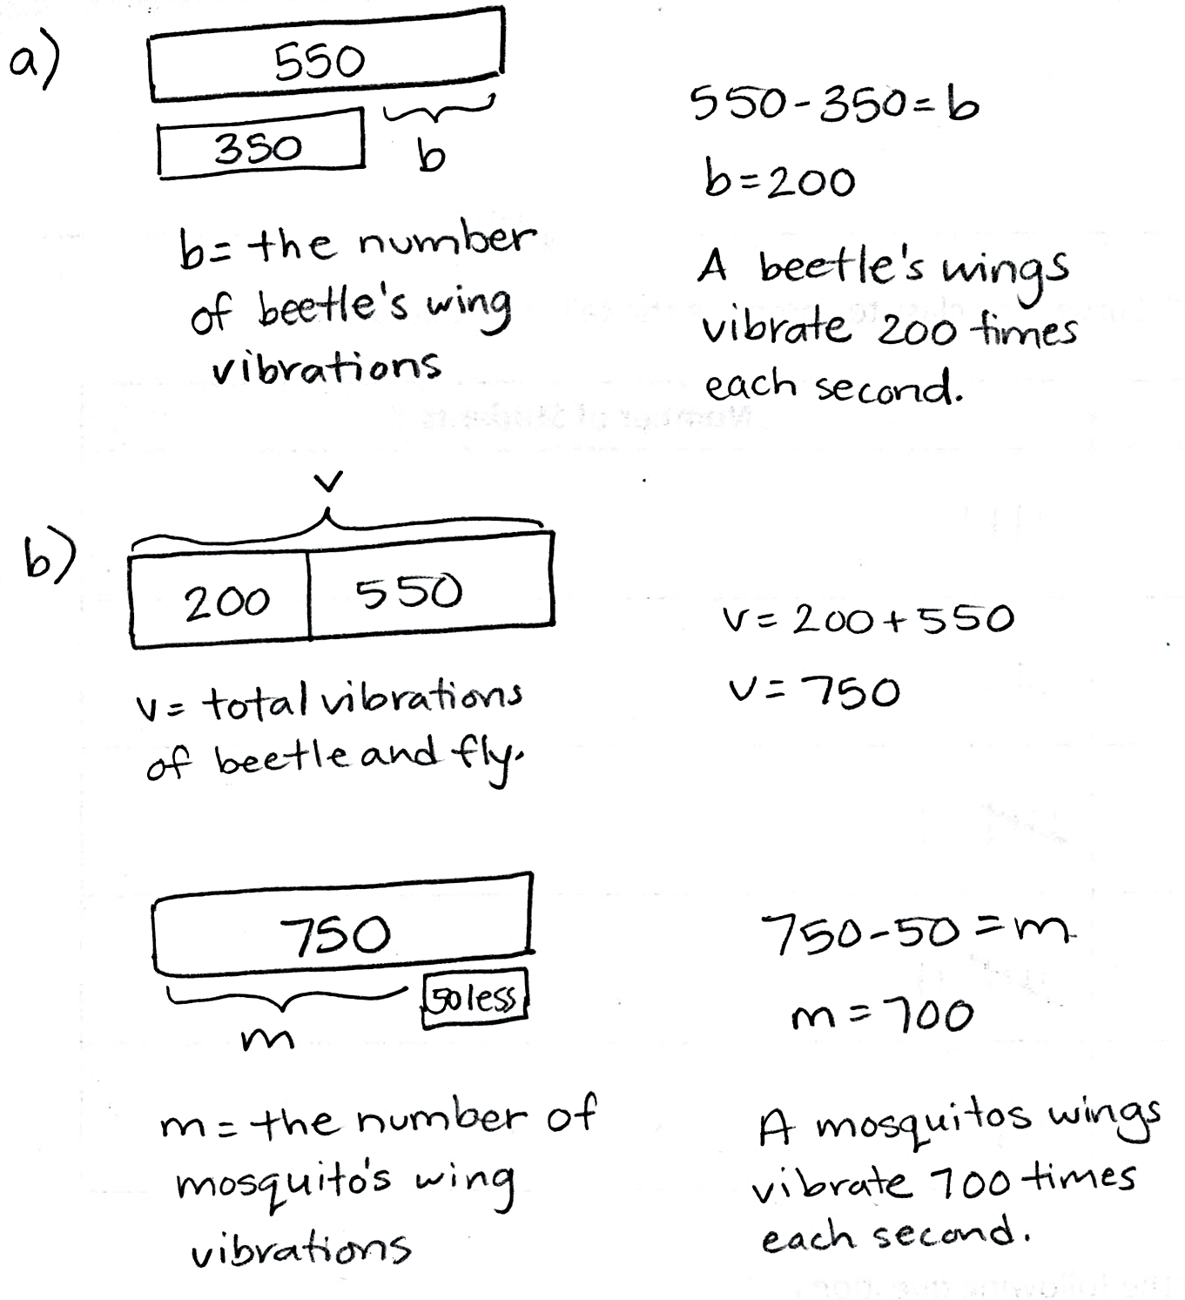
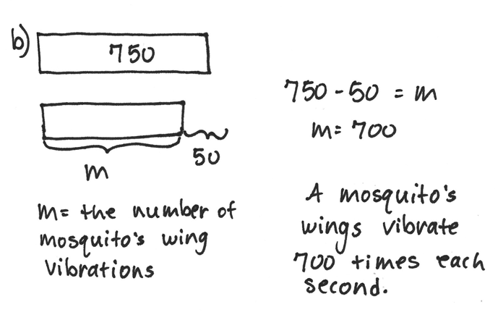
- The beetle’s number of wing vibrations is the same as the difference between the fly’s and honeybee’s.

- The mosquito’s number of wing vibrations is the same as 50 less than the beetle’s and fly’s combined.

Insect | Number of Wing Vibrations Each Second
Honeybee | 350
Beetle | b
Fly | 550
Mosquito | m

Note: The data from the chart will be used in the upcoming Concept Development, where students will first create a bar graph and then answer one- and two-step questions from the graph.
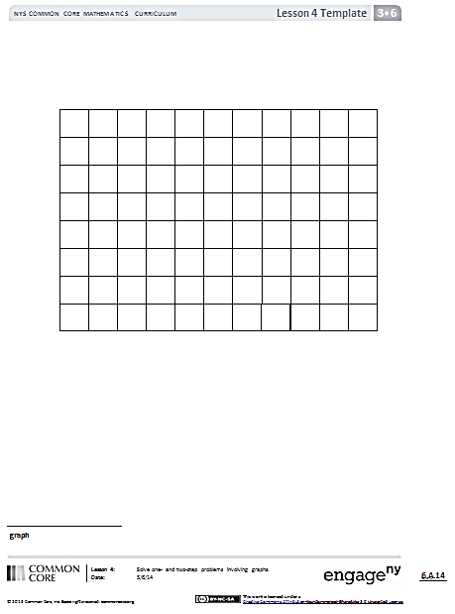
Concept Development (32 minutes)
Graph Template
Materials: (S) Graph (Template) pictured to the right, personal white board
T: (Pass out graph Template.) Let’s create a bar graph from the data in the Application Problem. We need to choose a scale that works for the data the graph represents. Talk to a partner: What scale would be best for this data? Why?
S: We could count by fives or tens. The numbers are big, so that would be a lot of tick marks to draw.
We could do it by hundreds since the numbers all end in zero.
T: In this case, using hundreds is a strong choice since the numbers are between 200 and 700. Decide if you will show the scale for your graph vertically or horizontally. Then, label it starting at zero.
S: (Label.)
T: The number of wing vibrations for the honeybee is 350 each second. Discuss the bar you will make for the honeybee with your partner. How many units will you shade in?
S: Maybe 4 units. We can round up. But to show the exact number, we just need to shade in 3 and one-half units.

NOTES ON
MULTIPLE MEANS
OF ACTION AND EXPRESSION:
Scaffold partner talk with sentence frames such as the ones listed below.
- I notice _____.
- The _____’s wings are faster than the _____’s.
- When I compare the _____ and _____, I see that….
- I didn’t know that….
- This data is interesting because….

T: Many of you noticed that you’ll need to shade a half unit to show this data precisely. Do you need to do the same for other insects?
S: We will also have to do this for the fly since it’s 550.
T: Go ahead and shade your bars.
S: (Shade bars.)
T: On your personal white board, write a number sentence to find the total number of vibrations 2 beetles and 1 honeybee can produce each second.
S: (350 + 200 + 200 = 750.)
T: Use a tape diagram to compare how many more vibrations a fly and honeybee combined produce than a mosquito.
S: (Work should resemble sample below.)
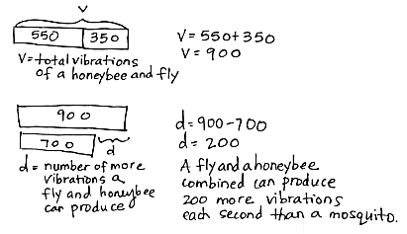

MP.3

T: Work with your partner to think of another question that can be solved using the data on this graph. Solve your question, and then trade questions with the pair of students next to you. Solve the new question, and check your work with their work.

NOTES ON
THE PROBLEM SET:
Problem 1(a) on the Problem Set may be the first time your students create a bar graph without the scaffold of a grid. Bring this to students’ attention, and quickly review how the bars should be created.

Problem Set (10 minutes)
Students should do their personal best to complete the Problem Set within the allotted 10 minutes. For some classes, it may be appropriate to modify the assignment by specifying which problems they work on first. Some problems do not specify a method for solving. Students should solve these problems using the RDW approach used for Application Problems.
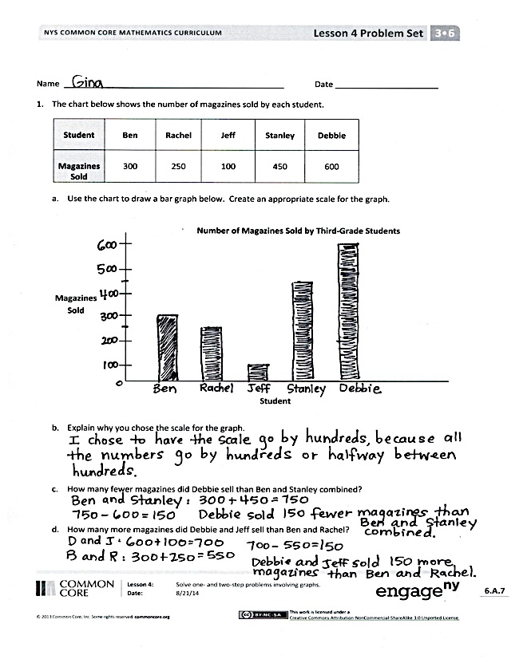
Student Debrief (10 minutes)
Lesson Objective: Solve one- and two-step problems involving graphs.
The Student Debrief is intended to invite reflection and active processing of the total lesson experience.
Invite students to review their solutions for the Problem Set. They should check work by comparing answers with a partner before going over answers as a class. Look for misconceptions or misunderstandings that can be addressed in the Debrief. Guide students in a conversation to debrief the Problem Set and process the lesson.
Any combination of the questions below may be used to lead the discussion.
- Invite students who used different scales for Problem 1 to share their work.
- How did you solve Problem 1(c)? What did you do first?
- What is the value of each interval in the bar graph in Problem 2? How do you know?
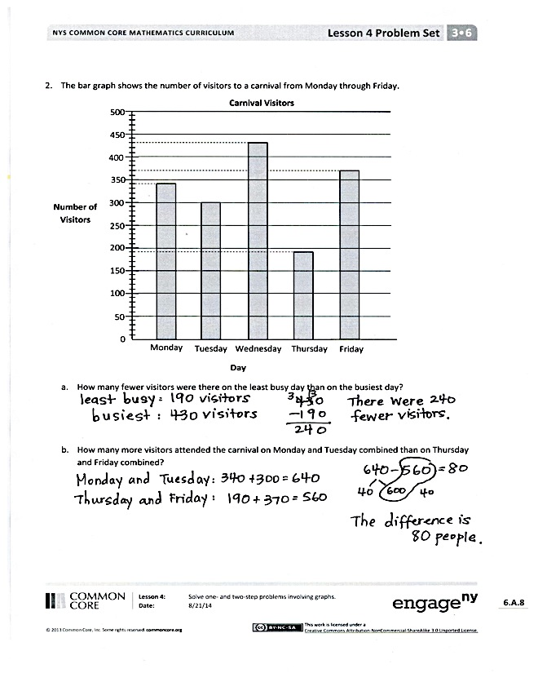
- How did you solve Problem 2(a)?
- Explain to your partner what you needed to do before answering Problem 2(b).
- Compare the chart from the Application Problem with the bar graph you made of that same data. How is each representation a useful tool? When might you choose to use each representation?
- How did the fluency activity, Read Bar Graphs, help you get ready for today’s lesson?
Exit Ticket (3 minutes)
After the Student Debrief, instruct students to complete the Exit Ticket. A review of their work will help with assessing students’ understanding of the concepts that were presented in today’s lesson and planning more effectively for future lessons. The questions may be read aloud to the students.
Name Date
- The chart below shows the number of magazines sold by each student.
Student | Ben | Rachel | Jeff | Stanley | Debbie
Magazines Sold | 300 | 250 | 100 | 450 | 600

- Use the chart to draw a bar graph below. Create an appropriate scale for the graph.

Magazines
Sold
Number of Magazines Sold by Third-Grade Students
Student

- Explain why you chose the scale for the graph.

- How many fewer magazines did Debbie sell than Ben and Stanley combined?

- How many more magazines did Debbie and Jeff sell than Ben and Rachel?

- The bar graph shows the number of visitors to a carnival from Monday through Friday.
Number of Visitors
0
50
100
150
200
250
300
350
400
450
500
Monday
Tuesday
Wednesday
Thursday
Friday
Carnival Visitors
Day

- How many fewer visitors were there on the least busy day than on the busiest day?

- How many more visitors attended the carnival on Monday and Tuesday combined than on Thursday and Friday combined?

Name Date
The graph below shows the number of library books checked out in five days.
Number of Library Books Checked Out
0
50
100
150
200
250
300
350
400
Monday
Tuesday
Wednesday
Thursday
Friday
Library Books Checked Out
Day

- How many books in total were checked out on Wednesday and Thursday?

- How many more books were checked out on Thursday and Friday than on Monday and Tuesday?

Name Date
- Maria counts the coins in her piggy bank and records the results in the tally chart below. Use the tally marks to find the total number of each coin.
Coins in Maria’s Piggy Bank
Coin | Tally | Number of Coins
Penny | //// //// //// //// //// //// //// //// //// //// //// //// //// ///
Nickel | //// //// //// //// //// //// //// //// //// //// //// //// //
Dime | //// //// //// //// //// //// //// //// //// //// //// //
Quarter | //// //// //// //// ////

- Use the tally chart to draw a bar graph below. The scale is given.
Number of Coins
Coin

Penny
Nickel
Dime
Quarter
10
Coins in Maria’s Piggy Bank
0

- How many more pennies are there than dimes?

- Maria donates 10 of each type of coin to charity. How many total coins does she have left? Show your work.

- Ms. Hollmann’s class goes on a field trip to the planetarium with Mr. Fiore’s class. The number of students in each class is shown in the picture graphs below.
Students in Ms. Hollmann’s Class
Students in Mr. Fiore’s Class
Boys
Girls

= 2 students

Boys
Girls

= 2 students

- How many fewer boys are on the trip than girls?

- It costs $2 for each student to attend the field trip. How much money will it cost for all students to attend?

- The cafeteria in the planetarium has 9 tables with 8 seats at each table. Counting students and teachers, how many empty seats will there be when the 2 classes eat lunch?

1
2
3
4
X
X
X
X
X
X
X
X
X
X
X
X
X
X
X
X
X
X
X
X
X
X
X
X
X
Number of Children
X = 1 Child
Number of Children in Third-Grade Families
Liz
Brian
Kari
Ryan
Number of Minutes
0
10
20
30
40
50
60
70
Number of Minutes Spent Practicing Piano
Child

line plot
bar graph
graph

