Lesson 3
Objective: Create scaled bar graphs.

Suggested Lesson Structure
 Fluency Practice (12 minutes)
 Application Problem (5 minutes)
 Concept Development (33 minutes)
 Student Debrief (10 minutes)
Total Time (60 minutes)
Fluency Practice (12 minutes)
- How Many Units of 6 3.OA.1 (3 minutes)
- Sprint: Multiply or Divide by 6 3.OA.4 (9 minutes)
How Many Units of 6 (3 minutes)
Note: This activity reviews multiplication and division with units of 6.
Direct students to count forward and backward by sixes to 60, occasionally changing the direction of the count.
T: How many units of 6 are in 12?
S: 2 units of 6.
T: Give me the division sentence with the number of sixes as the quotient.
S: 12 ÷ 6 = 2.
Continue the process with 24, 36, and 48.
Sprint: Multiply or Divide by 6 (9 minutes)
Materials: (S) Multiply or Divide by 6 Sprint
Note: This Sprint supports multiplication and division using units of 6.

Application Problem (5 minutes)
5
5
5
5
5
5
5
5
5
5
5
5
5
5
Tank
A
Tank
B
Tank
C
Tank
D
Tank
E
Number of Fish in Sal’s Pet Store
The vertical tape diagrams show the number of fish in Sal’s Pet Store.
  - Find the total number of fish in Tank C. Show your work.
- Tank B has a total of 30 fish. Draw the tape diagram for Tank B.
- How many more fish are in Tank B than in Tanks A and D combined?

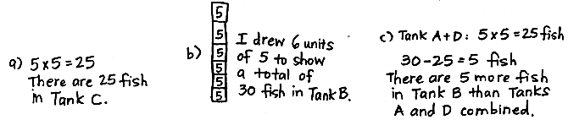

Note: This problem reviews reading vertical tape diagrams with a unit size larger than 1. It also anticipates the Concept Development, where students construct a scaled bar graph from the data in this problem.
Concept Development (33 minutes)
Materials: (S) Graph A (Template 1) pictured below, Graph B (Template 2) pictured below, colored pencils, straightedge
Problem 1: Construct a scaled bar graph.
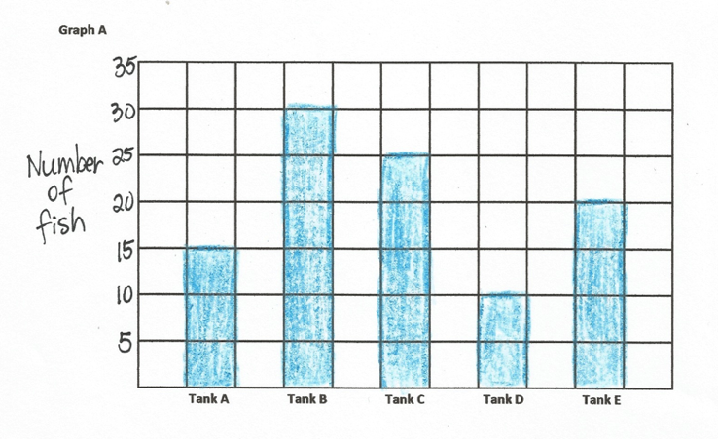
T: (Pass out Template 1 pictured below.) Draw the vertical tape diagrams from the Application Problem on the grid. (Allow students time to work.) Outline the bars with your colored pencil. Erase the unit labels inside the bar, and shade the entire bar with your colored pencil. (Model an example.)
Tank
Template 1 with Student Work
T: What does each square on the grid represent?
S: 5 fish!
T: We can show that by creating a scale on our bar graph. (Write 0 where the axes intersect, then write 5 near the first line on the vertical axis. Point to the next line up on the grid.) Turn and talk to a partner. What number should I write here? How do you know?
MP.6
S: Ten because you’re counting by fives. Ten because each square has a value of 5, and 2 fives is 10.
T: Count by fives to complete the rest of the scale on the graph.
MP.6
S: (Count and write.)
T: What do the numbers on the scale tell you?
S: The number of fish!
T: Label the scale Number of Fish. (Model.) What do the labels under each bar tell you?
S: Which tank the bar is for!
T: What’s a good title for this graph?
S: Number of Fish at Sal’s Pet Store.
T: Write the title, Number of Fish at Sal’s Pet Store. (Model.)
T: Turn and talk to a partner. How is this scaled bar graph similar to the vertical tape diagrams in the Application Problem? How is it different?
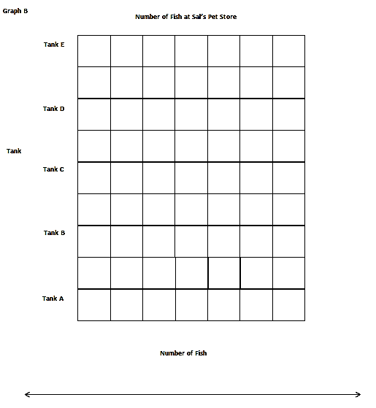
S: They both show the number of fish in Sal’s pet store. The value of the bars and the tape diagrams is the same. The way we show the value of the bars changed. In the Application Problem, we labeled each unit. In this graph, we made a scale to show the value.
Template 2
T: You’re right. This scaled bar graph doesn’t have labeled units, but it has a scale we can read to find the values of the bars. (Pass out Template 2, pictured to the right.) Let’s create a second bar graph from the data. What do you notice about the labels on this graph?
S: They are switched! Yeah, the tank labels are on the side, and the Number of fish label is now at the bottom.
T: Count by fives to label your scale along the horizontal edge. Then, shade in the correct number of squares for each tank. Will your bars be horizontal or vertical?
S: Horizontal. (Label and shade.)
T: Take Graph A and turn it so the paper is horizontal. Compare it with Graph B. What do you notice?
S: They’re the same!
T: A bar graph can be drawn vertically or horizontally, depending on where you decide to put the labels, but the information stays the same as long as the scales are the same.
T: Marcy buys 3 fish from Tank C. Write a subtraction sentence to show how many fish are left in
Tank C.
S: (Write 25 – 3 = 22.)
T: How many fish are left in Tank C?
S: 22 fish!
T: Discuss with a partner how I can show 22 fish on the bar graph.
S: (Discuss.)
T: I’m going to erase some of the Tank C bar. Tell me to stop when you think it shows 22 fish. (Erase until students say to stop.) Even though our scale counts by fives, we can show other values for the bars by drawing the bars in between the numbers on the scale.
Problem 2: Plot data from a bar graph on a number line.
T: Let’s use Graph B to create a number line to show the same information. There is an empty number line below the graph. Line up a straightedge with each column on the grid to make intervals on the number line that match the scale on the graph. (Model.)

NOTES ON
MULTIPLE MEANS
OF ACTION AND EXPRESSION:
Assist students with perceptual difficulties, low vision, and others with plotting corresponding points on the number line. To make tick marks, show students how to hold and align the straightedge with the scale at the bottom of the graph, not the bars. Precise alignment is desired, but comfort, confidence, accurate presentation of data, and a frustration-free experience are more valuable.

S: (Draw intervals.)
T: Will the intervals on the number line be labeled with the number of fish or with the tanks? Discuss with your partner.
S: The number of fish.
T: Why? Talk to your partner.
S: The number of fish because the number line shows the scale.
T: Label the intervals. (Allow students time to work.) Now, work with a partner to plot and label the number of fish in each tank on the number line.
S: (Plot and label.)
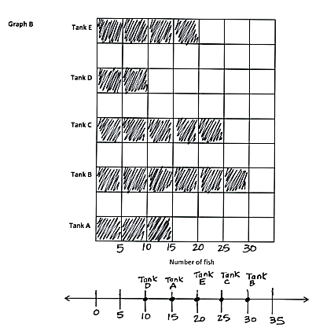
T: Talk to a partner. Compare how the information is shown on the bar graph and the number line.
Tank
Number of Fish at Sal’s Pet Store
S: The tick marks on the number line are in the same places as the graph’s scale. The spaces in between the tick marks on the number line are like the unit squares on the bar graph. On the number line, the tanks are just dots, not whole bars, so the labels look a little different, too.
T: We can read different information from the 2 representations. Compare the information we can read.
S: With a bar graph it’s easy to see the order from least to most fish just by looking at the size of the bars. The number line shows you how much, too, but you know which is the most by looking for the biggest number on the line, not by looking for the biggest bar.
T: Yes. A bar graph allows us to compare easily. A number line plots the information.
Problem Set (10 minutes)
Students should do their personal best to complete the Problem Set within the allotted 10 minutes. For some classes, it may be appropriate to modify the assignment by specifying which problems they work on first. Some problems do not specify a method for solving. Students should solve these problems using the RDW approach used for Application Problems.
For this Problem Set, the third page can be used as an extension for students who finish early.
Student Debrief (10 minutes)

NOTES ON
MULTIPLE MEANS
OF REPRESENTATION:
Students working below grade level and others may benefit from the following scaffolds for reading graphs on the Problem Set:
- Facilitate a guided practice of estimating and accurately determining challenging bar values. Start with smaller numbers and labeled increments, gradually increasing the challenge.
- Draw, or have students draw, a line (in a color other than black) aligning the top of the bar with its corresponding measure on the scale.
- Allow students to record the value inside of the bar—in increments as a tape diagram, or as a whole—until they become proficient.

Lesson Objective: Create scaled bar graphs.
The Student Debrief is intended to invite reflection and active processing of the total lesson experience.
Invite students to review their solutions for the Problem Set. They should check work by comparing answers with a partner before going over answers as a class. Look for misconceptions or misunderstandings that can be addressed in the Debrief. Guide students in a conversation to debrief the Problem Set and process the lesson.
Any combination of the questions below may be used to lead the discussion.
- Discuss your simplifying strategy, or a simplifying strategy you could have used, for Problem 1(b).
- Share number sentences for Problem 1(c).
- How did the straightedge help you read the bar graph in Problem 2?
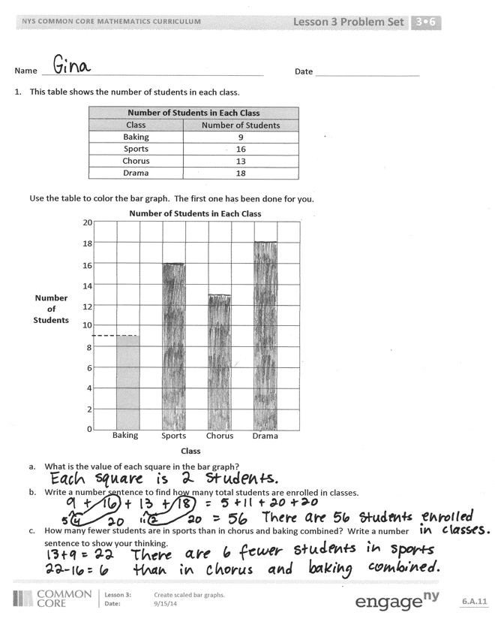
- Share your number line for Problem 4. How did the scale on the bar graph help you draw the intervals on the number line? What does each interval on the number line represent?
- Did you use the bar graph or the number line to answer the questions in Problem 5? Explain your choice.
- Compare vertical tape diagrams to a scaled bar graph. (If necessary, clarify the phrase scaled bar graph.) What is different? What is the same?
- Does the information change when a bar graph is drawn horizontally or vertically with the same scale? Why or why not?
- What is the purpose of a label on a bar graph?
- How is a bar graph’s scale more precise than a picture graph’s?
- How does the fluency activity, Group Counting on a Vertical Number Line, relate to reading a bar graph?

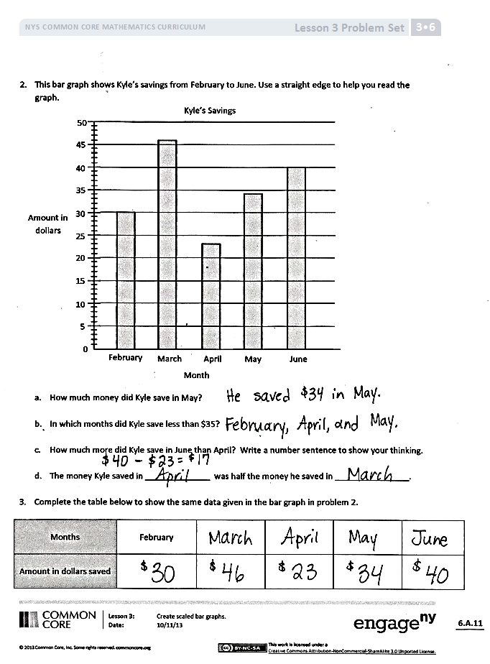
Exit Ticket (3 minutes)
After the Student Debrief, instruct students to complete the Exit Ticket. A review of their work will help with assessing students’ understanding of the concepts that were presented in today’s lesson and planning more effectively for future lessons. The questions may be read aloud to the students.

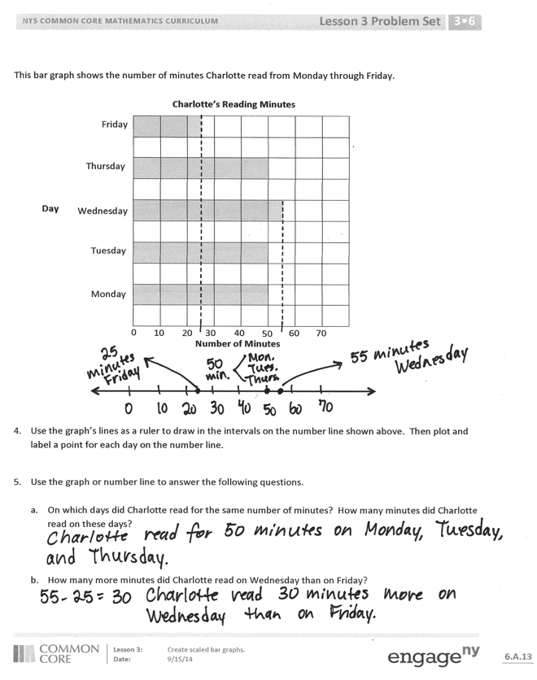

Number Correct: _______
A
Multiply or Divide by 6
 | 2 × 6 = |  |  |  | ___ × 6 = 60
 | 3 × 6 = |  |  |  | ___ × 6 = 12
 | 4 × 6 = |  |  |  | ___ × 6 = 18
 | 5 × 6 = |  |  |  | 60 ÷ 6 =
 | 1 × 6 = |  |  |  | 30 ÷ 6 =
 | 12 ÷ 6 = |  |  |  | 6 ÷ 6 =
 | 18 ÷ 6 = |  |  |  | 12 ÷ 6 =
 | 30 ÷ 6 = |  |  |  | 18 ÷ 6 =
 | 6 ÷ 6 = |  |  |  | ___ × 6 = 36
 | 24 ÷ 6 = |  |  |  | ___ × 6 = 42
 | 6 × 6 = |  |  |  | ___ × 6 = 54
 | 7 × 6 = |  |  |  | ___ × 6 = 48
 | 8 × 6 = |  |  |  | 42 ÷ 6 =
 | 9 × 6 = |  |  |  | 54 ÷ 6 =
 | 10 × 6 = |  |  |  | 36 ÷ 6 =
 | 48 ÷ 6 = |  |  |  | 48 ÷ 6 =
 | 42 ÷ 6 = |  |  |  | 11 × 6 =
 | 54 ÷ 6 = |  |  |  | 66 ÷ 6 =
 | 36 ÷ 6 = |  |  |  | 12 × 6 =
 | 60 ÷ 6 = |  |  |  | 72 ÷ 6 =
 | ___ × 6 = 30 |  |  |  | 14 × 6 =
 | ___ × 6 = 6 |  |  |  | 84 ÷ 6 =
B
[KEY]

Number Correct: _______
Improvement: _______
Multiply or Divide by 6
 | 1 × 6 = |  |  |  | ___ × 6 = 12
 | 2 × 6 = |  |  |  | ___ × 6 = 60
 | 3 × 6 = |  |  |  | ___ × 6 = 18
 | 4 × 6 = |  |  |  | 12 ÷ 6 =
 | 5 × 6 = |  |  |  | 6 ÷ 6 =
 | 18 ÷ 6 = |  |  |  | 60 ÷ 6 =
 | 12 ÷ 6 = |  |  |  | 30 ÷ 6 =
 | 24 ÷ 6 = |  |  |  | 18 ÷ 6 =
 | 6 ÷ 6 = |  |  |  | ___ × 6 = 18
 | 30 ÷ 6 = |  |  |  | ___ × 6 = 24
 | 10 × 6 = |  |  |  | ___ × 6 = 54
 | 6 × 6 = |  |  |  | ___ × 6 = 42
 | 7 × 6 = |  |  |  | 48 ÷ 6 =
 | 8 × 6 = |  |  |  | 54 ÷ 6 =
 | 9 × 6 = |  |  |  | 36 ÷ 6 =
 | 42 ÷ 6 = |  |  |  | 42 ÷ 6 =
 | 36 ÷ 6 = |  |  |  | 11 × 6 =
 | 48 ÷ 6 = |  |  |  | 66 ÷ 6 =
 | 60 ÷ 6 = |  |  |  | 12 × 6 =
 | 54 ÷ 6 = |  |  |  | 72 ÷ 6 =
 | ___ × 6 = 6 |  |  |  | 13 × 6 =
 | ___ × 6 = 30 |  |  |  | 78 ÷ 6 =

Name Date
- This table shows the number of students in each class.
Number of Students in Each Class
Class | Number of Students
Baking | 9
Sports | 16
Chorus | 13
Drama | 18

Use the table to color the bar graph. The first one has been done for you.
Baking
Chorus
Sports
Drama
Class
2
4
6
8
10
12
14
16
18
20

Number
of
Students
Number of Students in Each Class

0

- What is the value of each square in the bar graph?

- Write a number sentence to find how many total students are enrolled in classes.

- How many fewer students are in sports than in chorus and baking combined? Write a number sentence to show your thinking.
- This bar graph shows Kyle’s savings from February to June. Use a straightedge to help you read the graph.
Amount in Dollars
0
5
10
15
20
25
30
35
40
45
50
February
March
April
May
June
Month
Kyle’s Savings

- How much money did Kyle save in May?

- In which months did Kyle save less than $35?

- How much more did Kyle save in June than April? Write a number sentence to show your thinking.

- The money Kyle saved in ______________ was half the money he saved in ________________.

Months | February
Amount
Saved in Dollars

- Complete the table below to show the same data given in the bar graph in Problem 2.

This bar graph shows the number of minutes Charlotte read from Monday through Friday.
Monday
Tuesday
Wednesday
Thursday
Friday
10
20
30
40
50
60
70
Number of Minutes
Day
Charlotte’s Reading Minutes
0

- Use the graph’s lines as a ruler to draw in the intervals on the number line shown above. Then plot and label a point for each day on the number line.

- Use the graph or number line to answer the following questions.

- On which days did Charlotte read for the same number of minutes? How many minutes did Charlotte read on these days?

- How many more minutes did Charlotte read on Wednesday than on Friday?
Name Date
The bar graph below shows the students’ favorite ice cream flavors.
Vanilla
Strawberry
Chocolate
Butter Pecan
10
20
30
40
50
60
Number of Students
Favorite Ice Cream Flavors
Flavor
0

- Use the graph’s lines as a ruler to draw intervals on the number line shown above. Then plot and label a point for each flavor on the number line.

- Write a number sentence to show the total number of students who voted for butter pecan, vanilla, and chocolate.

Name Date
- This table shows the favorite subjects of third graders at Cayuga Elementary.
Favorite Subjects
Subject | Number of Student Votes
Math | 18
ELA | 13
History | 17
Science | ?

Use the table to color the bar graph.
Math
ELA
History
Science
2
4
6
8
10
12
14
16
18
20
Favorite Subjects
Number
of Student Votes
Subject

0

- How many students voted for science?

- How many more students voted for math than for science? Write a number sentence to show your thinking.

- Which gets more votes, math and ELA together, or history and science together? Show your work.
- This bar graph shows the number of liters of water Skyler uses this month.
Week 4
Week 3
Week 2
Week 1
10
20
30
40
50
60
70
Number of Liters
Week
Liters of Water Skyler Uses
0

- During which week does Skyler use the most water? __________________
The least? ___________________

- How many more liters does Skyler use in Week 4 than Week 2?

- Write a number sentence to show how many liters of water Skyler uses during Weeks 2 and 3 combined.

- How many liters does Skyler use in total?

- If Skyler uses 60 liters in each of the 4 weeks next month, will she use more or less than she uses this month? Show your work.

- Complete the table below to show the data displayed in the bar graph in Problem 2.

Liters of Water Skyler Uses
Week | Liters of Water

0F0F
Tank E
Tank D
Tank C
Tank B
Tank A
Tank
Tank A
Tank B
Tank C
Tank D
Tank E
Number of Fish at Sal’s Pet Store
Number of Fish
Tank

1F1F

graph A
graph B

