Lesson 2
Objective: Rotate tape diagrams vertically.

Suggested Lesson Structure
 Fluency Practice (9 minutes)
 Application Problem (10 minutes)
 Concept Development (31 minutes)
 Student Debrief (10 minutes)
Total Time (60 minutes)
Fluency Practice (9 minutes)
- Group Counting on a Vertical Number Line 3.OA.1 (3 minutes)
- Read Tape Diagrams 3.MD.4 (6 minutes)
Group Counting on a Vertical Number Line (3 minutes)
0
16
32
48
64
80
Note: Group counting reviews interpreting multiplication as repeated addition.
T: (Project a vertical number line partitioned into intervals of 8, as shown. Cover the number line so that only the numbers 0 and 16 show.) What is halfway between 0 and 16?
S: 8.
T: (Write 8 on the first hash mark.)
Continue for the remaining hashes so that the number line shows increments of eight to 80.
T: Let’s count by eights to 80.
Direct students to count forward and backward to 80, occasionally changing the direction of the count. Repeat the process using the following possible suggestions:
- Sixes to 60
- Sevens to 70
- Nines to 90

Read Tape Diagrams (6 minutes)
Materials: (S) Personal white board
Note: This fluency activity reviews the relationship between the value of each unit in a tape diagram and the total value of the tape diagram. It also reviews comparing tape diagrams in preparation for today’s lesson.
T: (Project a tape diagram with 7 units.) Each unit in the tape diagram has a value of 4. Write a multiplication sentence that represents the total value of the tape diagram.
S: (Write 7 $\text{×}$ 4 = 28.)
T: What is the total value of the tape diagram?
S: 28.
Use the same tape diagram. Repeat the process with the following suggested values for the units: 6, 3, 9, 7, and 8.
T: (Project tape diagrams as shown.) What is the value of each unit in Tape Diagrams A and B?
A:
8
8
8
84
B:
8
8
8
84
8
8
8
S: 8.
T: Write a multiplication sentence that represents the total value of Tape Diagram A.
S: (Write 4 $\text{×}$ 8 = 32.)
T: Write a multiplication sentence that represents the total value of Tape Diagram B.
S: (Write 7 $\text{×}$ 8 = 56.)
Continue with the following possible questions:
- What is the total value of both tape diagrams?
- How many more units of 8 are in Tape Diagram B than in Tape Diagram A?
- What is the difference in value between the 2 tape diagrams?
Application Problem (10 minutes)
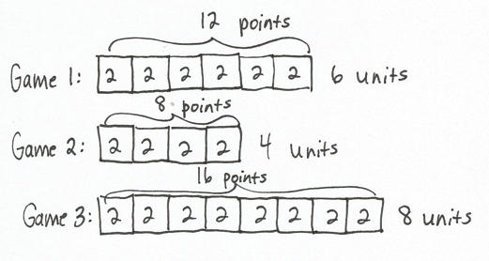
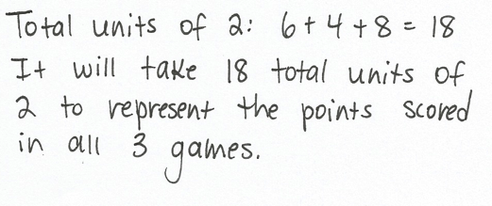
Reisha played in three basketball games. She scored 12 points in Game 1, 8 points in Game 2, and 16 points in Game 3. Each basket that she made was worth 2 points. She uses tape diagrams with a unit size of 2 to represent the points she scored in each game. How many total units of 2 will it take to represent the points she scored in all three games?

Note: This problem reviews building tape diagrams with a unit size larger than 1 in anticipation of students using this same skill in the Concept Development. Ask students to solve this problem on personal white boards so that they can easily modify their work as they use it in the Concept Development. Invite students to discuss what the total number of units represents in relation to the three basketball games (18 total units of 2 is equal to 18 total baskets scored).
Concept Development (31 minutes)
Materials: (S) Tape diagrams from Application Problem, personal white board
Problem 1: Rotate tape diagrams to make vertical tape diagrams with units of 2.
T: Turn your personal white board so your tape diagrams are vertical like mine. (Model.) Erase the brackets and the labels for the number of units and the points. How are these vertical tape diagrams similar to the picture graphs you made yesterday?

S: They both show us data. Each unit on the vertical tape diagrams represents 2 points. The pictures on the picture graph had a value greater than 1, and so does the unit in the vertical tape diagram.
T: How are the vertical tape diagrams different from the picture graphs?
S: The units are connected in the vertical tape diagrams. The pictures were separate in the picture graphs.
The units in the vertical tape diagrams are labeled, but in our picture graphs the value of the unit was shown on the bottom of the graph.

NOTES ON
MULTIPLE MEANS
OF ENGAGEMENT:
Students working above grade level and others may use parentheses and variables in their equations that represent the total points scored in all three games. Celebrate all true expressions, particularly those that apply the distributive property.
Students working below grade level and others may benefit from more scaffolded instruction for constructing and solving equations for three addends (number of units) and the total points.

T: Nice observations. Put your finger on the tape that shows data about Game 1. Now, write a multiplication equation to show the value of Game 1’s tape.
S: (Write 6 $\text{×}$ 2 = 12.)
T: What is the value of Game 1’s tape?
S: 12 points!
T: How did you know that the unit is points?
S: The Application Problem says Reisha scores 12 points in Game 1.
T: Let’s write a title on our vertical tape diagrams to help others understand our data. What do the data on the vertical tape diagrams show us?
S: The points Reisha scores in three basketball games.
T: Write Points Reisha Scores for your title. (Model appropriate placement of the title.)
Problem 2: Draw vertical tape diagrams with units of 4.
T: Suppose each unit has a value of 4 points instead of 2 points. Talk to a partner. How many units will I draw to represent Reisha’s points in Game 1? How do you know?
S: Three units because she scored 12 points in Game 1, and 3 units of 4 points equals 12 points.
Three units because 3 $\text{×}$ 4 = 12 or 12 $\text{÷}$ 4 = 3. Three units. The value of each unit is twice as much. Before we drew 6 units of 2, so now we draw half as many. Each new unit has the value of two old units.
T: Draw the 3 units vertically, and label each unit 4. (Model.) What label do we need for this tape?
S: Game 1.
Continue the process for Games 2 and 3.
T: How many total units of 4 does it take to represent the points Reisha scored in all three games?
S: 9 units!
T: How does this compare to the total units of 2 it took to represent Reisha’s total points?
S: It took half as many total units when we used units of 4.
T: Why does it take fewer units when you use units of 4?
S: The units are bigger. The units represent a larger amount.
T: How can you use vertical tape diagrams to write a multiplication sentence to represent Reisha’s total points in all three games?
MP.2
S: Multiply the total number of units times the value of each unit. We can multiply 9 times 4.
T: Write a multiplication number sentence to show the total points Reisha scored in all three games.
S: (Write 9 $\text{×}$ 4 = 36.)
T: How many points did Reisha score in all three games?

NOTES ON
MULTIPLE MEANS
OF REPRESENTATION:
In Problem 1 of the Problem Set, some students with perceptual challenges may have difficulty tracking rows of stamps as they count. Have students place a straightedge below each row as they count by fours. Students working below grade level may benefit from a fluency drill that reviews the fours group count.

S: 36 points!
Continue with the following possible suggestions:
- How many more units of 4 did you draw for Game 1 than Game 2? How does this help you find how many more points Reisha scored in Game 1 than in Game 2?
- Suppose Reisha scored 4 fewer points in Game 3. How many units of 4 do you need to erase from Game 3’s tape to show the new points?
- Reisha scores 21 points in a fourth game. Can you use units of 4 to represent the points Reisha scores in Game 4 on a vertical tape diagram?

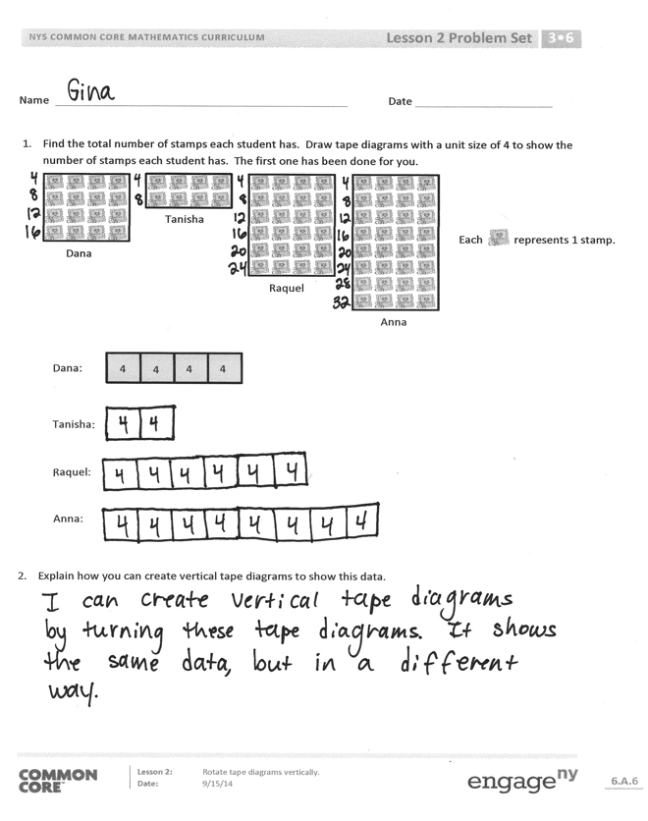
Problem Set (10 minutes)
Students should do their personal best to complete the Problem Set within the allotted 10 minutes. For some classes, it may be appropriate to modify the assignment by specifying which problems they work on first. Some problems do not specify a method for solving. Students should solve these problems using the RDW approach used for Application Problems.
Student Debrief (10 minutes)
Lesson Objective: Rotate tape diagrams vertically.
The Student Debrief is intended to invite reflection and active processing of the total lesson experience.
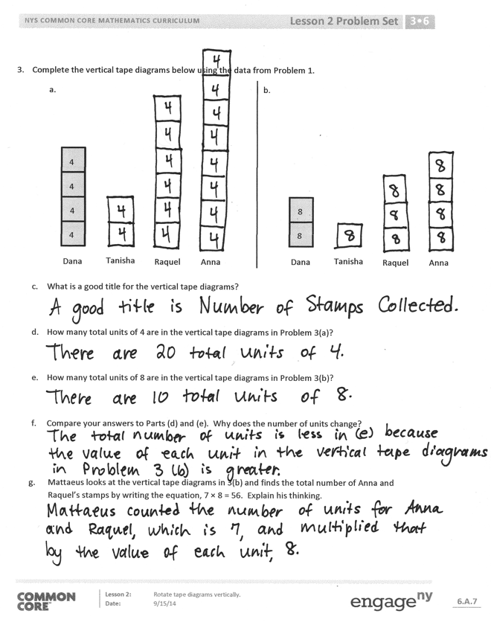
Invite students to review their solutions for the Problem Set. They should check work by comparing answers with a partner before going over answers as a class. Look for misconceptions or misunderstandings that can be addressed in the Debrief. Guide students in a conversation to debrief the Problem Set and process the lesson.
Any combination of the questions below may be used to lead the discussion.
- How does multiplication help you interpret the vertical tape diagrams on the Problem Set?
- Could you display the data in Problem 1 in a vertical tape diagram with units of 6? Why or why not?
- If the value of the unit for your vertical tape diagrams in Problem 1 was 2 instead of 4, how would the number of units change?
- In what ways do vertical tape diagrams relate to picture graphs?
- How did today’s Application Problem relate to our new learning?
- In what ways did the Fluency Practice prepare you for today’s lesson?

Exit Ticket (3 minutes)
After the Student Debrief, instruct students to complete the Exit Ticket. A review of their work will help with assessing students’ understanding of the concepts that were presented in today’s lesson and planning more effectively for future lessons. The questions may be read aloud to the students.

Name Date
- Find the total number of stamps each student has. Draw tape diagrams with a unit size of 4 to show the number of stamps each student has. The first one has been done for you.
Dana
Tanisha
Raquel
Anna
Each represents 1 stamp.

Tanisha:
Raquel:
Anna:
Dana:
4
4
4
4

- Explain how you can create vertical tape diagrams to show this data.

- Complete the vertical tape diagrams below using the data from Problem 1.
Tanisha
Raquel
Anna
Dana
4
4
4
4
Tanisha
Raquel
Anna
Dana
8
8
a.
b.

- What is a good title for the vertical tape diagrams?

- How many total units of 4 are in the vertical tape diagrams in Problem 3(a)?

- How many total units of 8 are in the vertical tape diagrams in Problem 3(b)?

- Compare your answers to Parts (d) and (e). Why does the number of units change?
- Mattaeus looks at the vertical tape diagrams in 3(b) and finds the total number of Anna and Raquel’s stamps by writing the equation, 7 × 8 = 56. Explain his thinking.

Name Date
The chart below shows a survey of the book club’s favorite type of books.
Book Club’s Favorite Type of Books
Type of Book | Number of Votes
Mystery | 12
Biography | 16
Fantasy | 20
Science Fiction | 8

- Draw tape diagrams with a unit size of 4 to represent the book club’s favorite type of books.

- Use your tape diagrams to draw vertical tape diagrams that represent the data.

Name Date
- Adi surveys third graders to find out their favorite fruits. The results are in the table below.
Favorite Fruits of Third Graders
Fruit | Number of Student Votes
Banana | 8
Apple | 16
Strawberry | 12
Peach | 4

Draw units of 2 to complete the tape diagrams to show the total votes for each fruit. The first one has been done for you.

Apple:
Strawberry:
Peach:

Banana:
2
2
2
2

- Explain how you can create vertical tape diagrams to show this data.

- Complete the vertical tape diagrams below using the data from Problem 1.
Apple
Strawberry
Peach
Banana
2
2
2
2
a.
b.
Apple
Strawberry
Peach
Banana
4
4

- What is a good title for the vertical tape diagrams?

- Compare the number of units used in the vertical tape diagrams in Problems 3(a) and 3(b). Why does the number of units change?

- Write a multiplication number sentence to show the total number of votes for strawberry in the vertical tape diagram in Problem 3(a).

- Write a multiplication number sentence to show the total number of votes for strawberry in the vertical tape diagram in Problem 3(b).

- What changes in your multiplication number sentences in (e) and (f)? Why?

