Lesson 1

Objective: Generate and organize data.

Suggested Lesson Structure

 Fluency Practice (9 minutes)

 Application Problem (7 minutes)

 Concept Development (34 minutes)

 Student Debrief (10 minutes)

**Total Time (60 minutes)**

Fluency Practice (9 minutes)

* Group Counting on a Vertical Number Line  **3.OA.1** (3 minutes)
* Model Division with Tape Diagrams **3.MD.4** (6 minutes)

Group Counting on a Vertical Number Line (3 minutes)

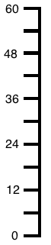

Note: Group counting reviews interpreting multiplication as repeated addition.

T: (Project a vertical number line partitioned into intervals of 6, as shown. Cover the number line so that only the numbers 0 and 12 show.) What is halfway between 0 and 12?

S: 6.

T: (Write 6 on the first hash mark.)

Continue for the remaining hashes so that the number line shows increments of six to 60.

T: Let’s count by sixes to 60.

Direct students to count forward and backward to 60, occasionally changing the direction of the count. Repeat the process with the following possible suggestions:

* Sevens to 70
* Eights to 80
* Nines to 90

Model Division with Tape Diagrams (6 minutes)

Materials: (S) Personal white board

Note: This fluency activity reviews using tape diagrams to model division.

T: (Project tape diagram with 6 as the whole.) What is the value of the whole?

S: 6.

T: (Partition the tape diagram into 2 equal parts.) How many equal parts is 6 broken into?

S: 2 equal parts.

T: Tell me a division equation to solve for the unknown group size.



S: 6 ÷ 2 = 3.

T: (Beneath the diagram, write 6 ÷ 2 = 3.)

T: On your personal white board, draw a rectangle with 8 as the whole.

S: (Draw a rectangle with 8 as the whole.)

T: Divide it into 2 equal parts, write a division equation to solve for the unknown, and label the value of the units.

S: (Partition the rectangle into 2 equal parts, write 8 ÷ 2 = 4, and label each unit with 4.)

Continue with the following possible suggestions, alternating between teacher drawings and student drawings: 6 ÷ 3, 8 ÷ 4, 10 ÷ 5, 10 ÷ 2, 9 ÷ 3, 12 ÷ 2, 12 ÷ 3, and 12 ÷ 4.

Application Problem (7 minutes)

Damien folds a paper strip into 6 equal parts. He shades 5 of the equal parts and then cuts off 2 shaded parts. Explain your thinking about what fraction is unshaded.

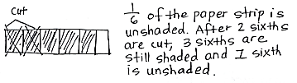Note: This Application Problem provides an opportunity to review the concept of defining the whole from Module 5. Some students may correctly argue that one-fourth is unshaded if they see the strip as a new whole partitioned into fourths.

Concept Development (34 minutes)

Materials: (S) Problem Set, class list (preferably in alphabetical order, as shown to the right)

Part 1: Collect data.

List the following five colors on the board: green, yellow, red, blue, and orange.

T: Today you will collect information, or data. We will survey to find out each person’s favorite color from one of the five colors listed on the board. How can we keep track of our data in an organized way? Turn and talk to your partner.

S: We can write everyone’s name with the person’s favorite color next to it.   
🡪 We can write each name and color code it with the person’s favorite color. 🡪 We can put it in a chart.

T: All of those ways work. One efficient way to collect and organize our data is by recording it on a tally chart. (Draw a single vertical tally markon the board.) Each tally like the one I drew has a value of 1 student. Count with me. (Draw tally marks as students count.)

|  |  |
| --- | --- |
|  | NOTES ON  MULTIPLE MEANS  OF REPRESENTATION: |
| Familiarize English language learners and others with common language used to discuss data, such as *most common, favorite, how many more,* and *how many fewer*. Offer explanations in students’ first language, if appropriate. Guiding students to use the language to quickly ask questions about the tally chart at this point in the Concept Development prepares them for independent work on the Problem Set. | |

S: 1 student, 2 students, 3 students, 4 students,   
5 students.

T: (Draw ~~IIII~~.) This is how 5 is represented with tally marks. How might writing each fifth tally mark with a slash help you count your data easily and quickly? Talk to your partner.

S: It’s bundling tally marks by fives. 🡪 We can bundle   
2 fives as ten.

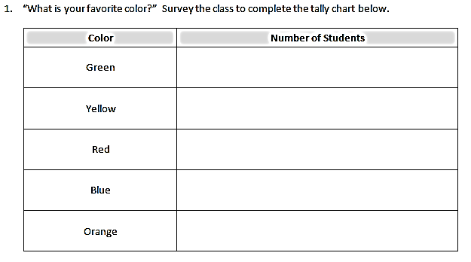T: (Pass out the Problem Set and class list.) Find the chart on Problem 1 of your Problem Set (pictured to the right). Take a minute now to choose your favorite color out of those listed on the chart. Record your favorite color with a tally mark on the chart, and cross your name off your class list.

T: (Students record.) Take six minutes to ask each of your classmates, “What is your favorite color?” Record each classmate’s answer with a tally mark next to his favorite color. Once you’re done with each person, cross her name off your class list to help you keep track of who you still need to ask. Remember, you may not change your color throughout the survey.

S: (Conduct survey for about six minutes.)

T: How many total students said green was their favorite color?

S: (Say the number of students.)

T: I am going to record it numerically on the board below the label *Green*.

Continue with the rest of the colors.

|  |  |  |  |  |
| --- | --- | --- | --- | --- |
| Green | Yellow | Red | Blue | Orange |
| 4 | 2 | 6 | 7 | 3 |

Total: 4 + 2 + 6 + 7 + 3 = 22

Example Board:

T: This chart is another way to show the same information.

T: Use mental math to find the total number of students surveyed. Say the total at my signal. (Signal.)

S: 22 students.

T: Discuss your mental math with your partner for 30 seconds.

S: I added 4 then 2 to get 6. Six and 6 is 12, and then I noticed I had 10 left. Twelve and 10 is 22.   
🡪 I made 2 tens, 6 plus 4 and 7 plus 3, and then I added 2 more.

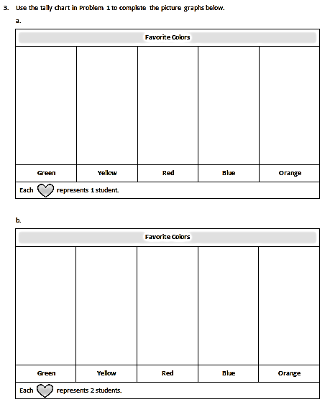Part 2: Construct a picture graph from the data.

T: Using pictures or a picture graph, let’s graph the data we collected. Read the directions for Problem 3 on your Problem Set (pictured right). (Pause for students to read.) Find the **key**, which tells you the value of a unit, on each picture graph. (Pause for students to locate the keys.) What is different about the keys on these two picture graphs?

S: In Problem 3(a), one heart represents 1 student, but in Problem 3(b), one heart represents 2 students.

T: Good observations! Talk to a partner: How would you represent 4 students in Problems 3(a) and 3(b)?

S: In 3(a), I would draw 4 hearts. 🡪 In 3(b), I would only draw 2 hearts because the value of each heart is 2 students.

T: (Draw .) Each heart represents 2 students, like in Problem 3(b). What is the value of this picture?

**MP.6**

S: 6 students.

T: Write a multiplication sentence to represent the value of my picture, where the number of hearts is the number of groups, and the number of students is the size of each group.

|  |  |
| --- | --- |
|  | NOTES ON  MULTIPLE MEANS  OF ACTION AND EXPRESSION: |
| Precise sketching of hearts drawn in the picture graph of Problem 3 may prove challenging for students working below grade level and others. The task of completing the picture graph may be eased by providing pre-cut hearts and half-hearts that can be glued. Alternatively, offer the option to draw a more accessible picture, such as a square. If students choose a different picture, they need to be sure to change the key in order to reflect their choice. | |

S: (Write 3 × 2 = 6.)

T: Turn and talk: How can we use the hearts to represent an odd number like 5?

S: We can draw 3 hearts and then cross off a part of 1 heart to represent 5. 🡪 We can show half of a heart to represent 1 student.

T: What is the value of half of 1 heart?

S: 1 student.

T: I’ll estimate to erase half of 1 heart.   
(Erase half of 1 heart to show ..) Now, my picture represents a value of 5.

T: Begin filling out the picture graphs in Problem 3. Represent your tally chart data as hearts and half-hearts to make your picture graphs.

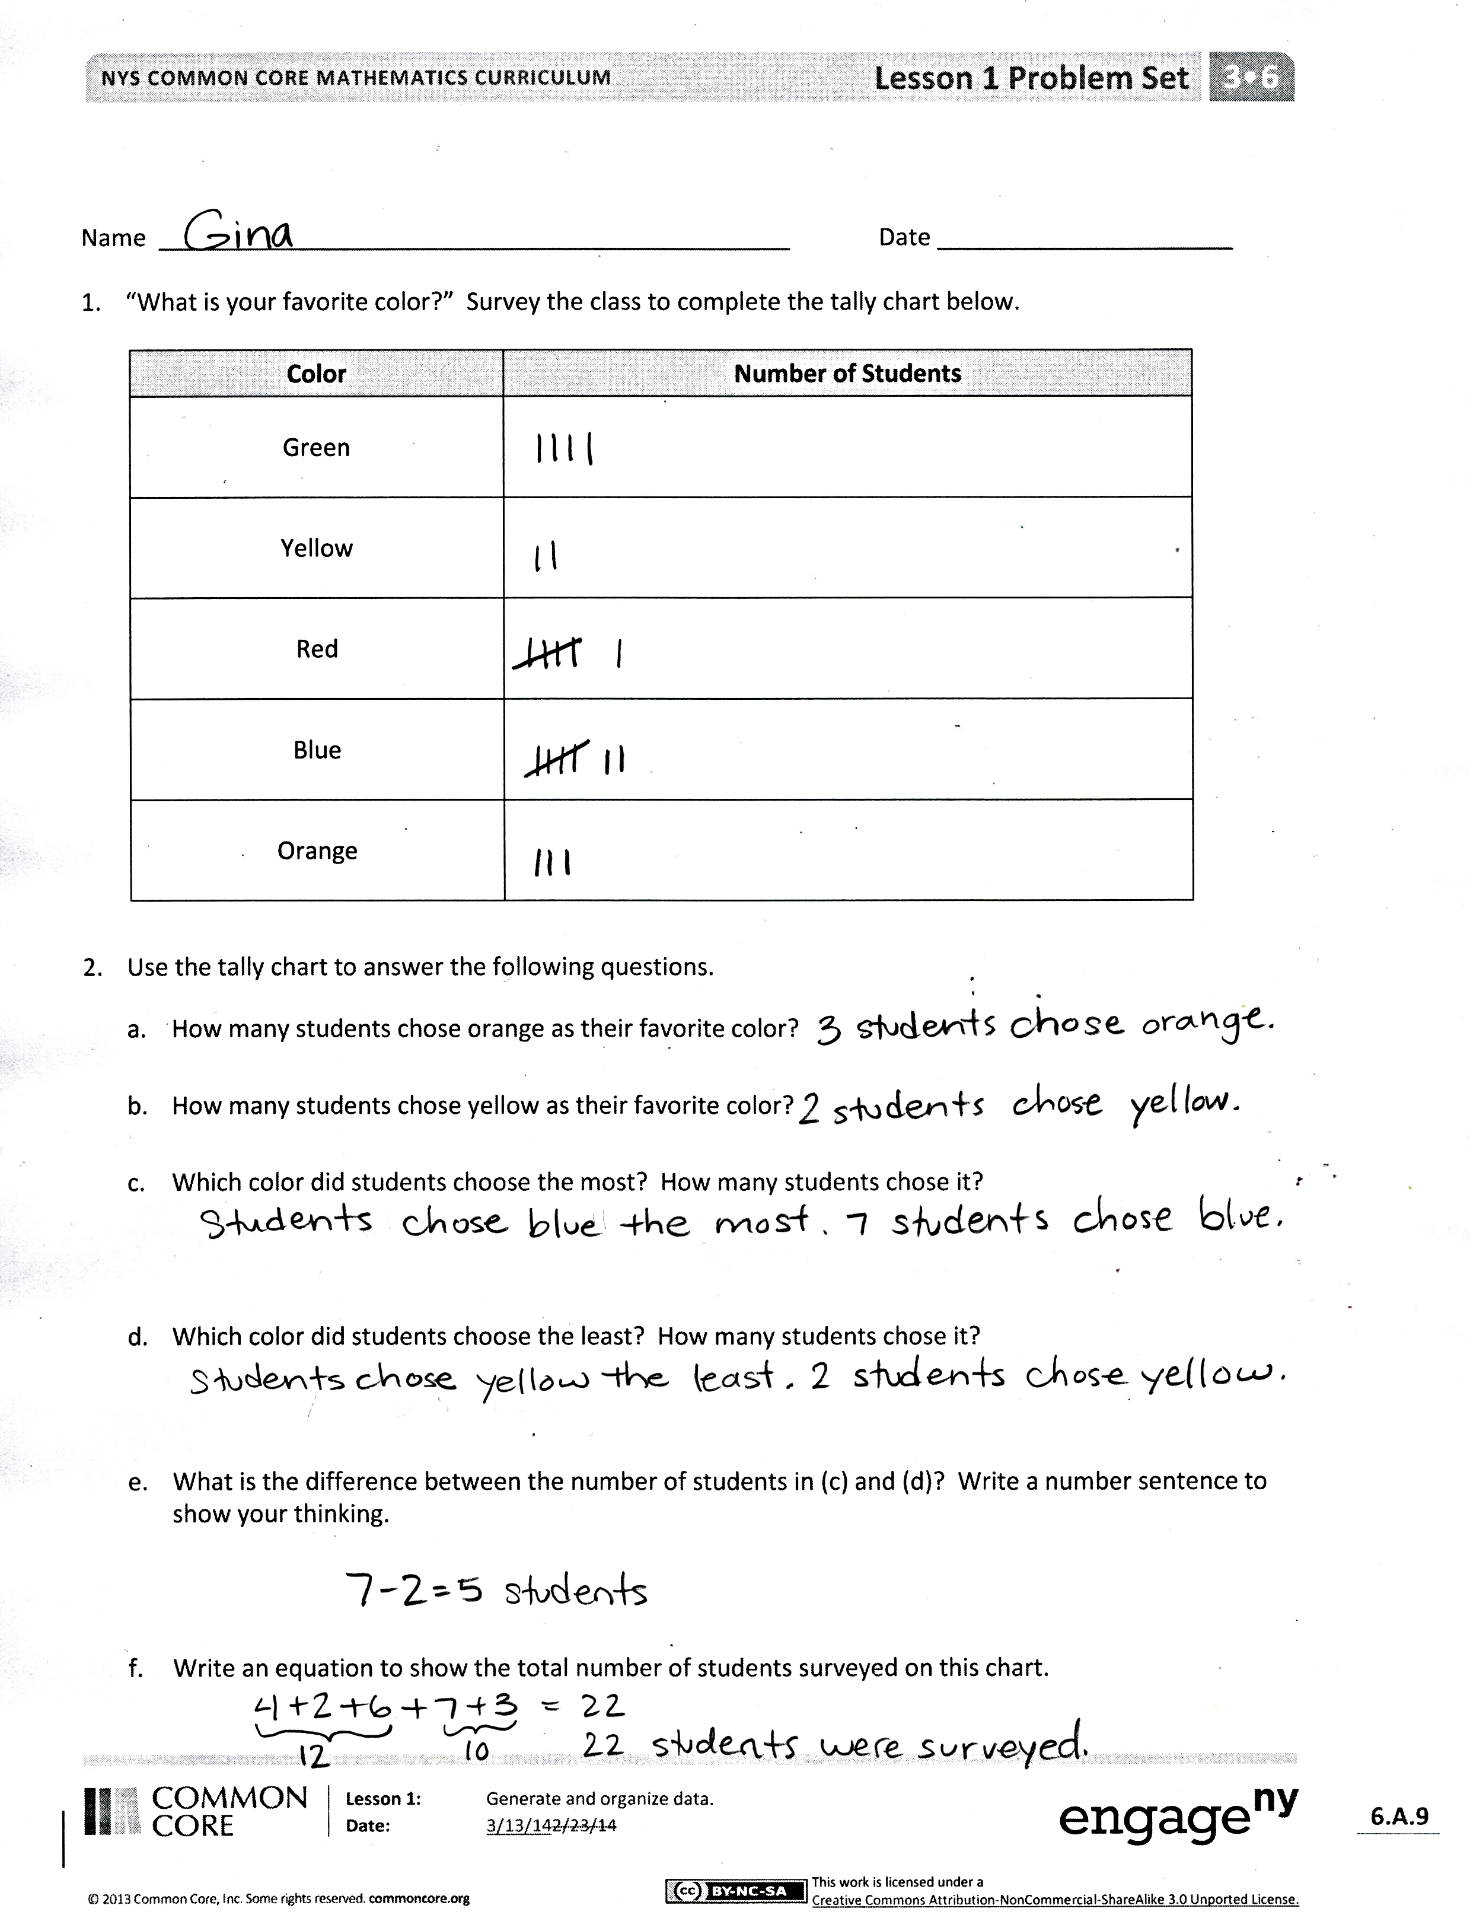Problem Set (10 minutes)

Students should do their personal best to complete Problems 2 and 4 within the allotted 10 minutes. Some problems do not specify a method for solving. This is an intentional reduction of scaffolding that invokes MP.5, Use Appropriate Tools Strategically. Students should solve these problems using the RDW approach used for Application Problems.

For some classes, it may be appropriate to modify the assignment by specifying which problems students should work on first. With this option, let the careful sequencing of the Problem Set guide the selections so that problems continue to be scaffolded. Balance word problems with other problem types to ensure a range of practice. Assign incomplete problems for homework or at another time during the day.

Student Debrief (10 minutes)

**Lesson Objective:** Generate and organize data.

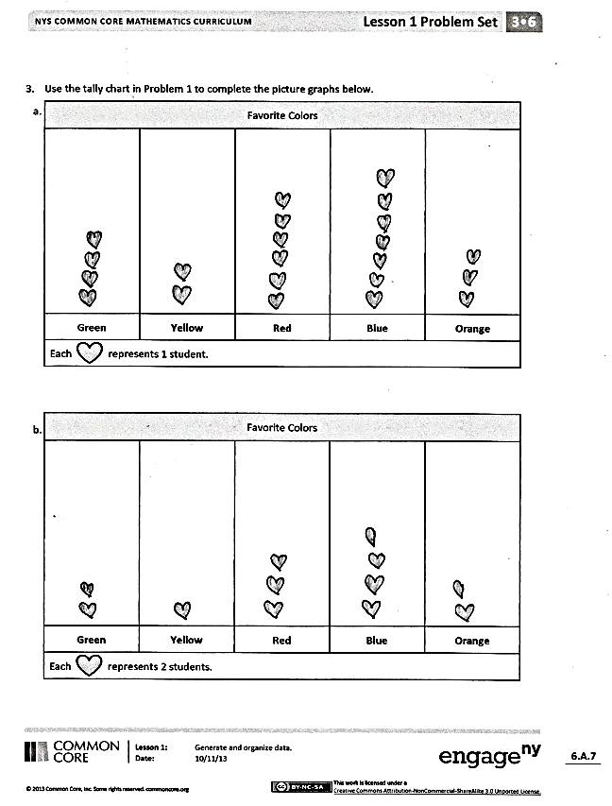The Student Debrief is intended to invite reflection and active processing of the total lesson experience.

Invite students to review their solutions for the Problem Set. They should check work by comparing answers with a partner before going over answers as a class. Look for misconceptions or misunderstandings that can be addressed in the Debrief. Guide students in a conversation to debrief the Problem Set and process the lesson.

Any combination of the questions below may be used to lead the discussion.

* Compare the data in the picture graphs in Problems 3(a) and 3(b).
* Share answers to Problems 4(c) and 4(d). What would 4(d) look like as a multiplication sentence?
* Compare picture graphs with tally charts. What makes each one useful? What are the limitations of each?
* Why is it important to use the **key** to understand the value of a unit in a picture graph?
* 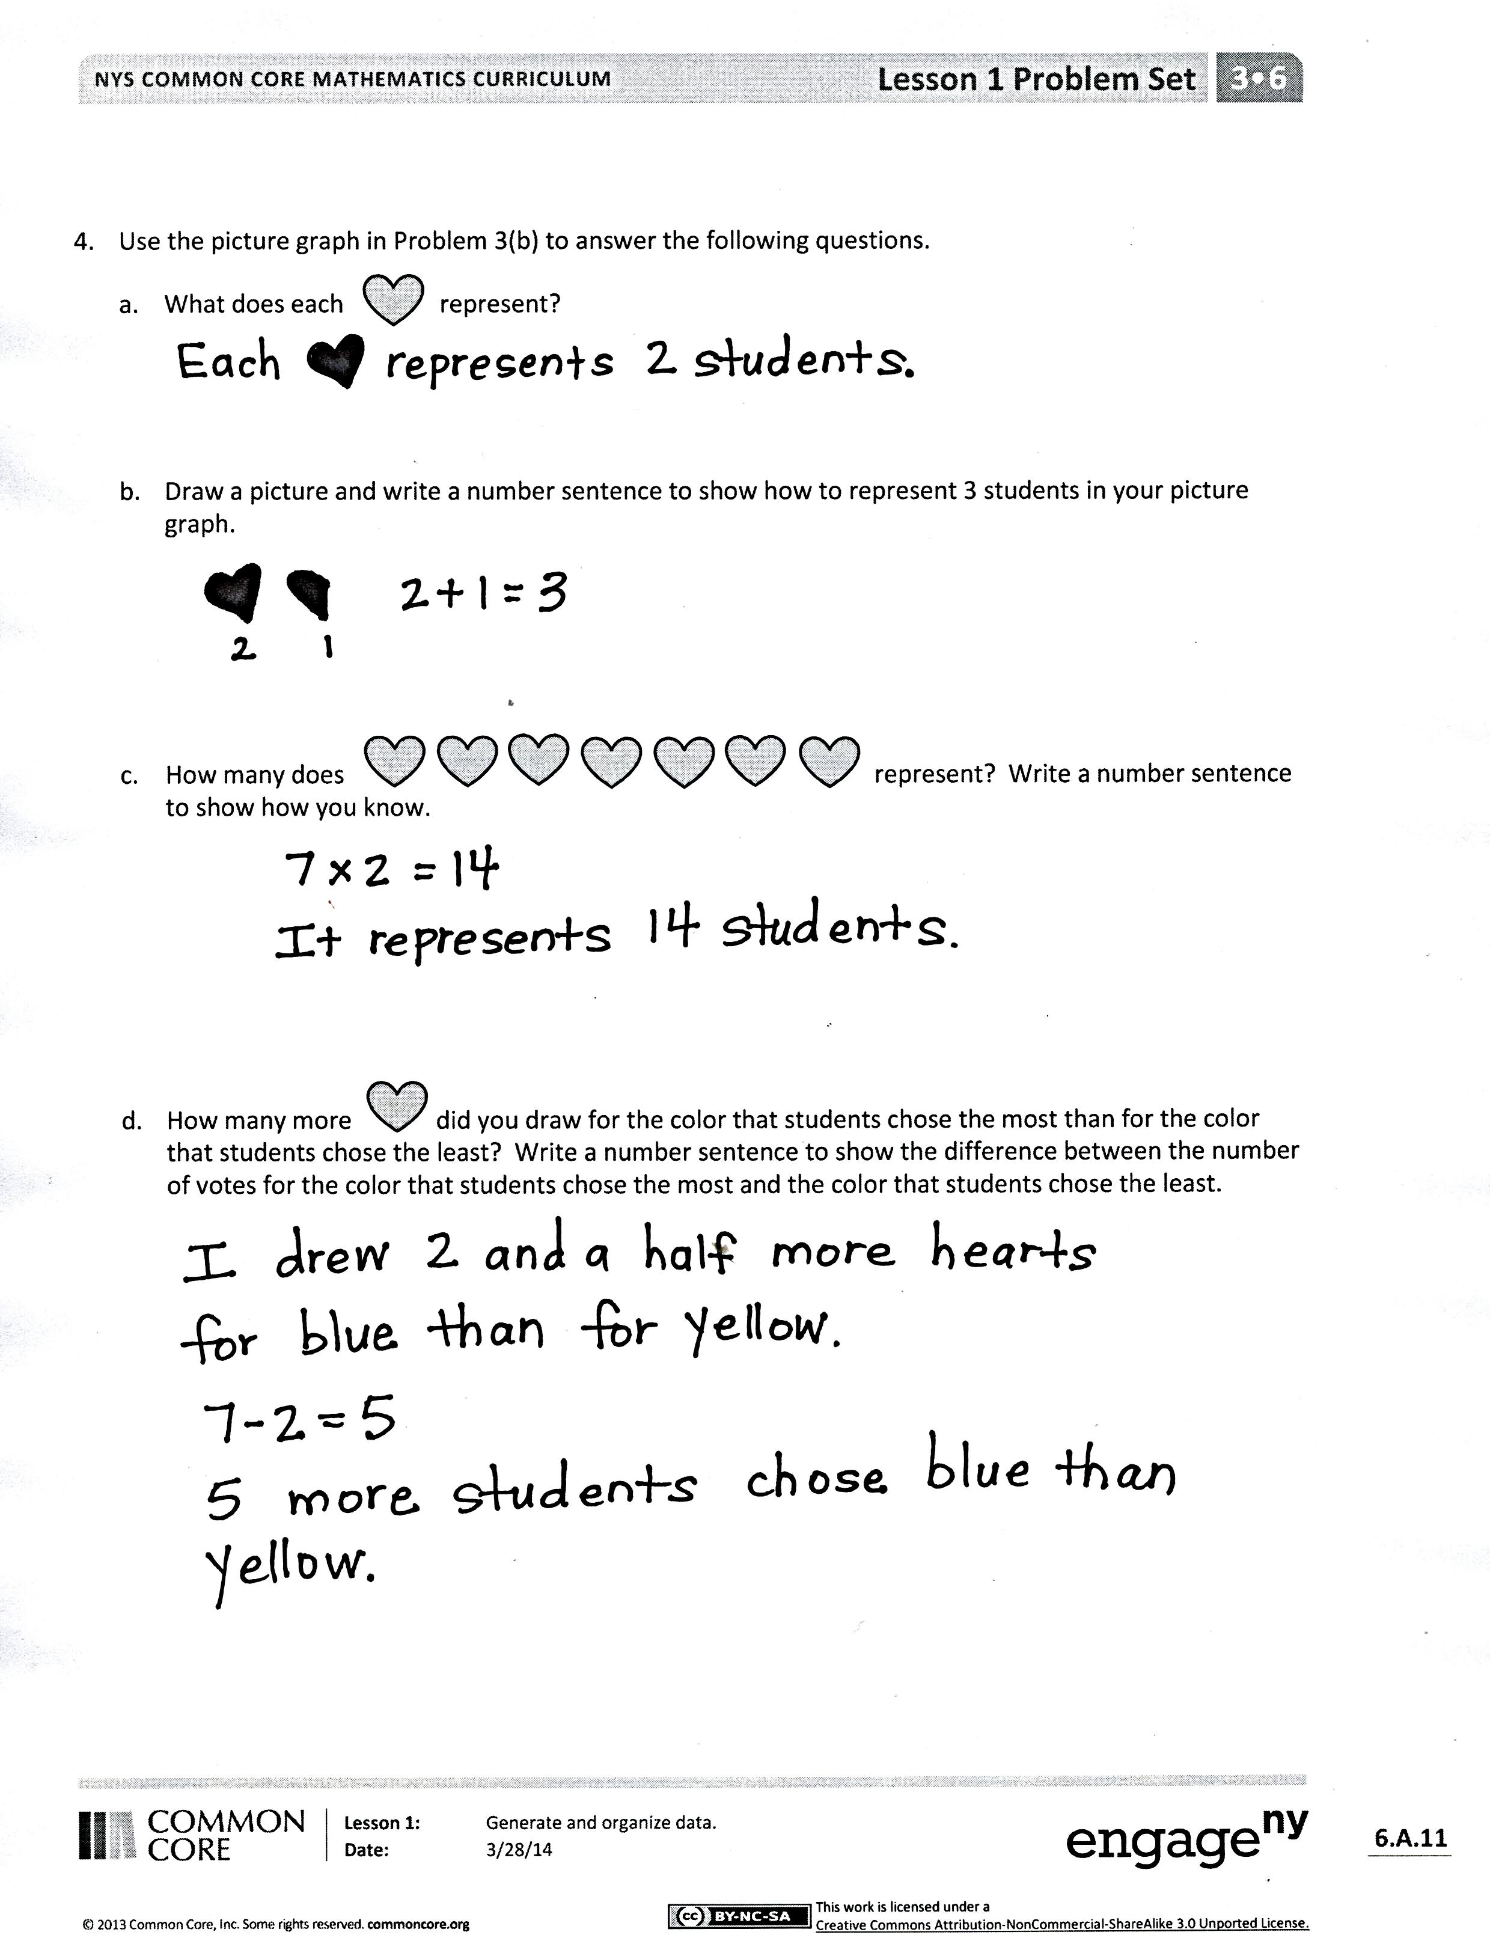What math vocabulary did we use today to talk about recording and gathering information? (*data*, *survey*)

Exit Ticket (3 minutes)

After the Student Debrief, instruct students to complete the Exit Ticket. A review of their work will help with assessing students’ understanding of the concepts that were presented in today’s lesson and planning more effectively for future lessons. The questions may be read aloud to the students.

Name Date

1. “What is your favorite color?” Survey the class to complete the tally chart below.

|  |  |
| --- | --- |
| **Color** | **Number of Students** |
| **Green** |  |
| **Yellow** |  |
| **Red** |  |
| **Blue** |  |
| **Orange** |  |

1. Use the tally chart to answer the following questions.
2. How many students chose orange as their favorite color?
3. How many students chose yellow as their favorite color?
4. Which color did students choose the most? How many students chose it?
5. Which color did students choose the least? How many students chose it?
6. What is the difference between the number of students in (c) and (d)? Write a number sentence to show your thinking.
7. Write an equation to show the total number of students surveyed on this chart.
8. Use the tally chart in Problem 1 to complete the picture graphs below.

|  |  |  |  |  |
| --- | --- | --- | --- | --- |
| **Favorite Colors** | | | | |
|  |  |  |  |  |
| **Green** | **Yellow** | **Red** | **Blue** | **Orange** |
| Each represents 1 student. | | | | |

|  |  |  |  |  |
| --- | --- | --- | --- | --- |
| **Favorite Colors** | | | | |
|  |  |  |  |  |
| **Green** | **Yellow** | **Red** | **Blue** | **Orange** |
| Each represents 2 students. | | | | |

1. Use the picture graph in Problem 3(b) to answer the following questions.
2. What does each represent?
3. Draw a picture and write a number sentence to show how to represent 3 students in your picture graph.
4. How many does represent? Write a number sentence to show how you know.
5. How many more did you draw for the color that students chose the most than for the color that students chose the least? Write a number sentence to show the difference between the number of votes for the color that students chose the most and the color that students chose the least.

Name Date

The picture graph below shows data from a survey of students' favorite sports.

|  |  |  |  |
| --- | --- | --- | --- |
| **Favorite Sports** | | | |
|  |  |  |  |
| **Football** | **Soccer** | **Tennis** | **Hockey** |
| Each represents 3 students. | | | |

1. The same number of students picked __________ and __________ as their favorite sport.
2. How many students picked tennis as their favorite sport?
3. How many more students picked soccer than tennis? Use a number sentence to show your thinking.
4. How many total students were surveyed?

Name Date

1. The tally chart below shows a survey of students’ favorite pets. Each tally mark represents 1 student.

|  |  |
| --- | --- |
| **Favorite Pets** | **Number of Students** |
| **Cats** | ~~////~~  / |
| **Turtles** | //// |
| **Fish** | // |
| **Dogs** | ~~////~~ /// |
| **Lizards** | // |

The chart shows a total of ________________ students.

1. Use the tally chart in Problem 1 to complete the picture graph below. The first one has been done for you.

|  |  |  |  |  |
| --- | --- | --- | --- | --- |
| **Favorite Pets** | | | | |
|  |  |  |  |  |
| **Cats** | **Turtles** | **Fish** | **Dogs** | **Lizards** |
| Each represents 1 student. | | | | |

1. The same number of students picked __________ and __________ as their favorite pet.
2. How many students picked dogs as their favorite pet?
3. How many more students chose cats than turtles as their favorite pet?
4. Use the tally chart in Problem 1 to complete the picture graph below.

|  |  |  |  |  |
| --- | --- | --- | --- | --- |
| **Favorite Pets** | | | | |
|  |  |  |  |  |
| **Cats** | **Turtles** | **Fish** | **Dogs** | **Lizards** |
| Each represents 2 students. | | | | |

a. What does each represent?

1. How many does represent? Write a number sentence to show how you know.
2. How many more did you draw for dogs than for fish? Write a number sentence to show how many more students chose dogs than fish.