Lesson 29
Objective: Compare fractions with the same numerator using <, >, or =, and use a model to reason about their size.

Suggested Lesson Structure
 Fluency Practice (12 minutes)
 Application Problem (8 minutes)
 Concept Development (30 minutes)
 Student Debrief (10 minutes)
Total Time (60 minutes)
Fluency Practice (12 minutes)
- Multiply by 8 3.OA.4 (8 minutes)
- Compare Fractions with the Same Numerator 3.NF.3d (4 minutes)
Multiply by 8 (8 minutes)
Materials: (S) Multiply by 8 (1─5) Pattern Sheet
Note: This Pattern Sheet supports fluency with multiplication using units of 8.
T: Skip-count by eights. (Write multiples horizontally as students count.)
S: 8, 16, 24, 32, 40, 48, 56, 64, 72, 80.
T: (Write 5 × 8 = ____.) Let’s skip-count by eights to find the answer. (Count with fingers to 5 as students count.)
S: 8, 16, 24, 32, 40.
T: (Circle 40 and write 5 × 8 = 40 above it. Write 8 × 3 = ____.) Let’s skip-count up by eights again. (Count with fingers to 3 as students count.)
S: 8, 16, 24.
T: Let’s see how we can skip-count down to find the answer, too. Start at 40. (Count down with your fingers as students say numbers.)
S: 40, 32, 24.
T: (Write 7 × 8 = ____.) Let’s skip-count up by eights. (Count with fingers to 7 as students count.)
S: 8, 16, 24, 32, 40, 48, 56.
T: (Write 9×8 = ____.) Let’s skip-count up by eights. (Count with fingers to 9 as students count.)
S: 8, 16, 24, 32, 40, 48, 56, 64, 72.
T: Let’s see how we can skip-count down to find the answer, too. Start at 80. (Count down with your fingers as students say the numbers.)
S: 80, 72.
T: Let’s practice multiplying by 8. Be sure to work left to right across the page. (Distribute Multiply by 8 Pattern Sheet.)
Compare Fractions with the Same Numerator (4 minutes)
Materials: (S) Personal white board
Note: This fluency activity reviews the concept of pictorially comparing fractions with the same numerators from Lesson 28.
T: (Project or draw a rectangle partitioned into 3 equal units with the first 2 units shaded.) Say the fraction that is shaded.
S: 2 thirds.
T: (Write $\frac{2}{3}$ to the left of the rectangle. Project or draw a rectangle of 6 equal, unshaded units directly below the first rectangle. Next to the second rectangle, write $\frac{2}{6}$.) How many units should I shade to show 2 sixths?
S: 2.
T: (Shade the first 2 units in the second rectangle.) On your personal white board, write the larger fraction.
S: (Write $\frac{2}{3}$.)
Continue with the following possible sequence: 3 tenths and 3 fourths, 5 sixths and 5 eighths, and 7 eighths and 7 tenths.
Application Problem (8 minutes)

NOTES ON
MULTIPLE MEANS
OF ENGAGEMENT:
Challenge students working above grade level to model the comparison on a number line (or two). Have students evaluate and compare the models. Ask (for example), “How might you decide when to use a rectangular model rather than a number line to solve?”

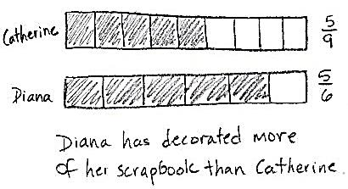
Catherine and Diana buy matching scrapbooks. Catherine decorates $\frac{5}{9}$ of the pages in her book. Diana decorates $\frac{5}{6}$ of the pages in her book. Who has decorated more pages of her scrapbook? Draw a picture to support your answer.

Note: This problem reviews the concept of pictorially comparing fractions with the same numerators from Lesson 28.
Concept Development (30 minutes)
Materials: (S) Personal white board, Lesson 25 Template 1
Seat students in pairs facing each other in a large circle around the room. The template should be in their personal white boards.
Lesson 25 Template 1
T: Today, we’ll only use the first rectangle on our template. At my signal, draw and shade a fraction less than $\frac{1}{2}$, and label it below the rectangle. (Signal.)
S: (Draw and label.)
T: Check your partner’s work to make sure it’s less than $\frac{1}{2}$.
S: (Check.)
T: This is how we’re going to play a game today. For the next round, we’ll see which partner is quicker, but still accurate. As soon as you finish drawing, raise your personal white board. If you are quicker, then you are the winner of the round. If you are the winner of the round, you will stand up, and your partner will stay seated. If you are standing, you will then move to partner with the person on your right, who is still seated. Ready? Erase your boards. At my signal, draw and label a fraction that is greater than $\frac{1}{2}$. (Signal.)
S: (Draw and label.)
The student who goes around the entire circle and arrives back at their original place faster than the other students wins the game. The winner can also be the student who has moved the furthest if it takes too long to play all the way around. Move the game at a brisk pace. Use a variety of fractions and mix it up between greater than and less than so that students constantly need to update their drawings and feel challenged. If preferred, mix it up by calling out equal to.
T: (Draw or show the images at the right.) Draw my shapes on your board. Make sure they match in size like mine.
S: (Draw.)
T: Partition both shapes into sixths.
S: (Partition.)
T: Partition the second shape to show double the number of units in the same whole.
S: (Partition.)
T: What fractional units do we have?
S: Sixths and twelfths.
T: Shade in 4 units of each shape and label the shaded fraction below each shape.
S: (Shade and label.)
T: Whispering to your partner, say a sentence comparing the fractions using the words greater than, less than, or equal to.
S: $\frac{4}{6}$ is greater than $\frac{4}{12}$.
T: Now, write the comparison as a number sentence with the correct symbol between the fractions.
S: (Write $\frac{4}{6}$ > $\frac{4}{12}$.)
T: (Draw or show the images at the right.) Draw my rectangles on your board. Make sure they match in size like mine.
S: (Draw.)
T: Partition the first rectangle into sevenths and the second one into fifths.
S: (Partition.)
T: Shade in 3 units of each rectangle and label the shaded fraction below each rectangle.
S: (Shade and label.)
T: Whispering to your partner, say a sentence comparing the fractions using the words greater than, less than, or equal to.
S: $\frac{3}{7}$ is less than $\frac{3}{5}$.
T: Now, write the comparison as a number sentence with the correct symbol between the fractions.
S: (Write $\frac{3}{7}$ < $\frac{3}{5}$.)
Do other examples, if necessary, using a variety of shapes and units.
T: Draw 2 number lines on your board and label the endpoints 0 and 1.

S: (Draw and label.)
T: Partition the first number line into eighths and the second one into tenths.
S: (Partition.)
T: On the first number line, label $\frac{8}{8}$.
S: (Label.)
T: On the second number line, label 2 copies of $\frac{5}{10}$.
S: (Label.)
T: Whispering to your partner, say a sentence comparing the fractions using the words greater than, less than, or equal to.
S: Wait, they’re the same! $\frac{8}{8}$ is equal to $\frac{10}{10}$.
T: How do you know?
S: Because they have the same point on the number line. That means they’re equivalent.
T: Now, write the comparison as a number sentence with the correct symbol between the fractions.
S: (Write $\frac{8}{8}$ = $\frac{10}{10}$.)
Do other examples with the number line. In subsequent examples that use smaller units or units that are farther apart, move to using a single number line.
Problem Set (10 minutes)

NOTES ON
MULTIPLE MEANS
OF ACTION AND EXPRESSION:
English language learners and students working below grade level may benefit from math (and English) fluency practice using the Problem Set. For Problems 1 through 4, encourage learners to whisper the unit fraction, whisper count the shaded units (e.g., 1 sixth, 2 sixths), and whisper the shaded fraction as they write.

Students should do their personal best to complete the Problem Set within the allotted 10 minutes. For some classes, it may be appropriate to modify the assignment by specifying which problems they work on first. Some problems do not specify a method for solving. Students should solve these problems using the RDW approach used for Application Problems.
Student Debrief (10 minutes)
Lesson Objective: Compare fractions with the same numerator using <, >, or =, and use a model to reason about their size.
The Student Debrief is intended to invite reflection and active processing of the total lesson experience.
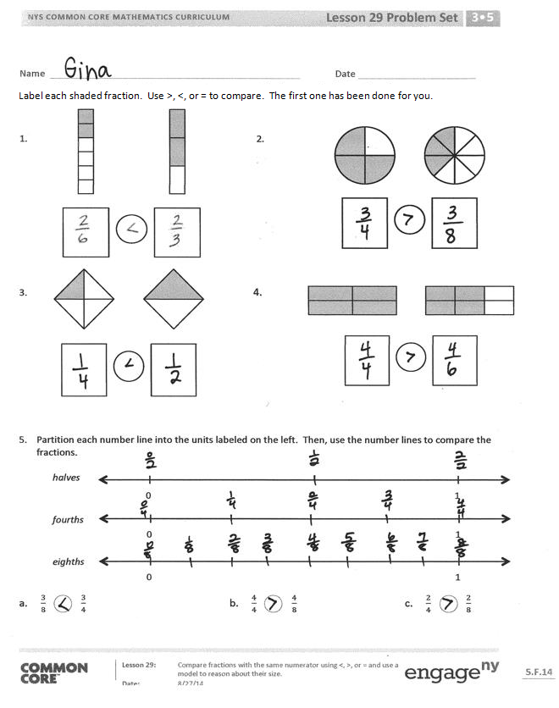
Invite students to review their solutions for the Problem Set. They should check work by comparing answers with a partner before going over answers as a class. Look for misconceptions or misunderstandings that can be addressed in the Debrief. Guide students in a conversation to debrief the Problem Set and process the lesson.
Any combination of the questions below may be used to lead the discussion.
- Look at the models in Problems 1─4. When comparing fractions, why is it so important that the wholes are the same size?
- Tell a partner how you used the models in Problems 1─4 to determine greater than, less than, or equal to.
- What if you didn’t have the models for these problems? How could you compare the fractions? (Write pairs of fractions with the same numerators on the board, and have students compare them without using a model.)
- To extend the lesson, draw fraction models greater than 1, and guide students to compare. For example, use $\frac{12}{9}$ and $\frac{12}{7}$.

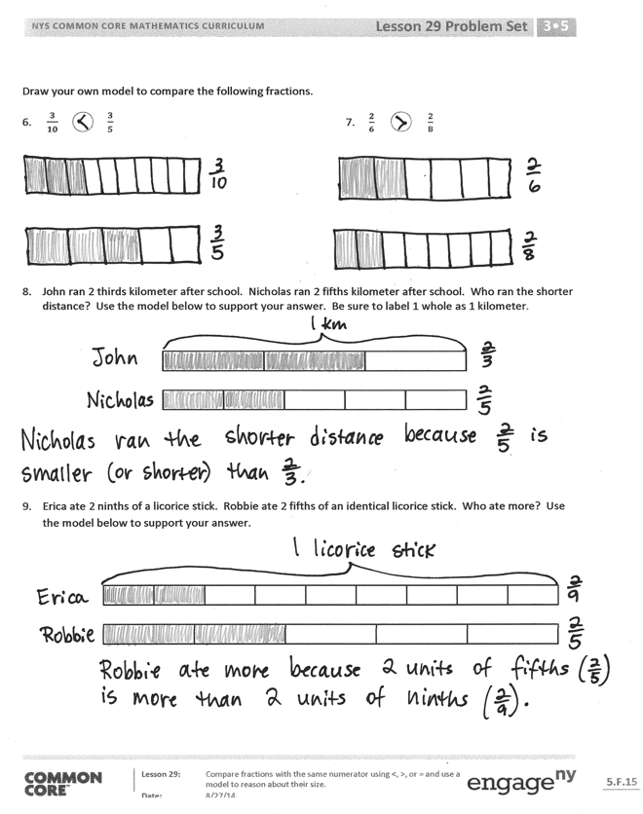
Exit Ticket (3 minutes)
After the Student Debrief, instruct students to complete the Exit Ticket. A review of their work will help with assessing students’ understanding of the concepts that were presented in today’s lesson and planning more effectively for future lessons. The questions may be read aloud to the students.

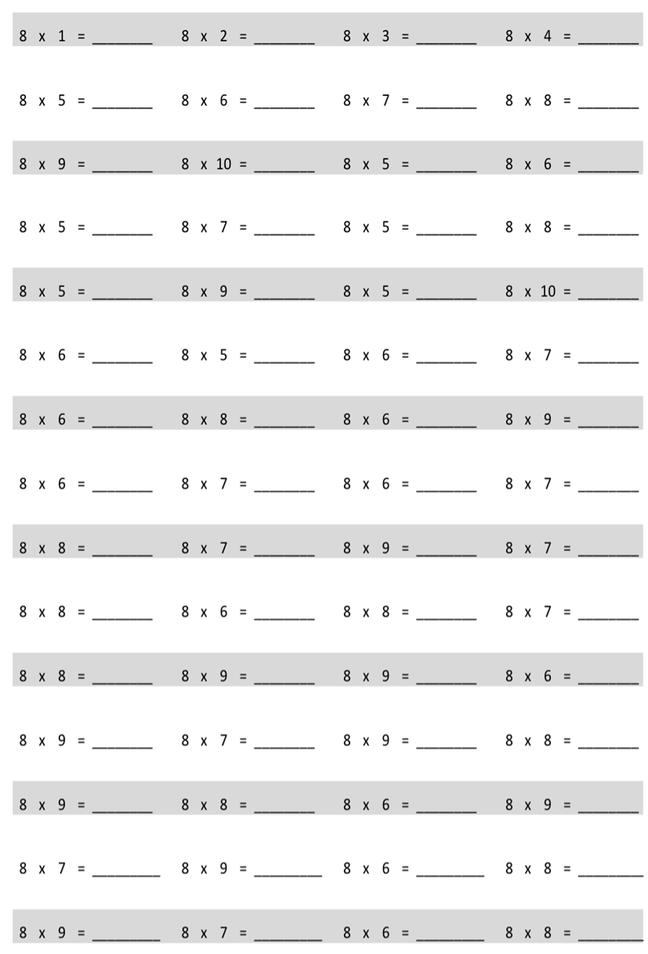
Multiply.

Name Date
Label each shaded fraction. Use >, <, or = to compare. The first one has been done for you.

- 2.

- 4.

- Partition each number line into the units labeled on the left. Then, use the number lines to compare the fractions.
0 1
0 1
0 1
halves
fourths
eighths

a. $\frac{3}{8} \frac{3}{4}$ b. $\frac{4}{4} \frac{4}{8}$ c. $\frac{2}{4} \frac{2}{8}$
Draw your own model to compare the following fractions.
6. $\frac{3}{10} \frac{3}{5}$ 7. $\frac{2}{6} \frac{2}{8}$

- John ran 2 thirds of a kilometer after school. Nicholas ran 2 fifths of a kilometer after school. Who ran the shorter distance? Use the model below to support your answer. Be sure to label 1 whole as 1 kilometer.

- Erica ate 2 ninths of a licorice stick. Robbie ate 2 fifths of an identical licorice stick. Who ate more?
Use the model below to support your answer.

Name Date
- Complete the number sentence by writing >, <, or =.
$\frac{3}{5}$_________ $\frac{3}{9}$
- Draw 2 number lines with endpoints 0 and 1 to show each fraction in Problem 1. Use the number lines to explain how you know your comparison in Problem 1 is correct.

Name Date
Label each shaded fraction. Use >, <, or = to compare.

1. 2.

3. 4.

5. Partition each number line into the units labeled on the left. Then, use the number lines to compare the fractions.
0 1
0 1
0 1
thirds
sixths
ninths

a. $\frac{2}{6} \frac{2}{3}$ b. $\frac{5}{9} \frac{5}{6}$ c. $\frac{3}{3} \frac{3}{9}$
Draw your own models to compare the following fractions.
6. $\frac{7}{10} \frac{7}{8}$ 7. $\frac{4}{6} \frac{4}{9}$

- For an art project, Michello used $\frac{3}{4}$ of a glue stick. Yamin used $\frac{3}{6}$ of an identical glue stick. Who used more of their glue stick? Use the model below to support your answer. Be sure to label 1 whole as 1 glue stick.

- After gym class, Jahsir drank 2 eighths of a bottle of water. Jade drank 2 fifths of an identical bottle of water. Who drank less water? Use the model below to support your answer.

multiply by 8 (1–5)

