Lesson 28
Objective: Compare fractions with the same numerator pictorially.

Suggested Lesson Structure
 Fluency Practice (12 minutes)
 Application Problem (8 minutes)
 Concept Development (30 minutes)
 Student Debrief (10 minutes)
Total Time (60 minutes)
Fluency Practice (12 minutes)
- Sprint: Subtract by 8 2.NBT.5 (8 minutes)
- Recognize Equal Fractions 3.NF.3b (4 minutes)
Sprint: Subtract by 8 (8 minutes)
Materials: (S) Subtract by 8 Sprint
Note: This Sprint supports fluency with subtraction by 8.
Recognize Equal Fractions (4 minutes)
Materials: (S) Personal white board
Note: This activity reviews the concepts of representing and naming equivalent fractions.
T: (Project or draw a rectangle partitioned into 2 equal units with the first unit shaded.) Say the fraction that’s shaded.
S: 1 half.
T: (Write $\frac{1}{2}$ to the side of the rectangle. Project or draw a rectangle partitioned into 4 equal, unshaded units directly below the first rectangle.) Say the fractional unit of this shape.
S: Fourths.
T: I’m going to start shading in fourths. Tell me to stop when I’ve shaded enough fourths to equal 1 half. (Shade 2 fourths.)
S: Stop!
T: (Write $\frac{1}{2}= \frac{}{4}$ to the side of the rectangle.) 1 half is the same as how many fourths?
S: 2 fourths.
T: (Write $\frac{1}{2}= \frac{2}{4}$.)
Continue with the following possible sequence: $\frac{1}{3}= \frac{}{9}$ and $\frac{6}{8}= \frac{}{4}$.
Application Problem (8 minutes)
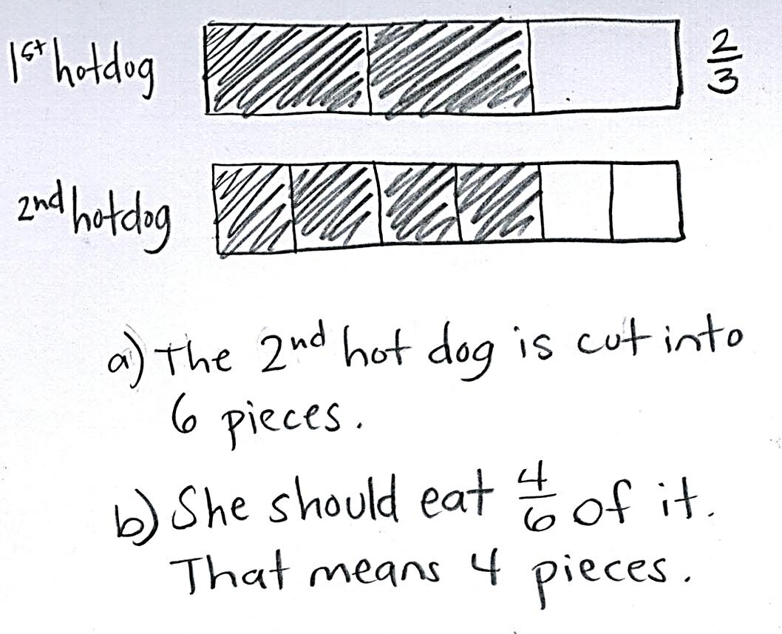
LaTonya has 2 equal-sized hotdogs. She cut the first one into thirds at lunch. Later, she cut the second hotdog to make double the number of pieces. Draw a model of LaTonya’s hotdogs.
- How many pieces is the second hotdog cut into?
- If she wants to eat $\frac{2}{3}$ of the second hotdog, how many pieces should she eat?
Note: This problem reviews the concept of equivalent fractions from Topic E. Encourage students to find other equivalent fractions based on their models. This problem is used in the Concept Development to provide a context in which students can compare fractions with the same numerators.
Concept Development (30 minutes)
Materials: (S) Work from Application Problem, personal white board
T: Look again at your models of LaTonya’s hotdogs. Let’s change the problem slightly. What if LaTonya eats 2 pieces of each hotdog? Figure out what fraction of each hotdog she eats.
S: (Work.) She eats $\frac{2}{3}$ of the first one and $\frac{2}{6}$ of the second one.
T: Did LaTonya eat the same amount of the first hotdog and second hotdog?
S: (Use models for help.) No.
T: But she ate 2 pieces of each hotdog. Why is the amount she ate different?
S: The number of pieces she ate is the same, but the size of each piece is different. Just like we saw yesterday, the more you cut up a whole, the smaller the pieces get. So, eating 2 pieces of thirds is more hotdog than 2 pieces of sixths.
T: (Project or draw the circles at the right.) Draw my pizzas on your personal white board.
MP.2
S: (Draw shapes.)
T: Estimate to partition both pizzas into fourths.
S: (Partition.)
T: Partition the second pizza to double the number of units.

NOTES ON
MULTIPLE MEANS
OF ENGAGEMENT:
Give students working below grade level the option of rectangular pizzas (rather than circles) to ease the task of partitioning.

S: (Partition.)
T: What units do we have?
S: Fourths and eighths.
T: Shade in 3 fourths and 3 eighths.
MP.2
S: (Shade.)
T: Which shaded portion would you rather eat? The fourths or eighths? Why?
S: I’d rather eat the fourths because it’s way more pizza. I’d rather eat the eighths because I’m not that hungry, and it’s less.
T: But both choices are 3 pieces. Aren’t they equivalent?

NOTES ON
MULTIPLE MEANS
OF ACTION AND EXPRESSION:
As students play a comparison game, facilitate peer-to-peer talk for English language learners with sentence frames, such as the following:
- “I partitioned into ____ (fractional unit). I shaded ___ (number of) ____ (fractional unit).”
- “I drew ___ (fractional unit), too. I shaded ___ (number of) ____ (fractional unit). ____ is less than ____.”

S: No. You can see fourths are larger. We know because the more times you cut the whole, the smaller the pieces get. So, eighths are tiny compared to fourths! The number of pieces we shaded is the same, but the sizes of the pieces are different, so the shaded amounts are not equivalent.
If necessary, continue with other examples varying the pictorial models.
T: Let’s work in pairs to play a comparison game.
Partner A, draw a whole and shade a fraction of the whole. Label the shaded part.
S: (Partner A draws and labels.)
T: Partner B, draw a fraction that is less than Partner A’s fraction. Use the same whole and same number of shaded parts, but choose a different fractional unit. Label the shaded parts.
S: (Partner B draws and labels.)

NOTES ON
MULTIPLE MEANS
OF ENGAGEMENT:
Extend Page 1 of the Problem Set for students working above grade level so they can use their knowledge of equivalencies. Say, “If 2 thirds is greater than 2 fifths, use equivalent fractions to name the same comparison. For example, 4 sixths is greater than 2 fifths.”

T: Partner A, check your friend’s work to be sure the fraction is less than yours.
S: (Partner A checks and helps make any corrections necessary.)
T: Partner B, draw a whole and shade a fraction. I will say less than or greater than for Partner A to draw another fraction.
Play several rounds.

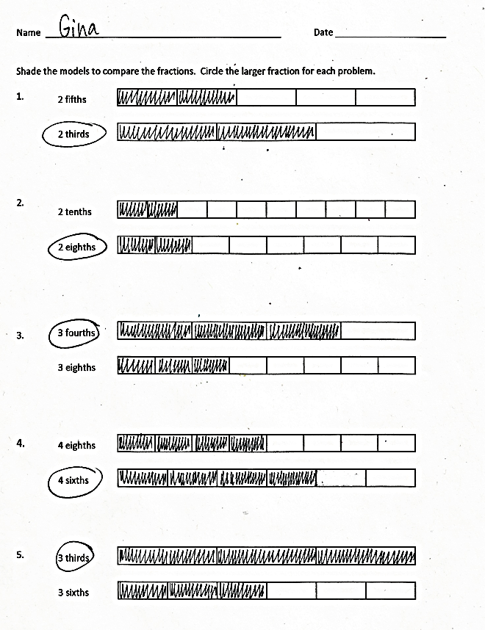
Problem Set (10 minutes)

Students should do their personal best to complete the Problem Set within the allotted 10 minutes. For some classes, it may be appropriate to modify the assignment by specifying which problems they work on first. Some problems do not specify a method for solving. Students should solve these problems using the RDW approach used for Application Problems.
Student Debrief (10 minutes)
Lesson Objective: Compare fractions with the same numerator pictorially.
The Student Debrief is intended to invite reflection and active processing of the total lesson experience.
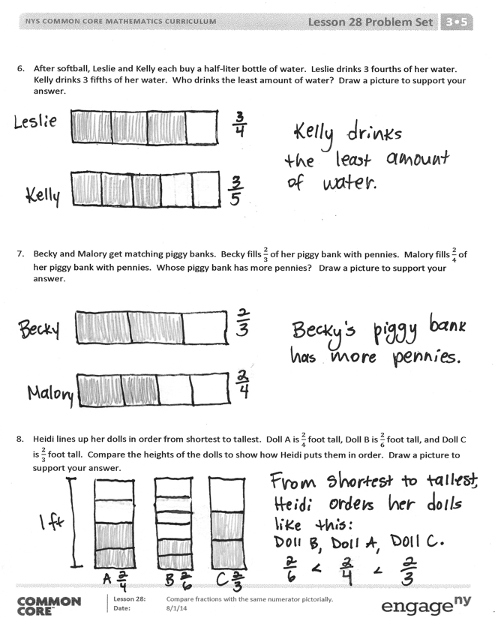
Invite students to review their solutions for the Problem Set. They should check work by comparing answers with a partner before going over answers as a class. Look for misconceptions or misunderstandings that can be addressed in the Debrief. Guide students in a conversation to debrief the Problem Set and process the lesson.
Any combination of the questions below may be used to lead the discussion.
- Look at your answers for Problems 7 and 8. Is 2 parts always equal to 2 parts? Why or why not?
- If you only know the number of shaded parts, can you tell if fractions are equivalent? Why or why not?
Exit Ticket (3 minutes)
After the Student Debrief, instruct students to complete the Exit Ticket. A review of their work will help with assessing students’ understanding of the concepts that were presented in today’s lesson and planning more effectively for future lessons. The questions may be read aloud to the students.

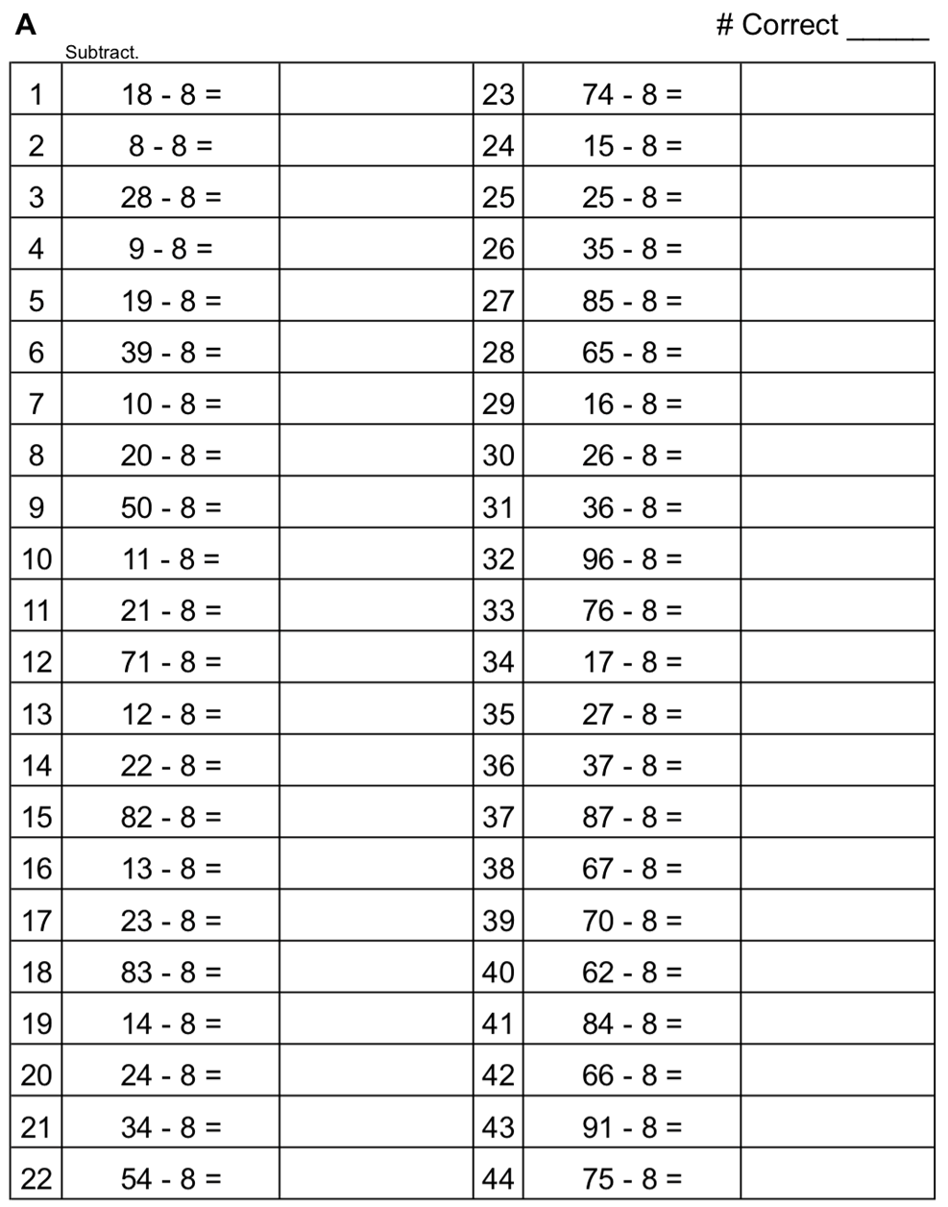
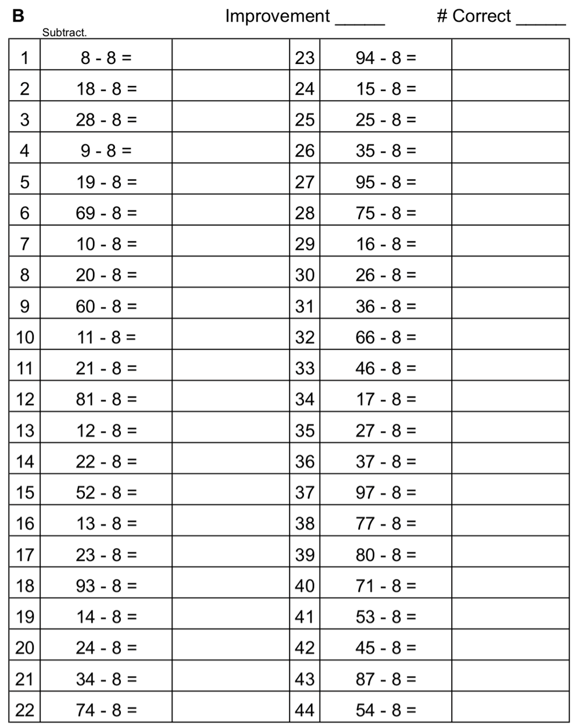

Name Date
Shade the models to compare the fractions. Circle the larger fraction for each problem.
2 fifths
2 thirds

3 fourths
3 eighths
4 eighths
4 sixths
3 sixths
3 thirds
2 tenths
2 eighths

- After softball, Leslie and Kelly each buy a half-liter bottle of water. Leslie drinks 3 fourths of her water. Kelly drinks 3 fifths of her water. Who drinks the least amount of water? Draw a picture to support your answer.

- Becky and Malory get matching piggy banks. Becky fills $\frac{2}{3}$ of her piggy bank with pennies. Malory fills $\frac{2}{4}$ of her piggy bank with pennies. Whose piggy bank has more pennies? Draw a picture to support your answer.

- Heidi lines up her dolls in order from shortest to tallest. Doll A is $\frac{2}{4}$ foot tall, Doll B is $\frac{2}{6}$ foot tall, and Doll C is $\frac{2}{3}$ foot tall. Compare the heights of the dolls to show how Heidi puts them in order. Draw a picture to support your answer.

Name Date
- Shade the models to compare the fractions.

2 thirds
2 eighths

Which is larger, 2 thirds or 2 eighths? Why? Use words to explain.

- Draw a model for each fraction. Circle the smaller fraction.

3 sevenths

3 fourths

Name Date
Shade the models to compare the fractions. Circle the larger fraction for each problem.
1 fifth
4 fourths
4 sixths
1 half
2 sevenths
2 fourths
4 ninths
4 fifths

5 tenths
5 sevenths

- Saleem and Edwin use inch rulers to measure the lengths of their caterpillars. Saleem’s caterpillar measures 3 fourths of an inch. Edwin’s caterpillar measures 3 eighths of an inch. Whose caterpillar is longer? Draw a picture to support your answer.

- Lily and Jasmine each bake the same-sized chocolate cake. Lily puts $\frac{5}{10}$ of a cup of sugar into her cake. Jasmine puts $\frac{5}{6}$of a cup of sugar into her cake. Who uses less sugar? Draw a picture to support your answer.

