Lesson 25
Objective: Express whole number fractions on the number line when the unit interval is 1.

Suggested Lesson Structure
 Fluency Practice (12 minutes)
 Application Problem (8 minutes)
 Concept Development (30 minutes)
 Student Debrief (10 minutes)
Total Time (60 minutes)
Fluency Practice (12 minutes)
- Sprint: Subtract by 6 2.NBT.5 (8 minutes)
- Express Whole Numbers as Different Fractions 3.NF.3c (4 minutes)
Sprint: Subtract by 6 (8 minutes)
Materials: (S) Subtract by 6 Sprint
Note: This Sprint supports fluency with subtraction by 6.
Express Whole Numbers as Different Fractions (4 minutes)
Materials: (S) Personal white board
Note: This activity reviews the concept of naming whole numbers as fractions from Lesson 24.
T: (Draw or project a number line from 0–4. Below the 0, write 0 = $\frac{}{5}$.) 0 is how many fifths?
S: 0 fifths.
T: (Write $\frac{0}{5}$below the 0 on the number line. Below the 1, write 1 = $\frac{}{5}$.) 1 is how many fifths?
S: 5 fifths.
T: (Write $\frac{5}{5}$ below the 1 on the number line. Below the 2, write 2 = $\frac{}{5}$.) On your personal white board, copy and fill in the number sentence.
S: (Write 2 = $\frac{10}{5}$.)
T: (Write $\frac{10}{5}$ below the 2 on the number line. Write 3 = $\frac{}{5}$.) On your board, copy and fill in the number sentence.
S: (Write 3 = $\frac{15}{5}$.)
T: (Write $\frac{15}{5}$ below the 3 on the number line. Write 4 = $\frac{}{5}$.) On your board, copy and fill in the number sentence.
S: (Write 4 = $\frac{20}{5}$.)
T: (Write $\frac{20}{5}$ below the 4 on the number line.)
Continue the process for fourths.
Application Problem (8 minutes)

NOTES ON
MULTIPLE MEANS
OF ENGAGEMENT:
Scaffold the Application Problem for students working below grade level with step-by-step questioning. Ask (for example) the following:
- What is the unit fraction?
- Name the unit that we are partitioning.
- Count by eighths to reach 1 whole, labeling the number line as you count.
- How many eighths are in 1 gallon?
- How many days will it take to drink 1 gallon?
- Count by eighths to reach 2 wholes, labeling the number line as you count.
- How many eighths are in 2 gallons?
- How many days will it take to drink 2 gallons?

Lincoln drinks 1 eighth gallon of milk every morning.
- How many days will it take Lincoln to drink 1 gallon of milk? Use a number line and words to explain your answer.
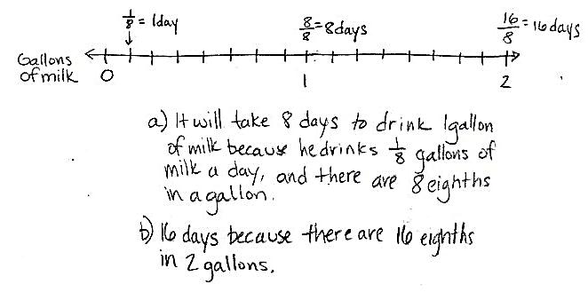
- How many days will it take Lincoln to drink 2 gallons? Extend your number line to show 2 gallons and use words to explain your answer.

Note: This activity reviews the concept of naming whole numbers as fractions from Lesson 24. Invite students to discuss how their number line shows the gallons of milk and the number of days.
Concept Development (30 minutes)
Materials: (S) 3 wholes (Template 1), 6 wholes (Template 2), personal white board
Note on materials: Template 1 is used again in Lessons 27 and 29.
Begin with templates in personal white boards. Template 1 should be face up.
3 Wholes Template
T: Each rectangle represents 1 whole. Partition the first rectangle into thirds. Write the whole as a fraction below it.
S: (Partition and label with $\frac{3}{3}$.)
T: $\frac{3}{3}$ is equivalent to how many wholes?
S: 1 whole!
T: Add that to your picture.
S: (Write $\frac{3}{3}=$ 1 whole.)
T: Now, partition the second rectangle into halves. Label the whole as a fraction below it.

NOTES ON
MULTIPLE MEANS
OF REPRESENTATION:
For English language learners, increase wait time, speak clearly, use gestures, and make eye-contact. When giving instructions for partitioning the 3 models, pause more frequently and check for understanding.

S: (Partition and label with $\frac{2}{2}$.)
T: $\frac{2}{2}$ is equivalent to how many wholes?
S: 1 whole!
T: Add that to your picture.
S: (Write $\frac{2}{2}=$ 1 whole.)
T: Now, partition the third rectangle into wholes.
S: What do you mean? It is already a whole. That means 0 partitions!
T: Talk with your partner about how we label this whole as a fraction.

NOTES ON
MULTIPLE MEANS
OF ENGAGEMENT:
Students working above grade level might enjoy this discussion toward discovery. Guide students to respectfully respond to peers with sentence starters, such as, “That’s an idea. I have a different way of seeing it. I think… because…” or “I see what you’re saying, however.”

S: 1. That’s not a fraction! It’s $\frac{0}{1}$ because there are no parts. No, it’s $\frac{1}{0}$ because we didn’t partition.
There’s a pattern of the same number for the number of equal parts we’re looking at and the total number of equal parts in whole number fractions. So, maybe this is$\frac{1}{1}$?
T: I hear some students noticing the pattern that whole number fractions have the same values for the number of equal parts we’re counting and the total number of equal parts; therefore, an equivalent way of writing 1
whole as a fraction is to write it as $\frac{1}{1}$. We started with 1 whole. We didn’t split it into more parts, so the whole is still in 1 piece, and we’re counting that 1 piece. Let’s look at the equivalent fractions we’ve written for 1 on the number line. At the bottom of your template, mark each of the 3 number lines with endpoints 0 and 1 above the line.
S: (Mark endpoints.)
T: Represent each rectangle on a different number line. Partition, label, and rename the wholes below the line.
S: (Partition and label number lines.)
T: What do you notice about the relationship between the partitioning on the rectangles and the number lines?
S: It’s the same. It goes 2 partitions, 1 partition, no partitions on the last number line!
T: Since we didn’t partition because the unit is 1 whole, on the last number line, we renamed the whole…?
S: $\frac{1}{1}$.
T: Flip your board over to Template 2. Each rectangle represents 1 whole. How many wholes are in each model?
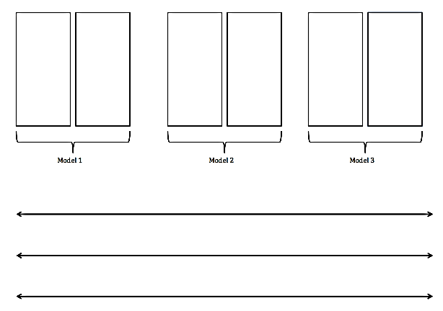
S: 2 wholes.
6 Wholes Template
T: Let’s partition Model 1 into thirds, Model 2 into halves, and Model 3 into wholes. Use Template 1 to help if you need it.
S: (Partition.)
T: Now, work with your partner to label each model.
S: (Label Model 1: $\frac{6}{3}$ = 2. Label Model 2: $\frac{4}{2}$ = 2. Students may or may not label Model 3 correctly: $\frac{2}{1}$ = 2.)
T: Let’s see how you labeled Model 3. How did you partition the model?
S: There are no partitions because they’re both wholes.
T: How many copies of 1 whole does the model have?
S: 2 copies of 1 whole.
T: (Write $\frac{2}{1}$ on the board.) For Model 3, we write the fraction as $\frac{2}{1}$ because there are 2 copies (point to the 2 in the fraction) of the unit, 1 whole (point to the 1 in the fraction). Let’s use our number lines again with these models. Label the endpoints on each number line 0 and 2.
Guide students through a similar sequence to the number line work they completed on Template 1.
T: I’d like you to circle $\frac{2}{2}$ on your second number line. Now, compare it to where you labeled $\frac{2}{1}$ on your third number line. Tell your partner the difference between $\frac{2}{1}$ and $\frac{2}{2}$.

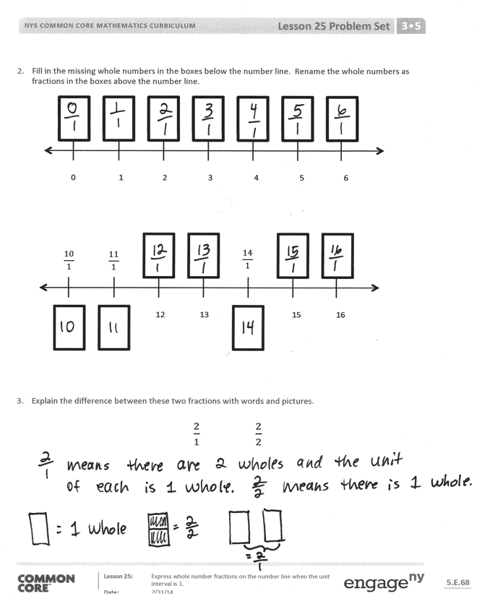
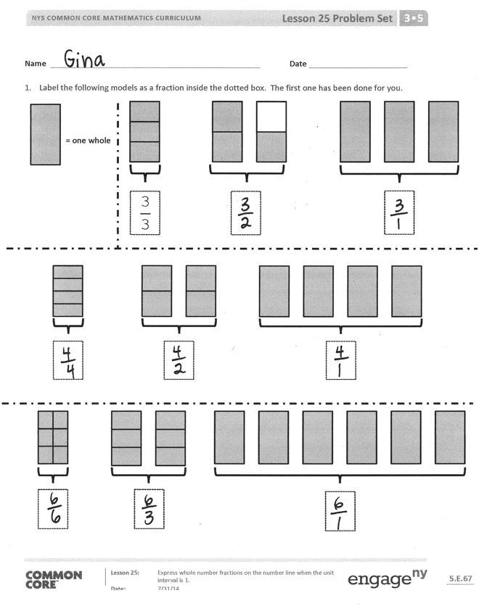
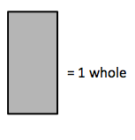
S: $\frac{2}{2}$ means it’s only 1 whole. There are 2 copies, and the unit is halves. $\frac{2}{1}$ means there are 2 wholes, and the unit of each is 1 whole. $\frac{2}{1}$ is much larger than $\frac{2}{2}$. It’s another whole! You can see that right there on the number line.
If necessary, have students complete a similar sequence with fourths.
Problem Set (10 minutes)
Students should do their personal best to complete the Problem Set within the allotted 10 minutes. For some classes, it may be appropriate to modify the assignment by specifying which problems they work on first. Some problems do not specify a method for solving. Students should solve these problems using the RDW approach used for Application Problems.
Student Debrief (10 minutes)
Lesson Objective: Express whole number fractions on the number line when the unit interval is 1.
The Student Debrief is intended to invite reflection and active processing of the total lesson experience.
Invite students to review their solutions for the Problem Set. They should check work by comparing answers with a partner before going over answers as a class. Look for misconceptions or misunderstandings that can be addressed in the Debrief. Guide students in a conversation to debrief the Problem Set and process the lesson.
Any combination of the questions below may be used to lead the discussion.
- Problem 1 presents a slightly different sequence than the lesson. Invite students to share what they notice about the relationship between the models in Problem 1. You might ask them to relate their work on that question to the guided practice in the lesson.
- Invite students to share their solutions to Problem 3. To solidify their understanding, ask them to apply their thinking to different fractions such as $\frac{3}{1}$ and $\frac{3}{3}$. You may want to use a number line during this portion of the discussion to help students notice that the difference between these fractions is even greater and continues to grow as the numbers go higher.
- Have students practice and articulate the lesson objective by closing with a series of pictures you quickly draw on the board. For example, you might make 10 circles. Then, say the following:
T: If each circle is 1 whole, how might you write the fraction for my total number of wholes?
S: $\frac{10}{1}$.
T: Explain to your partner how you know.
S: (Articulate understanding from the lesson.)
Exit Ticket (3 minutes)
After the Student Debrief, instruct students to complete the Exit Ticket. A review of their work will help with assessing students’ understanding of the concepts that were presented in today’s lesson and planning more effectively for future lessons. The questions may be read aloud to the students.

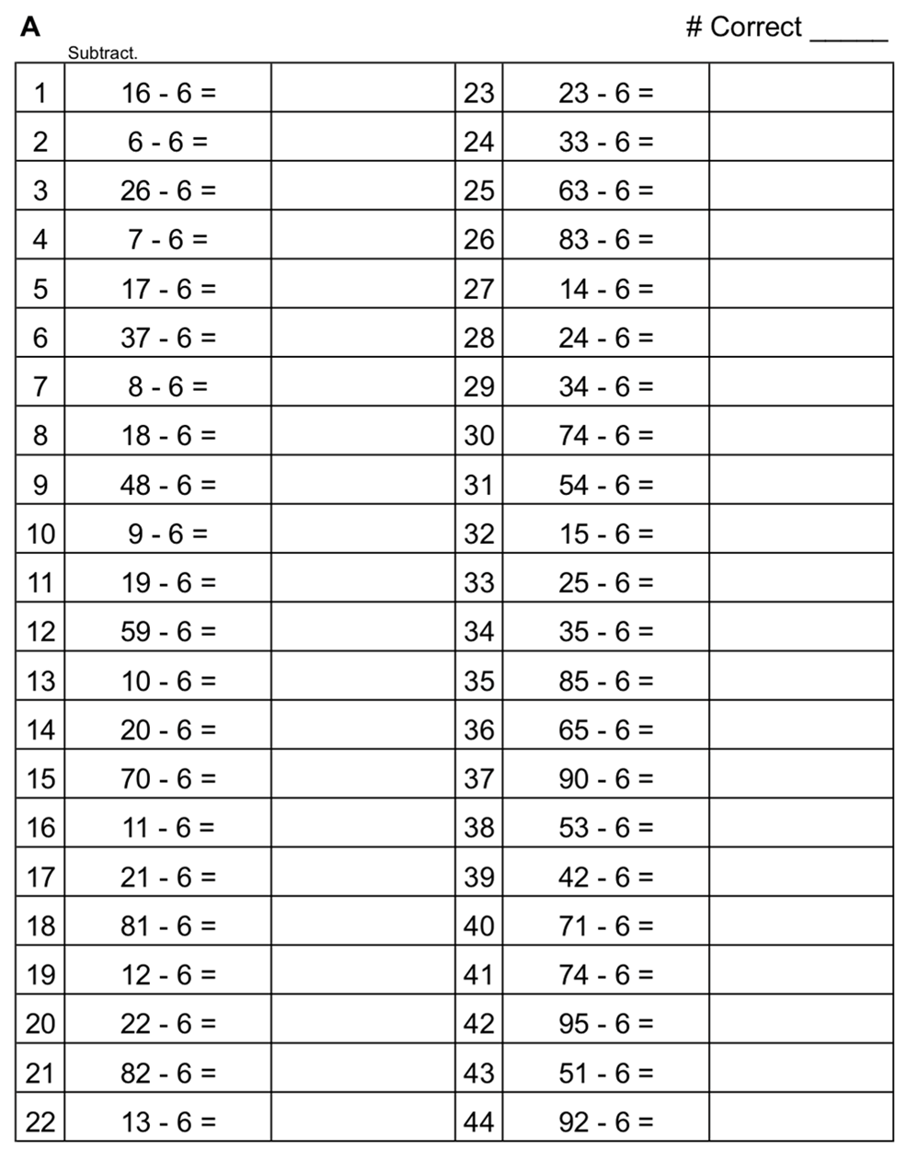

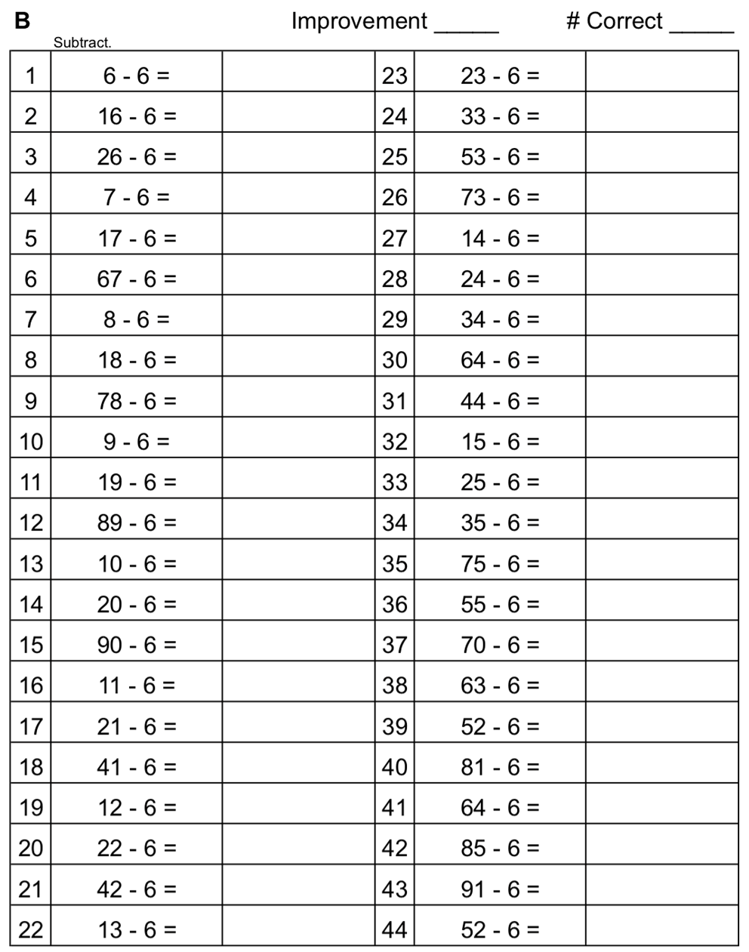

Name Date
- Label the following models as a fraction inside the dotted box. The first one has been done for you.
$$\frac{\text{3}}{\text{3}}$$
= 1 whole

- Fill in the missing whole numbers in the boxes below the number line. Rename the whole numbers as fractions in the boxes above the number line.
0 1 2 3 4 5 6

0 1 12 13 4 15 16
$$\frac{14}{1}$$
$$\frac{10}{1}$$
$$\frac{11}{1}$$

- Explain the difference between these two fractions with words and pictures.

$\frac{2}{1}$ $\frac{2}{2}$

Name Date
- Label the model as a fraction inside the box.
$$\frac{1}{1}$$

= 1 whole whole

- Partition the wholes into thirds. Rename the fraction for 3 wholes. Use the number line and words to explain your answer.
0 3

Name Date
- Label the following models as fractions inside the boxes.
= 1 whole
= 1 whole

- Fill in the missing whole numbers in the boxes below the number line. Rename the wholes as fractions in the boxes above the number line.
0 2 4 6 8 10 12
$$\frac{10}{1}$$

$$\frac{2}{1}$$

$$\frac{8}{1}$$

0 1 17 18 4 20 21
$$\frac{15}{1}$$
$$\frac{16}{1}$$
$$\frac{19}{1}$$

- Explain the difference between these fractions with words and pictures.

$\frac{5}{1}$ $\frac{5}{5}$

Model 1
Model 3
Model 2

3 wholes
6 wholes

