Lesson 24
Objective: Express whole numbers as fractions and recognize equivalence with different units.

Suggested Lesson Structure
 Fluency Practice (12 minutes)
 Application Problem (5 minutes)
 Concept Development (33 minutes)
 Student Debrief (10 minutes)
Total Time (60 minutes)
Fluency Practice (12 minutes)
- Sprint: Add by 7 2.NBT.5 (8 minutes)
- Write Equal Fractions 3.NF.3d (4 minutes)
Sprint: Add by 7 (8 minutes)
Materials: (S) Add by 7 Sprint
Note: This Sprint supports fluency with addition by 7.
Write Equal Fractions (4 minutes)
Materials: (S) Personal white board
Note: This activity reviews the skill of finding equivalent fractions on the number line from Topic E.
T: (Project number line with endpoints 0 and 1 partitioned into 2 equal parts by a dotted line.) Say the unit fraction represented by the dotted line.
S: 1 half.
T: (Write $\frac{1}{2}$ below the dotted line. To the right of the number line, write $\frac{1}{2}=\frac{}{4}.$) On your personal white board, write the number sentence and fill in the blank.
S: (Write $\frac{1}{2}=\frac{2}{4}$.)
T: (Write $\frac{2}{4}$ below $\frac{1}{2}$ on the number line.)
Continue with the following possible sequence, drawing a new number line for each example: $\frac{1}{3}=\frac{2}{}$ and $\frac{1}{4}=\frac{}{8}$.
Application Problem (5 minutes)
The zipper on Robert’s jacket is 1 foot long. It breaks on the first day of winter. He can only zip it $\frac{8}{12}$ of the way before it gets stuck. Draw and label a number line to show how far Robert can zip his jacket.
- Divide and label the number line in thirds. What fraction of the way can he zip his jacket in thirds?
- What fraction of Robert’s jacket is not zipped? Write your answer in twelfths and thirds.
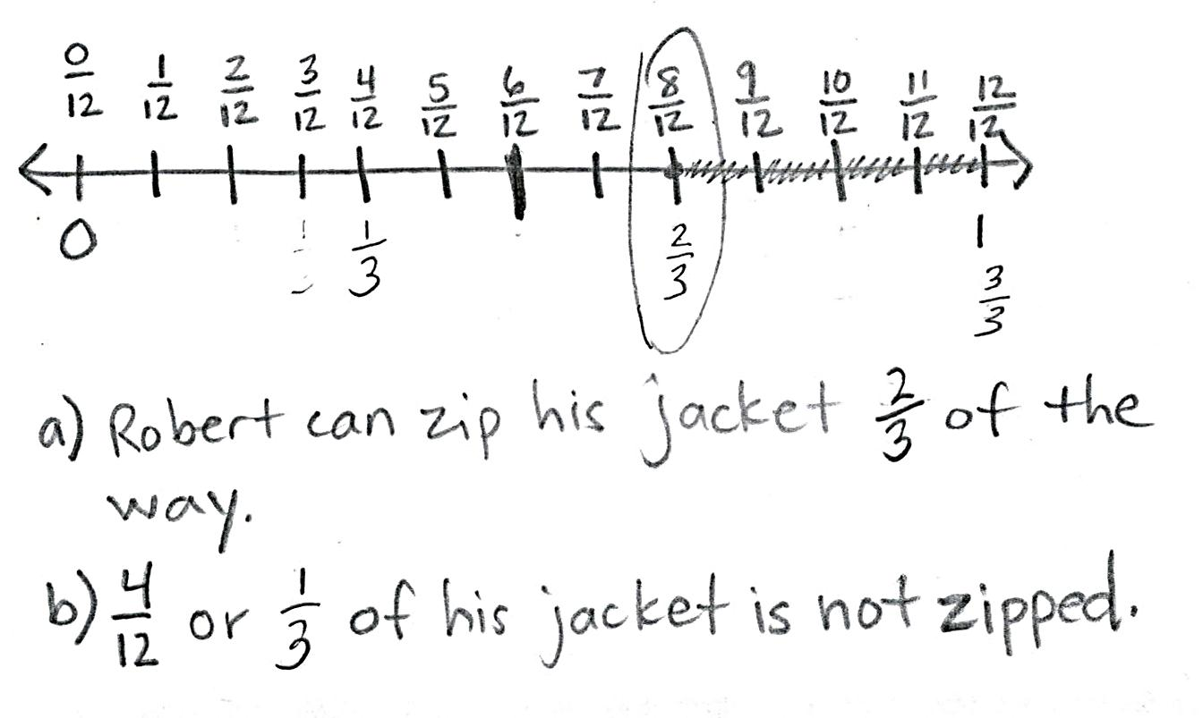

NOTES ON
MULTIPLE MEANS
OF ENGAGEMENT:
Partitioning the interval into two different fractional units is a stimulating challenge for students working above grade level.
Students working below grade level can draw two separate number lines or use fraction strips to solve.

Note: This problem reviews the skill of finding equivalent fractions on the number line from Topic E. Invite students to share their strategies for partitioning the number line into thirds and twelfths.
Concept Development (33 minutes)
Fraction Pieces Template
halves
fourths
thirds
sixths
1 whole

Materials: (S) Fraction pieces (Template), scissors, envelope, personal white board, sentence strip, crayons
Each student starts with a template, an envelope, and scissors.
T: Cut out all of the rectangles on your template, and initial each rectangle so you know which ones are yours.
S: (Cut and initial.)
T: Place the rectangle that says 1 whole on your personal white board. Take another rectangle. How many halves make 1 whole? Show by folding and labeling each unit fraction.
S: (Fold the second rectangle in half and label $\frac{1}{2}$ on each of the 2 parts.)
T: Now, cut on the fold. Draw circles around your whole and your parts to make a number bond.
_{1 whole}
$$\frac{1}{2}$$
$$\frac{1}{2}$$
S: (Draw a number bond using the shapes to represent wholes and parts.)
T: In your whole, write an equality that shows how many halves are equal to 1 whole. Remember, the equal sign is like a balance. Both sides have the same value.
S: (Write 1 whole = $\frac{2}{2}$ in the 1 whole rectangle.)
T: Put your halves inside your envelope.
Follow the same sequence for each rectangle so that students cut all pieces indicated on the template. Have students update the equality on their 1 whole rectangle each time they cut a new piece. At the end, it should read: 1 whole = $\frac{2}{2}=\frac{3}{3}=\frac{4}{4}=\frac{6}{6}$. Discuss the equality with students to ensure that they understand the meaning of the equal sign and the role it plays in this number sentence.
$$\frac{1}{2}$$
$$\frac{1}{2}$$
$$\frac{1}{4}$$
Image 1
Project or show Image 1, shown at the right.
T: Use your pieces to make this number bond on your board.
$$\frac{1}{4}$$
S: (Make the number bond.)
T: Discuss with your partner: Is this number bond true? Why or why not?
$$\frac{1}{4}$$
$$\frac{1}{4}$$
S: No, because the whole has only 2 pieces, but there are 4 parts! But fourths are just halves cut in 2. So, they’re the same pieces, but smaller now. $\frac{2}{4}$ is equivalent to $\frac{1}{2}$. So, $\frac{2}{2}=\frac{4}{4}$, just like what we wrote down on our 1 whole rectangle.

NOTES ON
MULTIPLE MEANS
OF ENGAGEMENT:
Students working below grade level may appreciate tangibly proving that 2 halves is the same as 4 fourths. Encourage students to place the (paper) fourths on top of the halves to show equivalency.

MP.7
MP.3
T: I hear some of you saying that $\frac{2}{2}$ and $\frac{4}{4}$ both equal 1 whole. So, can we say that this is true? (Project or show Image 2, shown on the next page.)
S: No, because thirds aren’t halves cut in 2. They look completely different. But when we put our thirds together and halves together, they make the same whole. Before, we found with our pieces that 1 whole = $\frac{2}{2}=\frac{3}{3}=\frac{4}{4}$. Then, it must be true!

Follow the same sequence with a variety of wholes and parts until students are comfortable with this representation of equivalence.
$$\frac{1}{2}$$
$$\frac{1}{2}$$
$$\frac{1}{3}$$
$$\frac{1}{3}$$
$$\frac{1}{3}$$
Image 2
T: Now, let’s place our different units on the same number line. Use your sentence strip to represent the interval from 0 to 1 on a number line. Mark the end points in with your pencil now.
S: (Mark end points 0 and 1 below the number line.)
T: Go ahead and fold your sentence strip to partition one unit at a time into halves, fourths, thirds, and then sixths. Label each fraction above the number line. As you count, be sure to rename 0 and the whole. Use a different color crayon to mark and label the fraction for each unit.
S: (Fold sentence strip and first label halves, then fourths, then thirds, and then sixths in different colors. Rename 0 and 1 in terms of each new unit.)
T: You should have a crowded number line! Compare it to your partner’s.
S: (Compare.)
T: Before today, we’ve been noticing a lot of equivalent fractions between wholes on the number line. Today, notice the fractions you wrote at 0 and 1. Look first at the fractions for 0. What pattern do you notice?
S: They all have 0 copies of the unit! The total number of equal parts changes. It shows you what unit you’re going to count by. Since our number line starts at 0, there is 0 of that unit in all of the fractions.
T: Even though the unit is different in each of our fractions at 0, are they equivalent? Think back to our work with shapes earlier.
S: We saw before that fractions with different units can still make the same whole. This time, the whole is just 0.
Follow the sequence to study the fractions written at 1. For both 0 and 1, students should see that every color they used is present.
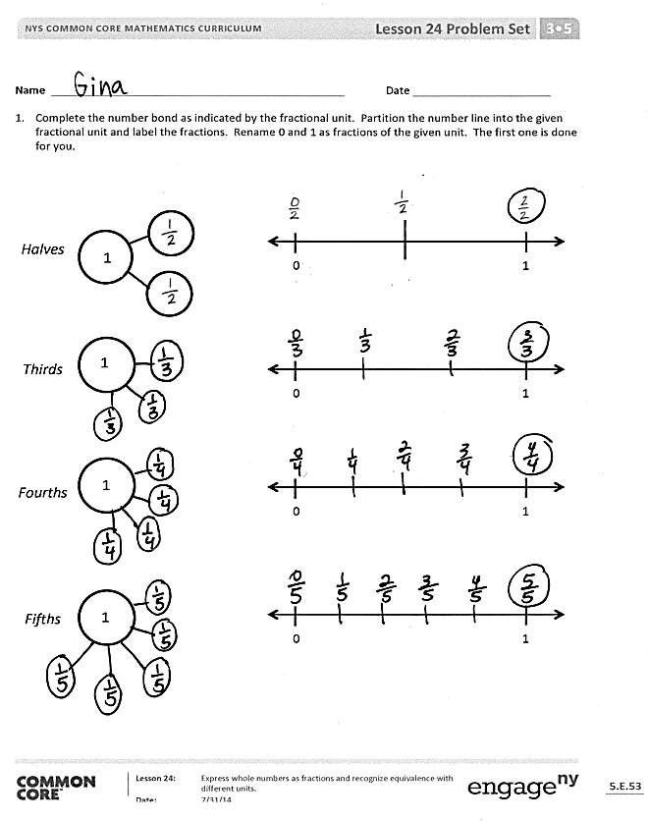
Problem Set (10 minutes)
Students should do their personal best to complete the Problem Set within the allotted 10 minutes. For some classes, it may be appropriate to modify the assignment by specifying which problems they work on first. Some problems do not specify a method for solving. Students should solve these problems using the RDW approach used for Application Problems.
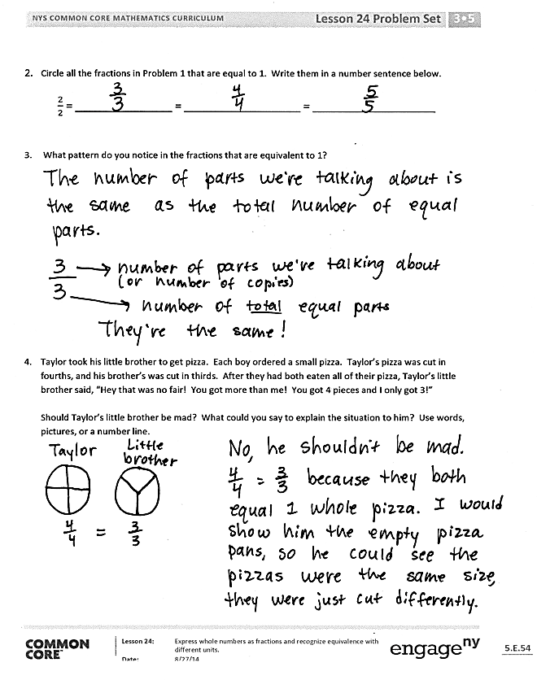
Student Debrief (10 minutes)
Lesson Objective: Express whole numbers as fractions and recognize equivalence with different units.
The Student Debrief is intended to invite reflection and active processing of the total lesson experience.
Invite students to review their solutions for the Problem Set. They should check work by comparing answers with a partner before going over answers as a class. Look for misconceptions or misunderstandings that can be addressed in the Debrief. Guide students in a conversation to debrief the Problem Set and process the lesson.
Any combination of the questions below may be used to lead the discussion.
- Invite students to share their thinking about Problem 3.
- Invite students to share their work on Problem 4.
- Have students use their fraction shapes from the lesson to model the number bonds in Problem 1.
- Ask students to generate other fractions equivalent to 1 whole. Provide the unit, and ask them to generate the fraction. The following is an example:
T: The unit is 1 millionth. What fraction is equivalent to 1 whole?
S: Wow! 1 million over 1 million!
Exit Ticket (3 minutes)
After the Student Debrief, instruct students to complete the Exit Ticket. A review of their work will help with assessing students’ understanding of the concepts that were presented in today’s lesson and planning more effectively for future lessons. The questions may be read aloud to the students.

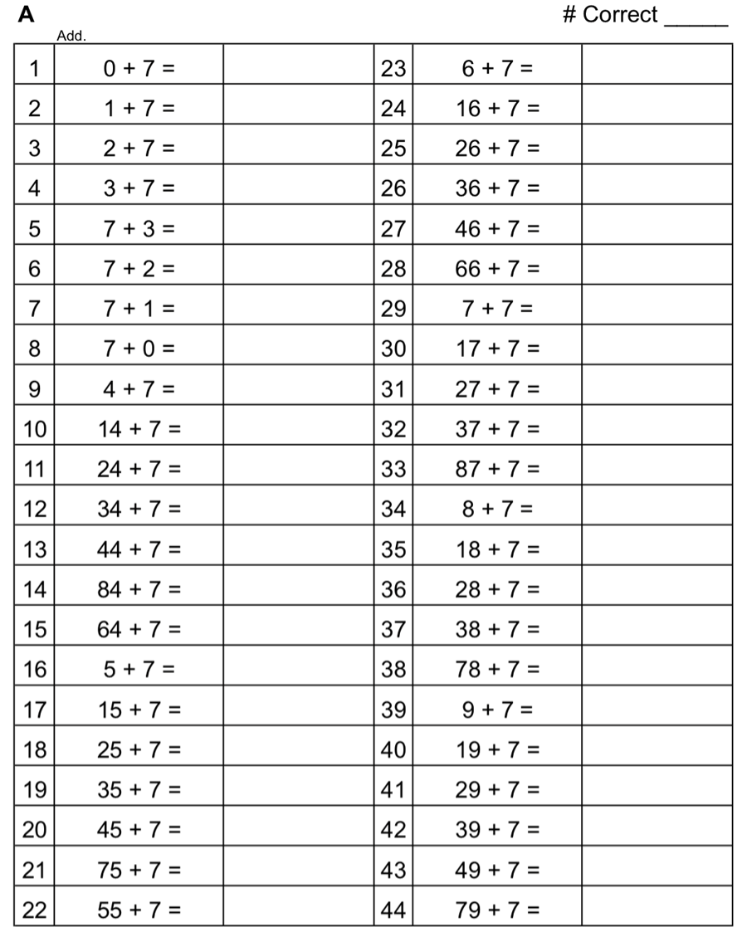

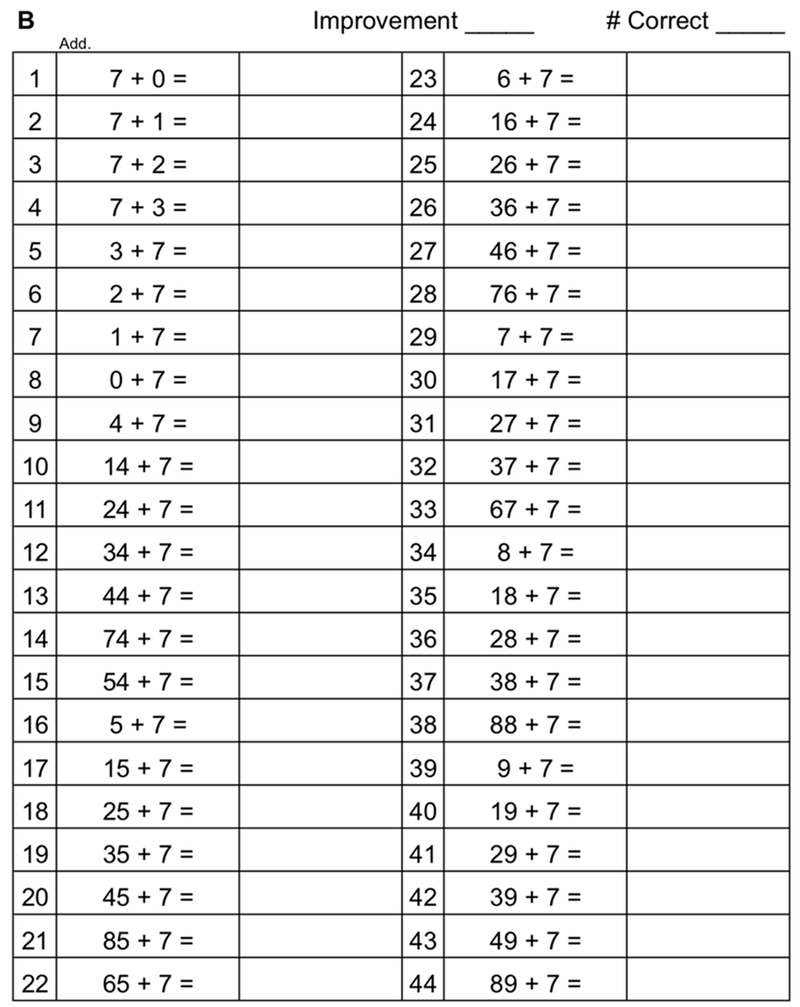

Name Date
- Complete the number bond as indicated by the fractional unit. Partition the number line into the given fractional unit and label the fractions. Rename 0 and 1 as fractions of the given unit. The first one is done for you.
1
1
1
0 1
0 1
0 1
Halves

Thirds

Fourths

Fifths
0 1

1

- Circle all the fractions in Problem 1 that are equal to 1. Write them in a number sentence below.

$\frac{2}{2}$ = _______________ = __________________ = ___________________

- What pattern do you notice in the fractions that are equivalent to 1?

- Taylor took his little brother to get pizza. Each boy ordered a small pizza. Taylor’s pizza was cut in fourths, and his brother’s was cut in thirds. After they had both eaten all of their pizza, Taylor’s little brother said, “Hey that was no fair! You got more than me! You got 4 pieces, and I only got 3.”

Should Taylor’s little brother be mad? What could you say to explain the situation to him? Use words, pictures, or a number line.

Name Date
- Complete the number bond as indicated by the fractional unit. Partition the number line into the given fractional unit and label the fractions. Rename 0 and 1 as fractions of the given unit.

0 1
1
Fourths

- How many copies of $\frac{1}{4}$ does it take to make 1 whole? What’s the fraction for 1 whole in this case? Use the number line or the number bond in Problem 1 to help you explain.

Name Date
- Complete the number bond as indicated by the fractional unit. Partition the number line into the given fractional unit and label the fractions. Rename 0 and 1 as fractions of the given unit.

1
Fifths

Sixths

Sevenths

Eighths
0 1

1
0 1
1

0 1
1

0 1

- Circle all the fractions in Problem 1 that are equal to 1. Write them in a number sentence below.

$\frac{5}{5}$ = _______________ = __________________ = ___________________

- What pattern do you notice in the fractions that are equivalent to 1? Following this pattern, how would you represent ninths as 1 whole?

- In Art class, Mr. Joselyn gave everyone a 1-foot stick to measure and cut. Vivian measured and cut her stick into 5 equal pieces. Scott measured and cut his into 7 equal pieces. Scott said to Vivian, “The total length of my stick is longer than yours because I have 7 pieces, and you only have 5.” Is Scott correct? Use words, pictures, or a number line to help you explain.

halves
thirds
fourths
1 whole
sixths

fraction pieces

