Lesson 23
Objective: Generate simple equivalent fractions by using visual fraction models and the number line.

Suggested Lesson Structure
 Fluency Practice (12 minutes)
 Concept Development (30 minutes)
 Application Problem (8 minutes)
 Student Debrief (10 minutes)
Total Time (60 minutes)
Fluency Practice (12 minutes)
- Sprint: Add by 6 2.NBT.5 (8 minutes)
- Find the Equivalent Fraction 3.NF.3d (4 minutes)
Sprint: Add by 6 (8 minutes)
Materials: (S) Add by 6 Sprint
Note: This Sprint supports fluency with addition by 6.
Find the Equivalent Fraction (4 minutes)

NOTES ON
MULTIPLE MEANS
OF ENGAGEMENT:
Students working below grade level may enjoy counting fractions more than once. First, with the addition of models, e.g., shading fourths, then without, gradually increasing speed with each repetition.

Materials: (T) Prepared fraction images (S) Personal white board
Note: This activity reviews finding equivalent fractions from Lesson 20.
T: (Project a square partitioned into 2 parts with 1 part shaded in.) Say the shaded fraction.
S: 1 half.
T: (Write $\frac{1}{2}$underneath the square.) Copy my picture and fraction on your personal white board.
S: (Copy the image and fraction on the board.)
T: (Project an identical square to the right of the first square.) On your board, draw a second identical square.
S: (Draw a second identical square.)
T: (Below the squares, write $\frac{1}{2}=\frac{}{4}$.) On your board, partition your second square to make fourths and fill in the number sentence.
S: (Draw a horizontal line to show 2 parts of 4 shaded and write $\frac{1}{2}=\frac{2}{4}$.)
Continue with the following possible sequence: $\frac{1}{2}=\frac{}{6}$, $\frac{2}{8}=\frac{}{4}$, and $\frac{5}{10}=\frac{}{20 }$.
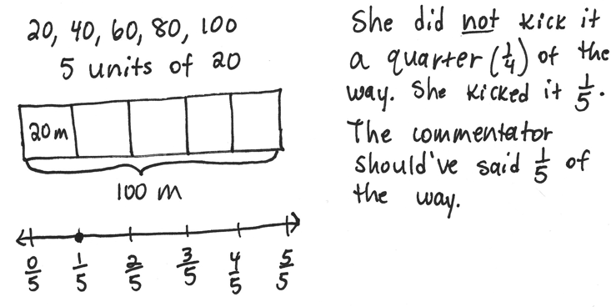
Application Problem (8 minutes)
Shannon stood at the end of a 100-meter long soccer field and kicked the ball to her teammate. She kicked it 20 meters. The commentator said she kicked it a quarter of the way down the field. Is that true? If not, what fraction should the commentator have said? Prove your answer by using a number line.
Note: This problem reviews partitioning a whole into equal parts from Topic A.
Concept Development (30 minutes)
Materials: (S) Index card (1 per pair, described below), sentence strip (1 per pair), chart paper (1 per group), markers, glue, math journal

Group A
Interval: 3–5
Unit: thirds

Group A
Interval: 3–5
Unit: sixths
Example Index Cards for Group A
Students work in pairs. Each pair receives one sentence strip and an index card. The index card designates endpoints on a number line and a unit with which to partition (examples to the right).
Divide the class so each group is composed of pairs (each group contains more than one pair). Create the following index cards and distribute one card to each pair per group:
Group A: Interval 3–5, thirds and sixths
Group B: Interval 1–3, sixths and twelfths
Group C: Interval 3–5, halves and fourths
Group D: Interval 1–3, fourths and eighths
Group E: Interval 4–6, sixths and twelfths
Group F: Interval 6–8, halves and fourths
Note: Differentiate the activity by strategically assigning just right intervals and units to pairs of students.

T: With your partner, use your sentence strip to make a number line with your given interval. Then, estimate to partition into your given unit by folding your sentence strip. Label the endpoints and fractions. Rename the wholes.
S: (Work in pairs.)
T: (Give one piece of chart paper to a member of each letter group.) Now, stand up and find your other letter group members. Once you’ve found them, glue your number lines in a column so that the ends match up on your chart paper. Compare number lines to find equivalent fractions. Record all possible equivalent fractions in your math journals.
S: (Find letter group members and glue fraction strips onto chart paper. Letter group members discuss and record equivalent fractions.)
T: (Hang each chart paper around the room.) Now, we’re going to do a museum walk. As a letter group, you will visit the other groups’ chart papers. One person in each group will be the recorder. You can switch recorders each time you visit a new chart paper. Your job will be to find and list all of the equivalent fractions you see at each chart paper.

NOTES ON
MULTIPLE MEANS
OF ENGAGEMENT:
Challenge students working above grade level to write more than two equivalent fractions on the Problem Set. As they begin to generate equivalencies mentally and rapidly, guide students to articulate the pattern and its rule.

S: (Go to another letter group’s chart paper and begin.)
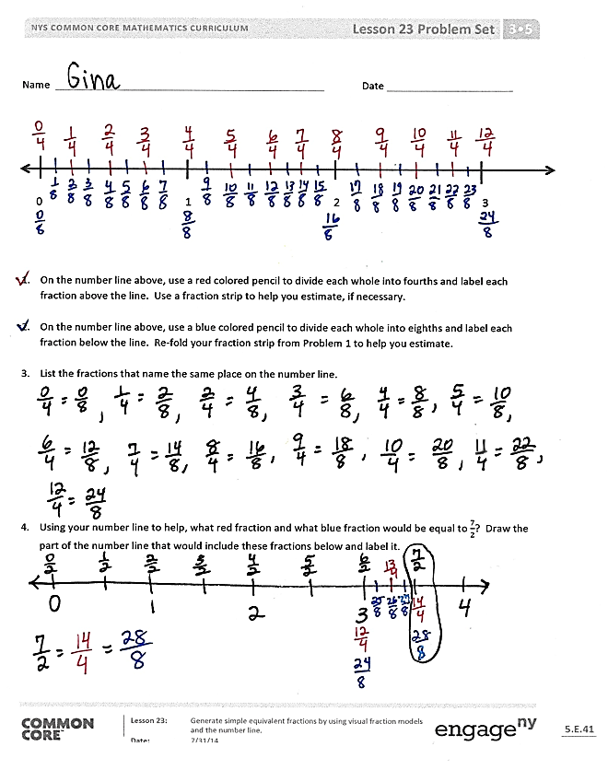
T: (Rotate groups briskly so that, at the beginning, students don’t finish finding all fractions at 1 station. As letter groups rotate and chart papers fill up, challenge groups to check others’ work to ensure no fractions are missing.)
T: (After rotation is complete.) Go back to your own chart paper with your letter group. Take your math journals and check your friends’ work. Did they name the same equivalent fractions you found?
Problem Set (10 minutes)
Students should do their personal best to complete the Problem Set within the allotted 10 minutes. For some classes, it may be appropriate to modify the assignment by specifying which problems they work on first. Some problems do not specify a method for solving. Students should solve these problems using the RDW approach used for Application Problems.

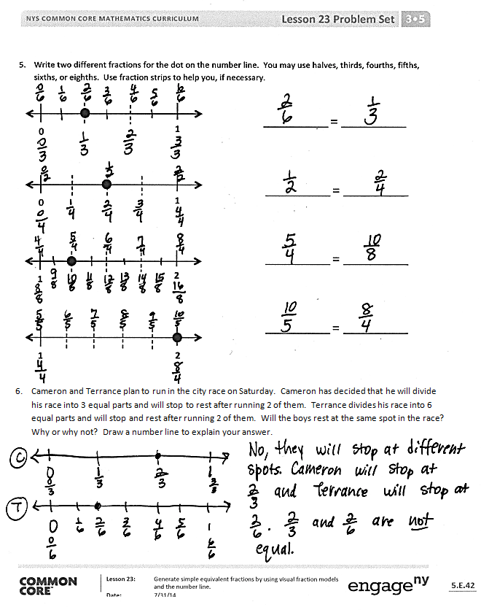
Student Debrief (10 minutes)
Lesson Objective: Generate simple equivalent fractions by using visual fraction models and the number line.
The Student Debrief is intended to invite reflection and active processing of the total lesson experience.
Invite students to review their solutions for the Problem Set. They should check work by comparing answers with a partner before going over answers as a class. Look for misconceptions or misunderstandings that can be addressed in the Debrief. Guide students in a conversation to debrief the Problem Set and process the lesson.
Any combination of the questions below may be used to lead the discussion.
- Could you have compared the number line you made in today’s lesson to a number line from a different group? What would the result be?
- How did your work change when the interval on your number line was no longer from
0 to 1?
- Could we sequentially connect the number lines you made in today’s lesson even though they are partitioned into different units? What would happen then?

NOTES ON
MULTIPLE MEANS
OF REPRESENTATION:
To assist comprehension, develop multiple ways of asking the same question. For example, the question, “Could we sequentially…?” can be changed to “What if we put all the number lines together in numerical order?” or “What do you think of a number line whose intervals are partitioned into different fractional units?”

- Compare all of the answers for Problem 5. (Use this comparison to advance the idea that the world of fractions is endless. There are many different fractions that label a single point.)
Exit Ticket (3 minutes)
After the Student Debrief, instruct students to complete the Exit Ticket. A review of their work will help with assessing students’ understanding of the concepts that were presented in today’s lesson and planning more effectively for future lessons. The questions may be read aloud to the students.

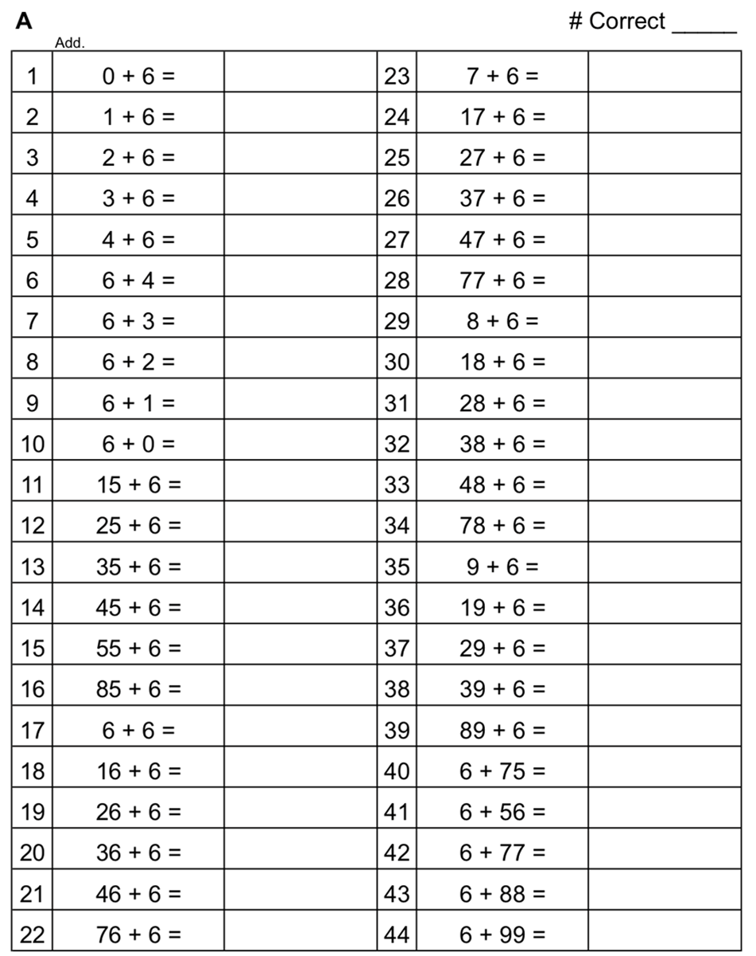

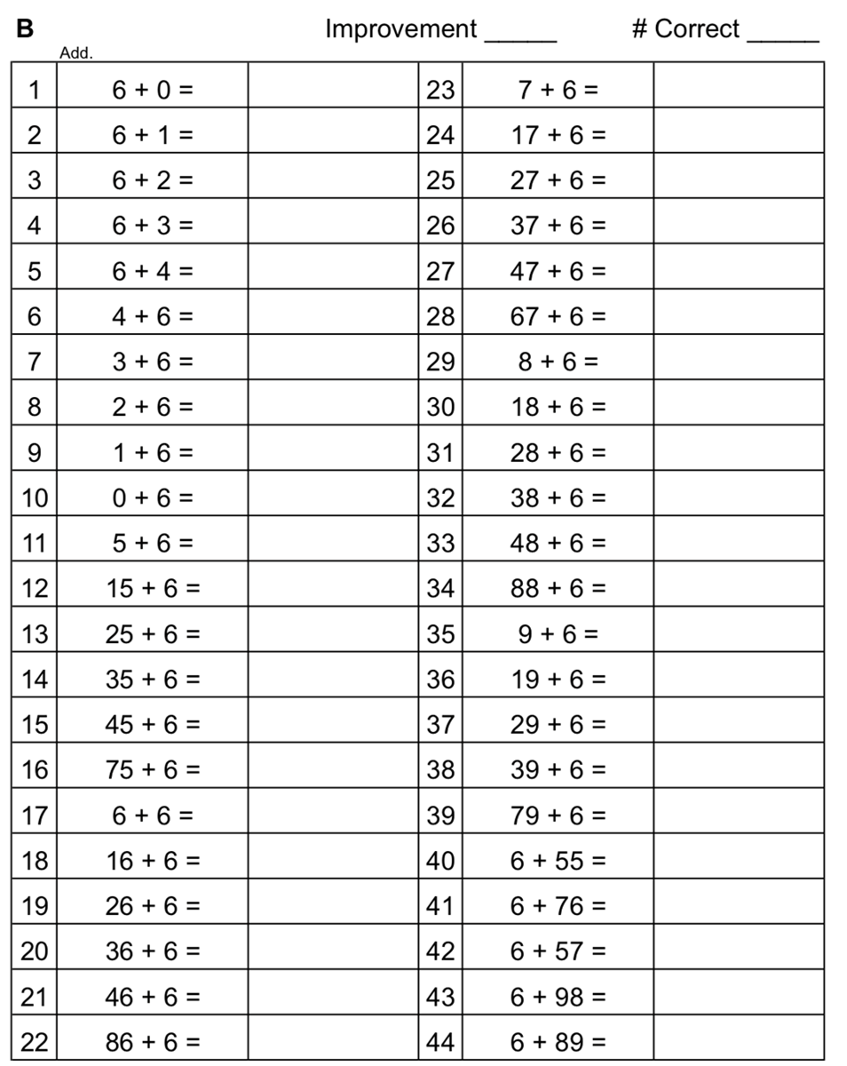

Name Date

0 1 2 3

- On the number line above, use a red colored pencil to divide each whole into fourths and label each fraction above the line. Use a fraction strip to help you estimate, if necessary.

- On the number line above, use a blue colored pencil to divide each whole into eighths and label each fraction below the line. Refold your fraction strip from Problem 1 to help you estimate.

- List the fractions that name the same place on the number line.

- Using your number line to help, what red fraction and what blue fraction would be equal to $\frac{7}{2}$? Draw the part of the number line that would include these fractions below and label it.

- Write two different fractions for the dot on the number line. You may use halves, thirds, fourths, fifths, sixths, or eighths. Use fraction strips to help you, if necessary.

0
1
0
1
1
2
1
2
_____________ = _____________

_____________ = _____________

_____________ = _____________

_____________ = _____________

- Cameron and Terrance plan to run in the city race on Saturday. Cameron has decided that he will divide his race into 3 equal parts and will stop to rest after running 2 of them. Terrance divides his race into 6 equal parts and will stop and rest after running 2 of them. Will the boys rest at the same spot in the race? Why or why not? Draw a number line to explain your answer.

Name Date
Henry and Maddie were in a pie-eating contest. The pies were cut either into thirds or sixths. Henry picked up a pie cut into sixths and ate $\frac{4}{6}$of it in 1 minute. Maddie picked up a pie cut into thirds. What fraction of her pie does Maddie have to eat in 1 minute to tie with Henry? Draw a number line and use words to explain your answer.

Name Date

0 1 2 3

- On the number line above, use a colored pencil to divide each whole into thirds and label each fraction above the line.

- On the number line above, use a different colored pencil to divide each whole into sixths and label each fraction below the line.

- Write the fractions that name the same place on the number line.

- Using your number line to help, name the fraction equivalent to $\frac{20}{6}.$ Name the fraction equivalent to $\frac{12}{3}$. Draw the part of the number line that would include these fractions below and label it.
$$\frac{12}{3}= \frac{}{6}$$

$$\frac{20}{6}= \frac{}{3}$$

- Write two different fraction names for the dot on the number line. You may use halves, thirds, fourths, fifths, sixths, eighths, or tenths.
0
1
0
1
1
2
1
2
_____________ = _____________

_____________ = _____________

_____________ = _____________

_____________ = _____________

- Danielle and Mandy each ordered a large pizza for dinner. Danielle’s pizza was cut into sixths, and Mandy’s pizza was cut into twelfths. Danielle ate 2 sixths of her pizza. If Mandy wants to eat the same amount of pizza as Danielle, how many slices of pizza will she have to eat? Write the answer as a fraction. Draw a number line to explain your answer.

