Lesson 22

Objective: Generate simple equivalent fractions by using visual fraction models and the number line.

Suggested Lesson Structure

 Fluency Practice (12 minutes)

 Application Problem (8 minutes)

 Concept Development (30 minutes)

 Student Debrief (10 minutes)

**Total Time (60 minutes)**

Fluency Practice (12 minutes)

* Whole Number Division **3.OA.7** (8 minutes)
* Counting by Fractions Equal to Whole Numbers on the Number Line **3.NF.3a** (4 minutes)

Whole Number Division (8 minutes)

Materials: (S) Blank paper

Note: This activity supports fluency with division. Steps 1 and 2 are timed for two minutes each. Step 3 is timed for one minute of testing for each partner. Step 4 is timed for two minutes.

1. Students self-select a number and write a set of multiples up to that number’s multiple of 10 vertically down the left-hand side of the page, e.g., 6, 12, 18, 24, 30, 36, 42, 48, 54, 60.
2. Select a multiple and divide it by the original number, e.g., 24 ÷ 6 = 4.
3. Change papers and test a partner by selecting multiples out of order, e.g., “What is 24 ÷ 6?” “What is 54 ÷ 6?” “What is 12 ÷ 6?”
4. Redo Steps 1 and 2 to see improvement.

Counting by Fractions Equal to Whole Numbers on the Number Line (4 minutes)

Materials: (S) Personal white board

Note: This activity reviews the concept of naming equivalent fractions on the number line from Lesson 21.

T: (Project a number line partitioned into 12 thirds.) Count by thirds. (Write fractions as students count.)

S: 1 third, 2 thirds, 3 thirds, 4 thirds, 5 thirds, 6 thirds, 7 thirds, 8 thirds, 9 thirds, 10 thirds 11 thirds, 12 thirds.

T: On your personal white board, write the fractions equal to whole numbers in order from least to greatest. Continue beyond those shown on our number line if you finish early.

S: (Write , , , and .)

Continue with the following possible sequence: halves and fourths.

Application Problem (8 minutes)

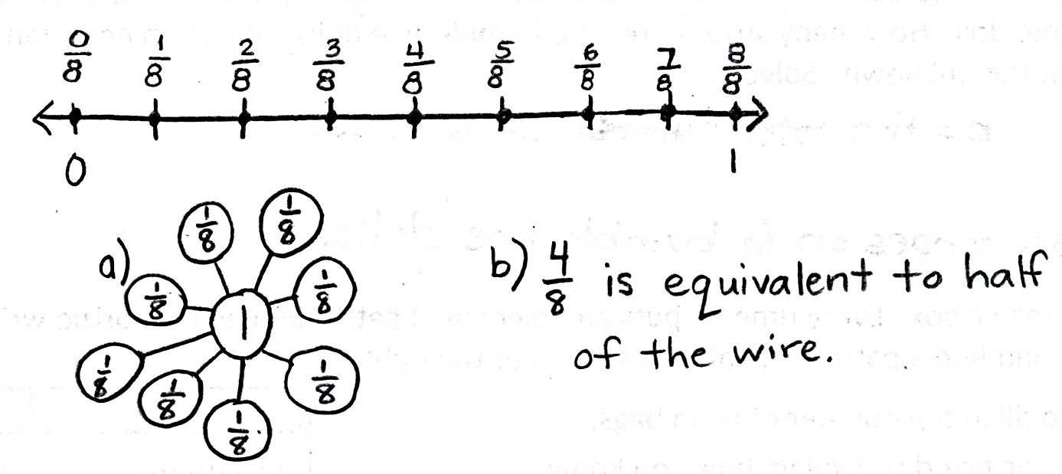Mr. Ramos wants to put a wire on the wall. He puts 9 nails equally spaced along the wire. Draw a number line representing the wire. Label it from 0 at the start of the wire to 1 at the end. Mark where Mr. Ramos puts each nail with a fraction.

1. Build a number bond with unit fractions to 1 whole.
2. Write the fraction of the nail that is equivalent toof the wire.

Note: This problem reviews placing fractions on a number line, decomposing 1 whole into unit fractions, and naming equivalent fractions. The first nail is located at , which represents no length of wire. This results in 9 nails rather than 8 nails, even though the number line is partitioned into eighths. Watch for and discuss misconceptions that arise.

Concept Development (30 minutes)

|  |  |
| --- | --- |
|  | NOTES ON  MULTIPLE MEANS  OF ENGAGEMENT: |
| Students working below grade level may alternatively use two fraction strips—one partitioned into sixths, the other partitioned into fourths—to compare 3 sixths and 2 fourths. Or, have students draw number lines on personal white boards so that they may erase partitioned sixths before partitioning fourths. | |

Materials: (S) Math journal or fraction strips made in Lesson 21, new 4 -inch × 1-inch fraction strips (3 per student), crayons, personal white board, glue

T: Take out your math journal and turn to the page where you glued your fraction strips yesterday. Name the fraction that is equivalent to 1 third.

S: .

T: Now, name the fractions that are equivalent to 1 half.

S: , and .

T: During our Debrief yesterday, I challenged you to find another fraction equivalent to 1 half, even though it wasn’t shaded. You came up with .

T: Now, I want you to work with a partner to look at your fraction strips again. See if you can find other equivalent fractions, shaded or unshaded. Draw and label them on your personal white board. For example, using my fraction strips, I can see that and are equivalent. Fourths are just halves cut in half again. Be ready to explain how you know, just like I did.

|  |  |
| --- | --- |
|  | NOTES ON  MULTIPLE MEANS  OF ENGAGEMENT: |
| Challenge students working above grade level to collect the data presented, e.g., sets of equivalencies, and organize it in a table or graph. Guide them to analyze the organized data and draw conclusions. Ask (for example), “Which fraction has more equivalent fractions? Why?” | |

**MP.3**

S: (Possible answers other than those already discussed: and )

T: (Have students share their work.) Let’s look at and Talk with your partner. Do you notice a relationship between the numbers in these fractions?

S: 3 is half of 6, and 2 is half of 4. 🡪 That’s true. If you make 2 copies of , then you get . 🡪 I see what you mean about the numbers doubling, but it’s not really 2 copies when you look at the fraction strips. Thirds are larger than sixths. 🡪 The numbers double because you’re cutting each third into 2 equal parts to get sixths. But that actually makes the pieces get smaller, even though the number of pieces is doubled. It’s still the same amount.

T: Now, look at and Does the same pattern you just noticed apply to these fractions?

S: (Discuss.)

It may be a good idea to have students repeat the process with whole number fractions if they are unsure.

T: I’m hearing you say that the numbers in these equivalent fractions doubled. Look again at these equivalent fractions: and What fraction would we get if we doubled the 4 and 6 in ?

S: .

T: (Pass out 3 fraction strips to each student.) Fold your strips into thirds, sixths, and twelfths. Label the unit fractions. Then, shade andto compare. Is equivalent to and ?

S: They are equivalent!

T: What did we do to the equal parts each time to make the number of shaded parts and total number of parts double?

S: We cut them in 2. Thirds get cut in 2 to make sixths, and sixths get cut in 2 to make twelfths.

T: Did the whole change?

S: Nope, it just has more equal parts.

T: What happens to the shaded area?

S: It stays the same size.

T: So, the fractions are?

S: Equivalent!

Have students glue the equivalent fractions into their math journals and label them.

Show the pictorial models to the right.

T: Let’s look at a different model. These 3 wholes are the same. Name the shaded fraction as I point to the model.

While pointing to each model, label with student responses: and.

T: Are these fractions equivalent? Work with your partner to use the number line to prove your answer. Be ready to share your thinking.

|  |  |
| --- | --- |
|  | NOTES ON  MULTIPLE MEANS  OF REPRESENTATION: |
| Celebrate and encourage English language learners’ use of math language in English. In the Problem Set, encourage learners to whisper the unit fraction, whisper count the shaded units, and whisper the shaded fraction as they write. | |

After students work, have pairs share at tables or select partners to present different methods to the class. Provide other examples using pictorial models and the number line as necessary.

Problem Set (10 minutes)

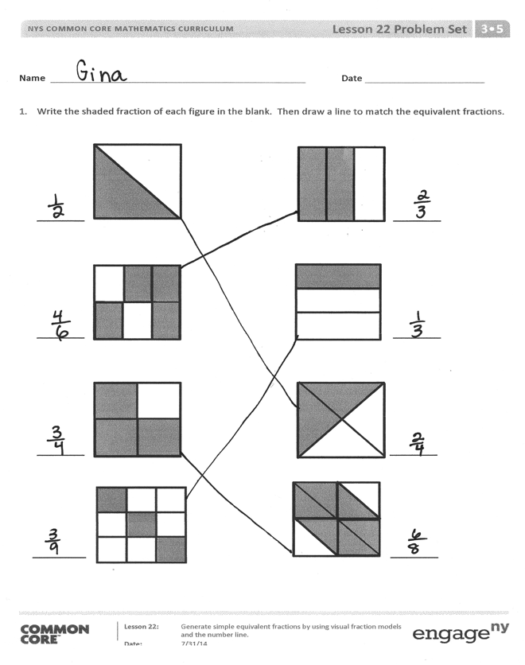Students should do their personal best to complete the Problem Set within the allotted 10 minutes. For some classes, it may be appropriate to modify the assignment by specifying which problems they work on first. Some problems do not specify a method for solving. Students should solve these problems using the RDW approach used for Application Problems.

Student Debrief (10 minutes)

**Lesson Objective:** Generate simple equivalent fractions by using visual fraction models and the number line.

The Student Debrief is intended to invite reflection and active processing of the total lesson experience.

Invite students to review their solutions for the Problem Set. They should check work by comparing answers with a partner before going over answers as a class. Look for misconceptions or misunderstandings that can be addressed in the Debrief. Guide students in a conversation to debrief the Problem Set and process the lesson.

Any combination of the questions below may be used to lead the discussion.

* What did you notice about the models in   
  Problem 1?

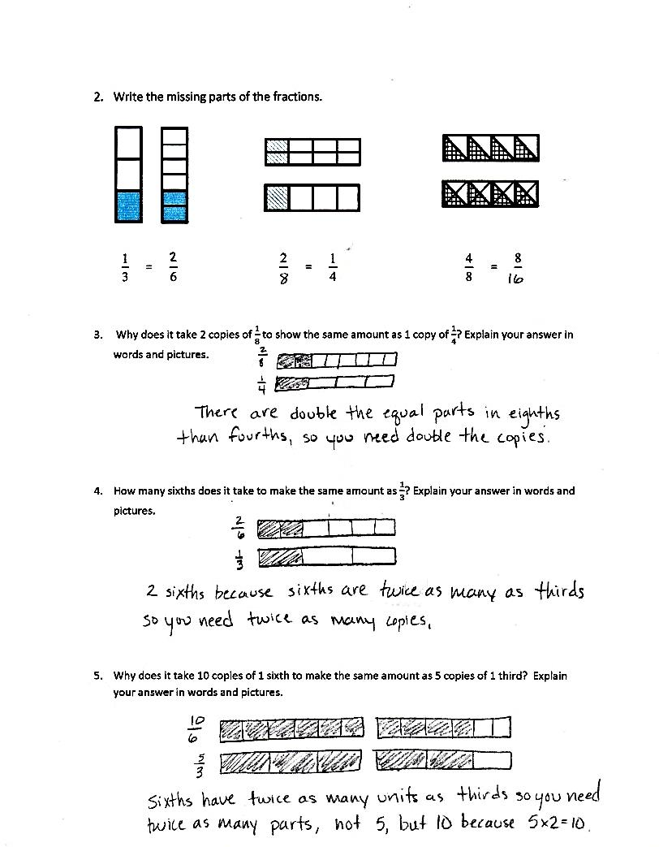

* In Problem 1, which shapes were most difficult to match? Why?
* What might be another way to draw a fraction equivalent to ?
* Look at Problem 2. What pattern do you notice between the 3 sets of models?
* How does the pattern you noticed in Problem 2 relate to other parts of today’s lesson?

Exit Ticket (3 minutes)

After the Student Debrief, instruct students to complete the Exit Ticket. A review of their work will help with assessing students’ understanding of the concepts that were presented in today’s lesson and planning more effectively for future lessons. The questions may be read aloud to the students.

Name Date

1. Write the shaded fraction of each figure in the blank. Then, draw a line to match the equivalent fractions.

________ ________

________ ________

________ ________

|  |  |  |
| --- | --- | --- |
|  |  |  |
|  |  |  |
|  |  |  |

_________ ________

1. Write the missing parts of the fractions.

 =   =   = 

1. Why does it take 2 copies of to show the same amount as 1 copy of ? Explain your answer in words and pictures.
2. How many sixths does it take to make the same amount as ? Explain your answer in words and pictures.
3. Why does it take 10 copies of 1 sixth to make the same amount as 5 copies of 1 third? Explain your answer in words and pictures.

Name Date

1. Draw and label two models that show equivalent fractions.
2. Draw a number line that proves your thinking about Problem 1.

Name Date

1. Write the shaded fraction of each figure in the blank. Then, draw a line to match the equivalent fractions.

|  |  |
| --- | --- |
|  |  |

|  |
| --- |
|  |
|  |
|  |
|  |
|  |

________ ________

|  |  |
| --- | --- |
|  |  |
|  |  |
|  |  |

|  |  |  |  |  |
| --- | --- | --- | --- | --- |
|  |  |  |  |  |

________ ________

|  |  |  |  |  |
| --- | --- | --- | --- | --- |
|  |  |  |  |  |
|  |  |  |  |  |

|  |  |
| --- | --- |
|  |  |
|  |  |
|  |  |
|  |  |
|  |  |

________ ________

|  |
| --- |
|  |
|  |
|  |
|  |

|  |  |
| --- | --- |
|  |  |
|  |  |
|  |  |
|  |  |

________ ________

1. Complete the fractions to make true statements.

 =   =   = 

1. Why does it take 3 copies of to show the same amount as 1 copy of ? Explain your answer in words and pictures.
2. How many ninths does it take to make the same amount as? Explain your answer in words and pictures.
3. A pie was cut into 8 equal slices. If Ruben ate of the pie, how many slices did he eat? Explain your answer using a number line and words.