Lesson 21
Objective: Recognize and show that equivalent fractions refer to the same point on the number line.

Suggested Lesson Structure
 Fluency Practice (12 minutes)
 Application Problem (8 minutes)
 Concept Development (30 minutes)
 Student Debrief (10 minutes)
Total Time (60 minutes)
Fluency Practice (12 minutes)
- Whole Number Division 3.OA.7 (8 minutes)
- 1 Whole Expressed as Unit Fractions 3.NF.1 (4 minutes)
Whole Number Division (8 minutes)
Materials: (S) Blank paper
Note: This activity supports fluency with division. Steps 1 and 2 are timed for two minutes. Step 3 is timed for 1 minute of testing for each partner. Step 4 is timed for two minutes.
- Students self-select a number and write a set of multiples up to that number’s multiple of 10 vertically down the left-hand side of the page, e.g., 6, 12, 18, 24, 30, 36, 42, 48, 54, 60.
- Select a multiple and divide it by the original number, e.g., 24 ÷ 6 = 4.
- Change papers and test a partner by selecting multiples out of order, e.g., “What is 24 ÷ 6?” “What is 54 ÷ 6?” “What is 12 ÷ 6?”
- Redo Steps 1 and 2 to see improvement.
Let the students know that the same activity will be done the next day so they have a chance to practice and improve further, possibly advancing to the next number, which might further challenge them.
1 Whole Expressed as Unit Fractions (4 minutes)
Materials: (S) Personal white board
Note: This problem reviews the concept of using a number bond to decompose 1 whole into unit fractions from Topic A.
T: Draw a number bond that partitions a whole into 3 equal parts.
S: (Draw a number bond.)
T: What is the unit fraction?
S: 1 third.
Continue with the following possible sequence: halves, fourths, fifths, sixths, and eighths.
Application Problem (8 minutes)
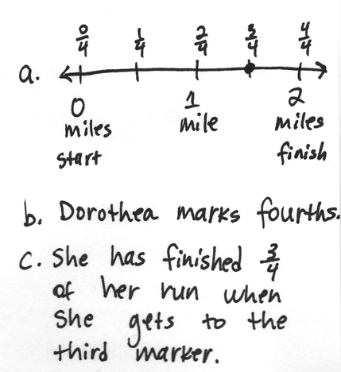
Dorothea is training to run a 2-mile race. She marks off her starting point and the finish line. To track her progress, she places a mark at 1 mile. She then places a mark halfway between her starting position and 1 mile, and another mark halfway between 1 mile and the finish line.
- Draw and label a number line to show the points Dorothea marks along her run.
- What fractional unit does Dorothea make as she marks the points on her run?
- What fraction of her run has she completed when she reaches the third marker?
Note: This problem reviews the importance of specifying the whole from Topic C. Invite students to discuss why the fractional units are fourths instead of halves.
Concept Development (30 minutes)
Materials: (S) 4 $\frac{1}{4}$-inch × 1-inch fraction strips (5 per student), math journal, crayons, glue

NOTES ON
MULTIPLE MEANS
OF REPRESENTATION:
The vocabulary word equivalent has the advantage of cognates in many languages. Build English language learners’ understanding of equivalent fractions through discussion, word webs, and questioning.
Ask the following:
- How are these equivalent fractions related?
- What particular property do they have in common?
- When might it be useful to interchange equivalent fractions?

T: We’re going to make different fractional units with our fraction strips. Fold your first strip into halves.
S: (Fold fraction strip.)
T: Label each part with a unit fraction. Then, use a crayon to shade in 1 half.
S: (Label and shade.)
T: Glue your fraction strip at the top of a new page in your math journal.
S: (Glue fraction strip.)
T: Fold another fraction strip to make fourths. Label each part with a unit fraction. Then, glue your fraction strip directly below the first one in your math journal. Make sure that the ends are lined up.
S: (Fold, label, place, and glue fraction strips.)
T: Now, shade the number of fourths that are equivalent to the shaded half. Whisper to your partner how many units you shaded.
S: (Shade and whisper “2.”)
Guide students through the same sequence for a fraction strip folded into eighths.
T: Write the shaded fraction to the right of each fraction strip in your journal.
S: (Write $\frac{1}{2},\frac{2}{4},$ and $\frac{4}{8}$.)
T: The fractional units are different. Discuss with a partner whether the fractions are equal or equivalent.
S: Since the fractional units are different, then they are not equal. They have a different number of shaded parts, so I’m not sure. The same amount of the fraction strip is shaded for each one. That must mean they’re equal.
T: I hear some uncertainty. Besides our fraction strips, what’s another tool we can use to test their equivalence?
S: We can place them on a number line.
T: Let’s do that. Place your personal white board under the fraction strip folded into halves. Use the fraction strip to measure a number line from 0 to 1. Label 0 halves, rename the whole, and then label $\frac{1}{2}$.
S: (Measure, draw, and label a number line.)
T: Move your board down so that your number line is under your fourths fraction strip. On the same number line, label the fourths. See if any fractions are located at the same point on the number line.
MP.7
S: Hey, $\frac{1}{2}$ and $\frac{2}{4}$ are at the same point! So are $\frac{2}{2}$, $\frac{4}{4}$, and 1. Zeroes too, but we already knew that!
T: Discuss with your partner what it means when two fractions are at the same point on the number line.
S: It means they’re the same. It proves what we saw with the fraction strips. They had the same amount shaded before, and now they’re in the same place on the number line. The fractions must be equivalent because they are at the same point.

NOTES ON
USING =:
It is worth spending a moment to ensure that students are clear on the meaning of the equal sign in this lesson because it is an important symbol throughout Topic E. Students become accustomed to associating its use with an operation and an answer, not fully understanding its application in a context such as $\frac{1}{2}=\frac{2}{4}$.
T: I can use the equal sign to show that the fractions are equivalent when I write them. (Write $\frac{1}{2}=\frac{2}{4}$.) The equal sign is like a balance. It means the same as. We might read this as $\frac{1}{2}$ is the same as $\frac{2}{4}$ because they have the same value. We just proved that with our number line! As long as the total values on both sides of the equal sign are the same, we can use it to show equivalence. (Write $\frac{2}{2}$ = $\frac{4}{4}$ = 1.) Turn and tell your partner: Is this statement true?
S: The equal sign works when there are two things, not three. But the value of $\frac{2}{2}$ is 1, and $\frac{4}{4}$ is 1, and 1 is 1, so I think it’s true. Remember, we can also say equals as the same as? $\frac{2}{2}$ is the same as $\frac{4}{4}$. Those are the same as 1. They are written differently, but they have the same value.

NOTES ON
MULTIPLE MEANS
OF ENGAGEMENT:
Slip the Problem Set into a clear plastic sheet protector. Using a dry erase marker, students working below grade level can highlight the intervals, shade unit fractions as they count, and circle equivalent fractions.
Present an open-ended alternative for students working above grade level who may enjoy finding unlimited equivalent fractions for a given point on the number line. Ask (for example), “How many equivalent fractions can you model for 3 halves?”
Instruct students to follow the same process to label eighths independently.
T: Fold your last 2 fraction strips. One should be thirds, and the other should be sixths. Label the parts with unit fractions, and glue these strips below the others in your math journal in order from greatest to least. Shade 1 third. Then, shade the number of sixths equal to 1 third.
S: (Fold, label, glue, and shade fraction strips.)
T: Now, work with your partner to measure and draw a new number line using your thirds and sixths. Then, using your other strips, find and label all of the fractions that are equivalent to thirds and sixths.
Note: If math journals are not used in the classroom, have students store these fraction strips in a safe place. They are used again in Lesson 22.
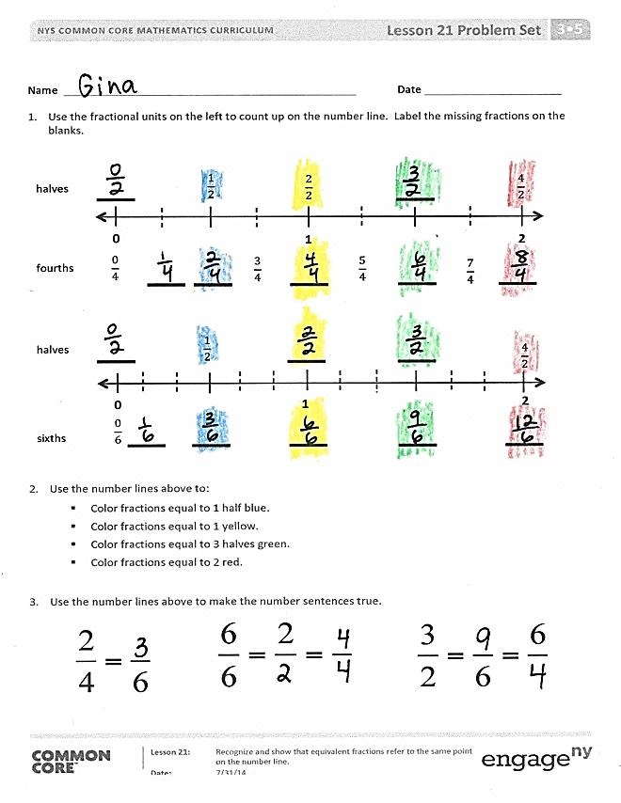
Problem Set (10 minutes)
Students should do their personal best to complete the Problem Set within the allotted 10 minutes. For some classes, it may be appropriate to modify the assignment by specifying which problems they work on first. Some problems do not specify a method for solving. Students should solve these problems using the RDW approach used for Application Problems.
Student Debrief (10 minutes)
Lesson Objective: Recognize and show that equivalent fractions refer to the same point on the number line.
The Student Debrief is intended to invite reflection and active processing of the total lesson experience.

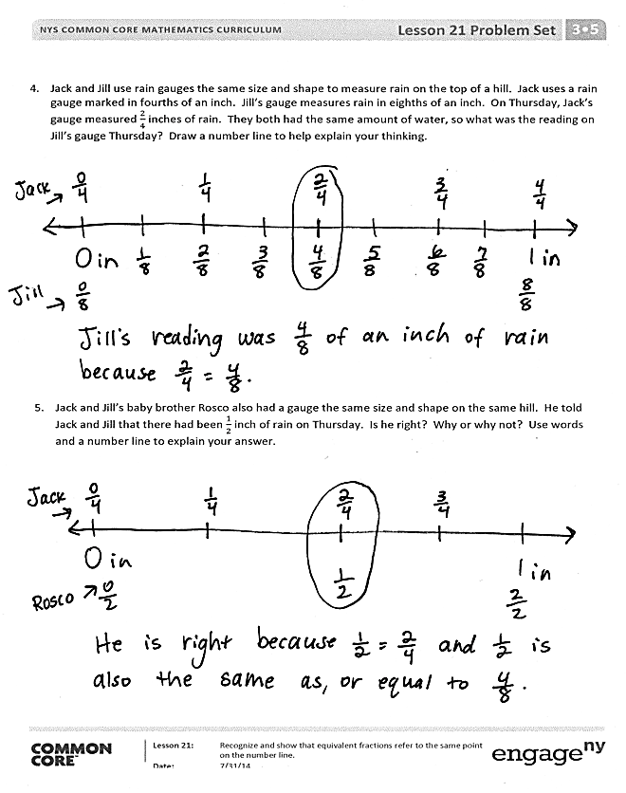
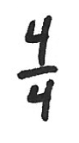
Invite students to review their solutions for the Problem Set. They should check work by comparing answers with a partner before going over answers as a class. Look for misconceptions or misunderstandings that can be addressed in the Debrief. Guide students in a conversation to debrief the Problem Set and process the lesson.
Any combination of the questions below may be used to lead the discussion.
- After students have checked their work for Problems 4 and 5, ask them to use the fraction strips in their math journals to see if they can name another equivalent fraction. ($\frac{3}{6}$ is the only possibility.) Ask students to talk about how they know the fractions are equivalent and possibly plot them on the same number line to emphasize the lesson objective.
- Guide students to articulate that equivalent fractions refer to the same point on the number line. You might stimulate their thinking by asking them to relate fractions strips to the number line. Ensure students are clear on what the word equivalent means and comfortable using it.
- In anticipation of Lesson 22, ask students to look at Problem 4. Ask them to study the fractions equivalent to 1 whole. Have students notice that the number of shaded parts is the same as the total number of parts (numerator and denominator are the same). Have them use the pattern to name other fractions equivalent to 1 whole. Generate excitement by encouraging them to use extremely large numbers, as well as those that are more familiar.
Exit Ticket (3 minutes)
After the Student Debrief, instruct students to complete the Exit Ticket. A review of their work will help with assessing students’ understanding of the concepts that were presented in today’s lesson and planning more effectively for future lessons. The questions may be read aloud to the students.

Name Date
- Use the fractional units on the left to count up on the number line. Label the missing fractions on the blanks.

1
$$\frac{7}{4}$$

$$Aπr^{2}$$
0
2
$$\frac{1}{2}$$

$$Aπr^{2}$$
$$\frac{4}{2}$$

2
$$\frac{5}{4}$$

$$Aπr^{2}$$
$$\frac{3}{4}$$

$$Aπr^{2}$$
$$\frac{2}{2}$$

$$Aπr^{2}$$
$$\frac{0}{4}$$

$$Aπr^{2}$$
$$\frac{1}{2}$$

$$Aπr^{2}$$
$$\frac{4}{2}$$

2
2
0
1
$$\frac{0}{6}$$

$$Aπr^{2}$$
halves

$$Aπr^{2}$$

fourths

$$Aπr^{2}$$

halves

$$Aπr^{2}$$

sixths

$$Aπr^{2}$$

- Use the number lines above to:
- Color fractions equal to 1 half blue.
- Color fractions equal to 1 yellow.
- Color fractions equal to 3 halves green.
- Color fractions equal to 2 red.

- Use the number lines above to make the number sentences true.
- Jack and Jill use rain gauges the same size and shape to measure rain on the top of a hill. Jack uses a rain gauge marked in fourths of an inch. Jill’s gauge measures rain in eighths of an inch. On Thursday, Jack’s gauge measured $\frac{2}{4}$ inches of rain. They both had the same amount of water, so what was the reading on Jill’s gauge Thursday? Draw a number line to help explain your thinking.

- Jack and Jill’s baby brother Rosco also had a gauge the same size and shape on the same hill. He told Jack and Jill that there had been $\frac{1}{2}$ inch of rain on Thursday. Is he right? Why or why not? Use words and a number line to explain your answer.

Name Date
Claire went home after school and told her mother that 1 whole is the same as $\frac{2}{2}$ and $\frac{6}{6}$. Her mother asked why, but Claire couldn’t explain. Use a number line and words to help Claire show and explain why
1 $= \frac{2}{2} = \frac{6}{6}.$

Name Date
- Use the fractional units on the left to count up on the number line. Label the missing fractions on the blanks.

1
$$\frac{7}{4}$$
0
2
$$\frac{2}{4}$$

$$Aπr^{2}$$
$$\frac{8}{4}$$

2
$$\frac{10}{8}$$

$$Aπr^{2}$$
$$\frac{6}{8}$$

$$Aπr^{2}$$
$$\frac{4}{4}$$

$$Aπr^{2}$$
$$\frac{0}{8}$$

$$Aπr^{2}$$
$$\frac{2}{3}$$

$$Aπr^{2}$$
$$\frac{6}{3}$$

2
2
0
1
$$\frac{1}{4}$$

$$Aπr^{2}$$
fourths

$$Aπr^{2}$$
$$\frac{15}{8}$$

$$Aπr^{2}$$
$$\frac{14}{8}$$

$$Aπr^{2}$$
$$\frac{13}{8}$$

$$Aπr^{2}$$
$$\frac{11}{8}$$

$$Aπr^{2}$$
$$\frac{9}{8}$$

$$Aπr^{2}$$
$$\frac{5}{8}$$

$$Aπr^{2}$$
$$\frac{3}{8}$$

$$Aπr^{2}$$
$$\frac{1}{8}$$

$$Aπr^{2}$$
eighths

$$Aπr^{2}$$

$$\frac{0}{3}$$

$$Aπr^{2}$$
$$\frac{4}{3}$$

$$Aπr^{2}$$
thirds

$$Aπr^{2}$$

sixths

$$Aπr^{2}$$

- Use the number lines above to:
- Color fractions equal to 1 purple.
- Color fractions equal to 2 fourths yellow.
- Color fractions equal to 2 blue.
- Color fractions equal to 5 thirds green.
- Write a pair of fractions that are equivalent.

________________ = ________________

- Use the number lines on the previous page to make the number sentences true.

- Mr. Fairfax ordered 3 large pizzas for a class party. Group A ate $\frac{6}{6}$ of the first pizza, and Group B ate $\frac{8}{6}$ of the remaining pizza. During the party, the class discussed which group ate more pizza.

- Did Group A or B eat more pizza? Use words and and pictures to explain your answer to the class.

- Later, Group C ate all remaining slices of pizza. What fraction of the pizza did group C eat? Use words and pictures to explain your answer.

