Lesson 19
Objective: Understand distance and position on the number line as strategies for comparing fractions. (Optional)

Suggested Lesson Structure
 Fluency Practice (12 minutes)
 Application Problem (10 minutes)
 Concept Development (28 minutes)
 Student Debrief (10 minutes)
Total Time (60 minutes)
Fluency Practice (12 minutes)
- Sprint: Express Fractions as Whole Numbers 3.NF.3c (9 minutes)
- Place Fractions on the Number Line 3.NF.2b (3 minutes)
Sprint: Express Fractions as Whole Numbers (9 minutes)
Materials: (S) Express Fractions as Whole Numbers Sprint
Note: This Sprint reviews representing whole number fractions as whole numbers.
Place Fractions on the Number Line (3 minutes)
Materials: (S) Personal white board
Note: This activity reviews the concept of placing fractions on a number line from Topic D.
T: (Draw a number line marked at 0, 1, 2, and 3.) Draw my number line on your personal white board.
S: (Draw.)
T: Estimate to mark and label 1 third on the interval 0 to 1.
S: (Estimate the point between 0 and 1 and write $\frac{1}{3}.$)
T: Write 3 thirds on your number line. Label the point as a fraction.
S: (Write $\frac{3}{3}$ above the 1 on the number line.)
Continue with the following possible sequence, drawing a new number line for the different fractional units: $\frac{6}{3}$, $\frac{9}{3}$, $\frac{4}{3}$, $\frac{7}{3}$, $\frac{2}{3}$, $\frac{8}{3}$, $\frac{1}{2}$, $\frac{2}{2}$, $\frac{4}{2}$, $\frac{3}{2}$, $\frac{5}{2}$, and $\frac{6}{2}$.
Application Problem (10 minutes)

NOTES ON
MULTIPLE MEANS
OF ACTION AND EXPRESSION:
Students working below grade level may benefit from acting out the Application Problem, lining up 2 sheets of paper to make a concrete example.
Note that this problem is different from the problem with the ribbon in Lesson 16. The first hole is not marking 0. 0 is the edge of the paper. Students working below grade level may not pick up on this. For all students, it is important when measuring to be clear about the location of 0.

Thomas has 2 sheets of paper. He wants to punch 4 equally spaced holes along the edge of each sheet.
Draw Thomas’ 2 sheets of paper next to each other so the ends meet. Label a number line from 0 at the start of his first paper to 2 at the end of his second paper. Show Thomas where to hole-punch his papers and label the fractions. What fraction is labeled at the eighth hole?
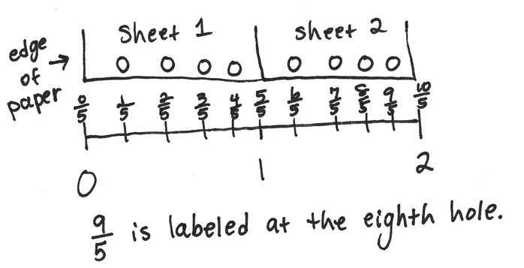

Note: This problem reviews the concept of placing fractions on a number line from Topic D. Also, this Application Problem is used during the Concept Development to discuss the difference between the position of a fraction on a number line and the fraction’s distance from 0.
Concept Development (28 minutes)
Materials: (S) Personal white board

NOTES ON
MULTIPLE MEANS
OF ACTION AND EXPRESSION:
For English language learners, model the directions or use gestures to clarify English language, e.g., extend both arms to demonstrate long.
Give English language learners a little more time to discuss with a partner their math thinking in English.

T: Draw 2 same-sized rectangles on your board, and partition both into 4 equal parts. Shade your top rectangle to show 1 fourth, and shade the bottom to show 3 copies of 1 fourth.
$$\frac{1}{4}$$
$$\frac{3}{4}$$

T: Compare the models. Which shaded fraction is larger? Tell your partner how you know.
S: I know 3 fourths is larger because 3 parts is greater than just 1 part of the same size.
T: Use your rectangles to measure and draw a number line from 0 to 1. Partition it into fourths. Label the wholes and fractions on your number line.
S: (Draw and label the number line.)
T: Talk with your partner to compare 1 fourth to 3 fourths using the number line. How do you know which is the larger fraction?
0 $\frac{1}{4}$ $\frac{2}{4}$ $\frac{3}{4}$ 1
S: 1 fourth is a shorter distance from 0, so it is the smaller fraction. 3 fourths is a greater distance away from 0, so it is the larger fraction.
T: Many of you are comparing the fractions by seeing their distance from 0. You’re right; 1 unit is a shorter distance from 0 than 3 units. If we know where 0 is on the number line, how can it help us find the smaller or larger fraction?
S: The smaller fraction will always be to the left of the larger fraction.
T: How do you know?
S: Because the farther you go to the right on the number line, the farther the distance from 0. That means the fraction to the left is always smaller. It’s closer to 0.
T: Think back to our Application Problem. What were we trying to find? The length of the page from the edge to each hole? Or were we simply finding the location of each hole?
S: The location of each hole.
T: Remember the pepper problem from yesterday? What were we comparing? The length of the peppers or the location of the peppers?
S: We were looking for the length of each pepper.
T: Talk to a partner: What is the same and what is different about the way we solved these problems?
S: In both, we placed fractions on the number line. To do that, we actually had to find the distance of each from 0, too. Yes, but in Thomas’, we were more worried about the position of each fraction, so he’d put the holes in the right places. And in the pepper problem, the distance from 0 to the fraction told us the length of each pepper, and then we compared that.
T: How do distance and position relate to each other when we compare fractions on the number line?
S: You use the distance from 0 to find the fraction’s placement. Or you use the placement to find the distance. So, they’re both part of comparing. The part you focus on just depends on what you’re trying to find out.
T: Relate that to your work on the pepper and hole-punch problems.
S: Sometimes, you focus more on the distance, like in the pepper problem, and sometimes you focus more on the position, like in Thomas’ problem. It depends on what the problem is asking.
T: Try and use both ways of thinking about comparing as you work through the problems on today’s Problem Set.
Problem Set (10 minutes)
Students should do their personal best to complete the Problem Set within the allotted 10 minutes. For some classes, it may be appropriate to modify the assignment by specifying which problems they work on first. Some problems do not specify a method for solving. Students should solve these problems using the RDW approach used for Application Problems.
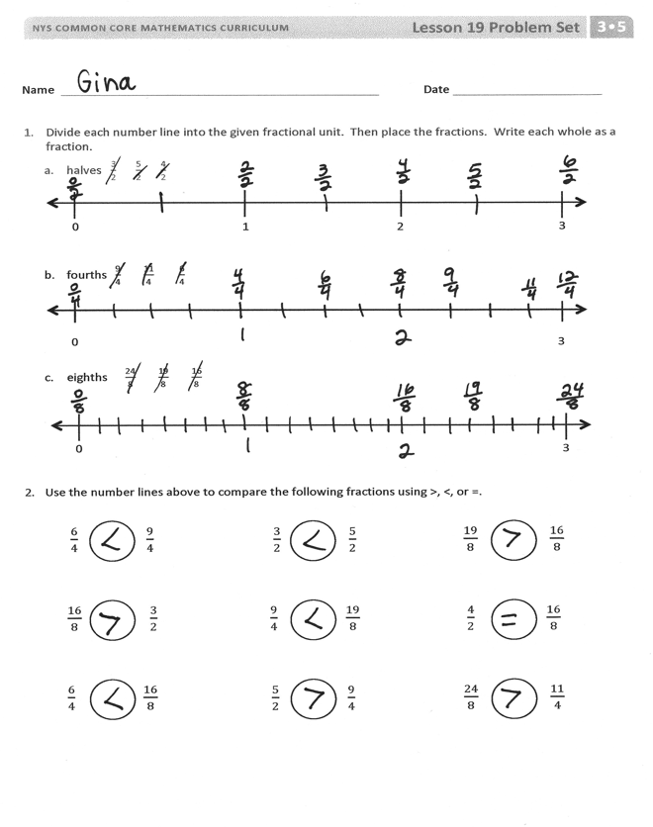
Student Debrief (10 minutes)
Lesson Objective: Understand distance and position on the number line as strategies for comparing fractions. (Optional)
The Student Debrief is intended to invite reflection and active processing of the total lesson experience.
Invite students to review their solutions for the Problem Set. They should check work by comparing answers with a partner before going over answers as a class. Look for misconceptions or misunderstandings that can be addressed in the Debrief. Guide students in a conversation to debrief the Problem Set and process the lesson.
Any combination of the questions below may be used to lead the discussion.
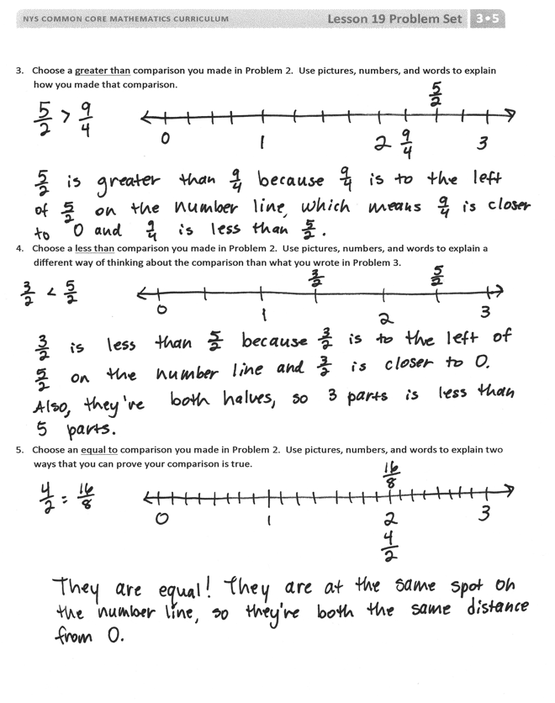
- Invite students to share their work on Problems 3–5. Students should have slightly different explanations for Problems 4 and 5. Invite a variety of responses so that both explanations are heard.
- Extend the lesson by having students work together (or guide them) to create word problems with real world contexts that emphasize different types of comparisons:
  - Create word problems with a context that emphasizes placement of the fraction on a number line (such as the hole-punch problem).
  - Create word problems with a context that emphasizes the distance of the fraction from 0 (such as the pepper problem).
  - Have students solve the problems together and discuss how the context of the problem affects the way in which the solution is delivered.

Exit Ticket (3 minutes)
After the Student Debrief, instruct students to complete the Exit Ticket. A review of their work will help with assessing students’ understanding of the concepts that were presented in today’s lesson and planning more effectively for future lessons. The questions may be read aloud to the students.

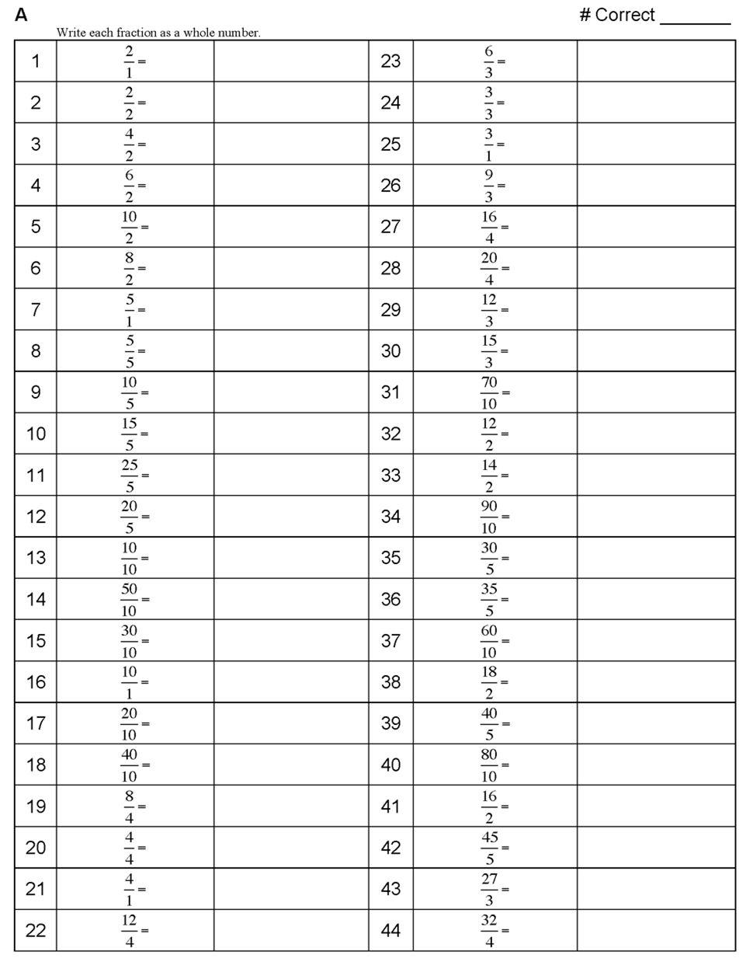

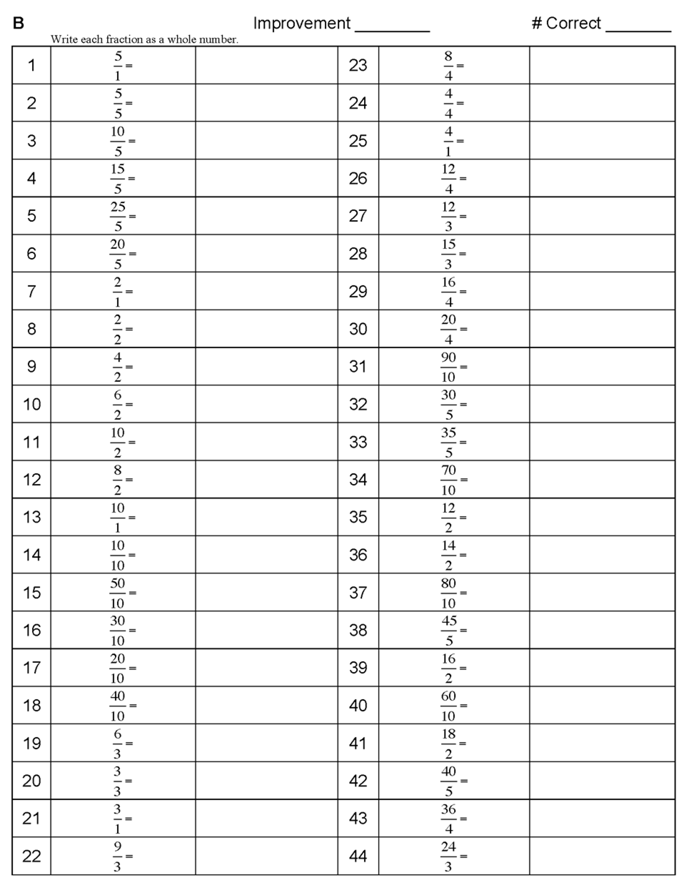

Name Date
- Divide each number line into the given fractional unit. Then, place the fractions. Write each whole as a fraction.
- halves $\frac{\text{3}}{\text{2}} \frac{\text{5}}{\text{2}} \frac{\text{4}}{\text{2}}$
0 1 2
3

- fourths$\frac{\text{9}}{\text{4}} \frac{\text{11}}{\text{4}} \frac{\text{6}}{\text{4}}$
0
3

- eighths $\frac{\text{24}}{\text{8}} \frac{\text{19}}{\text{8}} \frac{\text{16}}{\text{8}}$
0
3

- Use the number lines above to compare the following fractions using >, <, or =.

$\frac{\text{6}}{\text{4}}$ $\frac{\text{9}}{\text{4}}$

$\frac{\text{3}}{\text{2}}$ $\frac{\text{5}}{\text{2}}$

$\frac{\text{19}}{\text{8}}$ $\frac{\text{16}}{\text{8}}$

$\frac{\text{4}}{\text{2}}$ $\frac{\text{16}}{\text{8}}$

$\frac{\text{24}}{\text{8}}$ $\frac{\text{1}\text{1}}{\text{4}}$

$\frac{\text{9}}{\text{4}}$ $\frac{\text{19}}{\text{8}}$

$\frac{\text{5}}{\text{2}}$ $\frac{\text{9}}{\text{4}}$

$\frac{\text{16}}{\text{8}}$ $\frac{\text{3}}{\text{2}}$

$\frac{\text{6}}{\text{4}}$ $\frac{\text{16}}{\text{8}}$

- Choose a greater than comparison you made in Problem 2. Use pictures, numbers, and words to explain how you made that comparison.

- Choose a less than comparison you made in Problem 2. Use pictures, numbers, and words to explain a different way of thinking about the comparison than what you wrote in Problem 3.

- Choose an equal to comparison you made in Problem 2. Use pictures, numbers, and words to explain two ways that you can prove your comparison is true.

Name Date
- Divide the number line into the given fractional unit. Then, place the fractions. Write each whole as a fraction.
fourths $\frac{\text{2}}{\text{4}} \frac{\text{10}}{\text{4}} \frac{7}{\text{4}}$

0 1 2
3

- Use the number line above to compare the following fractions using >, <, or =.

$\frac{\text{3}}{\text{4}}$ $\frac{\text{5}}{\text{4}}$

$\frac{\text{7}}{\text{4}}$ $\frac{\text{4}}{\text{4}}$

$3$ $\frac{6}{\text{4}}$

- Use the number line from Problem 1. Which is larger: 2 wholes or $\frac{9}{4}$? Use words, pictures, and numbers to explain your answer.

Name Date
- Divide each number line into the given fractional unit. Then, place the fractions. Write each whole as a fraction.
- thirds $\frac{6}{3} \frac{5}{3} \frac{8}{3}$
1 2
3

- sixths $\frac{10}{6} \frac{18}{6} \frac{15}{6}$
1 2
3

- fifths $\frac{14}{5} \frac{7}{5} \frac{11}{5}$
1 2
3

- Use the number lines above to compare the following fractions using >, <, or =.
$\frac{\text{17}}{\text{6}}$ $\frac{15}{\text{6}}$

$\frac{\text{7}}{\text{3}}$ $\frac{\text{9}}{\text{3}}$

$\frac{\text{1}\text{1}}{\text{5}}$ $\frac{\text{8}}{\text{5}}$

$\frac{\text{11}}{\text{6}}$ $\frac{\text{5}}{\text{3}}$

$\frac{15}{\text{5}}$ $\frac{5}{\text{3}}$

$\frac{\text{13}}{\text{6}}$ $\frac{\text{8}}{\text{3}}$

$\frac{\text{6}}{\text{3}}$ $\frac{\text{12}}{\text{6}}$

$\frac{\text{4}}{\text{3}}$ $\frac{\text{8}}{\text{6}}$

$\frac{\text{10}}{\text{6}}$ $\frac{3}{\text{3}}$

- Use fractions from the number lines in Problem 1. Complete the sentence. Use words, pictures, or numbers to explain how you made that comparison.

____________ is greater than ____________.

- Use fractions from the number lines in Problem 1. Complete the sentence. Use words, pictures, or numbers to explain how you made that comparison.

____________ is less than ____________.

- Use fractions from the number lines in Problem 1. Complete the sentence. Use words, pictures, or numbers to explain how you made that comparison.

____________ is equal to ____________.

