Lesson 16
Objective: Place whole number fractions and fractions between whole numbers on the number line.

Suggested Lesson Structure
 Fluency Practice (12 minutes)
 Application Problem (7 minutes)
 Concept Development (31 minutes)
 Student Debrief (10 minutes)
Total Time (60 minutes)
Fluency Practice (12 minutes)
- Sprint: Divide by 9 3.OA.4 (7 minutes)
- Counting by Fractional Units 3.NF.1, 3.NF.3c (2 minutes)
- Place Fractions on a Number Line Between 0 and 1 3.NF.2a (3 minutes)
Sprint: Divide by 9 (7 minutes)
Materials: (S) Divide by 9 Sprint
Note: This Sprint supports fluency with division using units of 9.
Counting by Fractional Units (2 minutes)
Note: This activity reviews counting by fractional units and supports students as they work with fractions on the number line in Topic D.
T: Count by halves from 1 half to 6 halves and back to 0.
S: $\frac{1}{2}$, $\frac{2}{2}$, $\frac{3}{2}$, $\frac{4}{2}$, $\frac{5}{2}$, $\frac{6}{2}$, $\frac{5}{2}$, $\frac{4}{2}$, $\frac{3}{2}$, $\frac{2}{2}$, $\frac{1}{2}$, 0.
Continue with the following possible sequence: thirds, fifths, and fourths.
Place Fractions on a Number Line Between 0 and 1 (3 minutes)
Materials: (S) Personal white board
Note: This activity reviews the concept of placing fractions on a number line from Lesson 15.
T: (Draw a number line with endpoints 0 and 1.) Draw my number line on your board.

NOTES ON
MULTIPLE MEANS
OF REPRESENTATION:
Check English language learners’ listening comprehension of math language during the fluency activity Place Fractions on a Number Line Between 0 and 1. Celebrate improvement! “You heard 1 fifth and showed 1 fifth. Great job!”

S: (Draw.)
T: Estimate to mark and label 1 fifth.
S: (Estimate 1 fifth of the distance between 0 and 1 and write $\frac{1}{5}.$)
T: Estimate to mark and label 4 fifths.
S: (Estimate 4 fifths of the distance between 0 and 1 and write $\frac{4}{5}$.)
Continue with the following possible sequence: $\frac{1}{8}$, $\frac{7}{8}$, $\frac{3}{8}$, $\frac{5}{8}$, $\frac{3}{4}$, and $\frac{1}{4}.$
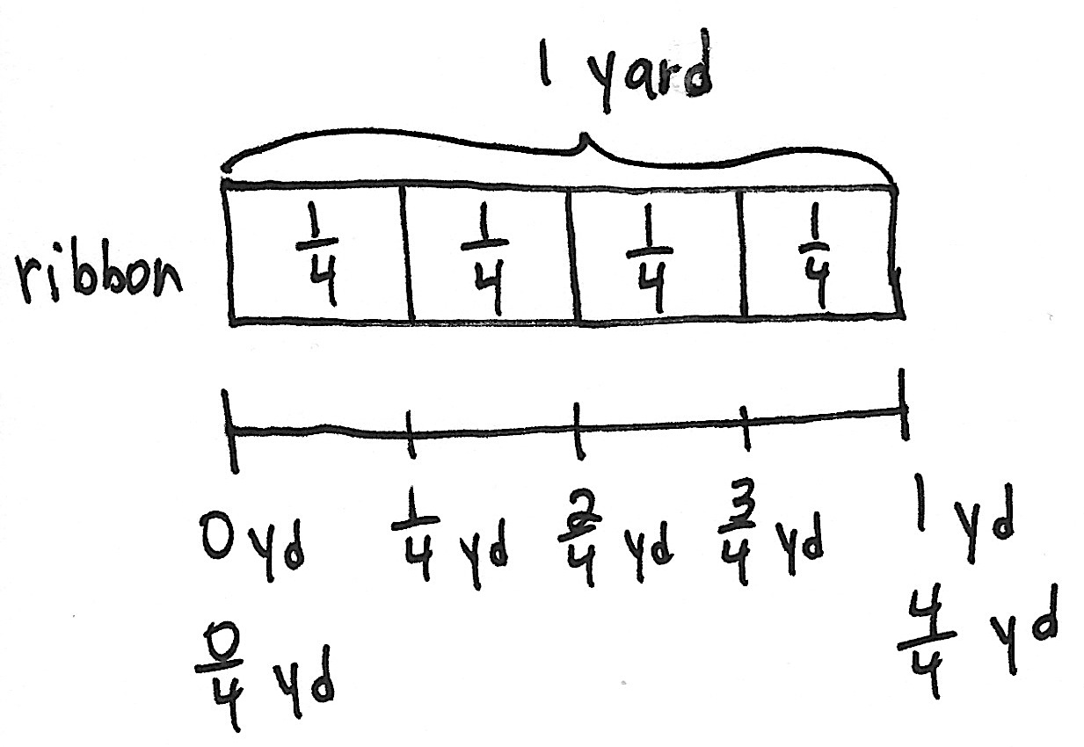
Application Problem (7 minutes)
Hannah bought 1 yard of ribbon to wrap 4 small presents. She wants to cut the ribbon into equal parts. Draw and label a number line from 0 yards to 1 yard to show where Hannah will cut the ribbon. Label all the fractions, including 0 fourths and 4 fourths. Also, label 0 yards and 1 yard.
Note: This problem reviews the concept of placing fractions on a number line from Lessons 14 and 15.
Concept Development (31 minutes)
1 2
Materials: (S) Personal white board
T: Draw a number line on your board with the endpoints 1 and 2. The last few days, our left endpoint was 0. Talk to a partner: Where has 0 gone?

NOTES ON
MULTIPLE MEANS
OF ENGAGEMENT:
If gauging that students working below grade level need it, build understanding with pictures or concrete materials. Extend the number line back to 0. Have students shade in fourths as they count. Use fraction strips as in Lesson 14, if needed.

S: It didn’t disappear; it is to the left of the 1. The arrow on the number line tells us that there are more numbers, but we just didn’t show them.
T: It’s as if we took a picture of a piece of the number line, but those missing numbers still exist. Partition your whole into 4 equal lengths. (Model.)
T: Our number line doesn’t start at 0, so we can’t start at 0 fourths. How many fourths are in 1 whole?
MP.7
S: 4 fourths.
T: We will label 4 fourths at whole number 1. Label the rest of the fractions up to 2. Check your work with a partner. (Allow work time.) What are the whole number fractions—the fractions equal to 1 and 2?
S: 4 fourths and 8 fourths.
$\frac{4}{4}$ $\frac{5}{4}$ $\frac{6}{4}$ $\frac{7}{4}$ $\frac{8}{4}$
1 2
T: Draw boxes around those fractions. (Model.)
T: 4 fourths is the same point on the number line as 1.
We call that equivalence. How many fourths would be equivalent to, or at the same point as, 2?
MP.7
S: 8 fourths.
T: Talk to a partner: What fraction is equivalent to, at the same point as, 3?
S: (After discussion.) 12 fourths.
T: Draw a number line with the endpoints 2 and 4. What whole number is missing from this number line?
2 3 4
S: The number 3.
T: Let’s place the number 3. It should be equally spaced between 2 and 4. Draw that in. (Model.)
T: We will partition each whole number interval into 3 equal lengths. Tell your partner what your number line will look like.
S: (Discuss.)
T: To label the number line that starts at 2, we have to know how many thirds are equivalent to 2 wholes. Discuss with your partner how to find the number of thirds in 2 wholes.
S: 3 thirds made 1 whole. So, 6 units of thirds make 2 wholes. 6 thirds are equivalent to 2 wholes.
T: Fill in the rest of your number line.
2 3 4
$\frac{6}{3}$ $\frac{7}{3}$ $\frac{8}{3}$ $\frac{9}{3}$ $\frac{10}{3}$ $\frac{11}{3}$ $\frac{12}{3}$

Follow with an example using endpoints 3 and 6 so students place 2 whole numbers on the number line, and then partition into halves.

NOTES ON
MULTIPLE MEANS
OF ENGAGEMENT:
Students working above grade level may solve quickly using mental math. Push students to notice and articulate patterns and relationships. As they work in pairs to partition number lines, have students make and analyze their predictions.

Close the guided practice by having students work in pairs. Partner A names a number line with endpoints between 0 and 5 and a unit fraction. Partners begin with halves and thirds. When they have demonstrated that they have done 2 number lines correctly, they may try fourths and fifths, etc. Partner B draws and Partner A assesses. Then, partners switch roles.
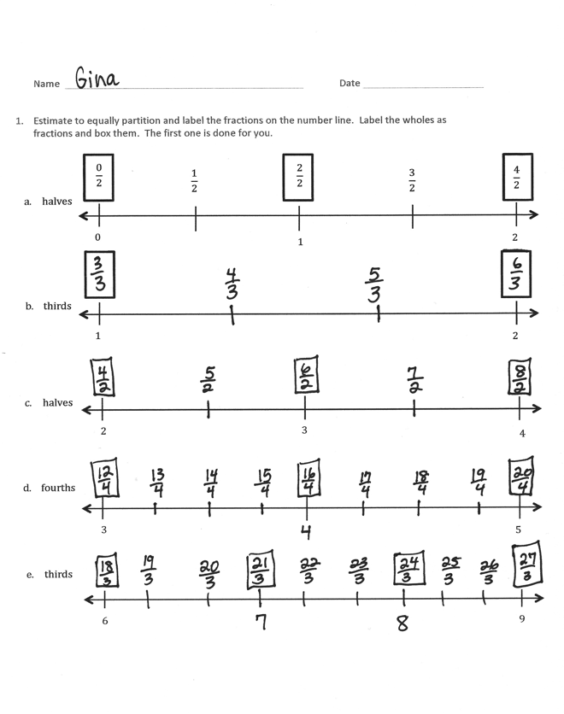
Problem Set (10 minutes)
Students should do their personal best to complete the Problem Set within the allotted 10 minutes. For some classes, it may be appropriate to modify the assignment by specifying which problems they work on first. Some problems do not specify a method for solving. Students should solve these problems using the RDW approach used for Application Problems.
Student Debrief (10 minutes)
Lesson Objective: Place whole number fractions and fractions between whole numbers on the number line.
The Student Debrief is intended to invite reflection and active processing of the total lesson experience.
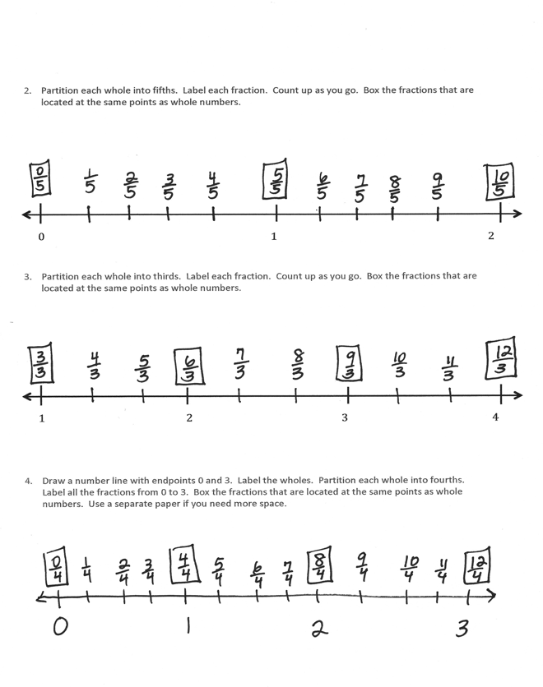
Invite students to review their solutions for the Problem Set. They should check work by comparing answers with a partner before going over answers as a class. Look for misconceptions or misunderstandings that can be addressed in the Debrief. Guide students in a conversation to debrief the Problem Set and process the lesson.
Any combination of the questions below may be used to lead the discussion.
- In Problem 1, what fractions are equivalent to, or at the exact same point as, 3 on the number line?
- What number is equivalent to, or at the exact same point as, 12 fourths in Problem 1?
- Point out Problem 3, which counts 3 thirds, 6 thirds, 9 thirds, and 12 thirds:
- Look at the fractions you boxed in Problem 3. What pattern do you notice?
- What is the connection between multiplication and fractions equal to whole numbers?
- How do you think that strategy might help you find other whole number fractions?

Exit Ticket (3 minutes)
After the Student Debrief, instruct students to complete the Exit Ticket. A review of their work will help with assessing students’ understanding of the concepts that were presented in today’s lesson and planning more effectively for future lessons. The questions may be read aloud to the students.

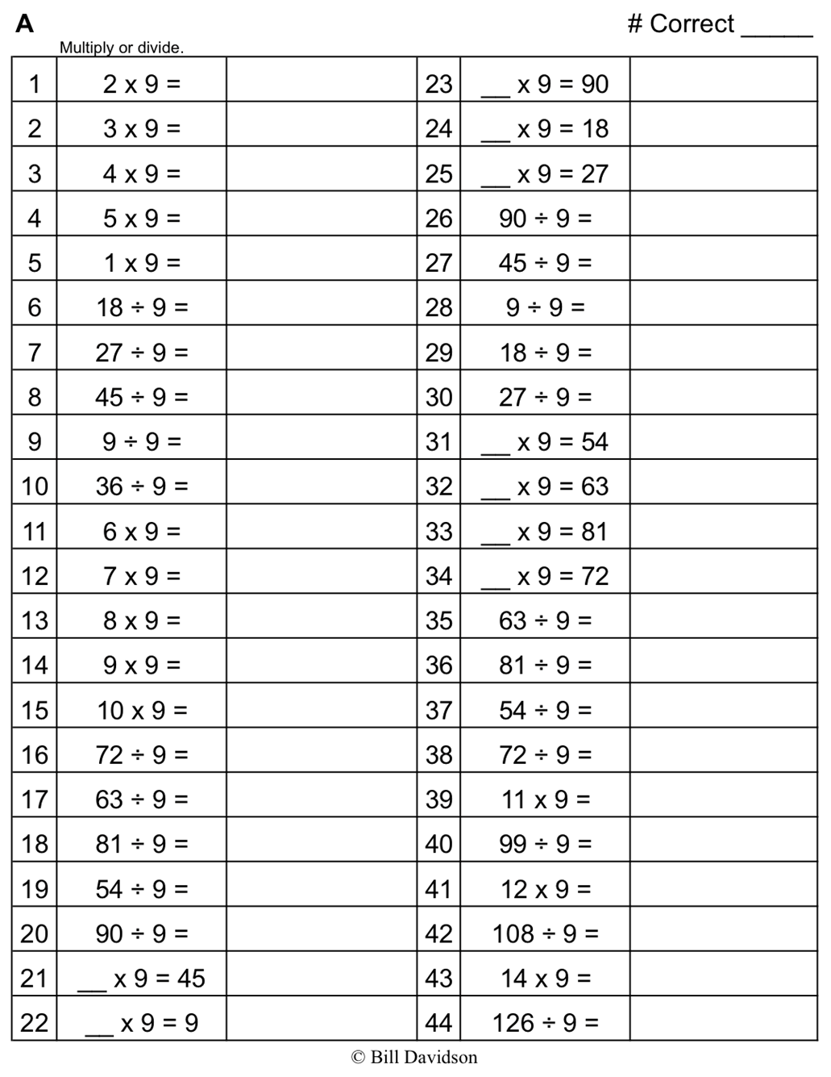

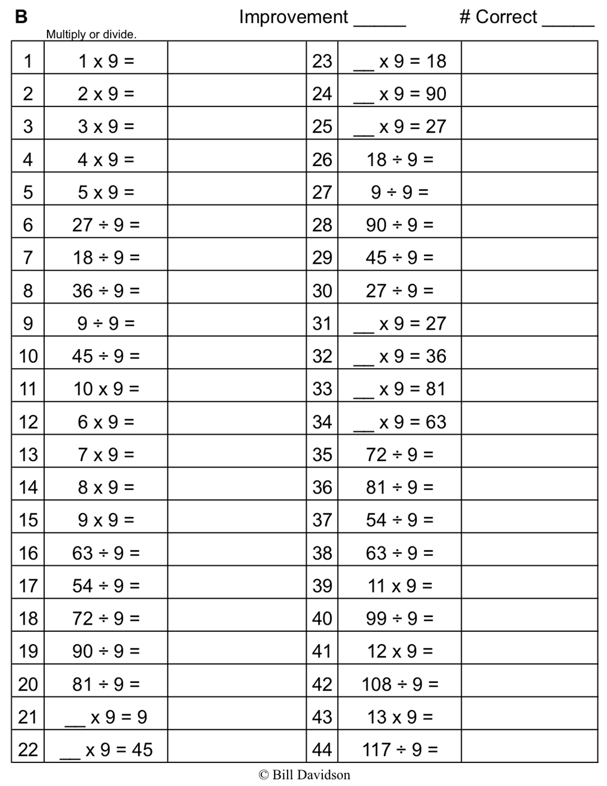

Name Date
- Estimate to equally partition and label the fractions on the number line. Label the wholes as fractions and box them. The first one is done for you.
1

- halves

- thirds

- halves

- fourths

- thirds

$$\frac{2}{2}$$

$$Aπr^{2}$$
$$\frac{4}{2}$$

2
6
1
2
2 3
4
3
5
3 3
9
$$\frac{3}{2}$$

$$Aπr^{2}$$
$$\frac{1}{2}$$

$$Aπr^{2}$$
0
2
$$\frac{0}{2}$$

- Partition each whole into fifths. Label each fraction. Count up as you go. Box the fractions that are located at the same points as whole numbers.

0 1 2

- Partition each whole into thirds. Label each fraction. Count up as you go. Box the fractions that are located at the same points as whole numbers.

1 2 3 4

- Draw a number line with endpoints 0 and 3. Label the wholes. Partition each whole into fourths. Label all the fractions from 0 to 3. Box the fractions that are located at the same points as whole numbers. Use a separate paper if you need more space.

Name Date
- Estimate to equally partition and label the fractions on the number line. Label the wholes as fractions and box them.

2 3
3
fifths

- Draw a number line with endpoints 0 and 2. Label the wholes. Estimate to partition each whole into sixths and label them. Box the fractions that are located at the same points as whole numbers.

Name Date
- Estimate to equally partition and label the fractions on the number line. Label the wholes as fractions and box them. The first one is done for you.
2 3
4
3
5
3 3
9
6
$$\frac{3}{3}$$

$$\frac{9}{3}$$

2
$$\frac{6}{3}$$

$$Aπr^{2}$$
1
3
2
3
2
$$\frac{8}{3}$$

$$Aπr^{2}$$
$$\frac{4}{3}$$

$$Aπr^{2}$$
$$\frac{5}{3}$$

$$Aπr^{2}$$
$$\frac{7}{3}$$

$$Aπr^{2}$$

- thirds

- eighths

- fourths

- halves

- fifths

- Partition each whole into sixths. Label each fraction. Count up as you go. Box the fractions that are located at the same points as whole numbers.

3 4 5

- Partition each whole into halves. Label each fraction. Count up as you go. Box the fractions that are located at the same points as whole numbers.

4 5 6 7

- Draw a number line with endpoints 0 and 3. Label the wholes. Partition each whole into fifths. Label all the fractions from 0 to 3. Box the fractions that are located at the same points as whole numbers. Use a separate paper if you need more space.

