Lesson 14
Objective: Place fractions on a number line with endpoints 0 and 1.

Suggested Lesson Structure
 Fluency Practice (12 minutes)
 Application Problem (7 minutes)
 Concept Development (33 minutes)
 Student Debrief (8 minutes)
Total Time (60 minutes)
Fluency Practice (12 minutes)
- Division 3.OA.2 (8 minutes)
- Counting by Fractional Units 3.NF.1, 3.NF.3 (3 minutes)
- Unit Fractions in 1 Whole 3.NF.1 (1 minute)
Division (8 minutes)
Materials: (T) Timer (S) Personal white board or paper
Note: This activity supports fluency with division facts.
T: Write as many different division facts as you can in the next three minutes. Take your mark, get set, go!
S: (Work independently.)
T: (At three minutes.) Share your work with your partner. Check to see if your partner’s problems are correct.
S: (Work with a partner.)
T: Try again for three minutes. Take your mark, get set, go!
S: (Work independently.)
T: (At three minutes.) Check your work with your partner. Tell your partner what division facts are easy for you.
S: (Work with a partner.)
T: Who improved? How did you improve? What helped you do more problems correctly?

Counting by Fractional Units (3 minutes)

NOTES ON
MULTIPLE MEANS
OF ENGAGEMENT:
- Change directions so that the sequence stays unpredictable.
- React to misunderstandings by repeating transitions until mastery.
- Support by recording on a number line as students count.
- Extend by having students say “1” or “1 whole” instead of a fraction (e.g., “…6 eighths, 7 eighths, 1,
7 eighths, 6 eighths…”).

Note: This activity reviews counting by fractional units and supports students as they work with fractions on the number line in Topic D.
T: Count by eighths from 1 eighth to 8 eighths and back to 0.
S: $\frac{1}{8}, \frac{2}{8}, \frac{3}{8}, \frac{4}{8}, \frac{5}{8}, \frac{6}{8}, \frac{7}{8}, \frac{8}{8}, \frac{7}{8}, \frac{6}{8}, \frac{5}{8}, \frac{4}{8},\frac{3}{8}, \frac{2}{8}, \frac{1}{8}$, 0.
Continue with the following possible sequence: fifths, thirds, and fourths.
Unit Fractions in 1 Whole (1 minute)
Note: This activity reviews how many unit fractions are in 1 whole, which is a skill that the students use during the Concept Development.
T: I’ll say a unit fraction. You say how many there are in 1 whole. 1 fifth.
S: 5. It takes 5 copies of 1 fifth to make 1 whole.
Continue with the following possible sequence: 1 tenth, 1 fourth, 1 third, 1 eighth, and 1 half.
Application Problem (7 minutes)
Mr. Ray is knitting a scarf. He says that he has completed 1 fifth of the total length of the scarf.

NOTES ON
MULTIPLE MEANS
OF REPRESENTATION:
Empower English language learners to solve word problems by activating prior knowledge. Guide students to make personal connections. Discuss their own experiences with knitting and scarves.

Draw a picture of the final scarf. Label what he has finished and what he still has to make. Draw a number bond with 2 parts to show the fraction he has made and the fraction he has not made.
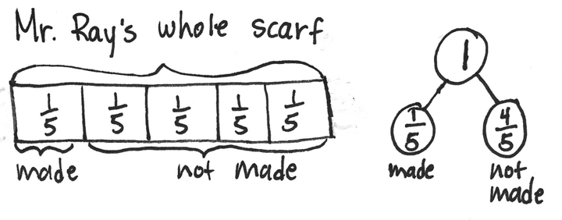

Note: This problem reviews the concept from Lesson 12 of representing the whole when given one equal part.

Concept Development (33 minutes)
Materials: (T) Board space, yardstick, large fraction strip for modeling (S) Fraction strips, blank paper, ruler
Part 1: Measure a line of length 1 whole.
T: (Model the steps below as students follow along on their personal white boards.)
- Draw a horizontal line with your ruler that is a bit longer than one of your fraction strips.
- Place a whole fraction strip just above the line you drew.
- Make a small mark on your line that is even with the left end of your strip.
- Label that mark 0 above the line. This is where we start measuring the length of the strip.
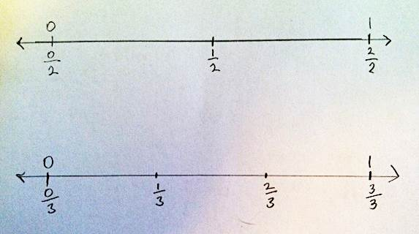
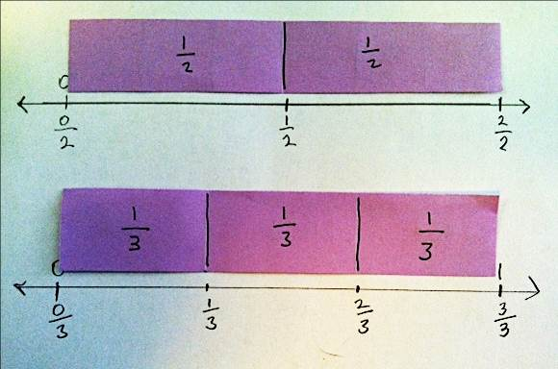
- Make a small mark on your line that is even with the right end of your strip.
MP.7
- Label that mark 1 above the line. If we start at 0, the 1 tells us when we’ve travelled 1 whole length of the strip.
Part 2: Measure the fractions.
T: (Model the steps below as students follow along on their boards.)
- Place your fraction strip with halves above the line.
- Make a mark on the number line at the right end of 1 half. This is the length of 1 half of the fraction strip.
- Label that mark $\frac{1}{2}$. Label 0 halves and 2 halves.
- Repeat the process to measure and label other fractions on a number line.
Part 3: Draw number bonds to correspond to the number lines.
Once students have become excellent at making and labeling fraction number lines using strips to measure, have them draw number bonds to correspond. Use questioning while circulating to help them see similarities and differences between the bonds, fraction strips, and fractions on the number line. If preferred, the following suggestions can be used:

NOTES ON
MULTIPLE MEANS
OF ENGAGEMENT:
This lesson gradually leads the student from the concrete level (fraction strips) to the pictorial level (number lines).

- What do both the number bond and number line show?
- Which model shows you how big the unit fraction is in relation to the whole? Explain how.
- How do your number lines help you make number bonds?
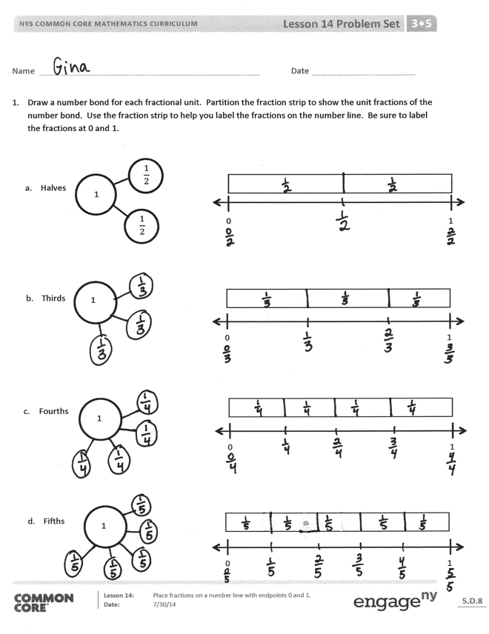
Problem Set (10 minutes)
Students should do their personal best to complete the Problem Set within the allotted 10 minutes. For some classes, it may be appropriate to modify the assignment by specifying which problems they work on first. Some problems do not specify a method for solving. Students should solve these problems using the RDW approach used for Application Problems.
Student Debrief (8 minutes)
Lesson Objective: Place fractions on a number line with endpoints 0 and 1.
The Student Debrief is intended to invite reflection and active processing of the total lesson experience. Invite students to review their solutions for the Problem Set. They should check work by comparing answers with a partner before going over answers as a class. Look for misconceptions or misunderstandings that can be addressed in the Debrief. Guide students in a conversation to debrief the Problem Set and process the lesson.
Any combination of the questions below may be used to lead the discussion.
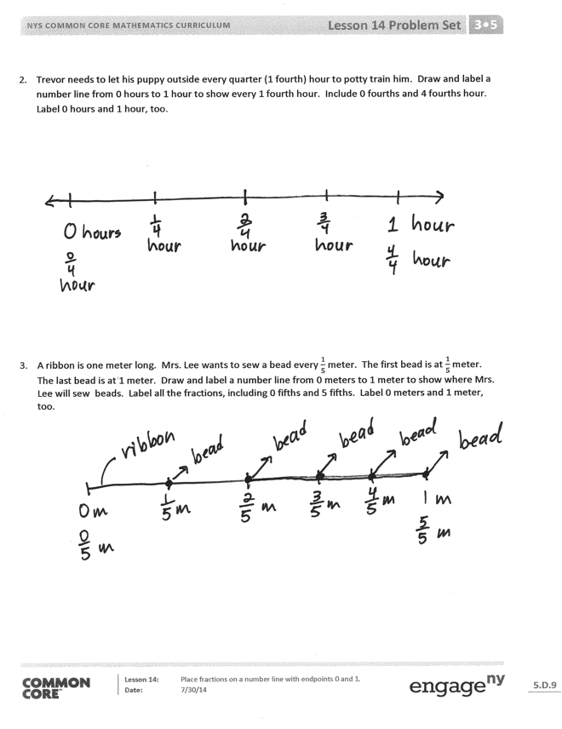
- Look at the number line you made for Problem 3. What does each point on the number line mean? (The following response is possible: “$\frac{1}{5}$ marks the distance from 0—the end of the ribbon—to where Mrs. Lee sews on the first bead.”)
- In Problem 2, the point is a point in time, not the whole length. In Problem 3, the point indicates the location of a bead. Let students have fun with the difference between these two problems. The puppy is in one location, which is like the mark on the line. The ribbon is the entire length. If preferred, the following suggestions can be used to guide the discussion:
  - Think about the units of measure in Problems 2 and 3. How are they the same? How are they different?
  - How does the unit of measure change what’s happening in the problem? How does that change what the number line shows?
  - How does what each number line shows stay the same?
  - Describe the process for labeling fractions on the number line.
  - Why is the fraction strip an important tool to use when labeling fractions on a number line?
  - What does the fraction strip help you measure?
Exit Ticket (3 minutes)
After the Student Debrief, instruct students to complete the Exit Ticket. A review of their work will help with assessing students’ understanding of the concepts that were presented in today’s lesson and planning more effectively for future lessons. The questions may be read aloud to the students.

Name Date
- Draw a number bond for each fractional unit. Partition the fraction strip to show the unit fractions of the number bond. Use the fraction strip to help you label the fractions on the number line. Be sure to label the fractions at 0 and 1.
1
$$\frac{1}{2}$$

$$\frac{1}{2}$$

0 1
0 1
0 1
0 1
- Halves

- Thirds

- Fourths

- Fifths

1

1

1
- Trevor needs to let his puppy outside every quarter (1 fourth) hour to potty train him. Draw and label a number line from 0 hours to 1 hour to show every 1 fourth hour. Include 0 fourths and 4 fourths hour. Label 0 hours and 1 hour, too.

- A ribbon is 1 meter long. Mrs. Lee wants to sew a bead every $\frac{1}{5}$ meter. The first bead is at $\frac{1}{5}$ meter. The last bead is at 1 meter. Draw and label a number line from 0 meters to 1 meter to show where Mrs. Lee will sew beads. Label all the fractions, including 0 fifths and 5 fifths. Label 0 meters and 1 meter, too.

Name Date
- Draw a number bond for the fractional unit. Partition the fraction strip and draw and label the fractions on the number line. Be sure to label the fractions at 0 and 1.
0 1

Sixths

1

Draw number bonds and a number line to help explain Problem 2.
- Ms. Metcalf wants to share $1 equally between 5 students.

- What fraction of a dollar will each student get?

- How much money will each student get?

Name Date
- Draw a number bond for each fractional unit. Partition the fraction strip to show the unit fractions of the number bond. Use the fraction strip to help you label the fractions on the number line. Be sure to label the fractions at 0 and 1.

- Halves

- Eighths

- Fifths

1
$$\frac{1}{2}$$

$$\frac{1}{2}$$

0 1
0 1
1
1
0 1

- Carter needs to wrap 7 presents. He lays the ribbon out flat and says, “If I make 6 equally spaced cuts, I’ll have just enough pieces. I can use 1 piece for each package, and I won’t have any pieces left over.” Does he have enough pieces to wrap all the presents?

- Mrs. Rivera is planting flowers in her 1-meter long rectangular plant box. She divides the plant box into sections $\frac{1}{9}$ meter in length, and plants 1 seed in each section. Draw and label a fraction strip representing the plant box from 0 meters to 1 meter. Represent each section where Mrs. Rivera will plant a seed. Label all the fractions.

- How many seeds will she be able to plant in 1 plant box?

- How many seeds will she be able to plant in 4 plant boxes?

- Draw a number line below your fraction strip and mark all the fractions.

