Lesson 13
Objective: Identify a shaded fractional part in different ways depending on the designation of the whole.

Suggested Lesson Structure
 Fluency Practice (9 minutes)
 Application Problem (5 minutes)
 Concept Development (35 minutes)
 Student Debrief (11 minutes)
Total Time (60 minutes)
Fluency Practice (9 minutes)
- Skip-Count by Fourths on the Clock 3.G.2, 3.NF.1 (3 minutes)
- Division 3.OA.2 (3 minutes)
- Draw a Whole 3.NF.3c (3 minutes)
Skip-Count by Fourths on the Clock (3 minutes)
Materials: (T) Clock
Note: This activity reviews counting by fourths on the clock from Module 2.
T: (Hold or project a clock.) Let’s skip-count by fourths on the clock starting with 1 o’clock.
S: 1, quarter past 1, half past 1, quarter ‘til 2, 2, quarter past 2, half past 2, quarter ‘til 3, 3.
T: Stop. From 3:00, skip-count by fourths backward.
S: 3, quarter ‘til 3, half past 2, quarter past 2, 2, quarter ‘til 2, half past 1, quarter past 1, 1.
Continue counting up and down by fourths.
Division (3 minutes)
Note: This activity reviews division from Modules 1 and 3.
T: (Write 4 ÷ 2 = ____.) Say the number sentence and the answer.
S: 4 divided by 2 equals 2.
Continue with the following possible sequence: 6 ÷ 2, 6 ÷ 3, 8 ÷ 2, 8 ÷ 4, 10 ÷ 2, 10 ÷ 5, 12 ÷ 2, 12 ÷ 6, 12 ÷ 4, and 12 ÷ 3.
Draw a Whole (3 minutes)
Materials: (S) Personal white board
Note: This activity reviews representing the whole when given 1 equal part from Lesson 12.
T: Draw 1 unit on your personal white board.
S: (Draw 1 unit.)
T: Label the unit $\frac{1}{3}$. (After students label.) Now draw a possible whole that corresponds to your unit of $\frac{1}{3}.$
Continue with the following possible sequence: $\frac{1}{5}, \frac{1}{6}, \frac{1}{4},$ and $\frac{1}{2}.$
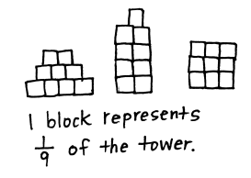
Application Problem (5 minutes)
Davis wants to make a picture using 9 square tiles. What fraction of the picture does 1 tile represent? Draw 3 different ways Davis could make his picture.
Note: This problem reviews identifying the unit fraction from Topic B. Invite students to share their pictures and discuss why their unit fraction is the same, even though their pictures are different.
Concept Development (35 minutes)
Materials: (S) 1 index card (or per pair), black markers, fraction strips, personal white board
T: Fold your index card to make 4 equal units. Shade and label the first unit. Each part is equal to what fraction of the whole?
1 card is 1 whole
$$\frac{1}{4}$$

S: 1 fourth.
T: What is the whole?
S: The index card.
T: With a black marker, trace the outside of your card to show the whole.
1 card is 1 whole
$$\frac{1}{4}$$

T: Flip your index card over so you cannot see the fraction you wrote. The new whole is half of the card. Outline it with marker. (After students outline.) Use your pencil to shade the same amount of space you shaded on the other side. (After students shade.) Talk with your partner about how to label the shaded amount on this side of the card.

NOTES ON
MULTIPLE MEANS
OF ENGAGEMENT:
Have students working above grade level answer an open-ended question, e.g., “What number patterns (or relationships) do you notice?”

$\frac{1}{2}$ card is 1 whole
$$\frac{1}{2}$$

S: The shaded part is $\frac{1}{2}$ because the new whole is different. I see the whole. The shaded part is just half of that.
T: Changing the whole changed the unit fraction that we use to describe the shaded part. What was 1 fourth of the whole card is 1 half of the new, smaller whole.
Display the figure to the right and give students a fraction strip of the same length.
T: This time, the whole is the entire rectangle. Trace the outline of your fraction strip, and then shade to draw the model on your board.
S: (Draw the model.)
T: Tell your partner how you can figure out what fraction is shaded.
S: I can estimate and draw lines to partition the rectangle. I can fold my fraction strip to figure out the unit fraction. Either way, 2 thirds are shaded.
$$\frac{1}{3}$$
$$\frac{1}{3}$$
$$\frac{1}{3}$$
T: Now, use your fraction strip to measure, partition, and label.
T: (Show the figure to the right and have students draw it on their boards using fraction strips for accuracy.) If each of the outlined rectangles represent 1 whole, then what fraction is shaded? Discuss with your partner.
MP.3
S: I can fold my fraction strip to measure the parts. I can estimate to draw lines inside the small rectangles and partition each into 3 equal pieces. Then 1 whole rectangle and 1 third are shaded, or $\frac{4}{3}$.
T: Talk with your partner about why it’s important to know the whole.
S: (Discuss.)

Display the picture to the right.
T: For his birthday, Kyle’s mom brought in cake to share with the class. When she picked up the 2 cake pans at the end of the day, she said, “Wow, your friends ate $\frac{3}{4}$ of the cake.” Kyle said, “No mom, we ate $\frac{6}{4}$ cakes.” Talk to a partner: Who is right? Use pictures, words, or numbers on your boards to help prove your answer.

NOTES ON
MULTIPLE MEANS
OF ACTION AND EXPRESSION:
Support English language learners as they construct their written response to Problem 7. Read the prompt aloud or have students read chorally. Provide sentence starters and a word bank.
Sentence starters may include:
- “I agree with…because…”
- “I think ____ is right because…”
Below are some possible words for the word bank:
specify shaded rectangle
whole fourths halves

S: (Discuss.)
Problem Set (10 minutes)
Students should do their personal best to complete the Problem Set within the allotted 10 minutes. For some classes, it may be appropriate to modify the assignment by specifying which problems they work on first. Some problems do not specify a method for solving. Students should solve these problems using the RDW approach used for Application Problems.
Student Debrief (11 minutes)
Lesson Objective: Identify a shaded fractional part in different ways depending on the designation of the whole.
The Student Debrief is intended to invite reflection and active processing of the total lesson experience.
Invite students to review their solutions for the Problem Set. They should check work by comparing answers with a partner before going over answers as a class. Look for misconceptions or misunderstandings that can be addressed in the Debrief. Guide students in a conversation to debrief the Problem Set and process the lesson.

NOTES ON
MULTIPLE MEANS
OF ENGAGEMENT:
Model a few examples of the Problem Set activities to support students working below grade level. Make sure they can specify the whole. Say, “Trace the whole with your finger.”
To aid partitioning in Part B, cover all but the shaded part.
For Problem 6, have students organize the data with a chart or table to facilitate comparisons, if needed.

Any combination of the questions below may be used to lead the discussion.
- In Problems 6(a)–6(d), box the rope that represents the whole. Circle the rope that represents the part.
- Compare Problems 6(e) and 6(f) to illustrate the part–whole relationship.
- Compare Rope C in Problems 6(a) and 6(d).
- Compare Rope B in Problems 6(a) and 6(d).
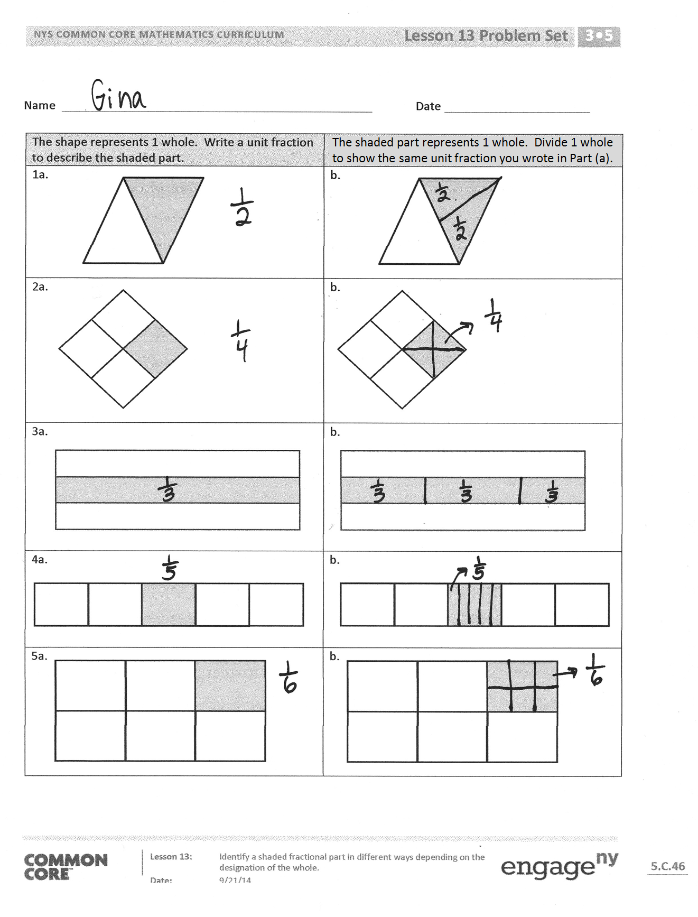
Exit Ticket (3 minutes)
After the Student Debrief, instruct students to complete the Exit Ticket. A review of their work will help with assessing students’ understanding of the concepts that were presented in today’s lesson and planning more effectively for future lessons. The questions may be read aloud to the students.

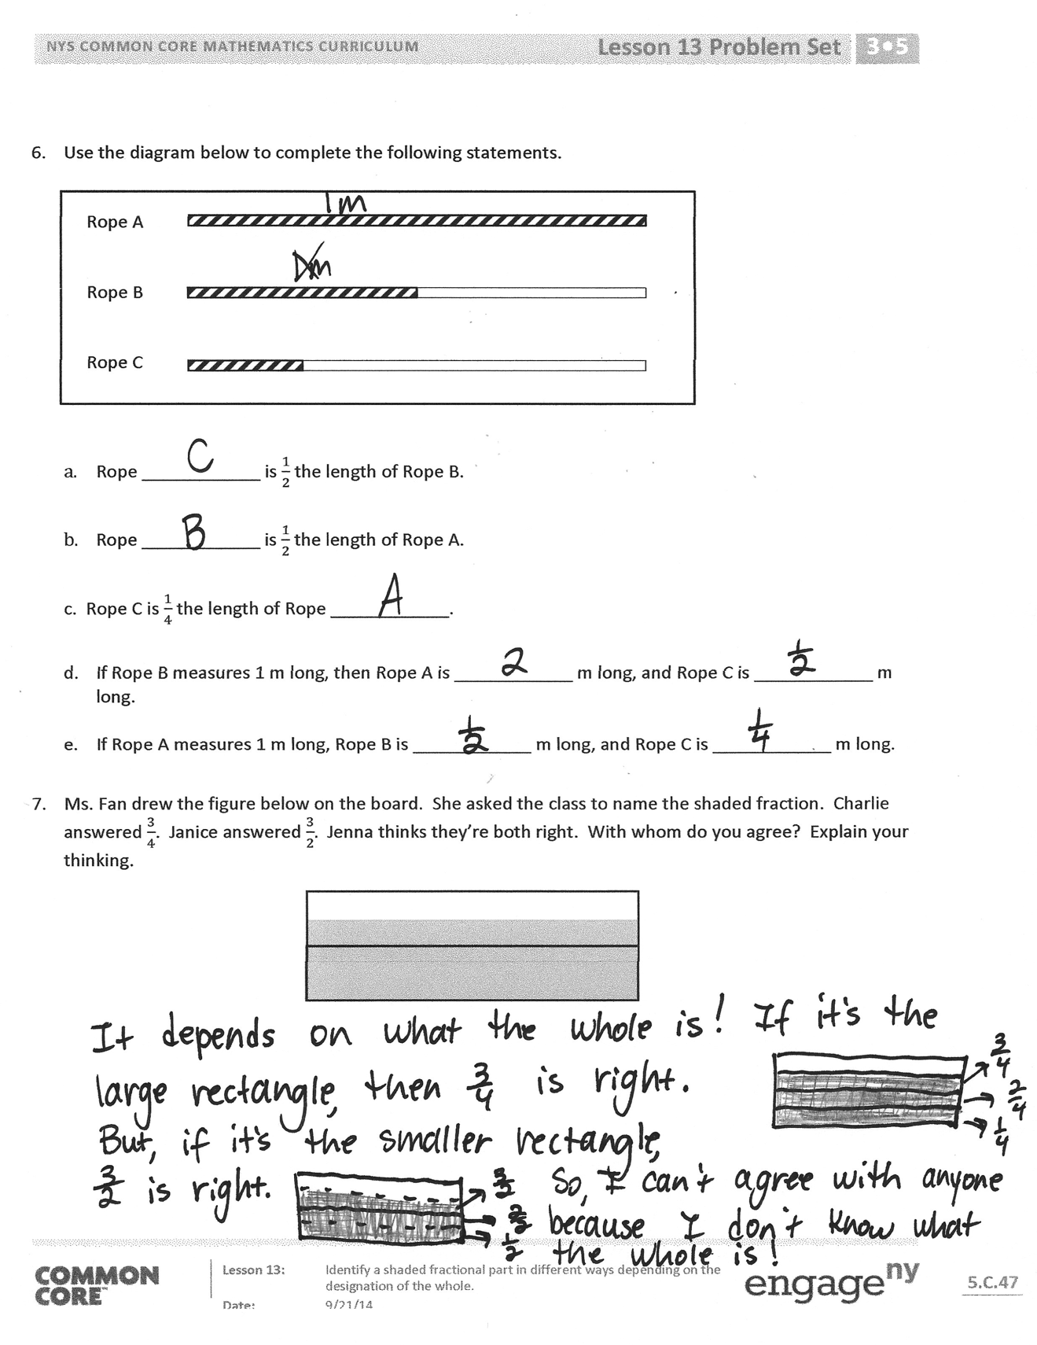

Name Date
The shape represents 1 whole. Write a unit fraction to describe the shaded part. | The shaded part represents 1 whole. Divide 1 whole to show the same unit fraction you wrote in Part (a).
1a. | b.
2a. | b.
3a. | b.
4a. | b.
5a. | b.

- Use the diagram below to complete the following statements.
Rope A

Rope B

Rope C

- Rope ____________ is $\frac{1}{2}$ the length of Rope B.
- Rope ____________ is $\frac{1}{2}$ the length of Rope A.
- Rope C is $\frac{1}{4}$ the length of Rope ____________.
- If Rope B measures 1 m long, then Rope A is ____________ m long, and Rope C is ____________ m long.

- If Rope A measures 1 m long, Rope B is ____________ m long, and Rope C is ____________ m long.
- Ms. Fan drew the figure below on the board. She asked the class to name the shaded fraction. Charlie answered $\frac{3}{4}$. Janice answered $\frac{3}{2}.$ Jenna thinks they’re both right. With whom do you agree? Explain your thinking.

Name Date
Ms. Silverstein asked the class to draw a model showing $\frac{2}{3}$ shaded. Karol and Deb drew the models below. Whose model is correct? Explain how you know.
Deb’s Diagram
Karol’s Diagram

Name Date
The shape represents 1 whole. Write a fraction to describe the shaded part. | The shaded part represents 1 whole. Divide 1 whole to show the same unit fraction you wrote in Part (a).
1a. | b.
2a. | b.
3a. | b.
4a. | b.

- Use the pictures below to complete the following statements.
Towel Rack A
Towel Rack B
Towel Rack C

- Towel Rack ____________ is about $\frac{1}{2}$ the length of Towel Rack C.

- Towel Rack ____________ is about $\frac{1}{3}$ the length of Towel Rack C.

- If Towel Rack C measures 6 ft long, then Towel Rack B is about ____________ ft long, and Towel Rack A is about ____________ ft long.

- About how many copies of Towel Rack A equal the length of Towel Rack C? Draw number bonds to help you.

- About how many copies of Towel Rack B equal the length of Towel Rack C? Draw number bonds to help you.

- Draw 3 strings—B, C, and D—by following the directions below. String A is already drawn for you.
- String B is $\frac{1}{3}$ of String A.
- String C is $\frac{1}{2}$ of String B.
- String D is $\frac{1}{3}$ of String C.

Extension: String E is 5 times the length of String D.

String A

