Lesson 12
Objective: Specify the corresponding whole when presented with one equal part.

Suggested Lesson Structure
 Fluency Practice (12 minutes)
 Application Problem (8 minutes)
 Concept Development (32 minutes)
 Student Debrief (8 minutes)
Total Time (60 minutes)
Fluency Practice (12 minutes)
- Sprint: Multiply with Nine 3.OA.4 (6 minutes)
- Unit and Non-Unit Fractions of 1 Whole 3.G.2, 3.NF.2 (3 minutes)
- More Units Than 1 Whole 3.NF.2b (3 minutes)
Sprint: Multiply with Nine (6 minutes)
Materials: (S) Multiply with Nine Sprint
Note: This Sprint supports fluency with multiplication using units of 9.
Unit and Non-Unit Fractions of 1 Whole (3 minutes)
Materials: (S) Personal white board
Note: This activity reviews naming the shaded and unshaded equal parts of a whole, as well as drawing number bonds to represent the fractional parts of 1 whole.
T: (Draw a shape partitioned in halves with 1 half shaded.) Write the fraction that is shaded.
S: (Write $\frac{1}{2}$.)
T: Write the fraction that is not shaded.
S: (Write $\frac{1}{2}$.)
T: Draw the number bond.
S: (Draw a number bond showing that 1 half and 1 half equals 2 halves.)
Continue with the following possible sequence: $\frac{2}{3}$ and $\frac{1}{3}$, $\frac{4}{5}$ and $\frac{1}{5}$, $\frac{9}{10}$ and $\frac{1}{10}$, and $\frac{7}{8}$ and $\frac{1}{8}$ .
More Units Than 1 Whole (3 minutes)

NOTES ON
MULTIPLE MEANS
OF REPRESENTATION:
In More Units Than 1 Whole, support students working below grade level with pictorial models drawn on personal white boards by either the teacher or the students. Alternatively, begin with halves, thirds, and fourths, gradually progressing to tenths.

Materials: (S) Personal white board (optional)
Note: This activity reviews naming fractions greater than 1 whole from Lesson 9. It may be appropriate for some classes to draw responses on personal white boards for extra support.
T: What’s 1 more fifth than 1 whole?
S: 6 fifths.
T: 2 more fifths than 1 whole?
S: 7 fifths.
Continue with the following possible sequence: 4 fifths, 3 fifths, 1 tenth, 7 tenths, 1 third, 2 thirds, 1 eighth,
5 eighths, 1 sixth, and 5 sixths.
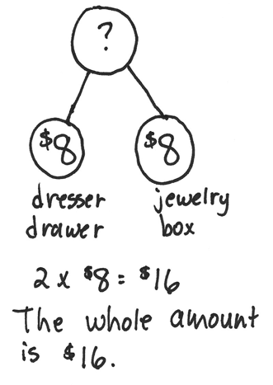
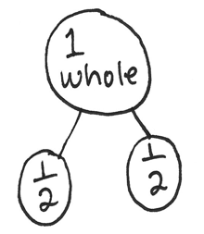
Application Problem (8 minutes)
Jennifer hid half of her birthday money in the dresser drawer.
The other half she put in her jewelry box. If she hid $8 in the drawer, how much money did she get for her birthday?
Note: This problem reviews the concept that 2 halves make 1 whole. Students may solve by adding or multiplying. They might draw a tape diagram or a number bond to model the problem.
Invite students to share their pictures with a partner.
Concept Development (32 minutes)
Materials: (S) Use similar materials to those used in Lesson 4 (at least 75 copies of each), 10-centimeter length of yarn, 4” × 1” rectangular piece of yellow construction paper, 3” × 1” brown paper, 1” × 1” orange square, water, small plastic cups, clay
Exploration: Designate the following stations for groups of 3 (more than 3 not suggested).

NOTES ON
MULTIPLE MEANS
OF ENGAGEMENT:
Organize students working below grade level at the stations with the easier fractional units and students working above grade level at the stations with the most challenging fractional units.

Station A: 1 half and 1 fourth
Station B: 1 half and 1 third
Station C: 1 third and 1 fourth
Station D: 1 third and 1 sixth
Station E: 1 fourth and 1 sixth
Station F: 1 fourth and 1 eighth
Station G: 1 fifth and 1 tenth
Station H: 1 fifth and 1 sixth
The students represent 1 whole using the materials at their stations.
Notes:
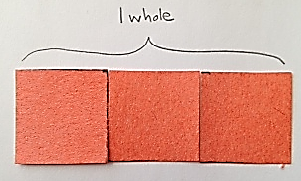
- Each item at the station represents the indicated unit fractions.
- Students show 1 whole corresponding to the given unit fraction. Each station includes 2 objects representing unit fractions, and therefore 2 different whole amounts.
- The entire quantity of each item must be used as the fraction indicated. For example, if showing 1 third with the orange square, the whole must use 3 thirds or 3 of the orange squares (pictured to the right).
T: (Hold up the same size ball of clay—200 g—from Lesson 4.) This piece of clay represents 1 third. What might 1 whole look like? Discuss with your partner.

NOTES ON
MULTIPLE MEANS
OF REPRESENTATION:
Give English language learners a little more time to respond, either in writing or in their first language.

S: (Discuss.)
T: (After discussion, model the whole as 3 equal lumps of clay weighing 600 g.)
T: (Hold up a 12-inch by 1-inch yellow strip.) This strip represents 1 fourth. What might 1 whole look like?
S: (Discuss.)
T: (After discussion, model the whole using 4 equal strips laid end-to-end for a length of 48 inches.)
T: (Show a 12-ounce cup of water.) The water in this cup represents 1 fifth. What might the whole look like? What if the water represents 1 fourth? (Measure the 2 quantities into 2 separate containers.)

NOTES ON
MULTIPLE MEANS
OF ACTION AND EXPRESSION:
The museum walk is a rich opportunity for students to practice language. Pair students and give them sentence frames or prompts to use at each station to help them discuss what they see with their partner.

Give the students 15 minutes to create their display. Next, conduct a museum walk where they tour the work of the other stations. During the tour, students should identify the fractions and think about their relationships. Use the following points to guide the students:
- Identify the unit fraction.
- Think about how the whole amount relates to your own and to other whole amounts.
- Compare the yarn to the yellow strip.
- Compare the yellow strip to the brown paper.

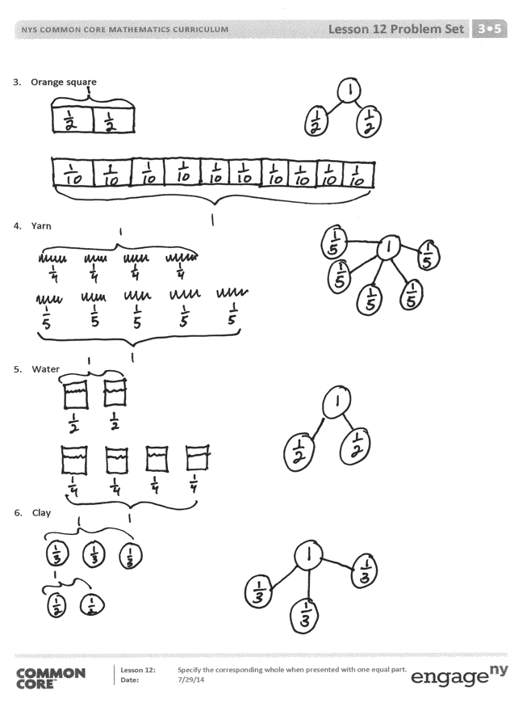
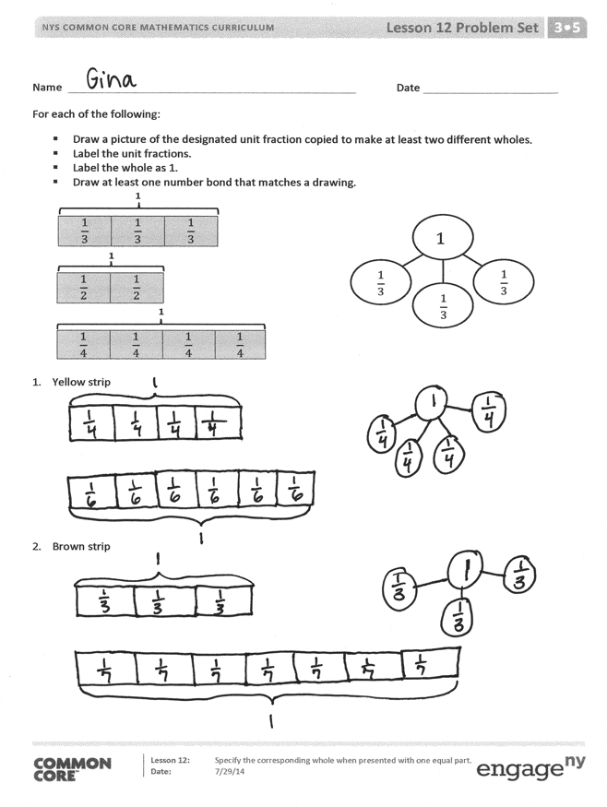
Problem Set (10 minutes)
Students should do their personal best to complete the Problem Set within the allotted 10 minutes. For some classes, it may be appropriate to modify the assignment by specifying which problems they work on first. Some problems do not specify a method for solving. Students should solve these problems using the RDW approach used for Application Problems.
Student Debrief (8 minutes)
Lesson Objective: Specify the corresponding whole when presented with one equal part.
The Student Debrief is intended to invite reflection and active processing of the total lesson experience.
Invite students to review their solutions for the Problem Set. They should check work by comparing answers with a partner before going over answers as a class. Look for misconceptions or misunderstandings that can be addressed in the Debrief. Guide students in a conversation to debrief the Problem Set and process the lesson. Any combination of the questions below may be used to lead the discussion.
- What were the different wholes we saw at each station that were the same?
- What different unit fractions did you see as you went from station to station?
- What did you notice about different unit fractions at the stations?
- Which wholes had the most equal parts?
- Which wholes had the least equal parts?
MP.2
- What surprised you about the different representations of thirds or any other fraction?
- How does the water compare to the clay? The clay to the yarn?
- What if all the wholes were the same size? What would happen to the equal parts?
- Does the picture in Problem 2 show that $\frac{1}{3}$ equals $\frac{1}{7}$? Why or why not? How would you need to change your picture to compare $\frac{1}{3}$ and $\frac{1}{7}$?
Exit Ticket (3 minutes)
After the Student Debrief, instruct students to complete the Exit Ticket. A review of their work will help with assessing students’ understanding of the concepts that were presented in today’s lesson and planning more effectively for future lessons. The questions may be read aloud to the students.

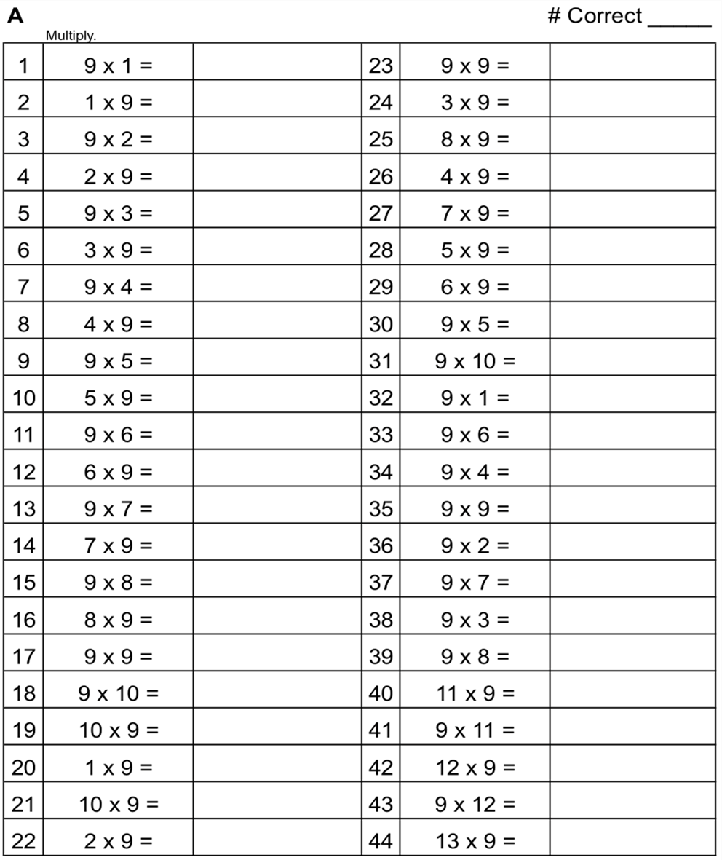

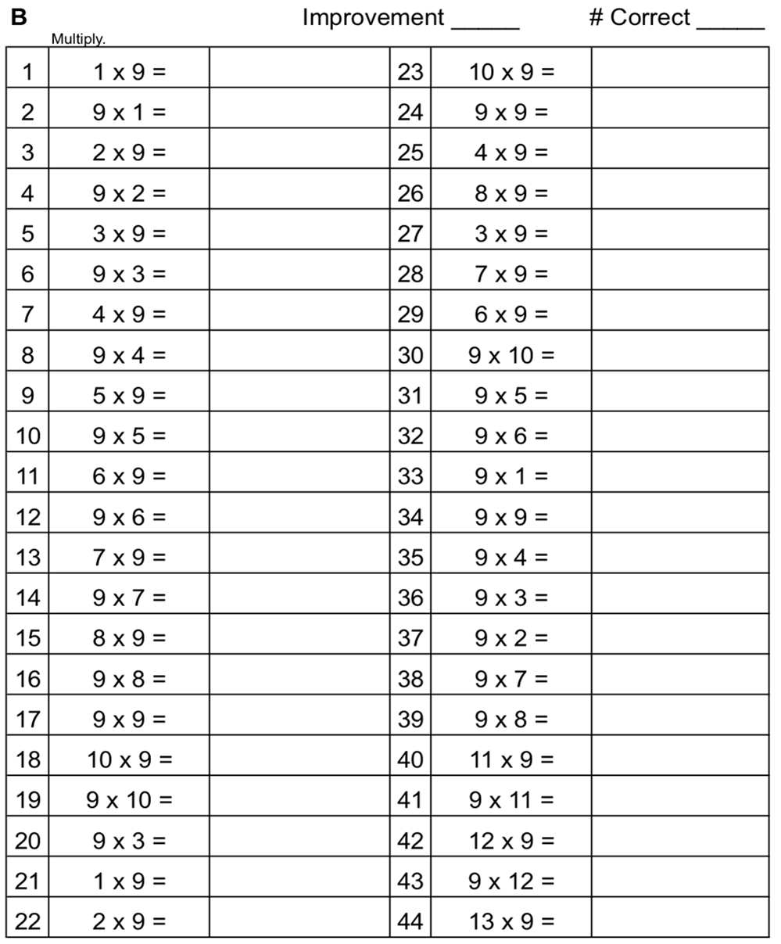

Name Date
For each of the following:
- Draw a picture of the designated unit fraction copied to make at least two different wholes.
- Label the unit fractions.
- Label the whole as 1.
- Draw at least one number bond that matches a drawing.
1
1
1
$$\frac{1}{3}$$ | $$\frac{1}{3}$$ | $$\frac{1}{3}$$

$$\frac{1}{2}$$ | $$\frac{1}{2}$$

$$\frac{1}{4}$$ | $$\frac{1}{4}$$ | $$\frac{1}{4}$$ | $$\frac{1}{4}$$

1
$$\frac{1}{3}$$

$$\frac{1}{3}$$

$$\frac{1}{3}$$

- Yellow strip

- Brown strip

- Orange square

- Yarn

- Water

- Clay

Name Date
Each shape represents the unit fraction. Draw a picture representing a possible whole.
$$\frac{1}{7}$$

$$\frac{1}{9}$$

- Aileen and Jack used the same triangle representing the unit fraction $\frac{1}{4}$ to create 1 whole. Who did it correctly? Explain your answer.
Aileen’s drawing
Jack’s drawing

Name Date
Each shape represents the given unit fraction. Estimate to draw a possible whole.

- $\frac{1}{2}$

- $\frac{1}{6}$

- 1 third

- 1 fourth

Each shape represents the given unit fraction. Estimate to draw a possible whole, label the unit fractions, and draw a number bond that matches the drawing. The first one is done for you.
- $\frac{1}{3}$ | $$\frac{1}{3}$$  $$\frac{1}{3}$$  $$\frac{1}{3}$$ | 1  $$\frac{1}{3}$$  $$\frac{1}{3}$$  $$\frac{1}{3}$$
- $\frac{1}{2}$

- $\frac{1}{5}$

- $\frac{1}{7}$

- Evan and Yong used this shape , representing the unit fraction $\frac{1}{3}$, to draw 1 whole. Shania thinks both of them did it correctly. Do you agree with her? Explain your answer.

Evan’s Shape
Yong’s Shape

