Lesson 11
Objective: Compare unit fractions with different-sized models representing the whole.

Suggested Lesson Structure
 Fluency Practice (8 minutes)
 Application Problem (6 minutes)
 Concept Development (32 minutes)
 Student Debrief (14 minutes)
Total Time (60 minutes)
Fluency Practice (8 minutes)
- Skip-Count by Fourths on the Clock 3.G.2, 3.NF.1 (3 minutes)
- Greater or Less Than 1 Whole 3.G.2, 3.NF.2b (2 minutes)
- Write Fractions Greater Than 1 Whole 3.NF.2b (3 minutes)
Skip-Count by Fourths on the Clock (3 minutes)

NOTES ON
MULTIPLE MEANS
OF ACTION AND EXPRESSION:
Skip-Count by Fourths on the Clock is a valuable opportunity for English language learners to practice everyday math language (time on the clock) within the comforts of choral response.
Scaffold this quick oral fluency activity with hand clocks. As students move the minute hand to reflect the count, they are tangibly partitioning fourths of the clock (the whole).

Materials: (T) Clock
Note: This activity reviews counting by fourths on the clock from Module 2.
T: (Hold or project a clock.) Let’s skip-count by fourths on the clock, starting with 5 o’clock.
S: 5, 5:15, 5:30, 5:45, 6, 6:15, 6:30, 6:45, 7.
Continue with the following possible sequences:
- 5, 5:15, half past 5, 5:45, 6, 6:15, half past 6, 6:45, 7.
- 5, quarter past 5, half past 5, quarter ‘til 6, 6, quarter past 6, half past 6, quarter ‘til 7, 7.

Greater or Less Than 1 Whole (2 minutes)
Note: This activity reviews identifying fractions greater and less than 1 whole.
T: (Write $\frac{1}{2}.$) Is this greater or less than 1 whole?
S: Less!
Continue with the following possible sequence: $\frac{1}{2}, \frac{3}{2}, \frac{1}{3}, \frac{2}{3}, \frac{4}{3}, \frac{5}{3}, \frac{3}{4}, \frac{5}{4}, \frac{11}{10}, \frac{9}{10}, \frac{11}{8}, \frac{5}{8}, \frac{11}{6}, \frac{5}{6}, \frac{11}{12},$ and $\frac{13}{12}$. It may be appropriate for some classes to draw responses on personal white boards for extra support.
Write Fractions Greater Than 1 Whole (3 minutes)
Materials: (S) Personal white board
Note: This activity reviews writing fractions greater than 1 whole from Lesson 9. As students build confidence, omit the first 2 questions.
T: How many halves are in 1 whole?
S: 2 halves.
T: What’s 1 more half than 2 halves?
S: 3 halves.
T: Write a fraction on your personal white board that is 1 more half than 1 whole.
S: (Write $\frac{3}{2}$.)
Continue with the following possible sequence: $\frac{1}{3}, \frac{1}{4}, \frac{1}{5}, \frac{1}{10}, \frac{1}{6},$ and $\frac{1}{8}.$
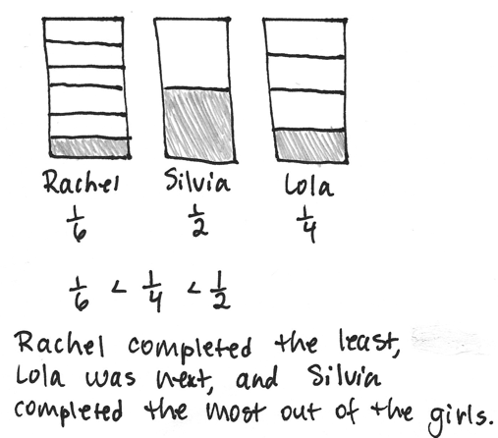
Application Problem (6 minutes)
Rachel, Silvia, and Lola each received the same homework assignment and only completed part of it. Rachel completed $\frac{1}{6}$ of her homework, Silvia completed $\frac{1}{2}$ of her homework, and Lola completed $\frac{1}{4}$ of her homework. Write the amount of homework each girl completed from least to greatest. Draw a picture to prove your answer.

Note: This problem reviews comparing unit fractions from Lesson 10. If time allows, revisit this problem during today’s Debrief. Ask students if they need to adjust their pictures based on what they learned today about comparing fractions.

Concept Development (32 minutes)
Materials: (T) 2 different-sized clear plastic cups, food coloring, water (S) Personal white board
T: (Write 1 is the same as 1.) Show thumbs up if you agree, thumbs down if you disagree.
S: (Show thumbs up or thumbs down.)
T: 1 liter of soda and 1 can of soda. (Draw pictures or show objects.) Is 1 still the same as 1? Turn and talk to your partner.
S: Yes, they’re still the same amount. No, a liter and a can are different. How many stays the same, but a liter is larger than a can, so how much in each is different.
T: How many and how much are important to our question. In this case, what each thing is changes it, too. Because a liter is larger, it has more soda than a can. Talk to a partner: How does this change your thinking about 1 is the same as 1?
MP.6
S: If the thing is larger, then it has more. Even though the number of things is the same, what it is might change how much of it there is. If what it is and how much it is are different, then 1 and 1 aren’t exactly the same.
T: As you compare 1 and 1, I hear you say that the size of the whole and how much is in it matters. The same is true when comparing fractions.
T: For breakfast this morning, my brother and I each had a glass of juice. (Present different-sized glasses partitioned into halves and fourths.) What fraction of my glass has juice?
My glass My brother’s glass
S: 1 fourth.
T: What fraction of my brother’s glass has juice?
S: 1 half.
T: When the wholes are the same, 1 half is greater than 1 fourth. Does this picture prove that? Discuss it with your partner.
S: 1 half is always larger than 1 fourth. It looks like you might have drunk more, but the wholes aren’t the same. The glasses are different sizes—like the can and the liter. We can’t really compare.
T: I’m hearing you say that we have to consider the size of the whole when we compare fractions.
To further illustrate the point, pour each glass of juice into containers that are the same size. It may be helpful to purposefully select your containers so that 1 fourth of the large glass is the larger quantity.

To transition into the pictorial work with wholes that are the same, offer another concrete example. This time use rectangular shaped wholes that are different in size, such as those shown to the right.

T: Let’s see how comparison changes when our wholes are the same. On your board, draw two rectangles that are the same size. Partition each into thirds.

NOTES ON
MULTIPLE MEANS
OF ENGAGEMENT:
Many students, including those working below grade level, may benefit from having pre-drawn wholes of the same shape and size.

S: (Draw and partition rectangles.)
T: Now, partition the first rectangle into sixths.
S: (Partition the first rectangle from thirds to sixths.)

T: Shade the unit fraction in each rectangle. Label your models and use the words greater than or less than to compare.
is less than
$\frac{1}{6}$ is less than $\frac{1}{3}$

S: (Shade, label, and compare models.)
T: Does this picture prove that 1 sixth is less than 1 third? Why or why not? Discuss with your partner.
S: Yes, because the shapes are the same size. One is just cut into more pieces than the other. We know the pieces are smaller if there are more of them, as long as the whole is the same.
Demonstrate with more examples if necessary, perhaps rotating one of the shapes so it appears different but does not change in size.
Problem Set (10 minutes)

NOTES ON
MULTIPLE MEANS
OF ENGAGEMENT:
The open-ended nature of Problems 1─8 on the Problem Set helps meet the needs of students working above grade level. Encourage creative solutions and maintain high expectations for precision and reasoning.

Students should do their personal best to complete the Problem Set within the allotted 10 minutes. For some classes, it may be appropriate to modify the assignment by specifying which problems they work on first. Some problems do not specify a method for solving. Students should solve these problems using the RDW approach used for Application Problems.

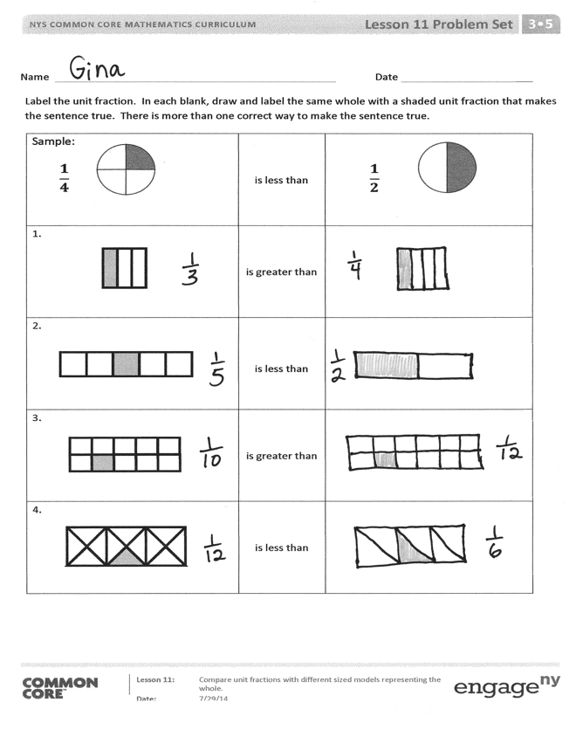
Student Debrief (14 minutes)
Lesson Objective: Compare unit fractions with different-sized models representing the whole.
The Student Debrief is intended to invite reflection and active processing of the total lesson experience.
Invite students to review their solutions for the Problem Set. They should check work by comparing answers with a partner before going over answers as a class. Look for misconceptions or misunderstandings that can be addressed in the Debrief. Guide students in a conversation to debrief the Problem Set and process the lesson.
Any combination of the questions below may be used to lead the discussion.
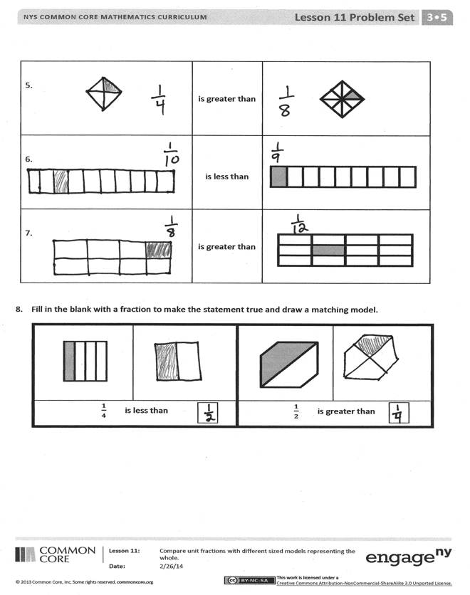
- Problem 10 presents wholes that are clearly different sizes, and also different shapes. Students may already have questioned this as they moved through the Problem Set. If so, consider crediting the student(s) who asked, and then pose the question to the rest of the class for discussion. The question of shape need not be answered today since it will be specifically addressed in Lesson 20. However, allowing the class to grapple with the question now may provide useful information that guides the delivery of Lesson 20.
- Guide a conversation through which students understand that to compare wholes numerically, they must be the same size. Consider closing by having students redraw the diagrams in Problem 9 so that Elizabeth is correct, and in Problem 10 so that Manny is correct.

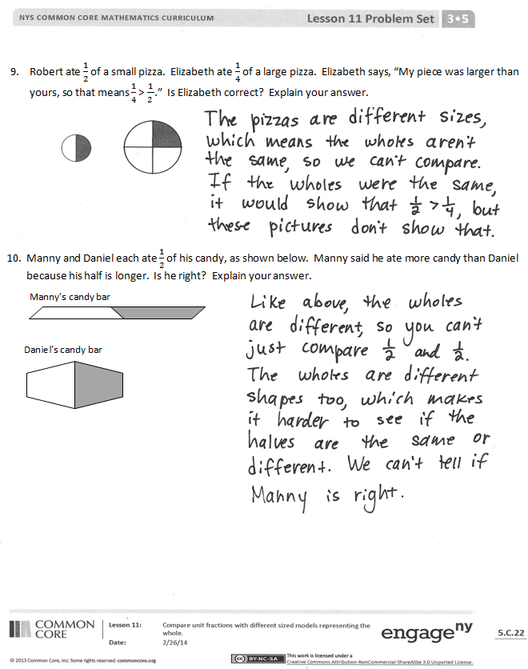
Exit Ticket (3 minutes)
After the Student Debrief, instruct students to complete the Exit Ticket. A review of their work will help with assessing students’ understanding of the concepts that were presented in today’s lesson and planning more effectively for future lessons. The questions may be read aloud to the students.

Name Date
Label the unit fraction. In each blank, draw and label the same whole with a shaded unit fraction that makes the sentence true. There is more than 1 correct way to make the sentence true.
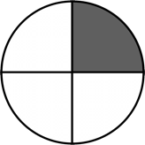  Sample:  $$\frac{1}{4}$$ | is less than | $$\frac{1}{2}$$
1. | is greater than
2. | is less than
3. | is greater than
4. | is less than
5. | is greater than
6. | is less than
7. | is greater than

- Fill in the blank with a fraction to make the statement true and draw a matching model.
$\frac{1}{4}$ is less than |  | $\frac{1}{2}$ is greater than

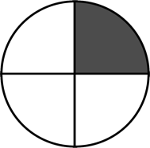
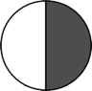
- Robert ate $\frac{1}{2}$ of a small pizza. Elizabeth ate $\frac{1}{4}$ of a large pizza. Elizabeth says, “My piece was larger than yours, so that means $\frac{1}{4}$ > $\frac{1}{2 }$.” Is Elizabeth correct? Explain your answer.

- Manny and Daniel each ate $\frac{1}{2}$ of his candy, as shown below. Manny said he ate more candy than Daniel because his half is longer. Is he right? Explain your answer.
Manny’s candy bar
Daniel’s candy bar

Name Date
- Fill in the blank with a fraction to make the statement true. Draw a matching model.
$\frac{1}{7}$ is less than |  | $\frac{1}{4}$ is greater than

- Tatiana ate $\frac{1}{2}$ of a small carrot. Louis ate $\frac{1}{4}$ of a large carrot. Who ate more? Use words and pictures to explain your answer.

Name Date
Label the unit fraction. In each blank, draw and label the same whole with a shaded unit fraction that makes the sentence true. There is more than 1 correct way to make the sentence true.
Sample:  $$\frac{1}{3}$$ | is less than | $$\frac{1}{2}$$
1. | is greater than
2. | is less than
3. | is greater than
4. | is less than
5. | is greater than
6. | is less than
7. | is greater than

- Fill in the blank with a fraction to make the statement true. Draw a matching model.
$\frac{1}{6}$ is greater than |  | $\frac{1}{5}$ is less than
$\frac{1}{3}$ is less than |  | $\frac{1}{2}$ is greater than
- Debbie ate $\frac{1}{8}$ of a large brownie. Julian ate $\frac{1}{2}$ of a small brownie. Julian says, “I ate more than you because $\frac{1}{2}>\frac{1}{8}$.”

- Use pictures and words to explain Julian’s mistake.

- How could you change the problem so that Julian is correct? Use pictures and words to explain.

