Lesson 10
Objective: Compare unit fractions by reasoning about their size using fraction strips.

Suggested Lesson Structure
 Fluency Practice (12 minutes)
 Application Problem (6 minutes)
 Concept Development (32 minutes)
 Student Debrief (10 minutes)
Total Time (60 minutes)
Fluency Practice (12 minutes)
- Sprint: Divide by Eight 3.OA.4 (9 minutes)
- Skip-Count by Fourths on the Clock 3.G.2, 3.NF.1 (2 minutes)
- Greater or Less Than 1 Whole 3.G.2, 3.NF.2 (1 minute)
Sprint: Divide by Eight (9 minutes)
Materials: (S) Divide by Eight Sprint
Note: This Sprint supports fluency with division using units of 8.
Skip-Count by Fourths on the Clock (2 minutes)
Materials: (T) Clock
Note: This activity reviews counting by fourths on the clock from Module 2.
T: (Hold or project a clock.) Let’s skip-count by fourths on the clock starting with 1 o’clock.
S: 1, 1:15, 1:30, 1:45, 2, 2:15, 2:30, 2:45, 3.
Continue with the following possible sequences:
- 1, 1:15, half past 1, 1:45, 2, 2:15, half past 2, 2:45, 3.
- 1, quarter past 1, half past 1, quarter ‘til 2, 2, quarter past 2, half past 2, quarter ‘til 3, 3.

Greater or Less Than 1 Whole (1 minute)
Note: This activity reviews identifying fractions greater and less than 1 whole.
T: (Write $\frac{1}{2}.$) Greater or less than 1 whole?
S: Less!
Continue with the following possible sequence: $\frac{3}{2}, \frac{5}{4}, \frac{3}{4 }, \frac{3}{7}, \frac{5}{3},$ and $\frac{5}{2}$. It may be appropriate for some classes to draw responses on personal white boards for extra support.
Application Problem (6 minutes)

NOTES ON
MULTIPLE MEANS
OF ENGAGEMENT:
Scaffold solving the Application Problem for students working below grade level with step-by-step questioning. For example, ask the following:
- “How much soup does 1 family receive?” (1 third of the batch of soup.)
- “2 families?” (2 thirds.)
- “3 families?” (3 thirds or 1 whole batch of soup.)
- “Does Sarah have to make more than 1 batch?” (Yes.)
- “How much of the second batch will she give away?” (2 thirds.)
- “How much will remain?” (1 third.)

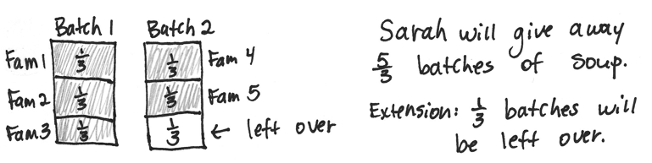
Sarah makes soup. She divides each batch equally into thirds to give away. Each family that she makes soup for gets 1 third of a batch. Sarah needs to make enough soup for 5 families. How much soup does Sarah give away? Write your answer in terms of batches.
Extension: What fraction will be left over for Sarah?
Note: This problem reviews writing fractions greater than 1 whole from Lesson 9.
Concept Development (32 minutes)
Materials: (S) Folded fraction strips (halves, thirds, fourths, sixths, and eighths) from Lesson 9, personal white board, 1 set of <, >, = cards per pair
T: Take out the fraction strips you folded yesterday.
S: (Take out strips folded into halves, thirds, fourths, sixths, and eighths.)
T: Look at the different units. Take a minute to arrange the strips in order from the largest to the smallest unit.
S: (Place the fraction strips in order: halves, thirds, fourths, sixths, and eighths.)
MP.2
T: Turn and talk to your partner about what you notice.
S: Eighths are the smallest even though the number 8 is the biggest. When the whole is folded into more units, each unit is smaller. I only folded once to get halves, and they’re the biggest.
T: Look at 1 half and 1 third. Which unit fraction is larger?
S: 1 half.
T: Explain to your partner how you know.
MP.2
S: I can just see 1 half is larger on the strip. When you split it between 2 people, the pieces are larger than if you split it between 3 people. There are fewer pieces, so the pieces are larger.
Continue with other examples using the fraction strips as necessary.
T: What happens when we aren’t using fraction strips? What if we’re talking about something round, like a pizza? Is 1 half still larger than 1 third? Turn and talk to your partner about why or why not.
S: I’m not sure. Sharing a pizza between 3 people is not as good as sharing it between 2 people. I think pieces that are halves are still larger. I agree because the number of parts doesn’t change even if the shape of the whole changes.
T: Let’s make a model and see what happens. Draw 5 circles that are the same size to represent pizzas on your personal white board.
S: (Draw.)
T: Estimate to partition the first circle into halves. Label the unit fraction.
S: (Draw and label.)
T: Estimate to partition the second circle into thirds. (Model if necessary.) Label the unit fraction.
S: (Draw and label.)
T: The more we cut, what’s happening to our pieces?
S: They’re getting smaller!
T: So, is 1 third still smaller than 1 half?
S: Yes!
T: Partition your remaining circles into fourths, sixths, and eighths. Label the unit fraction in each one.
S: (Draw and label.)
T: Compare your drawings to your fraction strips. Talk to a partner: Do you notice the same pattern as with your fraction strips?
S: (Discuss.)
Continue with other real world examples if necessary.

NOTES ON
MULTIPLE MEANS
OF ACTION AND EXPRESSION:
This partner activity benefits English language learners as it includes repeated use of math language in a reliable structure (e.g., “__ is greater than __”). It also offers the English language learner an opportunity to discuss the math with a peer, which may be more comfortable than speaking in front of the class or to the teacher.

T: Let’s compare unit fractions. For each turn, you and your partner will each choose any single fraction strip. Choose now.
S: (Choose a strip to play.)
T: Now, compare unit fractions by folding to show only the unit fraction. Then, place the appropriate symbol card (<, >, or =) on the table between your strips.
S: (Fold, compare, and place symbol cards.)
T: (Hold symbol cards face down.) I will flip one of my symbol cards to see if the unit fraction that is greater than or less than wins this round. If I flip equals, it’s a tie. (Flip a card.)
Continue at a rapid pace for a few rounds.
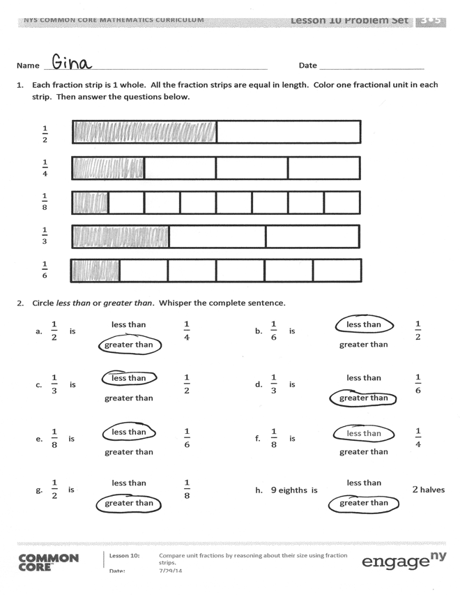
Problem Set (10 minutes)
Students should do their personal best to complete the Problem Set within the allotted 10 minutes. For some classes, it may be appropriate to modify the assignment by specifying which problems they work on first. Some problems do not specify a method for solving. Students should solve these problems using the RDW approach used for Application Problems.
Student Debrief (10 minutes)
Lesson Objective: Compare unit fractions by reasoning about their size using fraction strips.
The Student Debrief is intended to invite reflection and active processing of the total lesson experience.
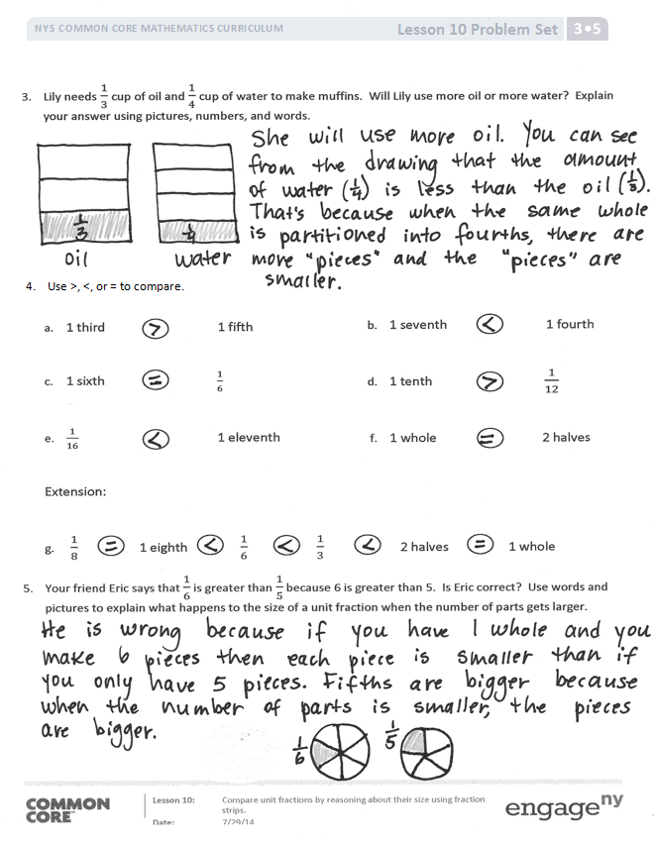
Invite students to review their solutions for the Problem Set. They should check work by comparing answers with a partner before going over answers as a class. Look for misconceptions or misunderstandings that can be addressed in the Debrief. Guide students in a conversation to debrief the Problem Set and process the lesson.
Any combination of the questions below may be used to lead the discussion.
- How did Problem 3 help you answer Problem 5?
- Compare Problems 3 and 5. How are they the same? Different?
- Lesson 11 builds understanding that unit fractions can only be compared when they refer to the same whole. In this Debrief, consider laying the foundation for that work by drawing students’ attention to the models they drew for Problems 3 and 5. Discussion might include reasoning about why the models they drew facilitated the process of comparison within each problem.

Exit Ticket (3 minutes)
After the Student Debrief, instruct students to complete the Exit Ticket. A review of their work will help with assessing students’ understanding of the concepts that were presented in today’s lesson and planning more effectively for future lessons. The questions may be read aloud to the students.

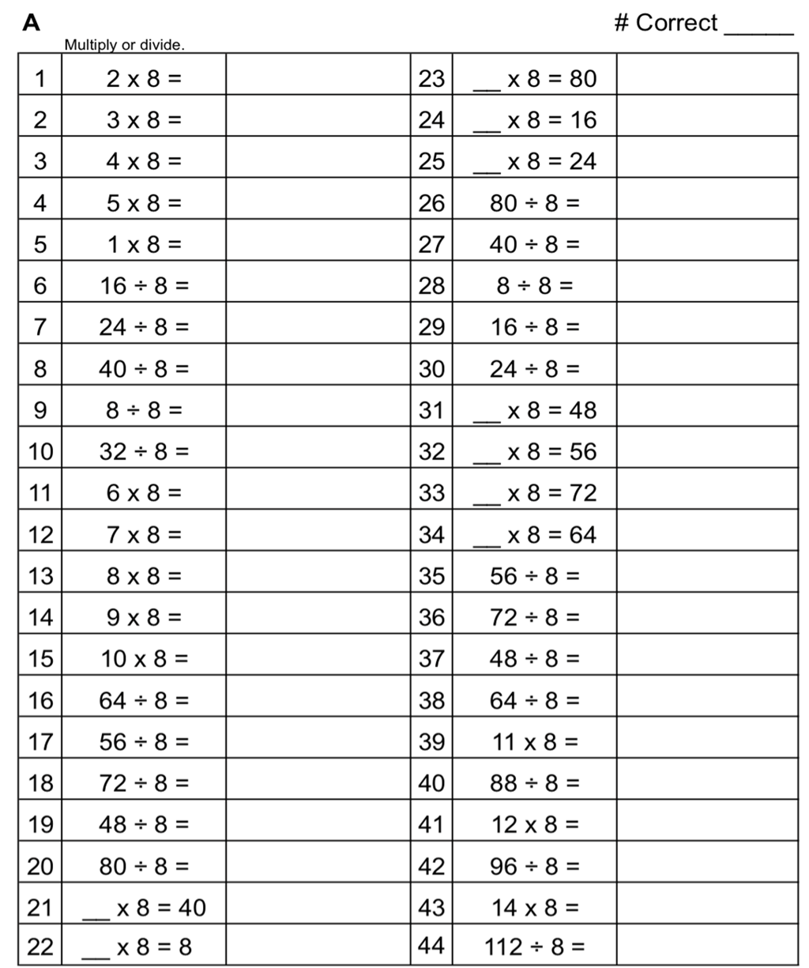
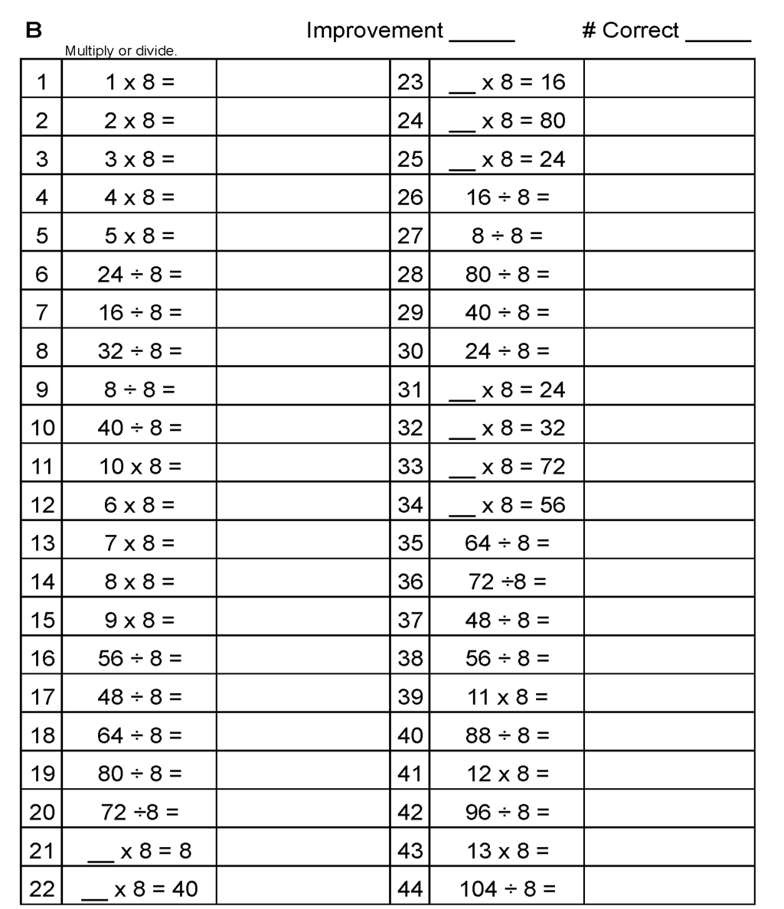
Name Date
- Each fraction strip is 1 whole. All the fraction strips are equal in length. Color 1 fractional unit in each strip. Then, answer the questions below.
$\frac{1}{2}$
$\frac{1}{4}$
$\frac{1}{8}$
$\frac{1}{3}$
$\frac{1}{6}$

- Circle less than or greater than. Whisper the complete sentence.

- $\frac{1}{2}$ is | less than | $\frac{1}{4}$ | - $\frac{1}{6}$ is | less than | $\frac{1}{2}$
 | greater than |  |  | greater than
- $\frac{1}{3}$ is | less than | $\frac{1}{2}$ | - $\frac{1}{3}$ is | less than | $\frac{1}{6}$
 | greater than |  |  | greater than
- $\frac{1}{8}$ is | less than | $\frac{1}{6}$ | - $\frac{1}{8}$ is | less than | $\frac{1}{4}$
 | greater than |  |  | greater than
- $\frac{1}{2}$ is | less than | $\frac{1}{8}$ | - 9 eighths is | less than | $2$ halves
 | greater than |  |  | greater than
- Lily needs $\frac{1}{3}$cup of oil and $\frac{1}{4}$cup of water to make muffins. Will Lily use more oil or more water?
Explain your answer using pictures, numbers, and words.

- Use >, <, or = to compare.
b. 1 seventh 1 fourth
d. 1 tenth $\frac{1}{12}$
f. 1 whole 2 halves

a. 1 third 1 fifth
c. 1 sixth $\frac{1}{6}$
e. $\frac{1}{16}$ 1 eleventh
Extension:
g. $\frac{1}{8}$ 1 eighth $\frac{1}{6}$ $\frac{1}{3}$ 2 halves 1 whole
- Your friend Eric says that $\frac{1}{6}$ is greater than $\frac{1}{5}$ because 6 is greater than 5. Is Eric correct? Use words and pictures to explain what happens to the size of a unit fraction when the number of parts gets larger.

Name Date
- Each fraction strip is 1 whole. All the fraction strips are equal in length. Color 1 fractional unit in each strip. Then, circle the largest fraction and draw a star to the right of the smallest fraction.

$\frac{1}{4}$
$\frac{1}{3}$
$\frac{1}{2}$

- Use >, <, or = to compare.
- 1 eighth 1 tenth
- 1 whole 5 fifths
- $\frac{1}{7}$ $\frac{1}{6}$

Name Date
- Each fraction strip is 1 whole. All the fraction strips are equal in length. Color 1 fractional unit in each strip. Then, answer the questions below.

$\frac{1}{2}$
$\frac{1}{3}$
$\frac{1}{5}$
$\frac{1}{4}$
$\frac{1}{9}$

- Circle less than or greater than. Whisper the complete sentence.

- $\frac{1}{2}$ is | less than | $\frac{1}{3}$ | - $\frac{1}{9}$ is | less than | $\frac{1}{2}$
 | greater than |  |  | greater than
- $\frac{1}{4}$ is | less than | $\frac{1}{2}$ | - $\frac{1}{4}$ is | less than | $\frac{1}{9}$
 | greater than |  |  | greater than
- $\frac{1}{5}$ is | less than | $\frac{1}{3}$ | - $\frac{1}{5}$ is | less than | $\frac{1}{4}$
 | greater than |  |  | greater than
- $\frac{1}{2}$ is | less than | $\frac{1}{5}$ | - 6 fifths is | less than | $3$ thirds
 | greater than |  |  | greater than

- After his football game, Malik drinks $\frac{1}{2}$a liter of water and $\frac{1}{3}$ of a liter of juice. Did Malik drink more water or juice? Draw and estimate to partition. Explain your answer.

- Use >, <, or = to compare.

- 1 fourth 1 eighth
- 1 seventh 1 fifth
- 1 eighth $\frac{1}{8}$
- 1 twelfth $\frac{1}{10}$
- $\frac{1}{15}$ 1 thirteenth
- 3 thirds 1 whole

- Write a word problem about comparing fractions for your friends to solve. Be sure to show the solution so that your friends can check their work.

