Lesson 9
Objective: Build and write fractions greater than one whole using unit fractions.

Suggested Lesson Structure
 Fluency Practice (12 minutes)
 Application Problem (10 minutes)
 Concept Development (28 minutes)
 Student Debrief (10 minutes)
Total Time (60 minutes)
Fluency Practice (12 minutes)
- Sprint: Multiply with Eight 3.OA.2 (8 minutes)
- Find the Unknown Part 3.NF.3d (2 minutes)
- Skip-Count by Halves on the Clock 3.G.2, 3.NF.1 (2 minutes)
Sprint: Multiply with Eight (8 minutes)
Materials: (S) Multiply with Eight Sprint
Note: This Sprint supports fluency with multiplication using units of 8.
Find the Unknown Part (2 minutes)
Note: This activity reviews representing parts of one whole as number bonds from Lesson 8.
T: (Project a number bond with $\frac{3}{3}$ as the whole and $\frac{2}{3}$ as a part.) Say the whole.
S: 3 thirds.
T: Say the known part.
S: 2 thirds.
T: Say the unknown part.
S: 1 third.
T: (Write $\frac{1}{3}$ in the unknown part.)
Continue with the following possible sequence: $\frac{6}{6}$ and $\frac{1}{6}, \frac{8}{8}$ and $\frac{3}{8}$, 1 whole and $\frac{3}{10}$, and 1 whole and $\frac{7}{12}$.
Skip-Count by Halves on the Clock (2 minutes)
Materials: (T) Clock
Note: This activity reviews counting by halves on the clock from Module 2.
T: (Hold or project a clock.) Let’s skip-count by halves on the clock, starting with 5 o’clock.
S: 5, half past 5, 6, half past 6, 7.
T: Stop. Skip-count by halves backward, starting with 7.
S: Half past 6, 6, half past 5, 5, half past 4, 4, half past 3, 3.
Continue counting up and down.
Application Problem (10 minutes)
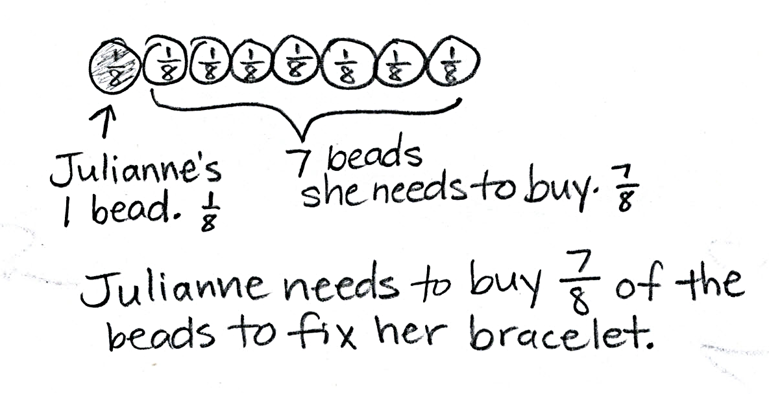
Julianne’s friendship bracelet had 8 beads. When it broke, the beads fell off. She could only find 1 bead. To fix her bracelet, what fraction of the beads does she need to buy?

NOTES ON
MULTIPLE MEANS
OF ENGAGEMENT:
For students working above grade level, extend the Application Problem with an open-ended prompt such as, “If Julianne adds another bead of the same size and shape to her bracelet, what fraction would the new bead represent? Why do you think so?”

Note: Students may represent 1 eighth or 7 eighths as the shaded part of the whole. Invite students to share their models and discuss how both representations correctly model the problem.
Concept Development (28 minutes)
Materials: (S) Personal white board, fraction strips
T: I brought 2 oranges for lunch today. I cut each one into fourths so that I could eat them easily. Draw a picture on your personal white board to show how I cut my 2 oranges.
S: (Draw.)
T: If 1 orange represents 1 whole, how many copies of 1 fourth are in 1 whole?
S: 4 copies.
T: Then, what is our unit?
S: Fourths.
T: How many copies of 1 fourth are in two whole oranges?
S: 8 copies.
T: Let’s count them.

NOTES ON
MULTIPLE MEANS
OF ACTION AND EXPRESSION:
Turn and Talk is an excellent way for English language learners to use English to discuss their math thinking. Let English language learners choose the language they wish to discuss their math reasoning, particularly if their English language fluency is limited.

S: 1 fourth, 2 fourths, 3 fourths… (up to 8 fourths).
T: Are you sure our unit is still fourths? Talk with your partner.
S: No, it’s in eighths because there are 8 pieces.
I disagree because the unit is fourths in each orange. Remember, each orange is a whole, so the unit is fourths. 2 oranges aren’t the whole!
T: I was so hungry I ate 1 whole orange and 1 piece of the second orange. Shade in the pieces I ate.
S: (Shade.)
T: How many pieces did I eat?
S: 5 pieces.
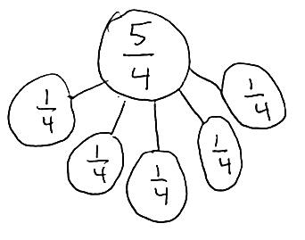
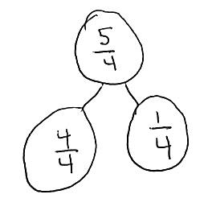
T: And what’s our unit?
S: Fourths.
T: So we can say that I ate 5 fourths of an orange for lunch. Let’s count them.
S: 1 fourth, 2 fourths, 3 fourths, 4 fourths, 5 fourths.
T: On your boards, work together to show 5 fourths as a number bond of unit fractions.
S: (Work with a partner to draw a number bond.)

NOTES ON
MULTIPLE MEANS
OF ENGAGEMENT:
For students working below grade level, respectfully facilitate self-assessment of personal goals. Guide students to reflect upon questions such as, “Which fraction skills am I good at? What would I like to be better at? What is my plan to improve?” Celebrate improvement.

T: Compare the number of pieces I ate to 1 whole orange. What do you notice?
S: The number of pieces is larger! You ate more pieces than the whole.
T: Yes. If the number of parts is greater than the number of equal parts in the whole, then you know that the fraction describes more than 1 whole.
T: Work with a partner to make a number bond with 2 parts. One part should show the pieces that make up the whole. The other part should show the pieces that are more than the whole.
S: (Work with a partner to draw a number bond.)
Demonstrate again using another concrete example. Follow by working with fraction strips. Fold fraction strips so that students have at least 2 strips representing halves, thirds, fourths, sixths, and eighths. Students can then build and identify fractions greater than 1 with the sets of fraction strips. Note that these fraction strips will be used again in Lesson 10. It might be a good idea to collect them or have students store them in a safe place.

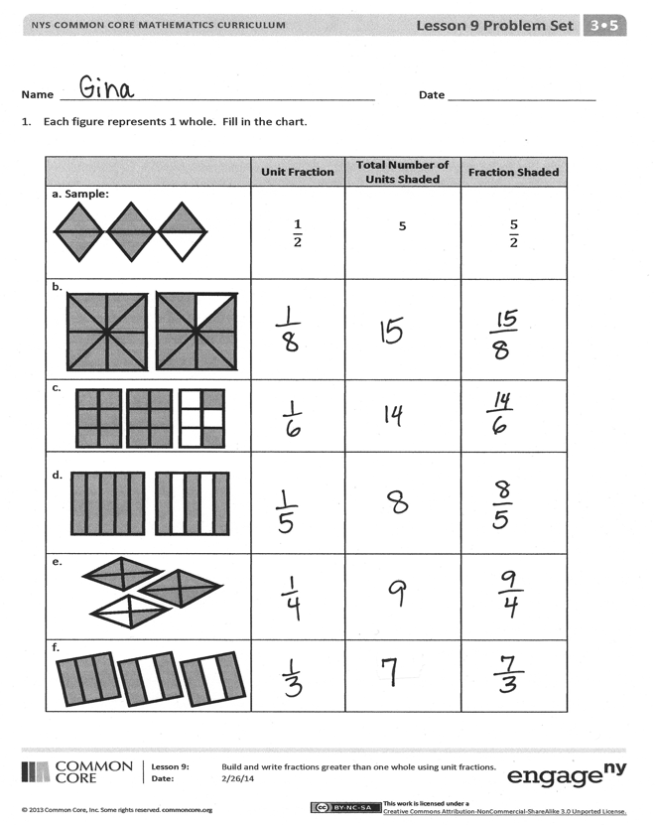
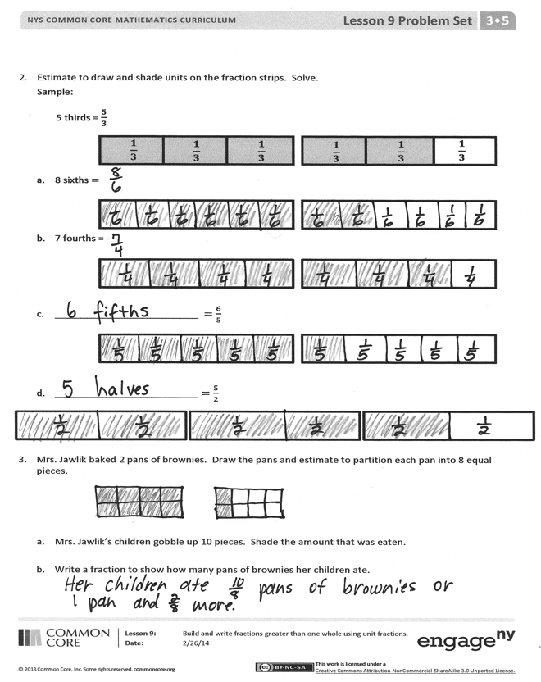
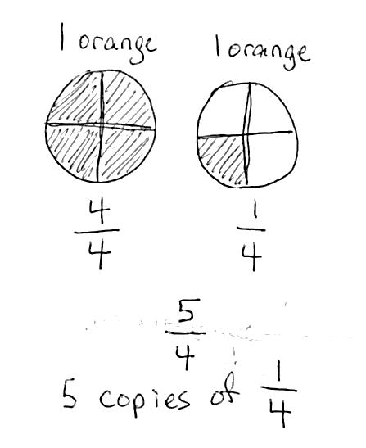
Problem Set (10 minutes)
Students should do their personal best to complete the Problem Set within the allotted 10 minutes. For some classes, it may be appropriate to modify the assignment by specifying which problems they work on first. Some problems do not specify a method for solving. Students should solve these problems using the RDW approach used for Application Problems.
Student Debrief (10 minutes)
Lesson Objective: Build and write fractions greater than one whole using unit fractions.
The Student Debrief is intended to invite reflection and active processing of the total lesson experience.
Invite students to review their solutions for the Problem Set. They should check work by comparing answers with a partner before going over answers as a class. Look for misconceptions or misunderstandings that can be addressed in the Debrief. Guide students in a conversation to debrief the Problem Set and process the lesson.
Any combination of the questions below may be used to lead the discussion.
- Problem 3 is likely to be challenging and may result in confusion about whether the children ate $\frac{10}{8}$ or $\frac{10}{16} .$ $\frac{10}{8}$ represents the amount of pans they ate, and $\frac{10}{16}$ represents the number of brownies they ate. The question asks for the number of pans. Have students share their work to spark a discussion that helps clarify this. The student work sample shows 2 different ways to write the answer.
- Although students have not been introduced to mixed numbers, it may be an intuitive way for them to answer the question. If so, briefly examine and discuss the 2 different answers. Have students then clarify the lesson’s objective. Have them discuss with a partner how to identify a fraction greater than one whole. If appropriate, advance to how they can identify a fraction greater than 2 wholes, etc.
Exit Ticket (3 minutes)
After the Student Debrief, instruct students to complete the Exit Ticket. A review of their work will help with assessing students’ understanding of the concepts that were presented in today’s lesson and planning more effectively for future lessons. The questions may be read aloud to the students.
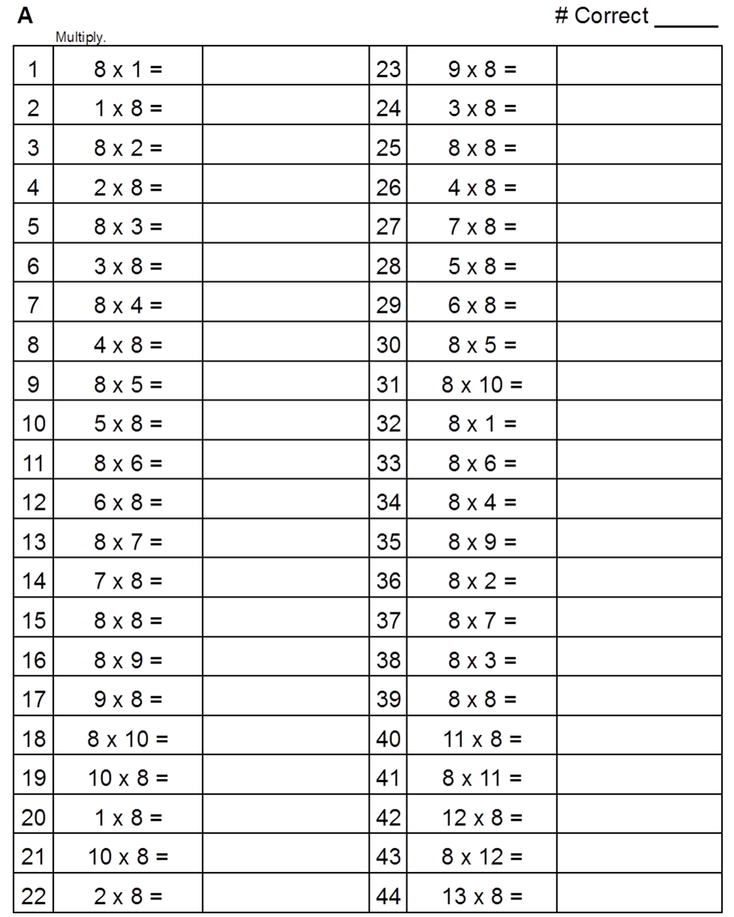
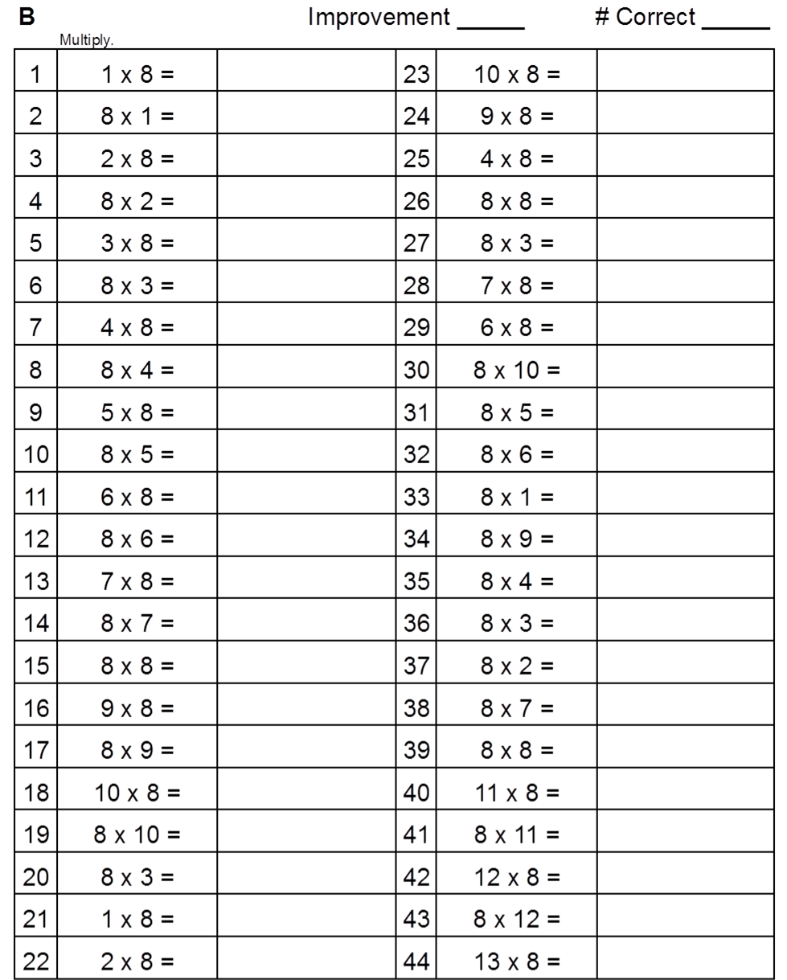

Name Date
- Each figure represents 1 whole. Fill in the chart.

 | Unit Fraction | Total Number of Units Shaded | Fraction Shaded
a. Sample: | $$\frac{1}{2}$$ | 5 | $$\frac{5}{2}$$
b.

c.

d.

e.

f.

- Estimate to draw and shade units on the fraction strips. Solve.
Sample:
5 thirds = $\frac{5}{3}$
$$\frac{1}{3}$$
$$\frac{1}{3}$$
$$\frac{1}{3}$$
$$\frac{1}{3}$$
$$\frac{1}{3}$$
$$\frac{1}{3}$$

- 8 sixths $=$

- 7 fourths =

- __________________________ $=\frac{6}{5}$

- __________________________$=\frac{5}{2}$

- Mrs. Jawlik baked 2 pans of brownies. Draw the pans and estimate to partition each pan into 8 equal pieces.

  - Mrs. Jawlik’s children gobbled up 10 pieces. Shade the amount that was eaten.

  - Write a fraction to show how many pans of brownies her children ate.

Name Date
- Each shape represents 1 whole. Fill in the chart.

 | Unit Fraction | Total Number of Units Shaded | Fraction Shaded

- Estimate to draw and shade units on the fraction strips. Solve.

- 4 thirds $=$

- ______________________$=\frac{10}{4}$

Name Date
- Each shape represents 1 whole. Fill in the chart.

 | Unit Fraction | Total Number of Units Shaded | Fraction Shaded
a. Sample: | $$\frac{1}{2}$$ | 3 | $$\frac{3}{2}$$
b.

c.

d.

e.

f.

- Estimate to draw and shade units on the fraction strips. Solve.
Sample:
7 fourths = $\frac{7}{4}$
$$\frac{1}{4}$$
$$\frac{1}{4}$$
$$\frac{1}{4}$$
$$\frac{1}{4}$$
$$\frac{1}{4}$$
$$\frac{1}{4}$$
$$\frac{1}{4}$$
$$\frac{1}{4}$$

- 5 thirds =

- __________________________$=\frac{9}{3}$

- Reggie bought 2 candy bars. Draw the candy bars and estimate to partition each bar into 4 equal pieces.

  - Reggie ate 5 pieces. Shade the amount he ate.

  - Write a fraction to show how many candy bars Reggie ate.

