Lesson 5
Objective: Partition a whole into equal parts and define the equal parts to identify the unit fraction numerically.

Suggested Lesson Structure
 Fluency Practice (15 minutes)
 Application Problem (10 minutes)
 Concept Development (25 minutes)
 Student Debrief (10 minutes)
Total Time (60 minutes)
Fluency Practice (15 minutes)
- Count by Eight 3.OA.7 (5 minutes)
- Write the Fractional Unit 3.NF.1 (5 minutes)
- Partition Shapes 3.NF.1 (5 minutes)
Count by Eight (5 minutes)
Materials: (S) Personal white board
Note: This activity supports fluency with multiplication using units of 8.
- Students count by eights as high as they can for 90 seconds. 0, 8, 16, 24, 32, 40, 48, 56, etc.
- Correct by reading the multiples. Students practice for an additional minute after correction.
- Students count by eight once again. Quickly celebrate improvement.
Write the Fractional Unit (5 minutes)
Materials: (S) Personal white board
Note: This activity reviews naming fractional units, as well as identifying shaded parts of a shape from
Topic A.
T: (Draw a shape with 3 units, 2 shaded in.) Write the fractional unit on your personal white board.
S: (Write thirds.)
T: Blank thirds are shaded. Write the number that goes in the blank.
S: (Write 2.)
Continue with the following possible sequence: 3 fourths, 2 fifths, 5 sixths, 7 tenths, and 5 eighths.
Partition Shapes (5 minutes)
Materials: (S) Personal white board
Note: This activity reviews partitioning shapes into equal parts from Topic A.
T: Draw a square.
S: (Draw.)
T: (Write halves.) Estimate to partition the square into equal halves.
S: (Partition.)
Continue with the following possible sequence: line, fifths; circle, fourths; circle, eighths; bar, tenths;
and bar, sixths.
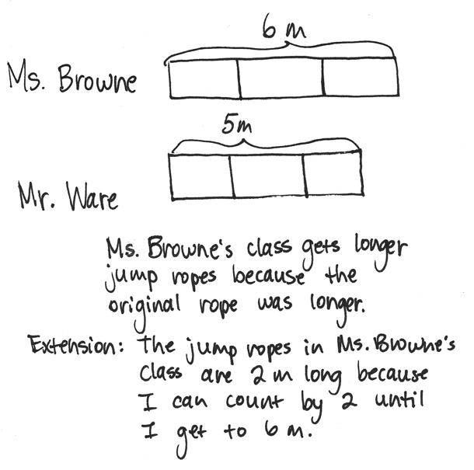
Application Problem (10 minutes)
Ms. Browne cut a 6-meter rope into 3 equal size pieces to make jump ropes. Mr. Ware cut a 5-meter rope into 3 equal size pieces to make jump ropes. Which class has longer jump ropes?
Extension: How long are the jump ropes in Ms. Browne’s class?
Note: This problem reviews partitioning different wholes into equal parts from Lesson 4.
Concept Development (25 minutes)
Materials: (S) Personal white board

NOTES ON
MULTIPLE MEANS
OF REPRESENTATION:
While introducing the new terms—unit form, numerical form, and unit fraction—check for student understanding. English language learners may choose to discuss definitions of these terms in their first language with you or their peers.

T: (Project or draw a circle, as shown below.) Whisper the name of this shape.
S: Circle.
1 half; $\frac{1}{2}$

T: Watch as I partition the whole. (Draw a line to partition the circle into 2 equal parts, as shown.) How many equal parts are there?
S: 2 equal parts.
T: What’s the name of each unit?
S: 1 half.
T: (Shade one unit.) What fraction is shaded?
S: 1 half.
T: 1 half is the unit form. (Write 1 half under the circle.) This is how we write it numerically. (Write $\frac{1}{2}$ under the circle.) Both of these refer to the same thing, 1 out of 2 equal units. We call this a unit fraction because it names one of the equal parts.
T: (Project or draw a square, as shown below.) What’s the name of this shape?
S: It’s a square.

NOTES ON
MULTIPLE MEANS
OF ENGAGEMENT:
Students working above grade level may enjoy identifying fractions with an added challenge of each shape representing a fraction rather than the whole. For example, ask the following:
“If shape 2 is 1 third, name the shaded region” (e.g., $\frac{3}{12}$ or $\frac{1}{4}$).

1 third; $\frac{1}{3}$

T: Draw it on your personal white board. (After students draw the square.) Estimate to partition the square into 3 equal parts.
S: (Partition.)
T: What’s the name of each unit?
S: 1 third.
T: Shade one unit. Then, write the fraction for the shaded amount in unit form and numerically on your board.
S: (Shade and write 1 third and $\frac{1}{3}$.)
T: Talk to a partner: Is the fraction that you wrote to represent the shaded part a unit fraction? Why or why not?
S: (Discuss.)
Continue the process with more shapes as needed. The following suggested shapes include examples of both shaded and non-shaded unit fractions. Alter language accordingly.

T: (Project or draw the following image.) Discuss with your partner: Does the shape have equal parts? How do you know?

S: No. The parts are not the same size. They’re also not exactly the same shape. The parts are not equal because the bottom parts are larger. The lines on the sides lean in at the top.

NOTES ON
MULTIPLE MEANS
OF ENGAGEMENT:
Review personal goals with students. For example, if students working below grade level chose to solve one word problem (per lesson) last week, encourage them to work toward completing two word problems by the end of this week.

MP.6
T: Most agree that the parts are not equal. How could you partition the shape to make the parts equal?
S: I can cut it into 2 equal parts. You have to cut it right down the middle going up and down. The lines aren’t all the same length like in a square.
T: Turn and talk: If the parts are not equal, can we call these fourths? Why or why not?
S: (Discuss.)
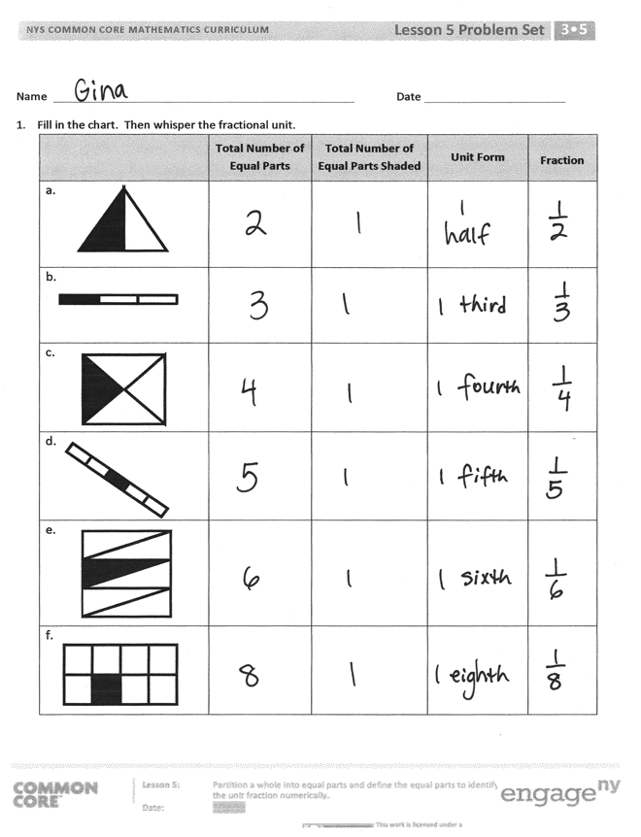
Problem Set (10 minutes)
Students should do their personal best to complete the Problem Set within the allotted 10 minutes. For some classes, it may be appropriate to modify the assignment by specifying which problems they work on first. Some problems do not specify a method for solving. Students should solve these problems using the RDW approach used for Application Problems.
Student Debrief (10 minutes)
Lesson Objective: Partition a whole into equal parts and define the equal parts to identify the unit fraction numerically.
The Student Debrief is intended to invite reflection and active processing of the total lesson experience.
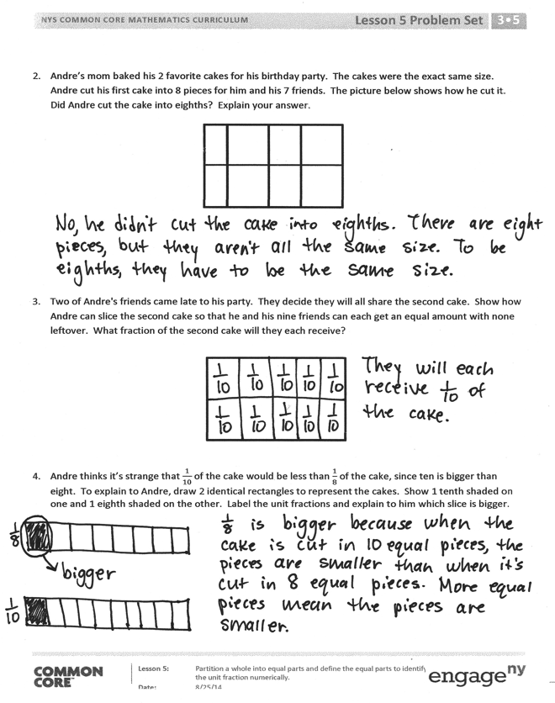
Invite students to review their solutions for the Problem Set. They should check work by comparing answers with a partner before going over answers as a class. Look for misconceptions or misunderstandings that can be addressed in the Debrief. Guide students in a conversation to debrief the Problem Set and process the lesson.
Any combination of the questions below may be used to lead the discussion.
- Are the fractions in Problem 1 unit fractions? How do you know?
- Use the following possible introduction to start a discussion about Problem 4: Let’s imagine we’re at Andre’s birthday party. Who would rather have an eighth of the cake? Who would rather have a tenth? Why? The following are some suggested sentence frames:
  - “I would rather have a __________ because _______________.”
  - “I agree/disagree because ____________.”
- Guide students to begin understanding that a greater number of parts results in smaller pieces.
Exit Ticket (3 minutes)
After the Student Debrief, instruct students to complete the Exit Ticket. A review of their work will help with assessing students’ understanding of the concepts that were presented in today’s lesson and planning more effectively for future lessons. The questions may be read aloud to the students.

Name Date
- Fill in the chart. Then, whisper the fractional unit.
 | Total Number of Equal Parts | Total Number of Equal Parts Shaded | Unit Form | Fraction
a.
b.

c.

d.

e.

f.

- Andre’s mom baked his 2 favorite cakes for his birthday party. The cakes were the exact same size. Andre cut his first cake into 8 pieces for him and his 7 friends. The picture below shows how he cut it. Did Andre cut the cake into eighths? Explain your answer.

- Two of Andre's friends came late to his party. They decide they will all share the second cake. Show how Andre can slice the second cake so that he and his nine friends can each get an equal amount with none leftover. What fraction of the second cake will they each receive?

- Andre thinks it’s strange that $\frac{1}{10}$ of the cake would be less than $\frac{1}{8}$ of the cake, since ten is bigger than eight. To explain to Andre, draw 2 identical rectangles to represent the cakes. Show 1 tenth shaded on one and 1 eighth shaded on the other. Label the unit fractions and explain to him which slice is bigger.

Name Date
- Fill in the chart.

 | Total Number of Equal Parts | Total Number of Equal Parts Shaded | Unit Form | Fraction

- Each image below is 1 whole. Write the fraction that is shaded.

____________________ _____________________ _____________________

- Draw two identical rectangles. Partition one into 5 equal parts. Partition the other rectangle into 8 equal parts. Label the unit fractions and shade 1 equal part in each rectangle. Use your rectangles to explain why $\frac{1}{5}$ is bigger than $\frac{1}{8}$.

Name Date
      - Fill in the chart. Then, whisper the fractional unit.

 | Total Number of Equal Parts | Total Number of Equal Parts Shaded | Unit Form | Fraction
a.

b.

c.

d.

e.

- This figure is divided into 6 parts. Are they sixths? Explain your answer.

- Terry and his 3 friends baked a pizza during his sleepover. They want to share the pizza equally. Show how Terry can slice the pizza so that he and his 3 friends can each get an equal amount with none left over.

- Draw two identical rectangles. Shade 1 seventh of one rectangle and 1 tenth of the other. Label the unit fractions. Use your rectangles to explain why $\frac{1}{7}$ is greater than $\frac{1}{10}$.

